The 2014-17 Global Coral Bleaching Event: The Most Severe and Widespread Coral Reef Destruction

Methods

Satellite-based Heat Stress
To measure heat stress that can lead to coral bleaching and mortality, we used daily global 0.05° (~5x5 km) sea surface temperatures and heat stress metrics from the U.S. National Oceanic and Atmospheric Administration’s Coral Reef Watch Satellite Coral Bleaching (CRW) version 3.1 Satellite Coral Bleaching Heat Stress Monitoring Product Suite dataset [1, 2]. The primary metric of heat stress, Degree Heating Week (DHW), accumulates the instantaneous bleaching heat stress, during the most recent 12-week period [2]. As the third global coral bleaching event (GCBE3) began in mid-2014, bleaching years as defined for this paper ran June through May for 2014-15, 2015-16, and 2016-17. The June-May timing also corresponds to a mid-year lull in heat stress and bleaching observations. Bleaching year maximum Bleaching Alert Level values for the entire period of GCBE3 were plotted in Fig. 1 and Extended Data Fig. 1a (the latter containing an overlay of reef-containing satellite pixels) and a summary of the number of pixels reaching Alert Levels 1-3 by bleaching year are summarized in Extended Data Table 1. We extracted the daily and bleaching year maximum Degree Heating Week (DHW) values for the pixel co-located with each field survey. We assigned a value of the 15th of the month for observations that contained an observation month without a date. For onsite observations on or next to coastlines, we extracted DHW values for these observations from the nearest valid ocean pixels. For Fig. 5, global Bleaching Alert Levels were calculated from the 0.25° (~25km) Optimum Interpolation Sea Surface Temperature (OISST), Version 2.1 dataset [3, 4] using the same methods as CRW’s operational products [2] and extracted for June-May bleaching years. OISST was chosen for this global application as the higher resolution CRW dataset [1] is not yet available back to 1982.

a)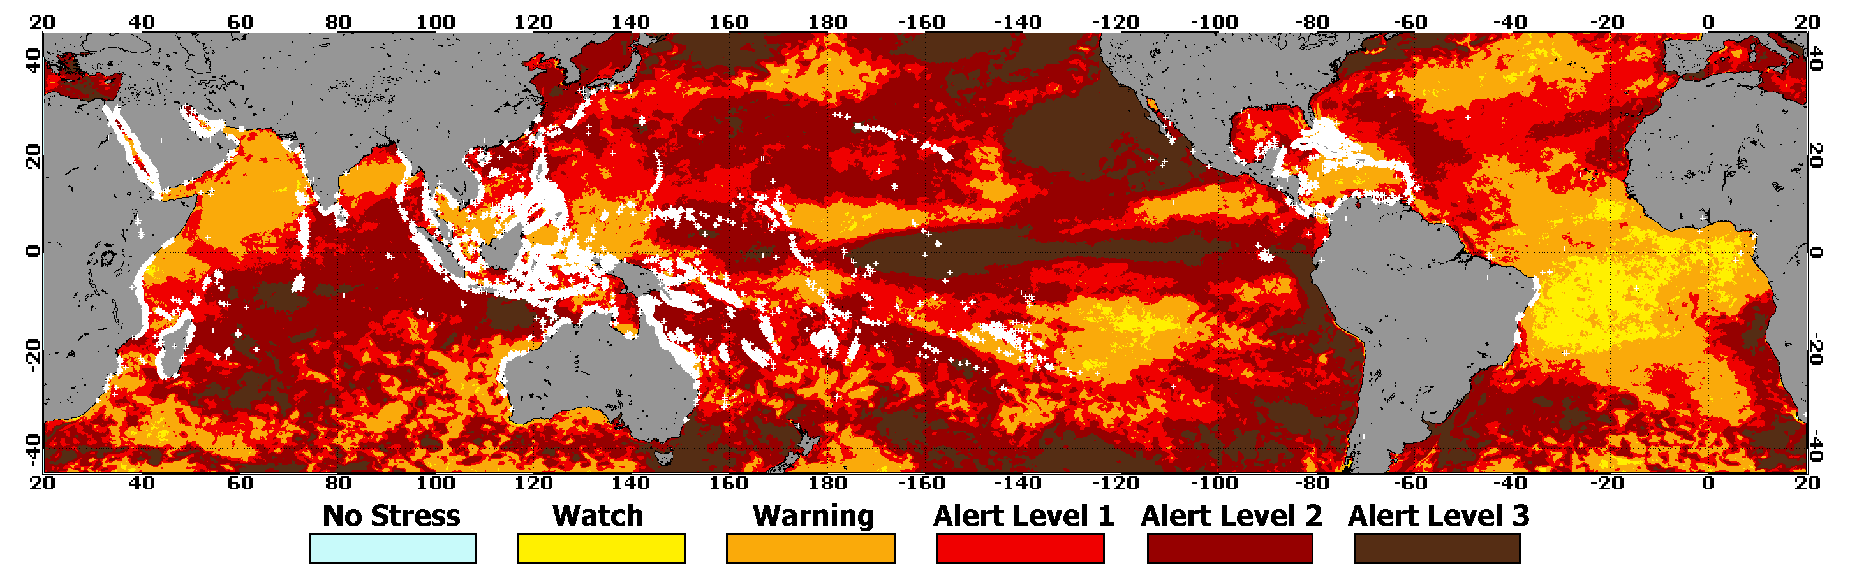
b)
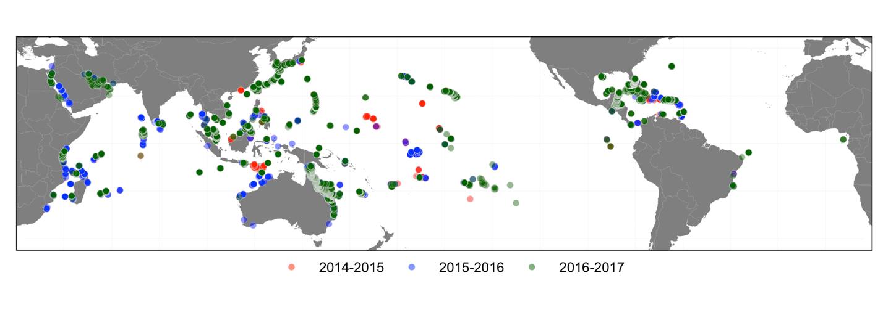
Extended Data Figure 1. a Global spatial pattern of maximum heat stress from 2014-17. Heat stress categories [2] of Alert Levels 1 and 2 correspond to heat stress likely to cause significant bleaching (≥ 4 °C-weeks) and severe bleaching with significant mortality (≥ 8 °C-weeks) respectively, and new Alert Level 3 corresponds to heat stress likely to cause severe, widespread mortality (≥ 16 °C-weeks). Overlapping survey dots result in blending of colors, with gray colors denoting sampling in all three years. White pluses plotted over underlying heat stress denote pixels containing coral reefs. b Map of contributed field surveys of bleaching or mortality in each bleaching year.

Extended Data Table 1. Numbers and percentages of ~5x5 km reef-containing pixels reaching CRW’s Bleaching Alert Levels 1, 2, and 3 for the three bleaching years during GCBE3 and reaching those levels more than once during 2014-17. All percentages are relative to the total number of 5 km global reef pixels in water: 53,997.

 | Percent (number) of pixels reaching each Alert Level
 | ≥ Alert Level 1 | ≥ Alert Level 2 | Alert Level 3
2014-15 | 15.9% (8570) | 2.1% (1144) | 0.1% (75)
2015-16 | 33.0% (17793) | 14.3% (7702) | 0.6% (299)
2016-17 | 25.1% (13546) | 11.7% (6292) | 0.1% (80)
2014-17 | 65.9% (35584) | 23.7% (12779) | 0.7% (394)
Multiple Events  (≥ twice) | 31.1% (16816) | 4.9% (2664) | 0.1% (60)

NOAA CRW’s current DHW metric only accumulates marine heat stress anomalies over a 12-week window, a period that has previously sufficed for mass heat stress events. In contrast to the recent past, marine heatwaves in the tropics now span multiple seasons and in 2014-17 persisted more than a year on some equatorial reefs [5]. This extension of bleaching seasons will necessitate a need for CRW to amend the calculation of DHW to encompass the entire period of these very lengthy bleaching events. These two changes will more effectively predict bleaching and mortality from prolonged and more intense heat exposure, which will assist management decisions and communication with local stakeholders as heat stress increasingly reaches unprecedented levels. They will also help to reveal the full extent of anthropogenic impact by unmasking the details of thermal events.

Bleaching and Mortality Observations
We collated field observational surveys conducted from 2014 through 2017 to document the spatial extent and severity of bleaching and mortality worldwide. The 2014-17 database (Extended Data Table 2, Extended Data Fig. 1b) follows the Donner et al. 2017 [6] format, including categories for (1) measures of coral bleaching as coral cover bleached (%), number of coral colonies bleached (n) and total number of colonies surveyed (N), or both; and/or (2) measures of coral mortality as coral cover dead (%), number of coral colonies dead (n), and total number of colonies surveyed (N), or both; (3) observation date; (4) observation location, including latitude, longitude, and reef site name; (5) data source; and (6) survey method used. We converted percentage bleached (and mortality, where available) into categorical variables following the same protocol as ReefBase (http://www.reefbase.org). While this simple method of bleaching collation has shortcomings (most notably, no requirement for data on bleaching by taxon), it allows for consistency in collation over time and inclusion of reports from rapid and low-technology bleaching assessments, as well as those conducted by citizen scientists through multiple programs (e.g., CORDIO-EA, ReefCheck, BleachWatch [7-10]). Additionally, we provided a qualitative questionnaire in which contributors could provide additional information about each observational dataset.

Extended Data Table 2 (found in a separate file). Bleaching and mortality observation database consisting of all aerial and in situ survey observations collated from the period of June 2014 – May 2017 during GCBE3.

The database was compiled from data submitted directly by individuals and extractions from large databases. CRW sent out multiple calls for coral reef survey (with or without observations of bleaching and/or mortality) data conducted during the time period of the GCBE3. We sought out a wide range of potential collaborators through direct contacts, calls for data on the NOAA Coral-List listserv, published calls for data [11], and an appeal through the team who created the film Chasing Coral [12]. We also extracted data on coral bleaching and mortality (where available) covering June 2014 – May 2017 from multiple regional/international databases/sources including Donner et al. 2017 [6], Reef Check International, Atlantic and Gulf Rapid Reef Assessment (AGRRA), Coastal Oceans Research and Development – Indian Ocean (CORDIO) East Africa, NOAA’s National Coral Reef Monitoring Program (NCRMP) [13], and Great Barrier Reef surveys [14]. After removing surveys that lacked information critical to this study, the remaining 15,066 bleaching and mortality surveys (Extended Data Table 2) spanned the period June 1, 2014 to May 31, 2017.

As the multiple individuals who contributed data to this paper used a variety of methods, the work presented here can be considered an unweighted meta-analysis of surveys conducted by numerous individuals, institutions, and organizations during the 2014-17 GCBE3. The techniques used were all highly comparable, well-accepted field methods. However, many surveys were conducted to meet multiple monitoring objectives and the timing did not always coincide with local bleaching events [15]. Past comparisons among coral reef survey methods have demonstrated that while there are some biases among methods, most provide comparable results among similar types of observations such as percent coral cover [16, 17]. Percentage of colonies bleached was often higher than the percentage of cover bleached because (1) small colonies bleached more often than large colonies; and/or (2) both partially- and fully-bleached colonies were counted as bleached in some survey methodologies. However, previous statistical comparison of the two methods found no significant differences when assessing the extent of coral bleaching or mortality [18]. Additionally, aggregating the data into broad categories minimizes the need for precise estimates of bleaching. Therefore, we assumed that the different observation methods provide comparable results for this meta-analysis.

Data Handling
We defined a unique bleaching observation (survey) as one with a unique combination of geographic coordinates, date, and depth or depth range. Each unique bleaching observation was assigned a data ID and included as a single, independent observation in the database. Multiple observations (quadrats or transects) taken at any reef site within a few days at the same depth range ($±$ 1 m) were combined into a single survey, with mean percent cover data or proportion of the number of colonies surveyed included in the database as the relevant observation. If percent bleached or mortality by individual colony data were provided, total coral area bleached was calculated by multiplying percent bleached or mortality of individual colony by the size dimensions of each colony and dividing that number by the total area of all coral colonies at each site. Each survey was categorized by bleaching year and oceanic region based on coordinate boundaries: Asia-Pacific (AP, 100°E to 100°W crossing the anti-meridian), Caribbean-Atlantic (CA, 100°W to 20°E crossing the prime meridian), and Indian Ocean-Middle East (IM, 20°E to 100°E).

Because heat stress often causes reductions in zooxanthellae (family Symbiodiniaceae) densities before bleaching becomes visible [19], coral colonies showing any degree of bleaching, from pale and partially bleached to fully bleached colonies, were identified as “bleached”. Similarly, we included partial and complete mortality under “mortality”, as it either indicated a heat stress response resulting in mortality due to bleaching or other, often heat-related, diseases. Therefore, partial and complete bleaching, and partial and complete mortality were combined as observations of bleaching and mortality, respectively.

As heat stress is not the only cause of bleaching, paling, and/or mortality of corals, some observations of bleaching or mortality may have been caused by other stress or predation. For this study, we used only bleaching observations that took place after satellite-based heat stress had begun, and we considered mortality data recorded after the peak of the heat stress event (i.e., the bleaching year maximum DHW) within a pixel or change in cover between repeat surveys during June 2014 – May 2017. Bleaching was compared against either the heat stress at the time of the observation or that year’s maximum heat stress if the observation was after the peak; mortality data were compared against that year’s maximum heat stress. A prior analysis of reefs showed that 6% bleaching and 4% recent mortality (within the past year) normally existed as a background level during surveys in years lacking any major disturbance [20]. As was used in a prior study of basin-scale bleaching and mortality [18], a value of approximately twice these (10%) was used to establish what was likely to be a threshold to determine significant levels of bleaching and mortality. Severe bleaching and mortality were identified as being at least half of the population (>50%).

Mortality data from the large databases only included corals known to have recently died (within the last year) or data that expert observers determined had recently died, most likely due to heat stress. In most cases, the actual cause of mortality was not known with complete certainty. Certain data contributors provided mortality data as a function of change over time (i.e., reduction in live coral cover since previous survey). These data were listed as mortality present on the ending date of this period.

Some monitoring programs reported percent bleaching or mortality in categories based on a range of values and a few different sets of ranges were used across the contributing programs. These were adjusted for consistency as follows. The ranges of the reported categories were determined, and the mid-point value of that range was entered in the database. Similarly, where data contributors provided ranges of percent bleached or mortality rather than single values, the mid-point values of the original ranges were used in the database.

Data Analyses
We fitted generalized linear mixed models (GLMMs) with binomial error structure in the R statistical software package [21, 22]. We considered DHW, year, and region (i.e., ocean basin) as the potential fixed effects, and the percent coral bleached or dead as the binomial response (i.e., whether percent of corals (area or number) in an individual reef survey exceeded the appropriate threshold (10% for significant impact, 50% for severe impact) or not, for both bleaching and mortality). Models including only the fixed effects exhibited some evidence of spatial autocorrelation of residuals within the first several thousand kilometers of distance in the second of two bleaching years. This was particularly found in 2015-2016 for significant bleaching (Extended Data Fig. 2: note the strong increasing trend in the top row, middle panel), and in 2016-2017 for severe bleaching (Extended Data Fig. 3: note the similar increasing trend in the top row, right). Consequently, for all subsequent analyses, we added a random effect of “Regional Virtual Station” which, for all bleaching observations, pulls together all surveys found within the boundaries of each of CRW’s 214 Regional Virtual Stations [23]. Once these effects were included, there was much less apparent autocorrelation in either the residuals or the random effect estimates themselves (Extended Data Figs. 2-4, middle and bottom rows), and models including these random effects exhibited about 2000 AIC units better fit than the models omitting them. So, we used these mixed-effects models for further inference.
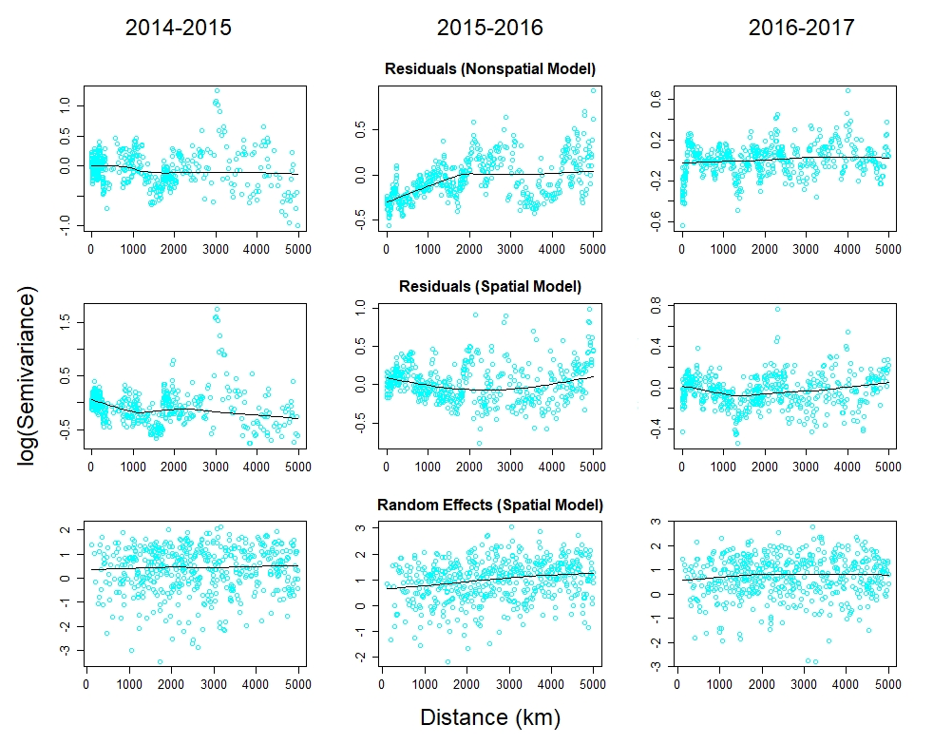
Extended Data Figure 2. Semivariograms of residuals of fixed-effect only models (top row), residuals of model including random effect of Regional Virtual Station (middle row), and random effect estimates from the model including random effects of Regional Virtual Station (bottom row) over the first 5000 kms of distance, for “significant bleaching” (>10% bleached). Note the pronounced increase in log(semivariance) with increasing distance over the first few thousand kilometers in 2015-2016 for the fixed-effects only model (top, middle). Distances between sites were calculated from latitude and longitude values using the library “geodist” in the software program R, using the “geodesic” method [24]. Semivariances were calculated using function “Variogram” in the R package “nlme” [25]. This yielded several million semivariance estimates. So, for plotting, these were then averaged over 500 distance bins with each bin set to average the same number of semivariances, and then log-transformed. Spatial autocorrelation over trend lines were plotted using the function “scatter.smooth” in the base R package [22] with degree 2 and span 0.25.

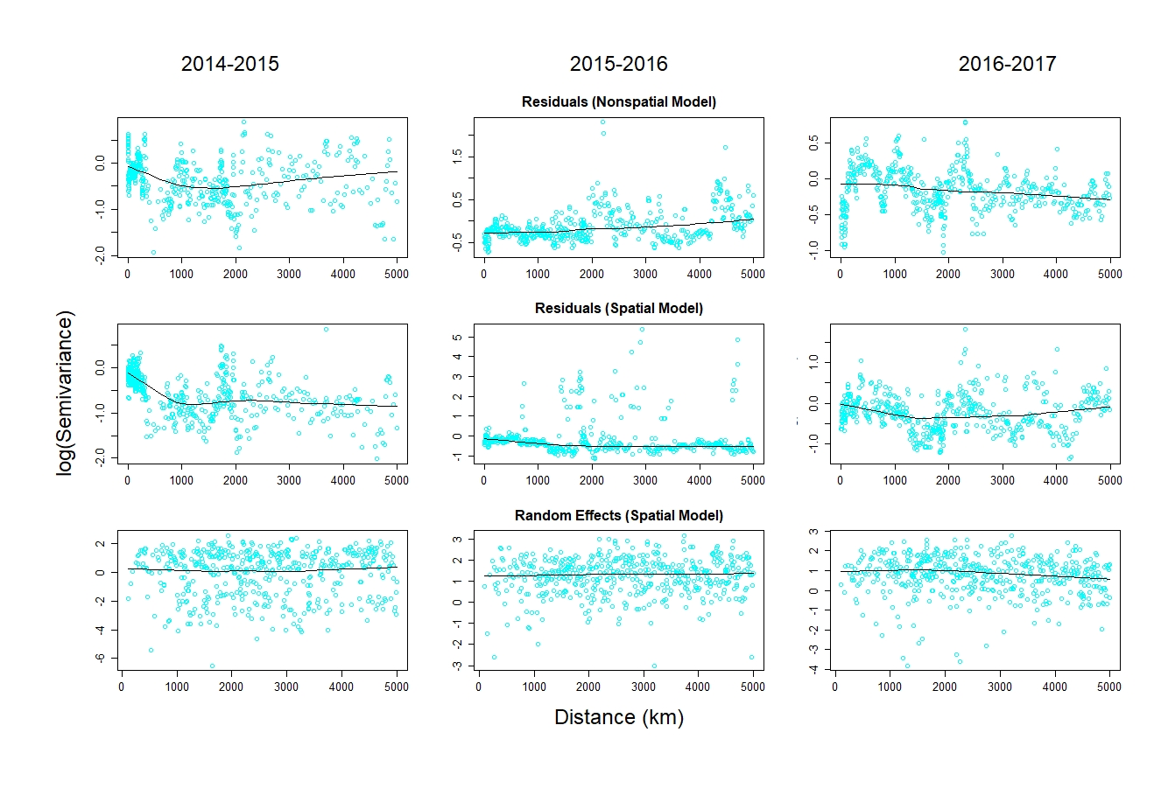Extended Data Figure 3. Semivariograms of residuals of fixed-effect only models (top row), residuals of model including random effect of Regional Virtual Station (middle row), and random effect estimates from the model including random effects of Regional Virtual Station (bottom row) over the first 5000 kms of distance, for “severe bleaching” (>50% bleached). Note the pronounced increase in log(semivariance) with increasing distance over the first few hundred kilometers in 2016-2017 for the fixed effects only model (top, right). See Extended Data Fig. 2 for details on calculation and plotting of semivariances.
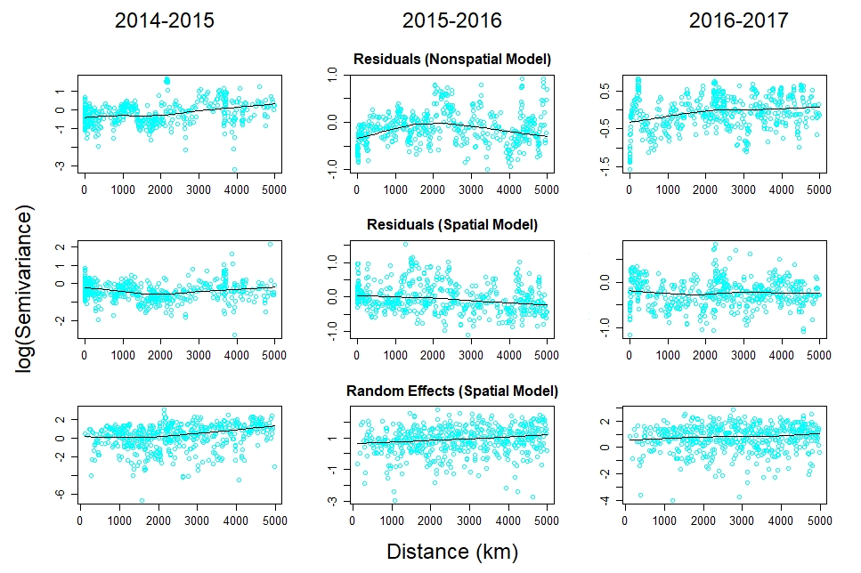
Extended Data Figure 4. Semivariograms of residuals of fixed-effect only models (top row), residuals of model including random effect of Regional Virtual Station (middle row), and random effect estimates from the model including random effects of Regional Virtual Station (bottom row) over the first 5000 kms of distance, for mortality (>10% mortality). See Extended Data Fig. 2 for details on calculation and plotting of semivariances.

To evaluate the evidence for the different possible effects and interactions among temperature, region, and bleaching year, we used Akaike Information Criterion (AIC) to compare the fit of models including full 3-way interactions (among DHW, bleaching year, and region), with models removing all possible combinations of interactions involving bleaching year and region. We wanted to consider models that had the same baseline level of bleaching at DHW=0, but still differed in their sensitivity to heat stress. This corresponds to models where interactions between DHW and bleaching year, or region, or both are retained, but there is no “main effect” (i.e., no difference at the intercept where DHW=0) of year or region, or no two-way interaction between year and region.

Despite the voluminous observations in the 2014-17 bleaching database (15,066 survey data points), the uneven spatial distribution of sampling (Extended Data Fig. 1b) yielded direct, observational data from only 6.6% (3592 pixels) of the total 53,997 reef-containing pixels worldwide [23]. To predict the probabilities of significant (≥10%) bleaching and mortality for all reef-containing pixels globally, we projected the statically modeled bleaching and mortality thresholds for each basin and year from data on the maximum satellite-measured heat stress (DHW) at each reef-containing pixel.

For Fig. 4, maximum DHW values from each pixel and for each of the three bleaching years of the GCBE3 were extracted, from which the probability of significant bleaching (Fig. 2) and significant mortality (Fig. 3) in each bleaching year was calculated using the fixed effect estimates from the GLMMs. Reef locations were assigned to one of 21 GCBE3 regions (Extended Data Table 3). Within each region the probabilities were summed across reef-containing pixels for each of the bleaching years yielding a measure of the cumulative probabilities of bleaching (area of colored diamonds) and mortality (area within the sub-diamonds) for each period. Regions were designated as either Northern or Southern Hemisphere for the purpose of display in which the cumulative probability of bleaching is represented, with the color of each diamond reflecting the maximum DHW during that bleaching year. Areas for each 12-month period (solid diamonds and enclosed dashed lines) were determined using fitted probabilities derived from the fixed effects of the best-fitting models of significant bleaching and mortality due to satellite-derived heat stress (Extended Data Fig. 5, Extended Data Fig. 7) summed across reef-containing pixels (i.e., two pixels with 30% probability of bleaching contribute the same as one pixel with a 60% probability of bleaching). The total reef area reflects the number of reef-containing pixels in each GCBE3 region (Fig. 4-inset). All GCBE3 summary values are reported in Extended Data Table 3.

Comparisons of satellite-derived heat stress to in-water observations of bleaching and mortality in each of the 214 NOAA CRW Satellite Regional Virtual Stations [23] yielded a very limited number of mismatches between satellite-measured heat stress and observed response in corals (<5% of all observations). Cases of high DHW values (≥8 °C-weeks) with less than 10% bleaching or mortality, and those with no measured heat stress but more than 50% bleaching or 10% mortality in individual surveys were scattered in space and time and showed no geographic pattern. While the GCBE had a worldwide scope, there are many factors that confound relationships between heat stress and coral beaching and mortality. These include poorly-timed observations that missed bleaching and mortality related to heat stress [15], and variations in bleaching and mortality with depth, light penetration, or habitat. In some sites, greater water depths have provided a layer of insulation from thermal events [26]. However, the potential for deep reefs to serve as refugia is uncertain and varies greatly [27-31]. Finer scale patterns of bleaching or mortality in nearshore reefs may have resulted from localized heating, cooling, or shading at spatial resolutions not detectable by the heat stress metric used in this study.

Extended Data Table 3. Predicted impacts during the GCBE3. Sums of ~5x5 km² satellite pixels within the 21 GCBE3 regions depicted in Fig.4. Left two tables provide sum of pixel probabilities for bleaching and mortality in each bleaching year. Third table shows percentage of three-year sum of bleaching pixels predicted to also contain significant mortality. Fourth table (far right) shows total number of pixels in each GCBE3 region. GCBE3 region #2 (Eastern Atlantic) not shown on Fig. 4 due to small reef area (4 of 53,997 reef-containing pixels).
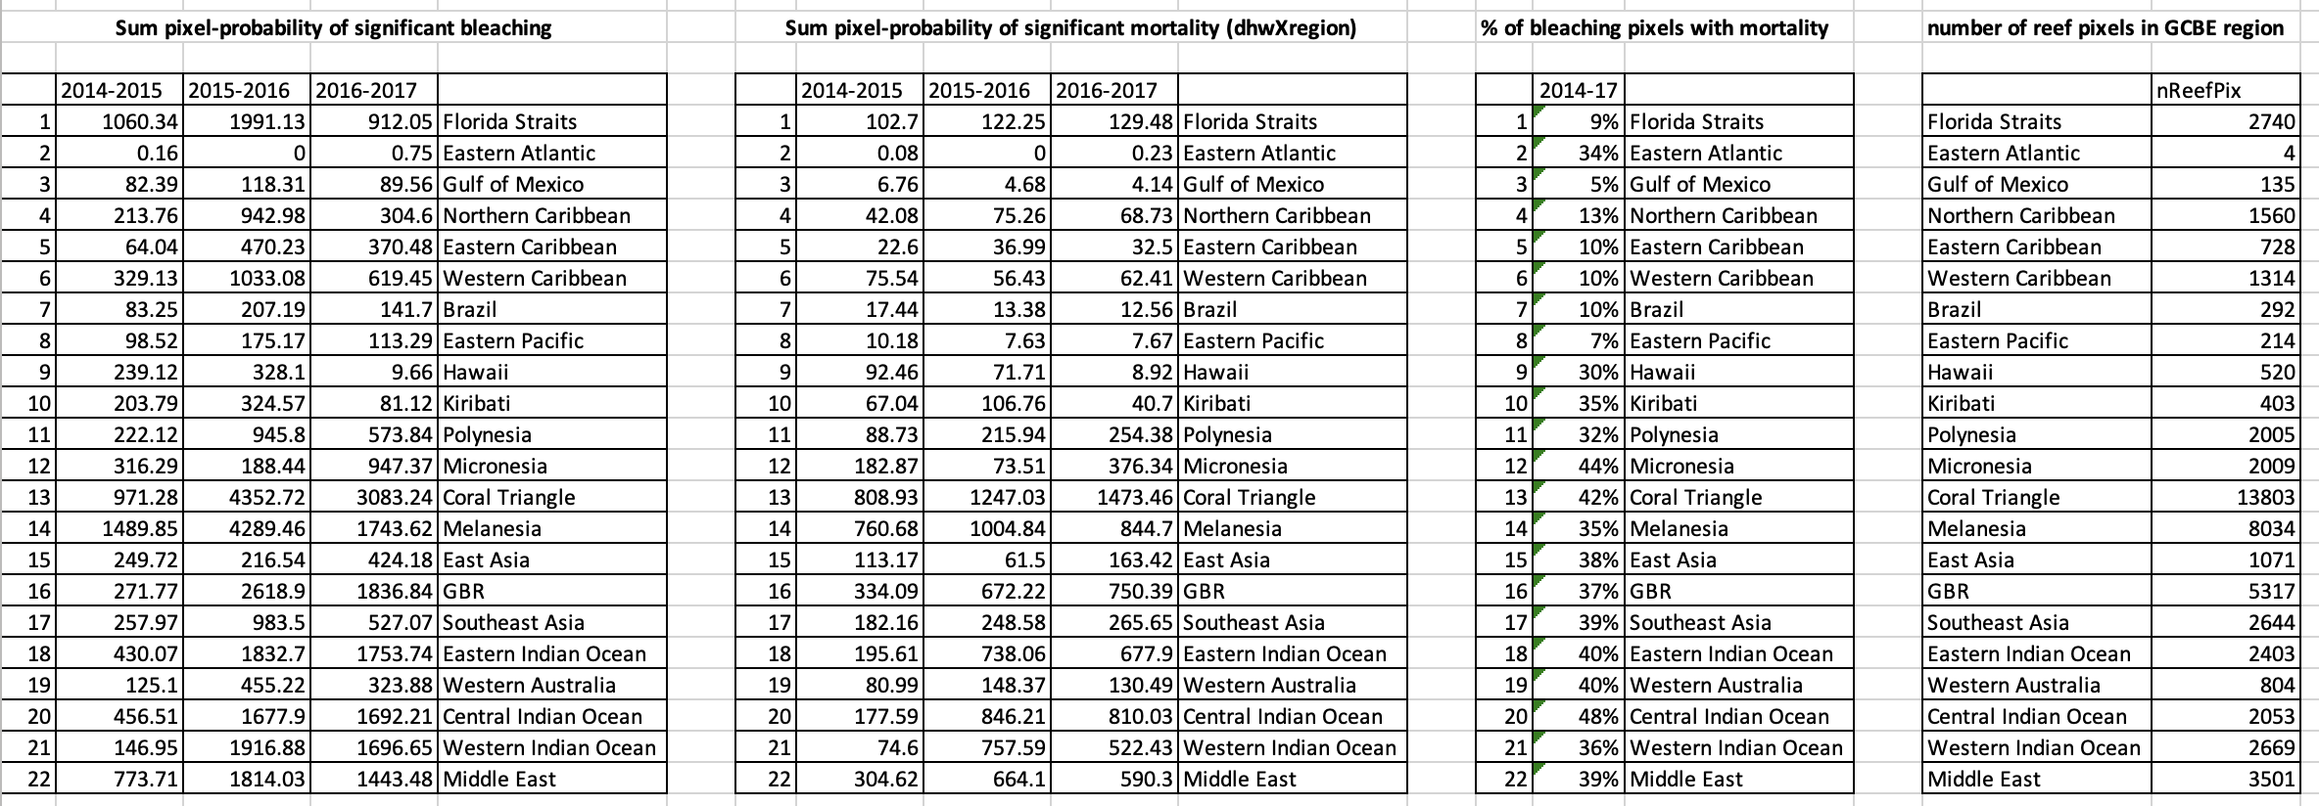

Model Selection
Model selection for significant bleaching (>10% of coral bleached) indicated that the best-fitting model was one with all main effects and interactions, except for an interaction between region and bleaching year (i.e., baseline bleaching when DHW=0 varied among years, and among regions, but year effects were consistent across regions and vice-versa). However, the retained three-way interaction involving DHW implies that the sensitivity of bleaching to temperature varied differently among regions in different years: see Extended Data Table 4 for model selection; Extended Data Fig. 5 for fitted thresholds of best-fitting model). For severe bleaching (>50% of coral bleached), the best-fitting model implied that all bleaching years and regions had a common baseline bleaching value at DHW=0 (i.e., no main effects of region or year, and no interaction between region and year), but that the bleaching thresholds did vary in different ways among years and regions, as in the “significant bleaching” (>10%) analysis (see Extended Data Table 5 for model selection; Extended Data Fig. 6 for best-fitting model). For significant (>10%) mortality, the best-fitting model included all main effects and interactions involving DHW, region, and bleaching year (see Extended Data Table 6 for model selection; Extended Data Fig. 7 for best-fitting model). For Fig. 2 we fitted models including only fixed effects and interactions for DHW and bleaching year (for panel a), and DHW and region (for panel b), to assist visualization of overall differences in bleaching thresholds among years and among regions. However, it is important to note that the best model for these data is that including interactions among all three fixed effects, and whose fitted relationships are plotted in Extended Data Fig. 5.

Extended Data Table 4. Model selection for significant bleaching (>10% coral bleached). Codes indicate the fixed effect structure of each model. “DHW” indicates degree-heating-weeks (⁰C-weeks) and is a continuously varying predictor. “R” and “BY” indicate the categorical variables region (Asia-Pacific, Caribbean/Atlantic, or Indian Ocean/Middle East) and “bleaching year” (2014-2015, 2015-2016, or 2016-2017), respectively. “+” indicates an additive effect, “x” indicates an interaction (inclusive of main and interactive effects), “:” indicates an interaction effect only (not including fixed effects), and “-” indicates the removal of a particular effect. For example, DHWxRxY – R:Y indicates a model including all main effects and interactions involving DHW, region, and bleaching year, except for the interaction between region and bleaching year. Similarly, DHWxY + DHWxR indicates a model with all main effects and interactions except for a three-way interaction of DHW, Y, and R, or an interaction between Y and R. “df” is degrees of freedom, “AIC” is Akaike’s Information Criterion, and Δ is the difference between the AIC of the given model and that of the best model in the model set (and so by definition the best-fitting model has Δ=0).
Model | df | AIC | Δ
DHWxRxY – R:Y | 15 | 12491.0 | 0
DHWxRxY | 19 | 12495.4 | 4.4
DHWxY + R | 9 | 12511.4 | 20.4
DHWxY + DHWxR | 11 | 12514.3 | 23.3
DHWxRxY – R:Y – R – Y | 11 | 12518.8 | 27.8
DHWxRxY - DHW:R:Y | 15 | 12521.1 | 30.1
DHWxY | 7 | 12540.5 | 49.4
DHWxR + Y | 9 | 12607.7 | 116.7
DHWxR | 7 | 12612.0 | 121.0
DHWxR + R:Y + Y | 13 | 12614.9 | 123.9
DHW + R + Y | 7 | 12623.7 | 132.7
DHW + R | 5 | 12628.2 | 137.2
DHW + RxY | 11 | 12630.6 | 139.6
DHW + Y | 5 | 12653.7 | 162.7
DHW | 3 | 12657.9 | 166.9

Extended Data Table 5. Model selection for severe bleaching (>50% coral bleached). See the caption for Extended Data Table 4. See Extended Data Table 4 for an explanation of model codes and the fixed effect structure of each model.
Model | df | AIC | Δ
DHWxRxY – RxY | 11 | 8109.5.0 | 0
DHWxRxY – R:Y | 15 | 8112.5 | 3.0
DHWxRxY | 19 | 8117.1 | 7.6
DHWxY + DHWxR | 11 | 8123.1 | 13.6
DHWxRxY - DHW:R:Y | 15 | 8128.7 | 19.2
DHWxY + R | 9 | 8135.9 | 26.4
DHWxY | 7 | 8136.8 | 27.3
DHWxR + Y | 9 | 8141.3 | 31.8
DHWxR | 7 | 8141.5 | 32.0
DHWxR + Y:R + Y | 13 | 8147.0 | 37.5
DHW + R | 5 | 8174.9 | 65.4
DHW + R + Y | 7 | 8175.2 | 65.7
DHW + Y | 5 | 8176.2 | 66.7
DHW | 3 | 8177.0 | 67.4
DHW + RxY | 11 | 8180.9 | 71.4

Extended Data Table 6. Model selection for significant mortality (>10% coral dead). See the caption for Extended Data Table 4. See Extended Data Table 4 for an explanation of model codes and the fixed effect structure of each model.
Model | df | AIC | Δ
DHWxRxY | 19 | 4824.5 | 0
DHWxRxY – RxY | 11 | 4826.3 | 1.8
DHWxRxY-R:Y | 15 | 4826.7 | 2.2
DHWxRxY - DHW:R:Y | 15 | 4842.7 | 18.2
DHWxY - DHWxR | 11 | 4849.2 | 24.7
DHWxY + Y:R + Y | 13 | 4878.2 | 53.7
DHWxR | 7 | 4880.5 | 56.0
DHWxR + Y | 9 | 4883.2 | 58.7
DHWxY | 7 | 4907.1 | 82.6
DHWxY + R | 9 | 4910.7 | 86.2
DHW | 3 | 4922.6 | 98.1
DHW + RxY | 11 | 4923.8 | 99.3
DHW + Y | 5 | 4925.5 | 101.0
DHW + R | 5 | 4925.9 | 101.4
DHW + R + Y | 7 | 4929.0 | 104.5

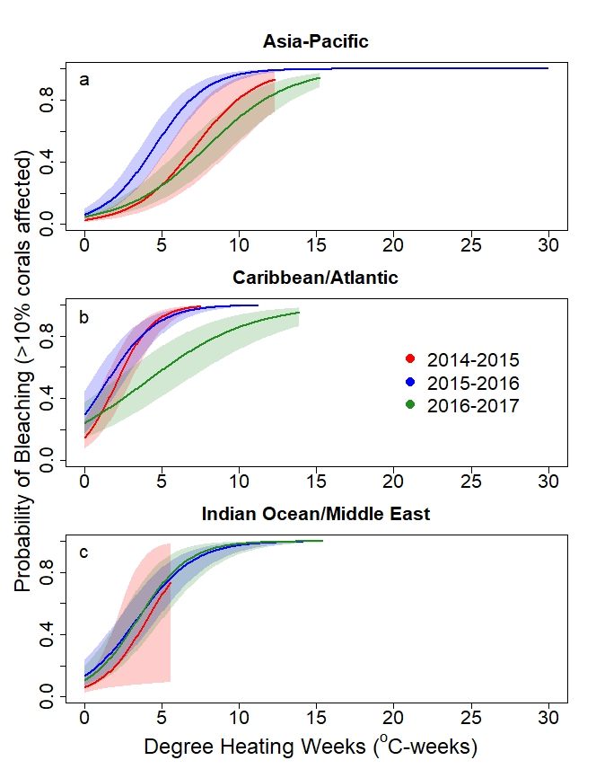
Extended Data Figure 5. The response curves for observed significant bleaching (affecting >10% of corals) as a function of heat stress varied among basins and bleaching years. Bleaching response curves, with 95% confidence limits (shading), in each of the three regions in the three bleaching years (2014-15, 2015-16, 2016-17): a Asia-Pacific (AP), b Caribbean/Atlantic (CA), and c Indian Ocean/Middle East (IM). The vertical axis is the probability of observed significant bleaching calculated from the bleaching/mortality database (n = 8089 surveys in AP, 5426 in CA, and 1587 in IM).
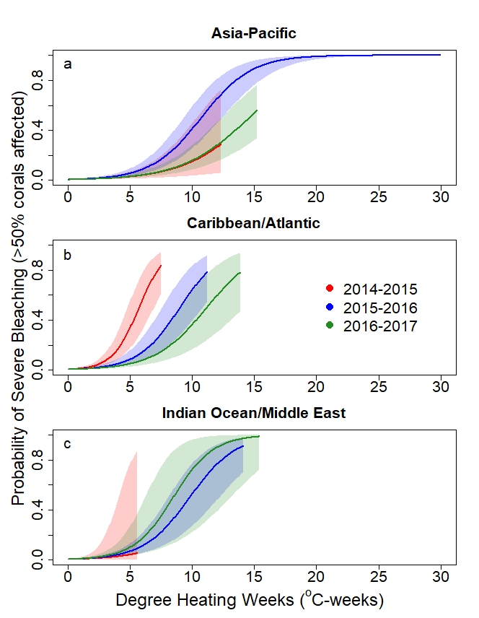
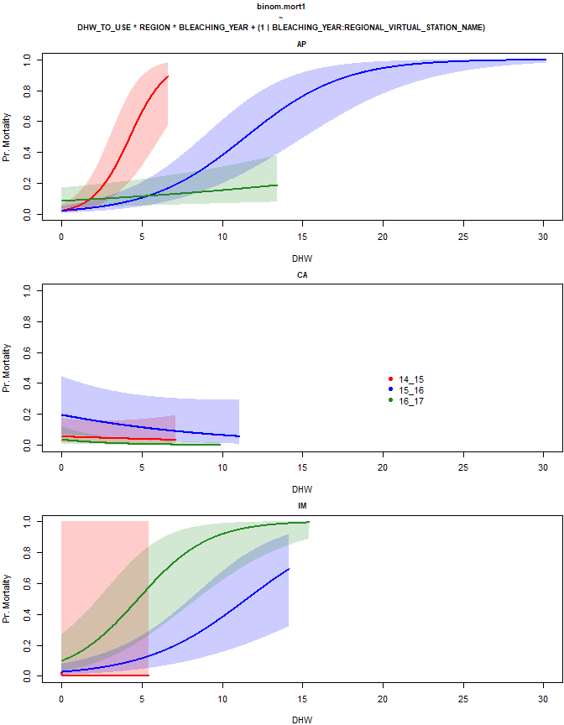Extended Data Figure 6. The response curves for observed severe bleaching (affecting > 50% of corals) as a function of heat stress varied among basins and bleaching years, generally diminishing in later years. Bleaching response curves, with 95% confidence limits (shading), in each of the three regions in the three bleaching years (2014-15, 2015-16, 2016-17): a Asia-Pacific (AP), b Caribbean/Atlantic (CA), and c Indian Ocean/Middle East (IM). The vertical axis is the probability of observed severe bleaching calculated from the bleaching/mortality database (n = 8089 surveys in AP, 5426 in CA, and 1587 in IM).
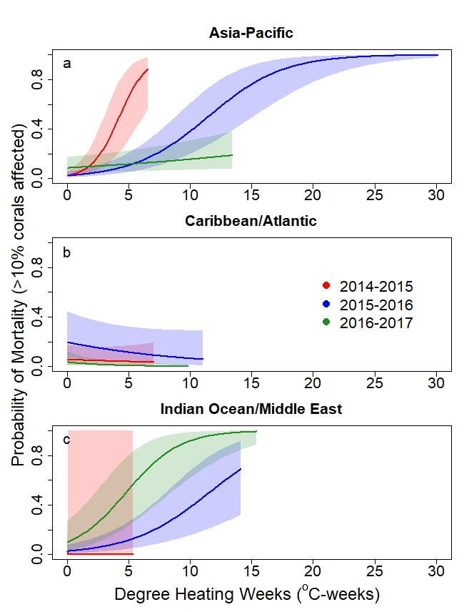
Extended Data Figure 7. The response curves for observed significant mortality (affecting >10% of corals) as a function of heat stress varied among basins and bleaching years, generally diminishing in later years. Mortality response curves, with 95% confidence limits (shading), in each of the three regions in the three bleaching years (2014-15, 2015-16, 2016-17): a Asia-Pacific (AP), b Caribbean/Atlantic (CA), and c Indian Ocean/Middle East (IM). The vertical axis is the probability of observed significant mortality calculated from the bleaching/mortality database (n = 8089 surveys in AP, 5426 in CA, and 1587 in IM).
Literature Cited
1. Liu, G., et al., NOAA Coral Reef Watch (CRW) Daily Global 5-km (0.05 degree) Satellite Coral Bleaching Heat Stress Monitoring Product Suite v3.1. 2018, NOAA National Centers for Environmental Information, https://doi.org/10.25921/6jgr-pt28.
2. Skirving, W., et al., CoralTemp and the Coral Reef Watch Coral Bleaching Heat Stress Product Suite Version 3.1. Remote Sensing, 2020. 12(23).
3. Huang, B., et al., NOAA 0.25-degree Daily Optimum Interpolation Sea Surface Temperature (OISST), Version 2.1. 2020, NOAA National Centers for Environmental Information, https://doi.org/10.25921/RE9P-PT57.
4. Reynolds, R.W., et al., Daily High-Resolution-Blended Analyses for Sea Surface Temperature. Journal of Climate, 2007. 20: p. 5473-5496.
5. Vargas-Ángel, B., et al., El Niño-associated catastrophic coral mortality at Jarvis Island, central Equatorial Pacific. Coral Reefs, 2019. 38(4): p. 731-741.
6. Donner, S.D., G.J.M. Rickbeil, and S.F. Heron, A new, high-resolution global mass coral bleaching database. PLoS ONE, 2017. 12(4): p. e0175490.
7. Gudka, M., et al., Participatory reporting of the 2016 bleaching event in the Western Indian Ocean. Coral Reefs, 2020. 39(1): p. 1-11.
8. Schläppy, M.-L., et al., Making Waves: Marine Citizen Science for Impact. Frontiers in Marine Science, 2017. 4(146).
9. Southeast Florida Action Network: SEAFAN BleachWatch Program. 2022, Florida Department of Environmental Protection Coral Reef Conservation Program. https://floridadep.gov/rcp/coral/content/bleachwatch.
10. Walter, C., Mote Marine Laboratory and Aquarium: BleachWatch. 2022, Mote Marine Laboratory and Aquarium, https://mote.org/research/program/coral-reef-science-monitoring/bleachwatch: Summerland Key, FL
11. Eakin, C.M., et al., Global coral bleaching 2014-2017: status and an appeal for observations. Reef Encounter, 2016. 31(43-1): p. 20-26.
12. Orlowski, J., Chasing Coral. 2017, Netflix: USA. p. 2:29.
13. Towle, E.K., et al., A National Status Report on United States Coral Reefs Based on 2012–2018 Data From National Oceanic and Atmospheric Administration’s National Coral Reef Monitoring Program. Frontiers in Marine Science, 2022. 8.
14. Hughes, T.P., J.T. Kerry, and T. Simpson, Large-scale bleaching of corals on the Great Barrier Reef. Ecology, 2018. 99(2): p. 501-501.
15. Claar, D.C. and J.K. Baum, Timing matters: survey timing during extended heat stress can influence perceptions of coral susceptibility to bleaching. Coral Reefs, 2019. 38(4): p. 559-565.
16. Hill, J. and C. Wilkinson, Methods for Ecological Monitoring of Coral Reefs, Version 1. 2004, Townsville, Australia: Australian Institute of Marine Science. 117.
17. Leujak, W. and R.F.G. Ormond, Comparative accuracy and efficiency of six coral community survey methods. Journal of Experimental Marine Biology and Ecology, 2007. 351(1-2): p. 168-187.
18. Eakin, C.M., et al., Caribbean corals in crisis: record thermal stress, bleaching, and mortality in 2005. PLoS ONE, 2010. 5(11): p. e13969.
19. Hoegh-Guldberg, O., M.P. Lesser, and R. Iglesias Prieto, Bleaching and physical/chemical stress on coral reefs, in Understanding the Stress Response of Corals and Symbiodinium in a rapidly changing environment, O. Hoegh-Guldberg, Editor. 2005, Universidad Nacional Autónoma de México, Instituto de Ciencias del Mar y Limnología, Unidad Académica Puerto Morelos: Mexico. p. 107-110.
20. Kramer, P.A., Synthesis of Coral Reef Health Indicators for the Western Atlantic: Results of the AGRRA Program (1997-2000). Atoll Research Bulletin, 2003. 496: p. 1-57.
21. Brooks, M.E., et al., glmmTMB Balances Speed and Flexibility Among Packages for Zero-inflated Generalized Linear Mixed Modeling. The R Journal, 2017. 9(2): p. 378-400.
22. R Core Team, R: A language and environment for statistical computing. 2021, R Foundation for Statistical Computing: Vienna, Austria.
23. CRW, NOAA Coral Reef Watch Version 3.1 Daily Global 5km Satellite Coral Bleaching Product Suite. 2019: College Park, Maryland, USA.
24. Padgham, M. and M.D. Sumner, geodist: Fast, Dependency-Free Geodesic Distance Calculations. 2021.
25. Pinheiro, J., et al., nlme: Linear and Nonlinear Mixed Effects Models, in R package version 3.1-153. 2021.
26. Johnston, M.A., et al., Coral bleaching and recovery from 2016 to 2017 at East and West Flower Garden Banks, Gulf of Mexico. Coral Reefs, 2019. 38(4): p. 787-799.
27. Baird, A.H., et al., A decline in bleaching suggests that depth can provide a refuge from global warming in most coral taxa. Marine Ecology Progress Series, 2018. 603: p. 257-264.
28. Frade, P.R., et al., Deep reefs of the Great Barrier Reef offer limited thermal refuge during mass coral bleaching. Nature Communications, 2018. 9(1): p. 3447.
29. Venegas, R.M., et al., The Rarity of Depth Refugia from Coral Bleaching Heat Stress in the Western and Central Pacific Islands. Scientific Reports, 2019. 9(1): p. 19710.
30. Pérez-Rosales, G., et al., Mesophotic coral communities escape thermal coral bleaching in French Polynesia. Royal Society Open Science, 2021. 8(11): p. 210139.
31. MacDonald, C., et al., Disturbance and distribution gradients influence resource availability and feeding behaviours in corallivore fishes following a warm-water anomaly. Scientific Reports, 2021. 11(1): p. 23656.

