Supplementary Information

Chromatin Reprogramming via Contact Guidance-Induced Nuclear Deformation Promotes Stem Cell Differentiation

Supplementary Table S1. List of Genes Differentially Expressed in MSCS on Micropillars compared to Flat Surface with p<0.05.

Supplementary Table S2. Gene Ontology Analysis on Genes Downregulated in Micropillars compared to flat Surface In Both Stem And Induced Conditions.

Supplementary Table S3. Top 20 Ontology Gene Sets Depleted and Enriched in Micropillars compared to Flat Surfaces.

Supplementary Table S4. Gene Ontology Analysis on Genes Differentially Expressed in Induced MSCs compared to Uninduced MSCs on a Flat Surface with p<0.05 and Absolute Fold Change > 1.5.

Supplementary Table S5. Raw Rata Used to plot figures in Main Text.

Supplementary Table S6. Primary Antibody Information for Immunostaining and Western Blot Analysis.
Antibody | Company | Catalog # | Dilution/  Application
Vinculin | Millipore | MAB3574 | 1:100 IF
Vimentin | Abcam | ab92547 | 1:100 IF
Tubulin | Abcam | ab6046 | 1:100 IF
YAP | Santa Cruz | sc-101199 | 1:100 IF
Lamin a/c | Abcam | ab8984 | 1:100 IF
GAPDH | Abcam | ab181602 | 1:5000 WB
H3 | Abcam | ab1791 | 1:2000 WB
H3ac | Abcam | ab47915 | 1:200 IF  1:1000 WB
H3K9ac | Cel signaling | 9649T | 1:200 IF
H3K14ac | Cel signaling | 7627T | 1:100 IF
H3K18ac | Cel signaling | 13998T | 1:100 IF
H3K27ac | Cel signaling | 8173T | 1:100 IF
H3K4me2 | Cel signaling | 9725T | 1:200 IF
H3K36me2 | Cel signaling | 2901T | 1:200 IF
H3K9me3 | Cel signaling | 13969T | 1:100 IF
H3K27me3 | Cel signaling | 9733T | 1:100 IF;  1:500 WB
H3K36me3 | Cel signaling | 4909T | 1:100 IF
H4K20me1 | Invitrogen | MA5-31762 | 1:100 IF
HDAC1 | Invitrogen | PA1-860 | 1:100 IF;  1:500 WB
HDAC2 | Sigma | H3159 | 1:200 IF;  1:1000 WB
HDAC3 | Cell Signaling | 7G6C5 | 1:100 IF;  1:500 WB
EZH2 | Cell Signaling | 5246T | 1:100 IF  1:200 WB
Non-phospho (active) β-catenin | Cell signaling | D2U8Y | 1:100 IF
RUNX2 | Santa Cruz | sc-390715 | 1:50 IF

Supplementary Table S7. Information of Secondary Antibody and Other Staining Materials for Immunostaining and Western Blot Analysis.
Anti-Mouse IgG, Alexa Fluor 488 | Invitrogen | A11001 | 1:1000 IF
Anti-Mouse IgG,  Alexa Fluor 594 | Invitrogen | A11032 | 1:1000 IF
Anti-Rabbit IgG,  Alexa Fluor 488 | Invitrogen | A21206 | 1:1000 IF
Anti-Rabbit IgG, Alexa Fluor 594 | Invitrogen | A11012 | 1:1000 IF
Anti-Mouse IgG, Peroxidase | Sigma | A-3682 | 1:5000 WB
Anti-Rabbit IgG, Peroxidase | Sigma | A-0545 | 1:5000 WB
Hoechst 33342 | Sigma | B2261 | 1:1000 IF
Alexa Fluor 488 Phalloidin | Invitrogen | A12379 | 1:40 IF
Alexa Fluor 594 Phalloidin | Invitrogen | A12381 | 1:40 IF
Mounting Medium with DAPI | Vector Lab | H-1200
Mounting Medium | Vector Lab | H-1000

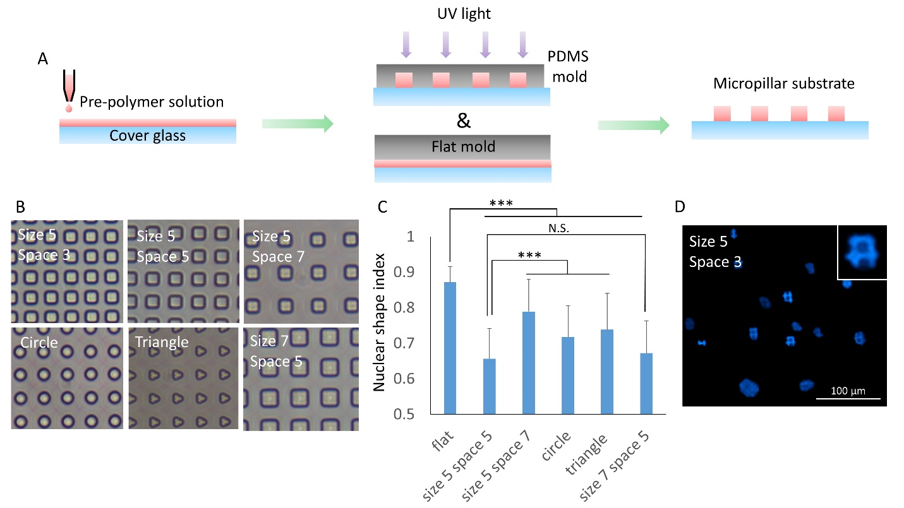
Supplementary Figure S1. Influence of microfeatures on nuclear deformation. (A) Schematic illustration of the fabrication process of flat and micropillar surfaces using mPOC. (B) Phase-contrast images of micropillars structures with different features. (C) Nuclear Shape Index of cells on various surfaces. n>140, ***p<0.001, N.S., no significant difference. (D) Typical staining image of cell nuclei on micropillars with a spacing of 3 μm. The small spacing caused major deformation at the bottom rather than changing the morphology of the whole nucleus for most cells. This is reasonable as decreasing spacing requires the cell nuclei to squeeze more to fit between the microstructures until they are too small to do so.

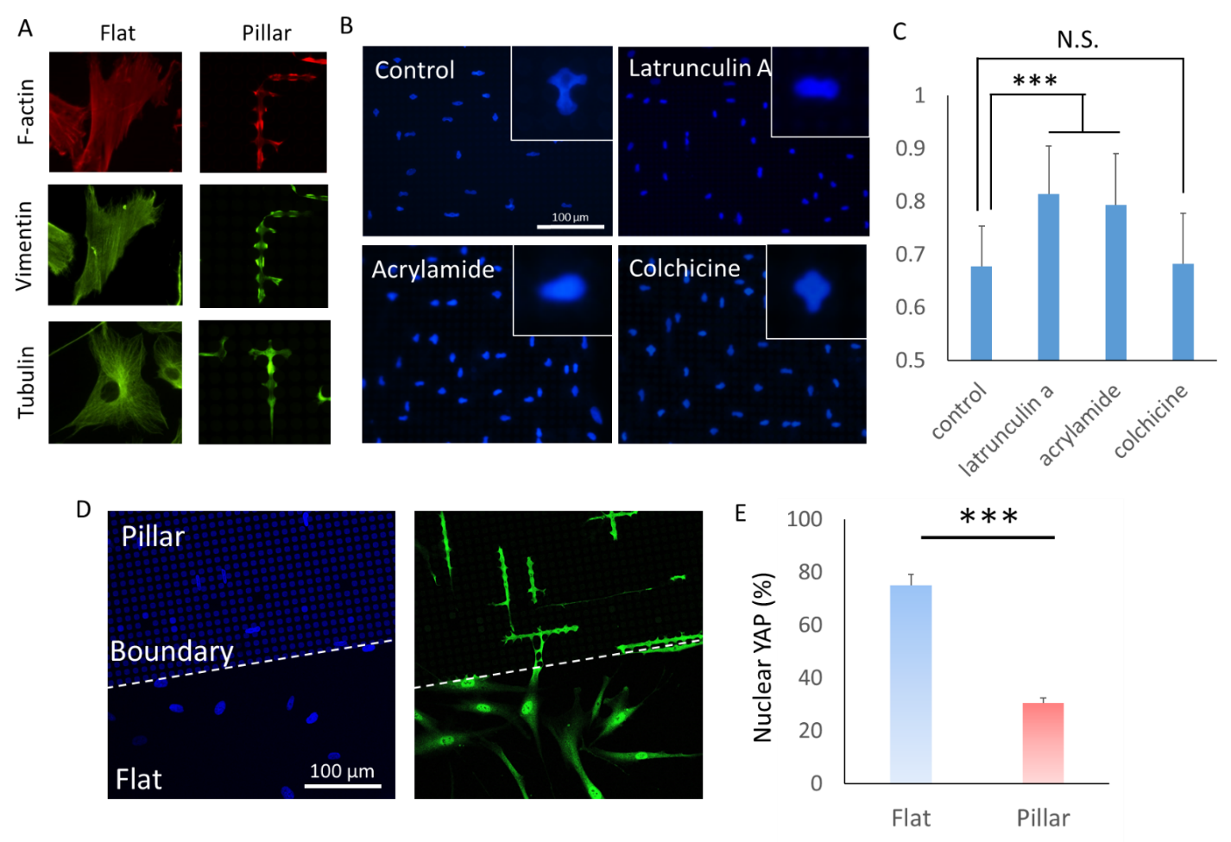
Supplementary Figure S2. Cytoskeleton and micropillars drive nuclear deformation and affect mechanotransdcution. (A) Cytoskeleton assembly of hMSCs on flat and micropillar surfaces. (B) Staining images of cell nuclei on the micropillar surface with different pharmacological treatments. (C) NSI of cells on micropillar surface with different pharmacological treatments. n>100, ***p<0.001, N.S., no significant difference. (D) Nuclei and YAP/TAZ staining images of cells and (E) quantification of nuclear accumulated YAP/TAZ. The majority of cells on the flat surface showed accumulated localization of YAP in the cell nucleus. In contrast, cells on micropillars showed small differences between nuclear and cytoplasmic YAP, with both cellular compartments exhibiting similar fluorescence intensities. The significant decrease in nuclear/cytoplasmic YAP ratio on micropillar structures combined with a decrease in formation of FAs and a weaker cytoskeleton assembly indicates a decreased response of cells to cytoskeleton mediated mechanical cues.

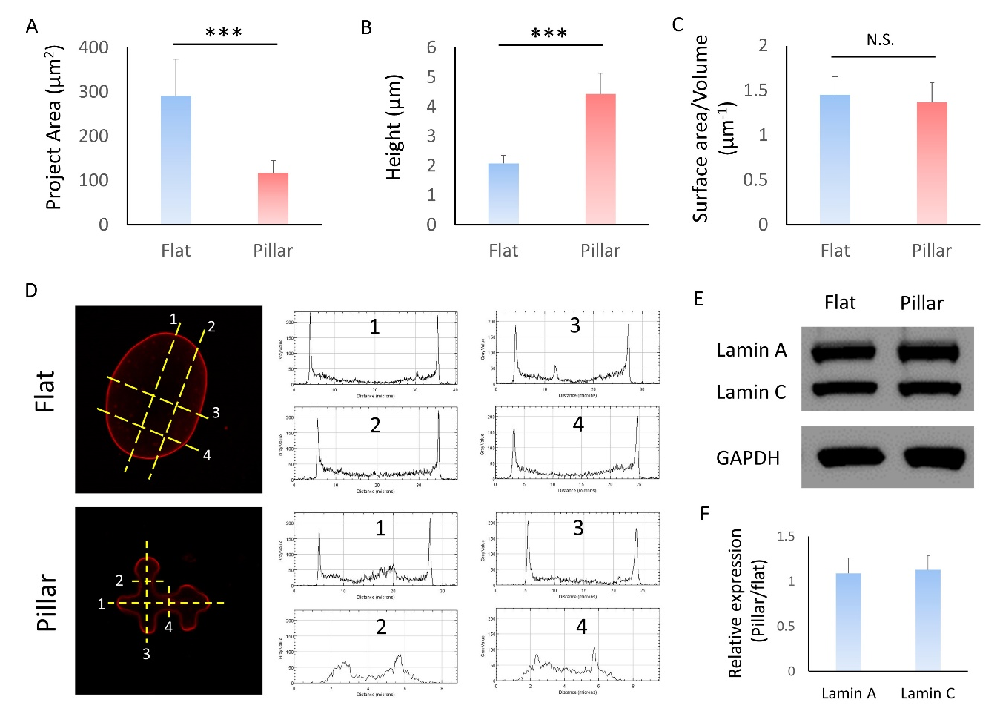

Supplementary Figure S3. Influences of micropillars on 3D morphological features of cell nuclei. (A) Project area, and (B) height, and (C) the ratio of surface area to volume of cell nuclei on flat and micropillar structures. n=33 and 34 (flat and micropillar), ***p<0.001, N.S., no significant difference. According to the results, we observed a more 3D configuration of deformed nuclei which could be due to the adhesive region in z direction provided by micropiilars that are called 2.5D culture system. Micropillars also induce anisotropic distribution of lamin a/c in xy (horizontal) plane as shown in (D) Intensity plot (right) along line 1-4 (left) in the nucleus on flat and micropillar surfaces. (E) and (F) Western blot image and analysis of lamin a/c on flat and micropillar surfaces.

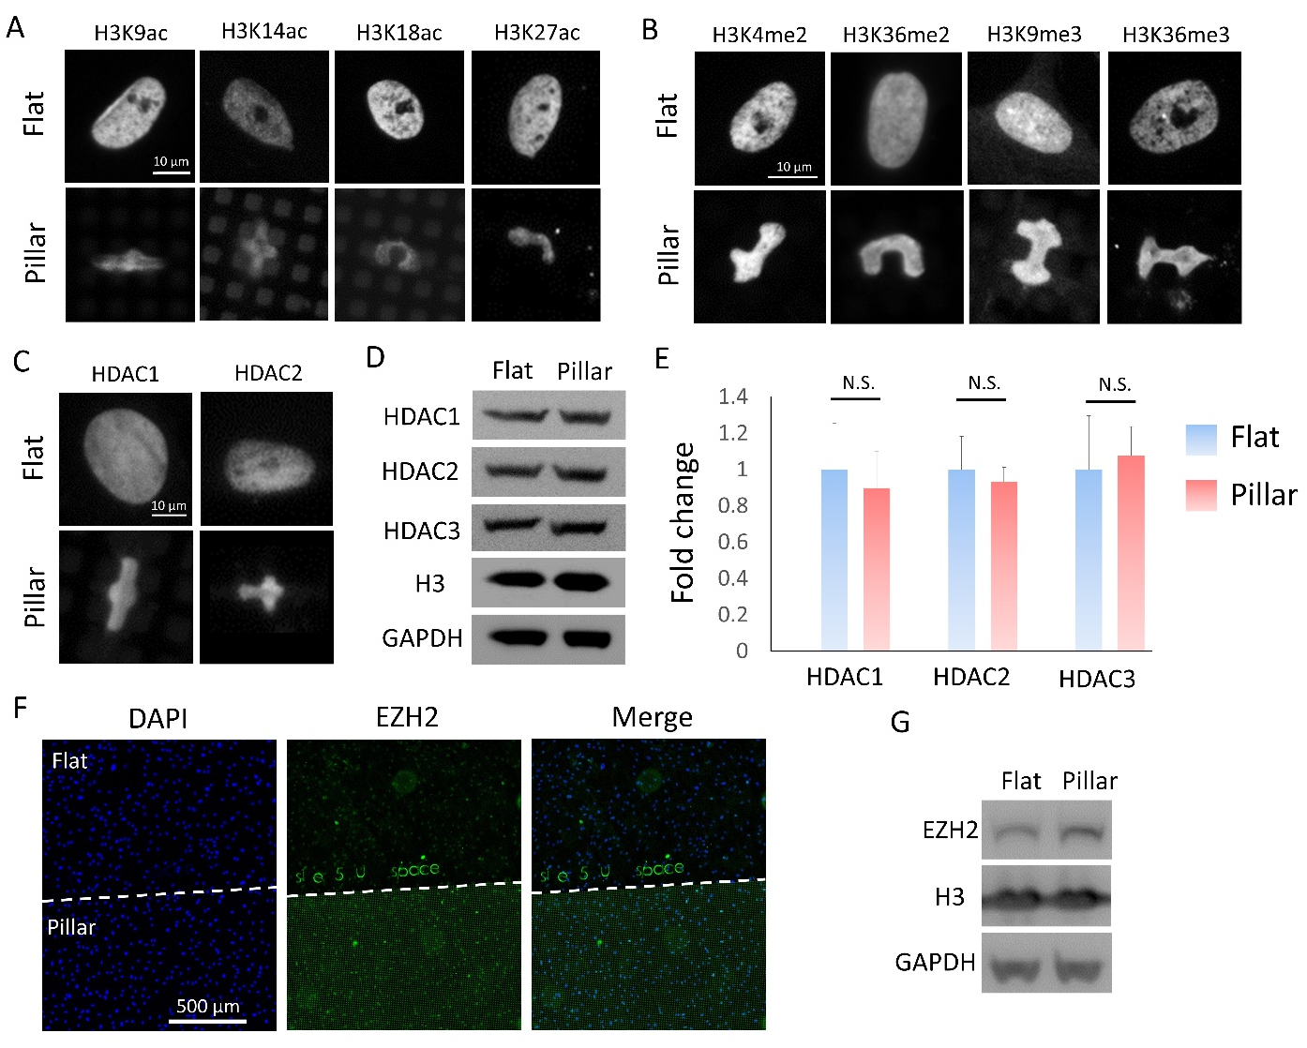

Supplementary Figure S4. Micropillars affected hMSCs epigenetics. (A) Immunostaining images of histone acetylation including acetylation of H3 at lysine 9 (H3K9ac), 14 (H3K14ac), 18 (H3K18ac), and 27 (H3K27ac) in cells on flat and micropillar surfaces. (B) Immunostaining images of active transcription markers include methylation of H3 at lysine 4 (H3K4me2) and 36 (H3K36me2 and H3K36me3), and repressive transcription markers include methylation of H3 at lysine 9 (H3K9me3) and 27 (H3K27me3) on flat and micropillar surfaces. (C) Immunostaining images of histone deacetylase 1 (HDAC1) and 2 (HDAC2) in cells on flat and micropillar surfaces. Total expression of H3 and GAPDH are shown as control. (D) Western blot images and (E) analysis of HDAC 1,2 and 3 in cells on flat and micropillar surfaces. n=3, N.S.: no significant difference. (F) Immunostaining images of cell nuclei (blue) and EZH2 (green) on flat and micropillar surfaces. (G) Western blot images and analysis of EZH2 in cells on flat and micropillar surfaces. Total expression of H3 and GAPDH are shown as control.

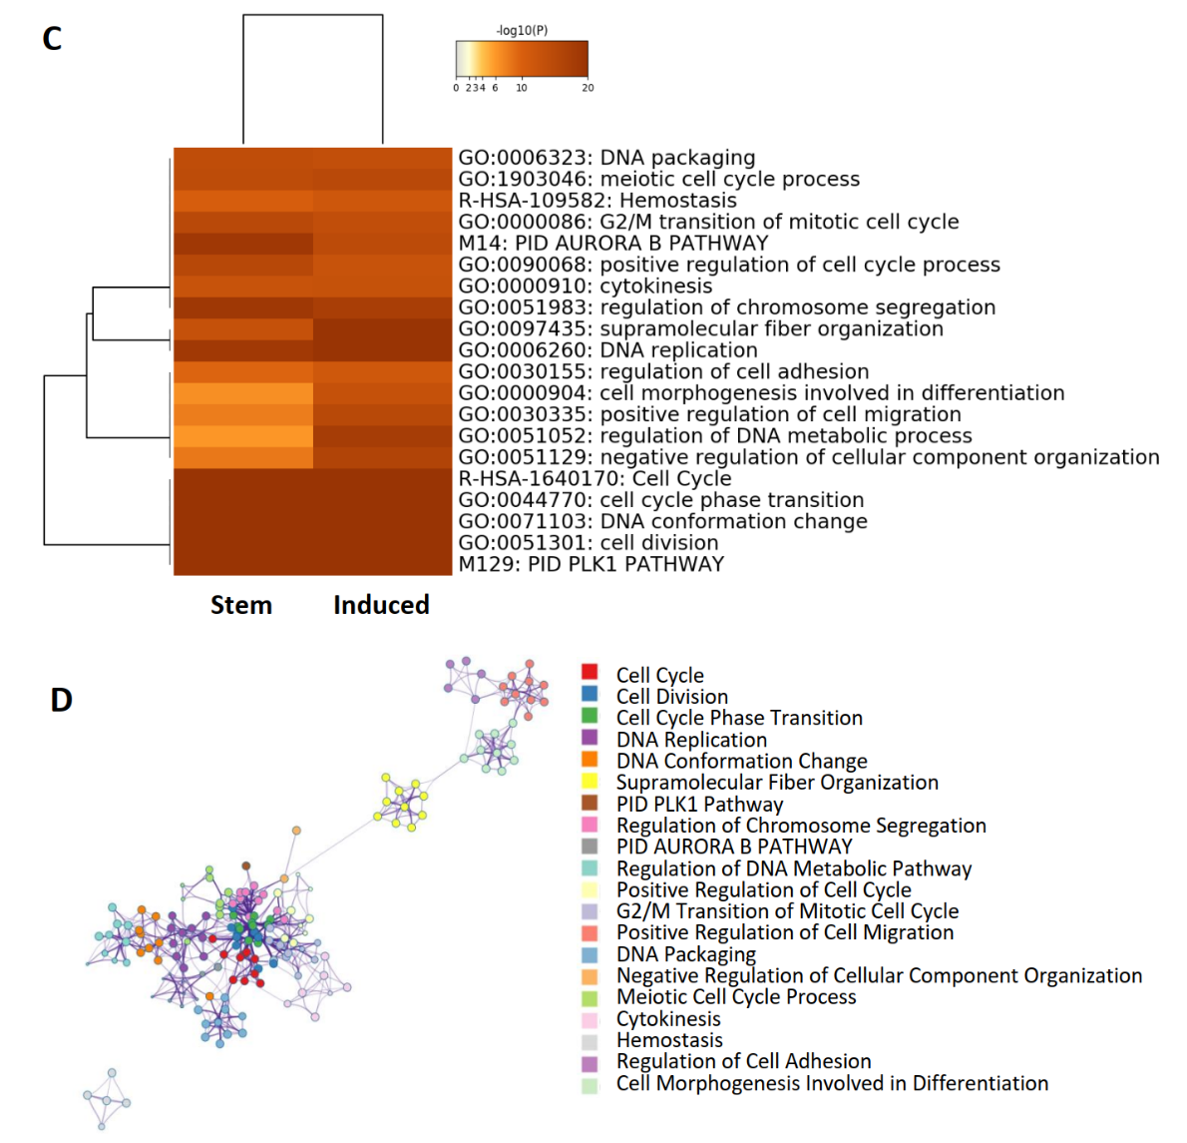
A
B
Supplementary Figure S5. Micropillars cause downregulation of genes associated with processes like cell cycle, DNA conformation and differentiation. (A) Gene Ontology (GO) analysis showing the top 20 most downregulated processes in cells seeded on micropillars compared to a flat surface in both stem and induced medium. (List of genes annotated to each process can be found in Table S3) (B) A network of top 20 most significantly enriched processes (in A). Processes are colored by cluster-ID, where nodes that share the same cluster-ID are typically close to each other (terms with a similarity, Kappa Scores > 0.3 are connected by edges).

Supplementary Figure S6. Genes within the Chromatin Modifying Enzymes set that is enriched in micropillars compared to flat surface
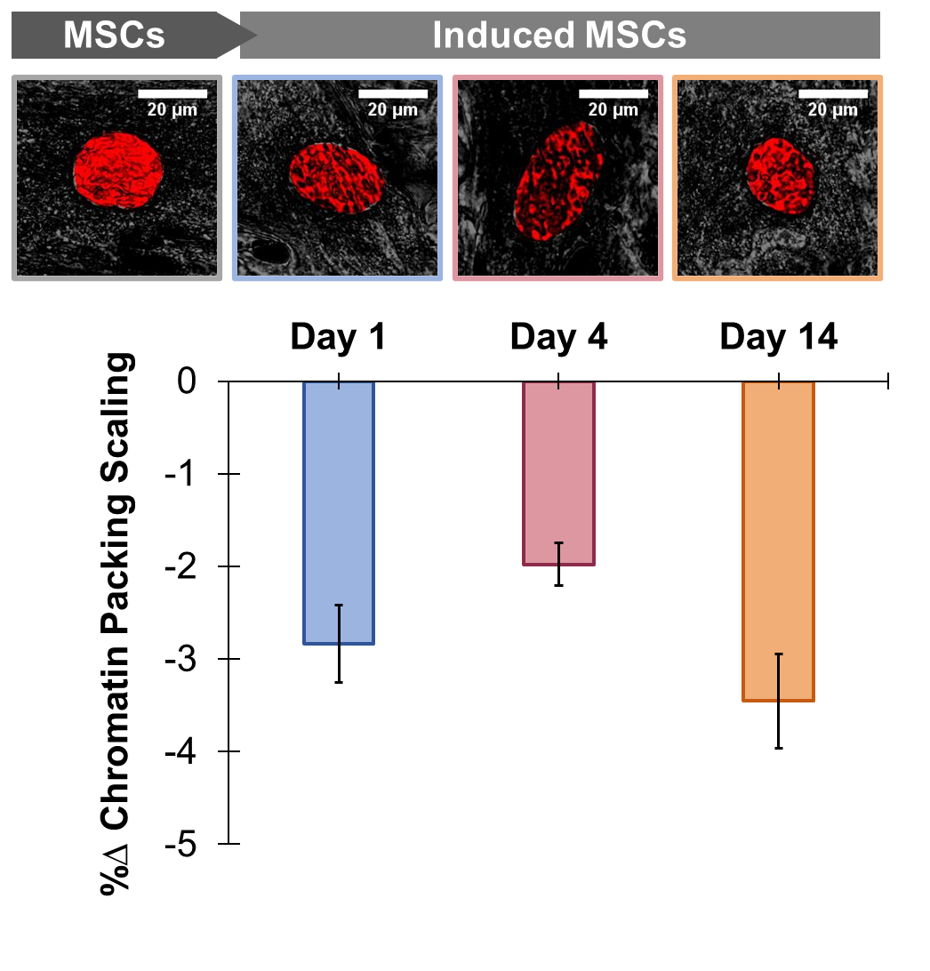
Supplementary Figure S7. Chromatin Packing Scaling decreases in differentiating MSCs. (A) Representative PWS images of stem cell and differentiating osteogenic progenitor on day 1, day 4, and day 14. (B) Live Cell PWS Microscopy reveals that chromatin packing scaling in osteogenic progenitors at day 1, day 4 and day 14 of differentiation decreases compared to stem cell populations at the same days (p-value < 0.0001), n>102 for cells on day 1, n>273 for cells on day 4, and n> 87 for cells on day 14.

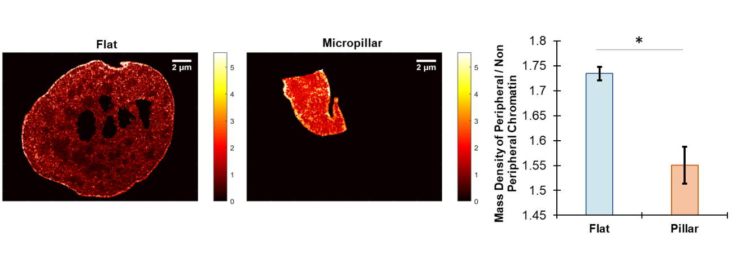
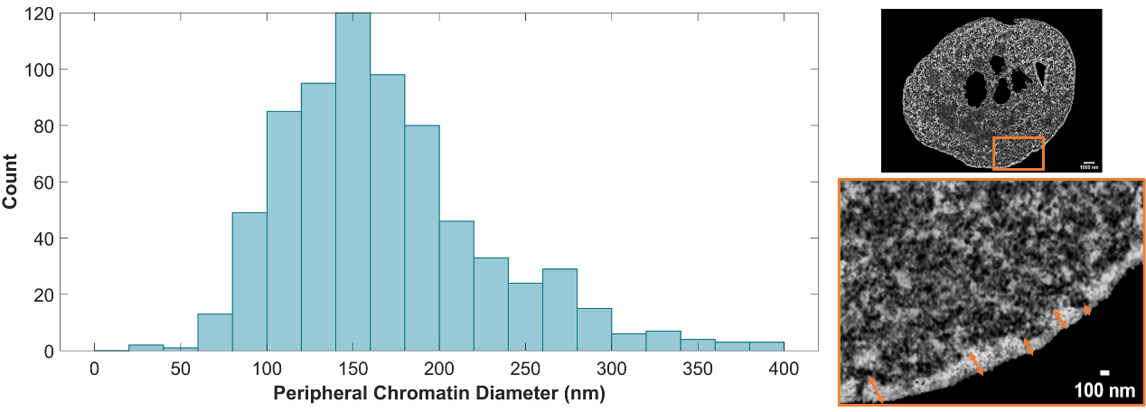
B
A
C
Supplementary Figure S8. Peripheral Chromatin Analysis from ChromTEM images. (A) Estimation of the diameter of peripheral chromatin from 716 measurements, median = 156 nm. (B) Colormap of Chromatin Mass Density of Nucleus in Flat and Micropillar surface (generated using hot colormap on MATLAB). (C) Ratio of the mass density of peripheral to non-peripheral chromatin within the nuclei significantly decreases in micropillar condition (p<0.05)

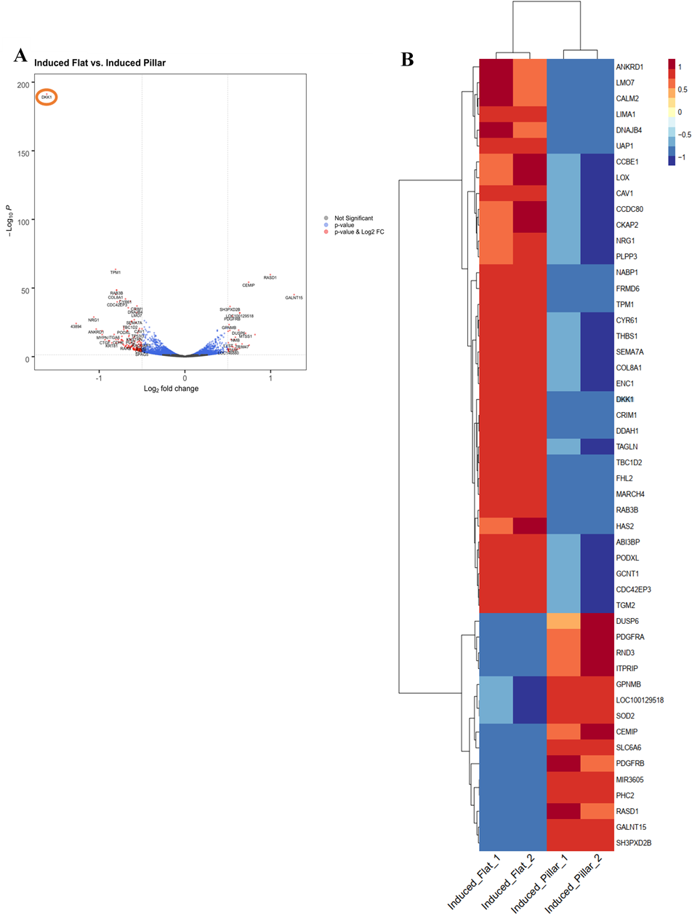
Supplementary Figure S9. Differentially Expressed Genes in induced MSCs seeded on Micropillars compared to Flat Surface. (A) Volcano plot displaying all differentially expressed genes in induced cells seeded on micropillars compared to the flat surface. Negative fold change indicates genes downregulated in the micropillar condition compared to flat. Blue data points indicate significant genes with p<0.05 and black data points indicate non-significant genes. Red data points indicate genes with p<0.05 and |fold change| >0.5. Labeled genes represent the most significantly differentially expressed genes based on the p-value and foldchange. Orange circle labels DKK1 gene. (B) Top 50 Differentially Expressed genes in induced MSCs seeded on the flat surface compared to control based on absolute log fold change in MSCs
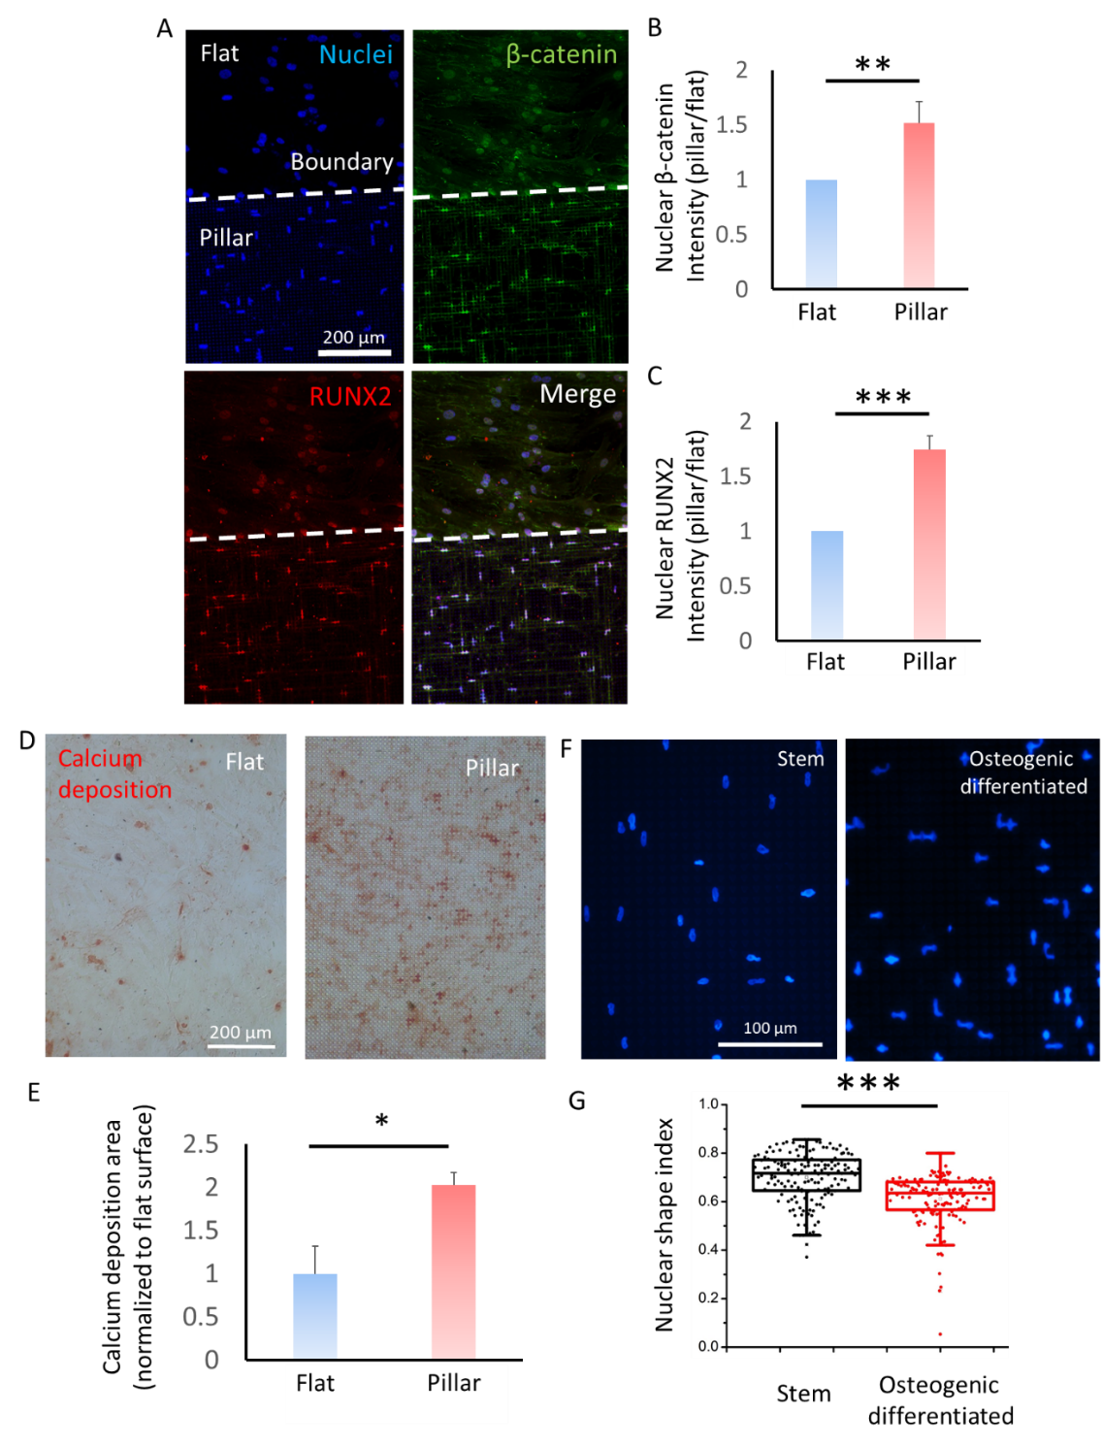
Supplementary Figure S10. Influence of micropillars on osteogenic differentiation of hMSCs. (A) Immunofluorescence images of β-catenin and RUNX2 on the same substrate containing both flat and micropillar surfaces. (B) Relative intensity of nuclear β-catenin and (C) nuclear RUNX2 on micropillars vs. flat surface. *p<0.05, **p<0.01, ***p<0.001, n=4. (D) Calcium deposition after osteogenic differentiation stained by Alizarin Red S (ARS) for 3 weeks on flat and micropillars surfaces. (E) Positive ARS stained area normalized to a flat surface. n=3, *p<0.05. (F) Staining images of cell nuclei on micropillars cultured in growth medium (stem) and osteogenic induction medium (osteogenic differentiated) for 7 days. (G) NSI analysis of hMSCs in stem and osteogenic differentiated state. n=147 and 153 (stem and differentiated), ***p<0.001.

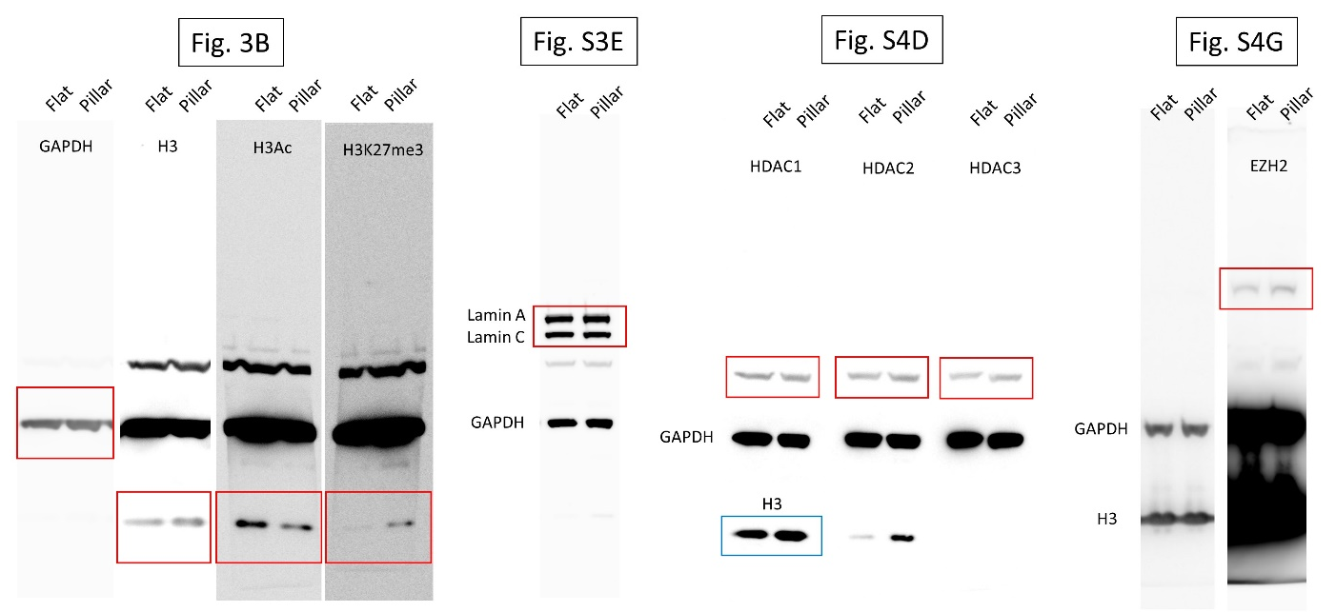
Supplementary Figure S11. Uncropped western blot gel images in Fig. 3B, S3E, S4D and S4G. Red frames indicate the target protein. Blue frame in Fig. S4D indicate total H3.

