An Interlaboratory Method Comparison Study of GB 4789.40-2016 and ISO 22964:2017

Detection of Cronobacter spp. in Infant Formula Products

Supplementary Information

1. Materials

Table S1. Formula of culture media used in the study
Medium | g/L
Druggan-Forsythe-Iversen Agar (DFI, pH 7.3±0.2) | 15
Tryptone | 5
Soy peptone | 5
Sodium chloride | 1
Ferric ammonium citrate | 1
Sodium desoxycholate | 1
Sodium thiosulphate | 0.1
Chromogen | 15
Agar
Chromogenic Cronobacter Isolation Agar (CCI, pH 7.3±0.2) | 0.3
Yeast extract | 5
Sodium chloride | 7
Tryptone | 1
Sodium thiosulphate | 0.25
Sodium desoxycholate | 1
Ferric ammonium citrate | 0.15
5-bromo-4-chloro-3-indolyl-α, D-glucopyranoside | 13.2
Agar
Cronobacter Screening Broth Base (CSB, pH 7.4±0.2) | 10
Peptone | 3
Meat extract | 5
Sodium chloride | 0.04
Bromocresol purple | 10
Sucrose
Modified Lauryl Sulphate Trypyose Broth Base (mLST, pH 6.6±0.2) | 34
Sodium chloride | 20
Enzymatic digest of animal and plant tissue | 5
Lactose | 2.75
Potassium dihydrogen phosphate | 2.75
Dipotassium hydrogen phosphate | 0.1
Sodium lauryl sulphate
Buffered Peptone Water (BPW, pH 7.4±0.2) | 10
Enzymatic digest of casein | 5
Sodium chloride | 3.5
Anhydrous di-sodium hydrogen phosphate | 1.5
Potassium dihydrogen phosphate

2. Data analysis

2.1 Summary of results categories
Table S2. Summary of results obtained with the reference and alternative methods for each category [1]
 | Reference-method positive  (R+) | Reference-method negative  (R-)
Alternative-method positive  (A+) | +/+  Positive Agreement (PA) | -/+  Positive Deviation (PD)
Alternative-method negative  (A) | +/-  Negative Deviation (ND) | -/-  Negative Agreement (NA)

2.2 Calculation of acceptability limits (AL) for sensitivity in the interlaboratory study [1]
The AL is defined as [(ND – PD)max] and calculated per level where fractional recovery was obtained as described below using the following three parameters:

${\left(p+\right)}_{ref}=\frac{P_{x}}{N_{x}}$ (S1)

where
Px = number of samples with a positive result obtained with the reference method at level x
(L1 or L2) for all laboratories;
Nx = number of samples tested at level x (L1 or L2) with the reference method by all laboratories.

${\left(p+\right)}_{alt}=\frac{{CP}_{x}}{N_{x}}$ (S2)
where
CPx = number of samples with a confirmed positive result obtained with the alternative method at level x (L1 or L2) for all laboratories;
Nx = number of samples tested at level x (L1 or L2) with the alternative method by all laboratories.
${\left(ND-PD\right)}_{max}=\sqrt{3N_{x}×\left({\left(p+\right)}_{ref}+{\left(p+\right)}_{alt}-2\left({\left(p+\right)}_{ref}×{\left(p+\right)}_{alt}\right)\right)}$ (S3)
where
Nx = number of samples tested at level x (L1 or L2) with the reference method by all laboratories

3. Matrix background microbial load

Table S3. Single laboratory study - Background microbial load of blank product matrices
 | Replicate
 | 1 | 2 | 3 | 4 | 5
Matrix 1: Dehydrated base milk powder
APC (CFU/g) | <10 | <10 | <10 | <10 | <10
Enterobacteriaceae (CFU/g) | <10 | <10 | <10 | <10 | <10
Cronobacter spp. /100 g | ND* | ND | ND | ND | ND
Matrix 2: Non-probiotic infant milk formula
APC (CFU/g) | <10 | <10 | <10 | <10 | <10
Enterobacteriaceae (CFU/g) | <10 | <10 | <10 | <10 | <10
Cronobacter spp. /100 g | ND | ND | ND | ND | ND
Matrix 3: Probiotic infant milk formula
APC (CFU/g) | 20 | 70 | 70 | 60 | 10
Enterobacteriaceae (CFU/g) | <10 | <10 | <10 | <10 | <10
Cronobacter spp. (/100 g) | ND | ND | ND | ND | ND
Lactic acid bacteria (CFU/g) | 4.8×10⁶ | 3.9×10⁶ | 4.9×10⁶ | 3.4×10⁶ | 4.9×10⁶
*ND: Not detected.
Table S4. Single laboratory study - Thermal stress efficiency of test cultures
 |  | Colony count |  | Stress efficiency
Strain | Medium | CFU/mL | Log₁₀ CFU/mL | Log₁₀ CFU/mL reduction
C. sakazakii  (ATCC 29544) | TSA | 1.6×10⁸ | 8.20 | 0.70
C. sakazakii  (ATCC 29544) | DFI | 3.2×10⁷ | 7.51 | 0.70
C. malonaticus  (DSM 18702) | TSA | 4.2×10⁸ | 8.62 | 1.30
C. malonaticus  (DSM 18702) | DFI | 2.1×10⁷ | 7.32 | 1.30

Table S5. Single laboratory study - Results summary per matrix type/strain/method at the low contamination level (L₁)
Method | Strain | Matrix Type | Number of results |  | Total
Method | Strain | Matrix Type | Positive | Negative | Total
Reference method  GB 4789.40-2016 | C. sakazakii  ATCC 29544 | Non-probiotic ingredient | 21 | 19 | 40
Reference method  GB 4789.40-2016 | C. sakazakii  ATCC 29544 | Non-probiotic infant formula | 9 | 31 | 40
Reference method  GB 4789.40-2016 | C. sakazakii  ATCC 29544 | Probiotic infant formula | 36 | 24 | 60
Reference method  GB 4789.40-2016 | C. malonaticus  DSM 18702 | Non-probiotic ingredient | 8 | 12 | 20
Reference method  GB 4789.40-2016 | C. malonaticus  DSM 18702 | Non-probiotic infant formula | 6 | 14 | 20
Reference method  GB 4789.40-2016 | C. malonaticus  DSM 18702 | Probiotic infant formula | 15 | 5 | 20
Reference method  GB 4789.40-2016 | Total |  | 95 (47.5%) | 105 (52.5%) | 200 (100%)
Alternative method  ISO 22964:2017 | C. sakazakii  ATCC 29544 | Non-probiotic ingredient | 14 | 26 | 40
Alternative method  ISO 22964:2017 | C. sakazakii  ATCC 29544 | Non-probiotic infant formula | 12 | 28 | 40
Alternative method  ISO 22964:2017 | C. sakazakii  ATCC 29544 | Probiotic infant formula | 36 | 24 | 60
Alternative method  ISO 22964:2017 | C. malonaticus  DSM 18702 | Non-probiotic ingredient | 13 | 7 | 20
Alternative method  ISO 22964:2017 | C. malonaticus  DSM 18702 | Non-probiotic infant formula | 8 | 12 | 20
Alternative method  ISO 22964:2017 | C. malonaticus  DSM 18702 | Probiotic infant formula | 18 | 4 | 20
Alternative method  ISO 22964:2017 | Total |  | 99 (49.5%) | 101 (50.5%) | 200 (100%)

Figure S6 Single laboratory study -Presentation of the RLOD of the alternative method
Matrix/Strain | RLOD | RLODL | RLODU | B=ln(RLOD) | Sn(d) | Z-test | p-value
Ingredient /ATCC29544 | 1.871 | 0.916 | 3.819 | 0.626 | 0.357 | 1.755 | 0.079
Non-probiotic infant formula/ATCC29544 | 0.717 | 0.296 | 1.739 | -0.332 | 0.443 | 0.750 | 1.547
Probiotic infant formula/ATCC29544 | 1.570 | 0.804 | 3.064 | 0.451 | 0.335 | 1.348 | 0.178
Combine | 1.343 | 0.882 | 2.045 | 0.295 | 0.210 | 1.404 | 0.160
Ingredient /DSM18702 | 0.487 | 0.194 | 1.222 | -0.720 | 0.460 | 1.565 | 1.882
Non-probiotic infant formula/DSM18702 | 0.698 | 0.235 | 2.074 | -0.359 | 0.544 | 0.660 | 1.491
Probiotic infant formula/DSM18702 | 0.861 | 0.392 | 1.894 | -0.149 | 0.394 | 0.379 | 1.295
Combine | 0.689 | 0.414 | 1.146 | -0.373 | 0.255 | 1.464 | 1.857
Ingredient /ATCC29544&DSM18702 | 1.124 | 0.649 | 1.947 | 0.1175 | 0.2752 | 0.425 | 0.671
Non-probiotic infant formula/ATCC29544&DSM18702 | 0.710 | 0.357 | 2.1.410 | -0.343 | 0.343 | 0.999 | 1.682
Probiotic infant formula/ATCC29544&DSM18702 | 1.232 | 0.737 | 2.031 | 0.202 | 0.253 | 0.795 | 0.427
Acceptance Limit | 2.5
- RLOD: the estimated relative level of detection value
- RLODU: the upper limit of the 95% confidence interval for RLOD
- RLODL: the lower limit of the 95% confidence interval for RLOD
- b=ln(RLOD): logarithm of the RLOD value
- sd(b): standard deviation of b
- z-Test statistic: absolute value of the test statistic of the z-Test with the null hypothesis H0: b=0
- p-value: p-value of the z-Test

Figure S1. Single laboratory study - Changes in Cronobacter count of the seed inocula during the sample stabilization period
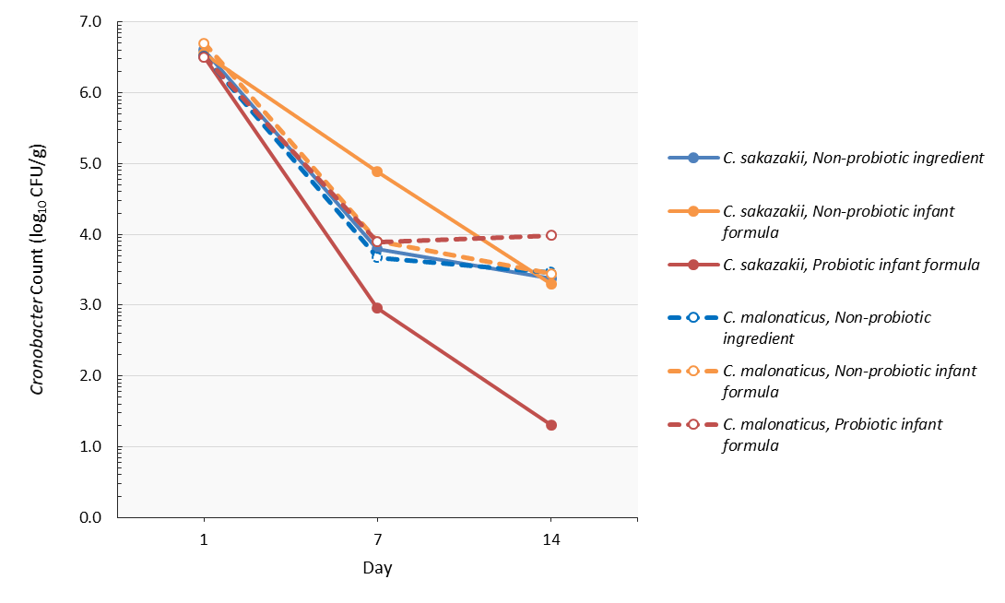

Figure.S2 gyrB sequencing result of ATCC29544 and dsm18702
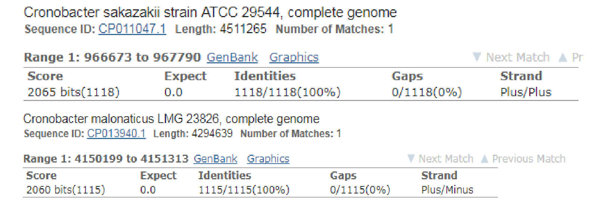

Table S7. Interlaboratory study - Thermal stress efficiency of the test culture
 |  | Colony count |  | Stress efficiency
Strain | Medium | CFU/mL | Log₁₀ CFU/mL | Log₁₀ CFU/mL reduction
C. sakazakii  (ATCC 29544) | TSA | 1.7×10⁸ | 8.23 | 1.26
C. sakazakii  (ATCC 29544) | DFI | 9.4×10⁶ | 6.97 | 1.26

Figure S3. Interlaboratory study - Changes in Cronobacter count of the seed inocula during the sample stabilization period
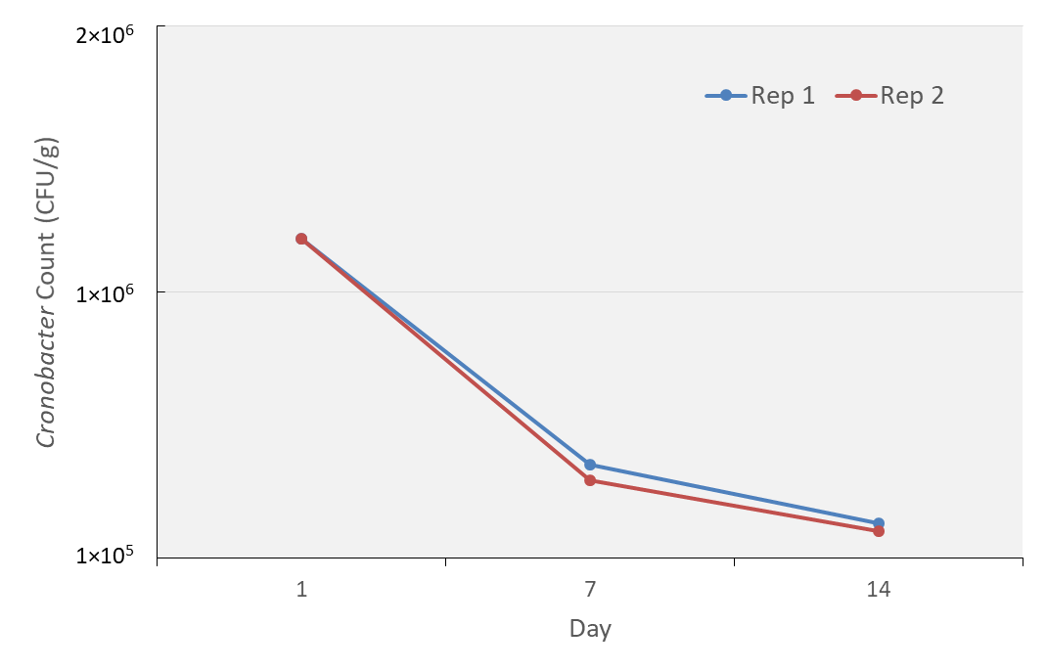

Table S8. Interlaboratory study – Sample condition upon receipt and analysis dates
Collaborator | Sample shipment date | Temperature upon shipping (°C) | Sample receipt date | Temperature upon receipt (°C) | Sample analysis date
1 | 5/20/2019 | 4 | 5/22/2019 | 24 | 5/29/2019
2 | 5/20/2019 | 4 | 5/22/2019 | 6 | 5/27/2019
3 | 5/20/2019 | 4 | 5/22/2019 | 4 | 5/27/2019
4 | 5/20/2019 | 4 | 5/22/2019 | 8.2 | 5/22/2019
5 | 5/20/2019 | 4 | 5/21/2019 | 8 | 5/26/2019
6 | 5/20/2019 | 4 | 5/22/2019 | Not measured | 5/22/2019
7 | 5/20/2019 | 4 | 5/21/2019 | 20 | 5/21/2019
8 | 5/20/2019 | 4 | 5/21/2019 | 4 | 5/21/2019
9 | 5/20/2019 | 4 | 5/21/2019 | 6 | 5/21/2019
10 | 5/20/2019 | 4 | 5/23/2019 | 6 | 5/23/2019
11 | 5/20/2019 | 4 | 5/21/2019 | Not measured | 5/21/2019
12 | 5/20/2019 | 4 | 5/21/2019 | 15.8 | 5/27/2019

Table S9. Interlaboratory Study - Results reported by collaborating laboratories (reference & alternative methods)
Collaborator | Contamination Level
Collaborator | Reference Method |  |  | Alternative Method |  |  | Alternative Method Confirmed by Reference
Collaborator | L₀  0 MPN/10g | L₁  1.30 MPN/10g | L₂  2.21 MPN/10g | L₀  0 MPN/10g | L₁  1.30 MPN/10g | L₂  2.21 MPN/10g | L₀  0 MPN/10g | L₁  1.30 MPN/10g | L₂  2.21 MPN/10g
Laboratory 1 | 0/8 | 3/8 | 5/8 | 0/8ª | 4/8^{b} | 6/8ª | 0/8ª | 4/8^{b} | 6/8ª
Laboratory 2 | 0/8 | 3/8 | 4/8 | 0/8 | 3/8 | 5/8 | 0/8 | 3/8 | 5/8
Laboratory 3 | 0/8 | 1/8 | 6/8 | 1/8 | 2/8 | 8/8 | 0/8 | 2/8 | 8/8
Laboratory 4 | 0/8 | 3/8 | 6/8 | 0/8 | 3/8 | 7/8 | 0/8 | 38 | 7/8
Laboratory 5 | 0/8 | 2/8 | 6/8 | 0/8 | 1/8 | 5/8 | 0/8 | 1/8 | 5/8
Laboratory 6^{c} | 0/8 | 1/8 | 6/8 | 0/8 | 3/8 | 7/8 | 0/8 | 3/8 | 7/8
Laboratory 7 | 0/8 | 3/8 | 5/8 | 0/8 | 3/8 | 7/8 | 0/8 | 3/8 | 7/8
Laboratory 8 | 0/8 | 3/8 | 6/8 | 0/8 | 3/8 | 8/8 | 0/8 | 3/8 | 8/8
Laboratory 9 | 0/8 | 2/8 | 5/8 | 0/8 | 4/8 | 8/8 | 0/8 | 4/8 | 8/8
Laboratory10 | 1/8 | 6/8 | 5/8 | 0/8 | 6/8 | 6/8 | 0/8 | 6/8 | 5/8
Laboratory 11^{c} | 0/8 | 2/8 | 4/8 | 0/8 | 0/8 | 3/8 | 0/8 | 3/8 | 6/8
Laboratory 12 | 0/8 | 3/8 | 7/8 | 0/8 | 1/8 | 6/8 | 0/8 | 1/8 | 6/8
Total | P₀ = 1 | P₁= 32 | P₂ = 65 | P₀ = 1 | P₁ = 33 | P₂ =76 | CP₀ = 0 | CP₁ =36 | CP₂ =78
a. Number of positive alternative-method results.
b. Number of positive alternative-method results confirmed by the reference method.
c. Data from Laboratory 6 and 11 are excluded from analysis due to lack of temperature measurement upon arrival.

Table S10. Interlaboratory Study – RLOD Calculations
Method | Method effect  F_{i} | Log method effect  f_{i} | SD of log method effect  S_{fi} | LOD_{50%}ª |  |  | LOD_{95%}^{b}
 |  |  |  | Detection limit  d_{0.5,i} | Lower conf. limit  d_{0.5,i,L} | Upper conf. limit  d_{0.5,i,U} | Detection limit  d_{0.5,i} | Lower conf. limit  d_{0.5,i,L} | Upper conf. limit  d_{0.5,i,U}
Reference | 0.406 | -0.901 | 0.114 | 1.71 | 1.36 | 2.15 | 7.38 | 5.87 | 9.28
Alternative | 0.477 | -0.741 | 0.110 | 1.45 | 1.17 | 1.81 | 6.28 | 5.05 | 7.82
Conclusions | The methods are not significantly different at the 5% significance level (change in deviance of the model with method effects to the null model D_{method}=1 with 1degree of freedom, p-value=0.32).
Conclusions | The relative limit of detection (RLOD) of the alternative method, as compared to the reference method, is 0.85 with a 90% confidence interval of 0.66-1.11.
a. LOD_{50%} : 50% limit of detection in MPN/sample size
b. LOD_{95%} : 95% limit of detection in MPN/sample size

References
1. International Organization for Standardization, ISO 16140-2:2016 Microbiology of the food chain-Method validation-Part 2: Protocol for the validation of alternative (proprietary) methods against a reference method. 2016.

