Supporting Information
Tailoring Water Dissociation Energy by Platinum Single-Atom Catalyst Coupled with Transition Metal/metal Oxide Heterostructure for Accelerating Alkaline Hydrogen Evolution Reaction
Kai Ling Zhou,ª Zelin Wang,ª Chang Bao Han,*ª Xiaoxing Ke,*ª Changhao Wang,ª Yuhong Jin,ª Qianqian Zhang,ª Jingbing Liu, ª Hao Wang*ª and Hui Yanª

^{a.} Faculty of Materials and Manufacturing, Beijing University of Technology, Beijing 100124, P. R. China
E-mail: cbhan@bjut.edu; kexiaoxing@bjut.edu.cn.cn; haowang@bjut.edu.cn

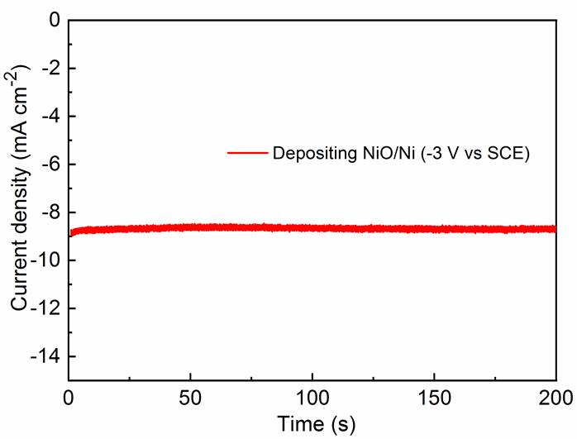
Figure S1. The electrochemical process with -3.0 V versus SCE for the deposition of NiO/Ni composite on the Ag NWs network.
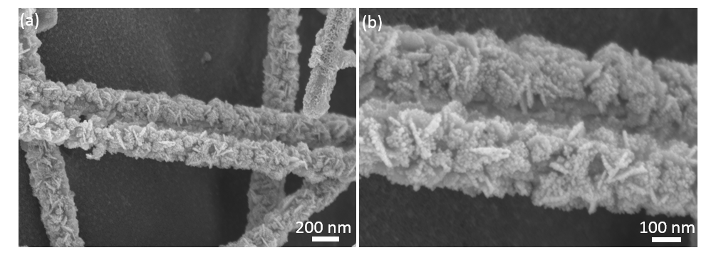
Figure S2. The scanning electron microscopy (SEM) images of NiO/Ni on Ag NWs with different magnifications.

Figure S3. (a-b) Transmission electron microscopy (TEM) images, (c) high-resolution TEM (HRTEM) and (d) fast Fourier transform (FFT) images of Ag NWs supported NiO/Ni.

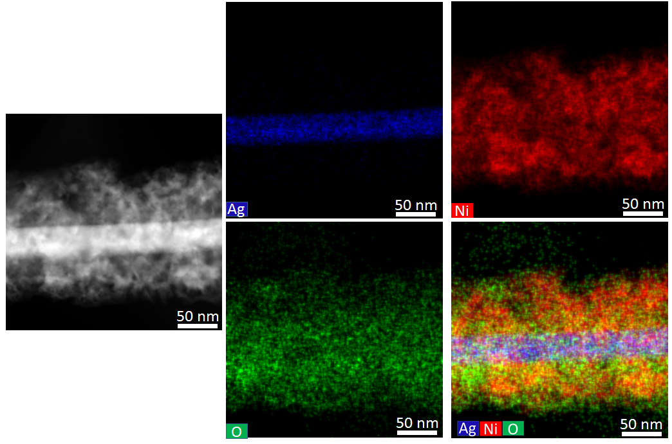
Figure S4. The elements mapping of Ag, Ni, and O in Ag NWs supported NiO/Ni.

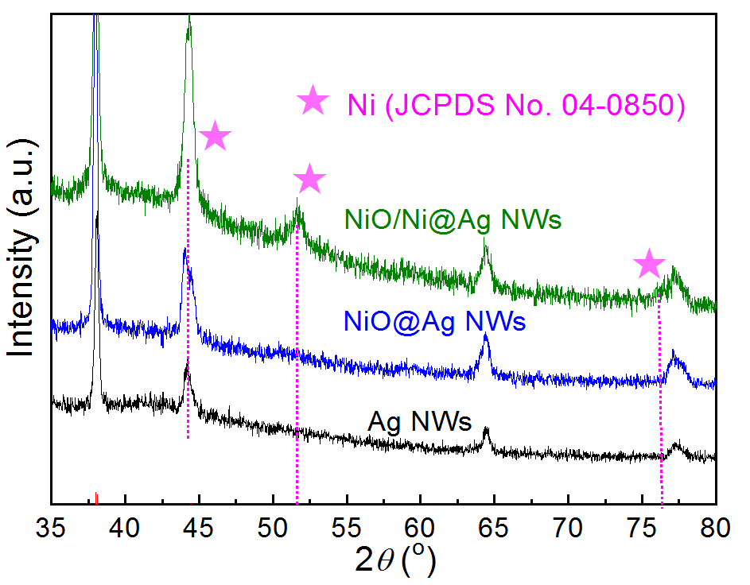
Figure S5. The X-ray diffraction (XRD) patterns of NiO/Ni and NiO on Ag NWs.

Figure S6. X-ray photoelectron spectroscopy spectra of NiO/Ni and NiO.

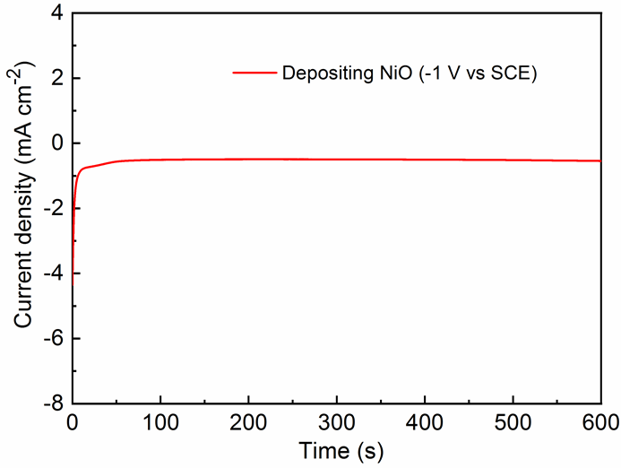
Figure S7. The electrochemical process with -1.0 V versus SCE for the deposition of NiO on the Ag NWs network.

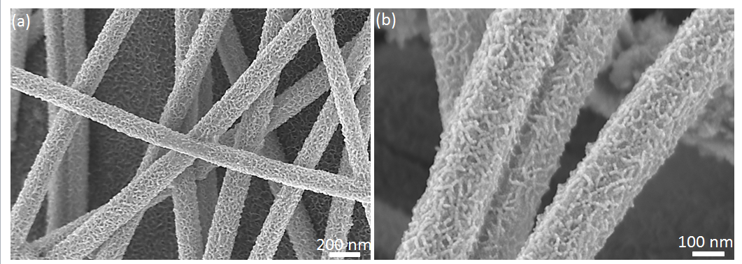
Figure S8. The SEM images of NiO on Ag NWs with different magnifications.
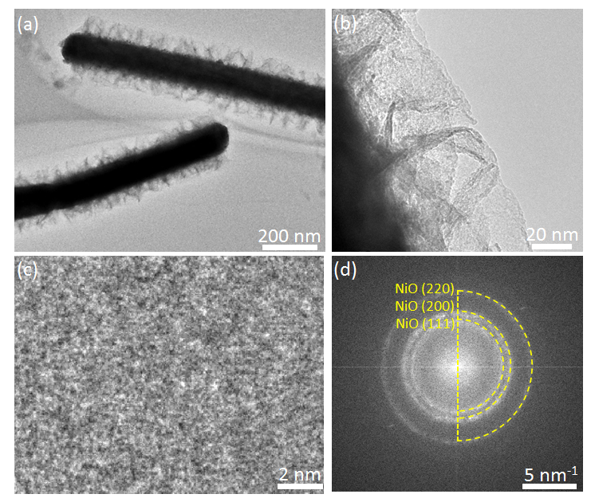
Figure S9. (a-b) TEM images, (c) HRTEM, and (d) FFT images of NiO on Ag NWs.

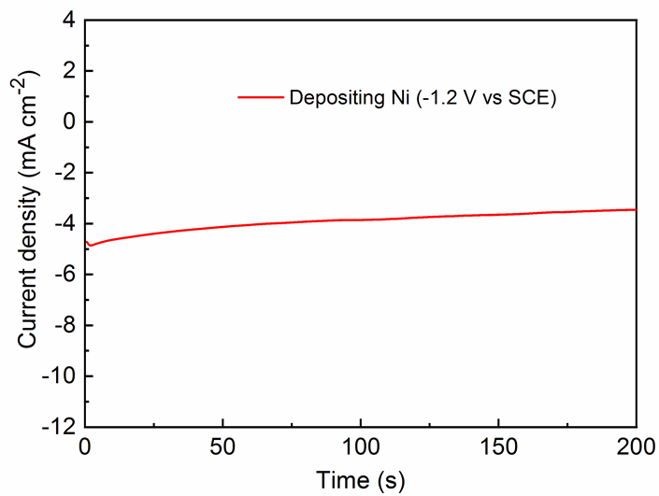
Figure S10. The electrochemical process with -1.2 V versus SCE for the deposition of metallic Ni on the Ag NWs network.

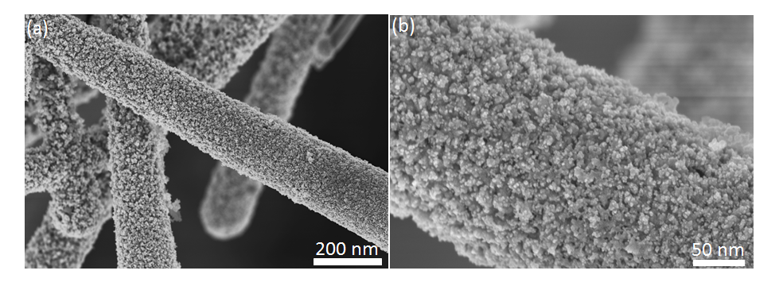
Figure S11. The SEM images of Ni on Ag NWs with different magnifications.

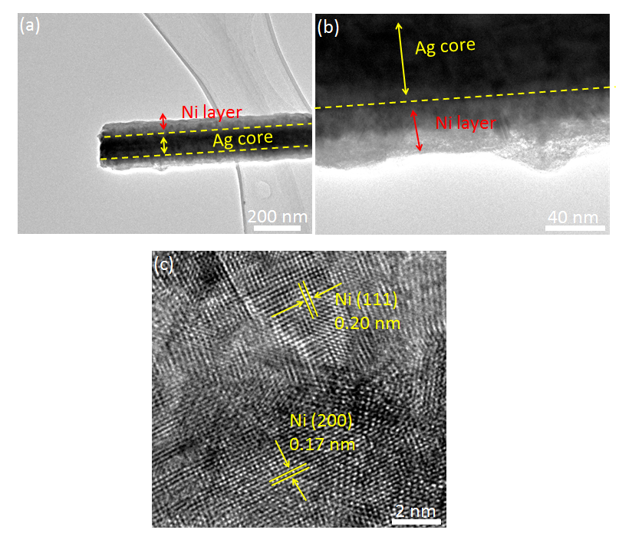
Figure S12. (a-b) TEM images and (c) HRTEM image of Ni.

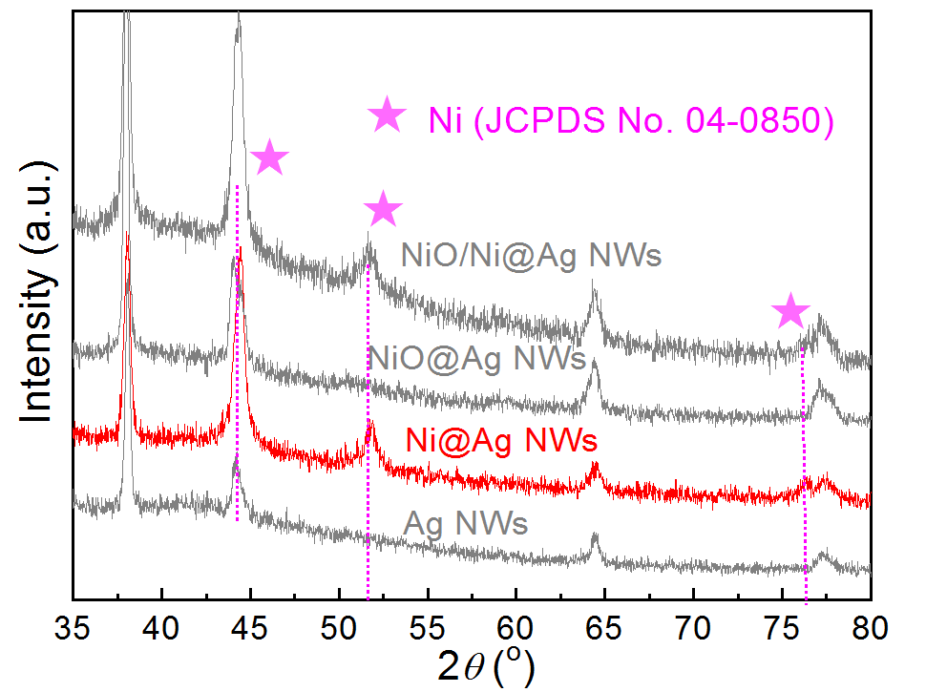
Figure S13. XRD patterns of Ag NWs supported Ni, and the XRD patterns of Ag NWs supported NiO/Ni and NiO are given as the comparison.

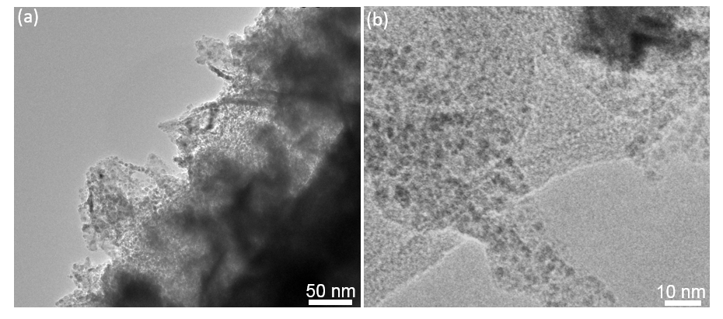
Figure S14. The scanning transmission electron microscopy (STEM) images of Pt_{SA}-NiO/Ni.

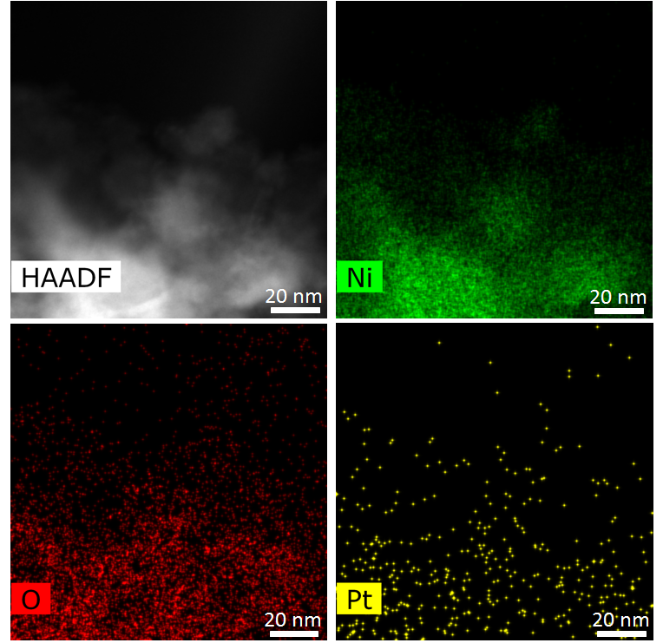
Figure S15. The elements mapping of Ni, O, and Pt in Pt_{SA}-NiO/Ni.
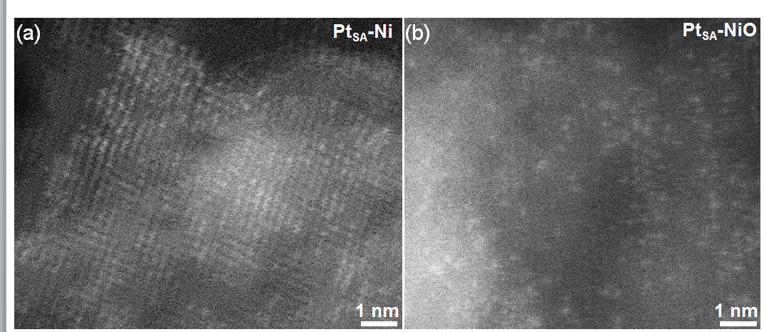
Figure S16. HAADF-STEM images of (a) Pt_{SA}-NiO and (b) Pt_{SA}-Ni, respectively.

Figure S17. The normalized difference spectra for Pt L₃-edge XANES using Pt foil as reference. The oxidation states are fitted by integrating the area of the white-line peak from 11557 to 11574 eV.

Figure S18. The DFT-optimized structure for (a) Pt_{SA}-NiO/Ni, (b) Pt_{SA}-NiO, and (c) Pt_{SA}-Ni catalysts, respectively based on the EXAFS analysis.

Figure S19. (a) Computational models of NiO/Ni heterostructure. (b) The localized electric field distribution of NiO/Ni heterostructure. (c) The localized electric field distribution of Pt atom at NiO/Ni phase junction. (d) 2D isosurface map of the cross-section consisting of Pt, Ni, and O atoms in Pt_{SA}-NiO/Ni with a unit of e A⁻³.

Figure S20. Highlighted total DOS of NiO/Ni and Pt_{SA}-NiO/Ni with aligned Fermi level.

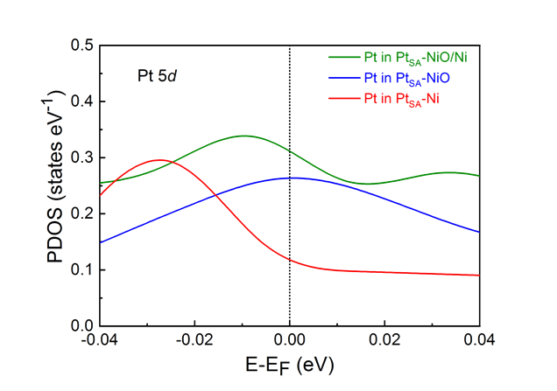
Figure S21. Highlighted Pt 5d band of Pt_{SA}-NiO, Pt_{SA}-Ni, and Pt_{SA}-NiO/Ni with aligned Fermi level.

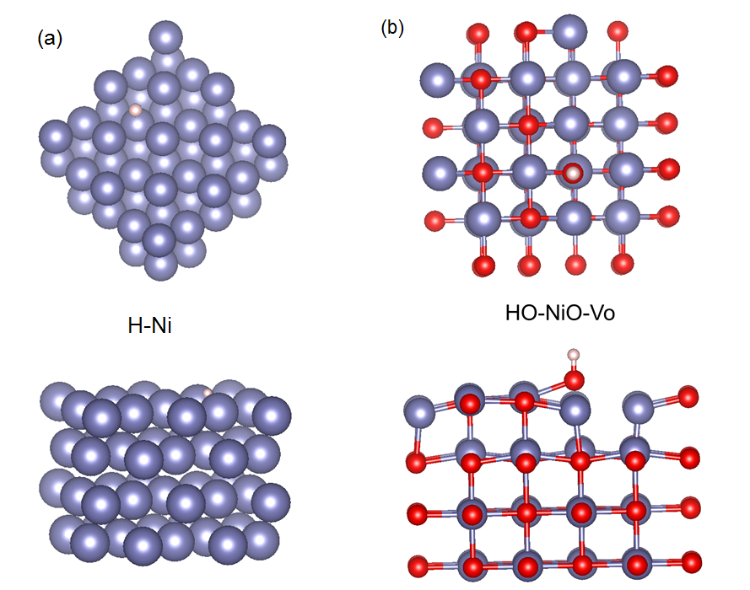

Figure S22. The optimal absorption site of metallic Ni for H, and O vacancies coupled NiO for HO.

Figure S23. O 1s spectra of NiO/Ni and NiO.

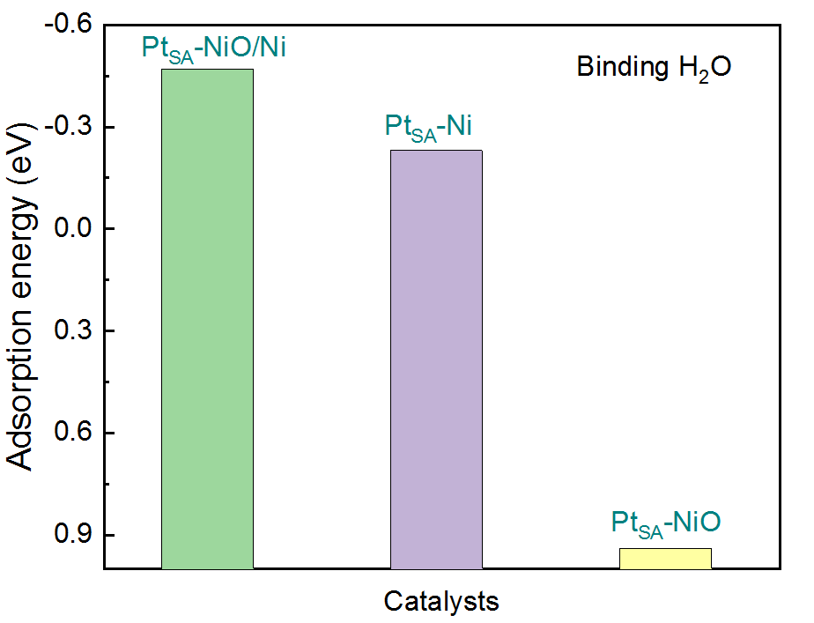

Figure S24. Calculated H₂O adsorption energies of Pt_{SA}-NiO/Ni, Pt_{SA}-NiO and Pt_{SA}-Ni catalysts
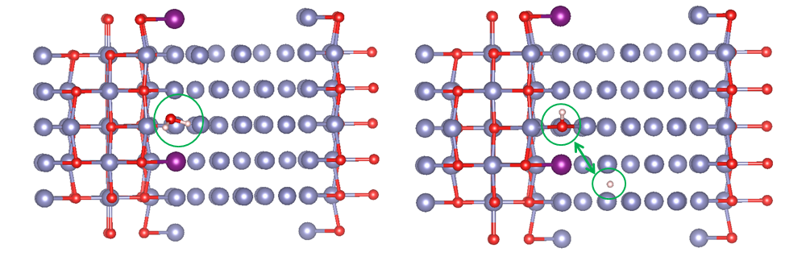
Figure S25. The optimal absorption site of Pt_{SA}-NiO/Ni catalyst for the dissociation of H₂O into OH and H.

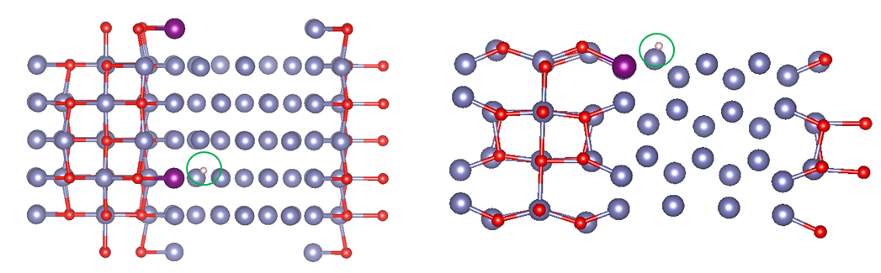
Figure S26. The optimal absorption site of Pt_{SA}-NiO/Ni catalyst for the dissociated proton.

Figure S27. Cyclic voltammograms performed in 1 M KOH solution in the potential window without the participation of faradaic processes for (a) Pt_{SA}-NiO/Ni, (b) Pt_{SA}-NiO, (c) Pt_{SA}-Ni, and (d) NiO/Ni. (e) The corresponding scan rate dependence of the average currents.

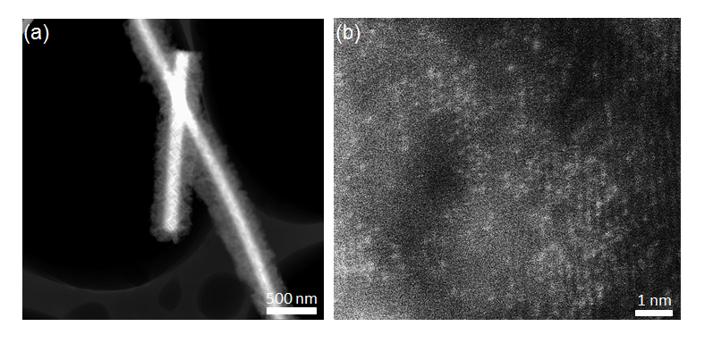
Figure S28. HAADF-STEM image of Pt_{SA}-NiO/Ni after the stability test.

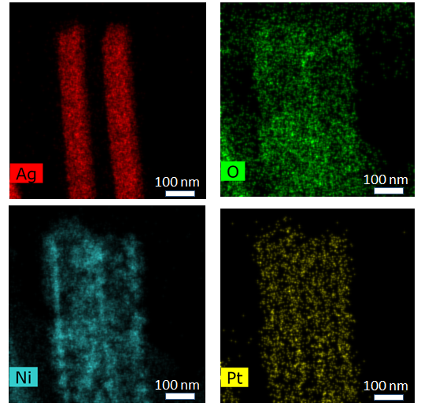
Figure S29. Elements mapping of Pt_{SA}-NiO/Ni after the stability test.

Figure S30. The double-layer capacitance measurement of Pt_{SA}-NiO/Ni after the stability test.

Table S1. FT-EXAFS fitting results of Pt_{SA}-NiO/Ni, Pt_{SA}-NiO and Pt_{SA}-Ni, and Pt foil was given as a reference.
 | Shell | CN | R(Å) | σ² | ΔE₀ | R factor
Pt foil | Pt-Pt | 12 | 2.76±0.01 | 0.004 | 10.4±0.6 | 0.0017
Pt_{SA}-NiO/Ni | Pt-Ni | 5.87±0.5 | 2.60±0.01 | 0.012 | 9.2±2.0 | 0.0095
Pt_{SA}-NiO/Ni | Pt-O | 1.31±0.2 | 1.99±0.02 | 0.001 | 9.2±2.0 | 0.0095
Pt_{SA}-NiO/Ni | Pt-Cl | 1.91±0.5 | 3.10±0.02 | 0.004 | 9.2±2.0 | 0.0095
Pt_{SA}-NiO | Pt-Ni | 2.14±0.2 | 2.70±0.01 | 0.005 | 18.6±1.8 | 0.0099
Pt_{SA}-NiO | Pt-O | 2.41±0.2 | 2.07±0.02 | 0.009 | 18.6±1.8 | 0.0099
Pt_{SA}-NiO | Pt-Cl | 1.62±0.3 | 3.20±0.02 | 0.004 | 18.6±1.8 | 0.0099
Pt_{SA}-Ni | Pt-Ni | 4.97±0.5 | 2.63±0.01 | 0.010 | 16.9±2.4 | 0.0054
Pt_{SA}-Ni | Pt-Cl | 1.40±0.2 | 2.31±0.01 | 0.002 | 16.9±2.4 | 0.0054
CN: coordination numbers of identical atoms; R: interatomic distance; σ²: Debye-Waller factors; ΔE₀: energy shift. R factor: goodness of fit. Ѕ₀² was set to 0.74, according to the experimental EXAFS fit of Pt foil reference by fixing CN as the known crystallographic value.

Table S2. Comparison of HER performances for Ag NWs supported Pt_{SA}-NiO/Ni with the reported HER catalysts.
 | Electrocatalysts | Electrolyte | Overpotential  at 10 mA cm⁻² (mV) | Tafel slop  (mV dec⁻¹) | Reference
1 | Pt_{SA}-NiO/Ni | 1.0 M KOH | 26 | 27 | This work
2 | Pt_{SA}-C₁N₁ | 1.0 M KOH | 46 | 36.8 | Nat. Commun., 2020, 11:1029.
3 | Ru-MoS₂/CC | 1.0 M KOH | 41 | 114 | Appl. Catal., B, 2019, 249, 91.
4 | Pt_{SA}-Co(OH)₂ | 1.0 M KOH | 29 | 35 | Energy Environ. Sci., 2020, 13:3082.
5 | RuCo@N-C | 1.0 M KOH | 28 | 31 | Nat. Commun., 2017, 8, 14969.
6 | Ru-MoO₂ | 1.0 M KOH | 29 | 44 | J. Mater. Chem. A, 2017, 5, 5475-5485.
7 | PtNi NWs/C | 1.0 M KOH | 40 | - | Angew. Chem.Int. Ed., 2016, 55, 12859.
8 | IrCo@N-C | 1.0 M KOH | 45 | 80 | Adv. Mater., 2018, 30,1705324.
9 | Hexagonal-PtNi | 1.0 M KOH | 65 | 74 | Nat. Commun., 2017, 8, 15131.
10 | Ru/C₃N₄/C | 0.1 M KOH | 79 | - | J. Am. Chem. Soc., 2016, 138, 16174.
11 | Cu_{2-x}S@Ru | 1.0 M KOH | 82 | 48 | Small, 2017, 13, 1700052.
12 | PtNi-O/C | 0.1 M KOH | 40 | 79 | J. Am. Chem. Soc., 2018, 140, 9046.
13 | Pt-Ni ASs | 1.0 M KOH | 28 | 27 | Adv. Mater., 2018,30, 1801741.
14 | Pt_{3.6}Ni-S NWs | 0.1 M KOH | 38 | - | Angew Chem. Int. Ed., 2018, 130,11852.
15 | Rh₂P | 1.0 M KOH | 30 | - | Adv. Energy Mater., 2018, 8,1703489.
16 | hcp excavated PtNi | 0.1 M KOH | 38 | 42 | Inorg. Chem. Front., 2018,5, 1365.
17 | Ni(OH)₂-PtO₂ NS/Ti | 0.1 M KOH | 44 | 89 | J. Mater. Chem. A, 2018, 6, 1967.
18 | Pt₃Ni₂ NWs-S/C | 0.1 M KOH | 45 | - | Nat. Commun., 2017, 8, 14580.
19 | Mo₂TiC₂T_{x}-Pt_{SA} | 0.5 M H₂SO₄ | 30 | 30 | Nat. Catal., 2018, 1, 985.
20 | Pt_{SA}/OLC | 0.5 M H₂SO₄ | 38 | 36 | Nat. Energy, 2019, 4, 512.
21 | Pt-MWCNTs | 0.5 M H₂SO₄ | 44 | 30 | Nano Energy, 2019, 63, 1038.
22 | Pt-MoS₂ | 0.1 M H₂SO₄ | 60 | 96 | Energy Environ. Sci., 2015, 8, 1594.
23 | er-WS₂-Pt | 0.5 M H₂SO₄ | 40 | 27 | Adv. Mater., 2017, 1704779.
24 | Pt@PCM | 0.5 M H₂SO₄ | 105 | 63 | Sci. Adv., 2018, 4, 6657.
25 | ALD50 Pt/NGNs | 0.5 M H₂SO₄ | 39 | 29 | Nat. Commun., 2016, 7, 13638.
26 | Pt_{SA}/m-WO_{3-x} | 0.5 M H₂SO₄ | 38 | 45 | Angew. Chem., Int. Ed., 2019, 131, 16184.
27 | Pt_{SA}/S-C | 0.5 M H₂SO₄ | 53 | 46 | Nat. Communicat., 2019, 10, 1.
28 | Ru/N-C NWs | 0.1 M H₂SO₄ | 47 | 14 | Nat. Communicat., 2019, 10, 1.
29 | Pd-Graphdiyne | 0.5 M H₂SO₄ | 55 | 47 | iScience, 2019, 11, 31.
30 | PtN_{x}/TiO₂ | 0.5 M H₂SO₄ | 67 | 34 | Nano Energy, 2020, 73, 104739
31 | PtML/Au NF/Ni foam | 0.5 M H₂SO₄ | 60 | 53 | Sci. Adv., 2015, 1, e1400268.
32 | Rh/SiNW | 0.5 M H₂SO₄ | 85 | 24 | Nat. Commun., 2016, 7, 12272.
33 | Pt@PM | 0.5 M H₂SO₄ | 106 | 65 | Sci. Adv., 2018, 4, eaao6657.
34 | RuP₂@NPC | 0.5 M H₂SO₄ | 38 | 38 | Angew. Chem., Int. Ed., 2017, 56, 11559.
35 | NiO-Ni/CNT | 1.0 M KOH | 86 | 82 | Nat. Commun., 2014, 5, 4695.
36 | Ni NP/Ni-NC | 1.0 M KOH | 147 | 114 | Energy Environ. Sci., 2019, 12, 149.
37 | Ni/NiP | 1.0 M KOH | 130 | 58 | Adv. Funct. Mater., 2016, 26, 3314.
38 | CoP/NCNHP | 1.0 M KOH | 115 | 66 | J. Am. Chem. Soc., 2018, 140, 2610.
39 | Co₂P | 1.0 M KOH | 160 | 61 | Adv. Mater., 2017, 29, 1606980.
40 | NiCoN/C nanocages | 1.0 M KOH | 103 | - | Adv. Mater., 2019, 31, 1805541.
41 | Co doped β-Mo₂C | 1.0 M KOH | 141 | 62 | Adv. Funct. Mater., 2020, 30, 2000561.
42 | NiP₂ NS/CC | 1.0 M KOH | 102 | 64 | Nanoscale, 2014, 6, 13440.

Supplementary Note 1. Turnover frequency (TOF) calculation of the Pt-based catalysts.

The TOF per Pt site of the fabricated Pt-based catalysts in this work was calculated by using the formula:

TOF (H₂/s) =$\frac{\text{\# total hydrogen turnover per geometric area}}{\text{\# active sites per geometric area}}$

The total number of hydrogen turnovers could be obtained by the current density as the following formula:

# total hydrogen turnover:

= (|j|$\frac{\text{mA}}{{\text{cm}}^{\text{2}}}$) ($\frac{\text{1 C/s}}{\text{1000 mA}}$) ($\frac{\text{1 mol }{\text{e}}^{\text{-}}}{\text{96485.3 C}}$) ($\frac{\text{1 mol}}{\text{2 mol }{\text{e}}^{\text{-}}}$) ($\frac{\text{6.022×}{\text{10}}^{\text{23}}\text{ molecules }{\text{H}}_{\text{2}}}{\text{1 mol }{\text{H}}_{\text{2}}}$)

= 3.12$×{\text{10}}^{\text{15}} \frac{{\text{H}}_{\text{2}}/s}{{\text{cm}}^{\text{2}}} \frac{\text{mA}}{{\text{cm}}^{\text{2}}}$

The number of catalytic active sites in the Pt-based catalysts was calculated according to the mass loading on the electrode, the Pt contents, and the Pt atomic weight with a hypothesis that each Pt atom accounts for one catalytic active site:

# Pt active site:

=$\left(\frac{\text{catalyst loading per geometric area }\left(\text{x}\text{ g/}{\text{cm}}^{\text{2}}\right)\text{×Pt wt\%}}{\text{Pt }\text{M}\text{w (g/mol)}}\right)\text{×}(\frac{\text{6.022×}{\text{10}}^{\text{23}}\text{Pt atoms}}{\text{1 mol Pt}})$

Hence, the Pt active site in Pt_{SA}-NiO/Ni can be calculated to be:

= $\left(\frac{0.0066×{10}^{-3}}{195.08 g/mol }\right)\text{×}(\frac{\text{6.022×}{\text{10}}^{\text{23}}\text{Pt atoms}}{\text{1 mol Pt}})$

= 2.03$×{10}^{16}$

So, the TOFs of per Pt site in Pt_{SA}-NiO/Ni can be calculated to be:

= $\frac{\text{3.12×}{\text{10}}^{\text{15}}}{\text{2.03}\text{×}{\text{10}}^{\text{1}\text{6}}}\text{×}$|j|

= 0.18$\text{×}$|j|

