Table 2. Peptide sequences
Clone name | Aminoacidic Sequence | Length (aa) | Molecular weight (Da) | pI
NSIP3 | HATVPMVEFINDVESPSKWF  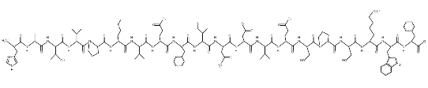 | 20 | 2333.64 | 4.65
NS1P4 | AVIDMENYMSNYKEHWYSQK  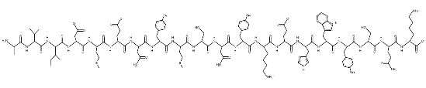 | 20 | 2536.82 | 5.45
NS1P6 | WSPMMNSEQMRGSNHGSAHI  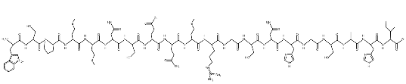 | 20 | 2257.50 | 6.92
NSIP8 | HPDLAVLKDHKTTKHSAHFP  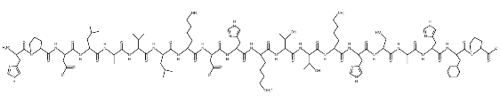 | 20 | 2279.59 | 8.53
NSIP9 | WPNHHKHVTPTHSLNWQN  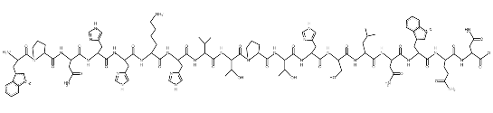 | 18 | 2233.44 | 8.78
NS1P14 | SWKHWTSPPDDKSKMHHTVS  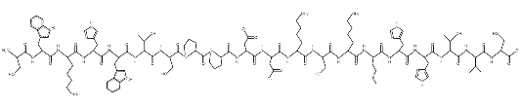 | 20 | 2391.65 | 8.29
Notes: pI: isoelectric point. PepDraw and Protparam estimated the primary structure and theoretical properties.

