Table 1Suggested structures to biotransformation products after 35 days of incubation sorted by accurate massª
From: Biotransformation of antibiotic norfloxacin by marine-derived fungi
Suggested Structure for the compounds |  | t_{R}  (min) | Theorical  Mass | Measured  Mass | Protonated molecular  formula^{b}  [M+H]⁺ | Error  (ppm) | Produced by this study | From the literature
 | 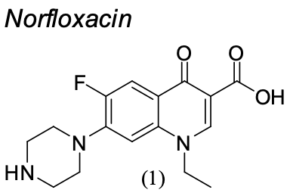 | 5.37 | 320.1405 | 320.1399 | C₁₆H₁₈FN₃O₃ | 1.7 | __ | __
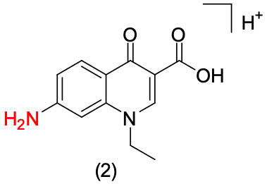 |  | 9.07-9.78  9.52-9.80 | 232.1204 | 232.1194 | C₁₂H₁₂N₂O₃ | 4.5  4.3 | A. sydowii  CBMAI 1241  P. raistrickii CBMAI 1235 | (2) Gao et al., 2018 –  Phanerochaete chrysosporium,  Pycnoporus sanguineus
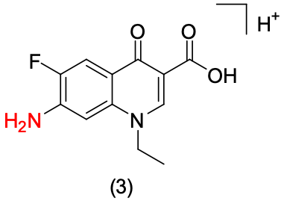 |  | 12.46  12.28-12.58 | 251.0826 | 251.0824 | C₁₂H₁₁FN₂O₃ | 0.4  -2.4 | A. sydowii  CBMAI 1241  P. raistrickii CBMAI 1235 | (3) Parshikov et al., 2001 –  Pestalotiopsis guepini;  (3) Prieto et al., 2011 – Trametes versicolor;  (3) Cvancarova et al., 2015 –  Trametes versicolor,  Irpex lacteus,  Dichomitus squalens and  Pleurotus ostreatus.
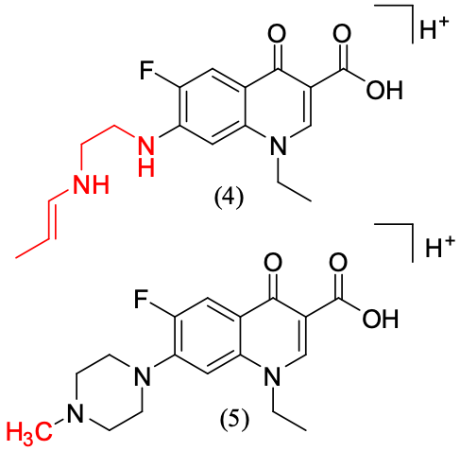 |  | 14.29-14.50  14.63 | 334.1561 | 334.1563 | C₁₇H₂₀FN₃O₃ | -0.4  2.9 | P. raistrickii CBMAI 931  A. sydowii  CBMAI 1241 | __
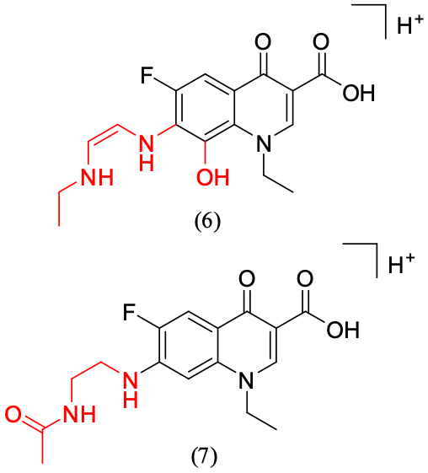 |  | 12.44 | 336.1354 | 336.1352 | C₁₆H₁₈FN₃O₄ | 0.6 | Abiotic control –  Phosphate buffer | (6) __  (7) Parshikov et al., 2001 –  Pestalotiopsis guepini;
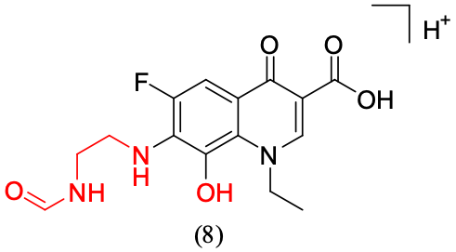 |  | 12.70 | 338,1148 | 338,1141 | C₁₅H₁₆FN₃O₅ | 1,8 | Abiotic control –  Phosphate buffer | __

Table 1 Suggested structures to biotransformation products after 35 days of incubation sorted by accurate massª

From: Biotransformation of antibiotic norfloxacin by marine-derived fungi
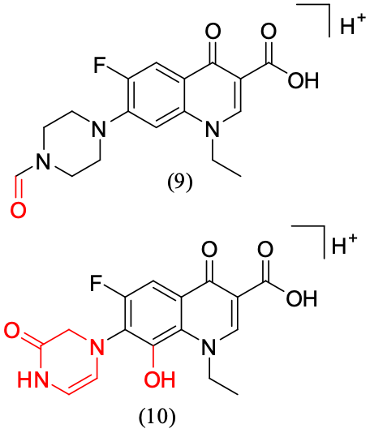 | 15.13  15.02-15.27 | 348,1354 | 348,1350 | C₁₆H₁₄FN₃O₅ | 0,9  -0,9 | Abiotic control –  Phosphate buffer  P. raistrickii CBMAI 1235 | (9) Cvancarova et al., 2015 –  Irpex lacteus, Panus tigrinus, Dichomitus squalens, Trametes versicolor and  Pleurotus ostreatus;  (9) Parshikov et al., 2001 –  Pestalotiopsis  guepini.  (10) __
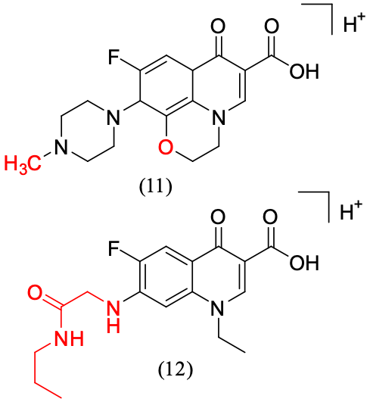 | 14.51-14.83 | 350,1511 | 350,1501 | C₁₇H₂₀FN₃O₄ | 2,8 | A. sydowii  CBMAI 1241 | __

ªAccurate masses analyzed by TOF and their theorical mass assigned to molecular formula, which it was given by calculated error (ppm) for the assignation of suggested structure. ^{b}These molecular formulas are hypothetical in cases of compounds without assigned structure.

