Appendix: Reproducibility in the UK Biobank of Genome-Wide Significant Signals Discovered in Earlier Genome-wide Association Studies
Jack W. O’Sullivan,*^{1,2} and John P. A. Ioannidis^{2,3}

1 Division of Cardiovascular Medicine, Stanford University, Stanford, California, USA
2 Meta-Research Innovation Center at Stanford (METRICS), Stanford University, Stanford, California, USA
3 Departments of Medicine, of Epidemiology and Population Health, of Biomedical Data Science, and of Statistics, Stanford University, Stanford, California, USA

Correspondence to:
*Jack W O’Sullivan
jackos@stanford.edu
Department of Medicine
Stanford University
California, USA

Table of contents
Extended methods 2
Supplementary Figures 4
eFigure 1 4
eFigure 2 5
eFigure 3 5
eFigure 4 6
eFigure 6 8
eFigure 7 9
eFigure 8 9
Supplementary Tables 10
eTable1 10
eTable2 11
References 11

Extended methods
We searched the GWAS Atlas (available at https://atlas.ctglab.nl/) for two, independent GWAS on the same trait conducted in Europeans (or results available exclusively for Europeans). The GWAS atlas is a publically available, and free collection of GWAS; it contains both GWAS conducted without UK Biobank (UKBB) data and also GWAS on all the traits available within the UBB. The authors of the GWAS atlas conducted 600 independent GWAS on all available traits from UK Biobank release 2 data (under application ID 16406) (1). The GWAS atlas contains 4,727 GWAS across 28 different domains, and allows users to download full summary statistics for all GWAS.

We searched the entirety of the GWAS atlas (by domain) for two GWAS on the same trait: an earlier GWAS using data not included in the UKBB (we termed this GWAS the ‘discovery GWAS’) and then a second, independent GWAS using exclusively UKBB data (we termed this GWAS the ‘replication GWAS’). Further inclusion criteria was GWAS conducted in European subjects (or results available for exclusively Europeans) and GWAS with more than 50 genome-wide significant SNPs. We searched the GWAS atlas up to December 2019. We chose the GWAS atlas as this atlas contained GWAS containing only UKBB data (conducted by the authors), as well as other GWAS containing no UKBB data (not conducted by the authors).

Once two independent GWAS were found for the same trait, we identified SNPs present in both GWAS (via rsID) and only included SNPs shared between the two GWAS. We then identified SNPs reaching Genome-wide significance (P<5e-8) in the discovery GWAS and assessed if these SNPs were reproduced in the replication GWAS (determined by P<5e-8 and effect size in a congruent direction e.g. OR both above 1). Before we assessed congruence of SNP effect direction we matched the effect alleles in both GWAS, if the effect allele differed between discovery and replication GWAS, we flipped the replication GWAS effect allele to match the discovery GWAS SNP effect allele. If we flipped the replication GWAS effect allele, we consequently inverted the SNP effect direction; i.e. for quantitative traits we made the SNP effect (β) negative if it was originally positive (or vice versa), and for binary traits we inverted the odds ratio: for example, an OR of 1.3 became 0.89 (1/1.3).

To determine the change in SNP effect size between the discovery GWAS and replication GWAS we perform three broad steps. First, to facilitate comparison of SNP effect sizes between discovery GWAS and replication GWAS for quantitative traits we standardised SNP effect sizes. The summary statistics publically available for UKBB GWAS (conducted by (1) were not standardised. Thus, with guidance with Watanabe (email correspondence January 2020), we standardized quantitative effect sizes (β) from Z-statistics as a function of MAF and sample size, via the formula from (2): $Standardised β =z/sqrt(2p(1-p)(n+z^{2}))$, where $z$ is Z score converted from P-value, $p$ is the minor allele frequency (MAF) and $n$is the sample size of the GWAS. Then, to further aid interpretation we aligned the SNP effect scale to an effect size per 1 standard deviation (SD). Standard deviations (SD) were taken from the UKBB for our quantitative traits (BMI, SBP, DBP, waist circumference, hip circumference, and pulse rate). Second we converted all SNP effect sizes to OR. For GWAS on binary traits (performed by logistic regression), these SNP effect sizes were already reported as OR (or, occasionally as log(OR), from which we calculated the OR (exp(OR)). However, for quantitative traits SNP effect sizes are reported as regression coefficients (β) from linear regression models. Chinn describes a method to convert linear regression coefficients to OR (3). This method was described to facilitate the meta-analysis of quantitative and binary effect sizes (similar to analyses performed in our study). Chinn shows that linear regression coefficients can be converted to a log(OR) by multiplying by 1.81, from which the OR can be calculated by taking the exponential, e.g. $OR =exp((1.81β))$, where $β$ is the linear regression coefficient (SNP effect size for quantitative trait, from linear regression). Third, to aid interpretation of our model, we converted all SNP effect sizes to positive. As all SNP effect sizes were now ORs, and ORs are symmetrical mathematical functions, we inverted OR that were below 1, via $1/OR$ (we did this for the same SNP in both the discovery and replication GWAS). We then constructed single predictor linear models as described in the main text.

Supplementary Figures

eFigure 1
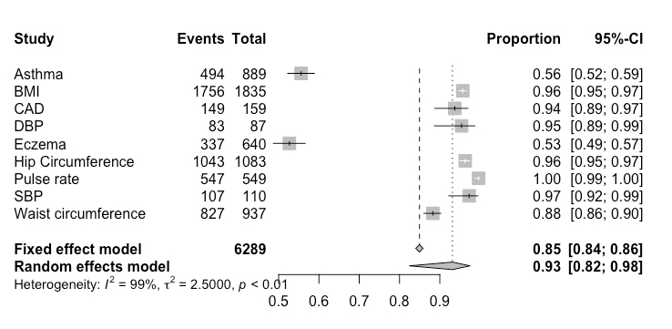
eFigure 1: Forest plot for SNP replication for all phenotypes

eFigure 2
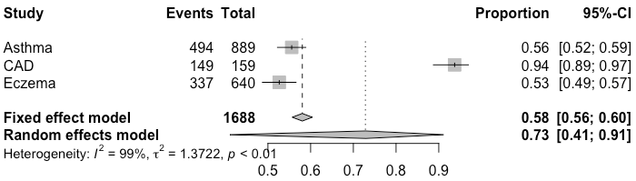
eFigure 2: Forest plot for SNP replication for binary phenotypes

eFigure 3
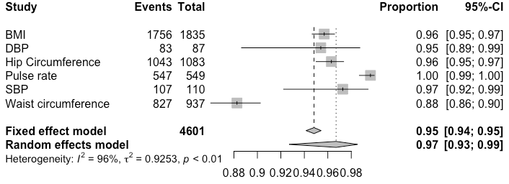
eFigure 3: Forest plot for SNP replication for quantitative phenotypes

eFigure 4
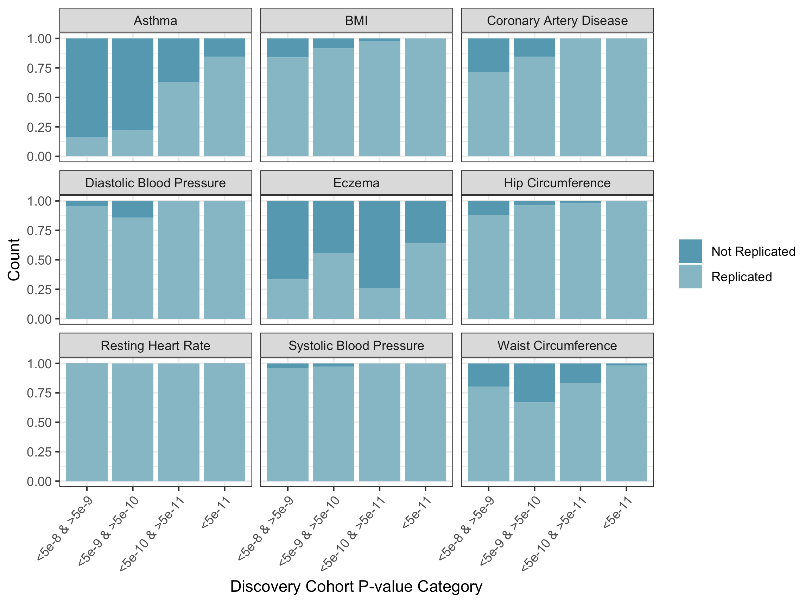
eFigure 4: Replication rate by P-value category across phenotypes.

eFigure 5
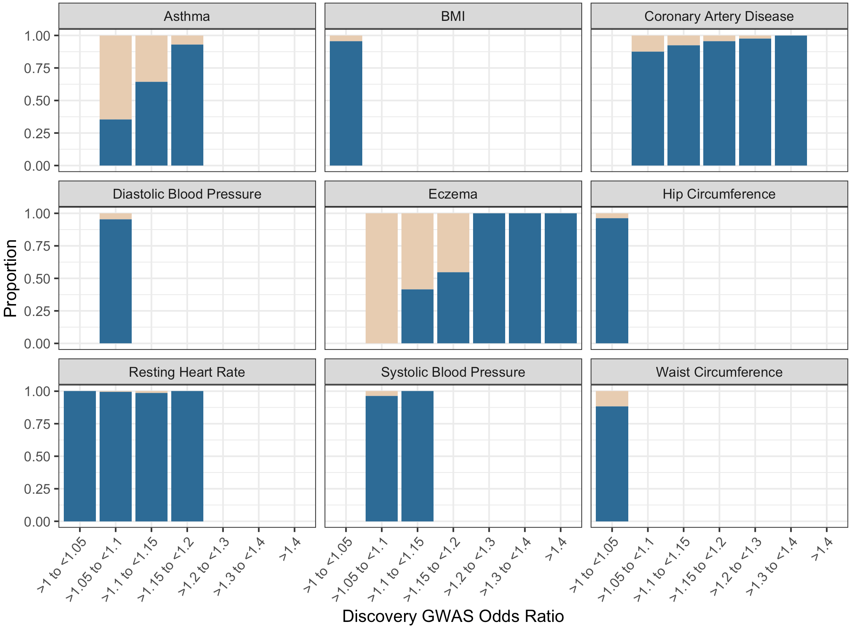
eFigure 5: Replication rate by Odds ratios across phenotypes.

eFigure 6
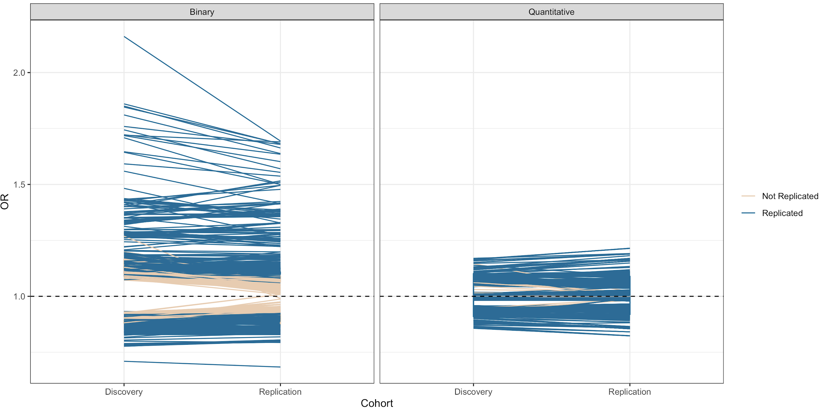
eFigure 6: Change in odds ratios of SNPs between discovery and replication cohorts (all phenotypes)

eFigure 7
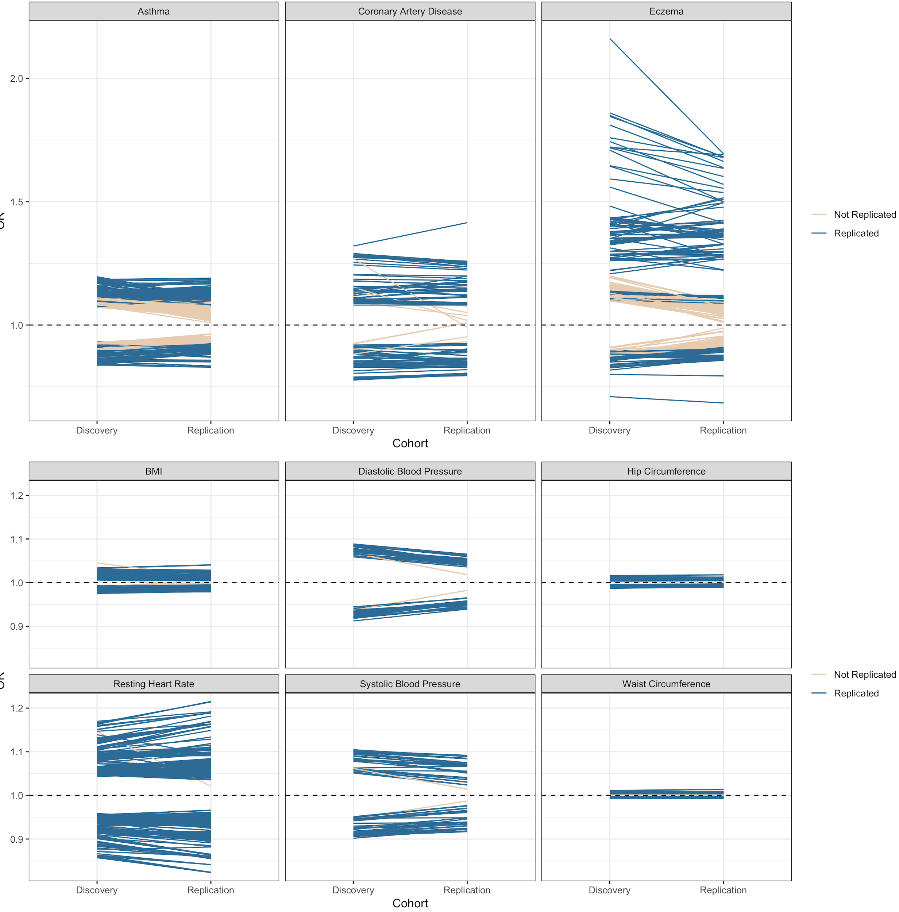
eFigure 7: Change in odds ratios of SNPs between discovery and replication cohorts for each phenotypes.

eFigure 8

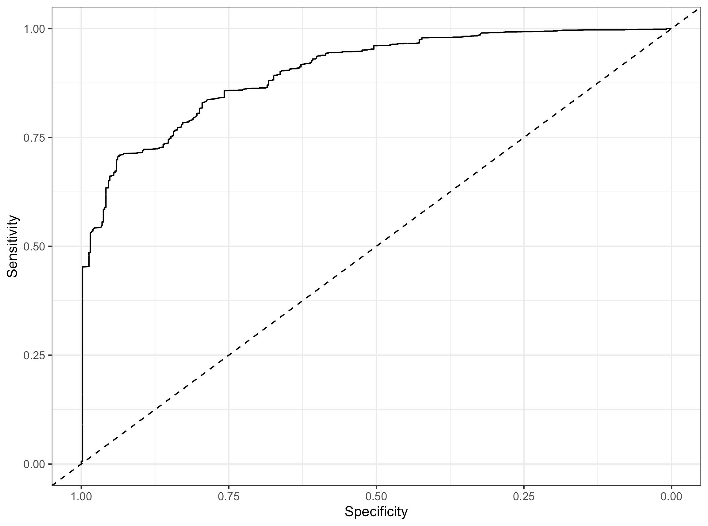
eFigure 8: ROC for SNP replication model.

Supplementary Tables

eTable1

Disease | Total sample size | Discovery GWAS Cases | Discovery GWAS Controls | Replication GWAS Cases | Replication GWAS Controls | Number of Genome-wide significant SNPs | Number of SNPs that are replicated (%)
Asthma | 225309 | 19954 | 107715 | 12362 | 85278 | 889 | 494 (56%)
SBP | 430797 | 69395 | N/A | 361402 | N/A | 110 | 107 (97%)
Eczema | 330142 | 10788 | 30047 | 9831 | 279476 | 640 | 337 (53%)
BMI | 613900 | 234069 | N/A | 379831 | N/A | 1835 | 1756 (96%)
Waist Circumference | 618033 | 232101 | N/A | 385932 | N/A | 937 | 827 (89%)
Hip circumference | 598925 | 213038 | N/A | 385887 | N/A | 1083 | 1043 (96%)
Coronary Artery Disease/IHD | 387786 | 22233 | 64762 | 14456 | 286335 | 159 | 149 (94%)
Resting Heart rate/Pulse Rate | 447198 | 85787 | N/A | 361411 | N/A | 549 | 547 (99%)
DBP | 430806 | 69395 | N/A | 361411 | N/A | 87 | 83 (95%)
eTable1: Number of included SNPs per phenotype and number replicated between cohorts.

eTable2
Predictor | P-value
Discovery GWAS SNP OR | <0.01
Discovery GWAS SNP P-value (continuous) | 0.3
Discovery GWAS SNP P-value <5e-9 & >5e-10 | 0.6
Discovery GWAS SNP P-value <5e-10 & >5e-11 | <0.01
Discovery GWAS SNP P-value <5e-11 | <0.01
Quantitative trait | <0.01
eTable2: P-values covariates for predicting SNP replication.

References
^{1.} Watanabe K, Stringer S, Frei O, et al. A global overview of pleiotropy and genetic architecture in complex traits. Nat. Genet. 2019;51(9):1339–1348.
^{2.} Zhu Z, Zhang F, Hu H, et al. Integration of summary data from GWAS and eQTL studies predicts complex trait gene targets. Nat. Genet. 2016;48(5):481–487.
^{3.} Chinn S. A simple method for converting an odds ratio to effect size for use in meta-analysis. Stat. Med. 2000;19(22):3127–3131.

