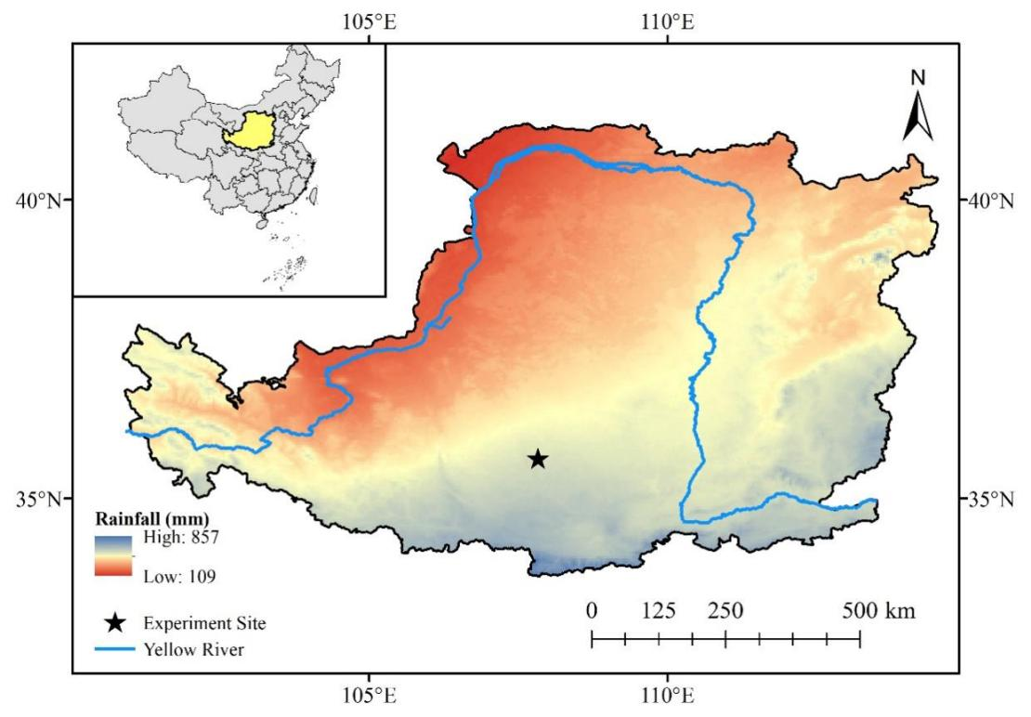
Fig. S1. The geographic location of the Chinese Loess Plateau in China, the distribution of precipitation over the plateau, and the location of the experiment site in the Plateau.

Fig. S2. Relationships of fine root length density with soil water depletion, soil organic carbon storage increment, and soil total nitrogen storage increment in the shallow (0-200 in-depth), middle (200-500 in-depth), and deep (500-1000 cm in-depth) soil layers for different aged alfalfa fields. M3, M4, M6, M7, M11, M12, M18, and M19 represent 3-, 4-, 6-, 7-, 11-, 12-, 18-, and 19-year-old alfalfa fields, respectively.

Fig. S3. Annual total alfalfa biomass yield (the sum of three cuts) during the growing season for 3-, 4-, 6-, 7-, 11-, 12-, 18-, and 19-year-old alfalfa fields. The error bars are standard deviations.

Fig. S4. Water depletion efficiency for carbon accumulation (WDE_{SOC}, g m⁻² SOC increment mm⁻¹ water depletion) and water depletion efficiency for nitrogen accumulation (WDE_{TN}, g m⁻² TN increment mm⁻¹ water depletion) as changed with the age of alfalfa.

