Table1. Comparison of scoring systems for predicting ICU mortality.
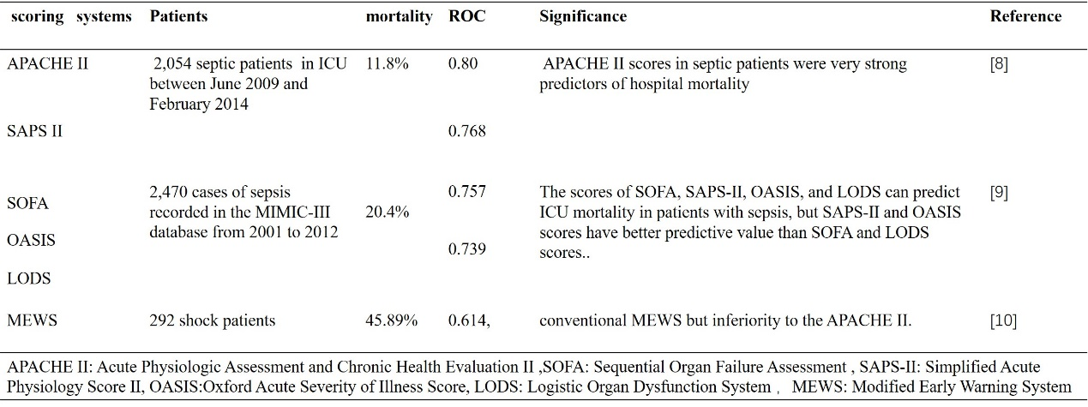

Table 2. Modified Early Warning Score.
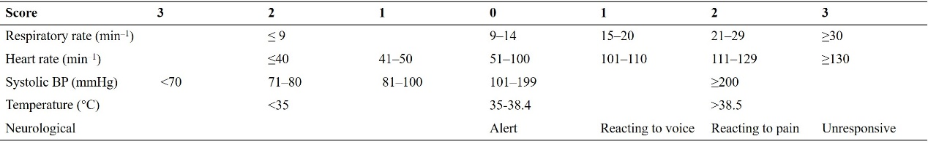

Table3.Baseline characteristics and comparisons of demographics data, chronic medical conditions or comorbidities, risk scores and laboratory parameters of the study population between different survival status in development group.
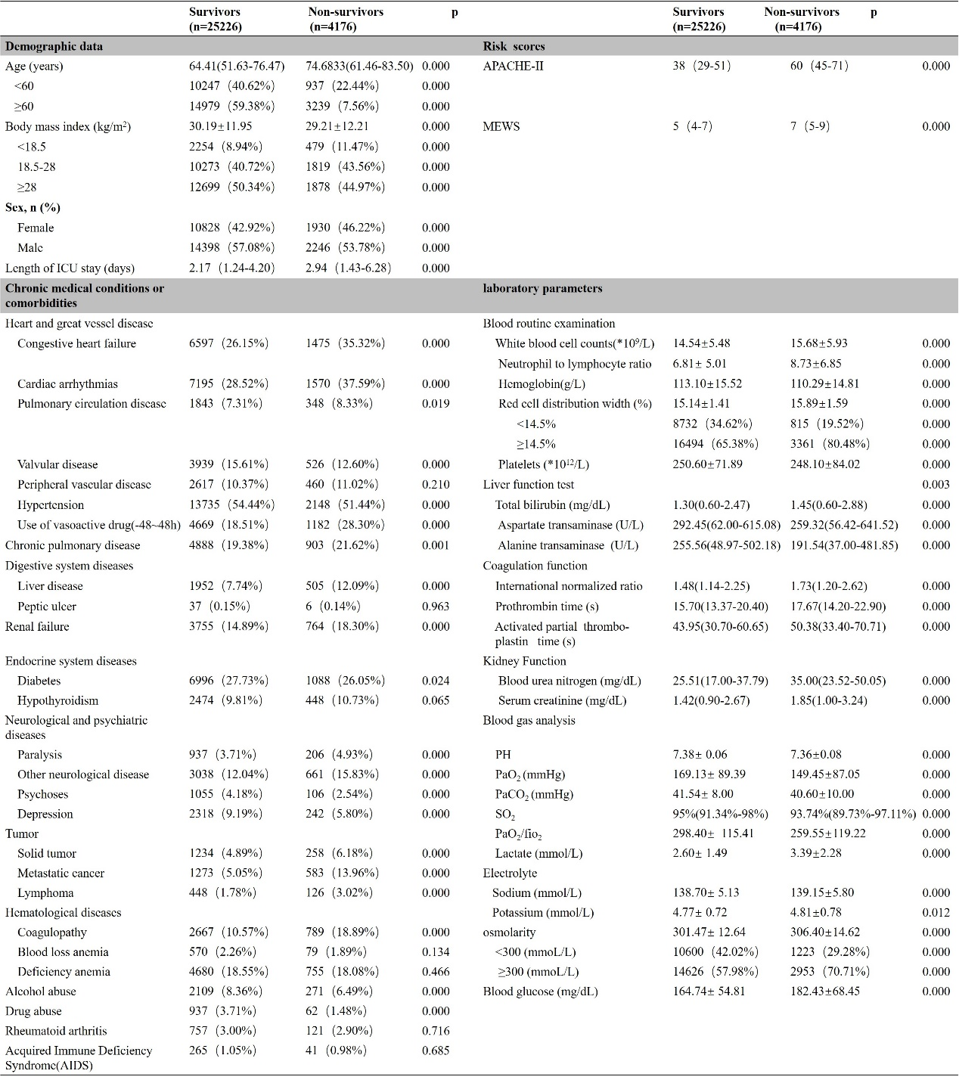

Table4. Univariate and multivariate analyses of factors associated with 28d- mortality rate in development cohort.
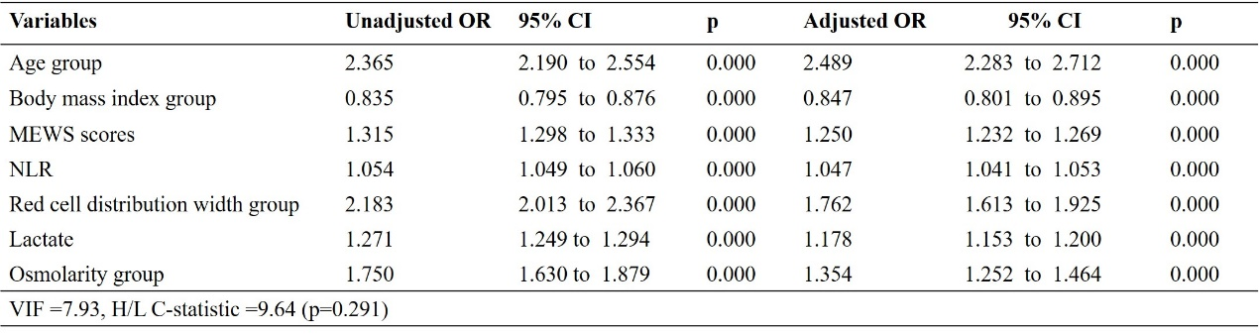

Table 5. The Performance of Broaln-MEWS, APACHE-II, MEWS, RDW, NLR, Lac in 28d-mortality of critical illness.
