The use of Uio-66 Metal-Organic Frameworks as a high-performance catalyst for the isomerization process of endo- to exo-dicyclopentadiene in a solvent-free condition
Narjes Khaton Maghsoodi and Mohammad Hossein Keshavarz*
Faculty of Applied Sciences, Malek Ashtar University of Technology, Iran

*Corresponding Author: Mohammad Hossein Keshavarz
E-mail: mhkeshavarz@mut-es.ac.ir; keshavarz7@gmail.com

Characterization of catalysts
The X-ray diffraction (XRD) patterns were recorded with AW-XDM300 X-ray Diffractometer at a step size of 0.05° with a Cu Ka radiation (λ=1.5406Å). BET surface area was analyzed by N₂ sorption/desorption using at 77k with a Belsorp mini instrument and degassing at 200 °C under vacuum. The Fourier transform infrared (FT-IR) spectra were recorded on an Infralum-08 spectrophotometer in the range of 400–4000 cm⁻¹. Gas chromatography–mass spectrometry (GC-MS) were analyzed using Agilent 6890 by 30 m length packed HP5((5%-phenyl)-methylpolysiloxane) column and mass selective detector.

531
111

Figure S1. XRD patterns of UiO-66 and UiO-66-vac

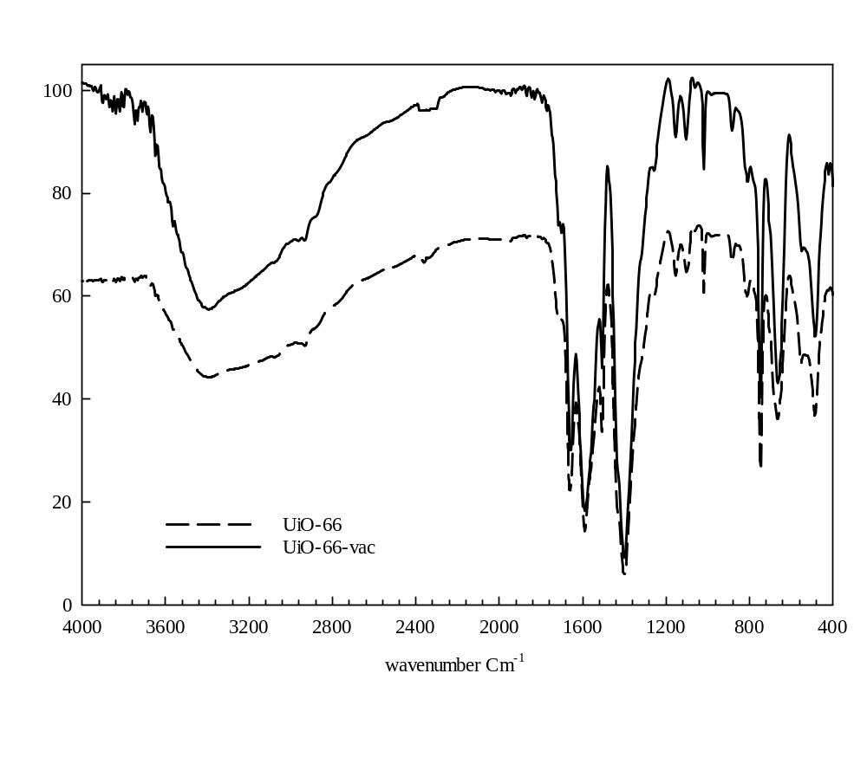

Figure S2. FT-IR spectra of UiO-66 and UiO-66-vac

Figure S3. N₂ adsorption-desorption isotherm of UiO-66 & UiO-66-vac.

- b)
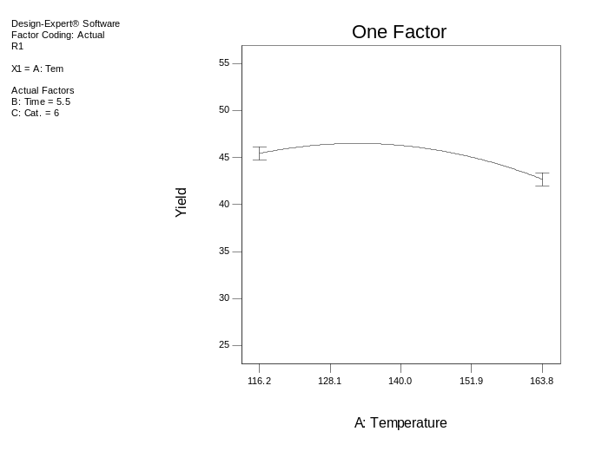
c)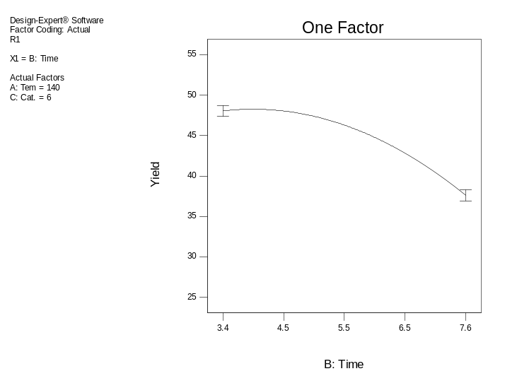
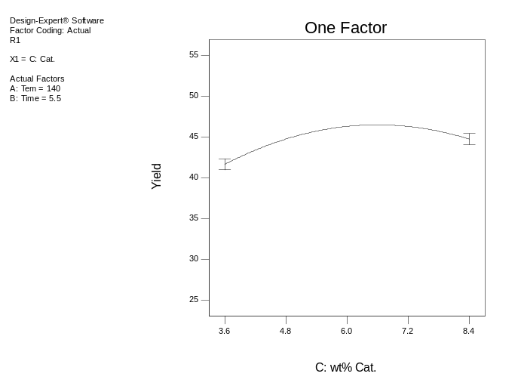
Figure S4. Effects of main factors on the yield of exo-DCPD: a) Temperature, b) Time and c) Wt% cat.
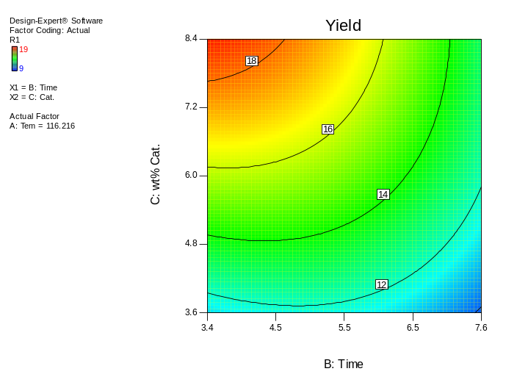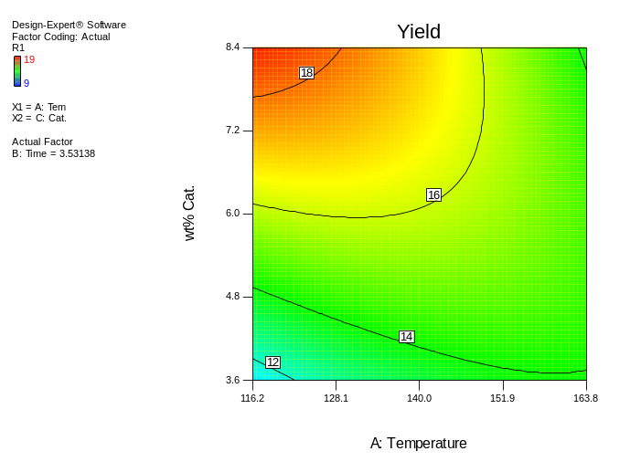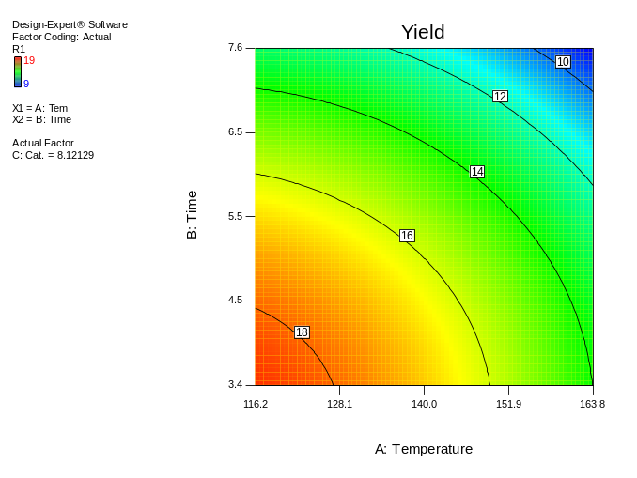
c)
a)
b)
Figure S5. Contours plots for main factors interactions on the isomerization endo-DCPD in the presence of UiO-66: a) Time-%Wt cat., b) Temperature-%Wt cat., and c) Temperature-Time

Table S1. ANOVA results of Response Surface model for yield in the isomerization of endo-DCPD to exo-DCPD using UiO-66 and UiO-66-vac
 |  |  | a) UiO-66
Source | Sum of Squares | df | Mean  Square | F Value |  | p-value  Prob > F
Model | 116.55 | 9 | 12.95 | 53.97 |  | < 0.0001 | significant
Temperature | 2.97 | 1 | 2.97 | 12.36 |  | 0.0056 | significant
Time | 39.04 | 1 | 39.04 | 162.69 |  | < 0.0001 | significant
Wt% Cat. | 7.86 | 1 | 7.86 | 32.77 |  | 0.0002 | significant
Temperature×Time | 0.13 | 1 | 0.13 | 0.52 |  | 0.4870 | not significant
Temperature×Wt% Cat. | 28.12 | 1 | 28.12 | 117.20 |  | < 0.0001 | significant
Time×Wt% Cat. | 10.12 | 1 | 10.12 | 42.19 |  | < 0.0001 | significant
Temperature ² | 8.04 | 1 | 8.04 | 33.50 |  | 0.0002 | significant
Time ² | 17.45 | 1 | 17.45 | 72.72 |  | < 0.0001 | significant
Wt% Cat.² | 8.04 | 1 | 8.04 | 33.50 |  | 0.0002 | significant
Residual | 2.40 | 10 | 0.24
Lack of Fit | 1.07 | 5 | 0.21 | 0.80 |  | 0.5939 | not significant
Pure Error | 1.33 | 5 | 0.27
Cor Total | 118.95 | 19

b)UiO-66-vac
Source | Sum of Squares | df | Mean  Square | F Value | p-value  Prob > F
Model | 1021.55 | 9 | 113.51 | 89.71 | < 0.0001 | significant
Temperature | 25.80 | 1 | 25.80 | 20.40 | 0.0011 | significant
Time | 371.96 | 1 | 371.96 | 293.99 | < 0.0001 | significant
Wt% Cat. | 32.57 | 1 | 32.57 | 25.74 | 0.0005 | significant
Temperature×Time | 0.13 | 1 | 0.13 | 0.099 | 0.7597 | not significant
Temperature×Wt% Cat. | 190.12 | 1 | 190.12 | 150.27 | < 0.0001 | significant
Time×Wt% Cat. | 78.12 | 1 | 78.12 | 61.75 | < 0.0001 | significant
Temperature ² | 71.26 | 1 | 71.26 | 56.33 | < 0.0001 | significant
Time ² | 172.64 | 1 | 172.64 | 136.45 | < 0.0001 | significant
Wt% Cat.² | 139.17 | 1 | 139.17 | 110.00 | < 0.0001 | significant
Residual | 12.65 | 10 | 1.27
Lack of Fit | 9.32 | 5 | 1.86 | 2.80 | 0.1418 | not significant
Pure Error | 3.33 | 5 | 0.67
Cor Total | 1034.20 | 19

