Supplementary Information
Figure S1

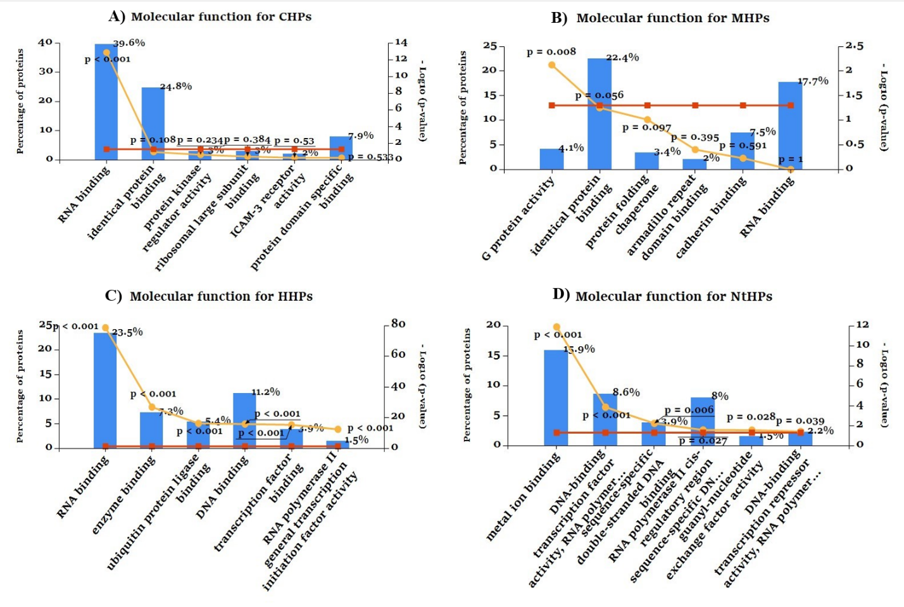

Figure S1. Functional Enrichment Analysis (I) Molecular Function analysis: Gene Ontology enrichment analysis for (A)CHPs, (B) MHPs, (C) HHPs and (D)NtHPs carried out by using the Funrich Tool. [1] RNA binding molecular function commonly share by CHPs, HHPs and MHPs, whereas NtHPs mostly enriched with metal ion binding, DNA binding transcription activity. (The blue bar shows the percentage of the genes, the red line, and yellow line stands for the reference p-Value and relative p-value respectively)

Figure S2

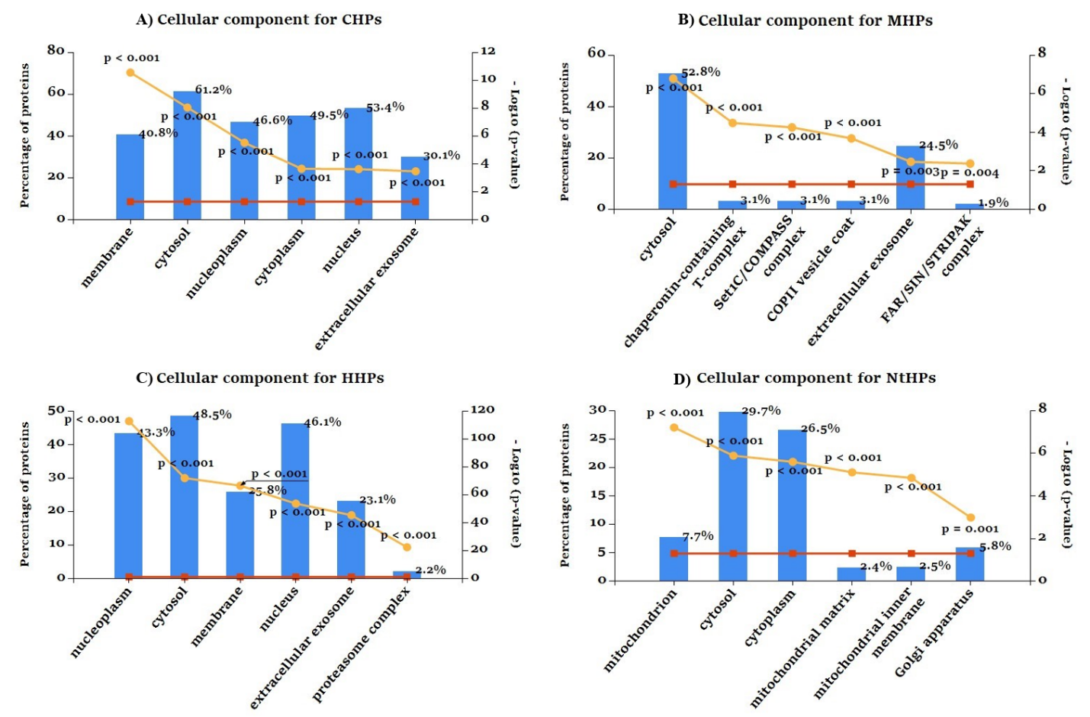

Figure S2. Functional Enrichment Analysis (II) Cellular Component: Gene Ontology enrichment analysis for (A)CHPs, (B) MHPs, (C) HHPs and (D)NtHPs carried out by using the Funrich Tool. [1] CHPs, HHPs and MHPs are commonly enriched with cytosol, extracellular exosome, whereas in contrast NtHPs also enriched with mitochondrion, mitochondrial membrane. (The blue bar shows the percentage of the genes, the red line, and yellow line stands for the reference p-Value and relative p-value respectively)

Figure S3

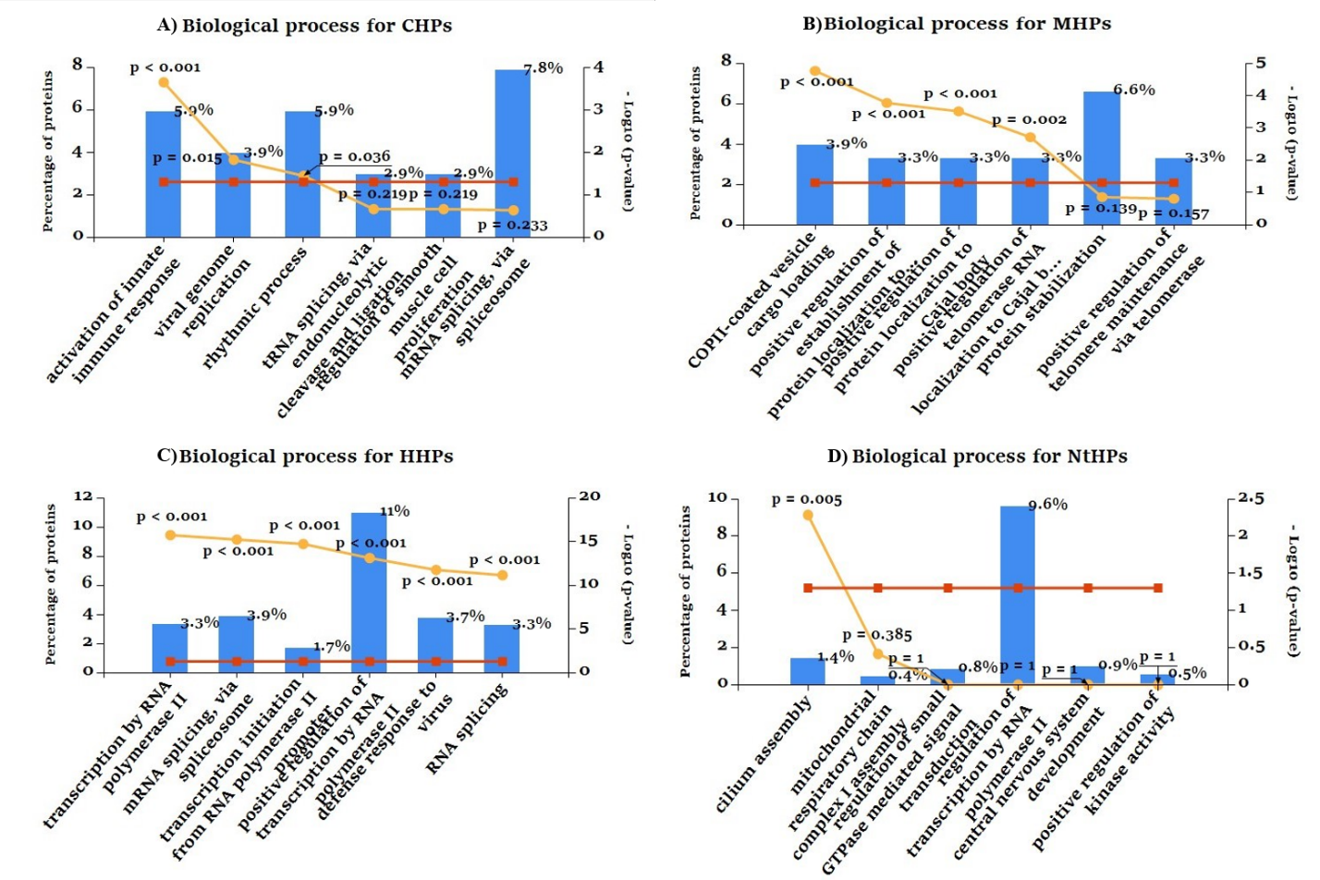

Figure S3. Functional Enrichment Analysis (III) Biological Process: Gene Ontology enrichment analysis for (A)CHPs, (B) MHPs, (C) HHPs and (D)NtHPs carried out by using the Funrich Tool. [1]. CHPs are enriched with immunological, rhythmic and core cellular process. HHPs involve in defence response and transcriptionary process and MHPs involve mostly in secretory process. whereas in contrast NtHPs also enriched with transcription regulation, mitochondrial respiratory chain, signal transduction etc biological processes. (The blue bar shows the percentage of the genes, the red line, and yellow line stands for the reference p-Value and relative p-value respectively)

Table S1: Essential gene data, (based on CRISPR-based approaches) were obtained from the Database of Essential Genes (DEG, V15.2) [2]

Human Protein Category | Total protein | Total essential gene
CHPs | 103 | 91(88.34%)
HHPs | 1744 | 1258(72.13%)
MHPs | 169 | 114(67.45%)
NtHPs | 14827 | 7077(47.73%)

Table S2: List of drugs targeting pathogen proteins that interact with CHPs. Drug target interaction data obtained from DrugBank [3]

S. No | pathogen_Protein | Drug.IDs | Species
1 | env | DB11854 | HIV-1
2 | env | DB04639 | HIV-1
3 | env | DB11796 | HIV-1
4 | env | DB02780 | HIV-1
5 | env | DB02904 | HIV-1
6 | env | DB03320 | HIV-1
7 | env | DB03817 | HIV-1
8 | Gag | DB08231 | HIV-1
9 | Gag | DB06039 | HIV-1
10 | gp41 | DB00109 | HIV-1
11 | IN | DB11751 | HIV-1
12 | IN | DB11799 | HIV-1
13 | IN | DB06817 | HIV-1
14 | IN | DB08930 | HIV-1
15 | IN | DB09101 | HIV-1
16 | Nef | DB08231 | HIV-1
17 | Pol | DB04623 | HIV-1
18 | Pol | DB00503 | HIV-1
19 | Pol | DB00701 | HIV-1
20 | Pol | DB00932 | HIV-1
21 | Pol | DB01072 | HIV-1
22 | Pol | DB01232 | HIV-1
23 | Pol | DB04887 | HIV-1
24 | Pol | DB00224 | HIV-1
25 | Pol | DB01264 | HIV-1
26 | Pol | DB01319 | HIV-1
27 | Pol | DB01601 | HIV-1
28 | Pol | DB01721 | HIV-1
29 | Pol | DB01887 | HIV-1
30 | Pol | DB02804 | HIV-1
31 | Pol | DB04353 | HIV-1
32 | Pol | DB02086 | HIV-1
33 | Pol | DB02994 | HIV-1
34 | Pol | DB03118 | HIV-1
35 | Pol | DB03676 | HIV-1
36 | Pol | DB03963 | HIV-1
37 | Pol | DB07575 | HIV-1
38 | Pol | DB08027 | HIV-1
39 | Pol | DB08231 | HIV-1
40 | Pol | DB07910 | HIV-1
41 | Pol | DB08115 | HIV-1
42 | Pol | DB05328 | HIV-1
43 | Pol | DB06581 | HIV-1
44 | Pol | DB08188 | HIV-1
45 | Pol | DB08502 | HIV-1
46 | Pol | DB13119 | HIV-1
47 | Pol | DB02102 | HIV-1
48 | Pol | DB02702 | HIV-1
49 | Pol | DB02729 | HIV-1
50 | Pol | DB04609 | HIV-1
51 | Pol | DB06910 | HIV-1
52 | Pol | DB07184 | HIV-1
53 | Pol | DB07332 | HIV-1
54 | Pol | DB07472 | HIV-1
55 | Pol | DB07473 | HIV-1
56 | Pol | DB07781 | HIV-1
57 | Pol | DB07797 | HIV-1
58 | Pol | DB07820 | HIV-1
59 | Pol | DB07826 | HIV-1
60 | Pol | DB07864 | HIV-1
61 | Pol | DB07867 | HIV-1
62 | Pol | DB07868 | HIV-1
63 | Pol | DB07869 | HIV-1
64 | Pol | DB07871 | HIV-1
65 | Pol | DB07884 | HIV-1
66 | Pol | DB07892 | HIV-1
67 | Pol | DB08154 | HIV-1
68 | Pol | DB08211 | HIV-1
69 | Pol | DB08286 | HIV-1
70 | Pol | DB08372 | HIV-1
71 | Pol | DB08379 | HIV-1
72 | Pol | DB08444 | HIV-1
73 | Pol | DB08446 | HIV-1
74 | Pol | DB08459 | HIV-1
75 | Pol | DB08460 | HIV-1
76 | Pol | DB08494 | HIV-1
77 | Pol | DB08528 | HIV-1
78 | Pol | DB08598 | HIV-1
79 | Pol | DB08634 | HIV-1
80 | Pol | DB08665 | HIV-1
81 | Pol | DB08680 | HIV-1
82 | Pol | DB08681 | HIV-1
83 | Pol | DB08682 | HIV-1
84 | Pol | DB06414 | HIV-1
85 | Pol | DB04886 | HIV-1
86 | Pol | DB05228 | HIV-1
87 | Pol | DB05644 | HIV-1
88 | Pol | DB02411 | HIV-1
89 | Pol | DB02668 | HIV-1
90 | Pol | DB03768 | HIV-1
91 | Pol | DB04454 | HIV-1
92 | Pol | DB07679 | HIV-1
93 | Pol | DB08622 | HIV-1
94 | Pol | DB07327 | HIV-1
95 | Pol | DB07505 | HIV-1
96 | Pol | DB08041 | HIV-1
97 | Pol | DB08428 | HIV-1
98 | Pol | DB08662 | HIV-1
99 | Pol | DB05398 | HIV-1
100 | Pol | DB05871 | HIV-1
101 | Pol | DB07885 | HIV-1
102 | Pol | DB08639 | HIV-1
103 | Pol | DB01732 | HIV-1
104 | Pol | DB01824 | HIV-1
105 | Pol | DB01891 | HIV-1
106 | Pol | DB02009 | HIV-1
107 | Pol | DB02033 | HIV-1
108 | Pol | DB02629 | HIV-1
109 | Pol | DB02683 | HIV-1
110 | Pol | DB02704 | HIV-1
111 | Pol | DB02768 | HIV-1
112 | Pol | DB02785 | HIV-1
113 | Pol | DB02972 | HIV-1
114 | Pol | DB03076 | HIV-1
115 | Pol | DB03141 | HIV-1
116 | Pol | DB03803 | HIV-1
117 | Pol | DB03908 | HIV-1
118 | Pol | DB04042 | HIV-1
119 | Pol | DB04190 | HIV-1
120 | Pol | DB04255 | HIV-1
121 | Pol | DB04547 | HIV-1
122 | Pol | DB06874 | HIV-1
123 | Pol | DB07018 | HIV-1
124 | Pol | DB07035 | HIV-1
125 | Pol | DB07337 | HIV-1
126 | Pol | DB07343 | HIV-1
127 | Pol | DB07451 | HIV-1
128 | Pol | DB07578 | HIV-1
129 | Pol | DB07806 | HIV-1
130 | Pol | DB07961 | HIV-1
131 | Pol | DB08034 | HIV-1
132 | Pol | DB08212 | HIV-1
133 | Pol | DB08281 | HIV-1
134 | Pol | DB08282 | HIV-1
135 | Pol | DB08284 | HIV-1
136 | Pol | DB08414 | HIV-1
137 | Pol | DB08457 | HIV-1
138 | Pol | DB08600 | HIV-1
139 | PR | DB03141 | HIV-1
140 | PR | DB15623 | HIV-1
141 | PR | DB00220 | HIV-1
142 | RT | DB00300 | HIV-1
143 | RT | DB00625 | HIV-1
144 | RT | DB00649 | HIV-1
145 | RT | DB00709 | HIV-1
146 | RT | DB00879 | HIV-1
147 | RT | DB00943 | HIV-1
148 | RT | DB01048 | HIV-1
149 | RT | DB11799 | HIV-1
150 | RT | DB12301 | HIV-1
151 | RT | DB12855 | HIV-1
152 | RT | DB14126 | HIV-1
153 | RT | DB07935 | HIV-1
154 | RT | DB11365 | HIV-1
155 | RT | DB00238 | HIV-1
156 | RT | DB00495 | HIV-1
157 | RT | DB00705 | HIV-1
158 | RT | DB00900 | HIV-1
159 | RT | DB08864 | HIV-1
160 | RT | DB09299 | HIV-1
161 | fbpC | DB02811 | Mycobacterium Tuberculosis
162 | fbpC | DB08558 | Mycobacterium Tuberculosis
163 | SerA | DB01694 | Mycobacterium Tuberculosis
164 | ahcY | DB07052 | Mycobacterium Tuberculosis

Reference for supplementary material
1] Pathan, M., Keerthikumar, S., Ang, C. S., Gangoda, L., Quek, C. Y., Williamson, N. A., Mouradov, D., Sieber, O. M., Simpson, R. J., Salim, A., Bacic, A., Hill, A. F., Stroud, D. A., Ryan, M. T., Agbinya, J. I., Mariadason, J. M., Burgess, A. W., & Mathivanan, S. (2015). FunRich: An open access standalone functional enrichment and interaction network analysis tool. Proteomics, 15(15), 2597–2601. https://doi.org/10.1002/pmic.201400515
2] Zhang, R., & Lin, Y. (2009). DEG 5.0, a database of essential genes in both prokaryotes and eukaryotes. Nucleic acids research, 37(Database issue), D455–D458. https://doi.org/10.1093/nar/gkn858
3] Wishart DS, Feunang YD, Guo AC, Lo EJ, Marcu A, Grant JR, Sajed T, Johnson D, Li C, Sayeeda Z, Assempour N, Iynkkaran I, Liu Y, Maciejewski A, Gale N, Wilson A, Chin L, Cummings R, Le D, Pon A, Knox C, Wilson M. DrugBank5.0: a major update to the DrugBank database for 2018. Nucleic Acids Res. 2017 Nov 8. doi: 10.1093/nar/gkx1037.

