Supplementary document
The Impact of insect herbivory in the level of cannabinoids in CBD hemp Varieties

Brando Jackson¹, Lenneisha Gilbert¹, Tigist Tolosa¹, Shelly Ann Henry¹, Victoria V Volkis², Simon Zebelo ^{1, 2}*

¹Department of Agriculture Food and Resource Sciences, University of Maryland Eastern Shore, MD 21804, USA
²Departement of Natural Sciences, University of Maryland Eastern Shore, MD 21853, USA

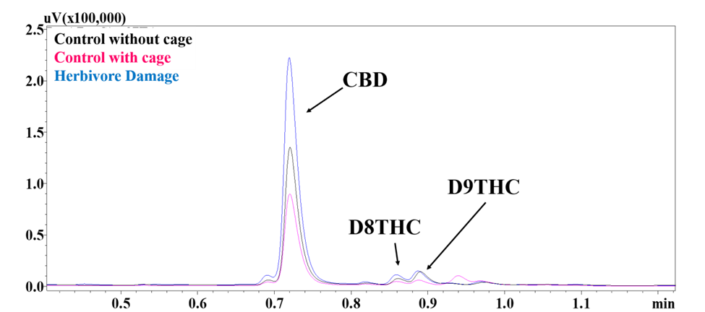
Figure S1. Representative GC-FID Chromatogram. Cannabidiol (CBD), delta-8- tetrahydrocannabinol (D8THC), delta-9 tetrahydrocannabinol (D9THC) and Cannabinol (CBN). Control without cage (black), Control with cage (Red), and Herbivore Damage (blue).
Figure S2. Cage hemp plants for herbivore trails

