Supplementary materials

Gene abbreviations
Gene abbreviations are listed for human orthologs.
Human homologs of discussed Candidate genes
AGK Acylglycerol Kinase
AMZ1 Archaelysin Family Metallopeptidase 1
ARMCX4 Armadillo Repeat Containing X-Linked 4
B2M Beta-2-Microglobulin
BCAS1 Brain Enriched Myelin Associated Protein 1
BST2 Bone Marrow Stromal Cell Antigen 2
BTG1 B-Cell Translocation Gene (BTG) Anti-Proliferation Factor 1
CABYR Calcium Binding Tyrosine Phosphorylation Regulated
CACYBP Calcyclin Binding Protein
CARTPT Cocaine- And Amphetamine Regulated Transcript (CART) Prepropeptide
CCDC88C Coiled-Coil Domain Containing 88C
CELF6 CUGBP Elav-like Family Member 6
CFAP74 Cilia And Flagella Associated Protein 74
DHX33 DEAH-Box Helicase 33
DRD3 Dopamine Receptor D3
EGR2 Early Growth Response 2
FABP7 Fatty Acid Binding Protein 7
FKBP4 FKBP Prolyl Isomerase 4
FTH1 Ferritin Heavy Chain 1
GABRG2 Gamma-Aminobutyric Acid (GABA) Type A Receptor Subunit Gamma 2
GAD2 Glutamate Decarboxylase 2
GADD45G Growth Arrest And DNA Damage Inducible Gamma
GPD1 Glycerol-3-Phosphate Dehydrogenase 1
GNA12 G Protein Subunit Alpha 12
GPR101 G Protein-Coupled Receptor 101
GPRIN3 G Protein-Regulated Inducer of Neurite Outgrowth (GPRIN) 3
GSTK1 Glutathione S-Transferase Kappa 1
GUCY1A3 Guanylate Cyclase 1 Soluble Subunit Alpha 1
HAPLN2 Hyaluronan And Proteoglycan Link Protein 2
HSPA5 Heat Shock Protein Family A (Hsp70) Member 5
IRS2 Insulin Receptor Substrate 2
KCTD17 Potassium Channel Tetramerization Domain Containing 17
KIF5A Kinesin Family Member 5A
KLHDC2 Kelch Domain Containing 2
LHFPL4 LHFPL Tetraspan Subfamily Member 4
LIN7B Lin-7 Homolog B, Crumbs Cell Polarity Complex Component
LYPD1 LY6/PLAUR Domain Containing 1
MBP Myelin Basic Protein
MIA3 MIA SH3 Domain ER Export Factor 3
MOBP Myelin Associated Oligodendrocyte Basic Protein
MOG Myelin Oligodendrocyte Glycoprotein
MUC3A Mucin 3A, Cell Surface Associated
NTS Neurotensin
OPALIN Oligodendrocytic Myelin Paranodal And Inner Loop Protein
PHLDA1 Pleckstrin Homology Like Domain Family A Member 1
PITPNM3 Phosphatidylinositol Transfer Protein, Membrane Associated (PITPNM) Family Member 3
PPFIA4 Protein Tyrosine Phosphatase, Receptor Type, F Polypeptide (PTPRF), Interacting Protein (Liprin), Alpha 4
PPP1R15A Protein Phosphatase 1 Regulatory Subunit 15A
PRKCG Protein Kinase C Gamma
RYR3 Ryanodine Receptor 3
RGS5 Regulator Of G Protein Signaling 5
RPS6KA2 Ribosomal Protein S6 Kinase A2
SNAP91 Synaptosome Associated Protein 91
SOD3 Superoxide Dismutase 3
SOX17 Sex Determining Region Y (SRY)-Box Transcription Factor 17
SPINT3 Serine Peptidase Inhibitor, Kunitz Type 3
SYNPR Synaptoporin
TIPARP TCDD Inducible Poly(ADP-Ribose) Polymerase
TTLL1 Tubulin Tyrosine Ligase (TTL) Family Tubulin Polyglutamylase Complex Subunit L1
USP46 Ubiquitin Specific Peptidase 46
VIM Vimentin
XAF1 XIAP Associated Factor 1
ZDBF2 Zinc Finder DBF-Type Containing 2

Other genes
BDNF Brain Derived Neurotrophic Factor
C1QL2 Complement C1q Like 2
CART Cocaine- and Amphetamine-Related Transcript
CREB1 cAMP Responsive Element Binding Protein 1
FAM53B Family With Sequence Similarity 53 Member B

Tissue abbreviations
From Gene-Tissue Expression (GTEx) V8 database. Tissues with the prefix “BRN” (brain) are located in the central nervous system (CNS).

ADP-SBC Adipose – subcutaneous STOMACH Stomach
ADP-VSO Adipose - visceral omentum TESTIS Testis
ADRNLGL Adrenal gland THYROID Thyroid
ART-CRN Artery – coronary UTERUS Uterus
ART-TB Artery – tibial VAGINA Vagina
BLADDER Bladder WHLBLD Whole blood
BRN-AMY Amygdala
BRN-ACC Anterior cingulate cortex (BA24)
BRN-CAU Caudate, basal ganglia
BRN-CB-a Cerebellar hemisphere
BRN-CB-b Cerebellum
BRN-CTX-a Frontal cortex (BA9)
BRN-CTX-b Cortex
BRN-HIPP Hippocampus
BRN-HYP Hypothalamus
BRN-NAC Nucleus accumbens, basal ganglia
BRN-PTRY Pituitary gland
BRN-PUT Putamen, basal ganglia
BRN-SN Substantia nigra
BRN-SPC Spinal cord (cervical C1)
BREAST Breast
CELL-FB Cells - cultured fibroblasts
CELL-LYM Cells - EBV-transformed lymphocytes
CVX-ECT Cervix - ectocervix
CVX-END Cervix - endocervix
CLN-SIG Colon - sigmoid
CLN-TRN Colon - transverse
ESP-GEJ Esophagus - gastroesophageal junction
ESP-MCS Esophagus mucosa
ESP-MSL Esophagus mucularis
FLPTB Fallopian tube
HRT-AA Heart - atrial appendage
HRT-LV Heart - left ventricle
KDY-CTX Kidney - cortex
KDY-MDL Kidney - medulla
LIVER Liver
LUNG Lung
SALGL Salivary gland
MSC-SK Skeletal muscle
NRV-TB Nerve - tibial
OVARY Ovary
PANCREAS Pancreas
PROSTATE Prostate
SKN-NSP Skin - not sun exposed, subrapubic
SKN-SLL Skin - sun exposed, lower leg
SIN-TIL Small intestine - terminal ileum
SPLEEN Spleen
Supplementary figures and legends

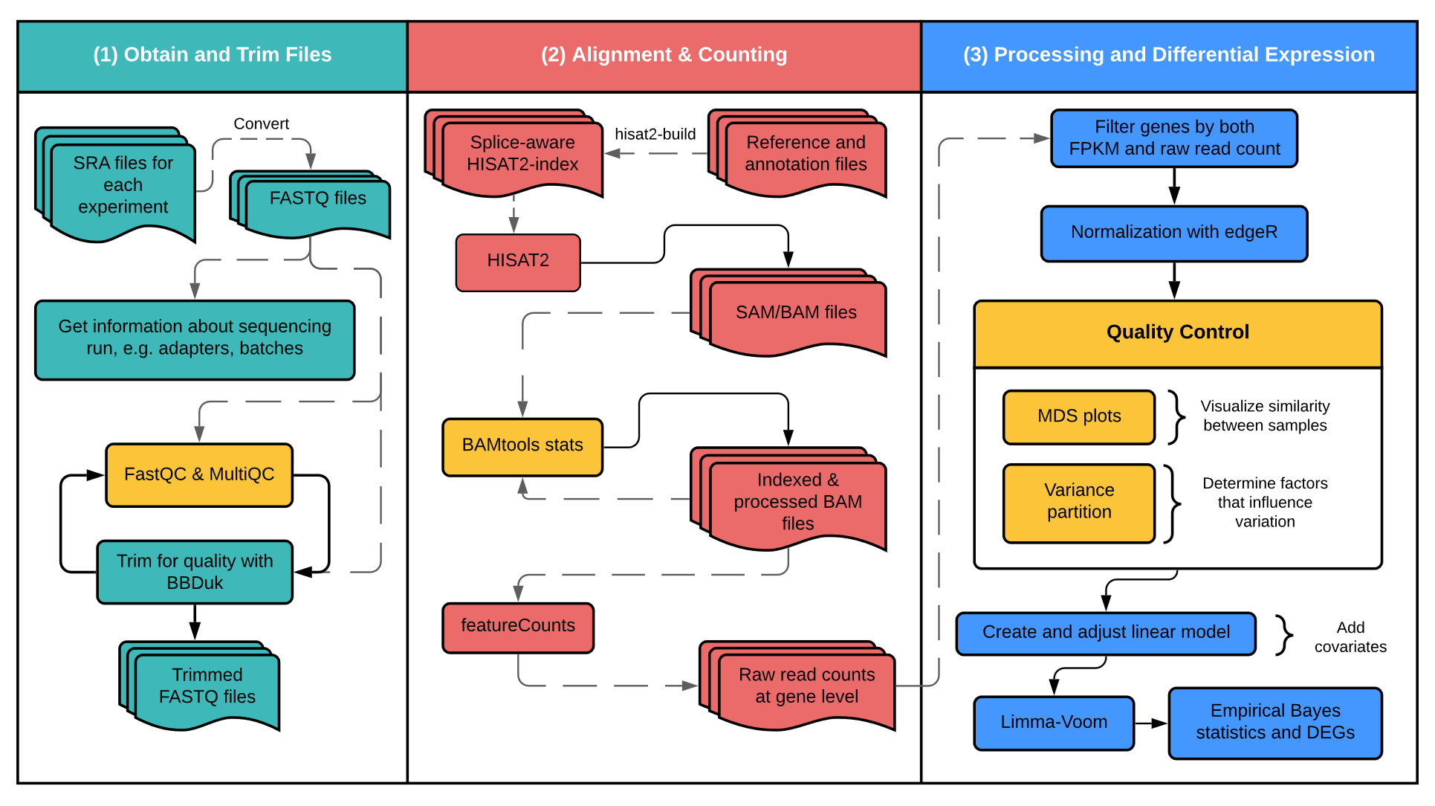
Supplementary Figure S1. RNA-seq pipeline for differential expression analysis. All 3 datasets were analyzed separately using the above pipeline.

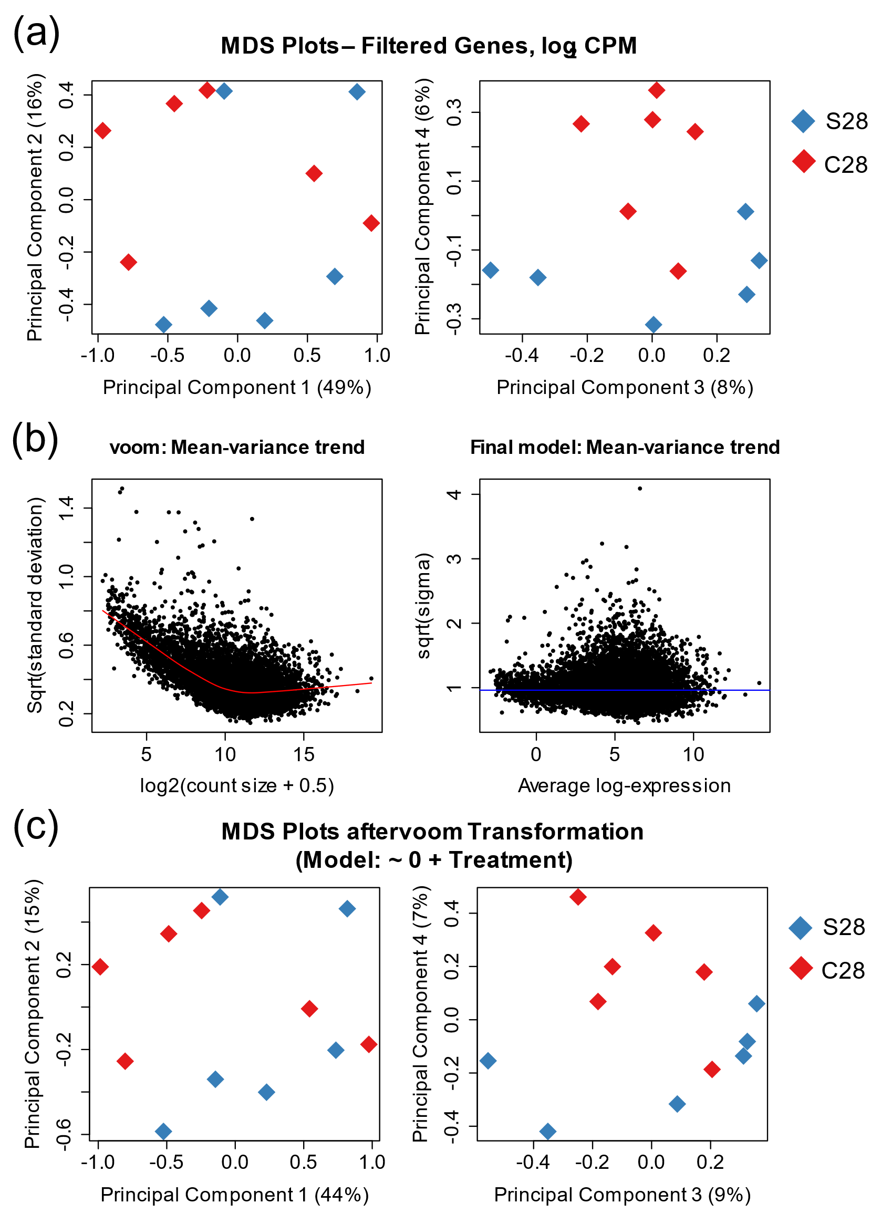

Supplementary Figure S2. RNA-seq processing for Carpenter S28 vs. C28 dataset. (a, c) Multidimensional scaling (MDS) plots for the top 100 genes with the largest fold change differences between groups before (a) and after (c) voom transformation. Principal components 1 and 2 (left) and 3 and 4 (right) are shown, along with the percentage of variation captured by each component. Blue and red signify the S28 and C28 groups, respectively. (b) limma voom was used to apply a linear model to the data. Gene expression was measured in CPM with (a, c) and without (b) log2 transformation.

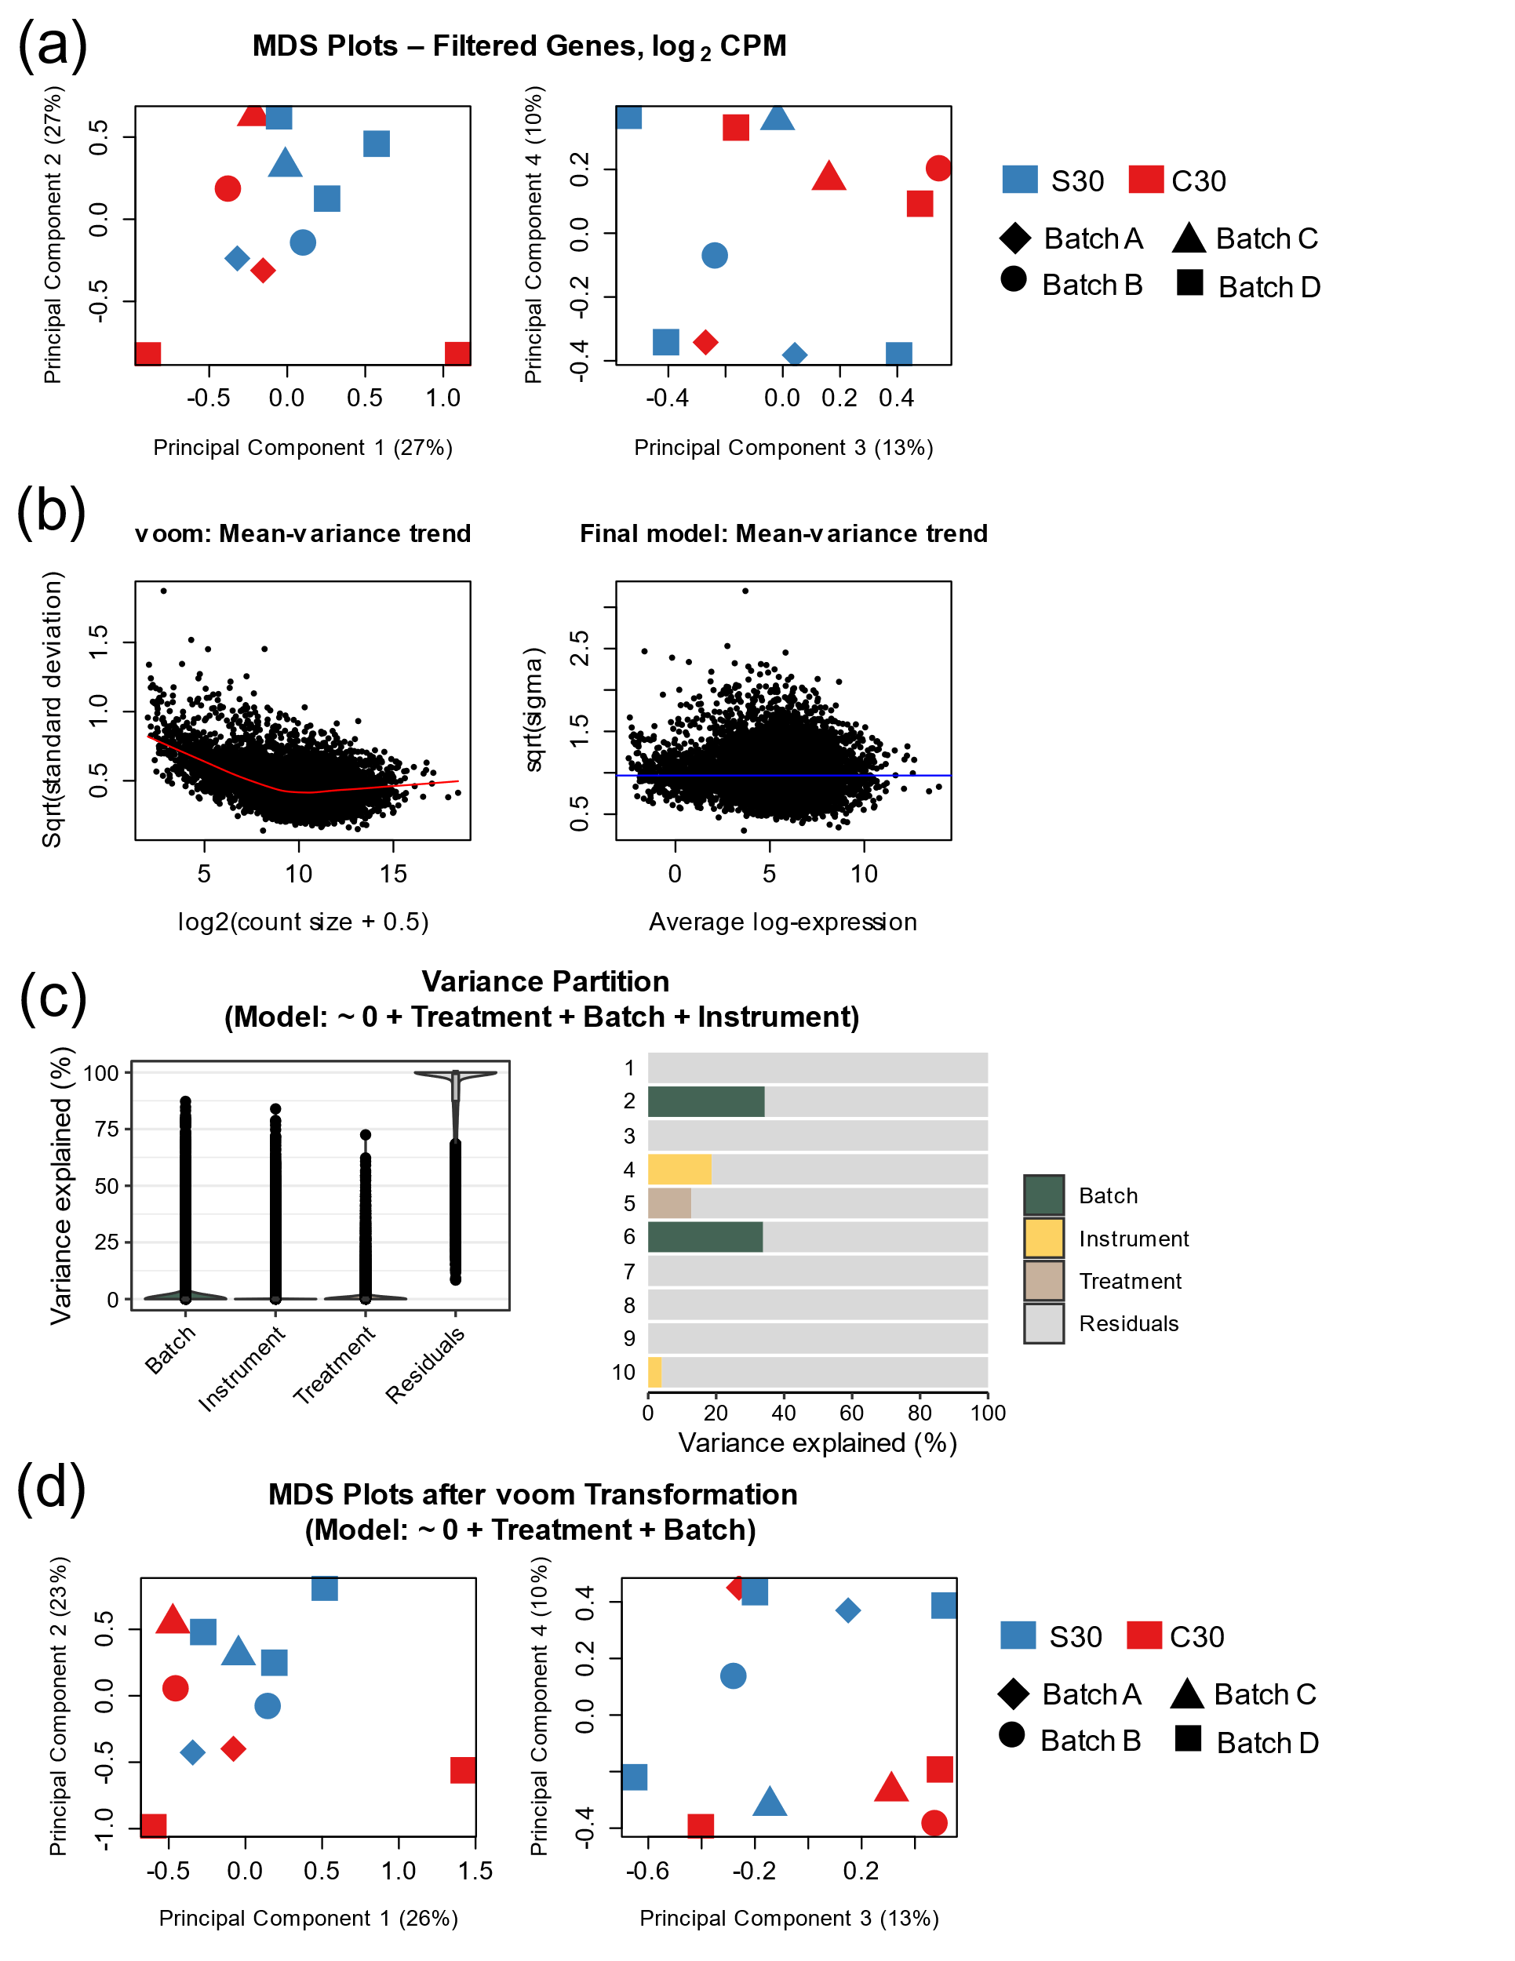

Supplementary Figure S3. RNA-seq processing for Walker S30 vs. C30 dataset. (a, d) Multidimensional scaling (MDS) plots for the top 100 genes with the largest fold change differences between groups before (a) and after (d) voom transformation. Principal components 1 and 2 (left) and 3 and 4 (right) are shown, along with the percentage of variation captured by each component. Blue and red signify the S30 and C30 groups, respectively. Shapes represent different sequencing batches. (b) limma voom was used to apply a linear model to the data, including both Treatment group and Batch, based on plots in (c) which indicate the highest percentage of variance was explained by Batch. (c) Variance partition plots showing the percentage of the gene expression variance explained by the variables sequencing Batch (green), sequencing Instrument (yellow), and Treatment (brown), along with Residuals (gray). Total percentages are shown on the left and are broken down by the first 10 dimensions on the right. Gene expression was measured in CPM with (a, d) and without (b, c) log2 transformation.

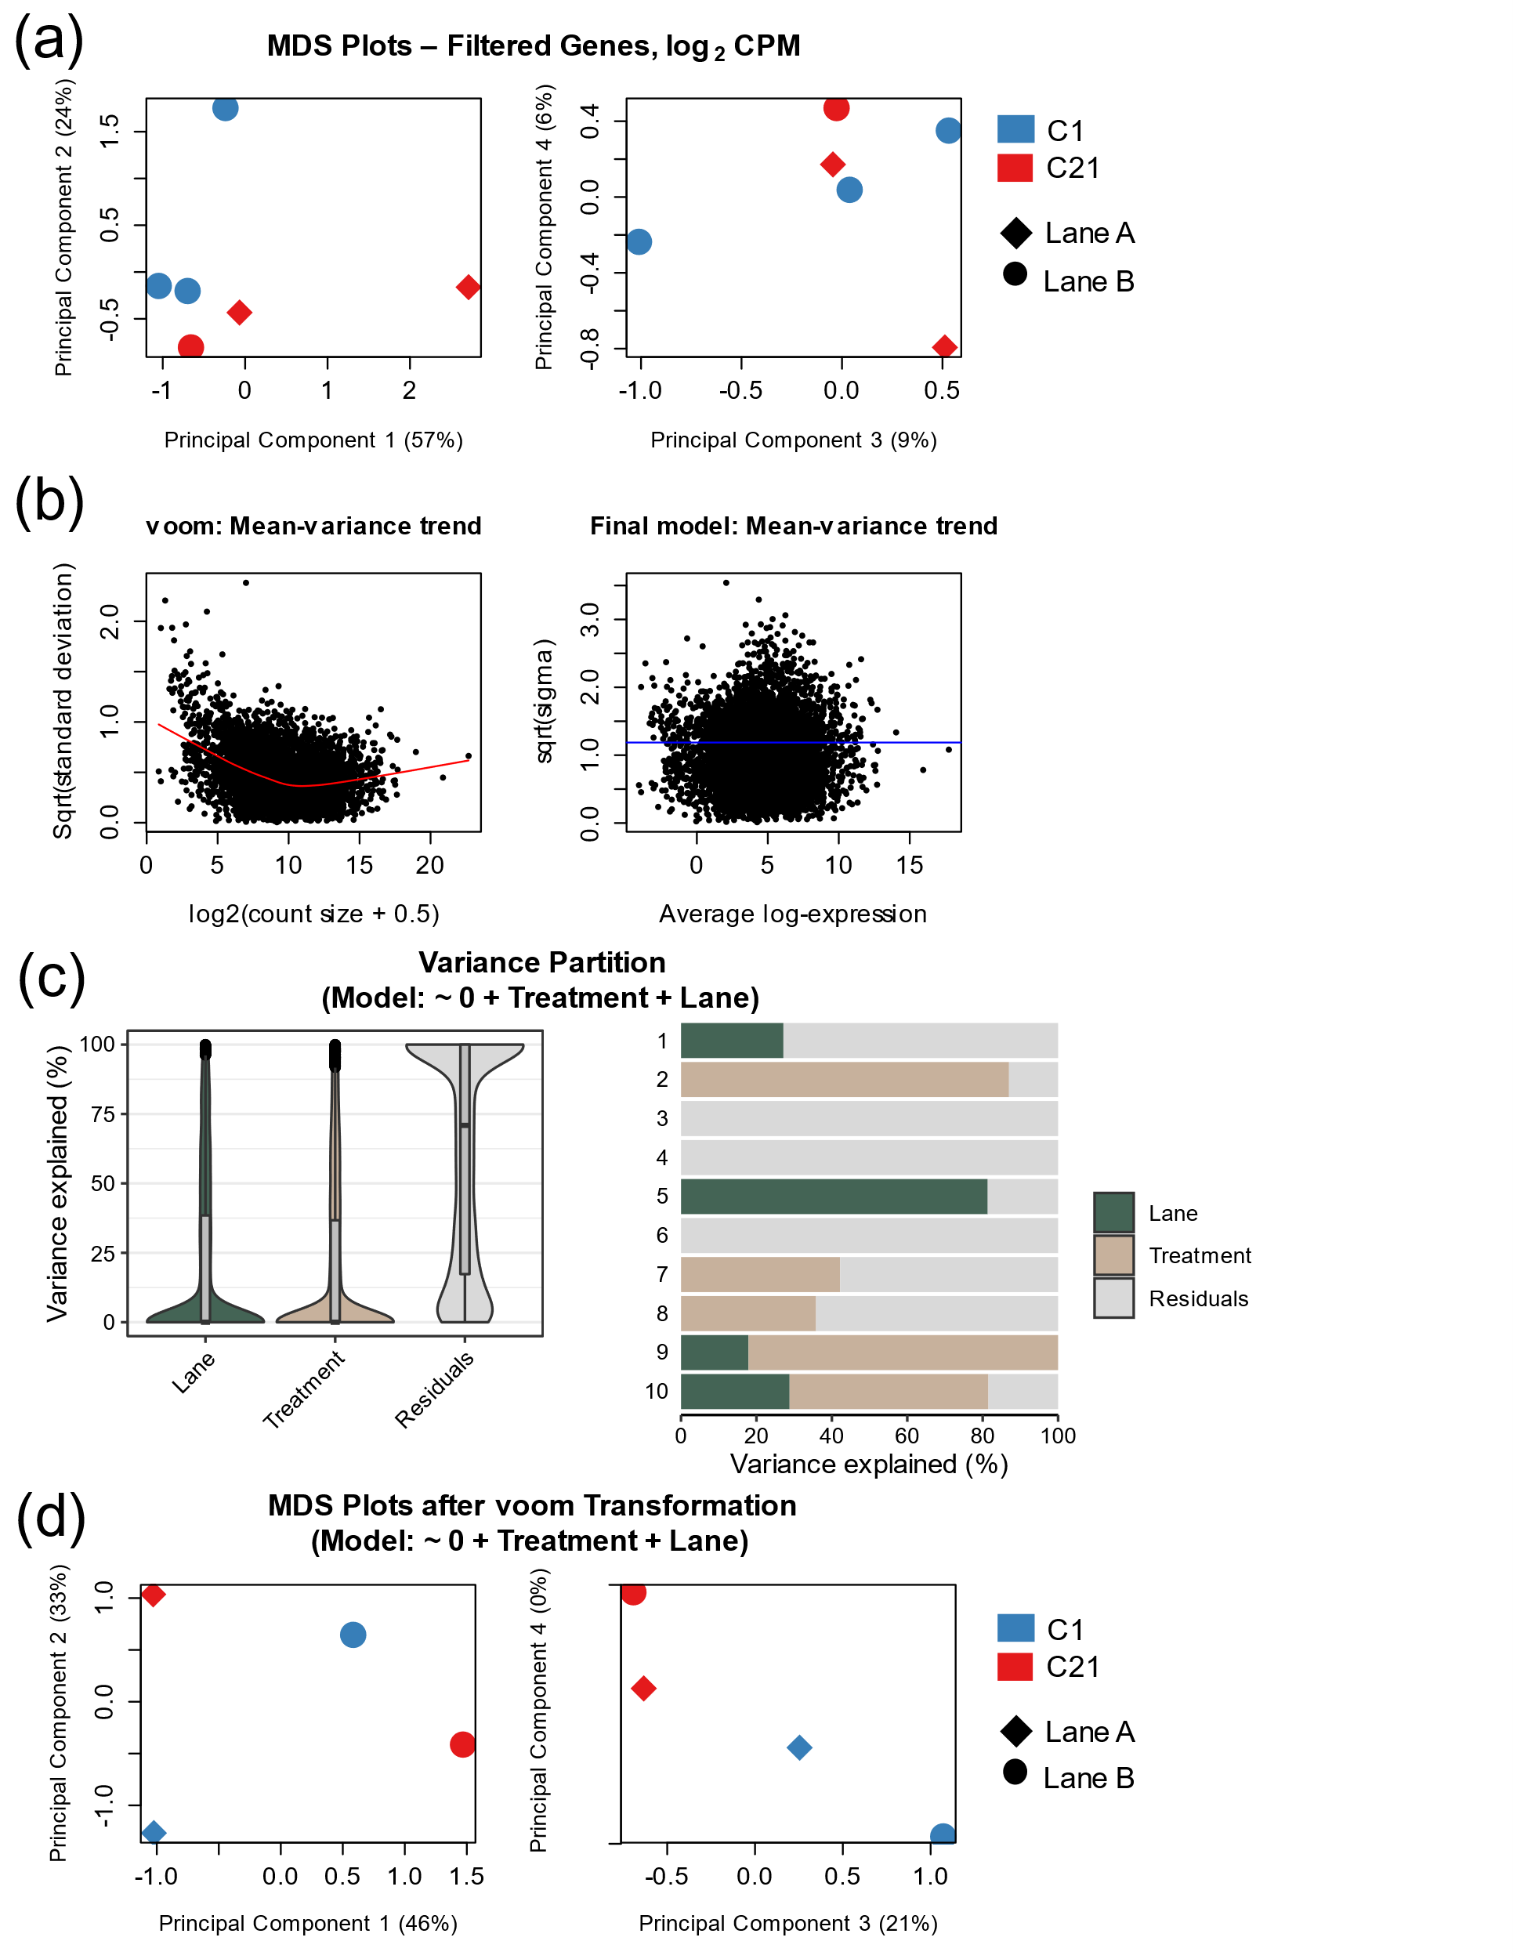

Supplementary Figure S4. RNA-seq processing for Powell C1 vs. C21 dataset. (a, d) Multidimensional scaling (MDS) plots for the top 100 genes with the largest fold change differences between groups before (a) and after (d) voom transformation and removal of 2 outliers. Principal components 1 and 2 (left) and 3 and 4 (right) are shown, along with the percentage of variation captured by each component. Blue and red signify the C1 and C21 groups, respectively. Shapes represent different sequencing lanes. (b) limma voom was used to apply a linear model to the data, including both Treatment group and Lane, based on plots (c) which indicate the highest percentage of variance was explained by Lane. (c) Variance partition plots showing the percentage of the gene expression variance explained by the variables sequencing Lane (green) and Treatment (brown), along with Residuals (gray). Total percentages are shown on the left and are broken down by the first 10 dimensions on the right. Gene expression was measured in CPM with (a, d) and without (b, c) log2 transformation.

Supplementary tables and captions

Supplementary Tables are attached in a separate Excel workbook. The first sheet of the workbook contains the table captions.

