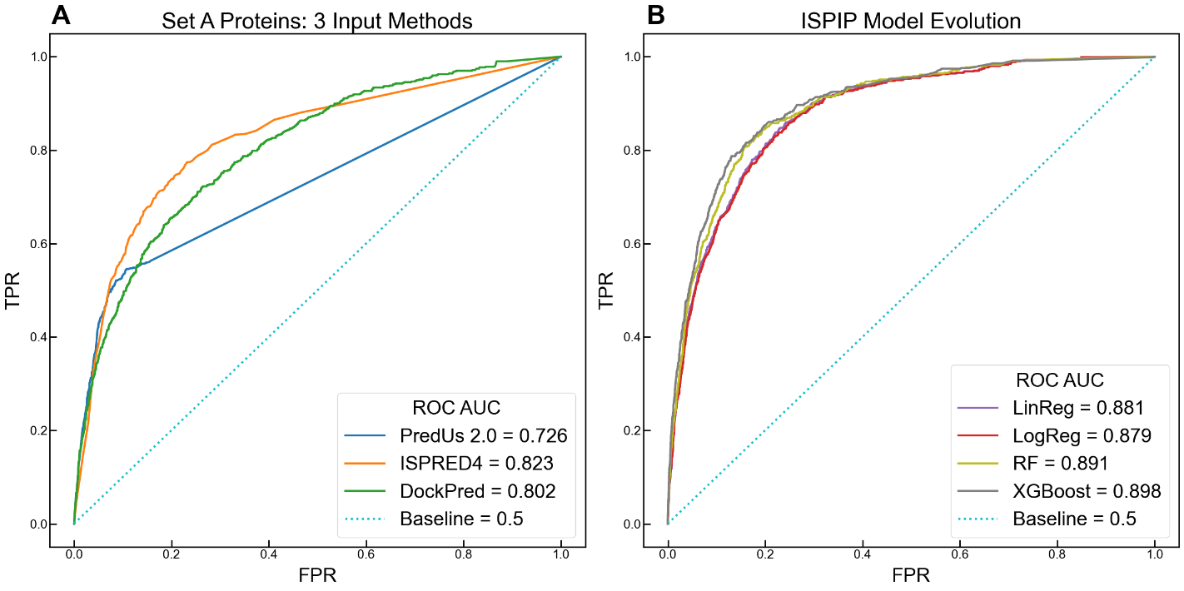
Figure S1. ROC illustrates enhanced ISPIP’s enhanced prediction on Set A proteins: (A) The ROC curves of the 3 input methods indicate that DockPred and ISPRED4 perform better than PredUs 2.0. (B) All the ISPIP models significantly outperform the input predictors, and ROC-AUC is boosted as the model evolves from simple linear regression to more complex ensemble decision tree algorithms.
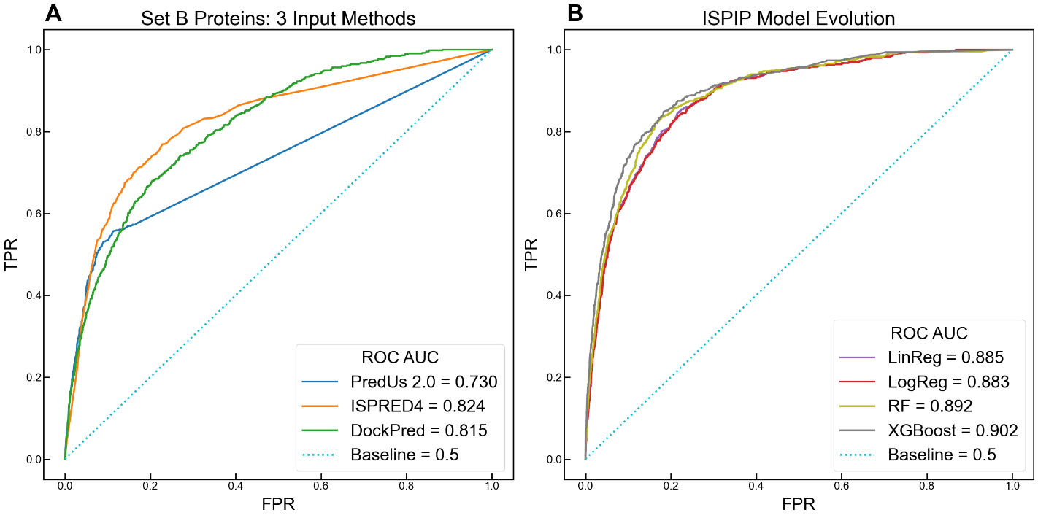
Figure S2. ROC illustrates enhanced ISPIP’s enhanced prediction on Set B proteins: (A, B) Similar to Figure S1, but slightly improved, model improvement was observed for Set B proteins, from which proteins larger than 450 residues were removed.
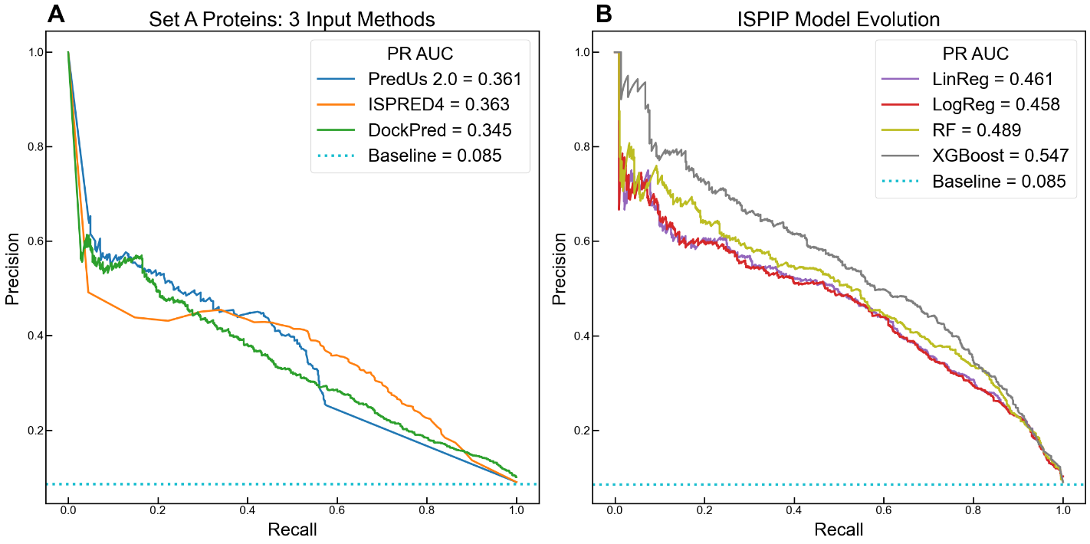
Figure S3. PR illustrates enhanced ISPIP’s enhanced prediction on Set B proteins: (A, B) The model improvement observed for Set A proteins through the PR-AUC (Figure 1) can also be seen for Set B proteins.

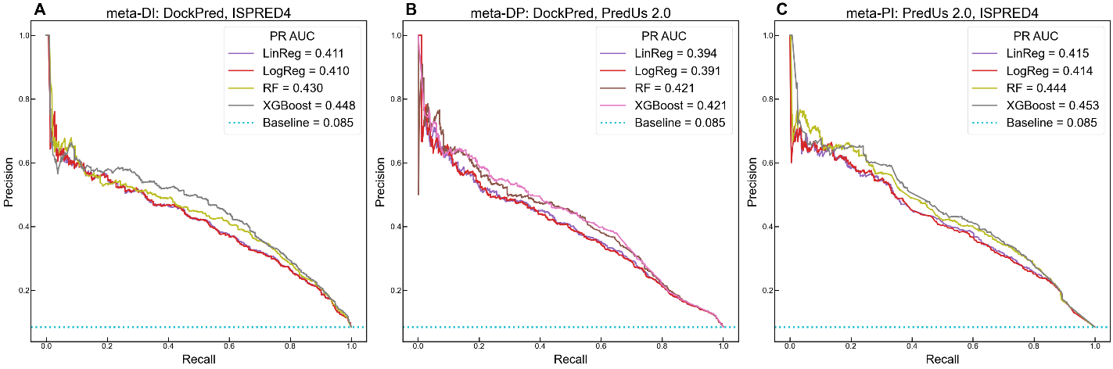
Figure S4. ISPIP models trained only on 2 of the 3 input classifiers: (A) Similar to the complete ISPIP model, the one trained on only DockPred and ISPRED4 showed enhanced performance with increasing model complexity. (B) Method combination yields enhanced prediction, even without being trained on ISPRED4. (C) The model trained on ISPRED4 and PredUs 2.0 performs the best out of the models trained on 2 of the 3 input classifiers.

