Supplementary material

Canna x generalis irrigated with greywater in a nature-based solution
Caroline S. Menezesª, Karen M. Takahashiª, Cláudia G. V. Bacchiª, Liana B. Lima^{b}, Paula L. Paulo^{a*}
ªFaculty of Engineering, Architecture and Urbanism and Geography, Federal University of Mato Grosso do Sul, Cidade Universitária, Campo Grande-MS, 79070-900, Brazil
^{b}Biosciences Institute, Botanic Laboratory, Federal University of Mato Grosso do Sul, Cidade Universitária, Campo Grande-MS, 79070-900, Brazil

Table A1 Concentrations of macronutrients and micronutrients in the leaves of Canna x generalis
Sample |  |  | Macronutrient (g·kg⁻¹) |  |  |  |  |  | Micronutrient (mg·kg⁻¹)
Stage | Subst. | Irrig. water | N | P | K | Ca | Mg | S | Fe | Mn | Zn | Cu | B
1 | - | M | 30.5 | 2.0 | 30.3 | 1.7 | 4.2 | 2.8 | 182.6 | 238.7 | 26.1 | 18.9 | 10.8
1 | S1 | TW+N | 28.7 | 1.4 | 58.8 | 8.3 | 11.2 | 1.5 | 447.7 | 426.1 | 19.0 | 7.1 | 76.0
1 | S1 | LGw+N | 27.3 | 2.4 | 61.3 | 9.8 | 4.3 | 1.8 | 410.7 | 120.3 | 22.2 | 6.5 | 90.1
1 | S1 | LGw | 11.5 | 1.1 | 31.8 | 7.1 | 4.1 | 1.8 | 320.8 | 682.3 | 19.5 | 5.9 | 36.5
1 | S2 | TW+N | 30.0 | 3.6 | 58.8 | 10.5 | 5.0 | 1.4 | 320.8 | 800.0 | 22.4 | 10.0 | 106.0
1 | S2 | LGw+N | 28.3 | 2.4 | 66.3 | 6.0 | 4.4 | 1.7 | 205.8 | 630.1 | 24.3 | 10.6 | 71.2
1 | S2 | LGw | 13.2 | 1.0 | 12.8 | 9.5 | 5.0 | 2.9 | 416.0 | 198.4 | 18.9 | 2.4 | 31.3
2 | - | M | * | 3.1 | 53.5 | 7.9 | 7.3 | 4.4 | 356.9 | 395.0 | 41.0 | 26.0 | *
2 | S1 | TWi | 10.8 | 1.1 | 23.8 | 9.7 | 7.3 | 0.8 | 195.6 | 213.6 | 18.3 | 4.8 | 31.7
2 | S1 | TWo | 10.3 | 3.1 | 31.5 | 10.8 | 4.7 | 0.9 | 82.1 | 440.6 | 24.6 | 81.0 | *
2 | S1 | LGwi | 11.0 | 1.0 | 24.2 | 7.0 | 3.6 | 2.5 | 161.8 | 253.2 | 17.0 | 8.9 | 45.3
2 | S1 | LGwo | * | 2.6 | 27.0 | 6.6 | 4.2 | 1.7 | 195.3 | 2451.0 | 22.8 | 6.7 | *
2 | S2 | TWi | * | 0.5 | 38.0 | 8.6 | 3.7 | 0.6 | 136.8 | 78.1 | 13.4 | 6.2 | *
2 | S2 | TWo | 11.7 | 0.8 | 34.2 | 11.9 | 7.0 | 1.0 | 74.1 | 197.7 | 18.8 | 11.6 | *
2 | S2 | LGwi | - | - | - | - | - | - | - | - | - | - | -
2 | S2 | LGwo | - | - | - | - | - | - | - | - | - | - | -
Abbreviations: M: initial seedling of the plant used in the stage; TW+N: tap water + nutrients; LGw+N: greywater + nutrients: LGw: greywater; TWi: tap water, indoor; TWo: tap water, outdoor; LGwi: greywater, indoor; LGwo: greywater, outdoor; Subst.: substrate; Irrig. water: irrigation water; *: nutrient could not be measured; -: no sample was available.

TW+N
LGw+N
LGw
Substrate 1 (n = 6)
Substrate 2 (n = 6)
Substrate 1 (n = 6)
Substrate 2 (n = 6)
Substrate 1 (n = 6)
Substrate 2 (n = 6)
Substrate 1
Substrate 2
Indoors (LGwi) (n = 3)
Outdoors (LGwo) (n = 3)
Indoors (LGwi) (n = 3)
Outdoors (LGwo) (n = 3)
TW
Substrate 1
Substrate 2
Indoors (TWi) (n = 3)
Outdoors (TWo) (n = 3)
Indoors (TWi) (n = 3)
Outdoors (TWo) (n = 3)
LGw
STAGE 1
STAGE 2
FigA1 Flowchart of the experimental design
Abbreviations: TW+N: tap water + nutrients; LGw+N: greywater + nutrients; LGw: greywater; TW: tap water; LGwi: greywater, indoor; LGwo: greywater, outdoor; n: number of mesocosms.

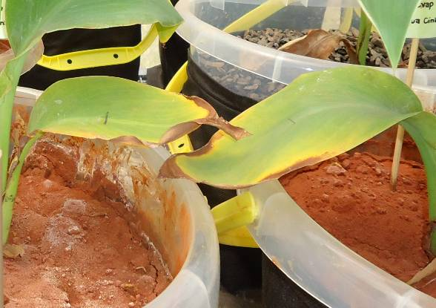
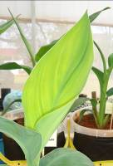
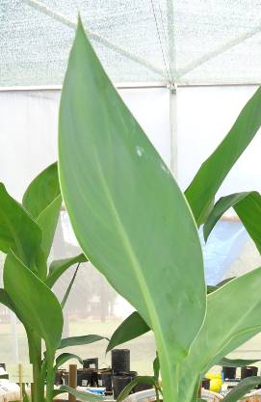
C
B
A

FigA2 (A) Leaf of a plant cultivated with the nutrient solution. Leaves of plants irrigated with greywater without the nutrient solution show symptoms of (B) nitrogen and (C) phosphorus deficiency

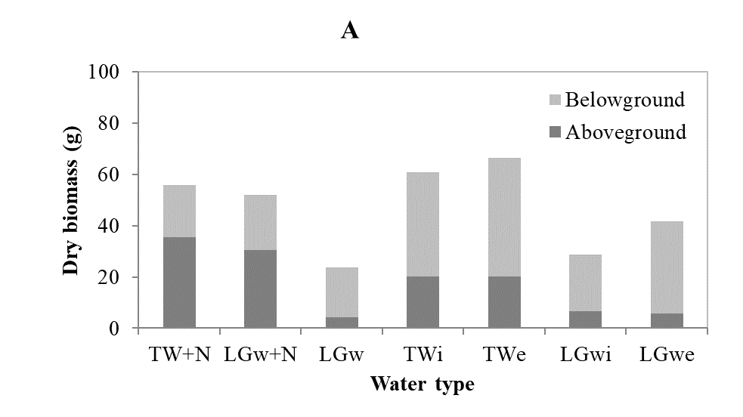
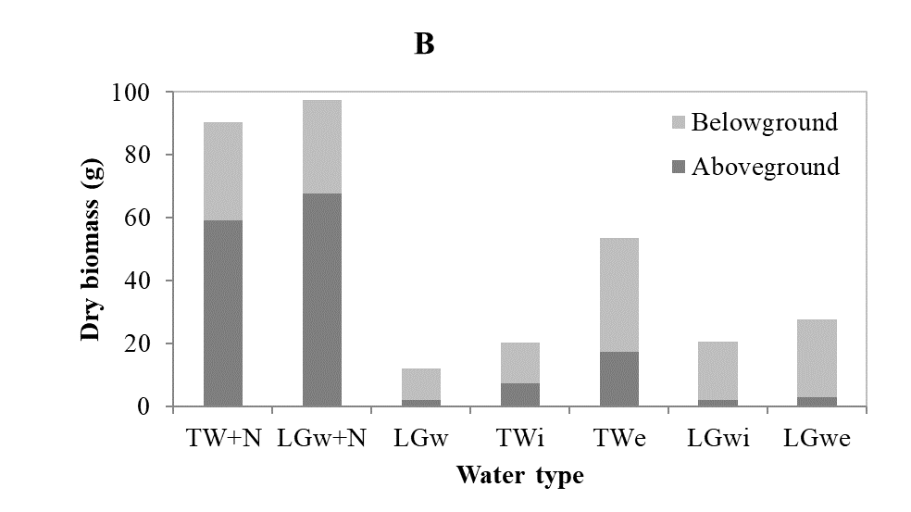
FigA3 Effects of irrigation water type on the aboveground and belowground dry biomass of plants after 80 days of cultivation in (A) substrate 1 (no. 2 gravel + soil) and (B) substrate 2 (fine gravel)

