Supplementary Material for
Photonic machine learning with on-chip diffractive optics
Tingzhao Fu, Yubin Zang, Yuyao Huang, Zhenmin Du, Honghao Huang, Chengyang Hu, Minghua Chen, Sigang Yang, Hongwei Chen*
Beijing National Research Center for Information Science and Technology, Department of Electronic Engineering, Tsinghua University, Beijing, 100084, China
*chenhw@tsinghua.edu.cn
Supplementary note 1: On-chip DONN model
Supplementary note 1.1: On-chip electromagnetic propagation model
On-chip electromagnetic propagation (OEP) model is the first part and prerequisite of the on-chip DONN model. Based on the OEP model, the parameters of on-chip DONN can be obtained by pre-training in advance. We use the OEP model to approximately calculate the propagation of light in a 2.5-dimensional (2.5D) variational finite-difference time-domain (FDTD) solver (Lumerical Mode Solution commercial software), in this way, when light propagates a certain distance in a slab waveguide, the amplitude and phase correction factors $η$ and $Δϕ$ for the modified Huygens-Fresnel principle in Eq. (1) can be determined. Figs. S1c and S1d indicate the amplitude and phase distribution of the input signal waveform after 250 μm propagation in the slab waveguide (thickness is 220nm, width is 300μm) based on the modified OEP model and FDTD, respectively. The calculated results of the two models for the electric field propagation of the same input signal (Figs. S1a and S1b) are highly consistent.
Supplementary Figure 1. a, b The field intensity and phase distribution of the input signal, respectively. c, d The field intensity and phase distribution of the input signal propagating 250 μm later in a slab waveguide, the results are calculated by the modified OEP model Eq. (1) (black line) and 2.5D variational FDTD (red line), respectively.

Supplementary note 1.2: Forward and error backward propagation (FEBP)
The forward propagation process can be expressed by Eq. (S-1):
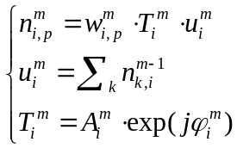 (S-1)
where $i$ represents a neuron of the $m$-th layer, $n_{i}^{m}$ is the output function of the $i$-th neuron, $w_{i}^{m}$ is the function of electromagnetic propagation, $p$ refers to a neuron of the next layer that is connected to neuron $i$ by optical diffraction, $u_{i}^{m}$ is the input wave to the $i$-th neuron of layer $m$, $T_{i}^{m}$ is the transmission coefficient of the $i$-th neuron of layer $m$, $A_{i}^{m}$ and $φ_{i}^{m}$ are the amplitude and phase factors, here $A_{i}^{m}≈1$ ^{[1]}.
The error backward propagation is realized by the gradient descent algorithm. Assuming that the on-chip DONN consists of $M$ layers (excluding the input and output layer), then the loss function $\left(L\right)$ can be defined as Eq. (S-2):
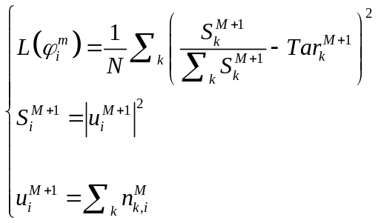 (S-2)
where $L\left(φ_{i}^{m}\right)$ is the loss function, $S_{i}^{M+1}$ is the detecting intensity of the output areas, ${T_{ar}}_{i}^{M+1}$ is the target intensity of the output areas, $N$ refers to the number of measurement points at the output detected area. Therefore, the problem of the optimization for an on-chip DONN can be summarized as $minL\left(φ_{i}^{m}\right)$, $0<φ_{i}^{m}≤2π$. The gradient calculation formula of the loss function is depicted in Eq. (S-3):
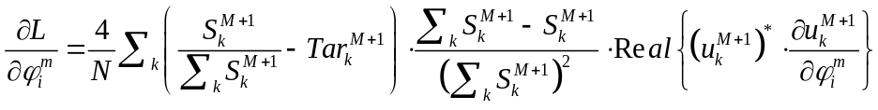 (S-3)
where $u_{k}^{M+1}$ quantifies the gradient of the complex-valued optical field at the output layer with respect to the phase values of the neuron in the previous layers, $m≤M$. Furtherly, In Eq. (S-3), $\frac{∂u_{k}^{M+1}}{∂φ_{i}^{m}}$ can be calculated by Eq. (S-4):
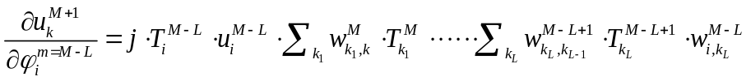 (S-4),
where, $3≤L≤M-1.$ So far, the parameters of an on-chip DONN can be obtained through continuous optimization in the training process by the gradient descent algorithm. The forward and error backward propagation can also refer to previous works ^{[1,2]}.

Supplementary note 1.3: Neuron-mapping process
Based on the OEP model and FEBP process, all parameters of on-chip DONN can be obtained. Subsequently, it is significantly important to accurately map the pre-trained parameters onto physical structures. In particular, the neuron-mapping process is the most critical and challenging. In this study, silicon-based slots are used to realize the pre-trained phase values of neurons. According to the effective medium theory (EMT) and FDTD simulation, the effective refractive index (ERI) of the slots under different widths can be calculated ^{[1,3]}. Here, the thickness of the slots is 220 nm, the lattice constant (the center distance between two adjacent slots) of the slots is fixed as 500 nm, and the width of the slot is set as 200 nm by considering the practical fabrication conditions. Therefore, the ERI of the slot is calculated as 2.166 by Eq. (2), which is listed here again, as shown in Eq. (S-5).
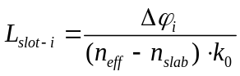 (S-5)
where $L_{slot-i}$ is the length of the slots in the $i$-th group, $n_{eff}$ is the ERI of the slot group through which light passes, $n_{slab}$ is the ERI of the slab waveguide, $k_{0}={2π}/λ$ is the wave number of light propagating in vacuum, $∆φ_{i}$ is the phase delay generated by the $i$-th slot group. According to Eq. (S-5), the length of each slot can be calculated by the pre-trained phase value $∆φ_{i}$. Thus, the $n_{eff}$ substituted in Eq. (S-5) should be a fixed value during the pre-training process. However, there is mutual interference between adjacent slots ^{[1]}. When the pre-trained neuron values after mapping onto the physical structures, the $n_{eff}$ realized by the physical structure unit is different from that in the pre-training stage and varies with the change of slot length, which seriously affects the neuron-mapping process. To reduce the impacts of mutual interference between adjacent slots during the neuron-mapping process, a silicon slot group composed of multiple identical slots is used to approximate a phase value of a neuron. The $n_{eff}$ calculated by the phase delay generated by the silicon slot group with a different number of slots is shown in Fig. S2a. It is evident that when the number of orange-yellow slots increases, the ERI (the red triangle) calculated by the phase delay generated by the slot groups tends to be a stable value. In addition, the distance between the input light and the hidden layer (HL) will also affect the accuracy of the neuron-mapping process. As shown in Fig. S2b, when the incident light propagates to the HL for 30 µm, the calculation result of the ERI of the identical slot by FDTD is different. When the distance between the input light and the HL increases to 250 μm, the value of the ERI tends to be stable. When the distance further increases to 450 μm, the overall change of the ERI of the slot is smaller. Therefore, by a comprehensive consideration, the distance between the input light and the first HL and the distance between adjacent HLs are set to 250 µm in this study. The relevant contents can also refer to the previous work ^{[1]}.

Supplementary Figure 2. a Calculation of the ERI under a different number of identical slots in a silicon slot group. The incident light source is flat light, and the center distance of the adjacent slots is 500 nm, the width of the slots is 200 nm, the thickness is 220 nm, and the length is 1.964 μm. The length of 1.964 μm is randomly generated. b The incident light source is a point light, and the distance between the light source and the HL is 30 µm, 250 µm, and 450 µm, respectively. Among them, the HL consists of 100 identical slots, numbered from 1 to 100. The dots are the ERI values calculated by the phase delay $∆φ_{i}$ generated by the light passing through the slot of the corresponding sequence number. $n_{eff0}$ is the ERI in the pre-training process, the period of the slots is 500 nm, the width of the slots is 200 nm, the thickness is 220 nm, and the length is 2 μm.

Supplementary note 2: Numerical calculation
After the super parameters of on-chip DONNs are determined, the phase values of neurons or other key parameters can be obtained through computer pre-training based on the on-chip DONN model. Supplementary Table 1 indicates the prediction accuracy of the on-chip DONNs, it is evident that with the increase in the number of HLs ($m$ means the number of HLs in the on-chip DONN), the prediction accuracy has not been significantly improved. Therefore, in the process of network design, it is necessary to comprehensively consider the performance of the network, the energy efficiency, and the integration of the chip. Figs. S3a and S3b are the convergence process of the loss function in the training process of on-chip DONN-1 and DONN-3. With the increase of training iterations, the loss curve gradually tends to be stable and converge. Figs. S3c and S3d show the confusion matrixes of testing results of on-chip DONN-1 and DONN-3 in the Iris plants dataset, respectively. In this design, there are 186 neurons on each HL, and their phase values are shown in the form of pixels in Fig. S4. The linear arrangement phase values of each HL are recombined and given in the form of a 6×31 matrix.

Supplementary Table 1 | The prediction accuracy of various DONNs
DONN with m hidden layers (DONN-m) | Accuracy
On-chip DONN-1 | 86.7%
On-chip DONN-2 | 86.7%
On-chip DONN-3 | 90%
On-chip DONN-4 | 90%
On-chip DONN-5 | 90%

Supplementary Figure 3. a, b The loss curves of numerical calculations on the training set of the on-chip DONN-1 and DONN-3, respectively. c, d The confusion matrixes for the chosen 30 samples from the Iris plants dataset of the on-chip DONN-1 and DONN-3, respectively. Meanwhile, the labels in the abscissa and ordinate represent the species of the Iris flower, in which “1” represents “Setosa,” “2” represents “Versicolor,” and “3” represents “Virginia,” respectively.

Supplementary Figure 4. The linear phase profile of each hidden layer is converted to a 6×31 pixelated image. a The phase profile of the on-chip DONN-1 hidden layer after training. b, c and d The phase profiles of the on-chip DONN-3 hidden layers after training. Meanwhile, each rectangular pixel in the figure represents a pre-trained phase value of a neuron.

Supplementary note 3: Numerical analysis of phase errors
Specific phase values of neurons can be pre-trained and obtained in advance, and then the physical connection of these phase values on hardware can be realized through physical structures. However, inevitable errors would be generated in the fabrication process. Eq. (S-6) is the transfer matrix of the on-chip DONNs. Here, we assume that the error factor is $δ=\left(δ_{1}, δ_{2},⋅⋅⋅,δ_{m}\right)$, whose values are ranging from 0 to 1. The phase value ${ Phase}^{err}$ including machining errors is the product of the original phase value ${ Phase}^{cal}$ and the error factors, as shown in Eq. (S-8). (S-7) and (S-9) are the diagonal matrixes before and after the fabrication errors are introduced, respectively.

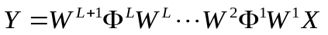 (S-6)

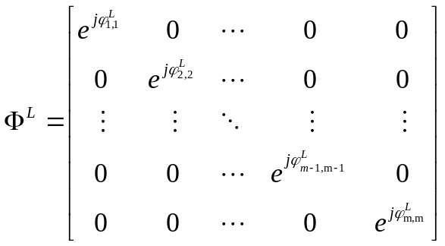 (S-7)

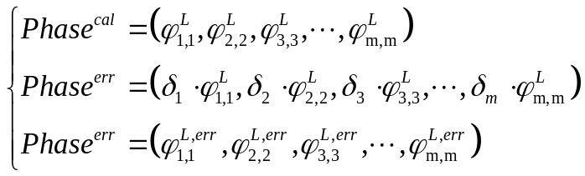 (S-8)

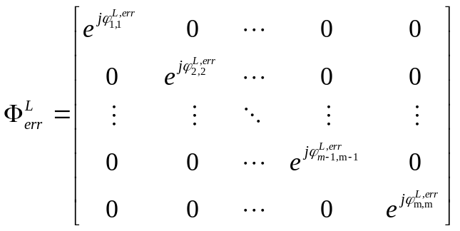 (S-9)
where $X$ is the input signals, $Y$ is the output results, $W$ is the diffractive connection matrix, ${Phase}^{cal}$ is the pre-trained parameters, $δ$ is the error factor generated by the fabrication, ${Phase}^{err}$ is the product of ${Phase}^{cal}$ and $δ$, $Φ^{L}$ and $Φ_{err}^{L}$ are diagonal matrices.

Supplementary note 4: On-chip DONN-system: fabrication and measurement
Supplementary note 4.1: Device fabrication
To experimentally evaluate the performance of the proposal on-chip DONNs, on-chip DONN-1 and DONN-3 were fabricated. For example, Fig. S5 shows the micrograph of Chip-3, which contains the on-chip DONN-3 with three HLs. The input signals are loaded by two cascaded $1×2$ Multimode interferometers (MMI) and four phase shifters. In this design, the thickness and width of the single-mode waveguide are 220 nm and 450 nm, and the footprint of the on-chip DONN-1 and DONN-3 are about 0.3 $×$ 0.5 mm² and 0.3 $×$ 1.0 mm², respectively. Fig. S6 is a picture of the chip after packaging.

Supplementary Figure 5. a The micrograph of Chip-3. The signal is loaded onto the waveguide through the input grating coupler (IGC) and then is divided into four channels by two cascaded $1×2$ MMIs. The input phase information is loaded by a thermo-optical phase shifter on each waveguide. After the signal is loaded onto the phase of light, it passes through three HLs (metasurfaces) and enters the output waveguide at the output interface. Finally, it is captured by the optical power meter via the output grating couplers (OGC). AS is the power attenuation structure, which is to prevent the negative impacts of light reflection in the non-detection area of the output interface. b Close-up of the HL, in which a silicon slot group consists of three identical slots to map the phase values onto physical structures.
Supplementary Figure 6. a The close-up view of chip wiring and packaging. b The diagram after packaging of the on-chip DONN. A protection device is adopted to the encapsulated chip, and the positions of the input and output optical fibers are fixed, which is convenient for the follow-up experimental works.

Supplementary Figure 7. a Experimentally obtained phase modulation curve as a function of the applied voltage. b The experimental testing procedure. c The experimental devices. d The close-up of the chip after packaging.

Supplementary note 4.2: Experimental demonstration
For the Iris plants dataset, each sample has four features, namely calyx length, calyx width, petal length, and petal width. The category of Iris flower species can be identified through these features. In this experiment, the signal is loaded via thermo-optical modulators. The relationship between the voltage and phase curve is shown in Fig. S7a. The experimental testing flow chart for predicting the classification tasks is shown in Fig. S7b. Fig. S7c shows the experimental devices. In addition, due to the fabrication errors, the testing accuracies of the Iris plants dataset of on-chip DONN-1 and DONN-3 are 56.7% and 60%, respectively, without introducing the algorithm compensation in experiments; When the algorithm compensation is introduced into the experiments, the testing accuracies of on-chip DONN-1 is improved to 86.7%, and DONN-3 is improved to 90%. Fig. S8 shows the experimental testing results before and after introducing the algorithm compensation.

Supplementary Figure 8. a, b The experimental testing results of the on-chip DONN-1, in which the red dot represents “Setosa,” the blue dot represents “Versicolor,” and the purple dot represents “Virginia.” In addition, the correct prediction result of serial numbers 1-10 should be “Setosa,” in other words, the power value corresponding to the red dot should be the maximum. The correct prediction result of serial numbers 11-20 should be “Versicolor,” which means that the power value corresponding to the blue dot should be the largest. The correct prediction result of serial numbers 21-30 should be “Virginia,” at this time, the power value corresponding to the purple dot should be the largest. For example, in Fig. S8a, the power value of the red dot for the No. 5 test sample is the largest, so the prediction is correct; while the power of the blue dot for the No. 15 testing sample should be the largest, but the power of the red dot is the largest at this time, so the prediction is incorrect. c, d The testing results of the on-chip DONN-3, and the data analysis is the same as a and b. The intensity is normalized according to the specific sample.

Supplementary note 5: Compensation analysis of DONN errors
Here is a specific example for the compensation analysis of on-chip DONN errors, Fig. S9a is a 1-hidden-layer DONN. Fig. S9b is the logic diagram of Fig. S9a, and Fig. S9c is the equivalent logic diagram after introducing the experimental compensation algorithm. The mathematical calculation process of Fig. S9a is expressed by Eq. (S-10). When the inevitable errors are brought by the fabrication process, the mathematical calculation process is expressed by Eq. (S-11). To reduce the impacts of machining errors on the performance of on-chip DONNs, two steps are adopted to reduce the negative influences caused by the machining errors. First, the phase compensation is introduced in the signal loading stage, meanwhile, the compensated phases of $\left(φ_{11},φ_{22},φ_{33},φ_{44}\right)$ are generated by the voltages of $\left(∆V_{1},∆V_{2},∆V_{3},∆V_{4}\right)$ according to Fig. S7a. Then, in the signal detection stage, the output power of different ports is multiplied by a power compensation factor, which refers to Fig. S9c for the specific process. Among them, the phase compensation process in the first stage is depicted by Eq. (S-12). The power detection process is depicted by Eq. (S-13), and the power compensation stage is expressed by Eq. (S-14).
Supplementary Figure 9. a is three-layer DONN with one hidden layer. b is a logic diagram of Fig. S10a. c is the equivalent logic diagram of Fig. S10b after introducing the experimental compensation algorithm.

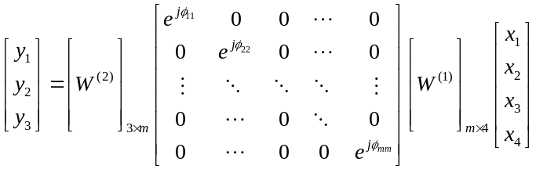 (S-10)
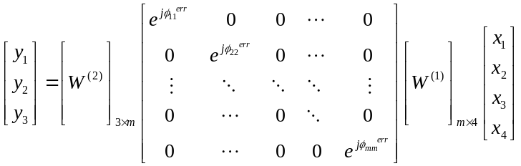 (S-11)
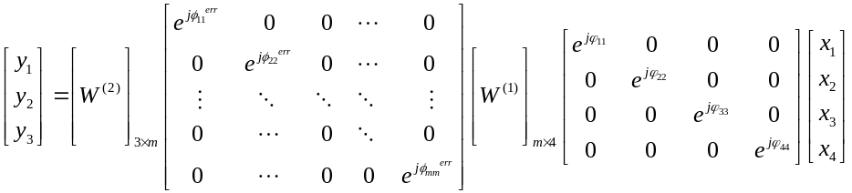(S-12)
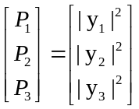 (S-13)
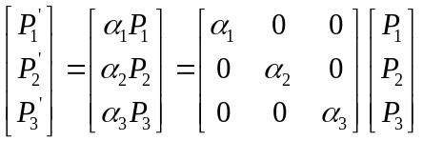 (S-14)

Supplementary note 6: Algorithm compensation
To compensate for the fabrication errors, an algorithm compensation method includes phase compensation, and power compensation is used to reduce the negative impacts of the introduced errors. Here, the input signals were applied to the phases of light through the input voltages, and the phase modulation curve is shown in Fig. S7a.

Supplementary note 6.1: Parameters of the algorithm compensation process
$X_{0}$: Original voltage configurations of the input signals (without compensation);
$X$: Compensation voltage for optimization (Particles’ positions);
$X_{min}$: Minimum compensation voltage;
$X_{max}$: Maximum compensation voltage;
$V$: Updating speed of $X$ (Particles’ velocities);
$V_{min}$: Minimum updating speed of $X$ for optimization;
$V_{max}$: Maximum updating speed of $X$ for optimization;
$T$: True labels;
$Y$: Chip’s outputs;
$Chip\left(∙\right)$: Chip’s forward calculation;
$Max_iteration$: Maximum number of iterations;
$E$: Targeted average loss;
$N_{p}$: Number of particles;
$N_{s}$: Number of samples in training process;
$i$: Iteration index;
$j$: Particle index;
$k$: Sample index;
$α$: Power compensation factor for optimization;
$p$: Searching index of power compensation factor;
$Δα$: Searching step of power compensation factor;
$α_{num}$: The total number of the searching index;
$Loss\left(∙\right)$: Loss function of the calculation process between $Y$ and$T$;
$Ncc\left(∙\right)$: Counting when the outputs $Y$ classify correctly with respect to $T$;
$L_{s}$: Single loss for each sample;
$L_{pavg}$: Average loss for each particle;
$N_{c}$: The total number of samples which were classified correctly;
$A_{cavg}$: Accuracy after power compensation;
$P_{best}$: The best performance for the particles through training;
$G_{best}$: The best performance for the whole particle group through training;
$L_{Gbest}$: The average loss of $G_{best}$ configurations;
$Sort(∙)$: Picking the best configurations from the samples;
$Find\left(∙\right)$: Finding the corresponding voltage compensation configurations with respect to the power compensations.
$Generate\left(∙\right)$: Generating the $V$ in the next iteration for particles.

Supplementary note 6.2: Pseudo code of the optimization process
Error compensation is an optimization problem, which aims to minimize the impact of fabrication errors on the performance of the system. The optimization problem is described mathematically as Eq. (S-15).
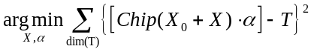 (S-15)
To find the minimum value of the optimization object function above, two steps are required:
Step 1. Compensations on voltages by fixing $α$=1 to make the loss function which is described as Eq. (S-16) to be converged, the compensation in this stage is called phase compensation.
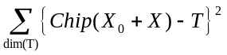 (S-16)
In this compensation, the optimized best voltage compensation configurations in each iteration will become the candidates for the power compensation in the next step.
Step 2. Compensation on power by fixing the best voltage compensation configurations in each iteration of the previous, $\left({∆V}_{1},{∆V}_{2},{∆V}_{3},{∆V}_{4}\right)$, and then finding a set of optimal power compensation factors $\left(α_{1},α_{2},α_{3}\right)$ by the traversal search method to further increase the accuracy of classification.

Before the algorithm starts, several determinations are required as:
① Determine $X_{max}$, $X_{min}$, $V_{max}$, $V_{min}$, $Max_iteration$, $N_{p}$, etc.;
② Randomly generate $X$ for each particle;
③ Set $P_{best}$, $G_{best}$, $L_{Gbest}$ and $α_{best}$ to be the positive infinity.

Then, start the training process: [$X_{best}$, $α_{best}$] = Function training ($X_{0}$, $T$).

while ($i<=Max_iteration$ and $L_{Gbest}<=E$):
for ($j=1$; $j<=N_{p}$; j++):
$L=0$;
for ($k=1$; $k<=N_{s}$;$k++$):
$Y=Chip (X_{0}(k)+X(i,j))$;
$L=L+Loss(Y, T(k))$;
end
$L_{pavg}(i, j)=L/N_{s}$;
$if L_{pavg}(i, j)<P_{best}(j)$:
$P_{best}(j)$ = $L_{pavg}(i, j)$;
end
if $Sort(P_{best})<G_{best}(i)$:
$G_{best}(i)$ = $Sort(P_{best})$;
end
$V=Generate (V, X, P_{best}, G_{best})$;
$X=X+V$;
$i=i+1$;
end
for$\left(i=1;i<length\left(G_{best}\right);i++\right)$
for$\left(p=1;p<α_{num};p++\right)$
$N_{c}=0$;
for$\left(k=1;k<N_{s};k++\right)$
$Y=Chip\left(X_{0}\left(k\right)+X_{Gbest}\left(i\right)\right)∙α\left(p\right)$;
$N_{c}= N_{c}+N_{cc}\left(Y,T\left(k\right)\right)$;
end
$A_{cavg}\left(i,p\right)={A_{c}}/{N_{s}}$;
end
end
$α_{best}=Sort\left(A_{cavg}\right)$;
$X_{best}=Find\left(α_{best}\right)$;
Validating performances using $X_{best}$ and $α_{best}$ on testing set.
return $X_{best}$ and $α_{best}$

Supplementary note 6.3: Optimization flow chart
Supplementary Figure 10. The flow chart of algorithm compensation process.

Supplementary note 6.4: Brief introduction of the compensation algorithm
We propose an algorithm compensation method including two-stage of phase compensation and power compensation. Through training, optimized voltage values in the phase compensation stage are notated as X, and power compensation factors in the power compensation stage are noted as $α$. Therefore, the optimization objective function of this optimization problem can be expressed as Eq. (S-15).
In the phase compensation stage, the aim is to find the minimum value of loss function in Eq. (S-16). Meanwhile, the $X_{0}$ represents the original voltage configurations, the operator $dim()$ means taking the number of dimensions of the vector, and T should be the one-hot vector of the original labels from the dataset. This training stage is based on particle swarm optimization (PSO). From the very beginning of the algorithm, parameters regarding iterations such as the maximum iteration numbers and the minimum values of the loss function are needed to be set. Then, configurations related to particles such as the ranging boundary of voltages (particles’ positions), and the boundary of the updating speed (particles’ velocities), should be determined. Other parameters related to the compensation algorithm should also be set. Then this algorithm will randomly generate the group of compensation voltage configurations particle by particle. Afterwards, the algorithm will run into iterations to find the best $X$ which can obtain the lowest value of the loss function.
As can be vividly seen from Fig. S10, before the beginning of the $i$-th iteration, the compensation voltage configurations for each particle are generated based on the best particle performance and other statistical features extracted from all particles in the ($i$-1)-th iteration. The footnote $j$ represents the particle’s index. If$i$ is lower than the maximum iteration number or the loss value of ($i$-1)-th iteration is larger than the minimum loss value, the algorithm will operate into the $i$-th iteration. Otherwise, the whole iteration will expire.
In the i-th iteration, performances of different particles’ compensation voltage configurations on different samples from the training dataset are needed to be recorded. For each compensation voltage configuration of one particle, PC will add the $X$ into the original voltage of each sample from the training dataset. Then, these modified voltages will be sent onto the phase-shifter via the I/O module and the driver (Fig. S7). The intensities of the output channels $Y$ without power compensation are transmitted back to the PC to calculate the loss values for each sample.
If voltages of all samples are sent, then the algorithm runs into the evaluation of particles’ performances. For each particle, the average loss can be computed by averaging the single loss value for each sample. After all particles’ performances are evaluated, the best performance can thus be obtained from the best performance of each particle for the lowest loss. The corresponding value is called the group best. The iteration will be executed and all results and voltage configurations will be recorded in each iteration until either iteration’s index exceeds the maximum value or the loss value is lower than the targeted value. The recorded group best configurations in each iteration will participate in the power compensation stage.
In the power compensation stage, power compensation factors are adopted via the traversal method to further increase the classification accuracy. By pre-determining both maximum and minimum power compensation factor’s boundary with searching steps, one can record the accuracies with respect to different power compensation factors and voltage configurations from each iteration’s $G_{best}$ in the phase compensation stage, and the best power compensation factor can be found according to the maximum accuracy.
In the end, this algorithm compensation method can find the best $X$ and $α$ for the minimum value of the target function and achieve the best prediction accuracy. Additionally, other algorithms can also be considered for experimental error compensation, such as the compensation algorithms used in the previous works ^{[4,5]}.

Supplementary note 7: On-chip DONN computational speed and power consumption
Supplementary note 7.1: Computation speed
Assuming that an on-chip DONN system has $N$ nodes and a 100 GHz data detection rate, the system includes $m$ layers, while each layer contains an $N×N$ weighting matrix, the number of floating-point operations per second (FLOPS) can be evaluated by the Eq. (S-17) ^{[6]}. Taking the on-chip DONN-3 we have already fabricated as an example, here $m=3$, $N=186$, therefore the computing speed of the DONN-3 can reach $2.08×{10}^{16}$ FLOPS.
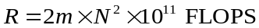 (S-17)
For computational speed, in addition to a large number of operations per second, the latency required to complete a single task is also critical. For the latency of on-chip DONNs, it is defined as the overall time between the start of the signal loading and the detection of the output, in other words, the process does not include input signal loading time and output detection time ^{[1,7]}. In our on-chip DONN, the latency can be calculated by Eq. (S-18):
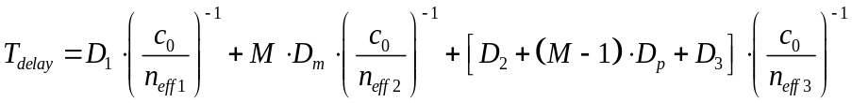 (S-18)
where $D_{1}$ is the distance from the narrow waveguide to the slab waveguide; $c_{0}$ is the vacuum light speed, $n_{eff1}$ is the ERI of the narrow waveguide; $M$ is the total number of the hidden layers; $D_{m}$ is the length of the longest slot in the all hidden layers; $n_{eff2}$ is the ERI of the silicon slots; $D_{2}$ is the distance from the start of the slab waveguide to the first hidden layer; $D_{p}$ is the propagation distance between the hidden layers;$D_{3}$ is the propagation distance between the last hidden layer and the output layer; $n_{eff3}$ is the ERI of the slab waveguide. As an example, for our designed Chip-3, $n_{eff1}=2.33$, $n_{eff2}=2.166$, $n_{eff3}=2.84$, the latency is approximately 27.56ps. The relevant parameters in Equation (S-18) have been annotated in the chip micrograph as shown in Fig. S11.

Supplementary Figure 11. The micrograph of Chip-3. The relevant parameters in Eq. (S-18) are marked in the figure.

Supplementary note 7.2: Power consumption
The input power of the laser under 1.55 μm is 10 mW. The input signals are loaded by the thermo-optic phase shifters, and the average energy required to set each phase shifter a 2π rad is around 30 mW. In addition to the light source, the signal loading, and the output detection, the calculation process of the computing part in our proposed on-chip DONN is fully passive, so the system does not need to consume extra energy in processing the inference tasks. To reduce the power consumption of the phase shifters, one could use doped side heaters ^{[8,9]} or liquid-crystal-based phase shifters ^{[10]}.

1. Fu, T.Z. et al. On-chip photonic diffractive optical neural network based on a spatial domain electromagnetic propagation model. Optics Express 29, 31924-31940 (2021).
2. Lin, X. et al. All-optical machine learning using diffractive deep neural networks. Science 361, 1004-+ (2018).
3. Wang, Z. et al. On-chip wavefront shaping with dielectric metasurface. Nature Communications 10(2019).
4. Zhou, T.K. et al. Large-scale neuromorphic optoelectronic computing with a reconfigurable diffractive processing unit. Nature Photonics 15, 367-373 (2021).
5. Bandyopadhyay, S. et al. Hardware error correction for programmable photonics. Optica 8, 1247-1255 (2021).
6. Shen, Y.C. et al. Deep learning with coherent nanophotonic circuits. Nature Photonics 11, 441-+ (2017).
7. Zarei, S. et al. Integrated photonic neural network based on silicon metalines. Optics Express 28, 36668-36684 (2020).
8. Absil, P.P. et al. Silicon photonics integrated circuits: a manufacturing platform for high density, low power optical I/O’s. Optics express 23, 9369-9378 (2015).
9. Masood, A. et al. Comparison of heater architectures for thermal control of silicon photonic circuits. in 10th International Conference on Group IV Photonics 83-84 (IEEE, 2013).
10. Xing, Y. et al. Digitally controlled phase shifter using an SOI slot waveguide with liquid crystal infiltration. IEEE Photonics Technology Letters 27, 1269-1272 (2015).

