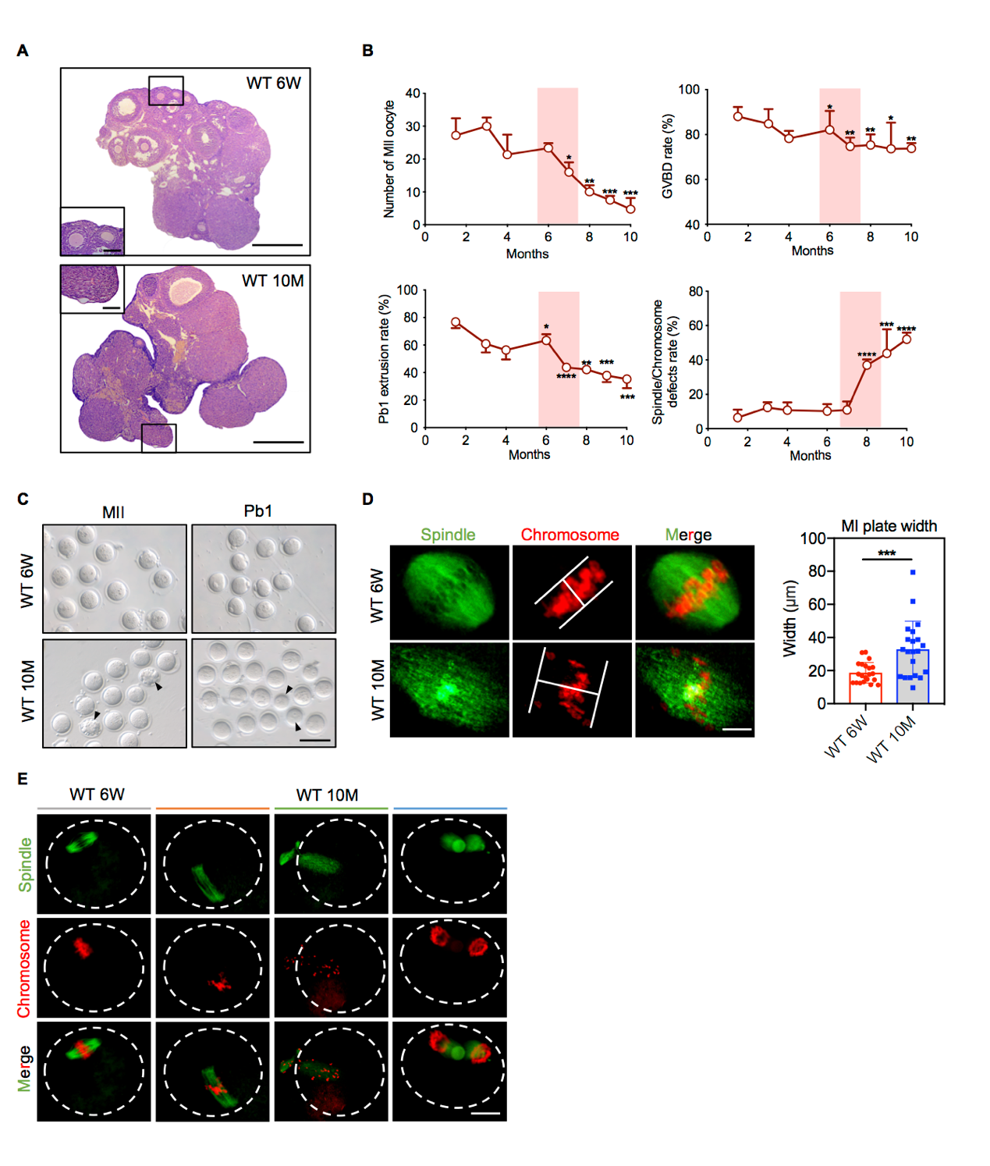
Fig. S1. Diminished follicle reserve and meiotic defects in aged ovaries. (A) HE staining of ovaries from young (6-week-old) and aged (10-month-old) mice. Scale bar, 50 µm, 500 µm. (B) The number of MIIOs and the GVBD, PBE, and meiotic defect rates were recorded in mice of different ages (6 weeks, 3 months, 4 months, 6 months, 7 months, 8 months, 9 months, and 10 months). The data are shown as the mean ± SEM of at least three independent experiments, *P < 0.05, **P < 0.01, ***P < 0.001, and ****P < 0.0001, Student’s t test. (C) Left: Images of MIIOs from young and aged mice. The arrowheads denote fragmented oocytes. Right: Images of PBE oocytes from young and aged mice after IVM. The arrowheads denote oocytes that failed to extrude a polar body. Scale bar, 100 µm. (D) Left: Images of the width of the MI plate in young (6-week-old) and aged (10-month-old) oocytes. Scale bar, 10 µm. Right: MI plate width in young (n=21) and aged oocytes (n=21). The data are shown as the mean ± SEM, ***P < 0.001, Student’s t test. (E) Spindle and chromosome morphology in young and aged oocytes. Scale bar, 25 µm.

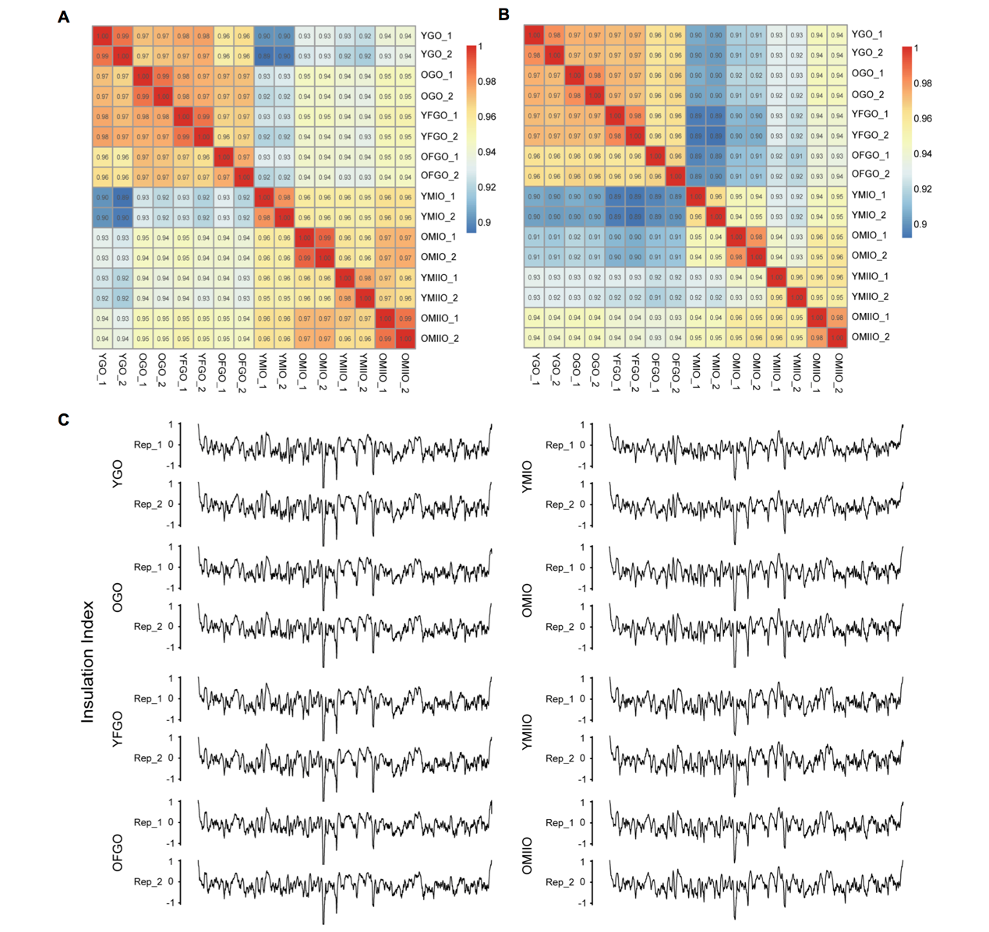
Fig. S2. Hi-C sample preparation and reproducibility assessment of Hi-C replicates. (A) Heatmap showing the correlations for pairwise combinations of Hi-C datasets generated in this study. The Pearson correlation coefficients were calculated using balanced chromatin interactions binned at 500 kb and the HiCRep package in R. Overall, the two biological replicates for each stage were highly correlated with each other, indicating a high degree of reproducibility. YGO, YFGO, YMIO, and YMIIO: oocytes from young mice. OGO, OFGO, OMIO, and OMIIO: oocytes from aged mice. (B) Pearson correlation coefficients calculated using insulation profiles at 10 kb resolution for the pairwise combinations of Hi-C datasets. Overall, the two biological replicates for each stage were highly correlated with each other, indicating a high degree of reproducibility. (C) Insulation profiles at 10 kb resolution for Chr1 in each Hi-C dataset. The local minima on the insulation profiles denote locations of high insulation ability, which correspond to TAD boundaries.
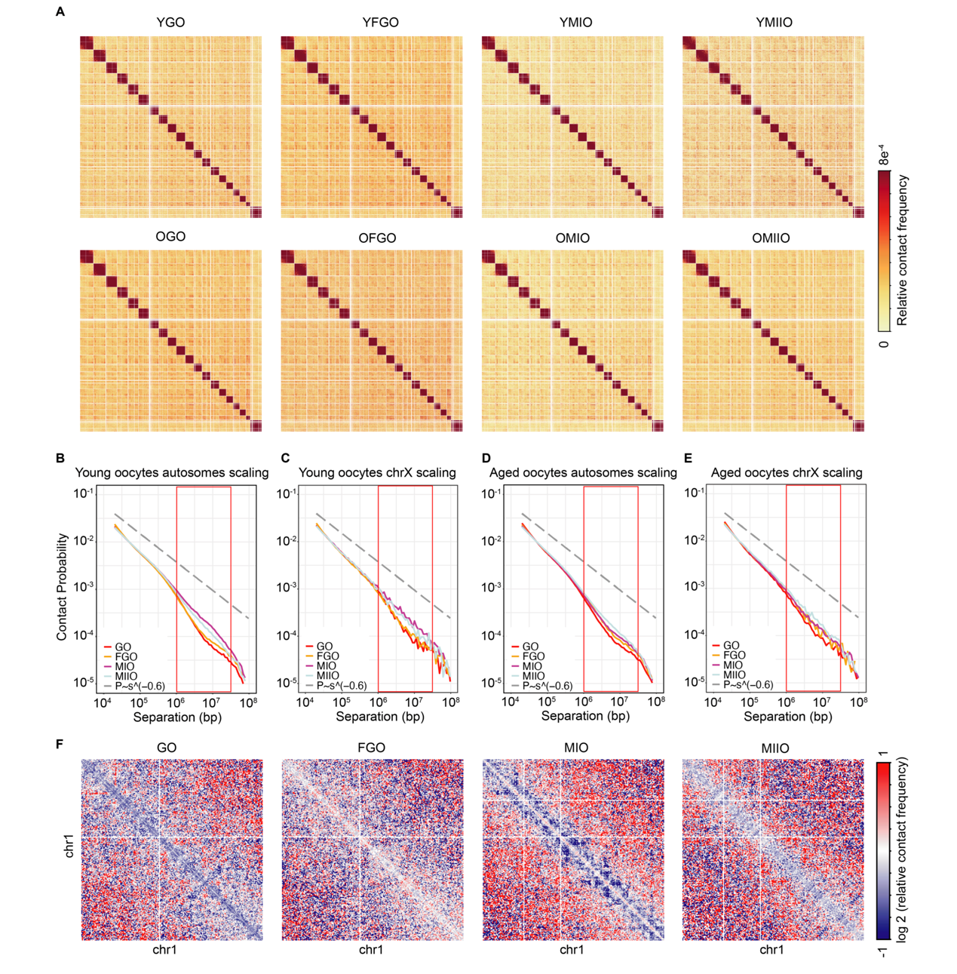
Fig. S3. Dynamic changes in chromatin conformation during oogenesis. (A) Genome-wide Hi-C interaction heatmaps binned at 1 Mb resolution show dynamic changes in 3D genome architecture during oogenesis of young and aged mice. (B) P(s) curves indicating the relationships between chromatin contact probability and genomic distances for chromatin interactions on autosomes of young oocytes. The dotted line corresponding to P(s) ~ s^{−0.6} is shown as a reference. (C) P(s) curves indicating the relationships between chromatin contact probability and genomic distances for chromatin interactions on chromosome X of young oocytes. The dotted line corresponding to P(s) ~ s^{−0.6} is shown as a reference. (D) P(s) curves indicating the relationships between chromatin contact probability and genomic distances for chromatin interactions on autosomes of aged oocytes. The dotted line corresponding to P(s) ~ s^{−0.6} is shown as a reference. (E) P(s) curves indicating the relationships between chromatin contact probability and genomic distances for chromatin interactions on chromosome X of aged oocytes. The dotted line corresponding to P(s) ~ s^{−0.6} is shown as a reference. (F) Difference heatmaps at 1 Mb resolution showing chromatin interactions that are increased (red) and decreased (blue) on chr1 in aged versus young oocytes.

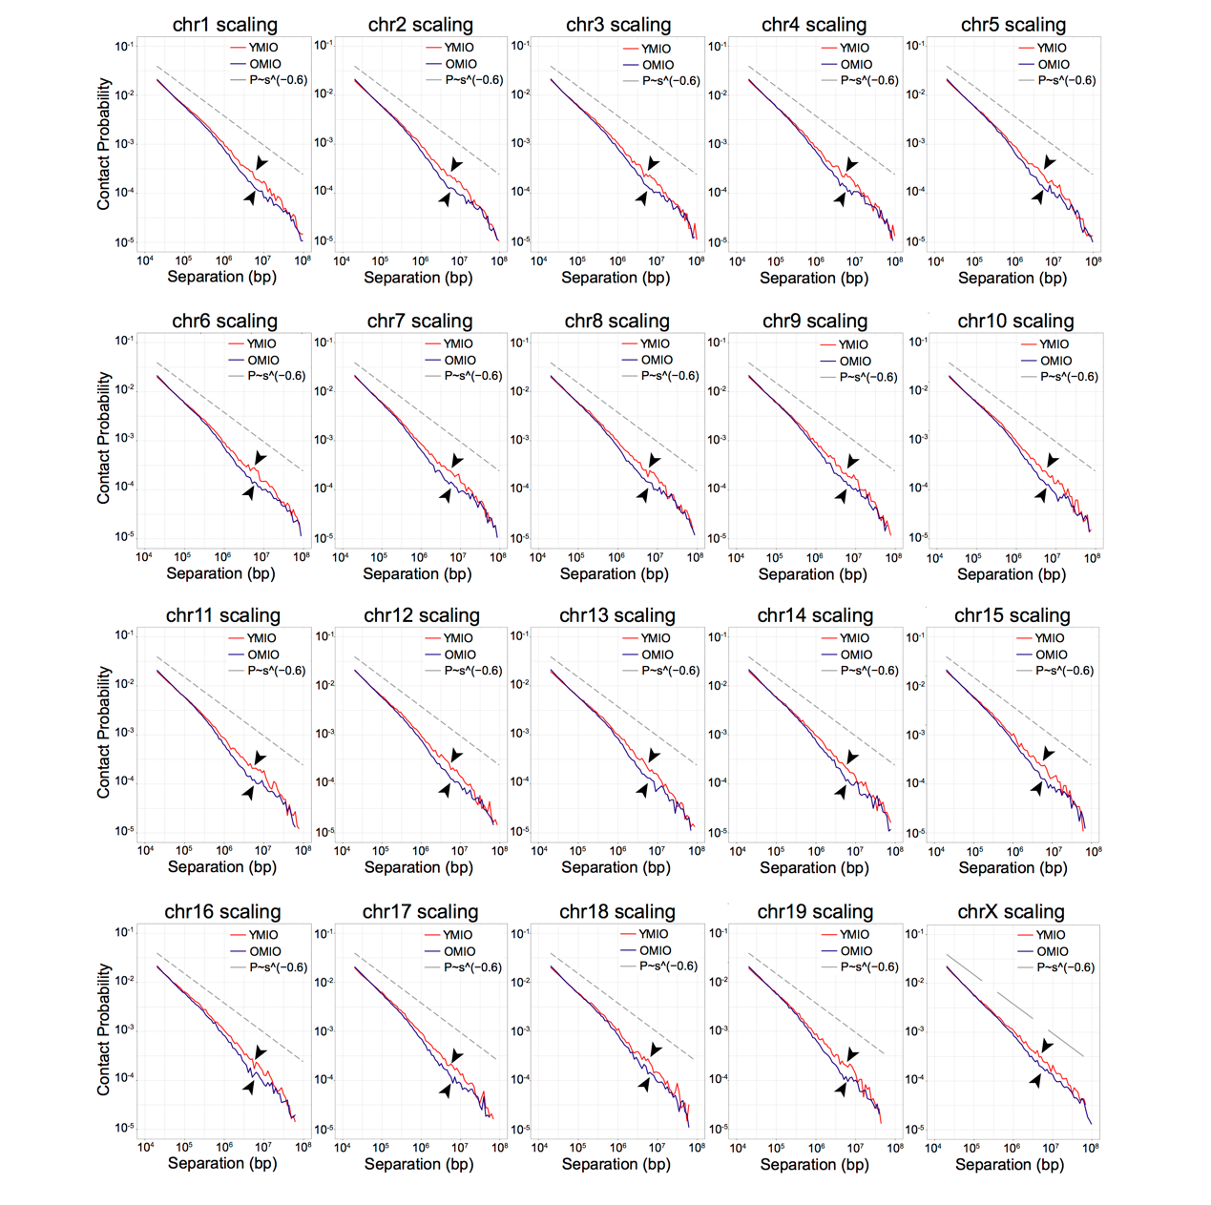
Fig. S4. P(s) curves of young and aged oocytes at MI for individual autosomes. P(s) curves indicate the relationships between chromatin contact probability and genomic distances for chromatin interactions on individual autosomes (chr1-19 and chromosome X) in young and aged oocytes. The dotted line corresponding to P(s) ~ s^{−0.6} is shown as a reference.

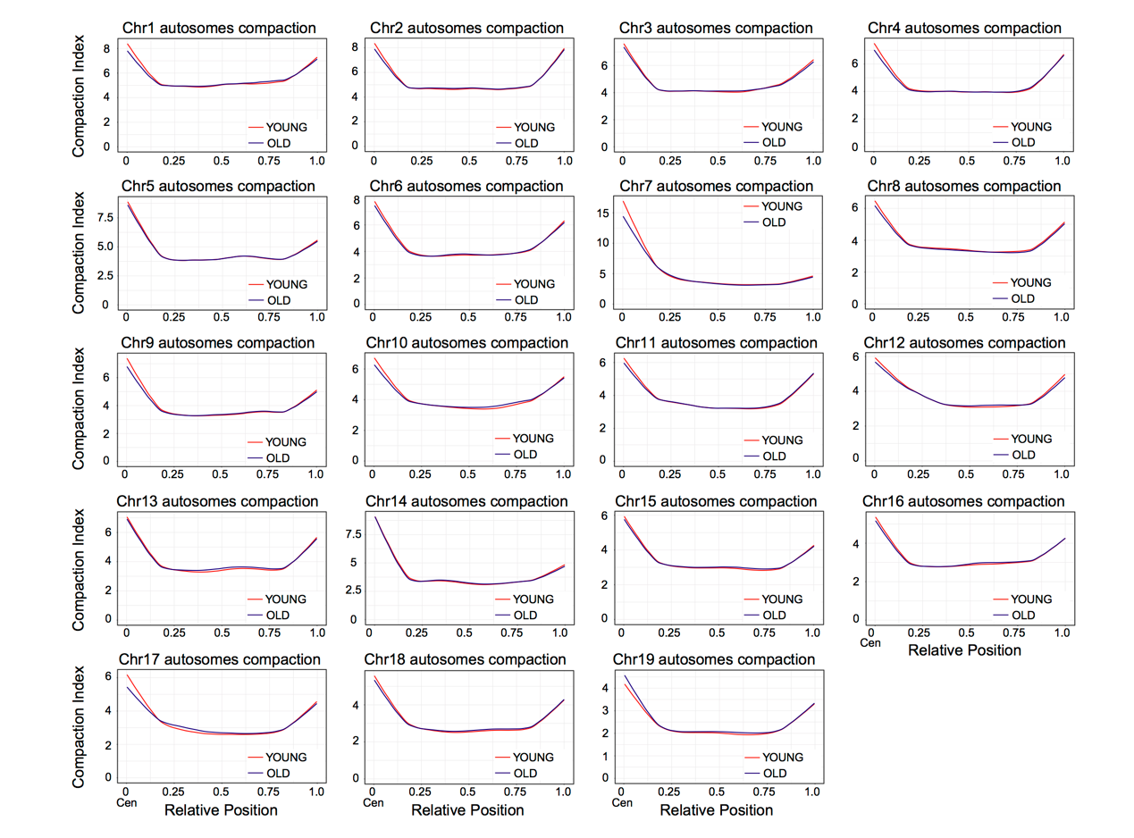
Fig. S5. Compaction index of young and aged oocytes at MI for individual autosomes. Plots quantify the compaction index along the diagonals of individual autosomes (chr1-19) in young and aged MIO. Seventeen of 19 chromosomes presented elevated chromosome compaction at centromere proximal regions.

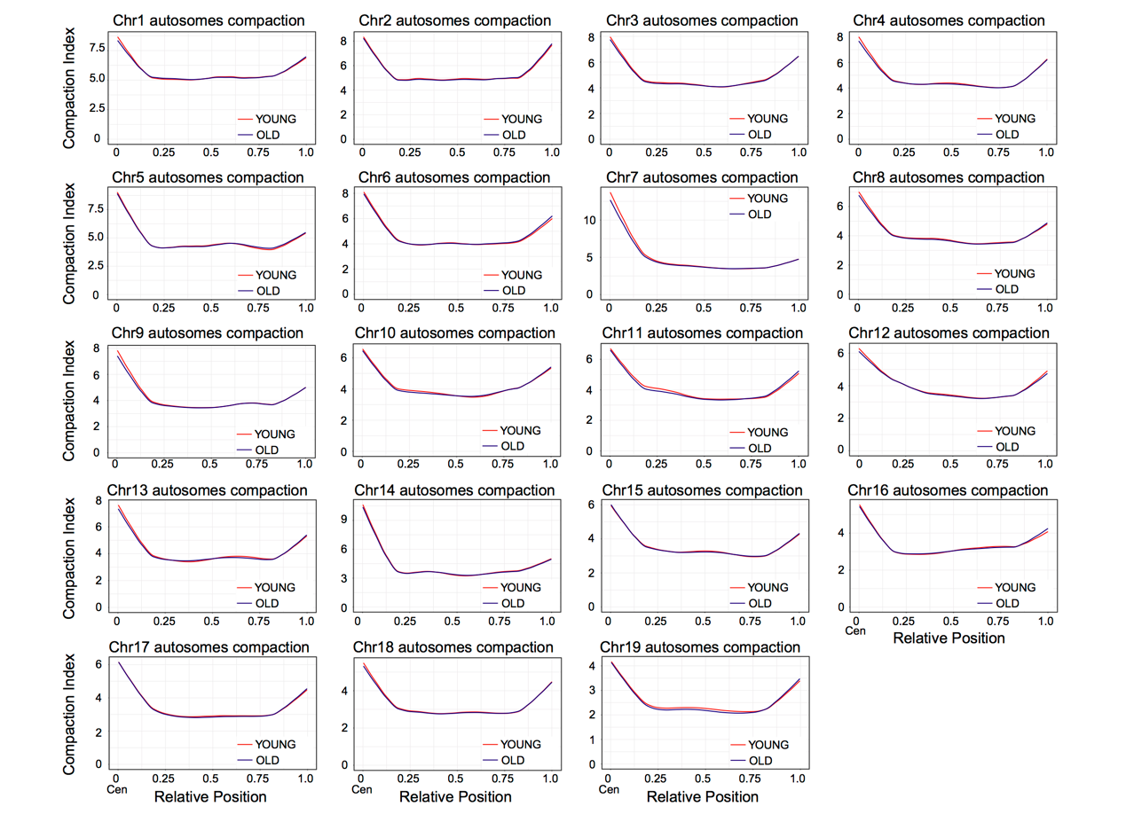
Fig. S6. Compaction index of young and aged oocytes at the full-grown stage for individual autosomes. Plots quantify the compaction index along the diagonals of individual autosomes (chr1-19) in young and aged FGOs.

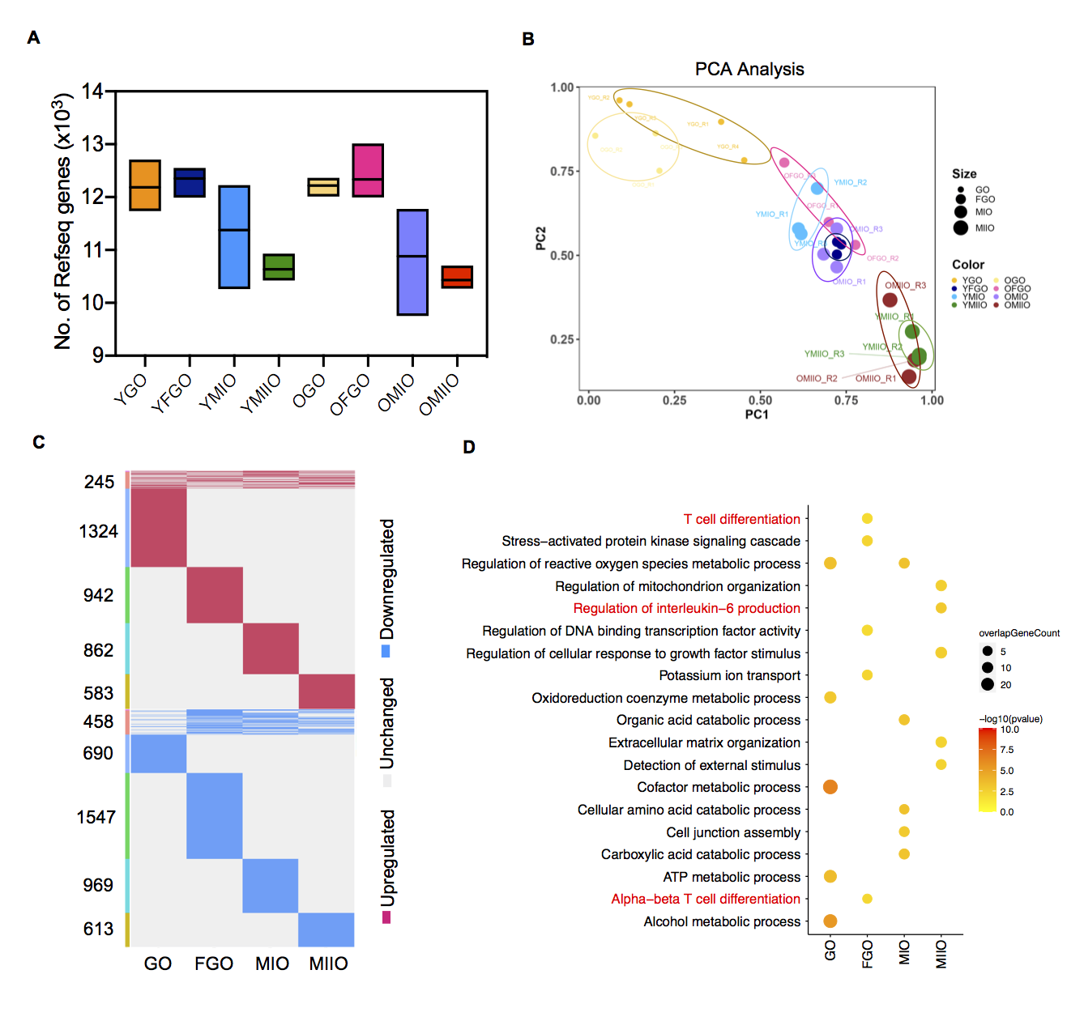
Fig. S7. Analysis of DEGs between young and aged oocytes. (A) Average numbers of detected genes (FPKM>1) in young and aged oocytes at different stages. (B) PCA plot of young and aged oocytes of different stages based on gene expression patterns separated by PC1 and PC2. The size and color of the dots represent the stage and age of the oocytes, respectively. (C) Heatmaps showing the distributions of DEGs in young and aged oocytes. Red, upregulated genes; blue, downregulated genes; gray, unchanged genes. The pink bars on the left of the heatmaps point to DEGs shared by at least two oocyte stages, and the others are oocyte subtype-specific DEGs. (D) Gene Ontology analysis of the upregulated DEGs in the four oocyte subtypes. The red font denotes biological processes associated with inflammation.

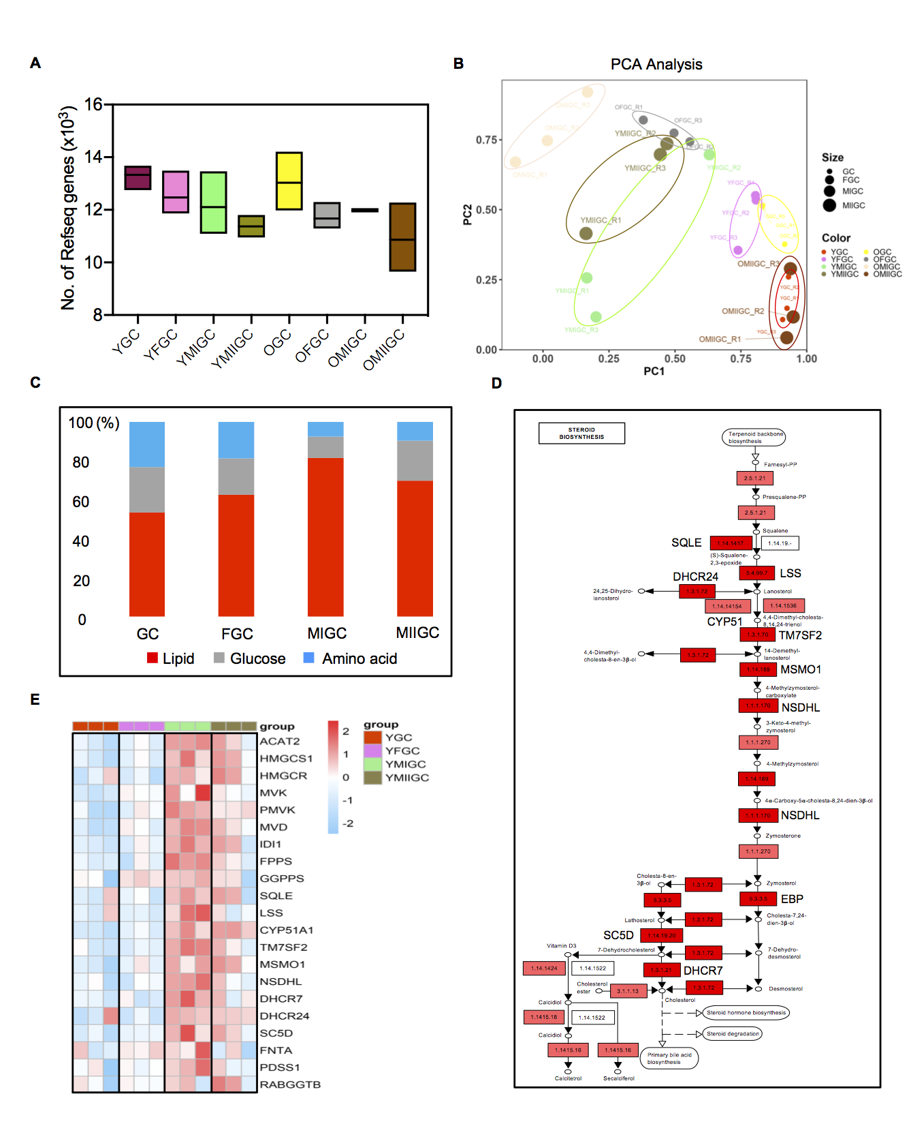
Fig. S8. Analysis of metabolism-associated genes in young GCs. (A) Average number of detected genes (FPKM>1) in young and aged GCs at different stages. YGC, YFGC, YMIGC, and YMIIGC: GCs from young mice. OGC, OFGC, OMIGC, and OMIIGC: GCs from aged mice. (B) PCA plot of young and aged GCs of different stages based on gene expression patterns separated by PC1 and PC2. The size and color of the dots represent the stage and age of the GCs, respectively. (C) Proportions of lipid-associated genes among the highly expressed metabolic genes at each stage. (D) KEGG map of MIGC stage-specific highly expressed genes. Many genes highlighted with red rectangles are involved in steroid biosynthesis. 1.14.1417: SQLE; 5.4.99.7: LSS; 1.3.1.72: DHCR24; 1.14.14154: CYP51; 1.3.1.70: TM7SF2; 1.14.189: MSMO1; 1.1.1.170: NSDHL; 5.3.3.5: EBP; 1.14.19.20: SC5D; 1.3.1.21: DHCR7. (E) Heatmap showing the expression levels of MVA pathway-associated genes in the four GC subtypes.

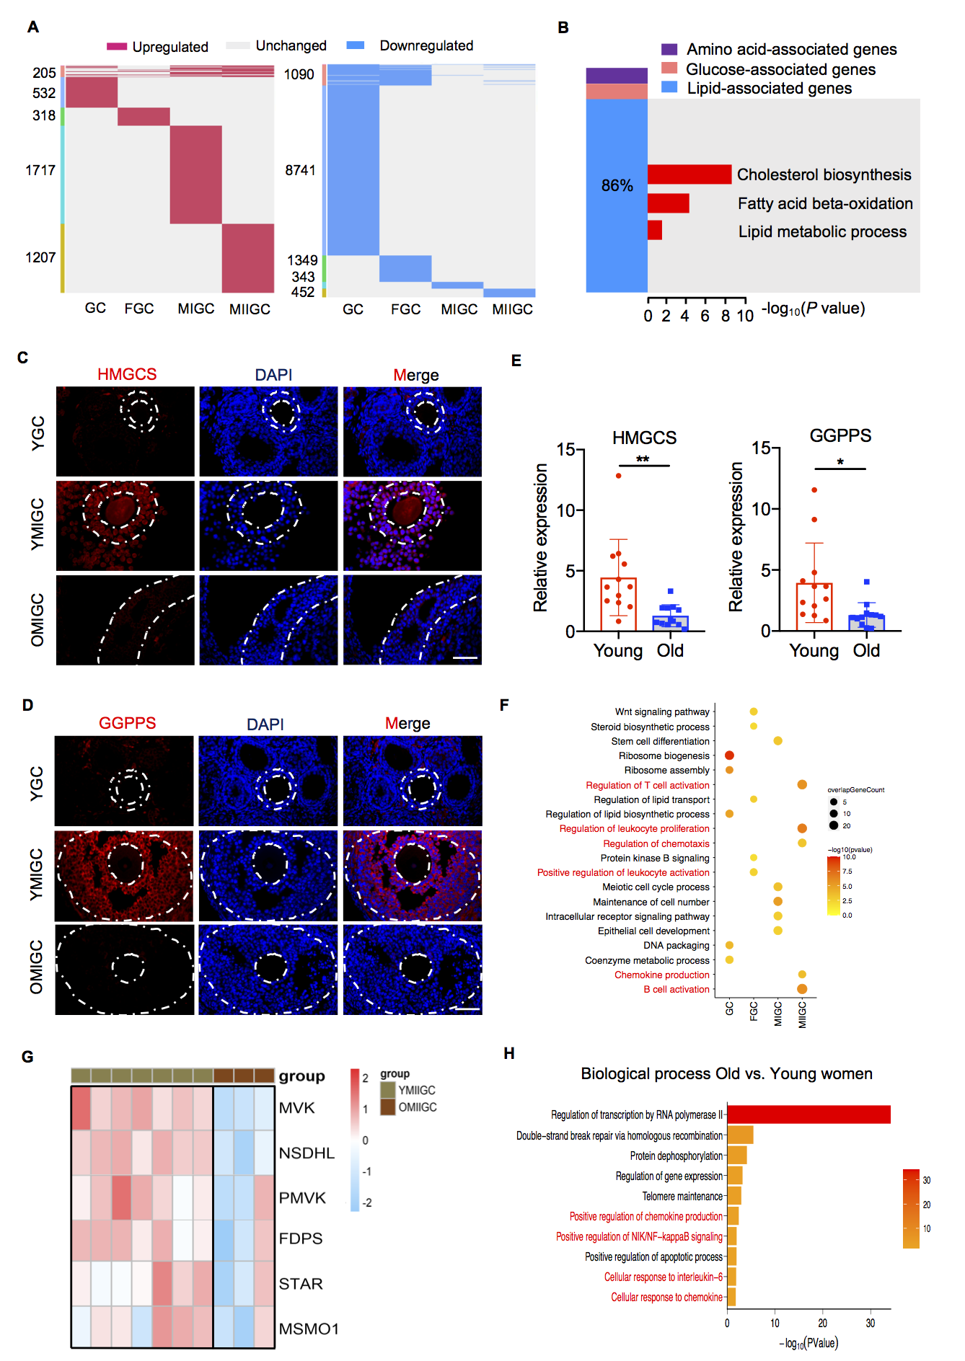
Fig. S9. Analysis of DEGs between young and aged GCs. (A) Heatmaps showing the distribution of DEGs in young and aged GCs. Red, upregulated genes; blue, downregulated genes; gray, unchanged genes. The pink bars on the left of the heatmaps point to DEGs shared by at least two GC stages, and the others are GC subtype-specific DEGs. (B) Left: Percentage of lipid-associated genes among the metabolic downregulated DEGs in aged MIGCs. Right: Gene Ontology analysis of the lipid-associated DEGs. Significance is indicated as the -log₁₀ (P value). (C) Immunofluorescence analysis of HMGCS in young and aged ovaries. Scale bar, 50 µm. (D) Immunofluorescence analysis of GGPPS in young and aged ovaries. Scale bar, 50 µm. (E) mRNA levels of HMGCS and GGPPS in young (n=12) and aged (n=12) MIGCs. The data are shown as the mean ± SEM, *P < 0.05, **P < 0.01, Student’s t test. (F) Gene Ontology analysis of the upregulated DEGs in the four mouse GC subtypes. The red font denotes biological processes associated with inflammation. (G) Heatmap showing the expression levels of DEGs associated with the MVA pathway in human GCs as determined by RNA-seq. (H) Gene Ontology biological processes of the upregulated DEGs in human GCs. The red font denotes biological processes associated with inflammation. Significance is indicated as the -log10 P value.

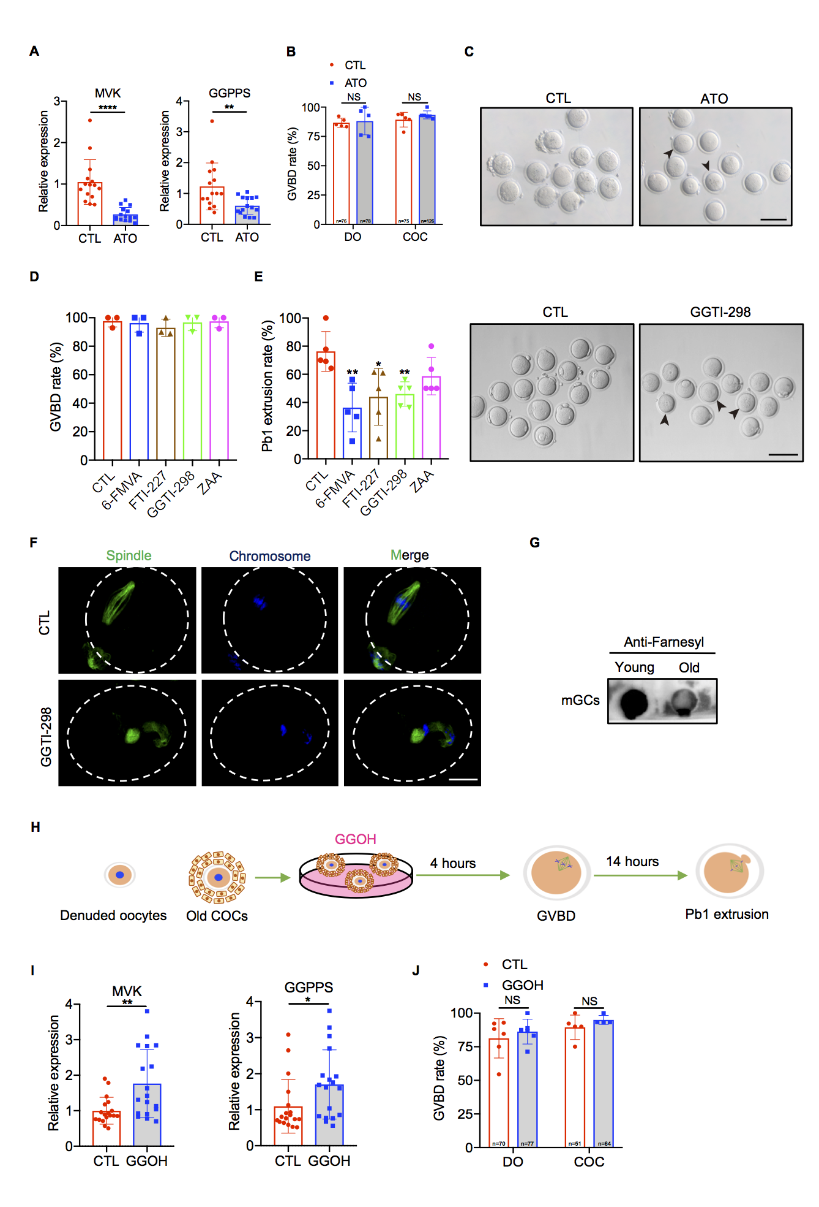
Fig. S10. Abnormal isoprenoid pathways cause age-associated oocyte meiotic defects. (A) mRNA levels of MVK and GGPPS in mouse GCs from the control (CTL) (n=15) and ATO (n=15) groups. CTL group: young COCs cultured in IVM medium. ATO group: young COCs cultured in IVM medium with 40 µM atorvastatin. The data are shown as the mean ± SEM, **P < 0.01, ****P < 0.0001, Student’s t test. (B) Rate of GVBD in the CTL (DO: n=76, COC: n=75) and ATO (DO: n=78, COC: n=126) groups. The data are shown as the mean ± SEM of at least five independent experiments, NS, not significant, Student’s t test. (C) Images of PBE oocytes from the CTL and ATO groups. The black arrowheads denote oocytes that failed to extrude a polar body. Scale bar, 100 µm. (D) COCs were treated with inhibitors of specific steps in the MVA pathway: 6-Fluoromevalonate (40 µM), FTI-227 (20 µM), GGTI-298 (20 µM), and Zaragozic Acid A (20 µM). The rate of GVBD was recorded. The data are shown as the mean ± SEM of three independent experiments. (E) Left: Rate of PBE in different groups. 6-FMVA, 6-Fluoromevalonate; ZAA, Zaragozic Acid A. The data are shown as the mean ± SEM of five independent experiments, *P < 0.05, **P < 0.01, Student’s t test. Right: Images of PBE from oocytes in the control (CTL) and GGTI-298 groups. CTL group: young COCs cultured in IVM medium. GGTI-298 group: young COCs cultured in IVM supplemented with 20 µM GGTI-298. Black arrowheads denote oocytes that failed to extrude a polar body. Scale bar, 100 µm. (F) Spindle and chromosome morphologies of oocytes in the CTL and GGTI-298 groups. Scale bar, 25 µm. (G) The levels of farnesyl in GCs from young and aged mice (dot blotting). (H) Schematic illustration of the experimental protocol used to confirm the effects of GGOH supplementation on oocyte maturation in vitro. (I) mRNA levels of MVK and GGPPS in GCs from the CTL (n=18) and GGOH (n=18) groups. The data are shown as the mean ± SEM, *P < 0.05, **P < 0.01, Student’s t test. (J) Rates of GVBD in the different treatment groups. The data are shown as the mean ± SEM, NS, not significant, Student’s t test.

Fig. S11. EGF signaling is regulated by the MVA pathway in GCs. (A) Expression levels of meiosis signal-associated genes in the four GC subtypes in young mice. (B) Number of potential ligand–receptor pairs in GCs and oocytes predicted by CellPhoneDB 2. (C) Number of ligand–receptor pairs in GCs and oocytes at each stage in young and aged mice. (D) mRNA levels of LHR, AREG, and EREG in GCs from young (n=34) and older (n=16) women. The data are shown as the mean ± SEM, *P < 0.05, Student’s t test. (E) Western blot analysis of MVK, LHR and AREG expression in KGN cells treated with atorvastatin or GGOH. The data are shown as the mean ± SEM of three independent experiments, *P < 0.05, Student’s t test.

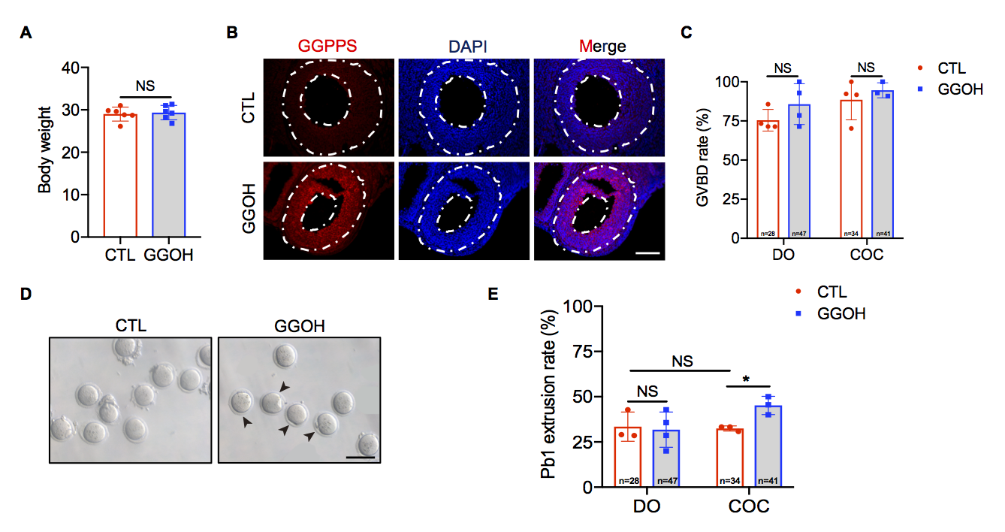
Fig. S12. GGOH supplementation improves aged oocyte quality. (A) Body weights of normal saline-treated (n=6) and GGOH-treated (n=6) mice. The data are shown as the mean ± SEM, NS, not significant, Student’s t test. (B) Immunofluorescence analysis of GGPPS in the ovaries of normal saline-treated and GGOH-treated mice. Scale bar, 50 µm. (C) Rates of GVBD in the CTL (DO: n=28, COC: n=34) and GGOH (DO: n=47, COC: n=41) groups. The data are shown as the mean ± SEM of at least three independent experiments, NS, not significant, Student’s t test. (D) Images of PBE oocytes from normal saline-treated and GGOH-treated mice. The black arrowheads denote oocytes that extrude a polar body. Scale bar, 100 µm. (E) Rate of PBE in the normal saline-treated (DO: n=28, COC: n=34) and GGOH-treated (DO: n=47, COC: n=41) groups. The data are shown as the mean ± SEM of at least three independent experiments, NS, not significant, *P < 0.05, Student’s t test.

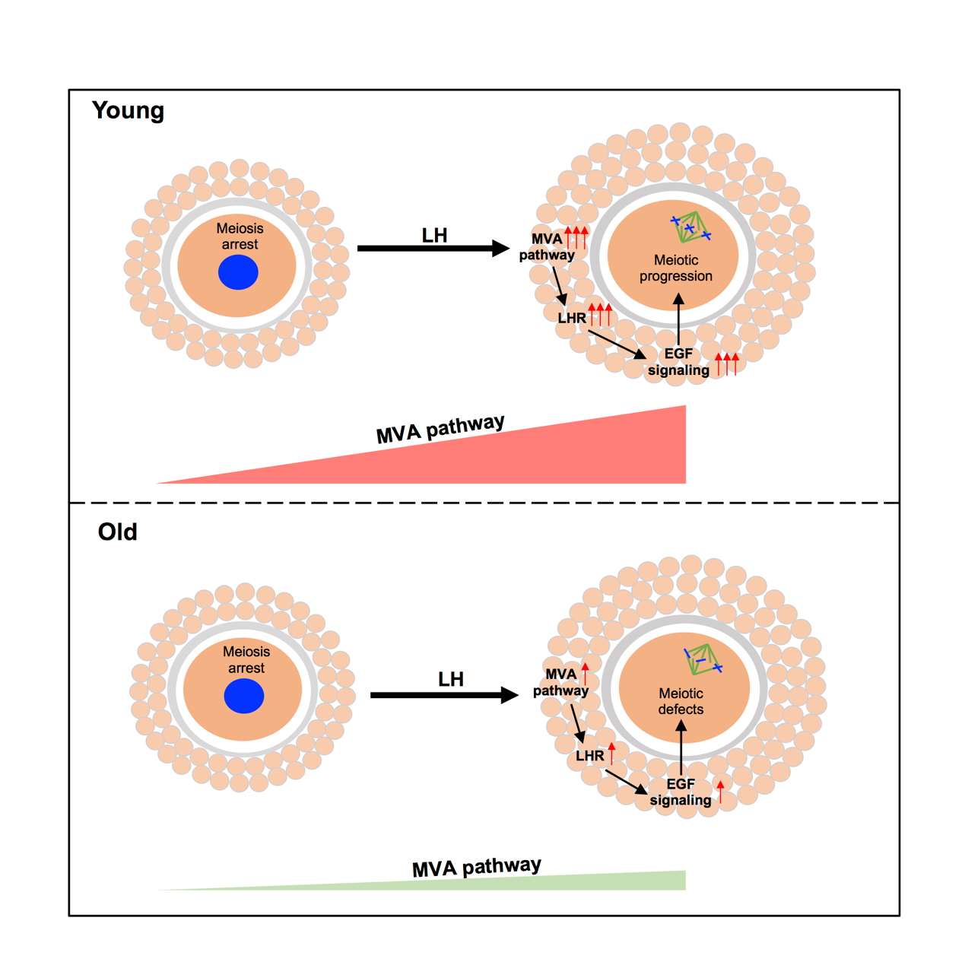
Fig. S13. Schematic of the abnormal MVA pathway in GCs dominating oocyte meiotic defects in ovary aging. Under normal circumstances, the MVA pathway surges and upregulates LHR/EGF signaling in MIGCs, causing the resumption of oocyte meiosis. Aging impairs MVA pathway activation, which results in LHR/EGF signaling deficiency in MIGCs and downregulates the expression of meiosis-associated genes, thereby contributing to meiotic defects in oocytes.

 | Batch | Total Reads | Side 1 Aligned | Side 2 Aligned | Both Sides Aligned | Same Fragment | Dangling Ends | Self Circles | Error Pairs | valid pairs | % valid Pairs | Unique | % Unique | cis Pairs | % cis Pairs
 |  |  |  |  |  |  |  |  |  |  |  | Valid Pairs | Valid Pairs | cis Pairs | % cis Pairs
YGO | replicate 1 | 50,348,142 | 41,457,475 | 41,396,281 | 32,505,614 | 8,153,573 | 6,494,000 | 1,586,098 | 73,475 | 19,875,423 | 61.14% | 12,414,588 | 38.19% | 8,483,825 | 68.34%
YGO | replicate 2 | 40,398,573 | 33,320,412 | 33,295,579 | 26,217,418 | 6,093,291 | 4,703,001 | 1,334,446 | 55,844 | 16,769,261 | 63.96% | 9,627,621 | 36.72% | 6,617,041 | 68.73%
OGO | replicate 1 | 62,843,786 | 53,921,539 | 53,844,937 | 44,922,690 | 13,480,480 | 11,998,340 | 1,408,267 | 73,873 | 24,960,140 | 55.56% | 15,492,558 | 34.49% | 9,412,832 | 60.76%
OGO | replicate 2 | 75,955,236 | 64,861,319 | 64,765,015 | 53,671,098 | 13,850,879 | 11,969,367 | 1,810,737 | 70,775 | 32,543,150 | 60.63% | 16,367,318 | 30.50% | 9,947,519 | 60.78%
YFGO | replicate 1 | 63,054,789 | 52,517,975 | 52,458,770 | 41,921,956 | 10,142,823 | 8,359,054 | 1,738,555 | 45,214 | 25,735,186 | 61.39% | 16,096,246 | 38.40% | 9,490,268 | 58.96%
YFGO | replicate 2 | 66,693,233 | 55,674,781 | 55,642,616 | 44,624,164 | 9,719,330 | 7,740,189 | 1,935,717 | 43,424 | 28,973,309 | 64.93% | 15,709,207 | 35.20% | 9,315,556 | 59.30%
OFGO | replicate 1 | 57,110,801 | 50,109,314 | 50,058,023 | 43,056,536 | 23,554,998 | 20,835,035 | 2,630,094 | 89,869 | 13,050,223 | 30.31% | 8,064,577 | 18.73% | 4,600,863 | 57.05%
OFGO | replicate 2 | 64,002,351 | 56,137,467 | 56,089,302 | 48,224,418 | 25,421,847 | 22,192,807 | 3,132,996 | 96,044 | 15,629,663 | 32.41% | 8,184,486 | 16.97% | 4,705,625 | 57.49%
YMI | replicate 1 | 43,062,161 | 34,730,548 | 34,726,693 | 26,395,080 | 8,871,259 | 7,557,784 | 1,266,624 | 46,851 | 13,537,334 | 51.29% | 7,715,003 | 29.23% | 5,689,387 | 73.74%
YMI | replicate 2 | 42,702,340 | 34,333,752 | 34,314,684 | 25,946,096 | 7,815,231 | 6,429,492 | 1,338,438 | 47,301 | 14,329,726 | 55.23% | 6,925,628 | 26.69% | 5,133,569 | 74.12%
OMI | replicate 1 | 47,600,824 | 38,216,208 | 38,252,125 | 28,867,509 | 5,160,710 | 3,972,283 | 1,172,456 | 15,971 | 19,781,837 | 68.53% | 13,011,124 | 45.07% | 9,327,859 | 71.69%
OMI | replicate 2 | 51,291,810 | 41,320,083 | 41,338,045 | 31,366,318 | 4,902,959 | 3,573,696 | 1,312,287 | 16,976 | 22,704,364 | 72.38% | 12,627,010 | 40.26% | 9,090,674 | 71.99%
YMII | replicate 1 | 35,525,991 | 27,352,769 | 27,386,364 | 19,213,142 | 6,589,192 | 5,865,049 | 713,996 | 10,147 | 9,426,487 | 49.06% | 6,050,667 | 31.49% | 4,195,172 | 69.33%
YMII | replicate 2 | 29,678,778 | 22,370,888 | 22,382,683 | 15,074,793 | 4,898,354 | 4,320,787 | 569,056 | 8,511 | 7,675,335 | 50.92% | 4,670,357 | 30.98% | 3,237,748 | 69.33%
OMII | replicate 1 | 48,043,323 | 38,240,113 | 38,264,799 | 28,461,589 | 6,552,283 | 3,922,066 | 2,609,734 | 20,483 | 17,968,723 | 63.13% | 11,749,828 | 41.28% | 7,631,654 | 64.95%
OMII | replicate 2 | 62,887,979 | 50,237,370 | 50,217,908 | 37,567,299 | 8,285,533 | 4,723,197 | 3,536,333 | 26,003 | 24,591,168 | 65.46% | 13,071,157 | 34.79% | 8,515,983 | 65.15%
Table S1. Mapping Statistics and Data Quality of Hi-C Datasets
Table S2. Clinical Parameters and Outcomes of the Young and Aged Patients
Index | Young  patients (n=34) | Aged  patients (n=16) | P value
Age (years) | 26.21±0.33 | 40.19±0.48 | <0.0001
BMI (kg/m²) | 23.06±0.48 | 123.07±0.85 | 0.99
AMH (ng/mL) | 3.25±0.38 | 1.32±0.32 | 0.002
FSH (IU/L) | 7.62±0.61 | 9.88±1.26 | 0.073
LH (IU/L) | 6.75±0.72 | 5.73±0.78 | 0.39
E2 (pg/mL) | 37.89±2.90 | 40.84±4.24 | 0.57
T (ng/mL) | 0.33±0.03 | 0.27±0.08 | 0.37
PRL (ng/mL) | 20.09±1.51 | 16.13±1.44 | 0.1
AFC | 19.06±1.75 | 8.94±1.30 | 0.0005
No. of collected oocytes | 11.24±0.90 | 4.31±0.90 | <0.0001
No. of fertilized oocytes | 8.47±0.89 | 3.88±0.85 | 0.023
No. of transferred embryos | 5.68±0.77 | 2.50±0.71 | 0.012

Table S3. Antibody information
Antibodies | Source | Catalogue number
Mouse anti-α-tubulin-FITC | Sigma | Cat# F2168
Rabbit anti-GGPS1 | Proteintech | Cat# 14944-1-AP
Rabbit anti-HMGCS1 | Proteintech | Cat# 17643-1-AP
Rabbit anti-MVK | Proteintech | Cat# 12228-1-AP
Rabbit anti-LHR | Affinity Biosciences | Cat# AF04
Rabbit anti-AREG | Santa Cruz Biotechnology | Cat# sc-74501
Human anti-centrome CREST | Antibodies Incorporated | Cat# 15-234
Cy5-conjugated donkey anti-human IgG | Jackson ImmunoResearch Laboratory | Cat# 709-175-149
Rabbit anti-GAPDH | Bioworld | Cat# AP0063

Table S4. Primer sequences
Oligonucleotides | Source | Catalogue number
18S-F (mouse samples):  ATGGCCGTTCTTAGTTGGTG | This study | N/A
18S-R (mouse samples):  CGGACATCTAAGGGCATCAC | This study | N/A
GGPPS-F (mouse samples):  AATGCTTGTGTGTGGTGGTC | This study | N/A
GGPPS-R (mouse samples):  CAGTTCTCCTGCATCGTGTG | This study | N/A
HMGCS-F (mouse samples):  TGACATGCTCTCCGAGTACC | This study | N/A
HMGCS-R (mouse samples):  GGCTAAAGGAGAACCCACCT | This study | N/A
MVK-F (mouse samples):  CTTGTTAGTCCTCGGCAAGC | This study | N/A
MVK-R (mouse samples):  ATAAGAACCTGGCTGCCACT | This study | N/A
AREG-F (mouse samples):  CCCTCTCCAAAGCAGACTCA | This study | N/A
AREG-R (mouse samples):  AAAGGTTCAGAGCCGGGTAA | This study | N/A
EREG-F (mouse samples):  GGTGGAATCTCCCTGGAACA | This Study | N/A
EREG-R (mouse samples):  ACTGGCTCCATGGAACATCA | This study | N/A
LHR-F (mouse samples):  CACTGCTCACAAGAGAAGGC | This study | N/A
LHR-R (mouse samples):  CTGCCACACCTACATTCTGC | This study | N/A
ZFP207-F (mouse samples):  GCTGCTCCTTTACTGGTTGG | This study | N/A
ZFP207-R (mouse samples):  GCAGTGGATCTGAAGCCTTG | This study | N/A
PTTG1-F (mouse samples):  AGAGAGGAGTCAGGCTGGTA | This study | N/A
PTTG1-R (mouse samples):  ATGGCCTCTAACCAACTGCT | This study | N/A
HAUS2-F (mouse samples):  ACTGAGCCATCTTCCTGCTT | This study | N/A
HAUS2-R (mouse samples):  GGACACGCACCATCACATAC | This study | N/A
MSH5-F (mouse samples):  GGTGTCTGTGGAGGTCAGAA | This study | N/A
MSH5-R (mouse samples):  CAGGAAAGAGGGTGCAGAGA | This study | N/A
RBM38-F (mouse samples):  GTGCCCGTGGATGTATAGGA | This study | N/A
RBM38-R (mouse samples):  TCCATCACCCTCACAACTCC | This study | N/A
18S-F (human samples):  CGGCTACCACATCCAAGGAA | This study | N/A
18S-R (human samples):  CTGGAATTACCGCGGCT | This study | N/A
GGPPS-F (human samples):  ACACGCTCACAAACACTAGC | This study | N/A
GGPPS-R (human samples):  ACTGTAGGCAGTCCTTGCTT | This study | N/A
MVK-F (human samples):  CCCAATCCAGTGTCACCTCT | This study | N/A
MVK-R (human samples):  AGGGACTTTGGTGTTGGTCA | This study | N/A
AREG-F (human samples):  ACATGGCATAGCAAGCAAGG | This study | N/A
AREG-R (human samples):  GTGCCTACTACCTGGGACAG | This study | N/A
EREG-F (human samples):  ATTTGAGACAGCCAGAGCCT | This study | N/A
EREG-R (human samples):  GCTTGGCAGCTGACGAAATA | This study | N/A
LHR-F (human samples):  GGTAGAGACCCTGAGCATCC | This study | N/A
LHR-R (human samples):  ACCTCCACAGAGTGACAAGG | This study | N/A

Table S5. Chemicals and commercial assays
Chemicals, Peptides, and Recombinant Proteins
Paraformaldehyde (PFA) | Sigma | Cat# 158127
Triton X-100 | Sigma | Cat# T9284
Atorvastatin | MedChemExpress | Cat# HYB0589
Geranylgeraniol | Sigma | N/A
M2 medium | Sigma | Cat# M7167
M16 medium | Sigma | Cat# M7292
DMEM/F-12 medium | Gibco | Cat# C11330500BT
Trypsin-EDTA (0.25%) | Gibco | Cat# 25200072
Penicillin–streptomycin | Gibco | Cat# 15140122
FBS | Gibco | Cat# 10270106
Hyaluronidase | Sigma | Cat# H3506
HTF medium | Merck Millipore | Cat# MR-070
KSOM medium | Merck Millipore | Cat# MR-106-D
Propidium iodide | Thermo Fisher | Cat# P3566
Hoechst 33342 | Thermo Fisher | Cat# H3570
VAHTS DNA Clean Beads | Vazyme Biotech | Cat# N411
M199 medium | Thermo Fisher | Cat# 11150059
Sodium pyruvate | Thermo Fisher | Cat# 11360070
16% Formaldehyde (w/v) | Invitrogen | Cat# 28909
Phusion High-Fidelity DNA Polymerase | Thermo Fisher | Cat# F-530 L
Agencourt AMPure® XP | Beckman | Cat# A63880
Biotin-14-dATP | Invitrogen | Cat# 19524016
DpnII, high conc. | New England Biolabs | Cat# R0543 M
Dynabeads® MyOneTM Streptavidin C1 | Invitrogen | Cat# 650.01
Klenow Fragment (3’→5’ exo-) | Invitrogen | Cat# M0212 L
T4 Polynucleotide Kinase | New England Biolabs | Cat# M0201S
T4 DNA Ligase | New England Biolabs | Cat# 15224090
dATP, 100 mM solution | Thermo Fisher | Cat# R0141
dCTP, 100 mM solution | Thermo Fisher | Cat# R0151
dGTP, 100 mM solution | Thermo Fisher | Cat# R0161
dTTP, 100 mM solution | Thermo Fisher | Cat# R0171
GlutaMAXTM | Thermo Fisher | Cat# 35050061
Critical Commercial Assays
Single Cell Sequence Specific Amplification Kit | Vazyme Biotech | Cat# P621
Discover-sc WTA Kit V2 | Vazyme Biotech | Cat# N711
TruePrep DNA Library Prep Kit V2 | Vazyme Biotech | Cat# TD503
Equalbit 1× dsDNA HS Assay Kit | Vazyme Biotech | Cat# EQ121
NEBNext, Ultra II End Repair/dA-Tailing Module | New England Biolabs | Cat# E7546 L
NEBNext, Ultra II End Ligation Module | New England Biolabs | Cat# E7595 L

Table S6. Software and algorithms
Prism (V8.0) | GraphPad | https://www.graphpad.com/scientific-software/prism/
KEGG Mapper (V4.1) | 52 | http://www.genome.jp/kegg/mapper.html
DESeq2 (V1.20.0) | 53 | https://bioconductor.org/packages/release/bioc/html/DESeq2.html
TopHat (V2.0.12) | 54 | http://ccb.jhu.edu/software/tophat/downloads/
GO (DAVID) | 49 | https://david-d.ncifcrf.gov/
TCseq (V1.12.0) | 50 | https://www.bioconductor.org/packages/release/bioc/html/TCseq.html
Bowtie2 (V2.2.2) | 55 | http://bowtie-bio.sourceforge.net/bowtie2/index.shtml
Hiclib | 45 | https://github.com/mirnylab/hiclib-legacy
Cooler | 46 | https://github.com/mirnylab/cooler
CellPhoneDB 2 | 51 | http://www.cellphonedb.org/
Cooltools | Mirny lab | https://github.com/mirnylab/cooltools
R package: HiCRep | 47 | https://github.com/qunhualilab/hicrep

