Supplementary data
Synthesis and anti-influenza virus activity evaluation
of novel andrographolide derivatives
Chunyang Zou^{1, 2}, Jinyu Men³, Yingjin Qu³, Chunfeng Jiang⁴, Yao Wang^{1,2}, Lixia Chen³, Lei Yuan³
✉ Chunyang Zou
zcy19980619@163.com

✉ Lei Yuan
leiyuan@syphu.edu.cn

Jinyu Men
menjinyu001@163.com

Chunfeng Jiang
837410509@qq.com

Yao Wang
413627321@qq.com

Lixia Chen
syzyclx@163.com

¹ Department of Pharmacy, Liaoning Vocational College of Medicine, Shenyang 110101, PR China

² Liaoning Institute of Basic Medicine, Shenyang 110101, PR China

³ Shenyang Pharmaceutical University, Shenyang 110016, PR China

⁴ Liaoning Institute of Science and Technology, Benxi 117004, PR China

Contents:
1. Initial synthetic route and method of IM4.
2. The ¹H NMR, ¹³C NMR, HR-MS and MS spectra of the target compounds and the intermediates.
3. Determination of the purity of all derivatives.

1. Initial synthetic route and method of IM4.
Figure 1s. The initial synthetic route of IM4.

1.1 3,14,19- Triacetate-andrographolide (IM-1)
Andrographolide (5.0 g, 14.3 mmol) was dissolved in acetic anhydride (15 ml) and the mixture was stirred for 10 minutes at 35 °C, then, anhydrous zinc chloride (1.0 g) was added, and the mixture was stirred until the solution transformed into pellucid, about 8 minutes. After the reaction was completed, the solution was poured into the ice water and stirred for another 2 hours, then, the mixture was filtered and recrystallization with ethanol. Yield: 96 %; White solid; m.p. 128-130 ºC; MS(ESI) m/z: 477.53 [M+H]⁺; ¹H-NMR (600 MHz, CDCl₃): δ 6.96 ( 1H, t, J = 6.0 Hz, 12-H), 5.88 (1H, d, J = 6.0 Hz, 14-H), 4.86 (1H, s, 17a-H), 4.57-4.52 (2H, m, 15-H), 4.51 (1H, s, 17b-H), 4.32 (1H, d, J = 12.0 Hz, 19a-H), 4.21-4.22 (1H, m, 3-H), 4.08 (1H, d, J = 12.0Hz, 19b-H), 2.35-2.43 (3H, m, 6-H and 11a-H), 2.10 (3H, s), 2.01 (6H, s), 1.92-2.01 (1H, brd, J = 13.1 Hz, 9-H), 1.82-1.85 (2H, m), 1.74-1.78 (2H, m), 1.68 (1H, d, J = 10.1 Hz, 2a-H), 1,49 (1H, dd, J = 13.1, 4.1 Hz, 5-H), 1.31 (2H, d, J = 12.6 Hz, 1-H), 0.99 (3H ,s, 18-CH₃), 0.71 (3H, s, 20-CH₃).

1.2 14-Deoxy-3,19-diacetate-andrographolide (IM-2)
To a solution of IM-1 (2.0 g, 4.2 mmol) of MeOH (10 ml), NaBH₄ (0.96 g, 25.4 mmol) was added in batches, keep the temperature between 25-30 °C. After completion of addition, the mixture was stirred for 1 hours. Then, 10 ml of water was added, and methanol was removed under reduced pressure, the suspension solution was extracted with DCM (3×10 ml), the organic phase was combined and washed with water (30 ml), and brine (30 ml). Yield: 95 %; White solid; m.p.118-119 ºC; MS(ESI) m/z: 419.51 [M+H]⁺; ¹H-NMR (600 MHz, CDCl₃): δ 7.15 (1H, s, 14-H), 5.13 (1H, s, 17a-H), 4.80 (2H, s, 15-H), 4.77 (1H, s, 17b-H), 4.63-4.65 (1H, m, 3-H), 4.35 (1H, d, J = 11.4 Hz, 19a-H), 4.10 (1H, d, J = 11.4 Hz, 19b-H), 2.38-2.42 (2H, m, 7-H), 2.11-2.13 (1H, brd, J = 18.2 Hz, 12a-H), 2.00 (6H, s, CH₃COO-), 1.91-1.93 (1H, dt, J = 13.1, 3.5 Hz, 12b-H), 1,83-1.85 (2H, m, 6-H), 1.79-1.80 (2H, m, 2-H), 1.80 (1H, brs, 9-H), 1.64-1.70 (2H, m, 11-H), 1.51 (1H, dd, J = 13.1, 4.2 Hz, 5-H), 1.22 (3H, s, 18-CH₃), 1.30 (2H, d, J = 10.2 Hz, 1-H), 0.71 (3H, s, 20-CH₃);

1.3 The synthesis of 3, 19-diacetyl-7-hydroxy-14-deoxyandrographolide (IM-3’)
Selenium dioxide (3.83 g, 34.56 mmol) and TBHP (5.21 ml, 34.56 mmol) in 1, 2-dichloroethane (50 ml) were stirred for 20 min at room temperature. Then a solution of IM-2 (10.0 g, 23.04 mmol) in 1, 2-dichloroethane (50 ml) was added and continued to stir for an additional 24 h at 60 °C. The reaction mixture was washed with a solution of saturated sodium thiosulfate (5 ml) and brine (10 ml), respectively. The organic extracts were dried over anhydrous Na₂SO₄ and concentrated in vacuo, the residue was purified by silica gel column chromatography to furnish the product. Yield: 39.5 %; White solid; m.p. 146-150 ºC; MS(ESI) m/z: 435.23 [M+H]⁺; ¹H-NMR (600 MHz, CDCl₃): δ 7.14 (1H, s, 14-H), 5.13 (1H, s, 17a-H), 4.80 (2H, s, 15-H), 4.77 (1H, s, 17b-H), 4.63 (1H, dd, J = 12.0, 4.3Hz, 3-H), 4.39 (1H, t, 7-H), 4.37 (1H, d, J = 11.8 Hz, 19a-H), 4.11 (1H, d, J = 11.8 Hz, 19b-H), 2.40-2.43 (1H, m,12a-H), 2.18-2.23 (2H, m, 9-H and 12b-H), 2.04 (3H, s, CH₃COO), 2.03 (3H, s, CH₃COO), 1.98-2.02 (1H,dt, J = 14.4, 2.4 Hz, 2a-H), 1.88-1.90 (1H, brd, J = 13.2, 2b-H), 1.64-1.81 (8H, m), 1.28-1.33 (1H, td, J = 13.2, 3.6 Hz, 1a-H), 1.01 (3H, s, 18-CH₃), 0.70 (3H, s, 20-CH₃).

1.4 ((1R,2R,4aS,5S)-2-acetoxy-6-((1,3-dioxoisoindolin-2-yl)methyl)-1,4a-dimethyl-5-(2-(2-oxo-2,5-dihydrofuran-3-yl)ethyl)-1,2,3,4,4a,5,8,8a-octahydronaphthalen-1-yl)methyl acetate (IM-4)
IM3’ (0.8 g, 1.8 mmol) was dissolved in DCM (5 ml), and Et₃N (0.5 ml, 3.6 mmol) was added, the solution was stirred at 0 °C for 10 minutes, then methanesulfonyl chloride (0.17 ml, 2.2 mmol) was dropped slowly, and the solution was stirred for another 2 hours at room temperature. The solvent was evaporated under reduced pressure. The product was used directly in the next step. A mixture of methylsulfonylated product (0.5 g, 0.58 mmol) and phthalimide potassium salt (0.91 g, 4.9 mmol) in anhydrous acetonitrile (10 ml) was stirred at reflux overnight. After the reaction was completed, removal of the acetonitrile, and the residue dissolved with DCM (20 ml) again and washed continuously with water (20 ml) and brine (20ml). Yield: 81 %; White solid; m.p. 146-150 ºC; MS(ESI) m/z: 564.76 [M+H]⁺; ¹H-NMR (600 MHz, CDCl₃): δ 7.87 (2H, dd, J = 5.4, 3.6 Hz, Ar-H), 7.74 (2H, dd, J = 5.4, 3.6 Hz, Ar-H), 7.24 (1H, s, 14-H), 5.34 (1H, s, 7-H), 4.82 (2H, s, 15-H), 4.56-4.59 (1H, m, 3-H), 4.40 (1H, d, J = 12.0 Hz, 19a-H), 4.32 (1H, d, J = 16.2 Hz, 17a-H), 4.19-4.23 (2H, m, 17b, 19b-H), 2.54-2.59 (1H, m, 12a-H), 2.37-2.42 (1H, m, 12b-H), 2.08 (1H, brs, 2a-H), 2.04 (3H, s, CH₃COO), 2.02 (3H, s, CH₃COO), 2.00-2.02 (1H, dt, J = 13.2, 3.4 Hz, 2b-H), 1.95 (1H, brs, 9-H), 1.85-1.91 (1H, m, 6a-H), 1.69-1.74 (3H, m), 1.45 (1H, dd, J = 10.7, 6.1 Hz, 5-H), 1.22-1.29 (2H, m), 0.96 (3H, s, 18-CH₃), 0.86 (3H, s, 20-CH₃); ¹³C-NMR (151 MHz, CDCl₃, TMS): δ 174.0 (C-16), 170.7 (C=O)^{ester}, 170.4 (C=O)^{ester}, 168.0 (C=O)^{amide}, 144.7 (C-14), 134.0×2 (C-3’, C-4’, Ar), 134.0 (C-13), 133.8 (C-8), 132.3(C-1’, Ar), 132.0 (C-6’, Ar), 123.3×2 (C-2’, C-5’, Ar), 121.4 (C-7), 79.8 (C-3), 70.1 (C-15), 64.3 (C-19), 52.4 (C-5), 50.0 (C-9), 40.6 (C-4), 40.0 (C-17), 36.9 (C-1), 36.5 (C-10), 29.6 (C-2), 27.2 (C-12), 24.6 (C-11), 23.8 (C-6), 22.1 (C-18), 21.1 (∗CH₃CO), 21.0 (∗CH₃CO), 14.3 (C-20).

2. The ¹H NMR, ¹³C NMR, HR-MS and MS spectra of the target compounds and the intermediates.
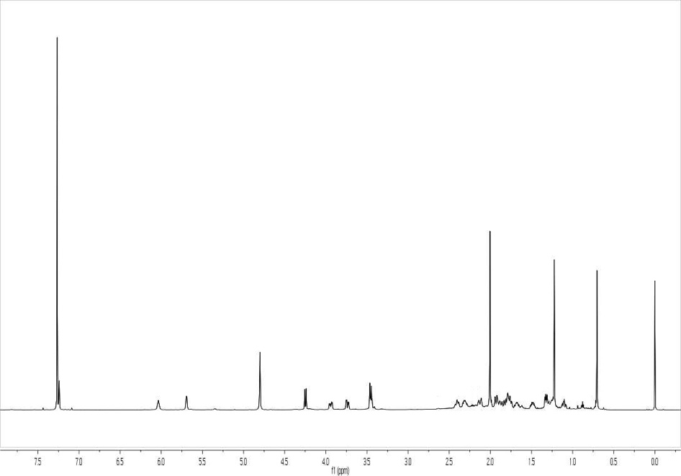
¹H NMR Spectrum of Compound 1
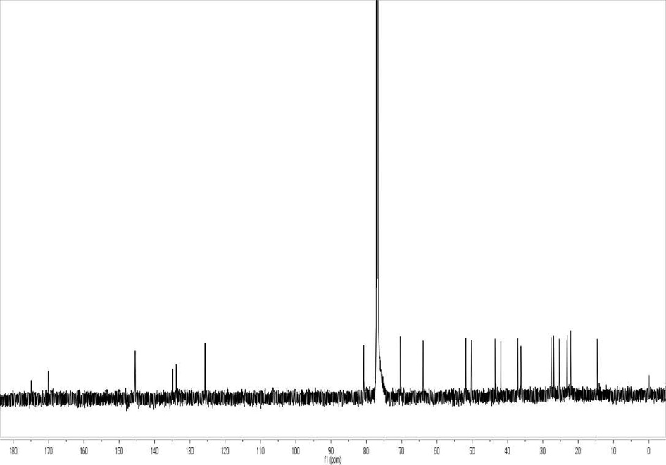
¹³C NMR Spectrum of Compound 1
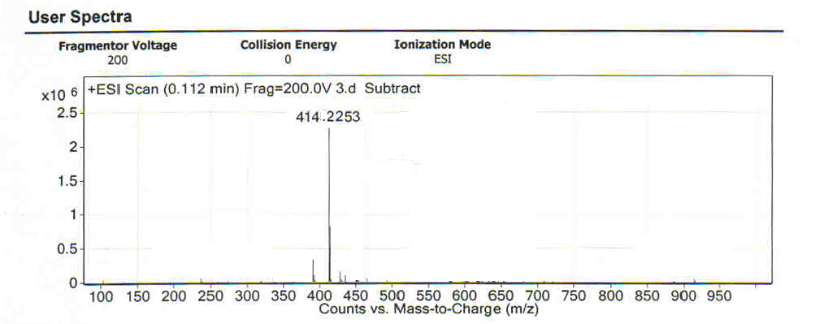
HR-MS of Compound 1
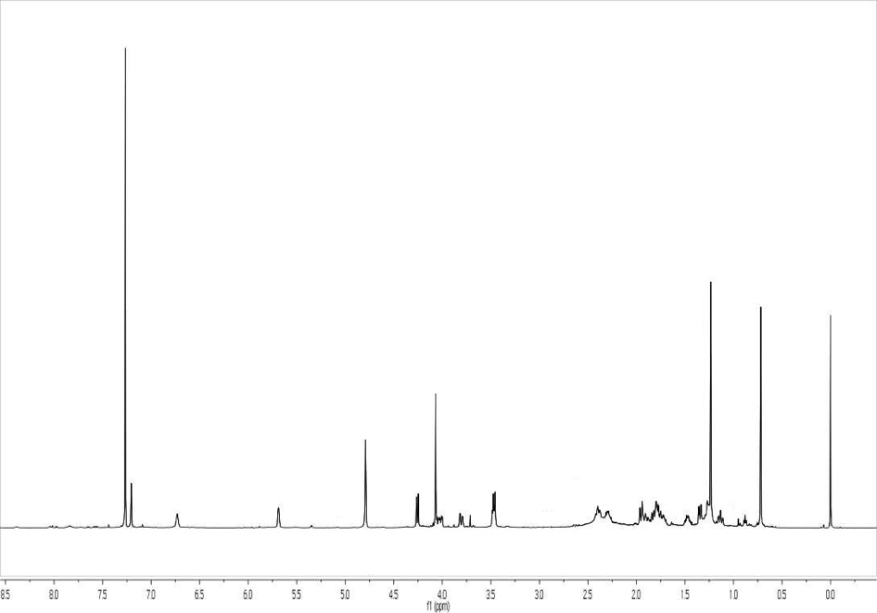
¹H NMR Spectrum of Compound 2
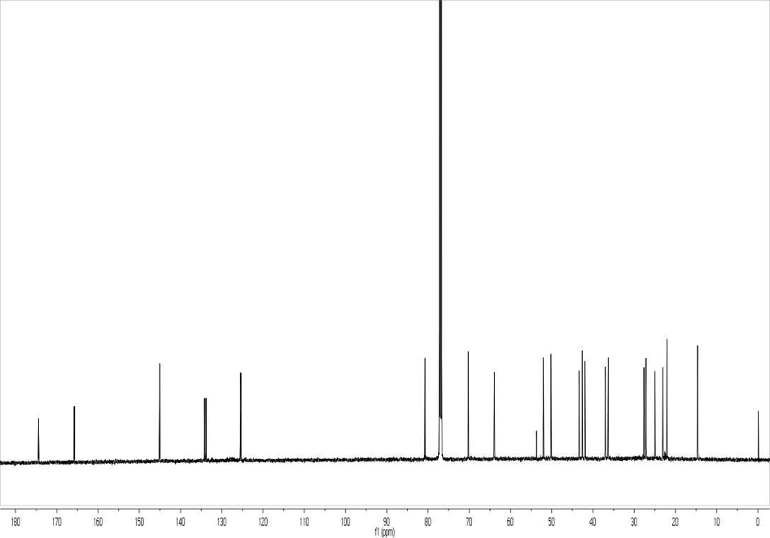
¹³C NMR Spectrum of Compound 2
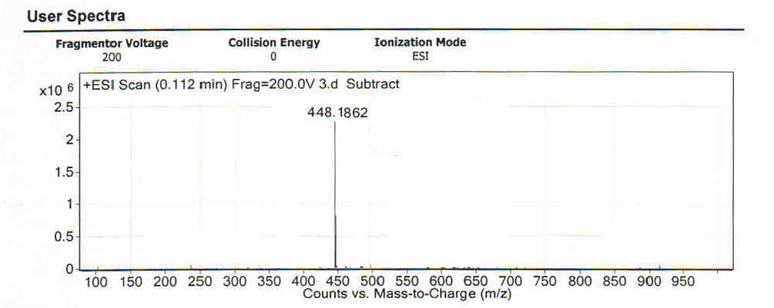
HR-MS of Compound 2
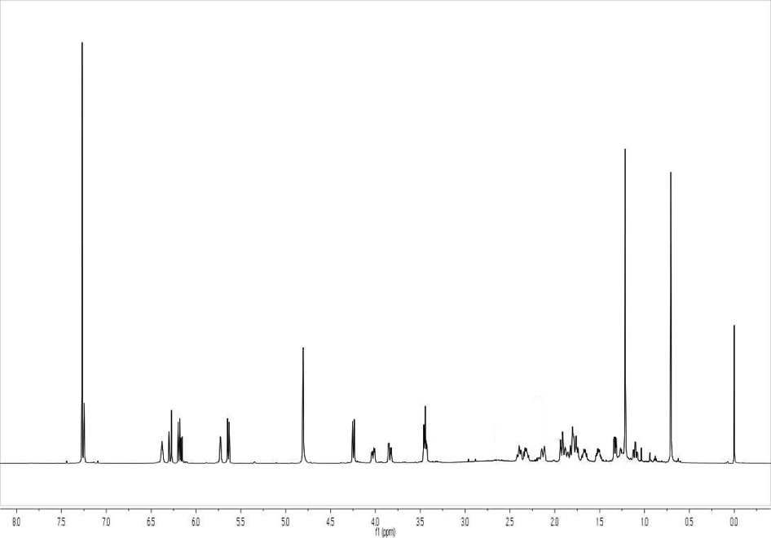
¹H NMR Spectrum of Compound 3
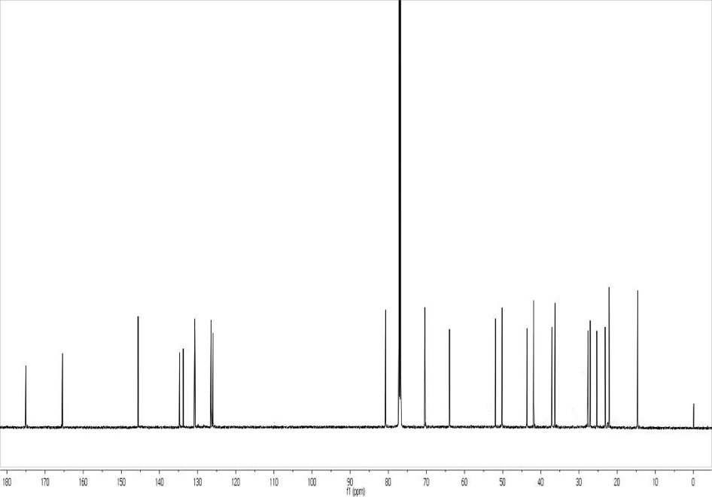
¹³C NMR Spectrum of Compound 3
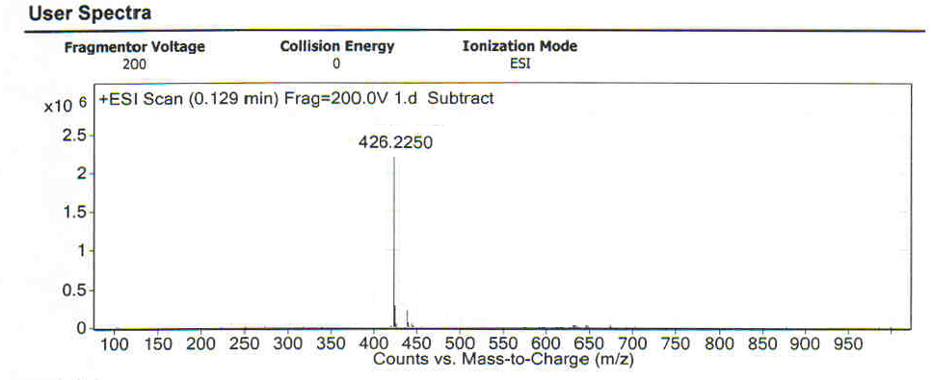
HR-MS of Compound 3
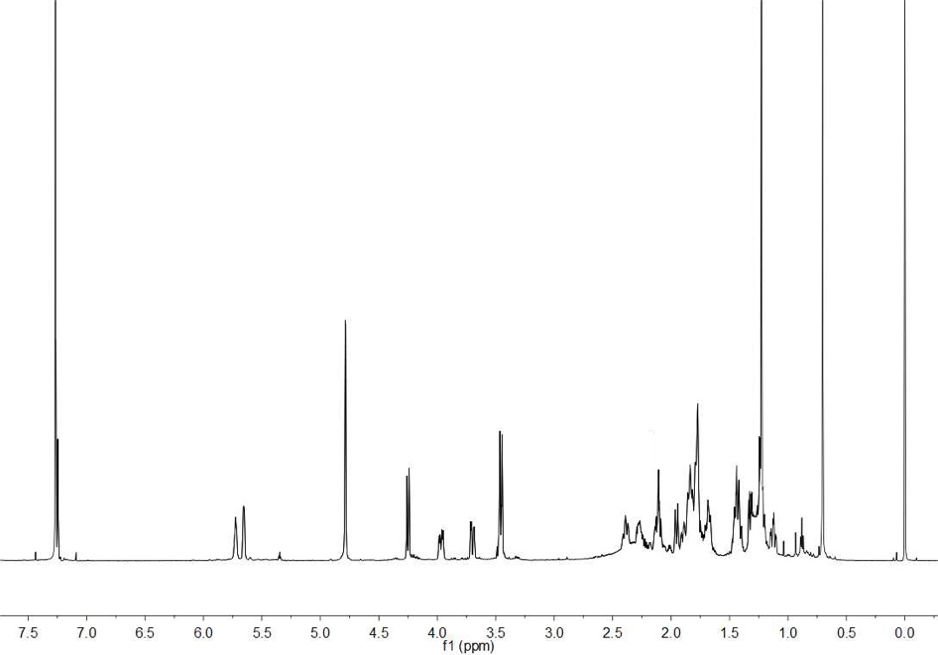
¹H NMR Spectrum of Compound 4
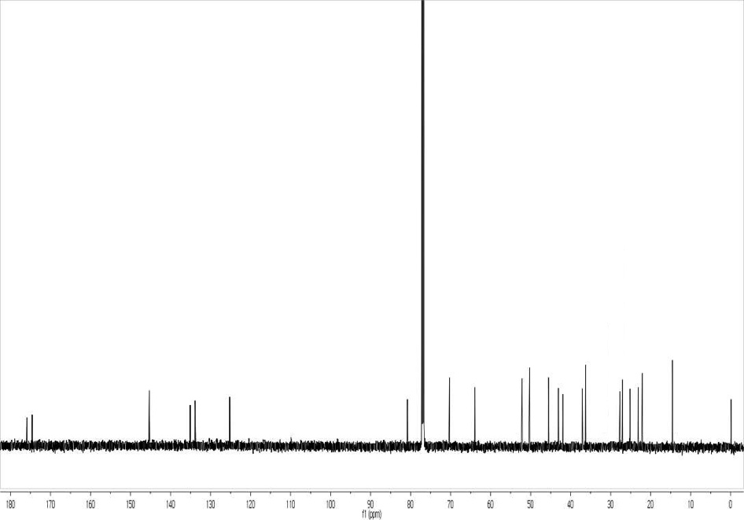
¹³C NMR Spectrum of Compound 4
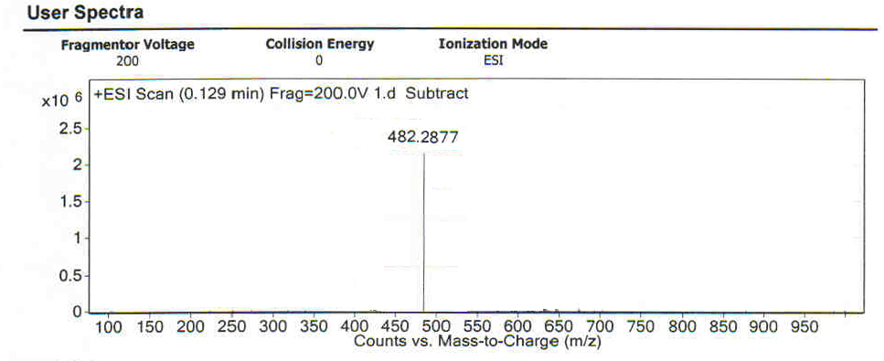
HR-MS of Compound 4
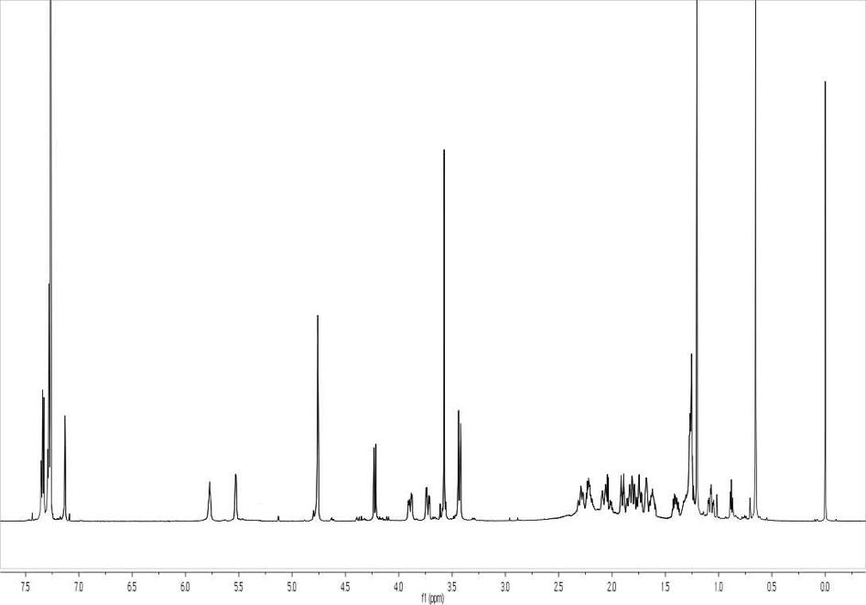
¹H NMR Spectrum of Compound 5
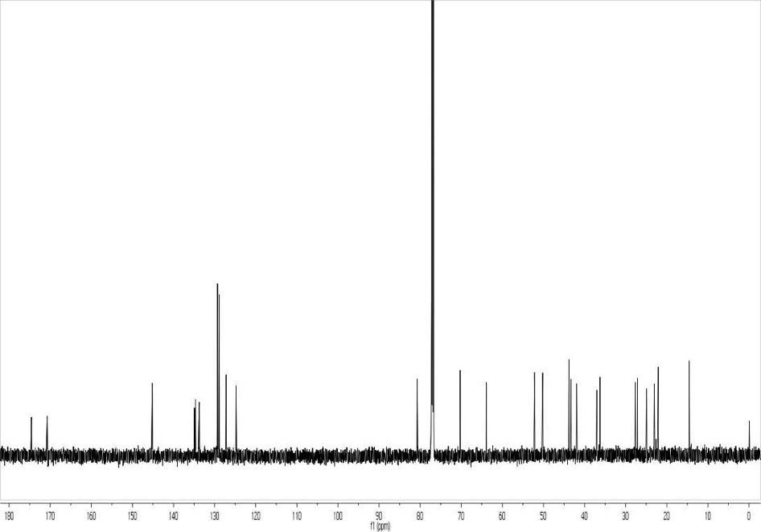
¹³C NMR Spectrum of Compound 5
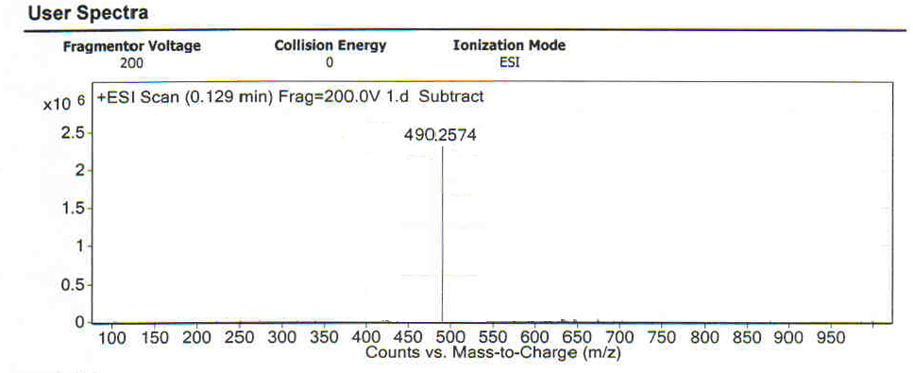
HR-MS of Compound 5
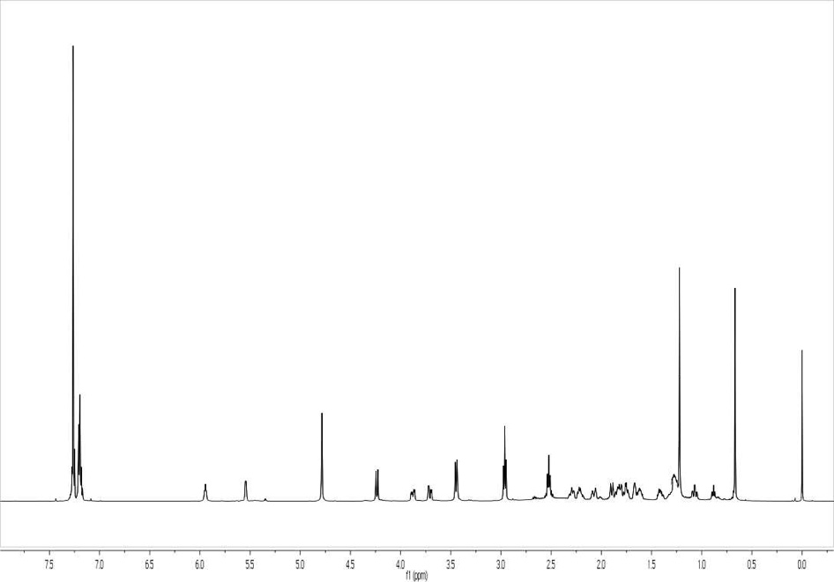
¹H NMR Spectrum of Compound 6
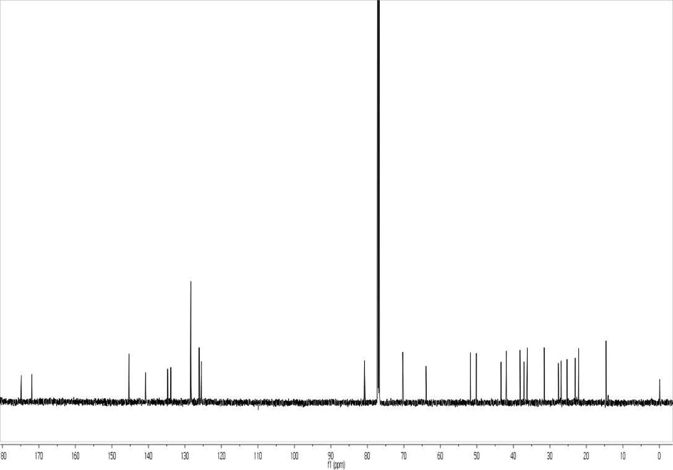
¹³C NMR Spectrum of Compound 6
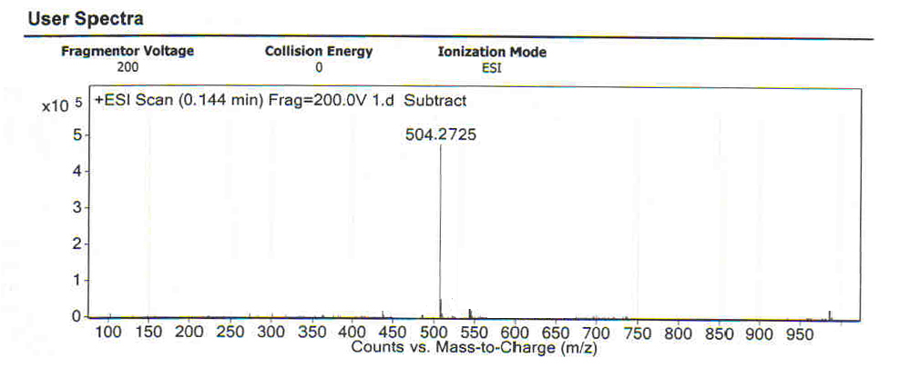
HR-MS of Compound 6
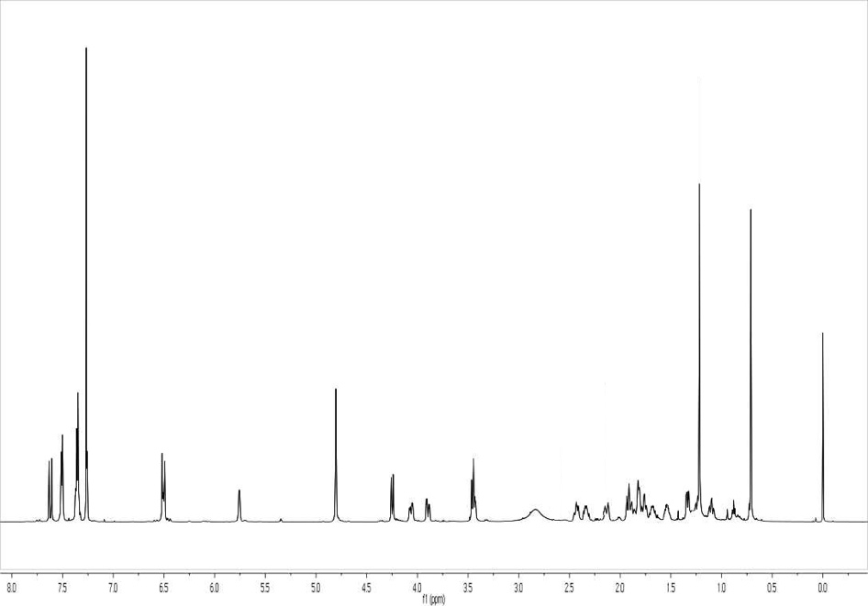
¹H NMR Spectrum of Compound 7
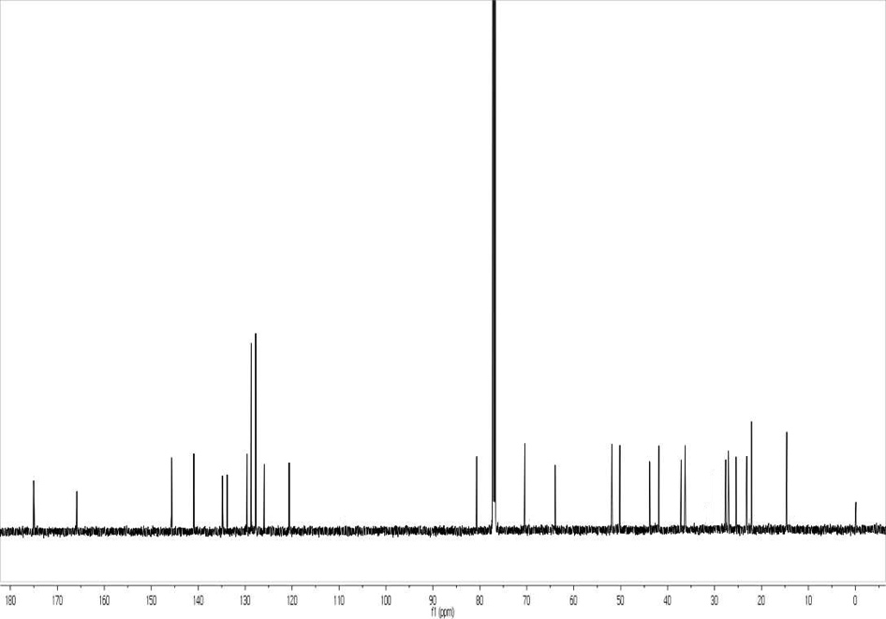
¹³C NMR Spectrum of Compound 7
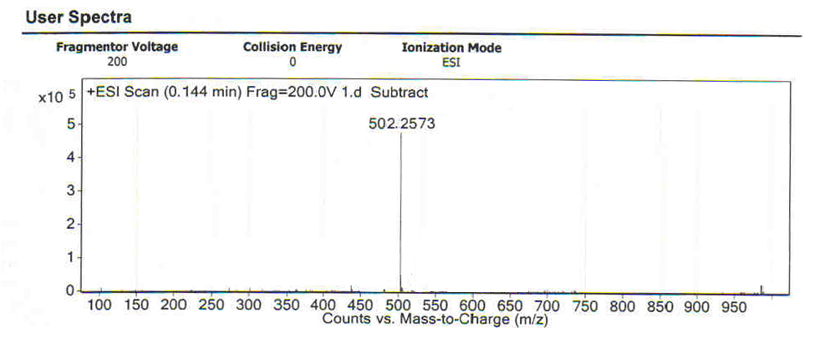
HR-MS of Compound 7
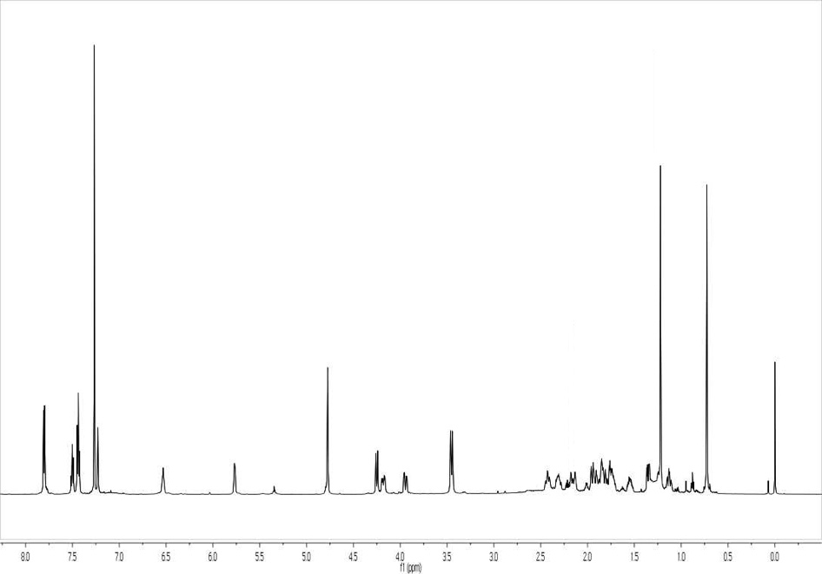
¹H NMR Spectrum of Compound 8
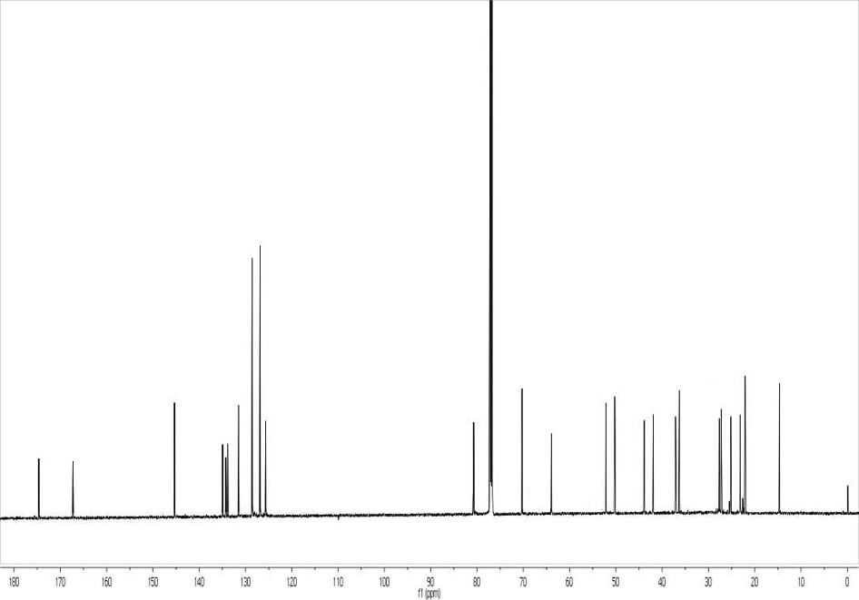
¹³C NMR Spectrum of Compound 8
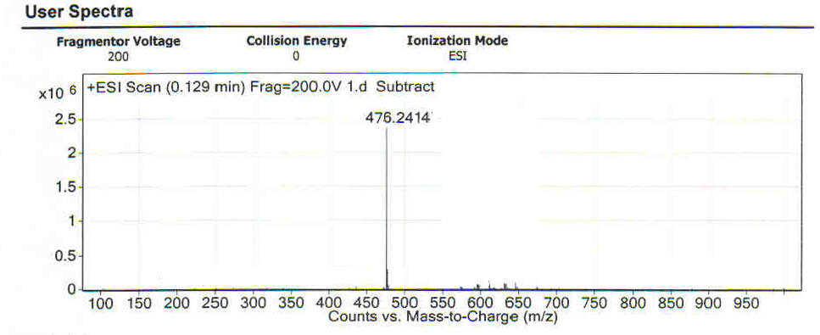
HR-MS of Compound 8
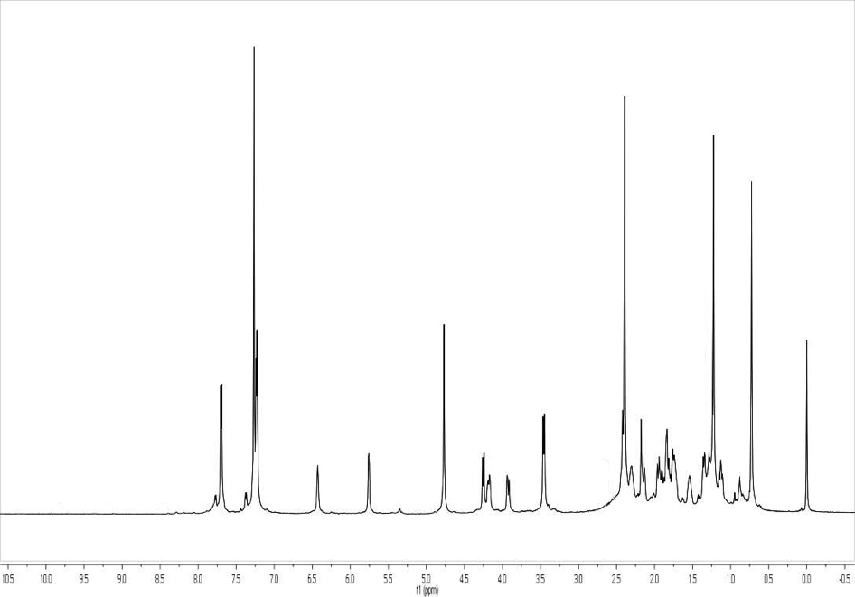
¹H NMR Spectrum of Compound 9
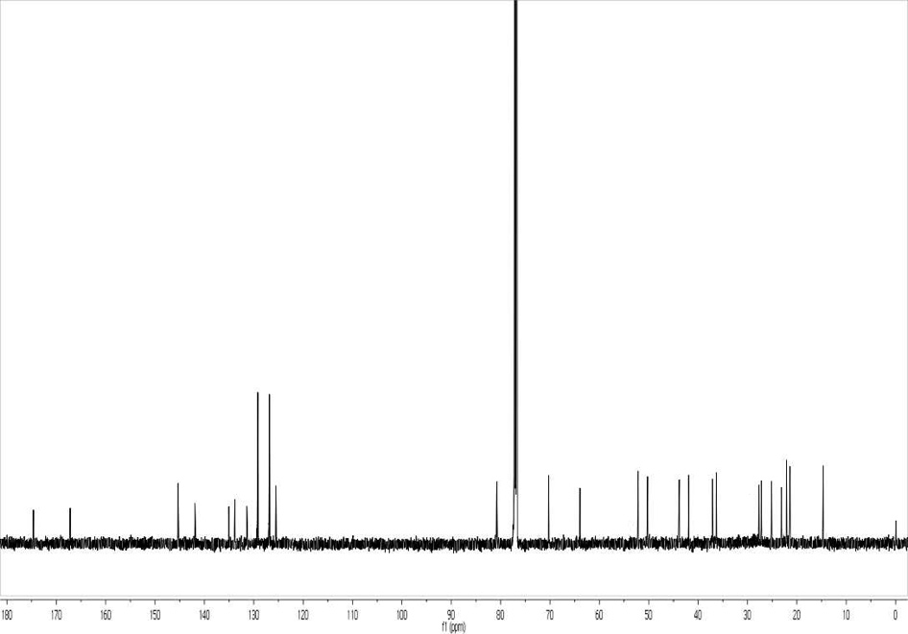
¹³C NMR Spectrum of Compound 9
HR-MS of Compound 9
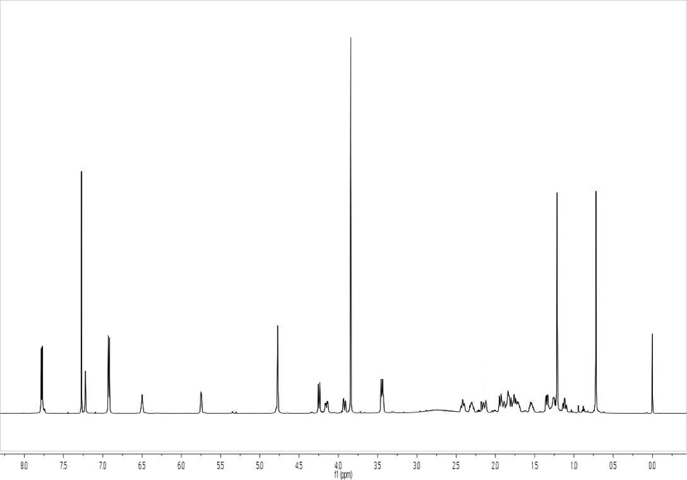
¹H NMR Spectrum of Compound 10

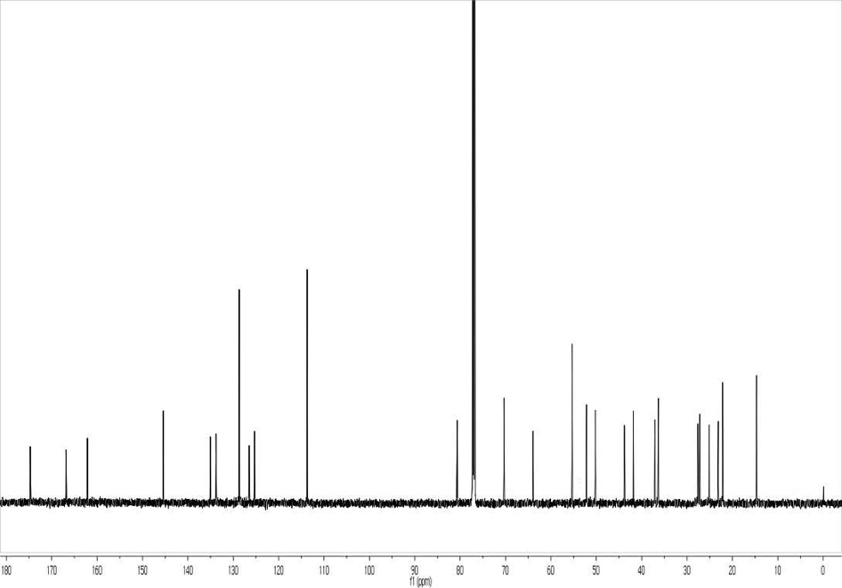
¹³C NMR Spectrum of Compound 10
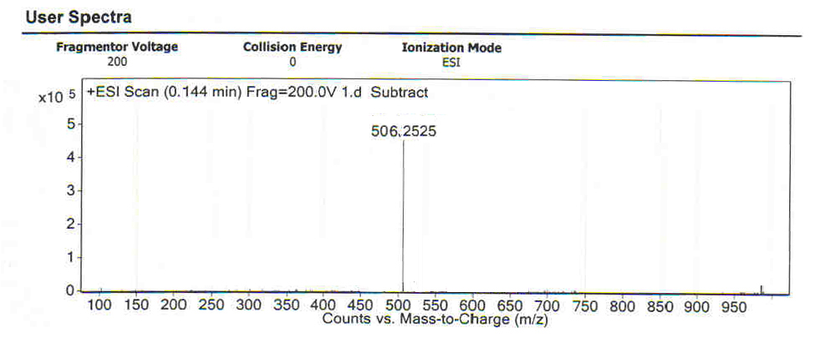
HR-MS of Compound 10
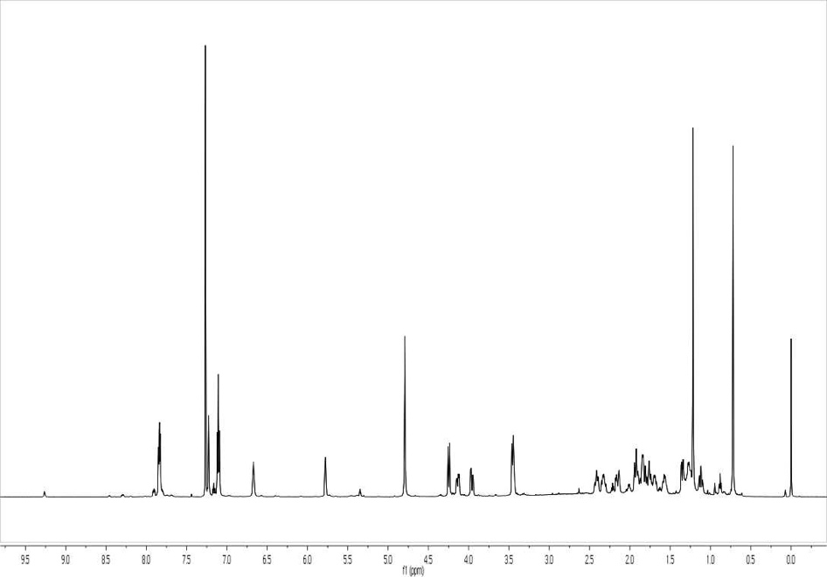
¹H NMR Spectrum of Compound 11
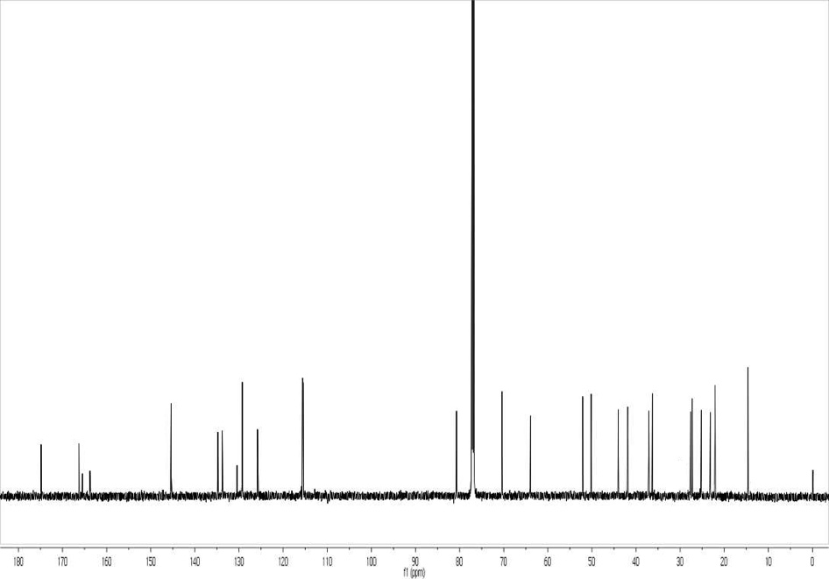
¹³C NMR Spectrum of Compound 11
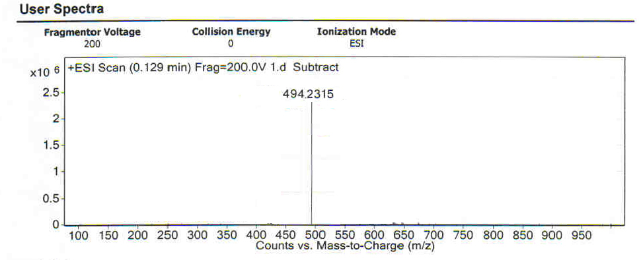
HR-MS of Compound 11
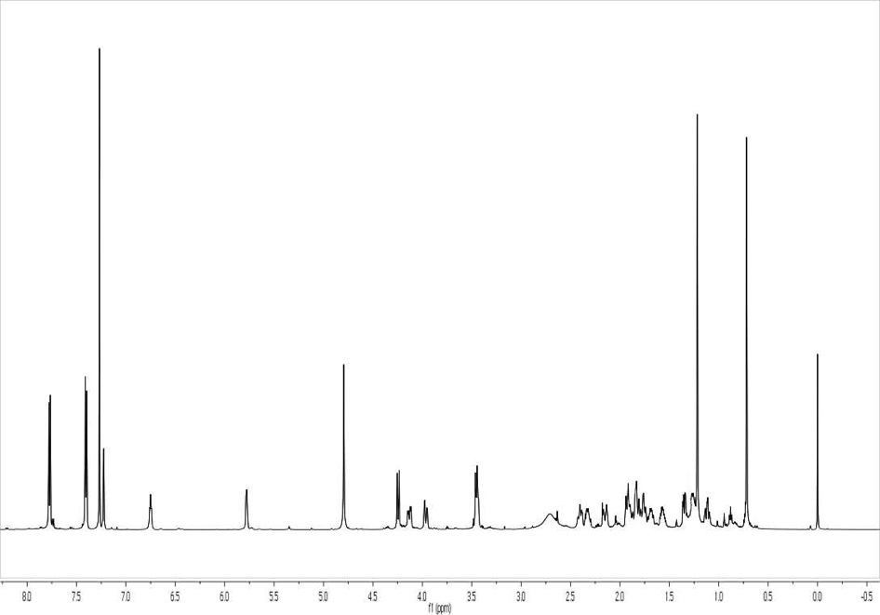
¹H NMR Spectrum of Compound 12
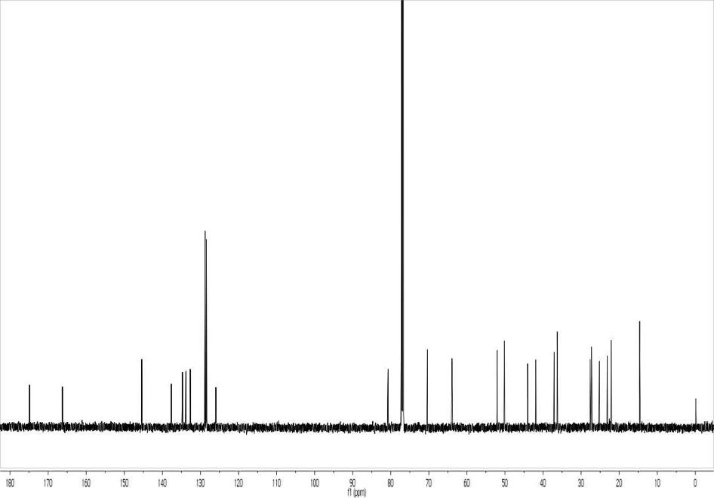
¹³C NMR Spectrum of Compound 12
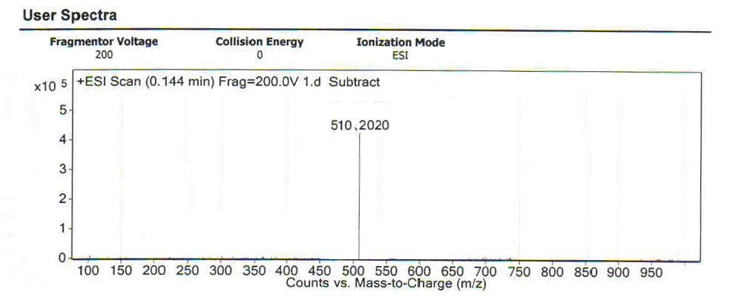
HR-MS of Compound 12
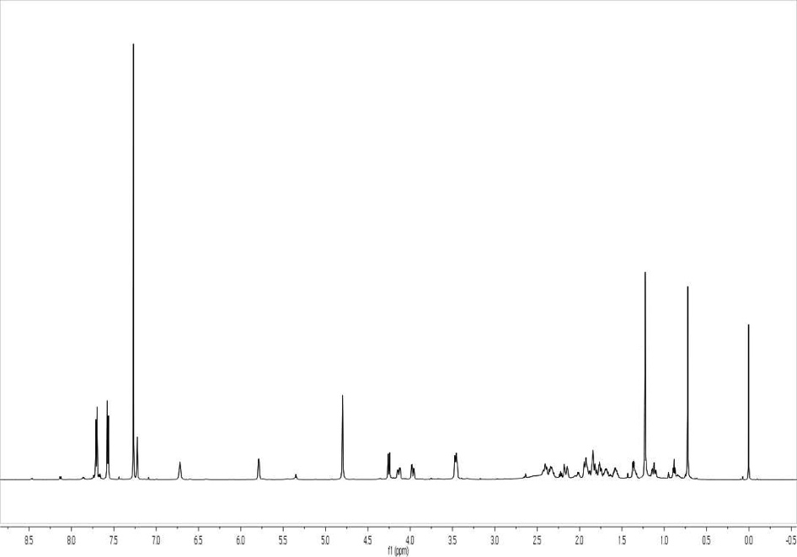
¹H NMR Spectrum of Compound 13
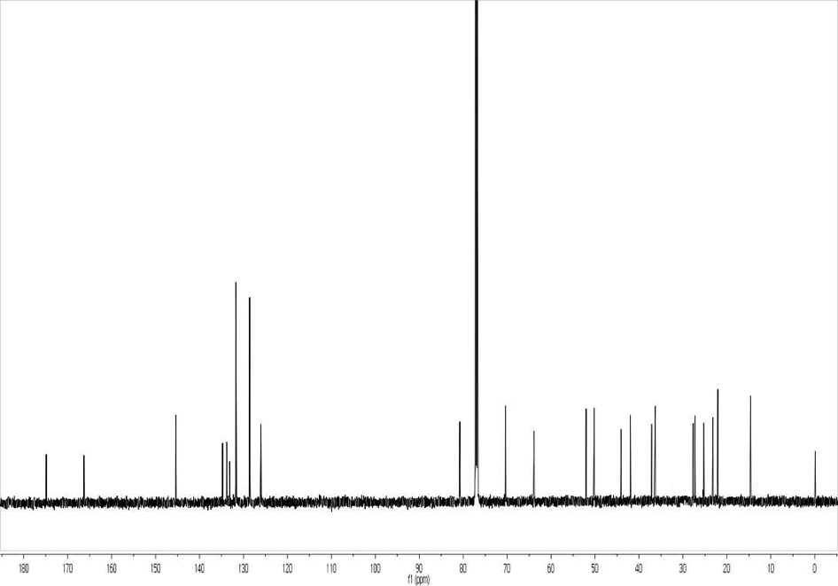
¹³C NMR Spectrum of Compound 13
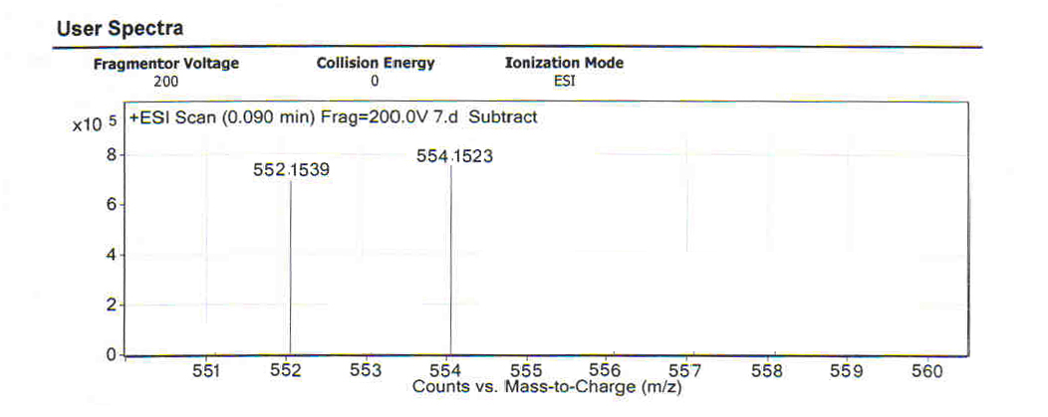
HR-MS of Compound 13
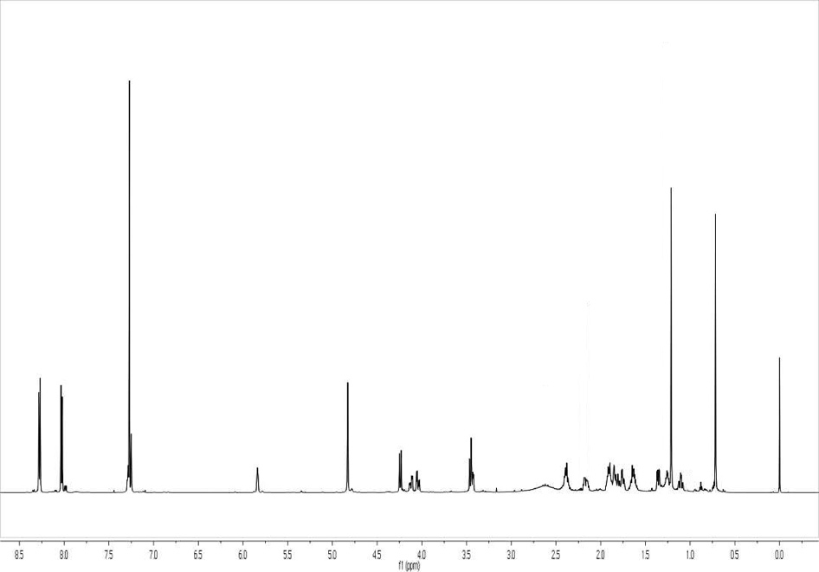
¹H NMR Spectrum of Compound 14
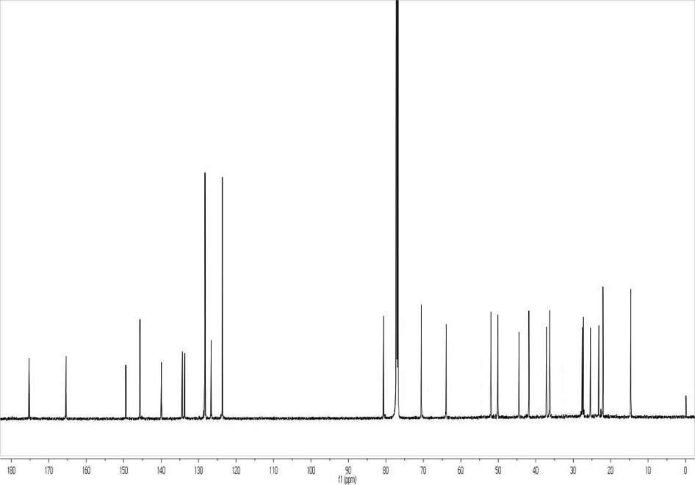
¹³C NMR Spectrum of Compound 14
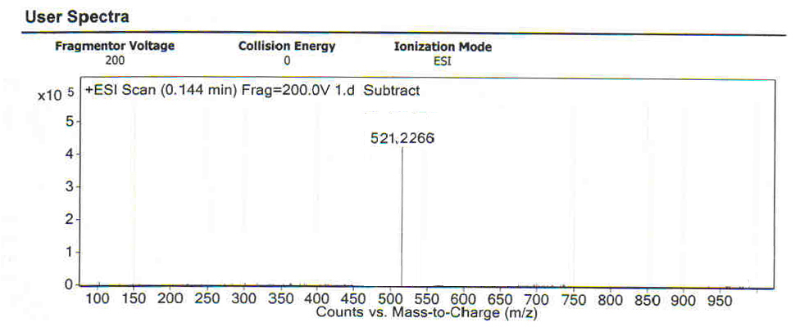
HR-MS of Compound 14
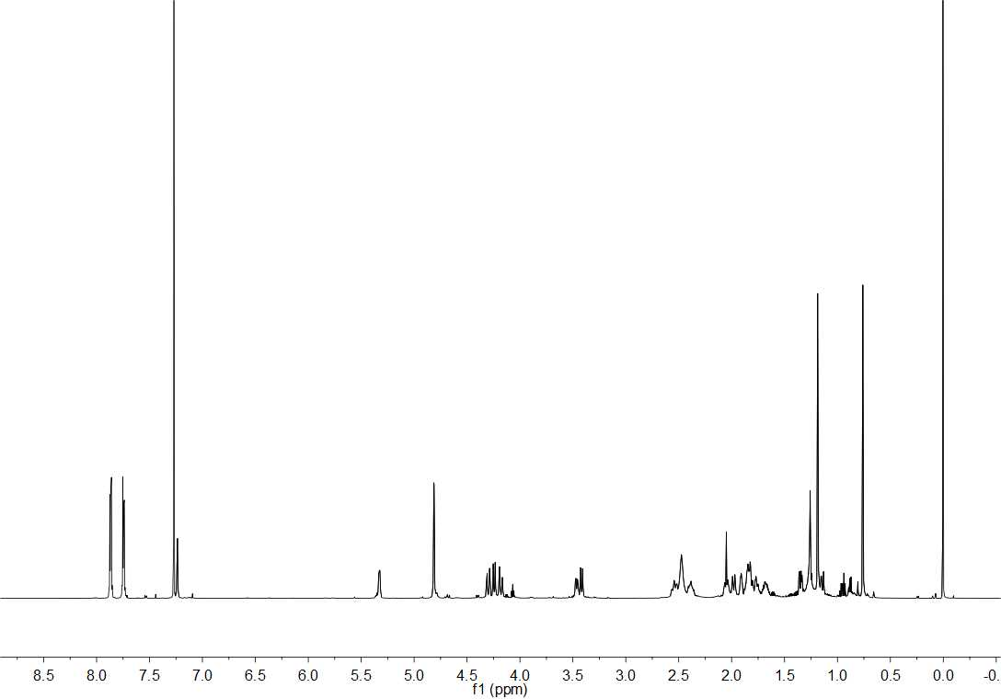
¹H NMR Spectrum of Compound 15
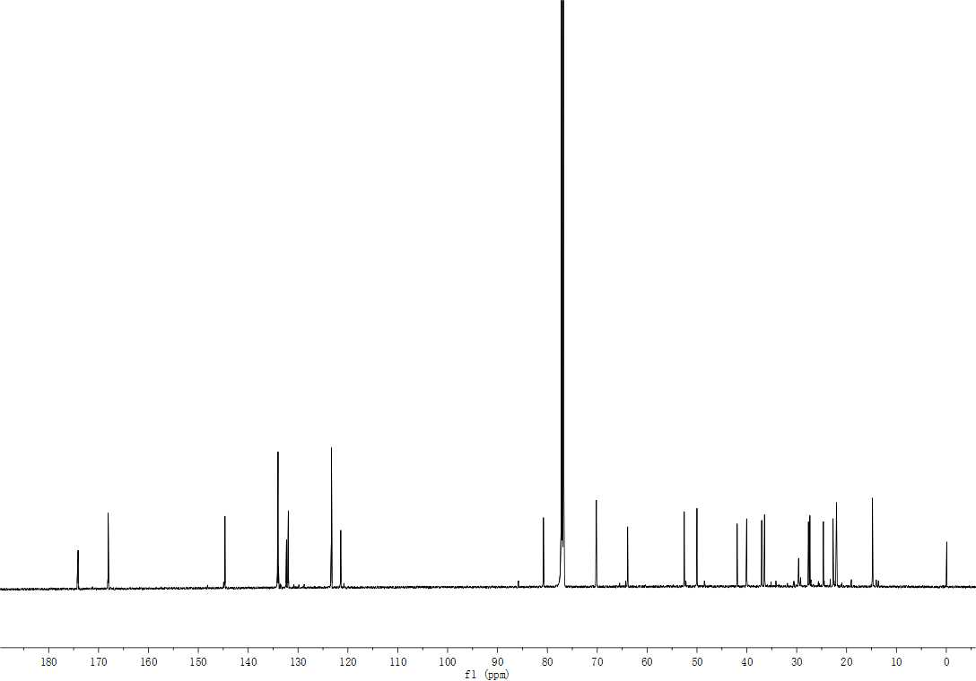
¹³C NMR Spectrum of Compound 15
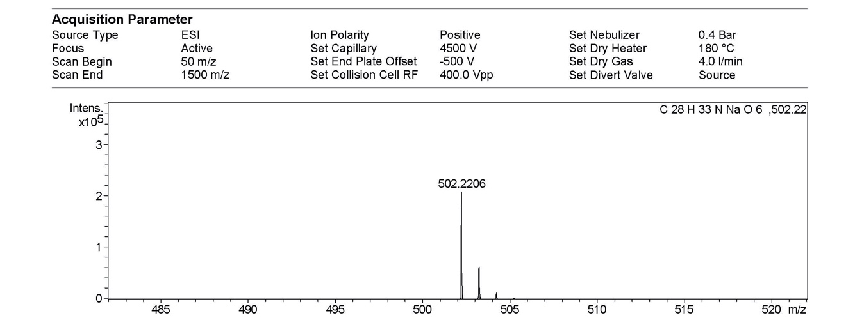
HR-MS of Compound 15
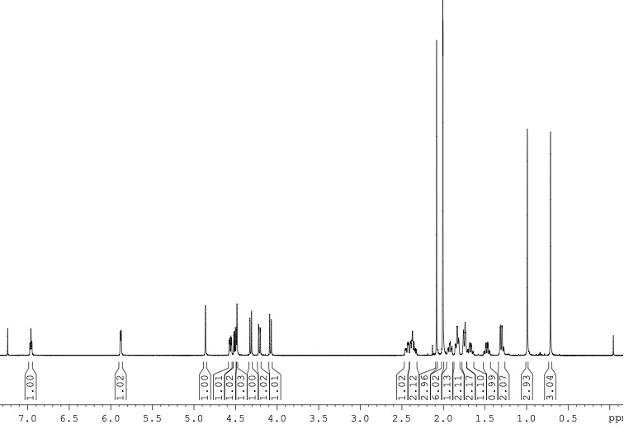
¹H NMR Spectrum of intermediate IM1

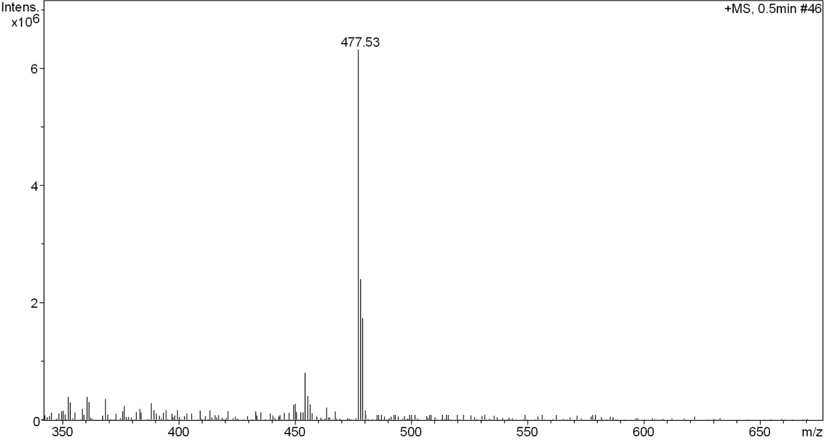
MS of intermediate IM1
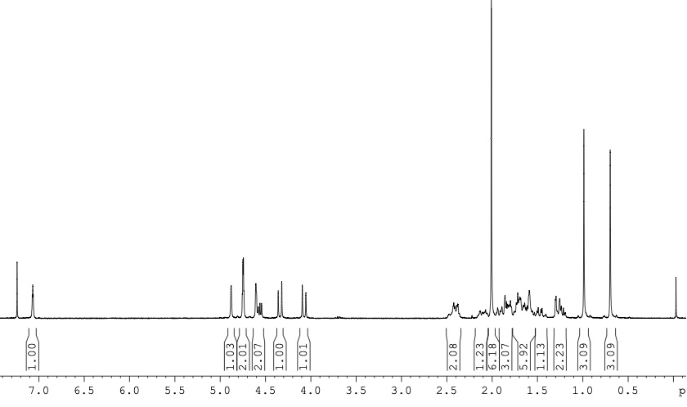
¹H NMR Spectrum of intermediate IM2

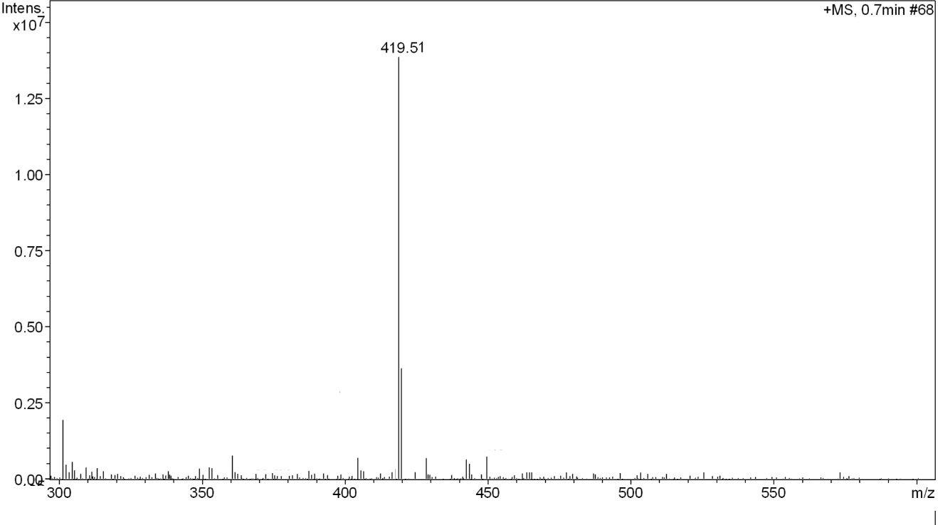
MS of intermediate IM2

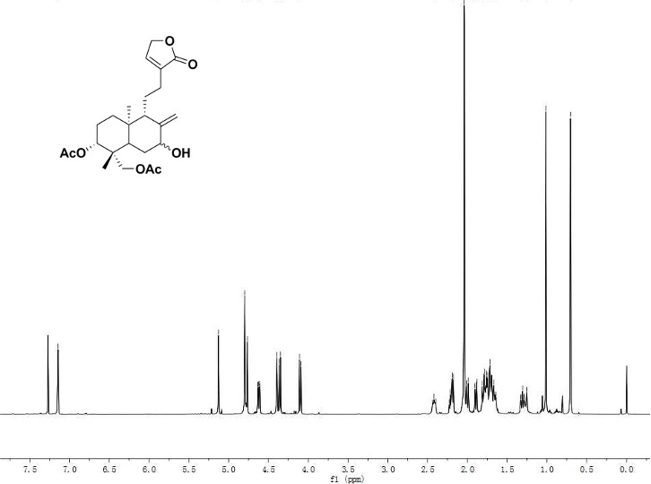
¹H NMR Spectrum of intermediate IM3’

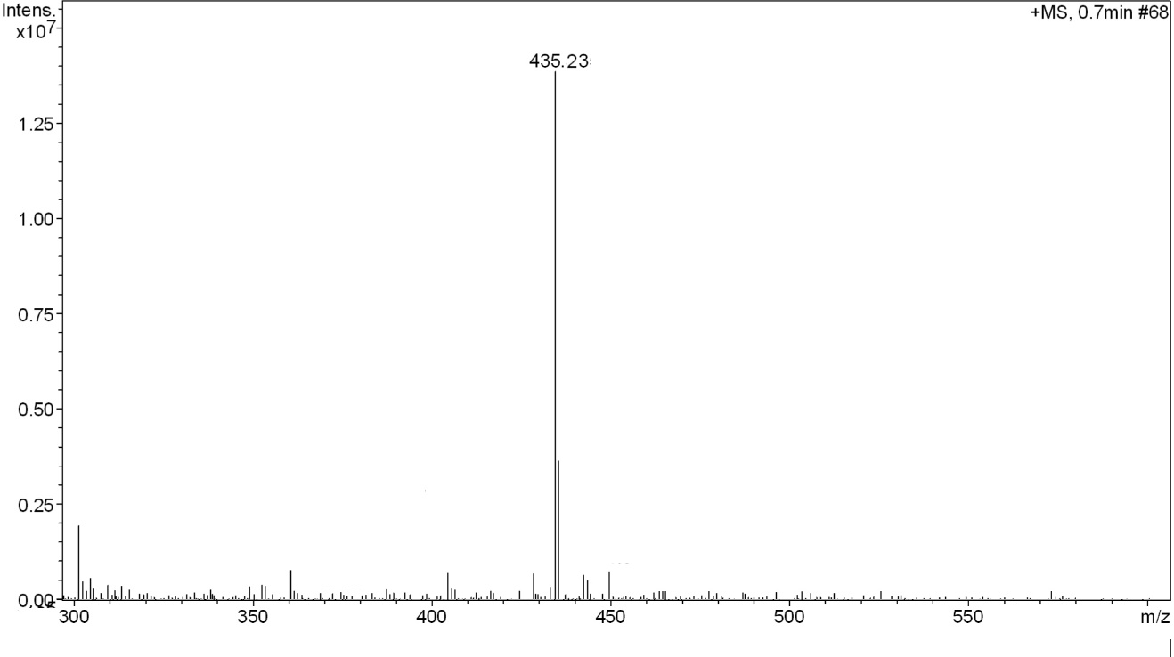
MS of intermediate IM3’

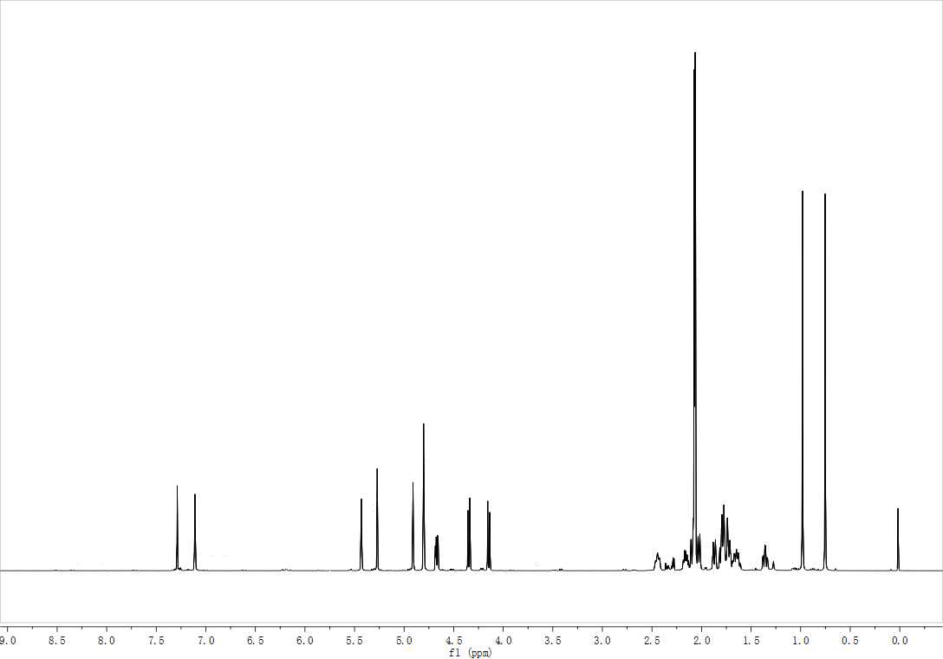
¹H NMR Spectrum of intermediate IM3a

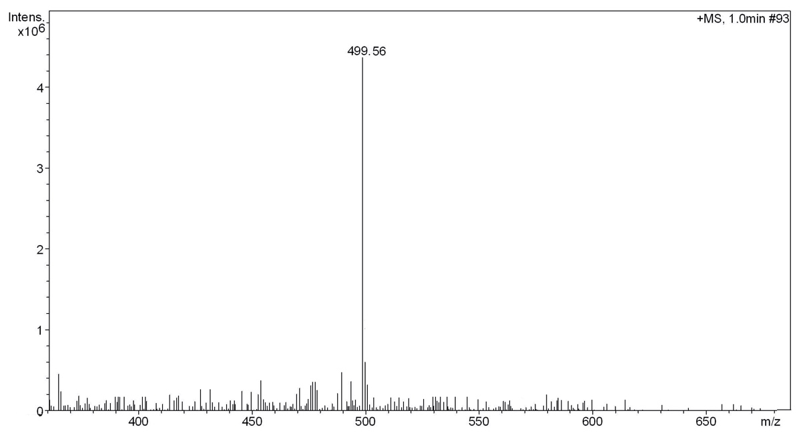
MS of intermediate IM3a

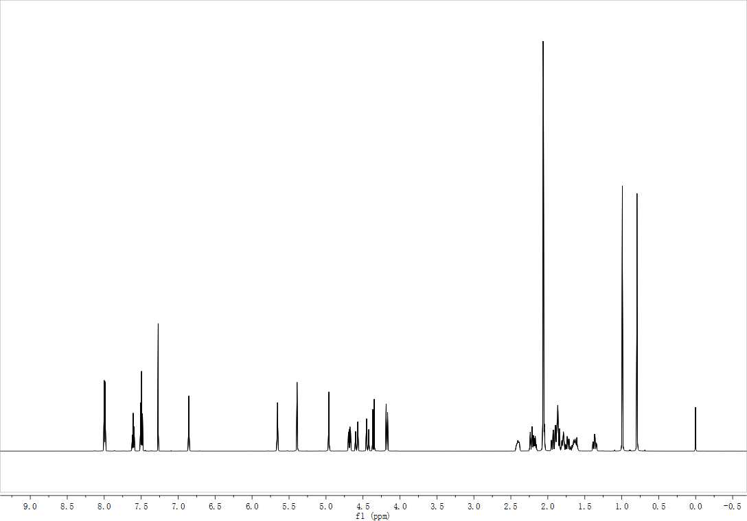
¹H NMR Spectrum of intermediate IM3b
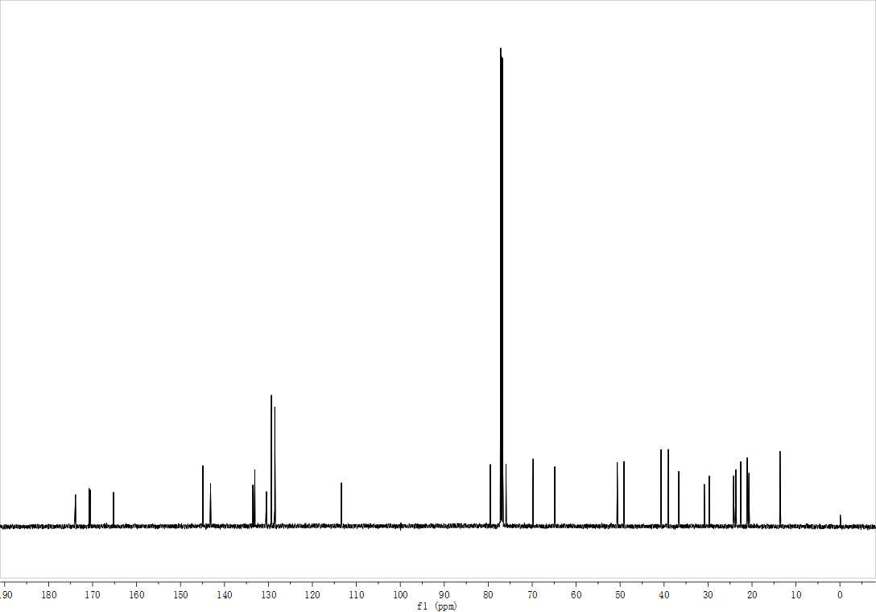
¹³C NMR Spectrum of intermediate IM3b

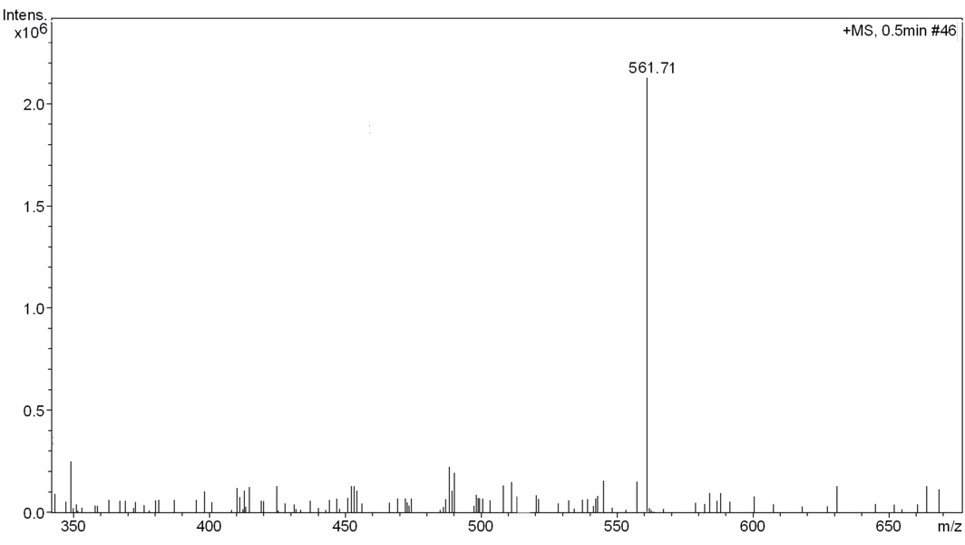
MS of intermediate IM3b
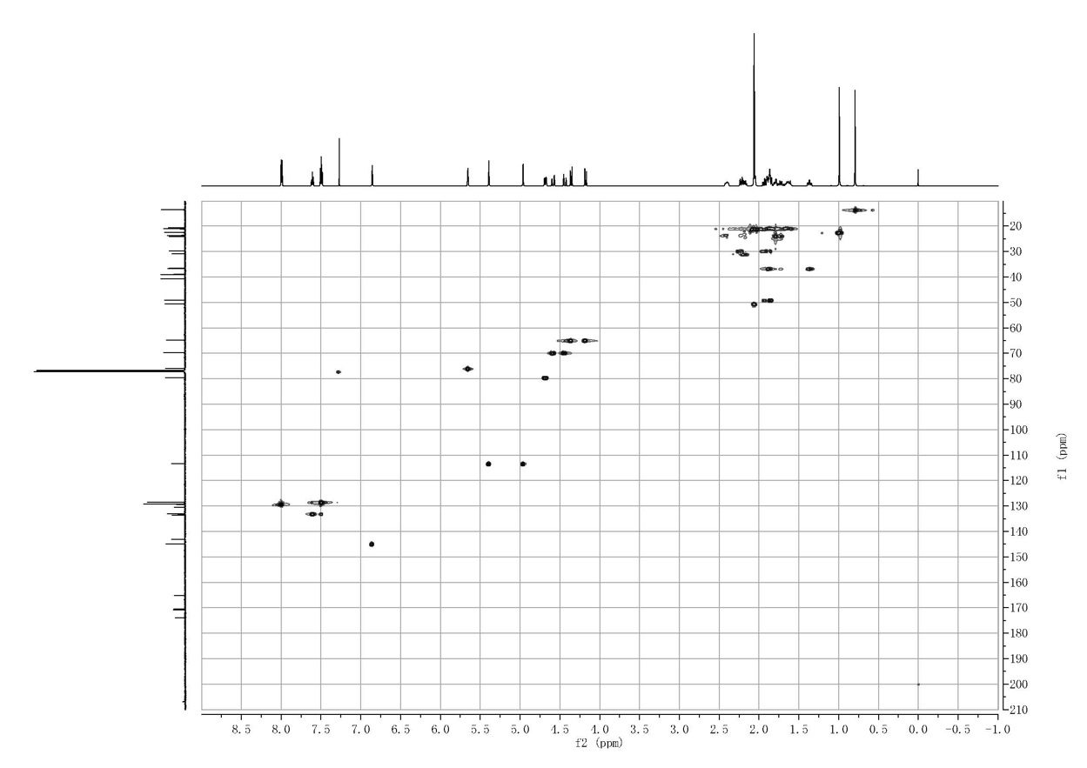
HMQC Spectrum of intermediate IM3b
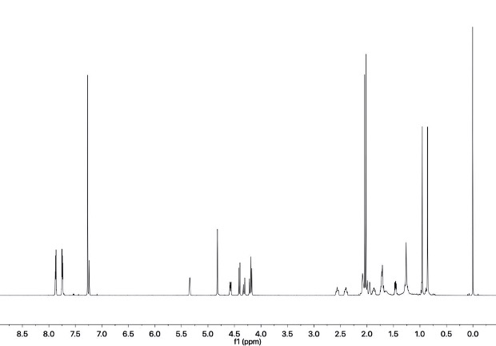
¹H NMR Spectrum of intermediate IM4
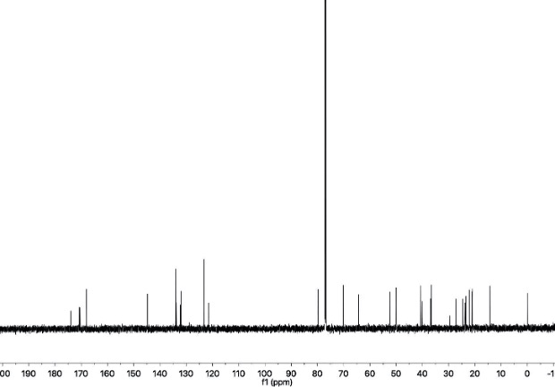
¹³C NMR Spectrum of Compound IM4
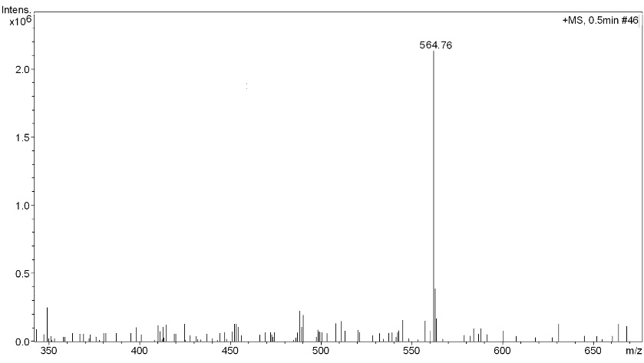
MS of intermediate IM4
3. Determination of the purity of all derivatives.
The purity of all derivatives was confirmed by HPLC method. The HPLC analyses were accomplished with an Agilent 1100 series HPLC system (Agilent Technologies, Waldbronn, U.S.) Separation was achieved on a Waters Symmetry C18 analytical column (5 μm, 4.6 mm (ID)×250 mm). The solvent contained 75% methanol in distilled water was delivered at 1.5 mL/min over 20min. The column was maintained at room temperature with a column oven. The derivatives were dissolved in methanol and detected at 220 nm. The purity of the samples was calculated from a surface integral of detected peaks and is described as percent (%). The purity of all derivatives ranged from 95.4% to 98.4%. Retention times are given in minutes (min).
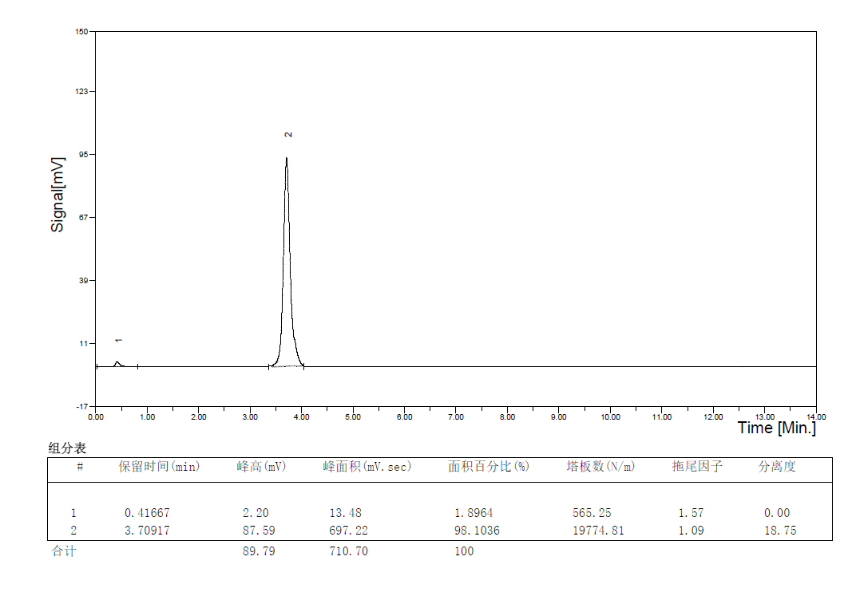
Figure 2s. The HPLC of compound 1.
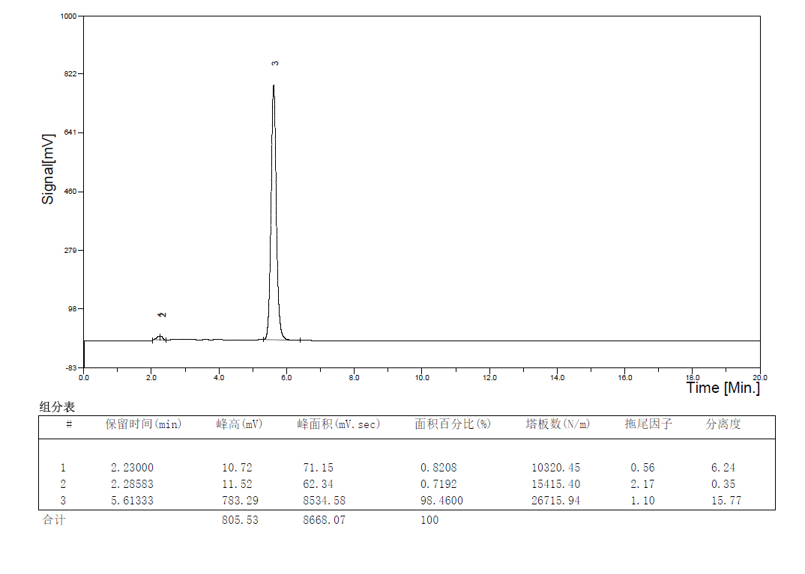
Figure 3s. The HPLC of compound 2.
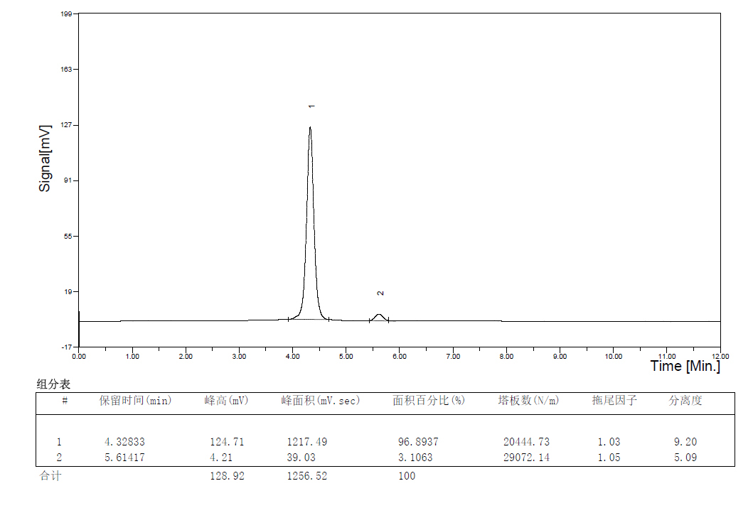
Figure 4s. The HPLC of compound 3.
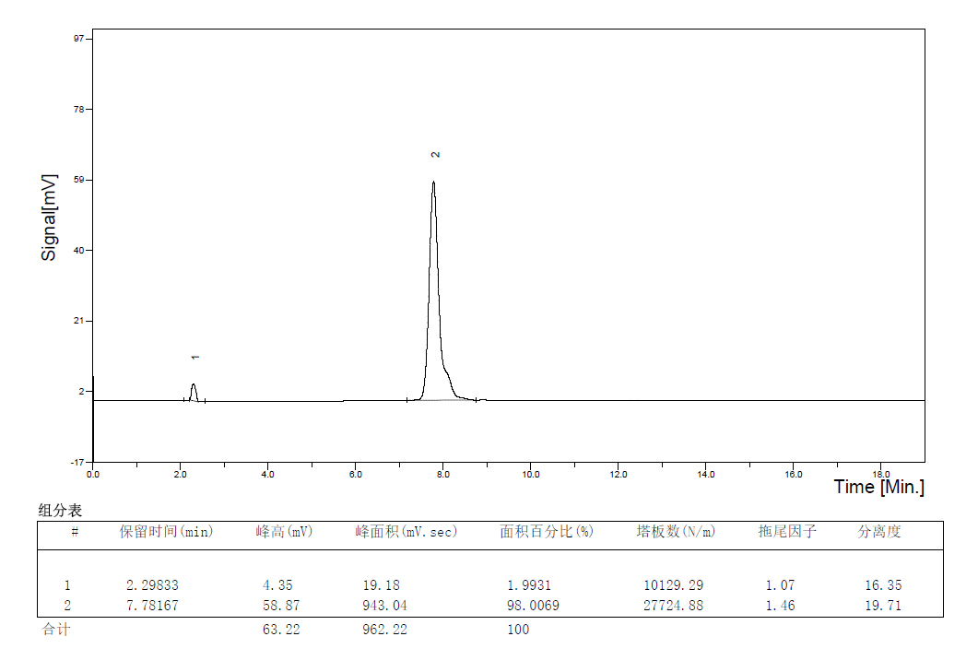
Figure 5s. The HPLC of compound 4.
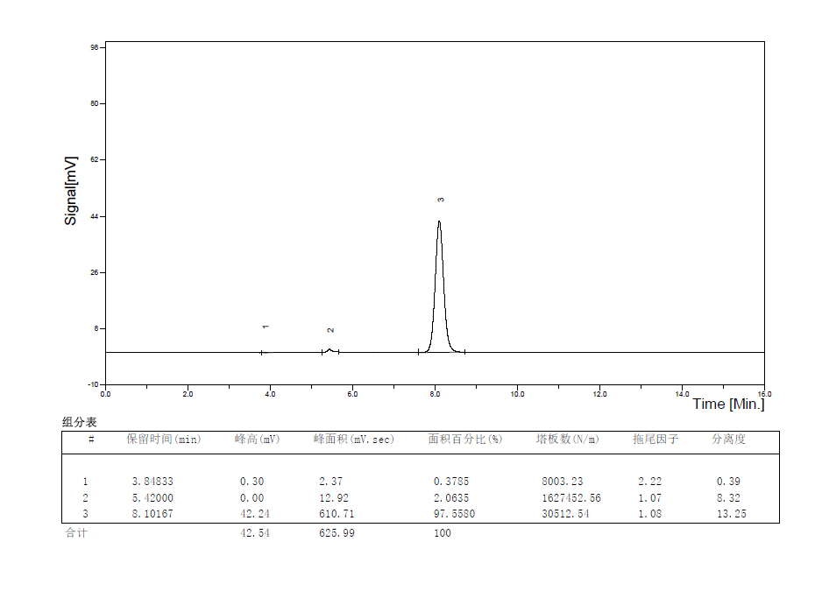
Figure 6s. The HPLC of compound 5.
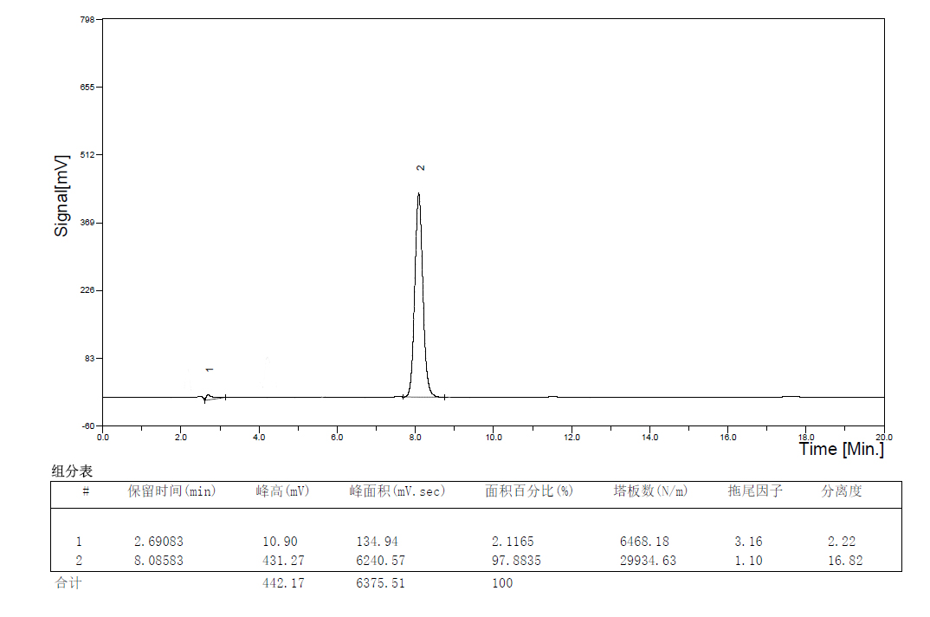
Figure 7s. The HPLC of compound 6.
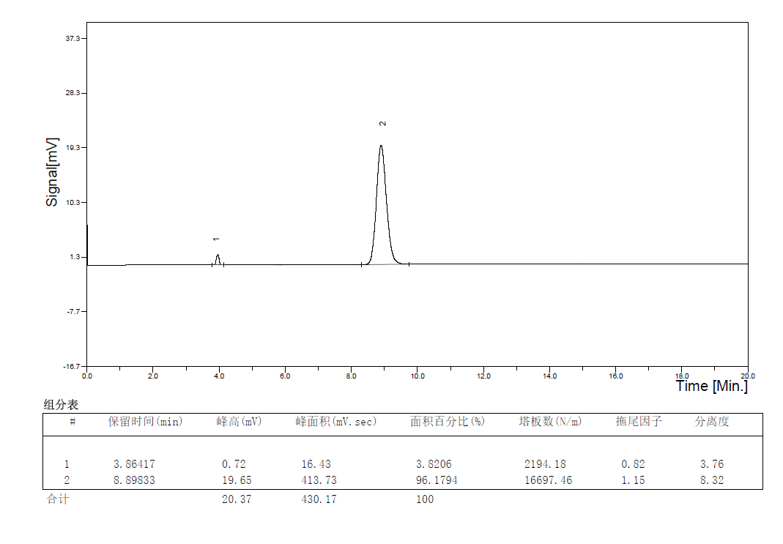
Figure 8s. The HPLC of compound 7.

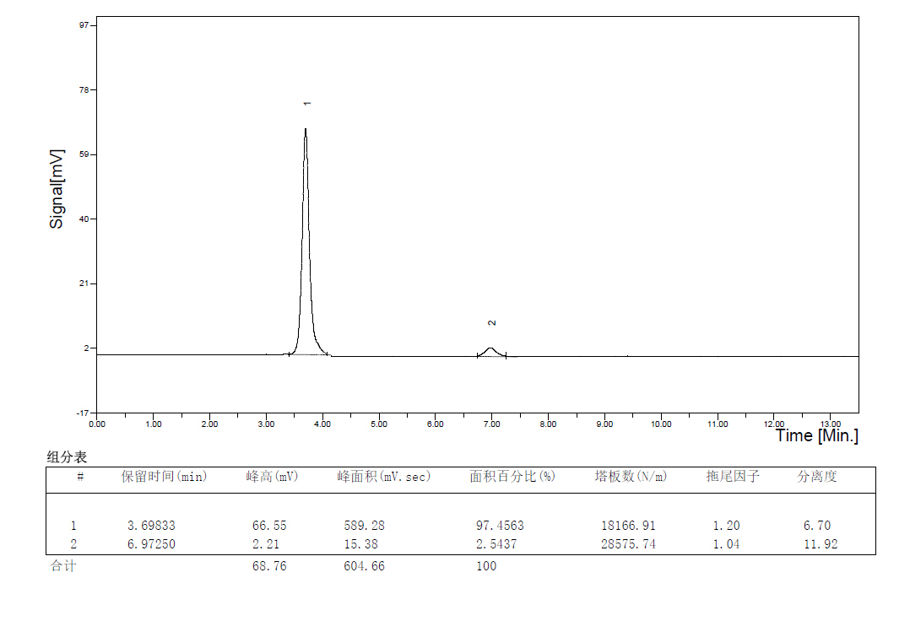
Figure 9s. The HPLC of compound 8.
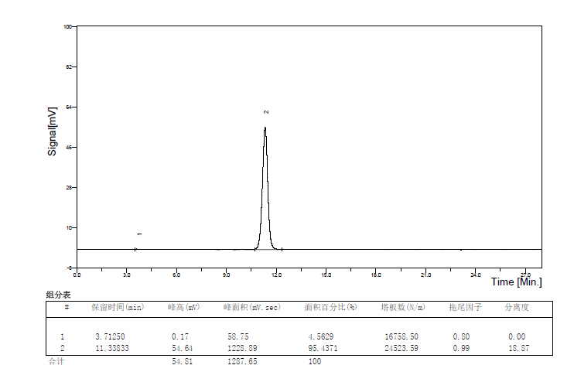
Figure 10s. The HPLC of compound 9.

Figure 11s. The HPLC of compound 10.
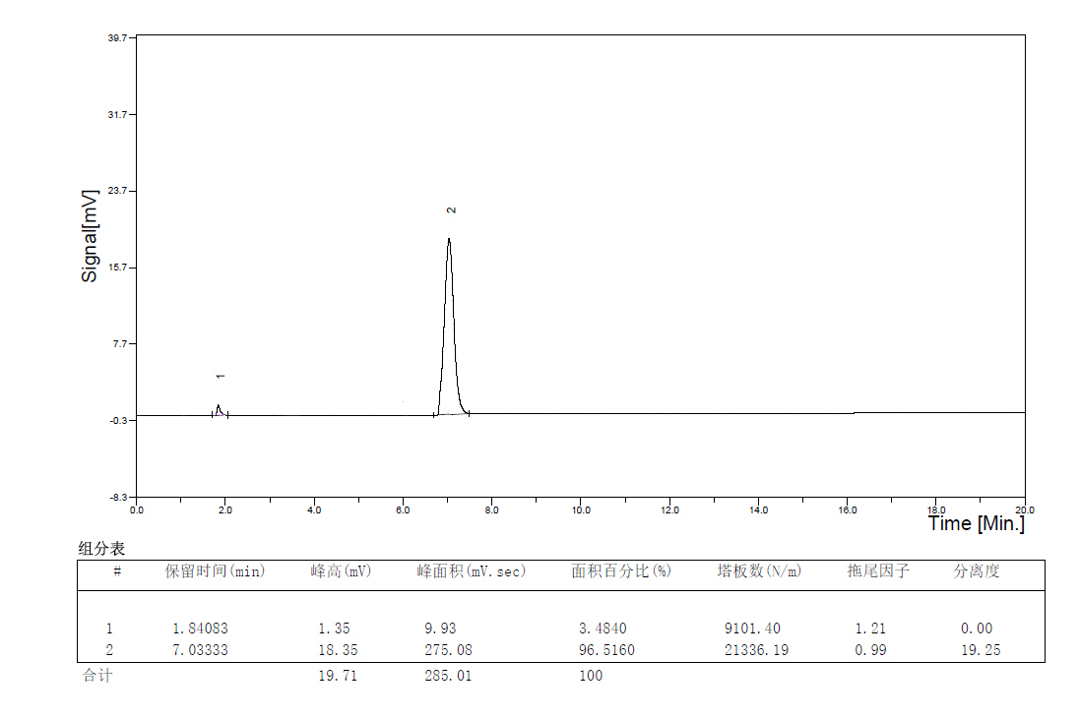
Figure 12s. The HPLC of compound 11.
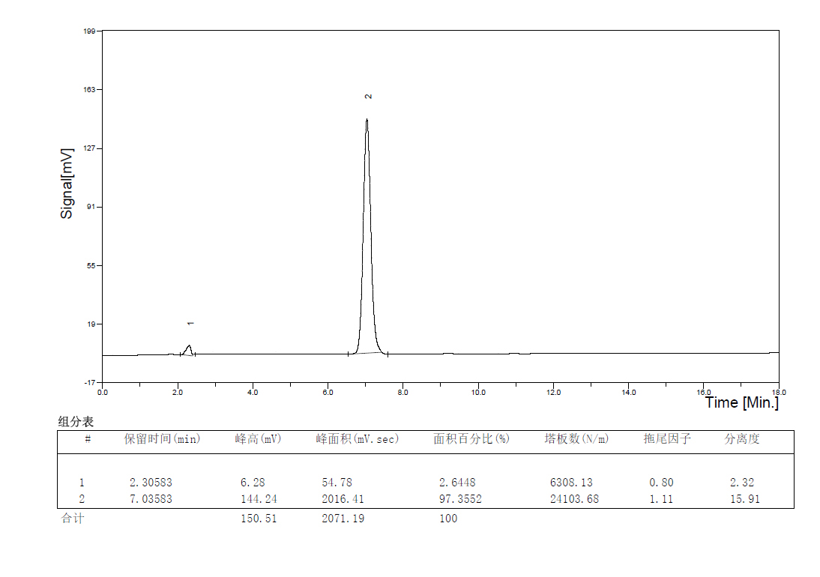
Figure 13s. The HPLC of compound 12.
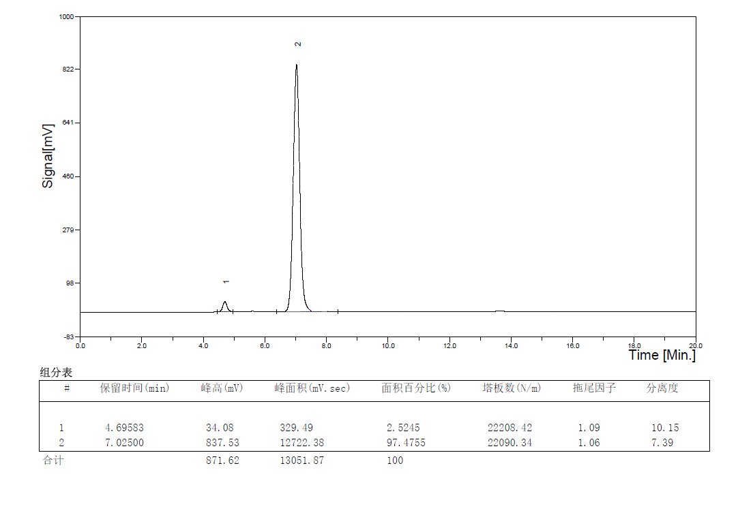
Figure 14s. The HPLC of compound 13.
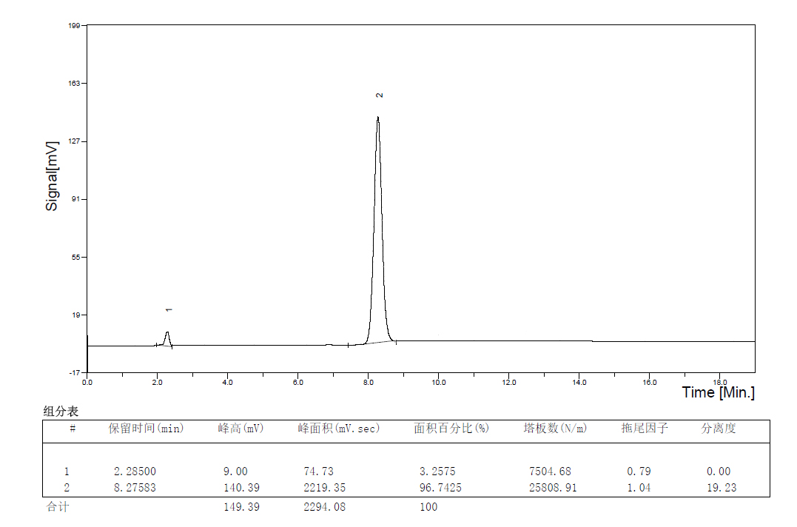
Figure 14s. The HPLC of compound 14.
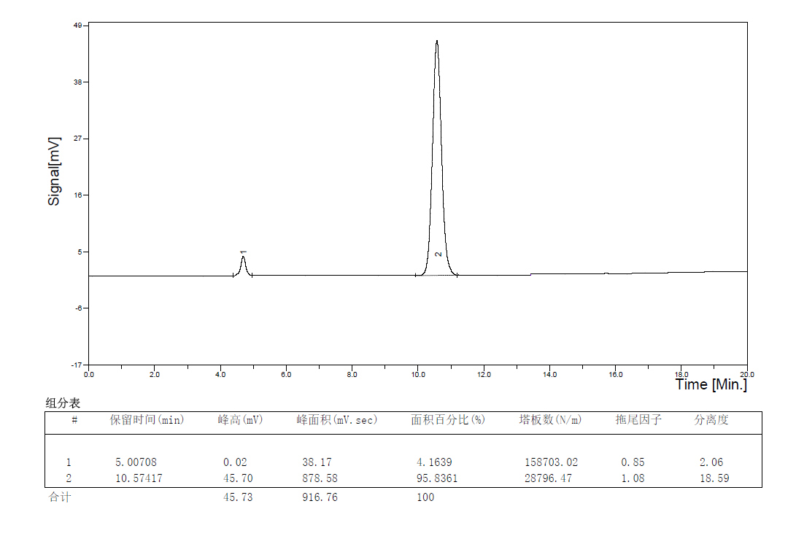
Figure 15s. The HPLC of compound 15.

