Topological Insulator as an Efficient Catalyst for Oxidative Carbonylation of Amines

Jiang Li, ^{‡1} Jia-Zhen Wu,^{‡1,2,} Sang-won Park,^{‡1} Tian-Nan Ye,^{1,3} Yang-Fan Lu,^{1,4} Masayoshi Miyazaki¹, Toshiharu Yokoyama¹, Tomofumi Tada,^{1,*} Masaaki Kitano^{1,*}, and Hideo Hosono^{1,5,*}

¹Materials Research Center for Element Strategy, Tokyo Institute of Technology, 4259 Nagatsuta, Midori-ku, Yokohama 226-8503, Japan.
²Department of Materials Science and Engineering, Southern University of Science and Technology, Guangdong 518055, China.
³Frontiers Science Center for Transformative Molecules, School of Chemistry and Chemical Engineering, Shanghai Jiao Tong University, Shanghai 200240, China.
⁴College of Materials Science and Engineering, National Engineering Research Center for Magnesium Alloys, Chongqing University, Chongqing 400030, P.R. China
⁵International Center for Materials Nanoarchitectonics (WPI-MANA) National Institute for Materials Science (NIMS), 1-1 Namiki, Tsukuba, Ibaraki 305-0044, Japan.

* Corresponding author e-mail: hosono@mces.titech.ac.jp, kitano.m.aa@m.titech.ac.jp, tada.t.ae@m.titech.ac.jp
‡ These authors have contributed equally.

Table S1. Oxidative carbonylation of butylamine with different catalysts.
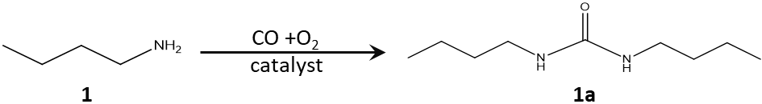
Catalysts | Amount (mg) | Temperature (ºC) | Time (h) | Dissolved species  (μg) ª |  | Conversion (%) ^{b} | Yield (%) ^{b}
Bi₂Se₃ bulk | 50 | 40 | 5 | Se(0) | Bi(0) | 100 | 99
Bi₂Se₃ NPs | 20 | 20 | 4 | Se(0) | Bi(0) | 100 | 99
BiSe | 50 | 40 | 5 | Se(0) | Bi(0) | 20 | 19
Se(0.25wt%)/Al₂O₃ | 50 | 40 | 5 | Se(26) | - | 100 | 99
Bi | 50 | 40 | 5 | Se(0) | Bi(0) | 0 | 0
Sb₂Se₃ | 50 | 40 | 5 | Se(12) | Sb(7) | 70 | 68
CuSe | 50 | 40 | 5 | Se(1400) | Cu(500) | 13 | 10
SeO₂ | 50 | 40 | 5 | Se(3800) | - | 100 | 54
Reaction conditions: butylamine (1 mmol), THF (2 ml), CO (0.5 MPa), O₂ (0.5 MPa).
ª Confirmed by ICP measurement
^{b} Estimated by GC measurement by using biphenyl as internal standard.

Table S2. Estimation of the number of active sites (Se) for selected bulk catalysts. Since CO cannot be well adsorbed on the bulk catalysts, the estimation was made by using surface area (S_{BET}) and the covalent radii of active atoms and Wigner-Seitz radii (r_{ws}) as the averaged radii for the bulk compounds.
Catalyst | r_{ws} ª ($Å$) | Active sites (sites m⁻²) | S_{BET} (m² g⁻¹) | Active sites (sites g⁻¹)
Bi₂Se₃ bulk | 1.891 | 5.34$×{10}^{18}$ | 1.0 | 5.34$×{10}^{18}$
Bi₂Se₃ NPs | 1.891 | 5.34$×{10}^{18}$ | 23.0 | 12.3$×{10}^{19}$
BiSe | 1.906 | 4.38$×{10}^{18}$ | 0.9 | 3.94$×{10}^{18}$
Sb₂Se₃ | 1.871 | 5.46$×{10}^{18}$ | 1.5 | 8.19$×{10}^{18}$
CuSe | 1.678 | 5.66$×{10}^{18}$ | 0.8 | 5.26$×{10}^{18}$
ª r_{ws} is given by (3V/4N$π$)^{1/3}, where V and N are the unit cell volume and the number of atoms involved, respectively.

Table S3. Turnover frequency (TOF) estimation for different Se-based catalysts. All Reactions were performed at same conditions: catalyst (50 mg), butylamine (1 mmol), THF (2 mL), CO (0.5 MPa), O₂ (0.5 MPa), 20 ºC.
Catalyst | S_{BET} (m² g⁻¹) | Active sites (sites g⁻¹) | Surface Se (μg) ª | Formation rate (mmol g⁻¹ h⁻¹) | TOF (h⁻¹)
Bi₂Se₃ bulk | 1.0 | 5.34$×{10}^{18}$ | 35 | 0.37 | 41.7
Bi₂Se₃ NPs | 23.0 | 12.3$×{10}^{19}$ | 805 | 8.3 | 40.7
BiSe | 0.9 | 3.94$×{10}^{18}$ | 26 | 0.05 | 7.6
Se(0.25wt%)/Al₂O₃ ^{b} | 29.8 | 19.0$×{10}^{18}$ | 125 | 0.17 | 5.4
Sb₂Se₃ | 1.5 | 8.19$×{10}^{18}$ | 54 | 0.15 | 11.0
CuSe | 0.8 | 5.26$×{10}^{18}$ | 34 | 0.01 | 1.1
ª The amount of surface Se on the 50 mg catalyst. (b) Since Se metal is dissolved during reaction, all the loaded Se is considered as active site.

Table S4. Activity comparison for the oxidative carbonylation of butylamine.

Catalysts | Pressure (MPa) | Solvent | t (ºC) | Time (h) | Yield (%) | TOF (h⁻¹) | Reference
Bi₂Se₃ bulk | 1 | THF | 40 | 5 | 99 | 344 | This work
Bi₂Se₃ NPs | 1 | THF | 20 | 4 | 99 | 41 | This work
Heterogeneous catalysts
Pd/ZrO₂-SO₄²⁻ | 4 | MeCN | 135 | 1 | 98 | 718 | Tetrahedron Lett. 42, 2161-2163 (2001)
Co₂Rh₂/C | 5 | Toluene | 100 | 3 | 84 | 5 | Adv. Synth. Catal. 351, 1233-1237 (2009)
Co/C-CN@Diatomite | 1.6 | 1,4-dioxane | 110 | 8 | 92 | 7 | Appl. Catal. A 549, 112-116 (2018)
[Pd]-APTS-Y + NaI | 0.3 | DMF | 60 | 8 | 86 | 149 | Ind. Eng. Chem. Res. 49, 1027-1032 (2010)
ImmPd-IL@SBA-15 + NaI | 0.7 | Ethanol | 60 | 4 | 89 | 11 | J. Mol. Catal. A-Chem. 400, 170-178 (2015)
Homogeneous catalysts
Pd(OAC)₂ + I₂ + K₂CO₃ | 0.3 | MeCN | 95 | 3 | 98 | 3 | Can. J. Chem. 68, 1544-1547 (1990)
W(CO)₆ + I₂ + K₂CO₃ | 8 | CH₂Cl₂ | 90 | 24 | 84 | 1 | J. Org. Chem. 65, 5216-5222 (2000)
PdI₂ + KI | 6 | DME | 100 | 1 | 100 | 500 | J. Org. Chem. 69, 4741-4750 (2004)
Au-Cu complex | 2 | toluene | RT | 40 | 99 | 5 | Angew. Chem., Int. Ed. 59, 2080-2084 (2020)

Table S5. Dissolved Se in the centrifugal solution after recycle measurements for oxidative carbonylation of butylamine by inductively coupled plasma mass spectrometry (ICP-MS).
Catalysts | No. of Recycle |  |  | Dissolved Se (μg)
Bi₂Se₃-bulk | 1 |  |  | 0
Bi₂Se₃-bulk | 10 |  |  | 0
Bi₂Se₃-bulk | 20 |  |  | 0
BiSe-bulk | 1 |  |  | 0
BiSe-bulk | 10 |  |  | 0
Se(0.25wt%)/Al₂O₃ | 1 |  |  | 26
Se(0.25wt%)/Al₂O₃ | 3 |  |  | 20
Reaction conditions: catalyst (50 mg), butylamine (1 mmol), THF (2 mL), CO (0.5 MPa), O₂ (0.5 MPa), 40 ºC for 1h (the reaction time for BiSe was 5 h).

Table S6. Reaction rate for the oxidative carbonylation of piperidine (6) for different Bi₂Se₃ samples.
Catalysts |  | Catalyst amount (mg) | Surface area (m² g⁻¹) |  | Formation rate (mmol g⁻¹ h⁻¹) |  | Formation rate (mmol m⁻² h⁻¹)
Bi₂Se₃-hand milled for 30 min |  | 50 | 1.0 |  | 0.80 |  | 0.80
Bi₂Se₃-hand milled for 60 min |  | 50 | 1.4 |  | 1.06 |  | 0.76
Bi₂Se₃-NPs |  | 20 | 23.0 |  | 17.5 |  | 0.76
Reaction conditions: piperidine (1 mmol), THF (2 mL), CO (0.5 MPa), O₂ (0.5 MPa), 70 ºC.

Table S7 DFT calculated energy changes for elementary reaction steps over Bi₂Se₃ 015 surface. The energies shown in red and blue are calculated with SOC ON and OFF, respectively.
Step | Elementary reaction steps | Products | E (eV)ª | TS (eV)
I | O₂(gas) → O₂(physi-sorb) | IM1 | -0.409/-0.248 | ---
II | O₂(physi-sorb) → O₂(ads) | IM2 | -0.123/0.064 | -0.010/+∞
III | O₂(ads) → 2O(ads) | IM3 | -1.358/-1.218 | 0.008/0.664
IV | BuNH₂ + O(ads) → BuNH(ads) + OH (ads) | IM4 | -2.741/-2.658 | ---
V | BuNH(ads) + CO + OH (ads)  → BuNHCO(ads) + OH (ads) | IM5 | -4.479/-4.361 | ---
VI | BuNHCO(ads) + OH (ads) + BuNH₂ → BuNHCO(ads) + BuNH(ads) + H₂O | IM6 | -4.601/-4.508 | ---
VII | BuNHCO(ads) + BuNH(ads) → (BuNH)₂CO(gas) | --- | -4.572/-4.395 | ---
ª All the energies are relative to the initial state of Bi₂Se₃ + 2BuNH₂ (gas) + CO (gas) +O₂ (gas).

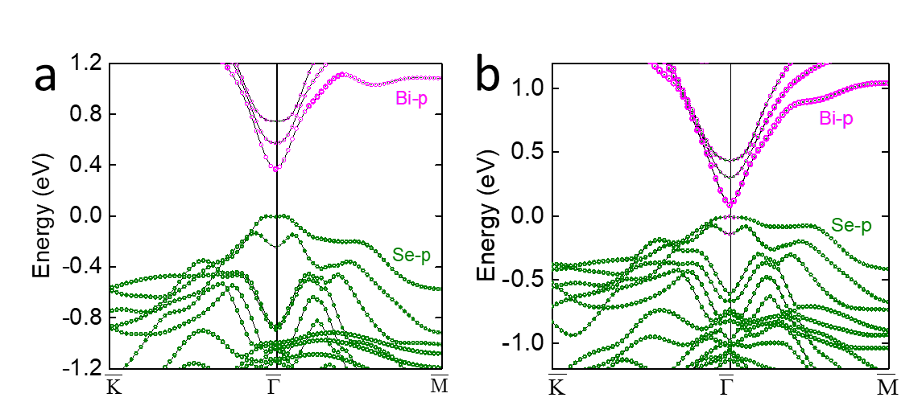

Figure S1. Electronic structures for the 001 surface of Bi₂Se₃ 3QL film with spin-obit coupling (SOC) (a) OFF and (b) ON. The valence bands near Fermi level were occupied by Se p orbits and the conduction bands were occupied by Bi p orbits when SOC was OFF. Typical TSSs appeared when SOC was ON: the band gap decreased to 0.08 eV, and the band inversion was observed at $\overline{Γ}$ point.

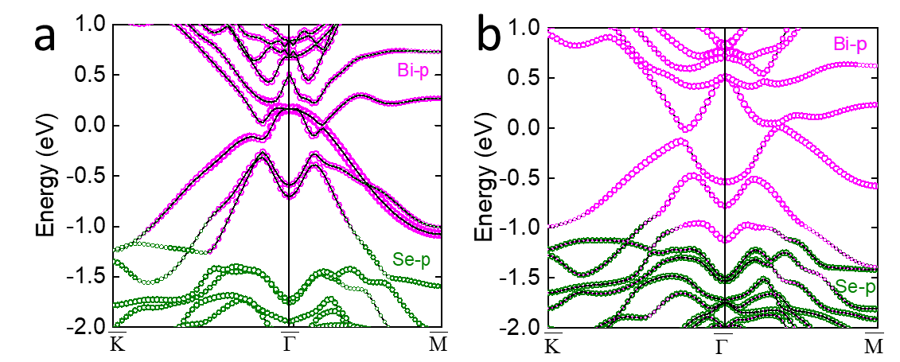
Figure S2. Electronic structures for the 001 surface of BiSe 4 QL film with SOC (a) OFF and (b) ON. Typical metallic state was revealed and the bands near Fermi level were occupied by Bi p orbits when SOC was OFF. The bands near Fermi level were separated when SOC was ON, however, the band inversion was not observed. BiSe was reported as weak topological insulator, hence its TSSs only appear at the side surface perpendicular to the 001 surface, and are not robust to the surface contamination or oxidation.

Figure S3. The powder XRD patterns for (a) Bi₂Se₃ NPs, (b) Bi₂Se₃ bulk, (c) ICSD standard data of Bi₂Se₃, (d) BiSe bulk and (e) ICSD standard data of BiSe.

Figure S4. Se 3d XPS spectra for (a) Bi₂Se₃ NPs, (b) Bi₂Se₃ bulk and (c) BiSe bulk.

Figure S5. Relationship between DBU formation rate and Bi₂Se₃ surface area. Reaction conditions: catalyst (50 mg), butylamine (1 mmol), THF (2 mL), CO (0.5 MPa), O₂ (0.5 MPa), 20 ºC.

Figure S6. XRD patterns for BiSe bulk catalyst after recycle measurements.

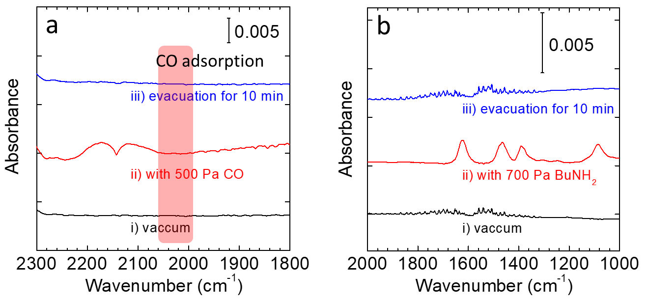

Figure S7. Difference FTIR spectra of Bi₂Se₃ bulk catalyst for (a) CO and (b) BuNH₂ adsorption at room temperature. The orange bar in (a) indicates the conventional CO adsorption peak.

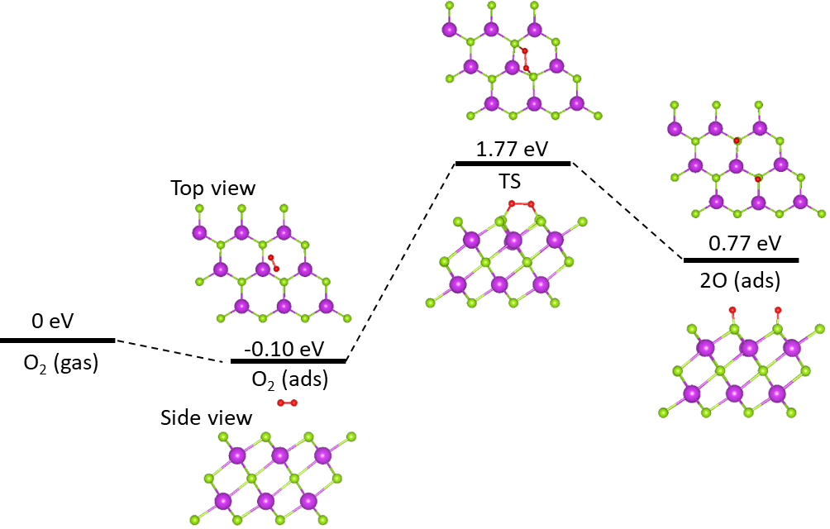

Figure S8. O₂ activation on the 001 surface of Bi₂Se₃ 3QL film with SOC ON.

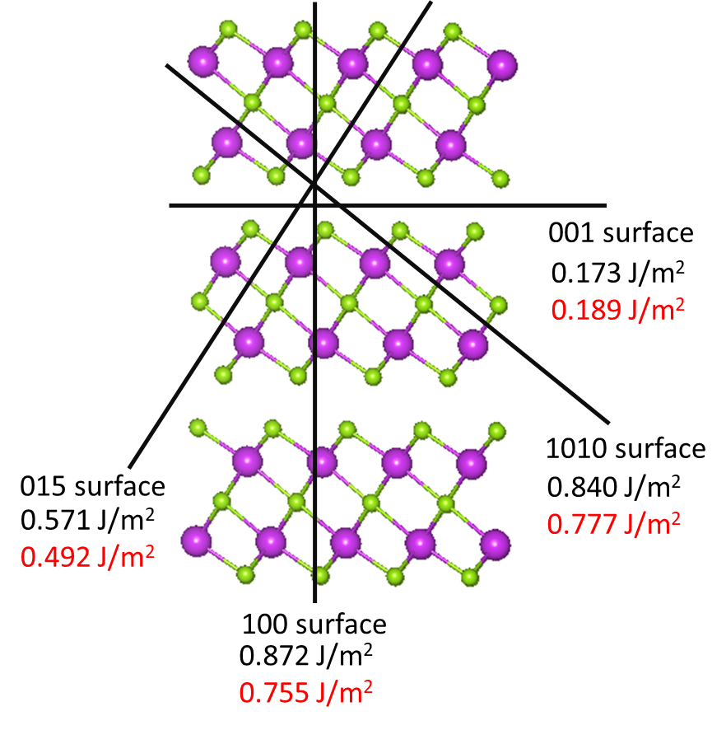

Figure S9. DFT prediction on the cleavage energy for different surfaces with SOC OFF (black) and ON (red).

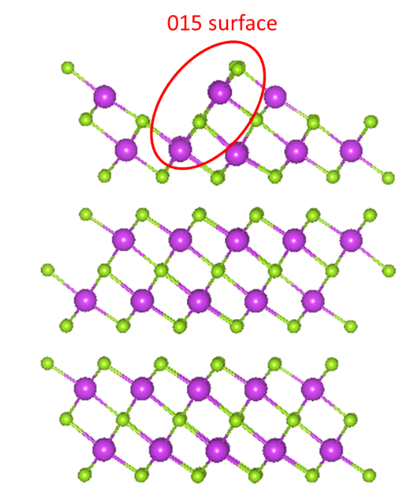
Figure S10. The model of Bi₂Se₃ 3 QL film with exposed 015 surface. The ratio of Bi to Se was kept as 2:3.

Figure S11. Bader charger changes for O₂ along the reaction trajectory with SOC (a) OFF and (b) ON. The initial state is IM1 and the final state is IM2.

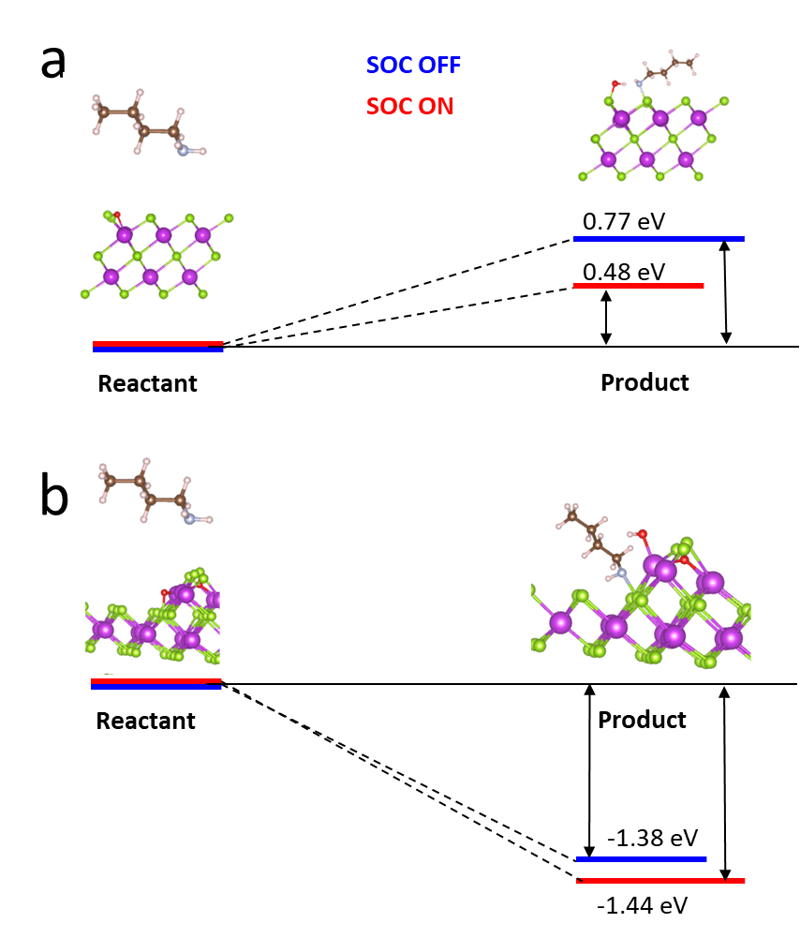
Figure S12. The adsorption energy for the BuNH+OH on the (a) 001 and (b) 015 surface with SOC OFF and ON. The reactant is composed of gas phase BuNH₂ and 3QL Bi₂Se₃ film with dissociated oxygen.

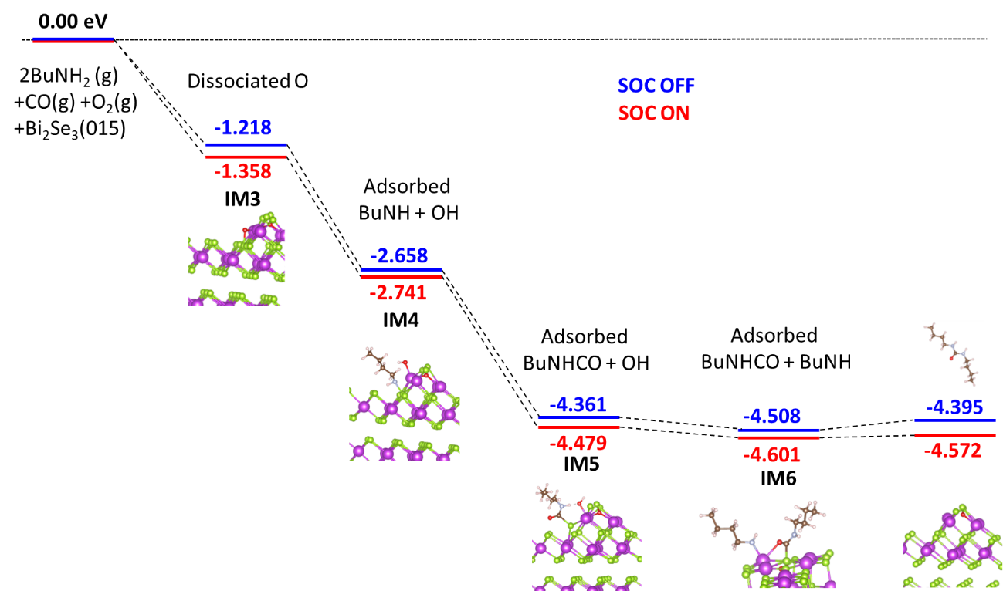
Figure S13. The energy profile for the plausible reaction process on the Bi₂Se₃ 015 surface with SOC OFF (blue) and ON (red). Here only show the energies for the formed intermediates and products. The configurations shown in inset are optimized with SOC ON.

Figure S14. Recycle measurement performed at 40 ºC for virginal Bi₂Se₃ bulk sample without passivation. Reaction conditions: catalyst (50 mg), reaction time (1 h), butylamine (1 mmol), THF (2 mL), CO (0.5 MPa) and O₂ (0.5 MPa).

The activity lost at initial 3 to 4 runs was mainly due to the partial oxidation of exposed Se sites. Hence we use the passivated Bi₂Se₃ samples for all activity measurements shown in main text.

Characterization of produced ureas via NMR measurement
1,3-Dibutylurea (1a)
White solid, 1H NMR (400 MHz, CDCl3): δ = 4.60 (brs, 2H), 3.17 (t, 4H), 1.54-1.43 (m, 4H), 1.42-1.29 (m, 4H), 0.93 (t, 6H).
13C NMR (101 MHz, CDCl3): δ = 158.55, 40.28, 32.37, 20.04, 13.76.

1,3-Dicyclopentylurea (2a)
White solid, 1H NMR (400 MHz, CDCl3): δ = 4.44 (brs, 2H), 4.09-3.87 (m, 2H), 2.07-1.88 (m, 4H), 1.75-1.47 (m, 8H), 1.47-1.25 (m, 4H).
13C NMR (101 MHz, CDCl3): δ = 157.83, 52.11, 33.66, 23.61.

1,3-Dicyclohexylurea (3a)
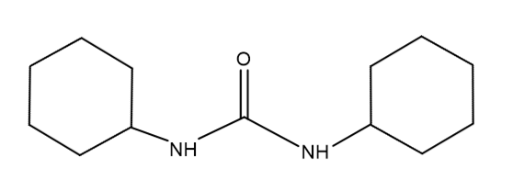
White solid, (due to the poor solubility in various deuterated solvent, the peak intensity is very weak) 1H NMR (400 MHz, CDCl3): δ = 4.09 (brs, 2H), 3.61-3.38 (m, 2H), 2.04-1.83 (m, 4H), 1.77-1.51 (m, 6H), 1.44-1.31 (m, 4H), 1.24-0.97 (m, 6H).
13C NMR (101 MHz, CDCl3): δ = 156.73, 49.17, 33.96, 25.63, 24.92.

1,3-Dibenzylurea (4a)
White solid, 1H NMR (400 MHz, DMSO-d6): δ = 7.41-7.15 (m, 10H), 6.45 (t, 2H), 4.26 (d, 4H).
13C NMR (101 MHz, DMSO-d6): δ = 158.60, 141.35, 128.67, 127.48, 127.02, 43.51.

Di(pyrrolidin-1-yl)methanone (5a)
Yellow oil, 1H NMR (400 MHz, CDCl3): δ = 3.44-3.29 (m, 8H), 1.90-1.73 (m, 8H).
13C NMR (101 MHz, CDCl3): δ = 161.44, 47.90, 25.53.

Di(piperidin-1-yl)methanone (6a)
Yellow oil, 1H NMR (400 MHz, CDCl3): δ = 3.25-3.02 (m, 8H), 1.65-1.43 (m, 12H).
13C NMR (101 MHz, CDCl3): δ = 164.79, 47.89, 25.76, 24.75.

Dimorpholinomethanone (7a)
Colorless solid, 1H NMR (400 MHz, CDCl3): δ = 3.68 (t, 8H), 3.27 (t, 8H).
13C NMR (101 MHz, CDCl3): δ = 163.78, 66.58, 47.23.

Bis(4-methylpiperidin-1-yl)methanone (8a)
Colorless oil, 1H NMR (400 MHz, CDCl3): δ = 3.64 (dq, 4H), 2.73 (td, 4H),1.62 (dd, 4H), 1.51 (dtd, 2H), 1.15 (qd, 4H), 0.95 (d, 6H).
13C NMR (101 MHz, CDCl3): δ = 164.62, 47.26, 34.11, 31.27, 21.87.

Octahydro-benzoimidazol-2-one (9a)
Because the reactant has trans- and cis- structures, the formed products also have two type structures. It is hardly to separate the ¹H-NMR peak at 2.02-1.08 ppm into 2 phases.
Colorless solid. Trans-: 1H NMR (400 MHz, CDCl3): δ = 5.90-5.59 (s, 2H), 3.18-2.95 (m, 2H), 2.02-1.08 (m, 8H)
13C NMR (101 MHz, CDCl3): δ = 164.16, 61.09, 29.53, 24.02.
cis-: 1H NMR (400 MHz, CDCl3): δ = 5.59-5.28 (s, 2H), 3.68-3.53 (m, 2H),2.02-1.08 (m, 8H),
13C NMR (101 MHz, CDCl3): δ = 165.30, 51.99, 28.36, 20.43.

1,3-Dibutylurea (1a)
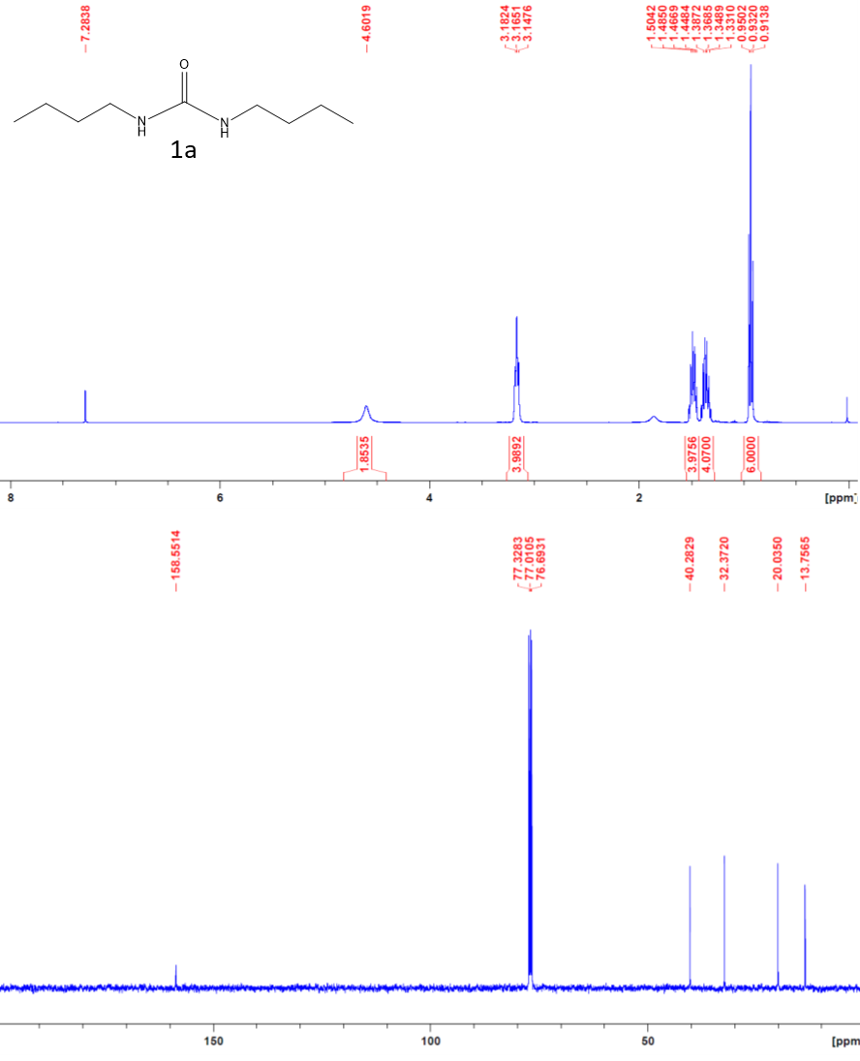

1,3-Dicyclopentylurea (2a)

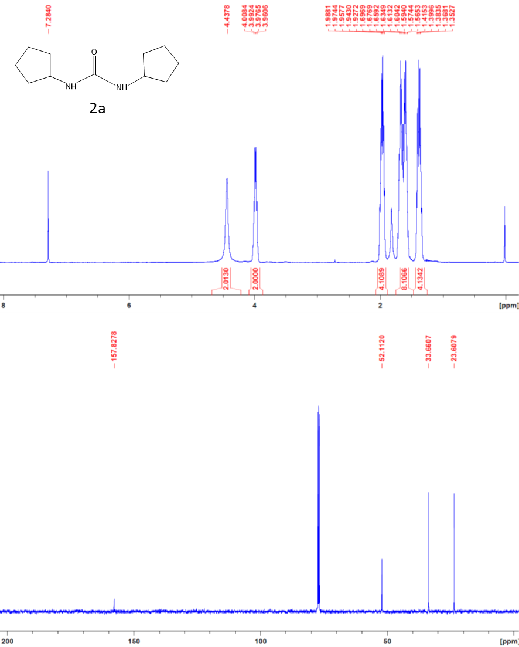

1,3-Dicyclohexylurea (3a)
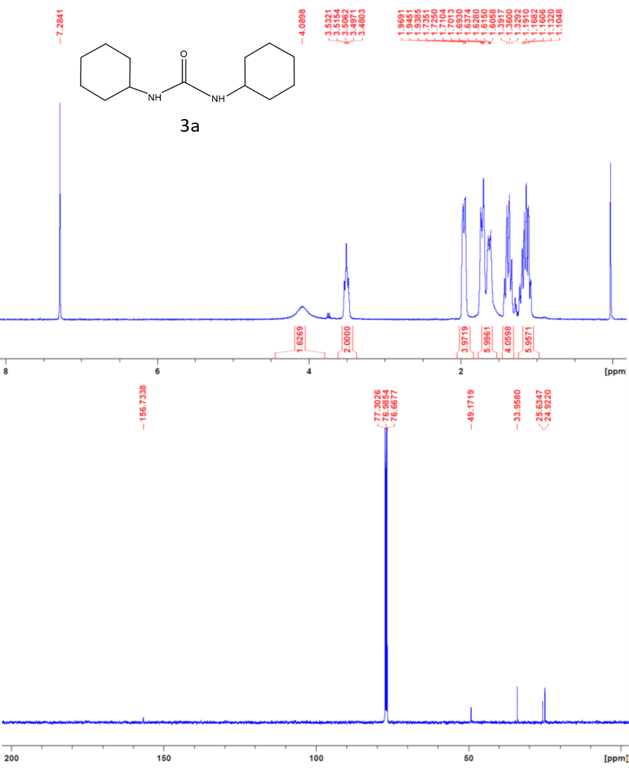

1,3-Dibenzylurea (4a)
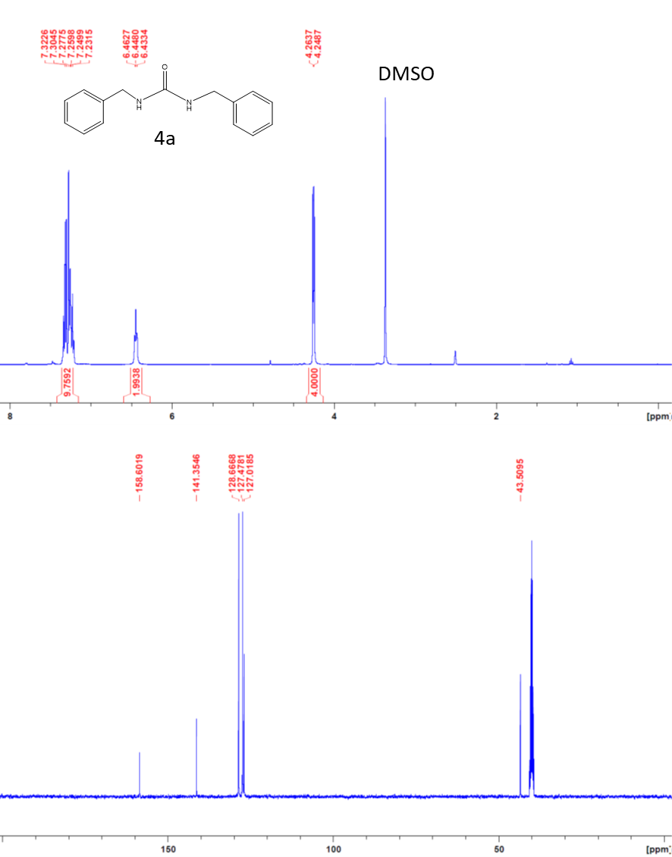

Di(pyrrolidin-1-yl)methanone (5a)
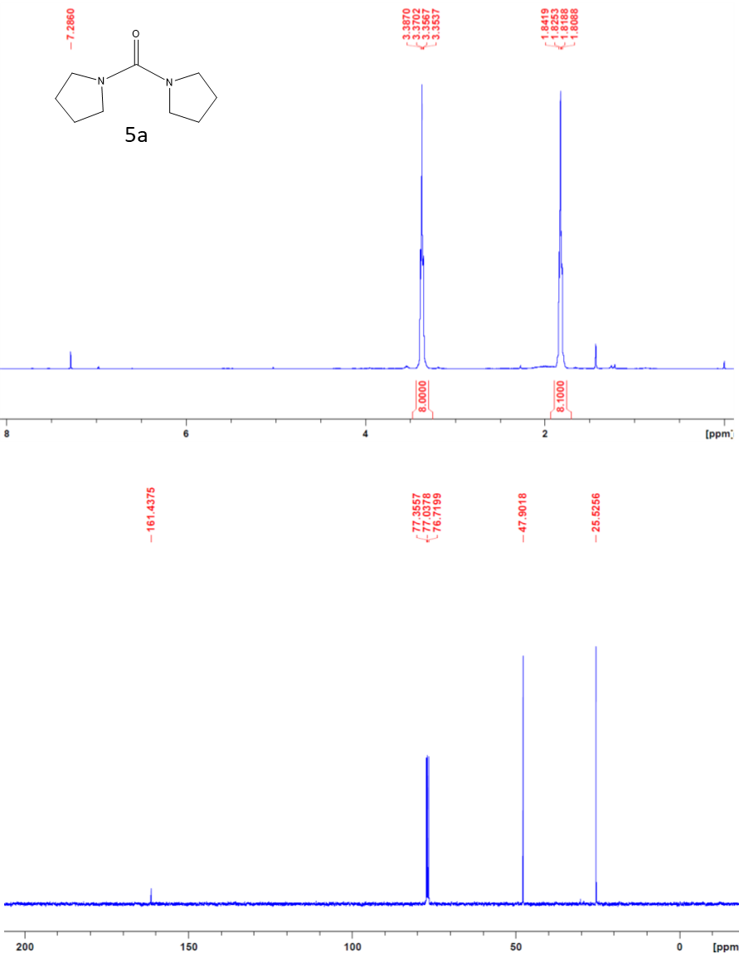

Di(piperidin-1-yl)methanone (6a)
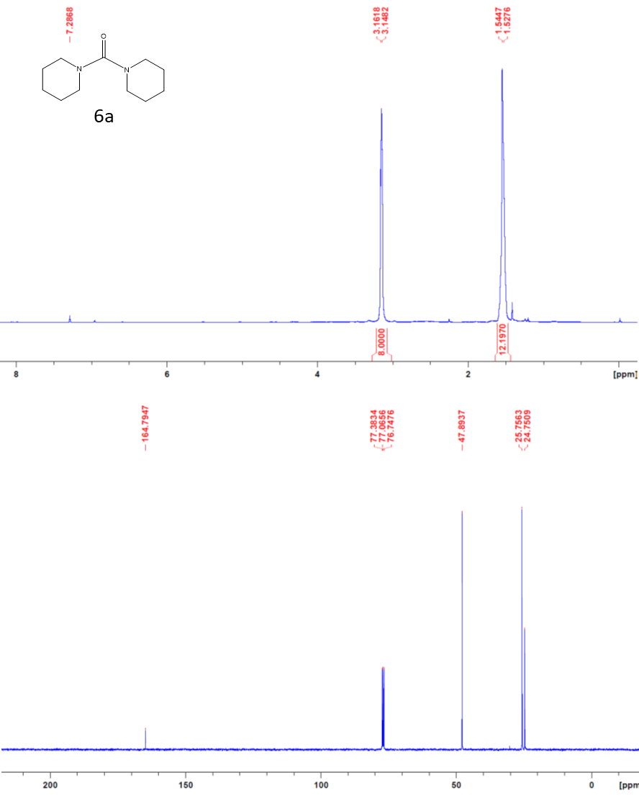

Dimorpholinomethanone (7a)
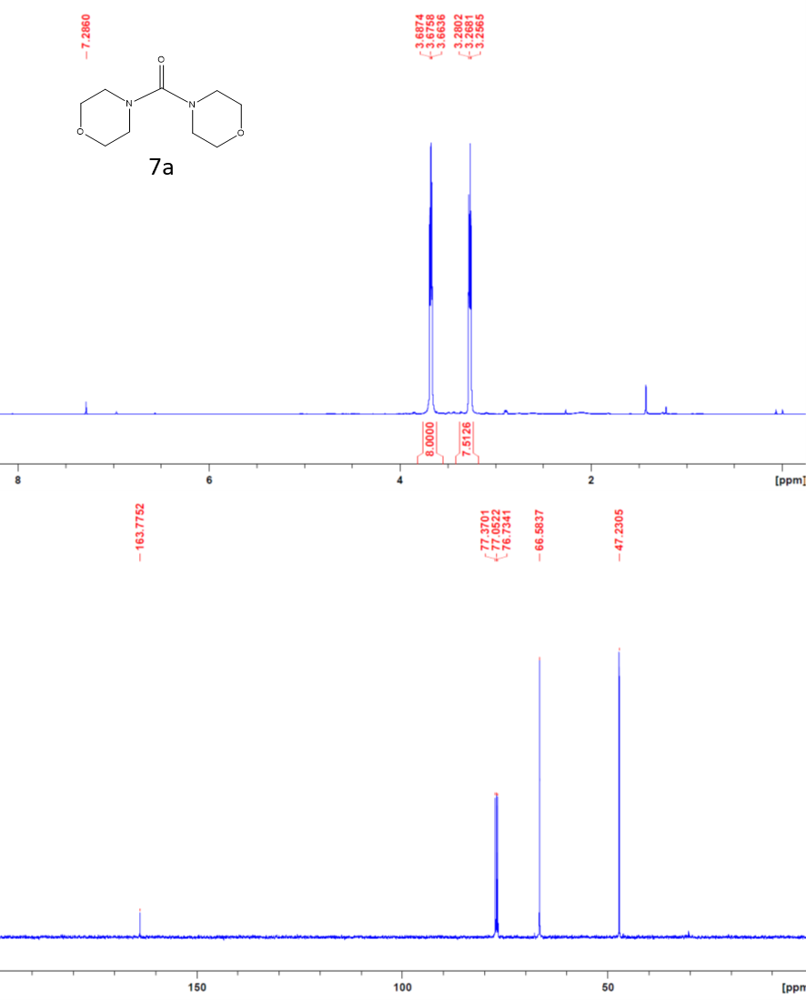

Bis(4-methylpiperidin-1-yl)methanone (8a)
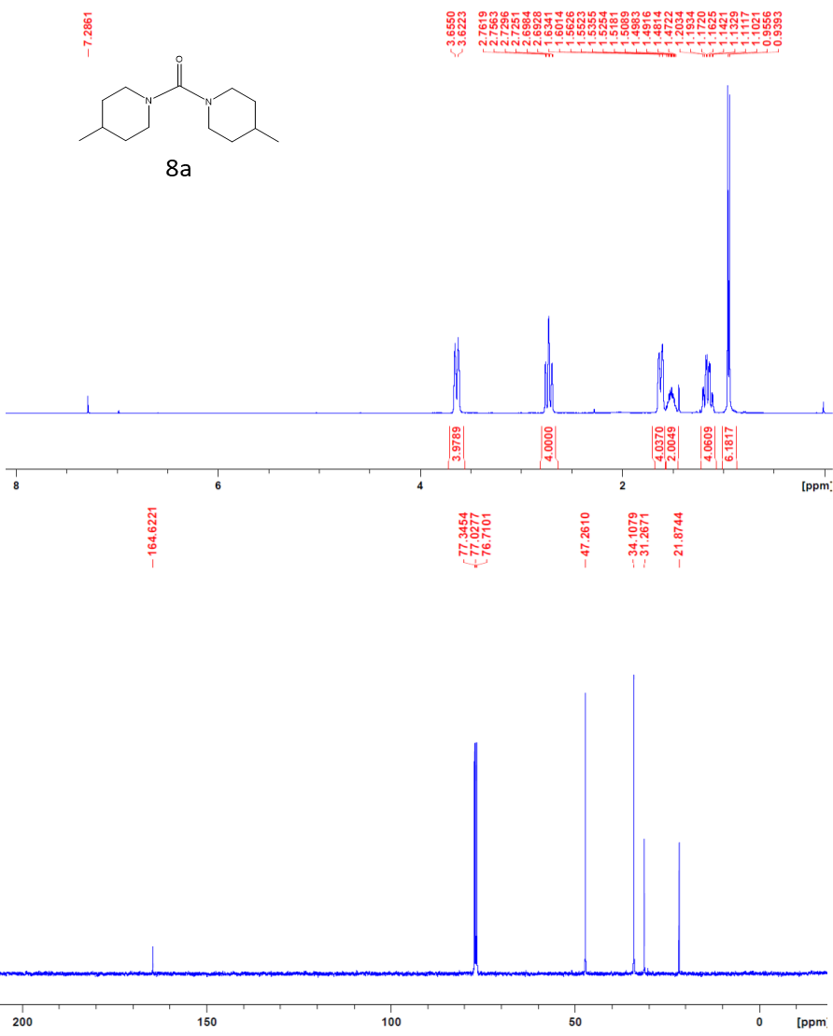

Octahydro-benzoimidazol-2-one (9a)
