Cancer | Database | GENE | Mutation
SARC(Sarcoma) | MSK-IMPACT | MUC4 | Altered/All = 0/2138
SARC(Sarcoma) | MSK-IMPACT | MUC6 | Altered/All = 0/2138
SARC(Sarcoma) | MSK-IMPACT | MUC16 | Altered/All = 0/2138
SARC(Sarcoma) | MSK-IMPACT | MUC17 | Altered/All = 0/2138
SARC(Sarcoma) | MSK-IMPACT | MUC4、MUC6、MUC16、MUC17 | Altered/All = 0/2138
SARC(Sarcoma) | MSK-IMPACT | FRG1 | Altered/All = 0/2138
SARC(Sarcoma) | MSK-IMPACT | TTN | Altered/All = 0/2138
SARC(Sarcoma) | MSK-IMPACT | ASH1L | Altered/All = 0/2138
SARC(Sarcoma) | MSK-IMPACT | WNK1 | Altered/All = 0/2138
SARC(Sarcoma) | MSK-IMPACT | ZNF717 | Altered/All = 0/2138
SARC(Sarcoma) | MSK-IMPACT | CD55 | Altered/All = 0/2138
SARC(Sarcoma) | TCGA | MUC4 | Altered/All = 10/253
SARC(Sarcoma) | TCGA | MUC6 | Altered/All = 7/253
SARC(Sarcoma) | TCGA | MUC16 | Altered/All = 44/253
SARC(Sarcoma) | TCGA | MUC17 | Altered/All = 17/253
SARC(Sarcoma) | TCGA | MUC4、MUC6、MUC16、MUC17 | Altered/All = 63/253
SARC(Sarcoma) | TCGA | FRG1 | Altered/All = 8/253
SARC(Sarcoma) | TCGA | TTN | Altered/All = 37/253
SARC(Sarcoma) | TCGA | ASH1L | Altered/All = 14/253
SARC(Sarcoma) | TCGA | WNK1 | Altered/All = 12/253
SARC(Sarcoma) | TCGA | ZNF717 | Altered/All = 3/253
SARC(Sarcoma) | TCGA | CD55 | Altered/All = 6/253
Table1. The top 10 high-frequency mutations distribution in TCGA and MSK-IMPACT.

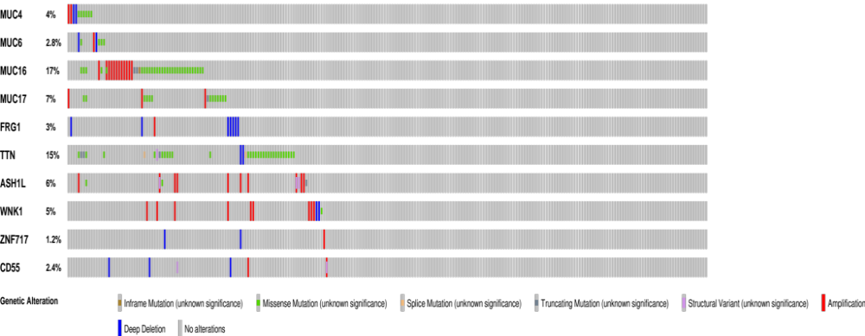
Figure.1 The mutation types of top 10 high-frequency mutations distribution in sarcoma in the TCGA

Gene | Cancer | Survival Type | Number of Patients | Altered group | Unaltered group | HR | p-Value
MUC4 | TCGA-SARC | Progress Free Survival | 253 | 10 | 243 | 1.68(0.82-3.43) | 0.1531
MUC4 | TCGA-SARC | Disease Free Survival | 148 | 7 | 141 | 1.75(0.7-4.37) | 0.2219
MUC4 | TCGA-SARC | Overall Survival | 253 | 10 | 243 | 1.18(0.43-3.21) | 0.7488
MUC6 | TCGA-SARC | Progress Free Survival | 253 | 7 | 246 | 1.46(0.6-3.56) | 0.4066
MUC6 | TCGA-SARC | Disease Free Survival | 148 | 6 | 142 | 1.6(0.58-4.4) | 0.3605
MUC6 | TCGA-SARC | Overall Survival | 253 | 7 | 246 | 0.67(0.17-2.73) | 0.5767
MUC16 | TCGA-SARC | Progress Free Survival | 253 | 44 | 209 | 1.01(0.64-1.58) | 0.9775
MUC16 | TCGA-SARC | Disease Free Survival | 148 | 20 | 128 | 0.79(0.36-1.72) | 0.5473
MUC16 | TCGA-SARC | Overall Survival | 253 | 44 | 209 | 0.88(0.5-1.56) | 0.6636
MUC17 | TCGA-SARC | Progress Free Survival | 253 | 17 | 236 | 1.05(0.55-2) | 0.881
MUC17 | TCGA-SARC | Disease Free Survival | 148 | 7 | 141 | 0.76(0.24-2.44) | 0.6465
MUC17 | TCGA-SARC | Overall Survival | 253 | 17 | 236 | 0.78(0.34-1.79) | 0.5571
MUC4、MUC6、MUC16MUC17 | TCGA-SARC | Progress Free Survival | 253 | 63 | 190 | 1.11(0.76-1.62) | 0.5804
MUC4、MUC6、MUC16MUC17 | TCGA-SARC | Disease Free Survival | 148 | 33 | 115 | 1.12(0.64-1.98) | 0.6821
MUC4、MUC6、MUC16MUC17 | TCGA-SARC | Overall Survival | 253 | 63 | 190 | 0.89(0.56-1.42) | 0.6176
ASH1L | TCGA-SARC | Progress Free Survival | 253 | 14 | 239 | 0.73(0.32-1.65) | 0.4434
ASH1L | TCGA-SARC | Disease Free Survival | 148 | 8 | 140 | 0.22(0.03-1.57) | 0.09632
ASH1L | TCGA-SARC | Overall Survival | 253 | 14 | 239 | 0.86(0.32-2.34) | 0.7641
CD55 | TCGA-SARC | Progress Free Survival | 253 | 6 | 247 | 0.64(0.2-2.01) | 0.4408
CD55 | TCGA-SARC | Disease Free Survival | 148 | 4 | 144 | 0.38(0.05-2.72) | 0.3131
CD55 | TCGA-SARC | Overall Survival | 253 | 6 | 247 | 0.66(0.16-2.7) | 0.5649
FRG1 | TCGA-SARC | Progress Free Survival | 253 | 8 | 245 | 0.57(0.18-1.79) | 0.3289
FRG1 | TCGA-SARC | Disease Free Survival | 148 | 4 | 144 | 0.41(0.06-2.99) | 0.3654
FRG1 | TCGA-SARC | Overall Survival | 253 | 8 | 245 | 0.92(0.29-2.91) | 0.8883
TTN | TCGA-SARC | Progress Free Survival | 253 | 37 | 216 | 1.36(0.88-2.11) | 0.1583
TTN | TCGA-SARC | Disease Free Survival | 148 | 19 | 129 | 1.03(0.51-2.09) | 0.9241
TTN | TCGA-SARC | Overall Survival | 253 | 37 | 216 | 1.25(0.74-2.11) | 0.41
WNK1 | TCGA-SARC | Progress Free Survival | 253 | 12 | 241 | 0.78(0.32-1.9) | 0.5758
WNK1 | TCGA-SARC | Disease Free Survival | 148 | 7 | 141 | 0.63(0.15-2.57) | 0.5137
WNK1 | TCGA-SARC | Overall Survival | 253 | 12 | 241 | 0.89(0.33-2.41) | 0.8124
ZNF717 | TCGA-SARC | Progress Free Survival | 253 | 3 | 250 | 0.53(0.07-3.84) | 0.527
ZNF717 | TCGA-SARC | Disease Free Survival | 148 | 1 | 147 | 0(0-Inf) | 0.5651
ZNF717 | TCGA-SARC | Overall Survival | 253 | 3 | 250 | 0(0-Inf) | 0.252
Table2. The prognosis analysis of the top 10 high-frequency mutations genes between two groups in TCGA.

