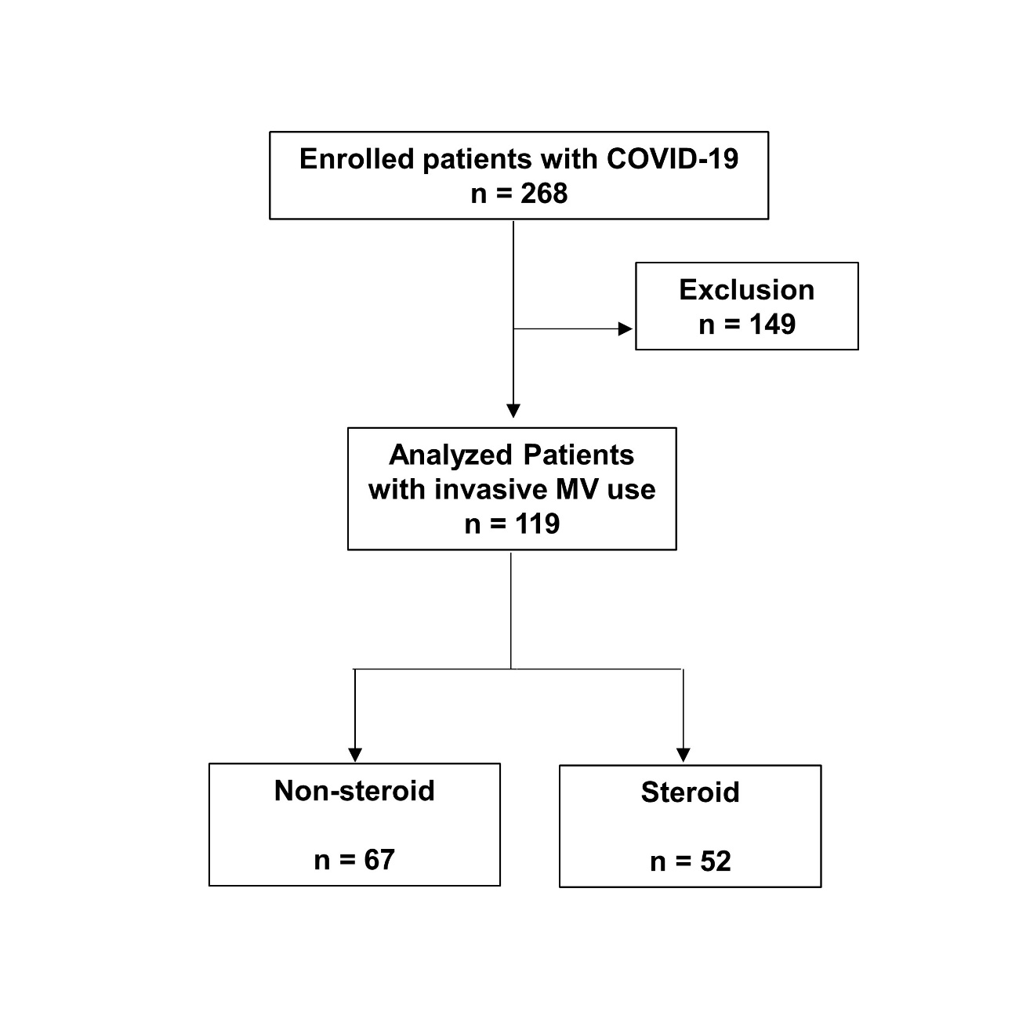
Figure S1 Patients flow
A total of 268 patients with COVID-19 participated in the study. Finally, 119 invasively ventilated patients were analyzed; 52 were administered dexamethasone (steroid group) and the remaining 67 were not (non-steroid group).

