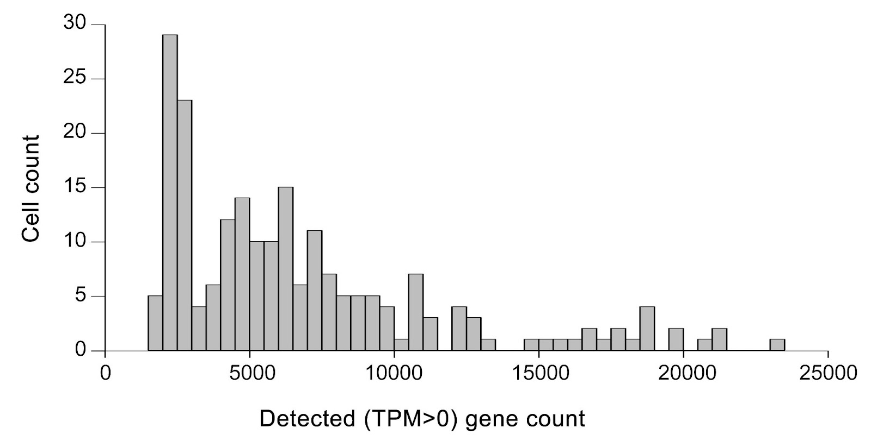Supplementary Figure 1 Gene count in sequenced cells. The number of genes expressed (TPM>0) in isolated sequenced cells (MMc cells) was determined by analyzing scRNA-seq data.

Supplementary Figure 2 Organs and cells included in the Tabula Muris data for female mice. (a) Organs represented in the data and their sample (cell) number. (b) Cell types represented in the data and their sample (cell) number.

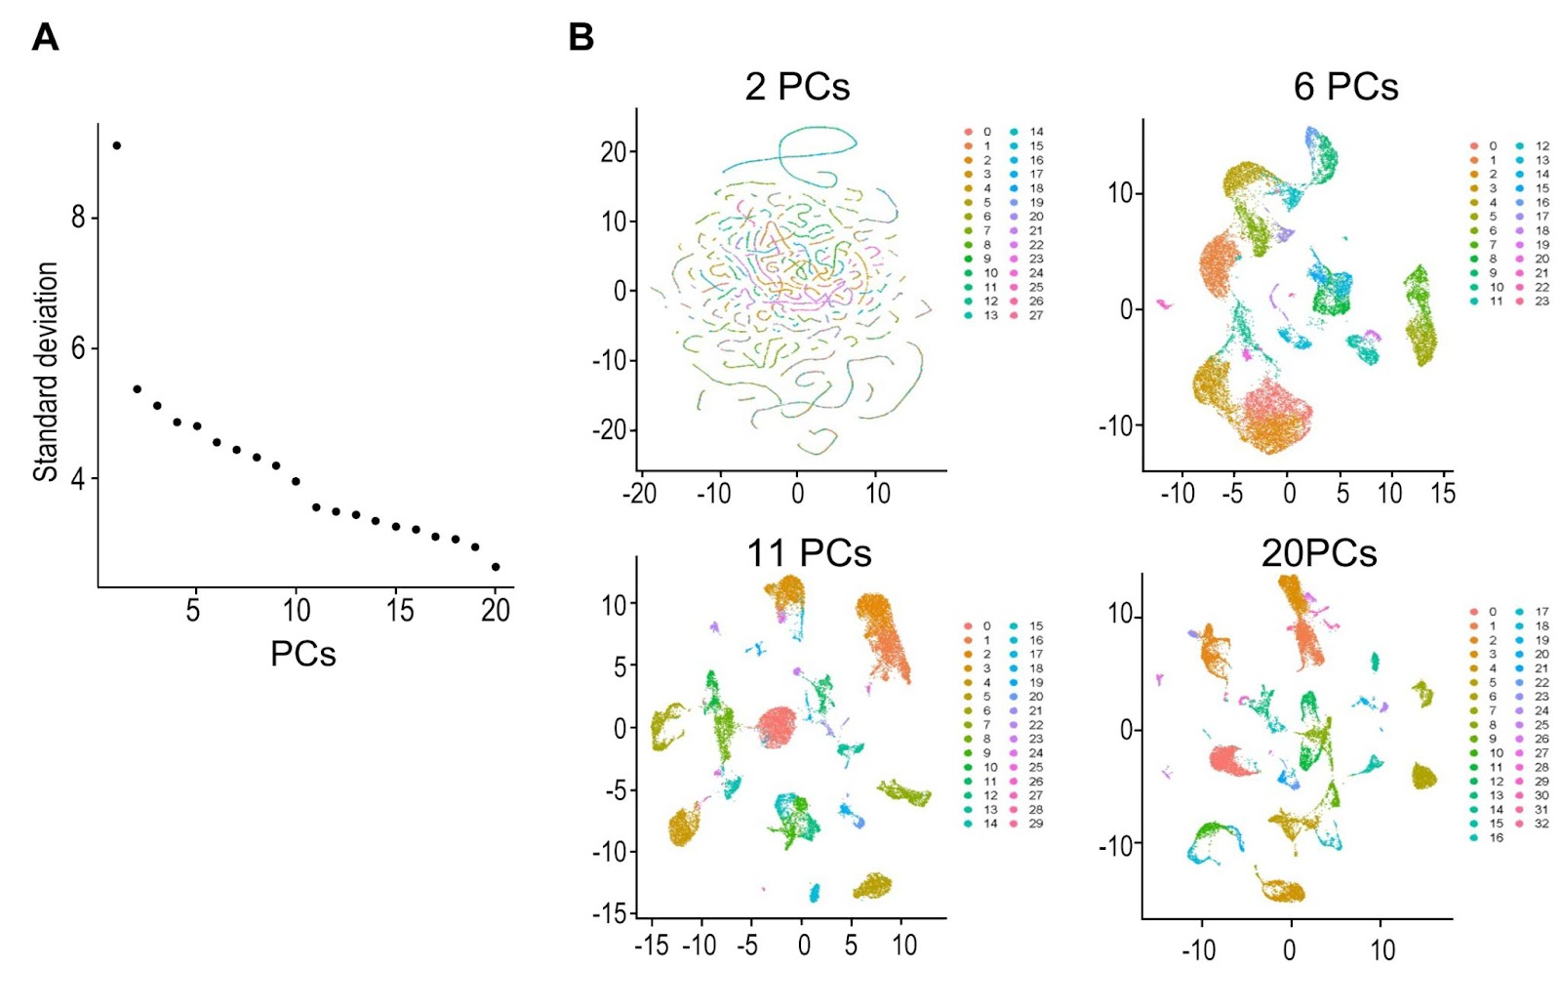Supplementary Figure 3 Identification of optimal PC sets for classifying the Tabula Muris scRNA-seq data. (a) Elbow plot representing the relationship between standard deviation and the number of PCs used in calculation. A major change in standard deviation was observed with 2, 6, 11, and 20 PCs. (b) UMAP representation of Tabula Muris scRNA-seq data using the PC sets identified in (a).

