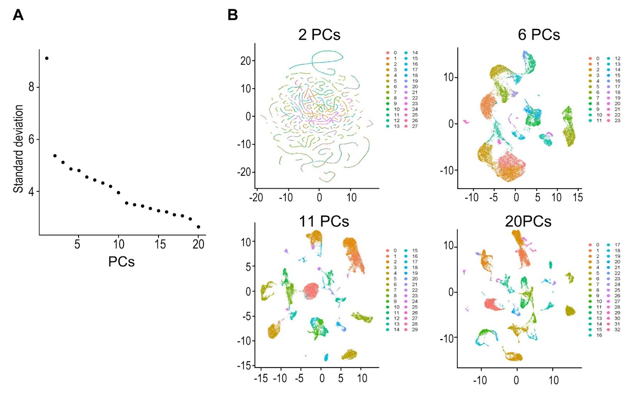Supplementary Figure 3 Identification of optimal PC sets for classifying the Tabula Muris scRNA-seq data. (a) Elbow plot representing the relationship between standard deviation and the number of PCs used in calculation. A major change in standard deviation was observed with 2, 6, 11, and 20 PCs. (b) UMAP representation of Tabula Muris scRNA-seq data using the PC sets identified in (a).

