Hemodialysis exacerbates proteolytic imbalance and pro-fibrotic platelet dysfunction

Short title: Pro-fibrotic platelet modulation in hemodialysis

Authors: Aaron J Velasquez-Mao¹, Mark A Velasquez², Zhengxiong Hui², Denise Armas-Ayon², Jingshen Wang³, Moriel H Vandsburger².

¹ UC Berkeley-UCSF Graduate Program in Bioengineering
² Department of Bioengineering, UC Berkeley
³ Department of Biostatistics, UC Berkeley

Corresponding Author:
Moriel Vandsburger, PhD
281 Hearst Memorial Mining Building
U.C. Berkeley
Berkeley, CA
94721
USA
1-510-664-9679
moriel@berkeley.edu

Supplemental Materials
Supplemental Table ST1. Dialysis patient demographics.
Table 1. Patient demographics (n=56)
Age, years - median (range) | 61.905 (23.83-85.25)
Gender ratio - [male/female] | 32/24
Pre-Dialysis Weight, kg - median (range) | 79.65 (49.6-160.7)
Post-Dialysis Weight, kg - median (range) | 78.35 (48.7-158.9)
Height, cm - median (range) | 167.65 (150-185.5)
Ethnicity
African American | 29
Asian American | 7
Caucasian | 13
Hispanic | 7
Prior time on dialysis, months - median (range) | 39.417 (1.97-221.77)
Filter surface area, m2 - [1.5/1.7/1.9] | 22/29/5
Vascular Access - [shunt/fistula/catheter] | 14/33/9
Cause of renal failure
Hypertension | 37
Diabetes mellitus | 25
Polycystic kidney disease | 1
IgA Nephropathy | 1
Analgesics | 0
MPGN | 0
Unknown | 14
Comorbidities
Anemia | 16
Hyperlipidemia | 10
CHF | 7
Hepatitis | 6
Hypothyroidism | 5
Medications
Lipid-lowering drugs | 20
Platelet inhibitor | 12
RAS Inhibitors | 10
Coumarin derivatives | 2
None | 11
Unknown | 15

Supplemental Table ST2. Healthy control demographics.
ST2. Control demographics (n = 25)
Age, years - median (range) | 53.9 (45.3-76.2)
Gender ratio - [male/female] | 16/9
Weight, kg - median (range) | 71.2 (45.4 - 113.4)
Height, cm - median (range) | 175 (155 - 188)
Ethnicity
African American | 0
Asian American | 5
Caucasian | 18
Hispanic | 2

Supplemental Table ST3. Enzyme immunoassay kits used to for plasma measurements.
Protein | Classification | Manufacturer | Detection range | Dilution
11TXB2 | Cardiovascular indicator | Elabsci (E-EL-H0207) | 15.6-1,000 pg/mL | 1:1, 1:6
CRP | Inflammatory indicator | ThermoFisher (EPX01A-10288-901) | 5.66-5800 pg/mL | 1:500
CTGF | Growth factor | Cloud-Clone (SEA010Hu) | 7.8-500 pg/mL | 1:1, 1:2
EGF | Growth factor | Cloud-Clone (SEA560Hu) | 3.9-250 pg/mL | 1:2, 1:4
FGF2 | Growth factor | Cloud-Clone (CEA551Hu) | 12.4-1,000 pg/mL | 1:1
GAPDH | Cardiovascular indicator | ThermoFisher (EPX01A-12154-901) | 244-250,000 pg/mL | 1:1
IFNγ | Inflammatory indicator | ThermoFisher (EPX01A-10228-901) | 12-11,925 pg/mL | 1:1
IGF1 | Growth factor | Cloud-Clone (SEA050Hu) | 156-10,000 pg/mL | 1:50, 1:100
IL1β | Inflammatory indicator | ThermoFisher (EPX01A-10224-901) | 2.14-8,750 pg/mL | 1:1
LAP (TGFβ1) | Growth factor | ThermoFisher (BMS2065) | 156-10,000 pg/mL | 1:2.5, 1:25
MMP2 | Proteolytic regulation | ThermoFisher (EPX03A-10829-901) | 36-146,700 pg/mL | 1:25, 1:50
MMP3 | Proteolytic regulation | ThermoFisher (EPX03A-10829-901) | 18-18,125 pg/mL | 1:25, 1:50
MMP9 | Proteolytic regulation | ThermoFisher (EPX03A-10829-901) | 0.72-2,950 pg/mL | 1:25, 1:50
MMP13 | Proteolytic regulation | ThermoFisher (EPX01A-12131-901) | 7.08-29,000 pg/mL | 1:1
MMP14 | Proteolytic regulation | Wuhan (EH0369) | 31-2,000 pg/mL | 1:2, 1:6
NTpBNP | Cardiovascular indicator | Wuhan (EH0350) | 39-2,500 pg/mL | 1:1, 1:2
PAF | Clotting Factor | Elabsci (E-EL-H2199) | 78.1-5,000 pg/mL | 1:6
PDGFB | Growth factor | RayBiotech (ELH-PDGFBB-1) | 1-400 pg/mL | 1:1, 1:2
PDGFD | Growth factor | Cloud-Clone (SEC919Hu) | 12.5-800 pg/mL | 1:1
PF4 | Clotting Factor | ThermoFisher (EHPF4) | 20.58-15,000 pg/mL | 1:100, 1:200
PGI2 | Cardiovascular indicator | Blue Gene (ABIN771046) | 25-500 pg/mL | 1:1
PPBP (βTG) | Growth factor | ThermoFisher (EHPPBP) | 4.1-1,000 pg/mL | 1:600, 1:5,000
TIMP1 | Proteolytic regulation | ThermoFisher (EPX01A-12018-901) | 146-150,000 pg/mL | 1:20, 1:50
TIMP2 | Proteolytic regulation | ThermoFisher (EHTIMP2) | 1.6-1,200 pg/mL | 1:300
TIMP3 | Proteolytic regulation | Cloud-Clone (SEA129Hu) | 150-10,000 pg/mL | 1:1, 1:4
TNFR1 | Inflammatory indicator | ThermoFisher (EPX01A-10203-901) | 189-774,400 pg/mL | 1:1
TPO | Cardiovascular indicator | ThermoFisher (EPX01A-12161-901) | 94-96,275 pg/mL | 1:1
vWF | Clotting Factor | ThermoFisher (EPX040-10825-901) | 0.00244-2.5 %plasma | 1:500
*Kits not purchased from ThermoFisher were purchased through Antibodies-Online.

Supplemental Table ST4. Primers used for PCR.
RNA Target | Details | Accession # | Assay ID (Thermo)
EGF | Growth factor | NM_001178130.2, NM_001178131.2, NM_001963.5 | Hs01099990_m1
FGF2 | Growth factor | NM_002006.4 | Hs00266645_m1
GAPDH | Metabolic indicator | NM_002046.5, NM_001256799.2, NM_001289745.1, NM_001289746.1 | Hs02786624_g1
IFNγ | Inflammatory cytokine | NM_000619.2 | Hs00989291_m1
IGF1 | Growth factor | NM_000618.4, NM_001111283.2, NM_001111284.1 | Hs01547656_m1
IL1β | Inflammatory cytokine | NM_000576.2 | Hs01555410_m1
MMP1 | Proteolytic regulation | NM_001145938.1 NM_002421.3 | Hs00899658_m1
MMP2 | Proteolytic regulation | NM_004530.5, NM_001127891.2, NM_001302508.1, NM_001302510.1, NM_001302509.1 | Hs01548727_m1
MMP3 | Proteolytic regulation | NM_002422.4 | Hs00968305_m1
MMP9 | Proteolytic regulation | NM_004994.2 | Hs00957562_m1
MMP13 | Proteolytic regulation | NM_002427.3 | Hs00942584_m1
MMP14 | Proteolytic regulation | NM_004995.3 | Hs01037003_g1
MMP24 | Proteolytic regulation | NM_006690.3 | Hs00198580_m1
P2RY12 | Loading Control | NM_022788.4 NM_176876.2 | Hs01881698_s1
PAFAH2 | Clotting factor | NM_000437.3 | Hs00166473_m1
PDGFB | Growth factor | NM_002608.3, NM_033016.3 | Hs00966522_m1
PDGFD | Growth factor | NM_025208.4, NM_033135.3 | Hs00228671_m1
PF4 | Clotting factor | NM_002619.3 | Hs00427220_g1
PPBP | Growth factor | NM_002704.3 | Hs00234077_m1
TBXAS1 | Clotting factor | NM_001061.4, NM_030984.3, NM_001130966.2, NM_001166253.1, NM_001166254.1, NM_001314028.1 | Hs01022706_m1
TGFβ1 | Growth factor | NM_000660.5 | Hs00998133_m1
TIMP1 | Proteolytic regulation | NM_003254.2 | Hs01092512_g1
TIMP2 | Proteolytic regulation | NM_003255.4 | Hs00234278_m1
TIMP3 | Proteolytic regulation | NM_000362.4 | Hs00165949_m1
TNFα | Inflammatory cytokine | NM_000594.3 | Hs00174128_m1
vWF | Clotting factor | NM_000552.4 | Hs01109446_m1
Gray = Ct values detected were above cutoff threshold.

Supplemental Table ST5. Antibodies used for WB.
Protein Target | Classification | Manufacturer
CTGF | Pro-fibrotic | ThermoFisher (MA5-26817, 31430)
EGF | Fibro-protective | ThermoFisher (M805, 31430)
FGF2 | Fibro-protective | ThermoFisher (MA5-15276, 31430)
GAPDH | Metabolic activity | ThermoFisher (MA5-15738, 31430)
IGF1 | Pro-fibrotic | ThermoFisher (MA1-088, 31430)
LAP (TGFβ1) | Pro-fibrotic | ThermoFisher (MA5-17186, 31430)
MMP1 | Proteolytic regulation | ThermoFisher (MA1-771, 31430)
MMP14 | Proteolytic regulation | ThermoFisher (PA5-13183, 31460)
MMP2 | Proteolytic regulation | ThermoFisher (MA1-772, 31430)
MMP24 | Proteolytic regulation | ThermoFisher (PA5-51333, 31460)
MMP3 | Proteolytic regulation | ThermoFisher (MA5-17123, 31430)
MMP9 | Proteolytic regulation | ThermoFisher (MA1-12895, 31430)
PDGFB | Pro-fibrotic | ThermoFisher (PA5-19524, 31460)
PDGFD | Pro-fibrotic | ThermoFisher (40-2100, 31460)
PF4 | Activation indicator | ThermoFisher (MA5-23926, 31430)
PPBP | Pro-fibrotic | ThermoFisher (PA5-51254, 31460)
TIMP1 | Proteolytic regulation | ThermoFisher (MA1-773, 31430)
TIMP2 | Proteolytic regulation | ThermoFisher (MA1-774, 31430)
TIMP3 | Proteolytic regulation | ThermoFisher (PA5-26133, 31460)
TNFR1 | Activation indicator | ThermoFisher (MA5-23706, 31430)
14-3-3y | Loading control | ThermoFisher (MA1-16587, 31430)
Goat Anti-Mouse IgG, HRP |  | ThermoFisher (31430)
Goat Anti-Rabbit IgG, HRP |  | ThermoFisher (31460)

Supplemental Table ST6. P-values of independent patient predictors of biomarker measurements by multiple linear regression.
Y | Independent Predictors of Y
Y | BFR | Vintage | Age | Sex | Weight
PAF (Plasma) | 0.017 | 0.11 | 0.16 | 0.55 | 0.59
MMP3 (Plasma) | 0.025 | 0.64 | 0.38 | 0.60 | 0.82
MMP14 (Plasma) | 0.12 | 0.038 | 0.31 | 0.25 | 0.88
PAF (ΔPlasma) | 0.018 | 0.066 | 0.83 | 0.15 | 0.10
MMP2 (ΔPlasma) | 0.058 | 0.55 | 0.45 | 0.29 | 0.70
MMP3 (ΔPlasma) | 0.020 | 0.33 | 0.67 | 0.24 | 0.046
TIMP1 (ΔPlasma) | 0.081 | 0.027 | 0.42 | 0.96 | 0.71
IFNg (ΔPlasma) | 0.81 | 0.043 | 0.70 | 0.35 | 0.72
TX11B2 (ΔPlasma) | 0.27 | 0.032 | 0.44 | 0.54 | 0.61
PAFAH2 (ΔRNA) | 0.72 | 0.00019 | 0.16 | 0.83 | 0.37
MMP3 (ΔPL) | 0.046 | 0.63 | 0.089
TIMP2 (ΔPL) | 0.18 | 0.012 | 0.41
PPBP (ΔPL) | 0.90 | 0.021 | 0.31
Highlighted = p-values < 0.05. Multivariate predictions of ΔPL markers were limited to 3 independent predictors because of sample size. Sex and weight were not found to significantly predict ΔPL measurements in any permutation of ≤ 3 predictors.

Supplemental Table ST7. Multiple linear regression of plasma clotting factors to MMP and TIMP upregulation in platelets.
Predictor(s) | R² | Adjusted R² | P-value
A = PAF (Plasma), B = 11TXB2 (Plasma), C = PAF (ΔPlasma), D = 11TXB2 (ΔPlasma)
y = MMP1 (ΔRNA). y = -0.93 + 2.0E-4*A + 7.6E-5*B
A+B | 0.91 | 0.85 | 0.027
A | 0.76 | 0.73 | 0.00050
B | 0.82 | 0.78 | 0.013
y = TIMP2 (ΔRNA). y = -0.93 + 3.3E-5*A + 7.2E-4*B - 1.0*C - 2.5*D
A+B+C+D | 0.98 | 0.93 | 0.044
A+B+C | 0.94 | 0.89 | 0.022
A+B+D | 0.97 | 0.95 | 0.0076
A+C+D | 0.58 | 0.46 | 0.028
B+C+D | 0.98 | 0.95 | 0.0061
A+B | 0.94 | 0.92 | 0.0032
A+C | 0.45 | 0.35 | 0.039
A+D | 0.44 | 0.34 | 0.040
B+C | 0.94 | 0.91 | 0.0038
B+D | 0.97 | 0.96 | 0.00080
C+D | 0.11 | 0.023 | 0.31
A | 0.28 | 0.23 | 0.049
B | 0.94 | 0.92 | 0.0004
C | 0.07 | 0.025 | 0.22
D | 0.093 | 0.049 | 0.16

Supplemental Table ST8. Multiple linear regression of platelet upregulation to acute inflammation.
Predictor(s) | R² | Adjusted R² | P-value
A = PDGFD (ΔRNA), B = TBXAS1 (ΔRNA), C = TIMP2 (ΔRNA)
y = CRP (ΔPlasma). y = -0.15 - 0.012*A + 0.14*B + 0.34*C
A+B+C | 0.87 | 0.82 | 0.00070
A+B | 0.40 | 0.30 | 0.048
A+C | 0.86 | 0.83 | 0.00010
B+C | 0.55 | 0.50 | 0.00040
A | 0.32 | 0.27 | 0.028
B | 0.11 | 0.09 | 0.035
C | 0.49 | 0.47 | 0.0002

Supplemental Table ST9. Multiple linear regression of platelet upregulation to plasma PGI2 levels.
Predictor(s) | R² | Adjusted R² | P-value
A = EGF(ΔRNA), B = GAPDH (ΔRNA)
y = PGI2 (Plasma). y = 1.8 + 0.90*A + 0.79*B
A+B | 0.82 | 0.70 | 0.078
A | 0.77 | 0.71 | 0.022
B | 0.79 | 0.74 | 0.018
A = PDGFD (ΔRNA), B = TBXAS1 (ΔRNA), C = TIMP2 (ΔRNA)
y = PGI2 (ΔPlasma). y = -0.14 + 0.29*A + 0.16*B + 0.07*C
A+B+C | 0.28 | 0.21 | 0.015
A+B | 0.24 | 0.20 | 0.0088
A+C | 0.27 | 0.23 | 0.0053
B+C | 0.24 | 0.19 | 0.012
A | 0.24 | 0.22 | 0.0021
B | 0.19 | 0.17 | 0.0073
C | 0.18 | 0.16 | 0.0094

Supplemental Table ST10. Multiple linear regression of fibrotic upregulation to platelet MMP levels.
Predictor(s) | R² | Adjusted R² | P-value
A = TGFb1 (ΔRNA), B = TIMP1 (ΔRNA), C = PPBP (ΔRNA)
y = MMP1 (ΔPL). y = -0.45 - 0.81*A + 0.64*B
A+B | 0.88 | 0.79 | 0.043
A | 0.68 | 0.61 | 0.042
B | 0.78 | 0.72 | 0.020
y = MMP2 (ΔPL). y = 0.75 + 1.0*A + 1.7*B - 0.29*C
A+B+C | 0.92 | 0.88 | 0.0033
A+B | 0.92 | 0.90 | 0.00050
A+C | 0.88 | 0.85 | 0.0015
B+C | 0.92 | 0.89 | 0.00050
A | 0.88 | 0.87 | 0.00020
B | 0.92 | 0.91 | 0.000043
C | 0.80 | 0.78 | 0.0011

Supplemental Table ST11. Multiple linear regression of fibrotic upregulation to intra-dialysis plasma TIMP changes.
Predictor(s) | R² | Adjusted R² | P-value
A = PPBP, B = TGFb1, C = GAPDH, D = TBXAS1, E = TIMP1 (ΔRNA)
y = TIMP3 (ΔPlasma). y = 0.13 + 0.21*A + 0.038*B - 0.091*C + 0.36*D + 0.20*E
A+B+C+D+E | 0.45 | 0.32 | 0.025
A+B+C+D | 0.43 | 0.32 | 0.016
A+B+C+E | 0.40 | 0.29 | 0.020
A+B+D+E | 0.44 | 0.33 | 0.013
A+C+D+E | 0.45 | 0.35 | 0.010
B+C+D+E | 0.41 | 0.30 | 0.021
A+B+C | 0.31 | 0.22 | 0.033
A+B+D | 0.41 | 0.33 | 0.0075
A+B+E | 0.28 | 0.20 | 0.042
A+C+D | 0.43 | 0.35 | 0.0058
A+C+E | 0.39 | 0.31 | 0.0084
A+D+E | 0.44 | 0.36 | 0.0048
B+C+D | 0.33 | 0.24 | 0.028
B+C+E | 0.37 | 0.29 | 0.013
B+D+E | 0.41 | 0.32 | 0.0086
C+D+E | 0.39 | 0.31 | 0.0093
A+B | 0.27 | 0.22 | 0.020
A+C | 0.3 | 0.24 | 0.013
A+D | 0.41 | 0.36 | 0.0023
A+E | 0.28 | 0.23 | 0.015
B+C | 0.21 | 0.15 | 0.055
B+D | 0.33 | 0.27 | 0.0098
B+E | 0.21 | 0.15 | 0.051
C+D | 0.29 | 0.23 | 0.017
C+E | 0.35 | 0.3 | 0.0047
D+E | 0.39 | 0.33 | 0.0029
A | 0.27 | 0.24 | 0.0046
B | 0.16 | 0.13 | 0.032
C | 0.14 | 0.11 | 0.049
D | 0.27 | 0.24 | 0.0055
E | 0.18 | 0.15 | 0.023

Supplemental Table ST12. Multiple linear regression of plasma MMP changes to platelet PAF upregulation.
Predictor(s) | R² | Adjusted R² | P-value
A = MMP2 (ΔPlasma), B = MMP14 (ΔPlasma)
y = PAFAH2 (ΔRNA). y = 0.14 + 1.4*A + 0.66*B
A+B | 0.60 | 0.50 | 0.026
A | 0.57 | 0.53 | 0.0070
B | 0.44 | 0.38 | 0.026

Supplemental Table ST13. Multiple linear regression of platelet MMPs and TIMPs to plasma TIMP elevation.
Predictor(s) | R² | Adjusted R² | P-value
A = MMP2 (ΔPL), B = MMP3 (ΔPL), C = TIMP2 (ΔPL)
y = TIMP1 (Plasma). y = 1.4E5 + 3.8E4*A + 2.3E4*C
A+C | 0.79 | 0.69 | 0.043
A | 0.80 | 0.77 | 0.0011
C | 0.63 | 0.57 | 0.011
y = TIMP2 (ΔPlasma). y = -0.021 - 0.22*B - 0.15*C
B+C | 0.70 | 0.58 | 0.050
B | 0.63 | 0.59 | 0.0059
C | 0.34 | 0.25 | 0.098

Supplemental Table ST14. Multiple linear regressions of plasma growth factors to platelet fibrotic production.
Predictor(s) | R² | Adjusted R² | P-value
A = TGFβ1 (ΔRNA), B = CTGF (ΔPL), C = TIMP1 (ΔPL)
y = FGF2 (Plasma). y = -1387 + 774*A - 4981*B - 84*C
A+B+C | 1.0 | 1.0 | 0.0021
A+B | 0.94 | 0.88 | 0.059
A+C | 0.80 | 0.60 | 0.200
B+C | 0.89 | 0.78 | 0.11
A | 0.18 | 0.14 | 0.030
B | 0.86 | 0.81 | 0.023
C | 0.78 | 0.70 | 0.048
A = IGF1 (Plasma), B = FGF2(ΔPlasma), C = IGF1 (ΔPlasma)
y = TIMP1 (ΔPL). y = 2.2 - 3.8E-5*A - 3.3*B + 3.2*C
A+B+C | 1 | 1 | 0.036
A+B | 0.95 | 0.89 | 0.053
A+C | 0.96 | 0.93 | 0.036
B+C | 0.91 | 0.87 | 0.0075
A | 0.82 | 0.76 | 0.035
B | 0.91 | 0.89 | 0.001
C | 0.8 | 0.78 | 0.0001

Supplemental Table ST15. Multiple linear regression of plasma fibrotic factors to platelet growth factor upregulation.
Predictor(s) | R² | Adjusted R² | P-value
A = MMP9 (Plasma), B = PDGFD (ΔPlasma), C = PPBP (ΔPlasma)
y = FGF2 (ΔRNA). y = -0.37 + 9.9E-5*A + 0.92*B +1.1*C
A+B+C | 0.76 | 0.65 | 0.015
A+B | 0.43 | 0.32 | 0.047
A+C | 0.57 | 0.47 | 0.023
B+C | 0.69 | 0.61 | 0.0092
A | 0.33 | 0.28 | 0.026
B | 0.3 | 0.24 | 0.042
C | 0.36 | 0.29 | 0.041

SF1. Biomarkers exhibiting comparable dialysis-to-control plasma ranges.
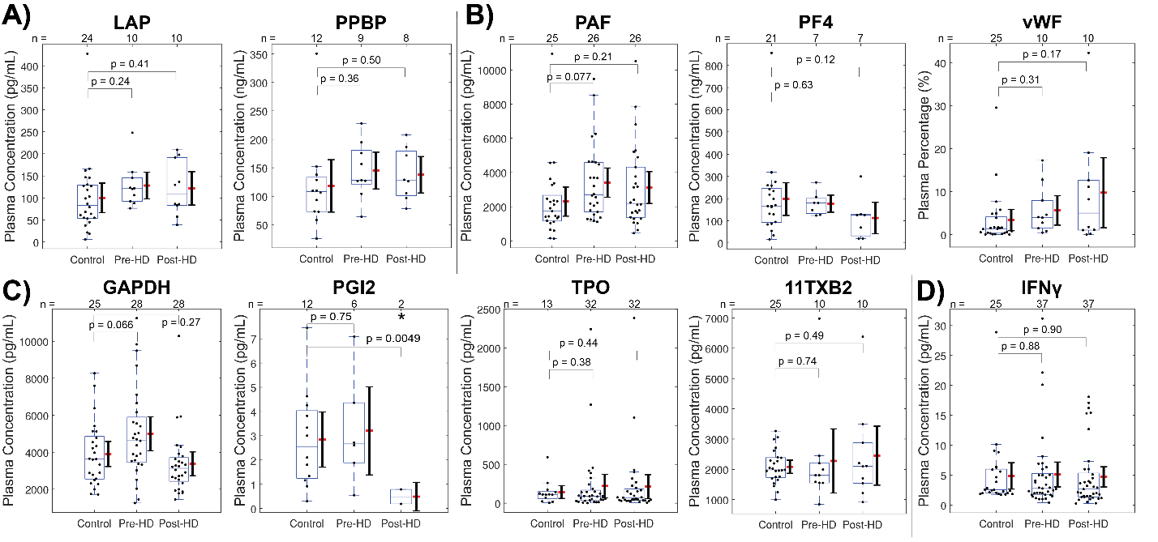
Comparison of plasma concentrations of (A) growth factors, (B) clotting factors, (C) cardiovascular indicators, and (D) inflammatory cytokines between healthy control and pre-dialysis or post-dialysis samples as measured by ELISA and compared by t test. *p < 0.05. Box and whisker plots represent quartiles. Adjacent ranges represent mean (red) ± 95% confidence interval. (C) Post-dialysis PGI₂ levels were significantly depressed compared to healthy controls.
SF2. Plasma biomarker levels unchanged by single dialysis sessions.
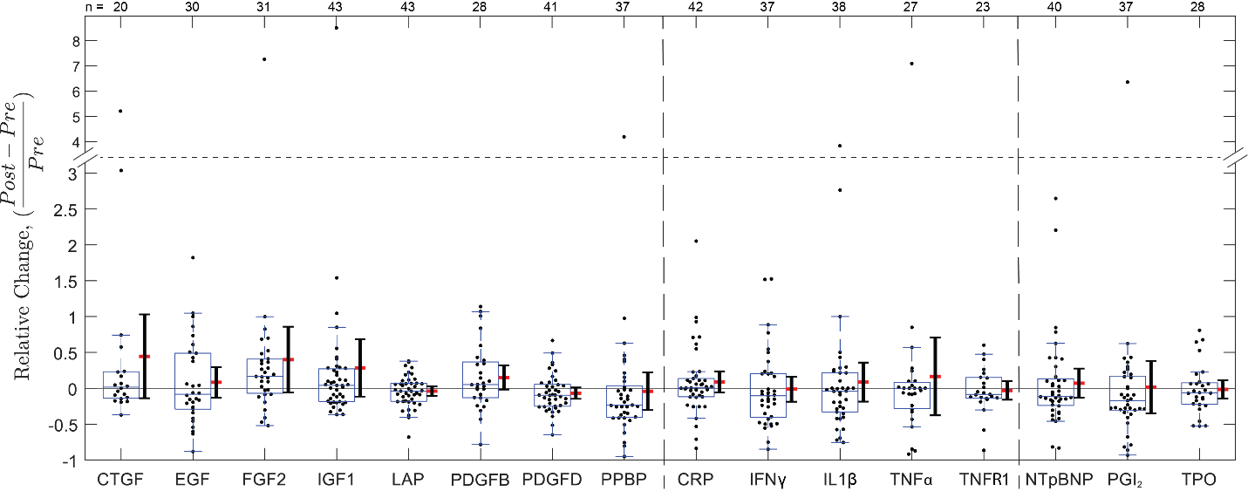
Relative changes in paired plasma samples from dialysis patients pre- and post-treatment as measured by ELISA. Statistical significance was assessed using one-sample t tests. *p < 0.05. Box and whisker plots represent quartiles. Adjacent ranges represent mean (red) ± 95% confidence interval.
SF3. Multiple linear regression of blood flow rate and patient weight to intra-dialysis changes of plasma MMP3. 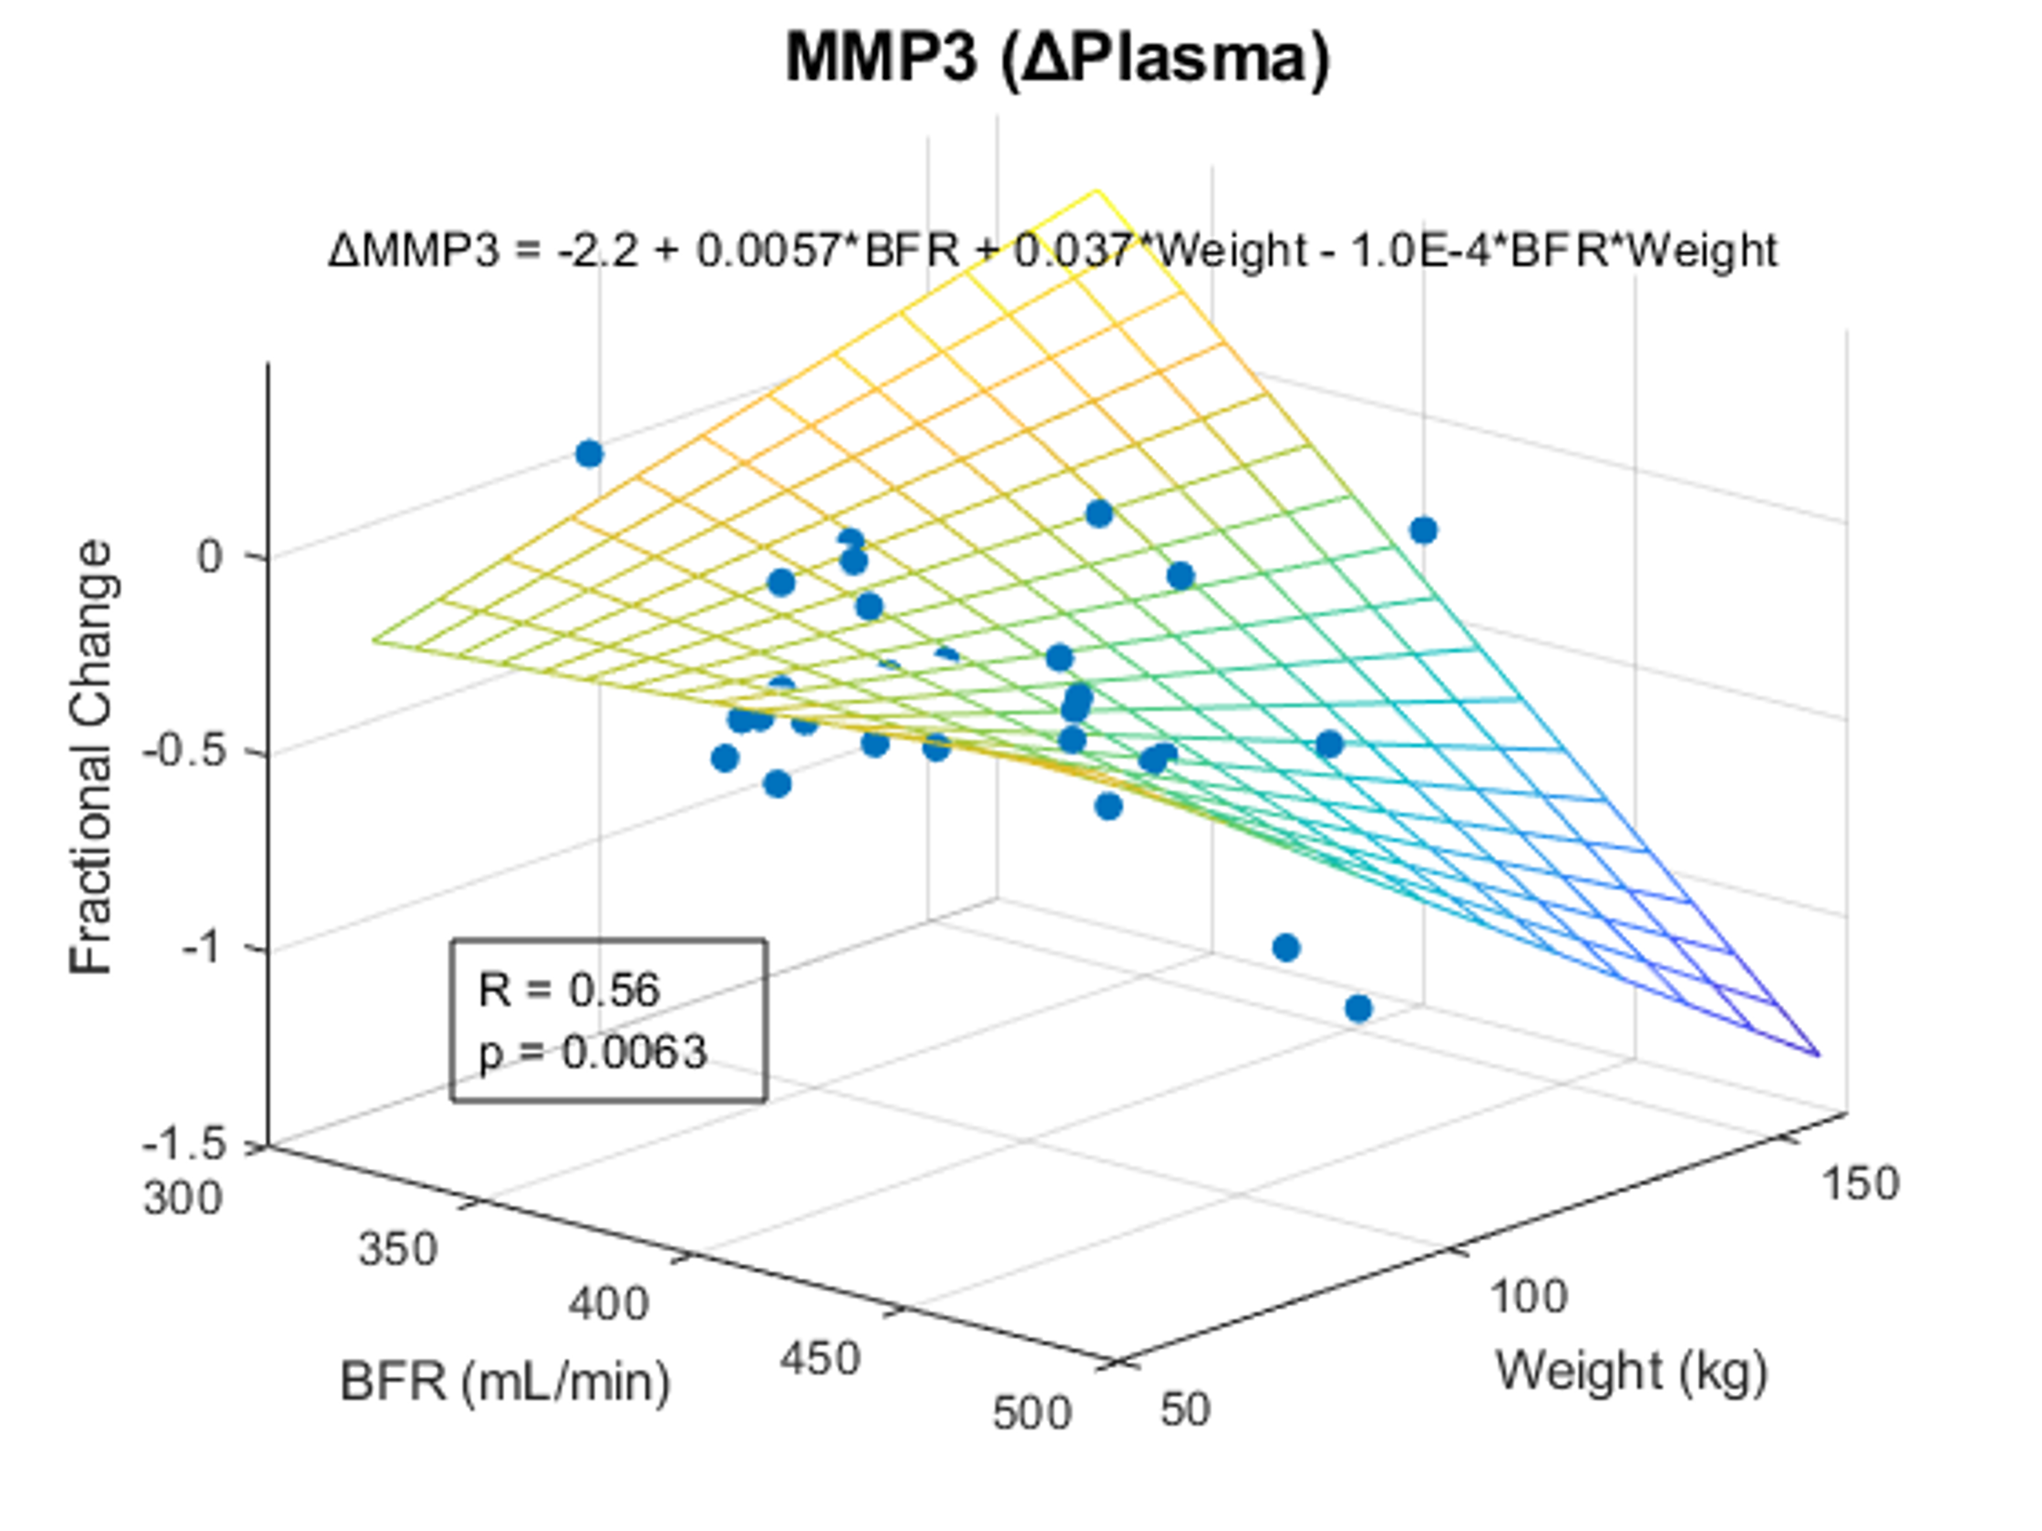
Significant multivariate correlation of plasma ΔMMP3 to blood flow rate and patient weight, subtracting interactions between predictors.

SF4. Raw data to Figure 4 significant correlations.

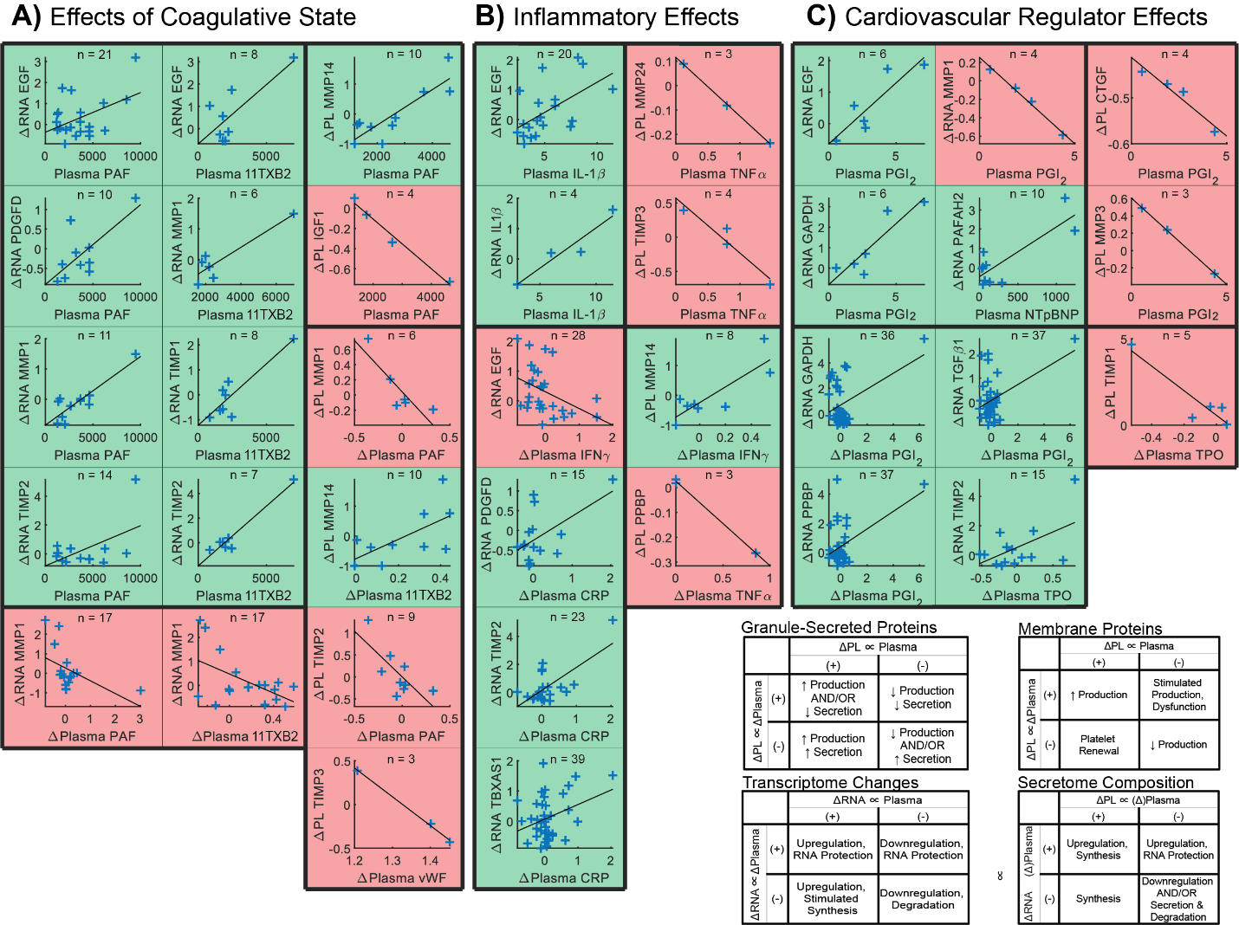
Significant Pearson correlations (p < 0.05) of intra-dialysis platelet lysate RNA or protein relative changes against pre-dialysis plasma protein levels or intra-dialysis plasma relative changes, categorized by interpreted effects on platelets caused by (A) coagulative, (B) inflammatory, and (C) cardiovascular indicators.

SF5. Raw data to Figure 5 significant correlations.

Significant Pearson correlations (p < 0.05) of platelet ΔRNA against platelet Δprotein, platelet ΔRNA against Δplasma, and platelet Δprotein against plasma or Δplasma.
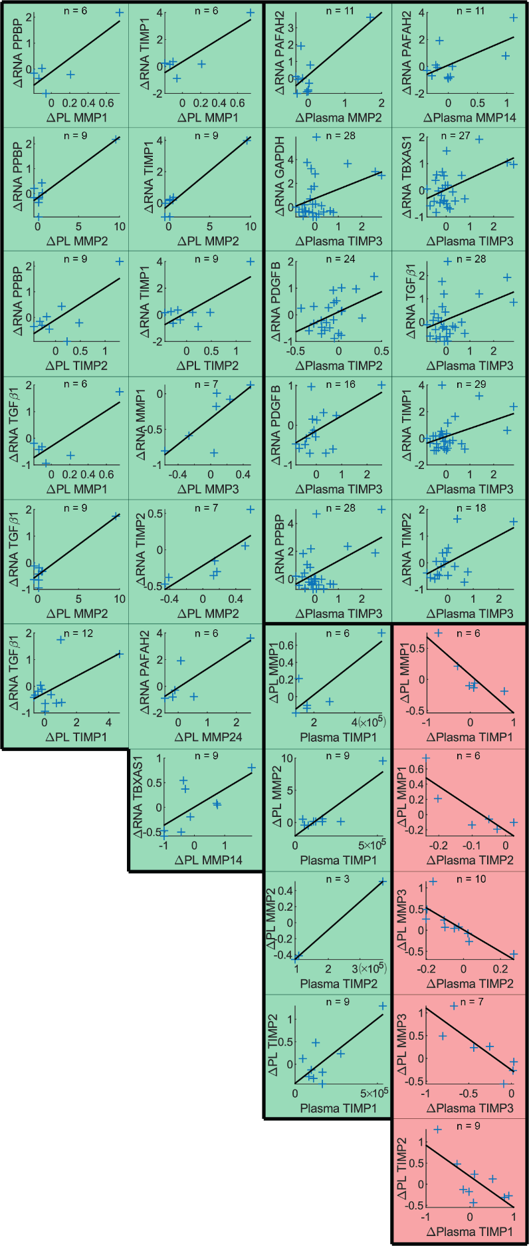

SF6. Raw data to Figure 6 significant correlations

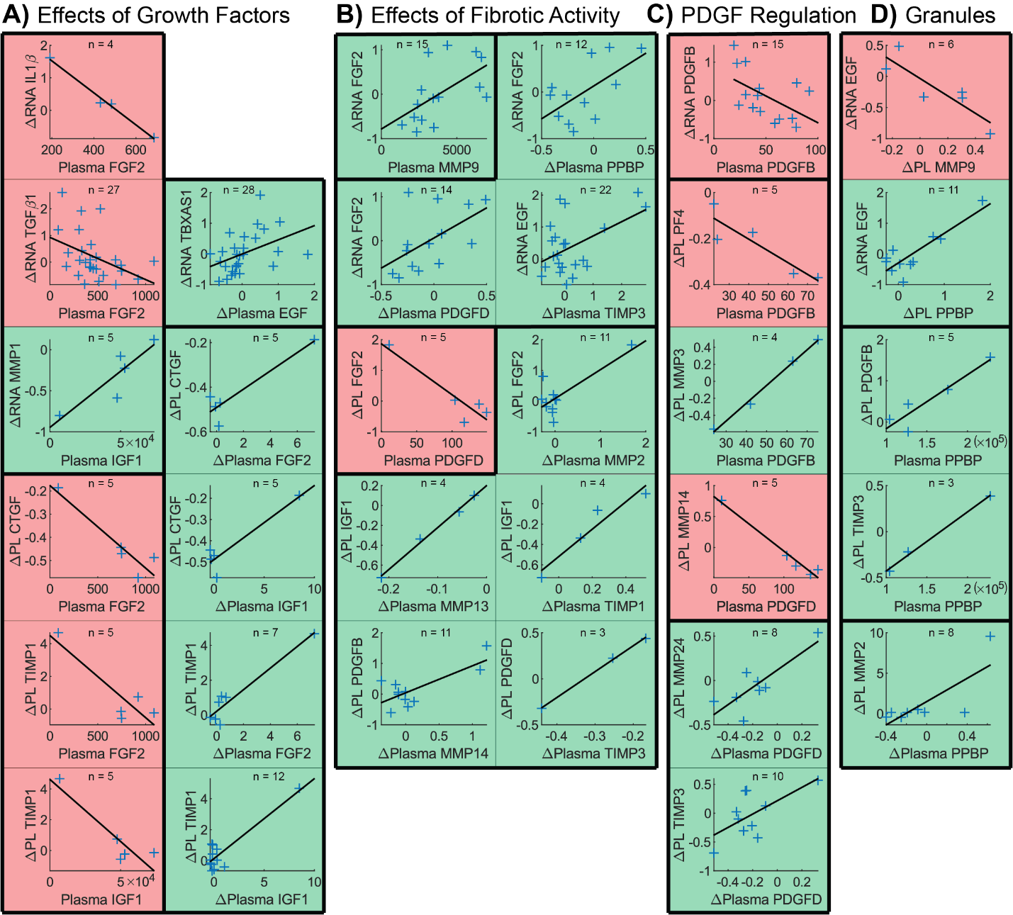

Significant Pearson correlations (p < 0.05) of intra-dialysis platelet lysate RNA or protein relative changes against pre-dialysis plasma protein levels or intra-dialysis plasma relative changes, categorized by interpreted effects on platelets caused by (A) growth factors, (B) fibrotic activity, and (C) PDGFs. (D) Correlations amongst alpha-granule and lysosome proteins elucidate physiological adaptations contributing to pro-fibrotic or fibro-protective functions.

