Intentional Travel Groups and Social Networks during the COVID-19 Pandemic

This PDF file includes:
Supplementary Fig. S1. Hong Kong MTR map
Supplementary Fig. S2. The results of KS-tests for the distribution of exit time difference between two riders in group trips
Supplementary Fig. S3. The algorithm-based detection of optimal changepoints in numbers of daily confirmed cases using the Pelt Search Method
Supplementary Table S1. Hong Kong COVID-19 Related Measures in 2020

Supplementary Information
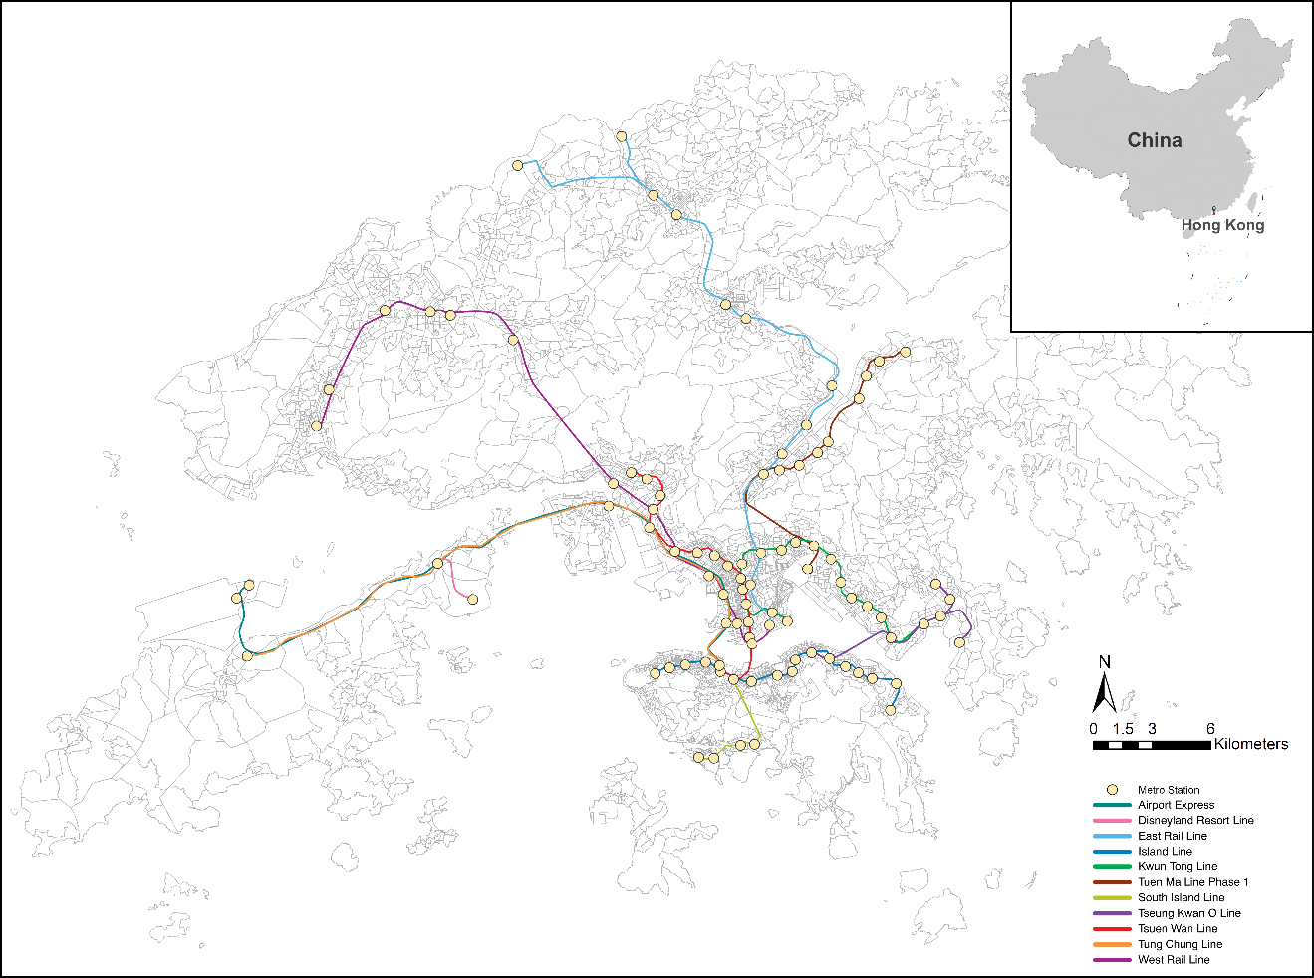

Supplementary Fig. S1. Hong Kong MTR map.

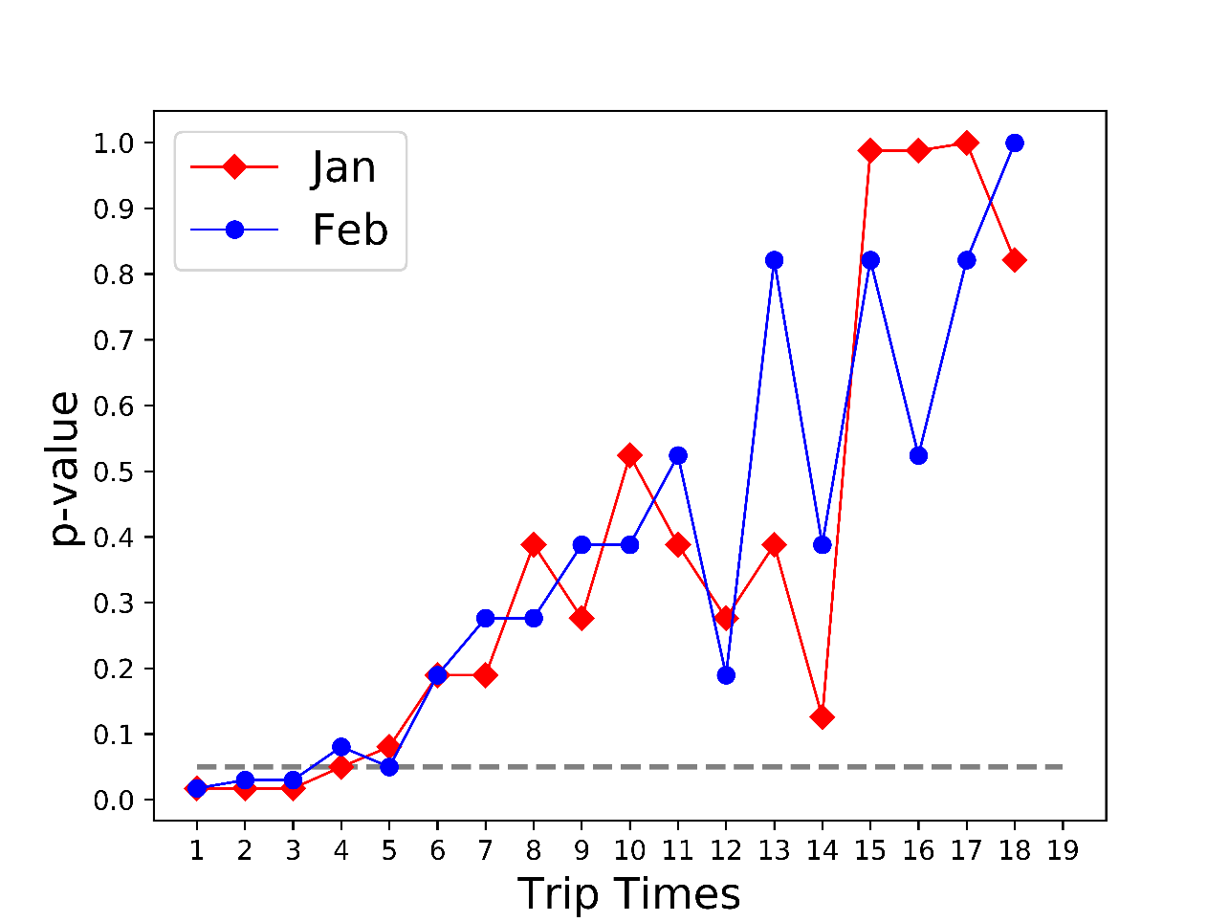
Supplementary Fig. S2. The results of KS-tests for the distribution of exit time difference between two riders in group trips.

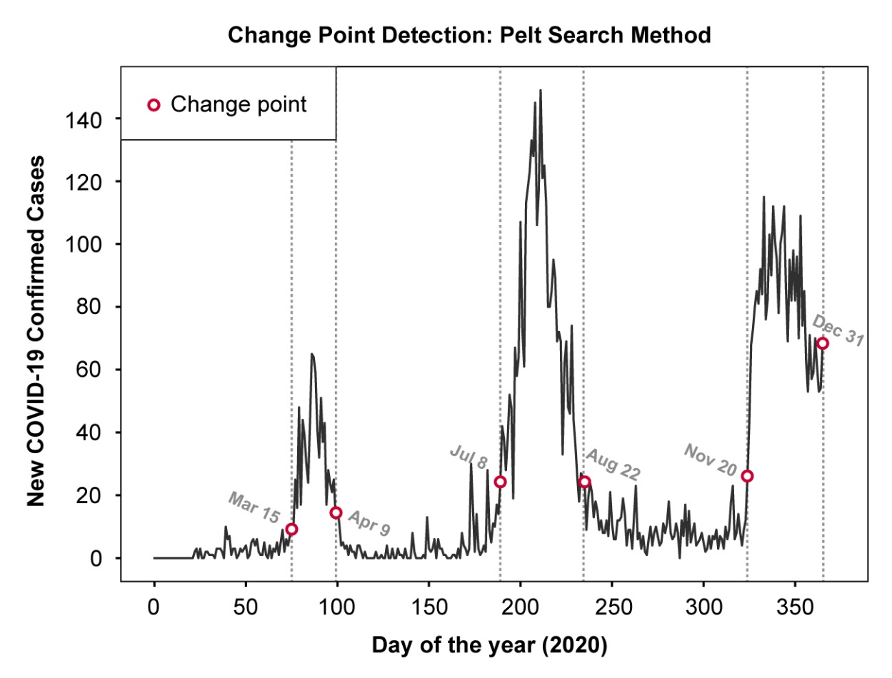
Supplementary Fig. S3. The algorithm-based detection of optimal changepoints in numbers of daily confirmed cases using the Pelt Search Method.

Supplementary Table S1. Hong Kong COVID-19 Related Measures in 2020
Dates | COVID-19 Related Measures
Jan 25 | Suspension on physical class meetings of schools after holiday (the local public holiday for Chinese Spring Festival - Jan 25 to Jan 28);
Jan 28 | Working-from-home mandate;
Feb 4 | Restrictions on cross-border travel between Hong Kong and mainland China;
March 18 | Restrictions on international travel
March 28 | Restrictions on capacity of public spaces and social gatherings;
May 8 | Ease of social gatherings
May 27 | Resume of physical class meetings;
July 11 | Tighten restrictions on social gatherings
July 15 | Suspension of physical class meetings;
July 23 | Mask-wearing mandate in public spaces
July 29 | Tighten restrictions on social gatherings, closure of non-essential businesses, and bans on dining-in;
Aug 28 | Ease of social gatherings ang resume of some non-essential businesses;
Dec 2 | Tighten restrictions on social gatherings and capacity of public spaces.

