Intentional Travel Groups and Social Networks during the COVID-19 Pandemic

This PDF file includes:
Figure 1. Hong Kong MTR map
Figure 2. The results of KS-tests for the distribution of exit time difference between two riders in group trips

Supplementary Information
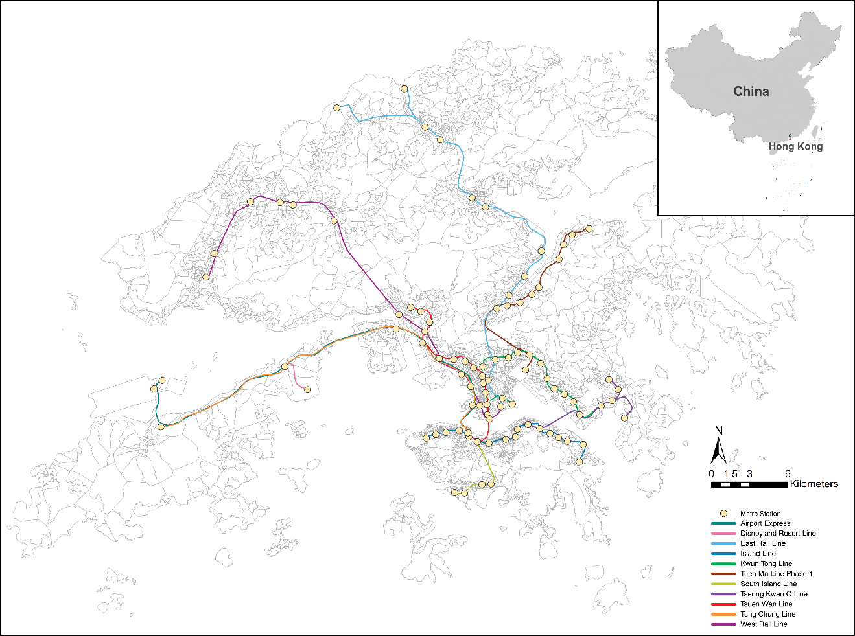

Supplementary Figure 1. Hong Kong MTR map.

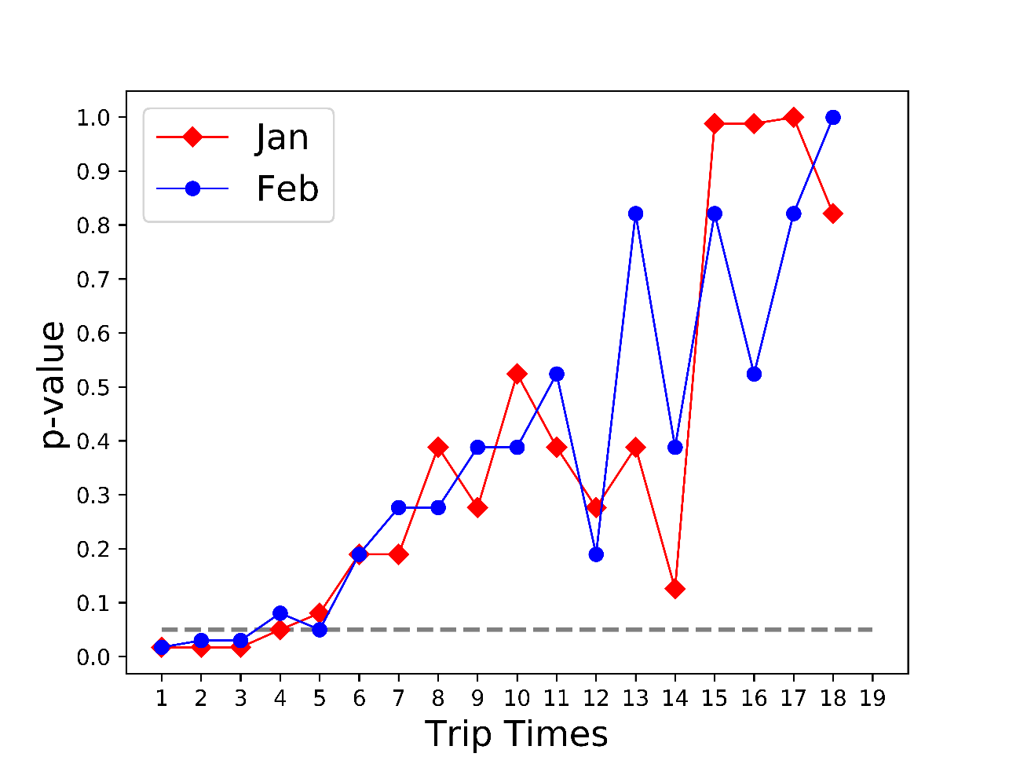
Supplementary Figure 2. The results of KS-tests for the distribution of exit time difference between two riders in group trips.

