Supplementary Material

Climate change driven shifts in plant-soil feedbacks – A meta-analysis
Kamrul Hassan^{1,2*}, K. M. Golam Dastogeer³, Yolima Carrillo¹ and Uffe N. Nielsen¹
¹Hawkesbury Institute for the Environment, Western Sydney University, Penrith, New South Wales, Australia.
²Department of Entomology, Sylhet Agricultural University, Sylhet- 3100, Bangladesh.
³Department of Plant Pathology, Bangladesh Agricultural University, Mymensngh-2202, Bangladesh.
*Corresponding author: kamrul.hassan@westernsydney.edu.au

Table S1 Studies included in the meta-analysis and the number of observations extracted from each paper.
Study | References | Observations
1 | Duel et al. (2019) | 16
2 | Anna et al. (2019) | 24
3 | Florianová & Münzbergová (2018) | 16
4 | Fry et al. (2018) | 4
5 | Hines et al. (2017) | 32
6 | Kaisermann et al. (2017) | 8
7 | Xi et al. (2018) | 2
8 | Snyder & Harmon-Threatt (2019) | 4
9 | Valliere & Allen (2016) | 4
10 | van Grunsven et al. (2010) | 24
11 | Hassan et al. (2021) | 20
12 | Hassan et al. (under review) | 8
13 | Hassan et al. (in preparation) | 16
14 | Hassan et al. (in preparation) | 4
Total |  | 182
Means, standard deviations or standard error, and sample sizes for control and experimental groups were extracted for each experiment from each paper.

Table S2 Overview of main findings of papers used in the meta-analysis.
Paper | Author | Climate manipulation | FG | Main findings
1 | Snyder et al., 2019 | Ambient (270 ml) & Drought (75 ml) received by weekly. | Forb | Species showed negative PSFs when cultivated in well-watered conditions, with weaker negative PSFs observed under drought conditions. This result suggest that drought altered the species co-existence in field conditions.
2 | Duell et al., 2019 | Temperature (ambient & +5◦C) | Grass | In ambient temperature, both native and non-native grasses showed negative PSFs, whereas non-native species showed positive PSFs under elevated temperatures. This study suggests that both soil conditioning and climate alter PSFs of non-native species.
3 | Aldorfová  & Münzbergová, 2019 | Ambient & Drought (30% reduction | Forb | PSFs were negative under drought conditions and weaker under ambient conditions. However, native species experienced more negative PSFs than invasive. These results suggest not only soil conditioning but also species origin and water availability can modify PSFs.
4 | Xi et al., (2018) | Ambient & Drought (85 % reduction than ambient) | Tree | Negative PSFs were weaker in drought condition. Negative PSFs were associated with increased bacterial diversity in drought treatments, with no treatment effects on fungal communities. This study highlights the importance of PSFs on ecosystem functioning and stability in changing climate.
5 | Fry et al., 2018 | Ambient (36% soil moisture) & Drought (7% soil moisture) | Forb | PSFs were species specific and varied within functional group. Forb Scabiosa columbaria showed negative PSFs in well-watered conditions but neutral PSFs under drought. On the contrary, Scabiosa minor displayed positive PSFs in well-watered conditions but consistent neutral PSFs under drought. These results suggested that drought disrupt plant-soil biotic interactions and can benefits plants.
6 | Florianová & Münzbergová 2018 | Ambient (water twice in every other day) & Drought (watered only when plant showed wilting) | Forb | In most cases, invasive species showed positive PSFs in both moist and drier environment irrespectively to light treatment. However, negative PSFs were observed in a few cases, especially the invasive forb, Impatiens balsamina.
7 | Kaisermann et al., 2017 | Drought legacies (ambient, drought: 60% water holding capacity) | Grass, Forb | Drought legacies modified bacterial and fungal composition and reduced growth of species more in conspecific soil (negative PSFs) than heterospecific soil. On the contrary, positive PSFs were observed in ambient legacies. The PSFs were altered via plant competitive interactions.
8 | Hines et al., 2017 | Ambient & elevated temperature (1.5/3.0°C day/night) | Grass, Forb | Grasses and forbs were differently influenced by the history of climate change manipulation. Performance of species within grass and forbs varied with temperature and soil biota effects.
9 | Valliere & Allen 2016 | Well-watered (60% water holding capacity) & drought  (20% water holding capacity) | Shrub | Soil inoculum with low nitrogen caused neutral PSFs in ambient and positive PSF under drought. On the contrary, high N availability caused positive PSFs in ambient and negative in drought. Low availability of N increased mycorrhizal colonization relative to high N availability. This study highlights the need to consider the importance of interactive effects of climate stress and N deposition.
10 | van Grunsven et al., 2010 | Ambient & elevated temperature (+5◦C) | Grass, forb, shrub | Temperature manipulation did not alter the direction and strength of PSFs, neither for native nor non-native species. However, non-native species benefitted more from positive PSFs than native suggesting that introduced species may escape soil borne pathogens in temperate climates.
11 | Hassan et al., 2021 | Prolonged drought legacies (laboratory)- ambient and drought (50% reduction relative to ambient in field) | Grass, forb, legume | Drought-induced shifts in PSFs were species specific (negative to positive or vice-versa) and varied with and among functional group when cultivated in monoculture. Indications that drought destabilize plant communities due to given weaker positive to neutral PSFs in soils with prolonged drought legacies relative to stronger positive PSFs in soil with ambient rainfall legacies
12 | Hassan et al.,  (In Review) | Prolonged drought legacies - ambient and drought (50% reduction relative to ambient in field) | Grass, forb, legume | Three species showed positive PSFs under ambient rainfall conditions that shifted to negative under drought conditions. By contrast, PSFs were negative for the exotic forb, Plantain This is the first study measuring PSFs under field condition following more than seven years ambient and drought treatments. The study indicated that persistent drought increased negative plant-soil interactions driven by more plant parasites under drought.
13 | Hassan et al.,  (In preparation) | Prolonged drought legacies - ambient and drought (50% reduction relative to ambient in field) | Legume | The herbivore Helicoverpa armigera induced neutral to negative PSF under ambient rainfall and negative PSFs in soil with drought legacies in intraspecific competition of two legumes. PSFs were positive in ambient and negative in drought legacy soils in interspecific competition with aboveground herbivore cotton bollworm.
14 | Hassan et al.  (In preparation) | Prolonged drought legacies - ambient and drought (50% reduction relative to ambient in field) | Legume | Both single and dual herbivory significantly altered the magnitude and direction of PSFs between ambient and prolonged drought legacies.

Table S3 Summary of multilevel model output for temperature and drought effects on mean PSF effect sizes.

Climate | DF | Q-value | p-value | AIC | BIC | AICc
Overall | 181 | 533.636 | <0.001 | 587.583 | 597.179 | 587.719
Ambient water | 54 | 166.926 | <0.001 | 184.831 | 190.798 | 185.311
Drought | 54 | 145.463 | <0.001 | 177.892 | 183.859 | 178.372
Ambient temperature | 35 | 100.763 | <0.001 | 114.977 | 119.643 | 115.752
Elevated temperature | 35 | 117.997 | <0.001 | 118.236 | 122.902 | 119.010
Q, total heterogeneity; p, significance of Q heterogeneity; df, degree of freedom; AIC, Akaike Information Criterion; BIC; Bayesian Information Criterion (BIC); AICc, AIC with a correction for small sample size.

Table S4 Summary of multilevel model output for ambient and elevated temperature PSF effect sizes.

Parameter | Ambient temperature |  |  |  | Elevated temperature
 | Q, df, p-value | AIC | BIC | AICc | Q, df, p-value | AIC | BIC | AICc
FG
Grass | 56.337,17, <0.001 | 58.047 | 60.546 | 59.893 | 41.090,17,0.000 | 48.778 | 51.277 | 50.624
Forb | 28.748,13,0.007 | 37.879 | 39.574 | 40.546 | 44.523,13, <0.001 | 47.784 | 49.479 | 50.450
Shrub | 5.483,3,0.139 | 9.913 | 7.391 | 21.193 | 17.071,3,0.000 | 12.837 | 11.035 | 24.837
Origin
Native | 50.532,17, <0.001 | 60.794 | 63.293 | 62.640 | 44.297,17, <0.01 | 59.056 | 61.556 | 60.903
Non-native | 48.199,17, <0.001 | 54.288 | 56.78 | 56.134 | 65.706,17<0.001 | 60.324 | 62.824 | 62.171
Life cycle
Annual | 56.018,17, <0.001 | 52.396 | 54.520 | 54.578 | 71.734,15, <0.001 | 56.529 | 58.653 | 58.710
Perennial | 43.865,19, <0.001 | 65.793 | 68.626 | 67.393 | 43.658,19, <0.001 | 62.490 | 65.323 | 64.090
GC
Monoculture | 9.148,7,0.242 | 18.716 | 18.607 | 21.716 | 11.488,7,0.118 | 20.964 | 20.856 | 23.964
Mixture | 90.722,27, <0.001 | 95.427 | 99.315 | 96.417 | 105.32,27, <0.001 | 96.664 | 100.552 | 97.708
EC
Laboratory | 47.909,19<0.001 | 51.217 | 54.051 | 52.817 | 60.394,19, <0.001 | 55.739 | 58.572 | 57.339
Field | 48.935,15, <0.001 | 60.287 | 61.703 | 61.287 | 50.210,15<0.001 | 59.539 | 60.955 | 60.539
Q, total heterogeneity; p, significance of Q heterogeneity; df, degree of freedom; AIC, Akaike Information Criterion; BIC; Bayesian Information Criterion (BIC); AICc, AIC with a correction for small sample size. FG; Functional group; GC; Growing condition; EC; Experimental condition.

Table S5 Summary of multilevel model output for ambient water and drought on PSF effect sizes.

Parameter | Ambient water |  |  |  | Drought
 | Q, df, p-value | AIC | BIC | AICc | Q, df, p-value | AIC | BIC | AICc
FG
Grass | 27.012,7, <0.0001 | 34.257 | 34.094 | 42.257 | 11.339,7,0.124 | 25.8663 | 25.7040 | 33.8663
Forb | 84.214,28, <0.0001 | 89.2337 | 93.2303 | 90.2337 | 87.90,28, <0.0001 | 93.3631 | 97.3597 | 94.3631
Legume | 19.736,14,0.138 | 39.688 | 41.605 | 42.088 | 31.267,14,0.005 | 53.694 | 55.611 | 56.094
Origin
Native | 64.037,16, <0.001 | 62.932 | 65.249 | 64.932 | 42.218,16, <0.001 | 57.148 | 59.466 | 59.148
Non-native | 102.763,37, <0.001 | 123.912 | 128.745 | 124.640 | 99.011,37, <0.001 | 123.353 | 128.186 | 124.080
Life cycle
Annual | 51.927,16, <0.001 | 51.798 | 54.116 | 53.798 | 50.894,16, <0.001 | 56.553 | 58.871 | 58.553
Perennial | 110.532,37, <0.001 | 135.771 | 140.604 | 136.498 | 94.247,37, <0.001 | 125.258 | 130.090 | 125.985
GC
Monoculture | 158.323,48, <0.001 | 166.871 | 172.485 | 167.417 | 134.48,48, <0.001 | 157.325 | 162.938 | 157.870
Mixture | 7.870,5,0.01 | 18.469 | 17.297 | 42.469 | 1.711,5,0.887 | 15.959 | 14.784 | 39.956
EC
Laboratory | 137.630,50<0.001 | 160.469 | 166.205 | 160.991 | 130.95,50, <0.001 | 164.400 | 170.137 | 164.922
Field | 20.294,3, <0.001 | 16.940 | 15.138 | 28.940 | 3.665,3, 0.299 | 11.193 | 9.390 | 23.193
Q, total heterogeneity; p, significance of Q heterogeneity; df, degree of freedom; AIC, Akaike Information Criterion; BIC; Bayesian Information Criterion (BIC); AICc, AIC with a correction for small sample size. FG; Functional group; GC; Growing condition; EC; Experimental condition.

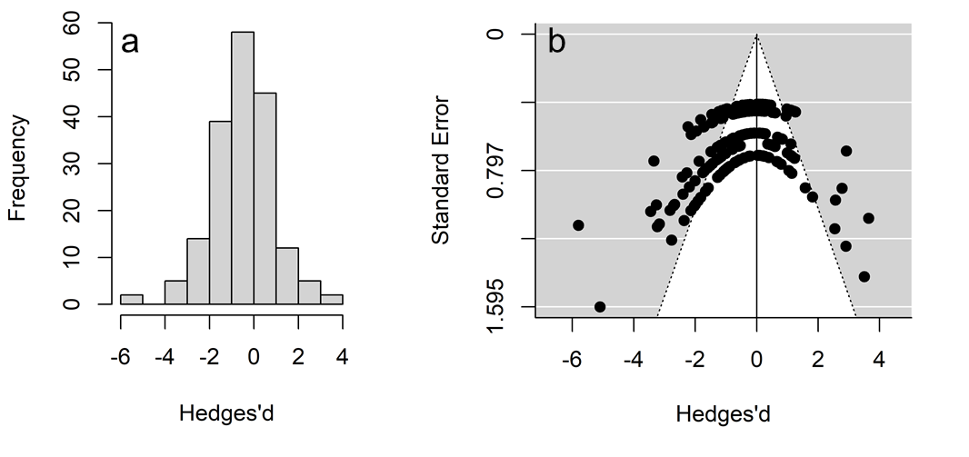
Fig. S1 Histogram (a) and Funnel plot (b) based on number of PSF experiments by effect size. Negative effect sizes suggest that plants grow better in soils cultivated by the same species than soils cultivated by another species (n = 182). The distribution of effect sizes does not suggest a publication bias toward significant results.

