Supporting Information

Efficient Mineralization of Organic Pollutants Using Visible-light-induced PTCDA Anions Electronic Reservoir and Photogenerated Holes

Yan Guo ^{[a, b]}, Qixin Zhou, ^{[b]} Jun Nan* ^{[a]} and Yongfa Zhu* ^{[b]}
[a] Department State Key Laboratory of Urban Water Resource and Environment, School of Environmental Engineering, Institution Harbin Institute of Technology, Harbin 150090, China
[b] Department Department of Chemistry, Tsinghua University, Beijing, 100084, China

Contents
1. Characterization. 3
2. Photoelectrochemical measurements 4
3. Activity Evaluation 4
4. Theoretical calculations. 5
5. Fukui Function for orbital weights. 7
6. Support figures and tables for high-flux and deep mineralization 9
1) The universality of photocatalysis cooperative PMS for PTCDA photocatalyst with large conjugate 9
2) PTCDA/PMS system quickly degrade high concentration BPA (100ppm). 10
3) PTCDA/PMS requires only low concentrations of PMS 11
4) PTCDA/PMS is universal for the removal of organic pollutants 12
5) PTCDA has excellent cycle stability 13
6) Carbon nanotubes have strong adsorption 14
7) PTCDA/PMS system is superior to traditional Fenton - like system 15
8) PTCDA responds to a wide visible spectrum 18
9) High utilization rate of PMS in PTCDA/PMS system 20
10) Electrochemical reduction produces PTCDA anions 21
11) Light induced PTCDA anions as electron reservoir for PMS 22
12) PMS and PTCDA formed strong adsorption 27
13) Excellent photogenerated electron-hole separation in PTCDA/PMS system 29
14) Many hydroxyl - adducts of BPA produce in the Co₃O₄/PMS system 30
15) Alkyl radicals were detected during PTCDA/PMS degradation of BPA 31
16) Active oxygen component identification 32
17) Performance of PTCDA/PMS to degrade BPA in different water bodies 33
18) Xenon light source used in this study can simulate sunlight 33
19) PTCDA/PMS has excellent degradation performance under actual sunlight 34
7. Characterization of PTCDA's charge transport capability. 35
Reference 41

- Characterization.
The intensity of the xenon lamp or sunlight is tested with an optical power meter (Thorlabs PM100D). The crystalline phase was identiﬁed via powder X-ray diﬀraction (XRD) (Bruker D8 X-ray diffractometer with Cu Ka radiation with λ=0.15418 nm). The morphologies of the samples were survived by transmission electron microscope (TEM) on JEOL JEM-1400 TEM at an accelerating voltage of 100 kV. XPS were analyzed using a Thermo ESCALAB 250 with Al Kα X-ray (hν=1486.6 eV) radiation. The thickness of the sample is measured by multifunctional single molecule force instrument (AFM) on Oxford cypher s. Electron paramagnetic resonance spectrometer (ESR) spectra were recorded from the sample mixture, containing spin-trapping probes such as 5,5-dimethyl-1-pirroline-N-oxide (DMPO), 2,2,6,6-Tetramethyl-4-piperidone (TEMP) and products, after exposure to visible light for selected times to test EPR signal at room temperature. The EPR test of alkyl radicals uses acetonitrile as the solvent. UV-Vis diffuse reflection spectra (DRS) were identiﬁed on a spectrophotometer (Shimadzu, UV2550) with BaSO₄ as reference. Perkline LS55 fluorescence spectrophotometer with λ_{ex}=535 nm was used to analyze the steady-state photoluminescence (PL) spectra. The surface photovoltage (SPV) spectra were detected by a home-built apparatus, equipped with a lock-in ampliﬁer (SR830, USA) synchronized with a light chopper (SR540, USA). Total organic carbon (TOC) analyser (Multi N/C 2100s) was employed for mineralization degree analysis of pollutants.
- Photoelectrochemical measurements
Photoelectrochemical measurements were recorded on a CHI-660 E (China) electrochemical workstation with a standard three-electrode cell, including reference electrode (saturated calomel electrode), counter electrode (Pt wire) and working electrodes (as-prepared samples covered ITO glass). Na₂SO₄ (0.1 mol/L) was used as electrolyte solution. For the working electrodes, 1 mg sample was dispersed in water to obtain a slurry. Then the slurry was coated onto the ITO glass and dried naturally. Electrochemical impedance spectroscopy spectra were recorded under an AC perturbation signal of 10 mV over the frequency range from 1000 KHz to 10 KHz. The conditions of cyclic voltammetry curves are that the sample was dropped on a platinum carbon electrode and the electrolyte is acetonitrile with 0.1M Bu4NPF6, scan rate 100 mV/min.
- Activity Evaluation
The photocatalytic activity was estimated by measuring the degradation of Bisphenol A (BPA), 4-chlorophenol (4-CP), 2,4-dichlorophenol (2,4-DCP) and phenol. The sunlight is simulated by a 300W lamp equipped with different filters was used as the visible light source. 20 mg of samples was dispersed in 50 mL of organic pollutants solution added with PMS. To avoid any misleading results, no buffer reagents are used. Before the light irradiation, the mixture was stirred for 30 min to reach the adsorption equilibrium in the dark and the temperature of the system was maintained at 20 °C by continuous circulating water. 2 mL of the solution versus time were taken out from the reactor and injected into an amber glass vial containing excess methanol (0.1 M) to inhibit the reaction of residual radicals. The concentration was detected by the HPLC system (SHIMADZU). Most degradation experiments were performed in duplicate or triplicate, and the results were presented with the mean data with standard deviations.

Table S1. The wavelength and intensity of the light source used in this paper
λ | light intensity (mW / cm²)
350 nm | 20.48
400 nm | 154.38
450 nm | 154.27
496 nm | 141.69
550 nm | 154.42
590 nm | 140.98
650 nm | 124.44
700 nm | 146.16
≥420nm | 564.67
- Theoretical calculations.
The DFT calculation were carried out as implemented in Gaussian 09 package (Gaussian, Inc., Wallingford CT, 2009.), using hybrid functional M06-2X, which uses 54 % exact exchange and 46 % DFT exchange, Grimme-D3 dispersion correction^{[1]}, in combination with the def2-tzvp basis set^{[2]}.
The adsorption energy of HSO₅⁻ adsorbed on PTCDA was calculated, which was defined as:
$E_{a-ads}\left( {HSO}_{5}^{-}\right)=-[E_{total}-(E_{{HSO}_{5}^{-}}+E_{PDI})]$. (1)
Where $E_{a-ads}\left( {HSO}_{5}^{-}\right)$ refers to the total energy of HSO₅⁻ adsorbed on PTCDA, $E_{total}$ is the total energy of the system containing PTCDA and HSO₅⁻, $E_{{HSO}_{5}^{-}}$ is the energy of HSO₅⁻ and $E_{PDI}$ is the energy of PTCDA. And when calculating the adsorption energy, the basis set superposition error (BSSE) was corrected using counterpoise (CP) method.

- Fukui Function for orbital weights.
The well function is defined as the partial derivative of the electron density at a point in space with respect to the electron number:
$f\left(r\right)={(\frac{∂μ}{∂ϑ\left(r\right)})}_{N}={(\frac{∂ρ\left(r\right)}{∂N})}_{ϑ(r)}$ (2)
Where r is the potential vector, $μ$ is the chemical potential, $ρ$ is the electron density, N is the number of electrons, and $ϑ$ is the attraction potential (configuration-dependent) of the nucleus to the electrons at a certain position. Considering the integer of N and the discontinuous of the function, the finite difference approximation is used to take the limit from both sides.
$f^{+}\left(r\right)=\lim_{ϵ→0^{+}}{\frac{ρ_{N+ϵ}\left(r\right)-ρ_{N}\left(r\right)}{ϵ} }$(3)
$f^{-}\left(r\right)=\lim_{ϵ→0^{-}}{\frac{ρ_{N}\left(r\right)-ρ_{N-ϵ}\left(r\right)}{ϵ}}$(4)
$f^{0}\left(r\right)=\left[f^{(+)}\left(r\right)+f^{(-)}\left(r\right)\right]/2$(5)
From Formula 1, when a molecule gains an electron, the electron tends to go to the place with a high value of F, because adding an electron at this site can stabilize the molecule and reduce the chemical potential. The large locus of F is vulnerable to nucleophilic attack. From Equation 2, when a molecule is attacked by electrophilic attack, the instability degree of the system will be small after the electron of Small F is taken away. Here are the sites vulnerable to electrophilic attacks.
Double descriptors based on Fukui function were used to investigate both electrophilicity and nucleophilicity:
$∆f\left(r\right)=f^{(+)}\left(r\right)-f^{(-)}\left(r\right)$(6)
The more negative this value is, the more vulnerable it is to electrophilic attack. The more positive, the more vulnerable to nucleophilic attack.

Support figures and tables for high-flux and deep mineralization

The universality of photocatalysis cooperative PMS for PTCDA photocatalyst with large conjugate
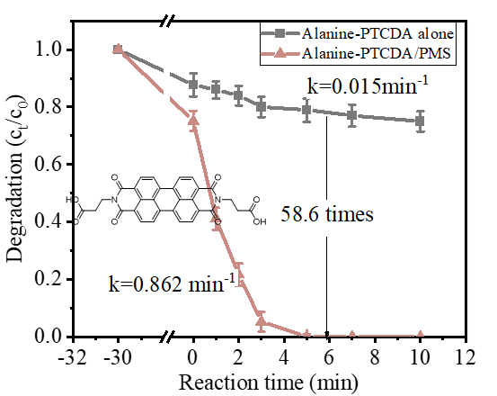
Figure S1. The BPA degradation effect for Alanine-PTCDA/PMS system.
Similarly, alanine-PTCDA also has a large conjugate system. For alanine-PTCDA, the degradation rate constant after coupling with PMS is 58.6 times that of photocatalysis alone. Considering that compared with alanine-PTCDA, PTCDA has easy-to-obtain raw materials and simple preparation. This study chose PTCDA as a model catalyst for subsequent work.

PTCDA/PMS system quickly degrade high concentration BPA (100ppm).
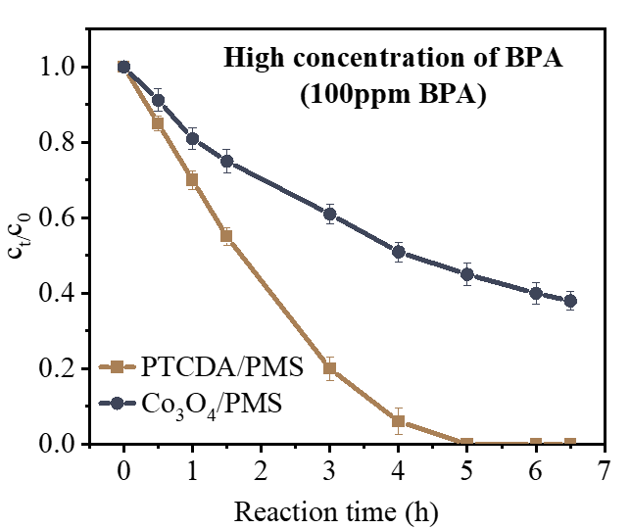
Figure S2. PTCDA/PMS and Co/PMS systems degrade high concentrations of BPA. [Catalyst] =0.4g L⁻¹, [BPA] = 0.1 g L^{–1}, [PMS] = 0.09 g L^{–1} and temperature = 20 °C. The light is λ≥420nm and the intensity is ~300mw/cm².
For high concentrations of BPA, the degradation effect of PTCDA/PMS is better than that of Co₃O₄/PMS system.

PTCDA/PMS requires only low concentrations of PMS
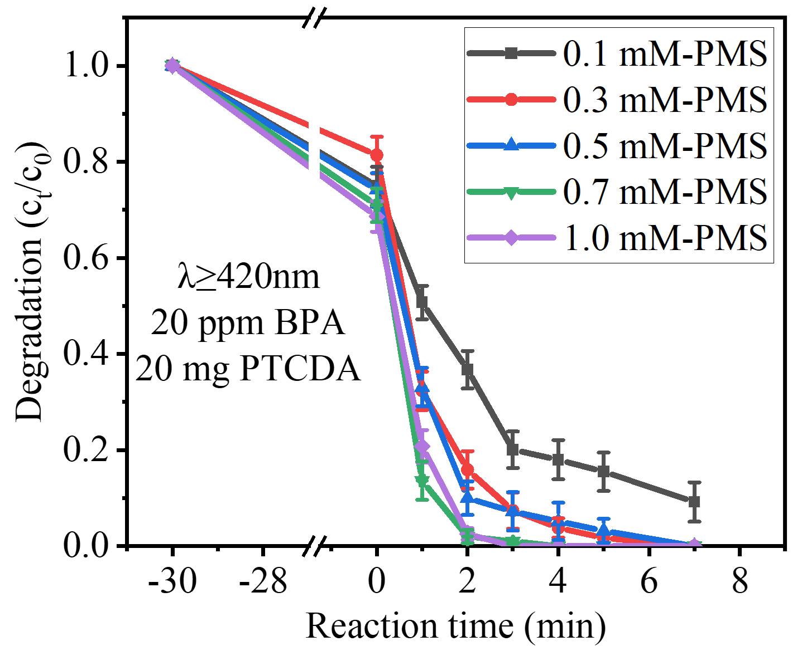
Figure S3. The concentration changes for BPA at different PMS content in PTCDA/PMS system. Experimental conditions: [Catalyst] = 20 mg, [BPA]=20mg/L, the light is λ ≥ 420nm and the light intensity is ~300 mw/cm².
In order to explore the optimal PMS dosage, the degradation effect test of different PMS concentrations was carried out. As the PMS concentration gradually increased in the range of 0.1~1.0mM, the removal effect of PTCDA/PMS system on BPA increased. Considering that too high PMS dosage will increase the cost, 0.3mM PMS is selected as the subsequent concentration.

PTCDA/PMS is universal for the removal of organic pollutants
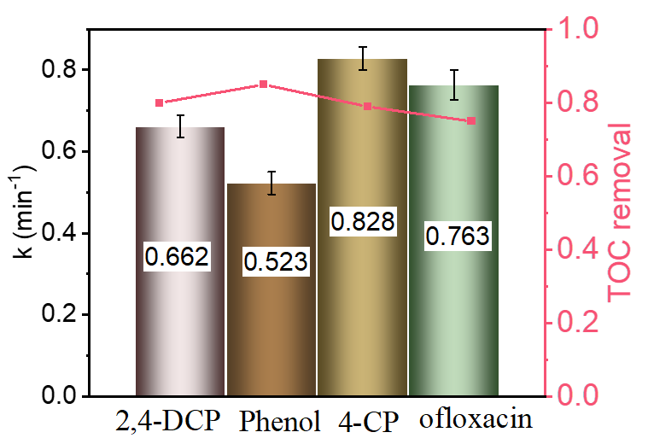
Figure S4. The BPA removal effect of PTCDA on different pollutants.

PTCDA/PMS has excellent degradation rate constant and salinity for different organic pollutants, which shows that the system has universal applicability.

PTCDA has excellent cycle stability
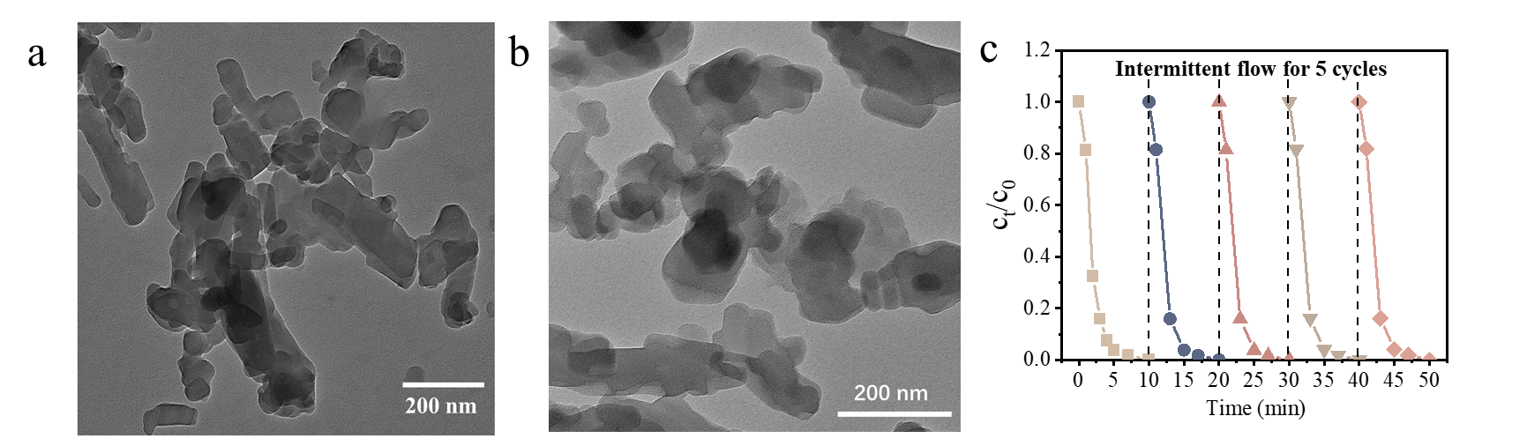
Figure S5. TEM picture of PTCDA (a) and used after 5 cycles (b). The BPA degradation effect in batch reactor for PTCDA/PMS system. (c)
Compared with the transmission electron microscope images of PTCDA before and after the reaction, the morphology of PTCDA did not change significantly, indicating that PTCDA has excellent stability. After 5 cycles, the degradation effect of PTCDA/PMS remained 100%.

Carbon nanotubes have strong adsorption
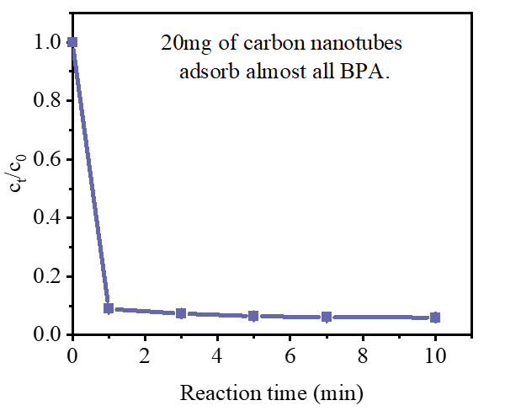
Figure S6. The adsorption effect of 20mg (0.4 g L^{–1}) carbon nanotubes on BPA.
Keep the experimental parameters consistent as much as possible to contrast the results (including catalyst dosage, PMS dosage, reaction temperature). Note that carbon nanotubes with a dosage of 20mg (0.4 g L^{–1}) can almost adsorb all 20mg/L of BPA that interference evaluation of PMS activation effect, so reduce the catalyst dosage to 5mg (0.1g L⁻¹).

PTCDA/PMS system is superior to traditional Fenton - like system
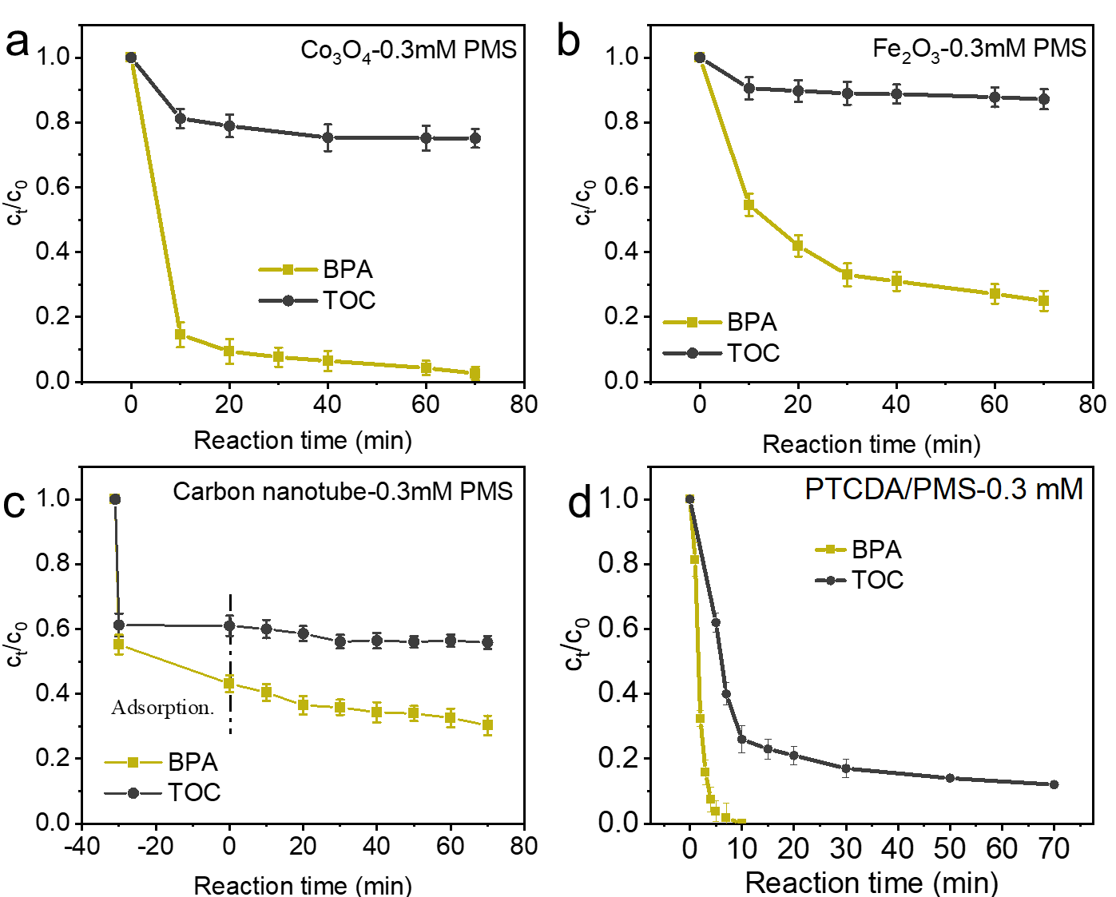
Figure S7. Kinetic curves of BPA degradation and mineralization added with 0.3 mM PMS for (a) Co₃O₄/PMS, (b) Fe₃O₄/PMS, (c) Carbon nanotube/PMS and (d) PTCDA/PMS systems.
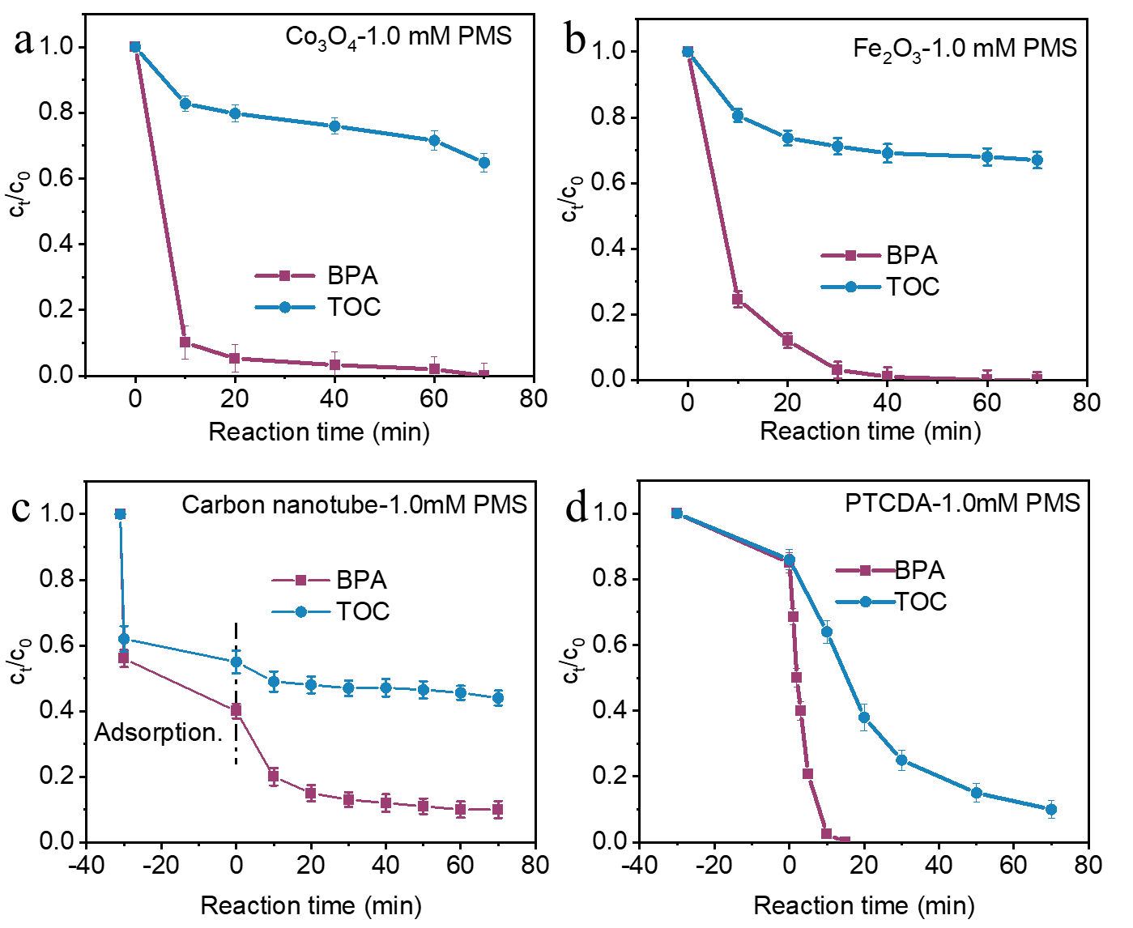
Figure S8. Kinetic curves of BPA degradation and mineralization added with 1.0 mM PMS for (a) Co₃O₄/PMS, (b) Fe₃O₄/PMS, (c) Carbon nanotube/PMS and (d) PTCDA/PMS systems.
The figure shows the degradation effect and salinity data of BPA by different catalytic systems at the dosage of 0.3mm and 1.0Mmpms. The Fenton - like degradation of BPA by traditional excessive metal catalyst has a very fast degradation rate, which indicates that the PMS activation degradation is high throughput. However, the salinity of these systems is not high and will not improve significantly over time, which may be better than the depletion of PMS. Further increasing the PMS concentration to 1.0mM, the mineralization of Fenton - like system with traditional excessive metal catalyst did not increase significantly. In PTCDA/PMS system, TOC removal of ~88% was obtained at low concentrations of PMS.

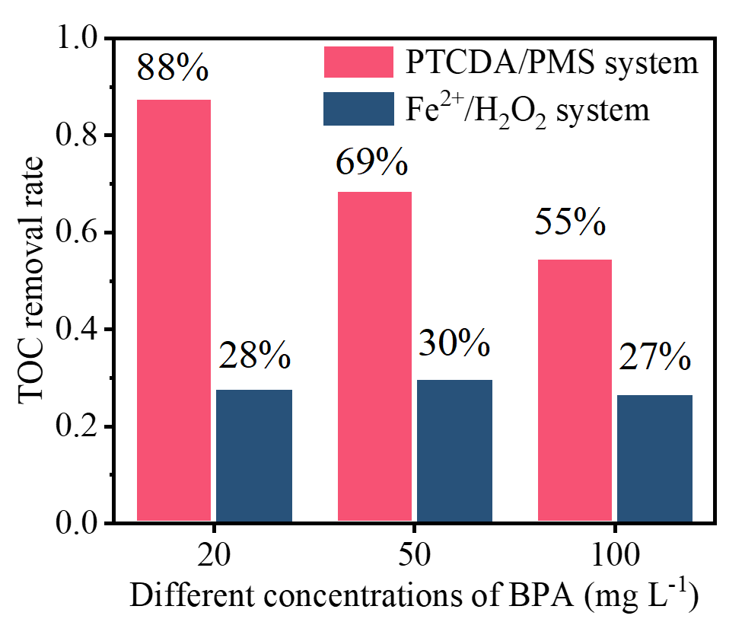
Figure S9. Mineralization of PTCDA/PMS systems and homogeneous Fenton systems (Fe²⁺/ H₂O₂) for BPA with different concentrations. The reaction time is 120 minutes. [PTCDA catalyst] = 0.4 g L⁻¹, [PMS] = 0.09 g L^{–1}, [Fe²⁺] = 0.3mM, [H₂O₂] = 0.3mM, temperature = 20 °C. The light is λ ≥ 420 nm and the intensity are ~300 mw/cm².
Homogeneous Fenton (Fe²⁺/H₂O₂) is an advanced oxidation technology widely used in industry, so it is necessary to compare the PTCDA/PMS system with homogeneous Fenton. The figure shows the salinity at different BPA concentrations. Obviously, the salinity of the system in this paper is far better than that of homogeneous Fenton.

PTCDA responds to a wide visible spectrum
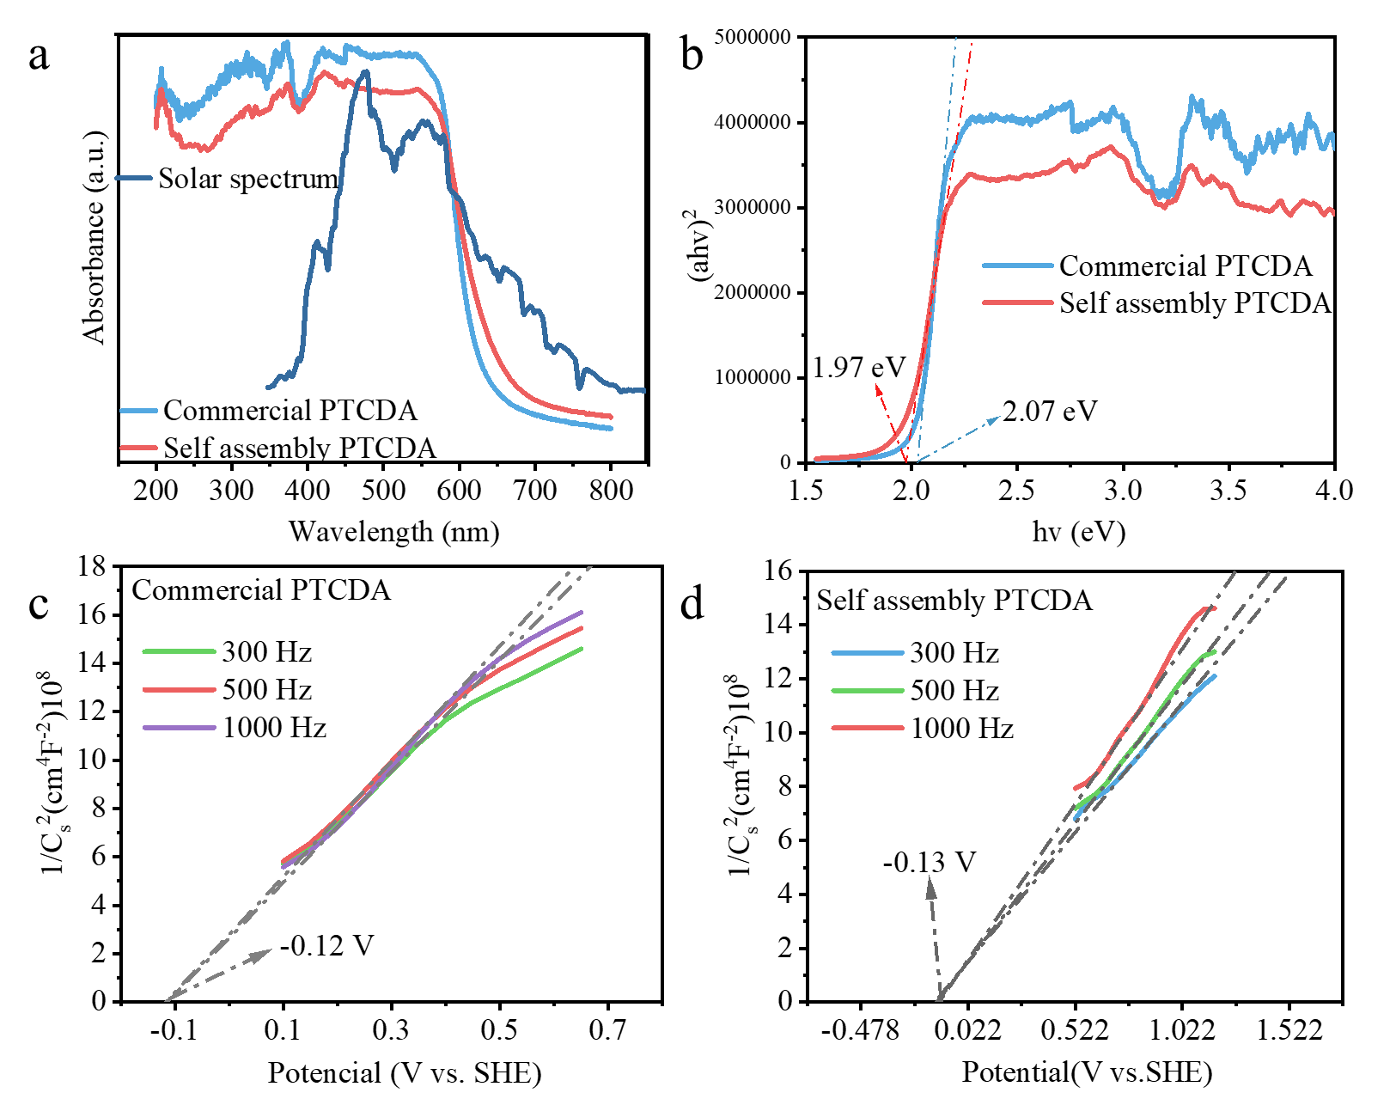
Figure S10 (a) UV–vis–NIR diffuse reflection spectrum of PTCDA and solar spectrum. (b) Plots of the transformed Kubelka–Munk function vs. the light energy. Mott-Schottky plots for (c) commercial PTCDA and (d) self-assembled PTCDA.
The information available from Figure S10 is as follows:
The DRS of samples in Figure S10a exhibits a wider absorption at visible-near-infrared light region from 430 to 800 nm than that of commercial PTCDA. Even their absorption edge may extend to 700 nm. The band gaps of commercial PTCDA and self-assembled PTCDA derived from the corresponding Tauc plots (Figure S10b), were turned out to be 2.07 eV and 1.97 eV, respectively.
Band gap: E_{g-CPTCDA}=2.07 eV, E_{g-SPTCDA} =1.97 eV,
The Position of conduction band (vs. SHE): E_{c- CPTCDA} =-0.12-0.2=-0.32 eV, E_{c- SPTCDA} = -0.13-0.2=-0.33 eV
The Position of valance band (vs. SHE):
E_{v- CPTCDA} = E_{g- CPTCDA} + E_{c- CPTCDA} = 2.07 + (-0.32) =1.75 eV
E_{v- SPTCDA} = E_{g- SPTCDA} + E_{c- SPTCDA} = 1.97 + (-0.33) =1.64 eV

High utilization rate of PMS in PTCDA/PMS system
The goal of PMS as an oxidant is to oxidize BPA to CO₂, so the utilization rate of PMS can be calculated according to the degree of mineralization in the catalyst/PMS system (See SI for calculated detailed). Here, the utilization rate of PMS is defined as the amount of mineralized BPA per millimole of PMS.
$$PMS utilization=\frac{TOC removal}{PMS dosage}$$
Table S2. PMS utilization rate in different catalytic systems
Catalysis system | Mineralization | PMS utilization  (mg (BPA)/mmol (PMS))
Fe₂O₃/0.3 mM PMS | 13% | 8.67
Co₃O₄/0.3 mM PMS | 25% | 16.67
PDA/0.3 mM PMS | 88% | 58.67
CNT/0.3 mM PMS | 5% | 3.33
Fe₂O₃/1.0 mM PMS | 33% | 6.6
Co₃O₄/1.0 mM PMS | 35% | 7.0
PDA/1.0 mM PMS | 90% | 18.0
Low concentration of 0.3 mM PMS is added to PTCDA/PMS system, and 58.7mg BPA can be mineralized per millimole of PMS (Table S2). However, this value is 16.7, 8.7 and 3.3 for Co₃O₄, Fe₂O₃, and CNT respectively. Further increasing the PMS dosage to 1.0 mM, the utilization rate of excessive metal catalyst for PMS was still not improved.

Electrochemical reduction produces PTCDA anions
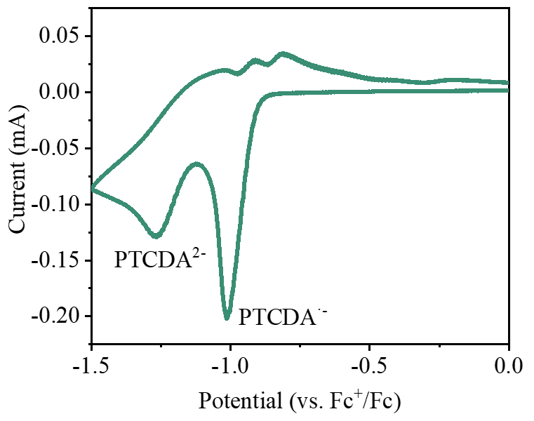
Figure S11. Cyclic voltammetry curves of self-assembled PTCDA as electrolyte. Conditions: The electrolyte is acetonitrile with 0.1M Bu4NPF6, scan rate 100 mV/min.
First, it was proved that PTCDA can be converted into PTCDA anion to form an electronic warehouse. The self-assembled PTCDA shows an onset reduction potential of -1.015 versus ferrocene, which corresponds to the formation of its anion (PTCDA⁻), while the second onset reduction potential (deduced by the first onset and the potential difference between two peaks) at -1.269 V indicates the transformation from PTCDA⁻ to the dianion state (PTCDA²⁻). Whether it is PTCDA⁻ or PTCDA²⁻, such a low potential can reduce PMS. The cyclic voltammetry curve proves that PTCDA can produce reducing anions when bias is applied.

Light induced PTCDA anions as electron reservoir for PMS
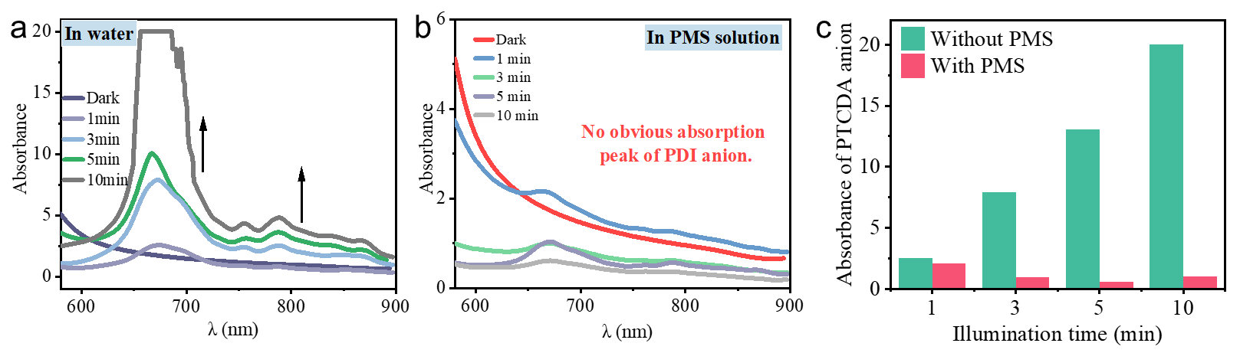
Figure S12. UV/Vis absorption spectra of PTCDA (0.025 g L–1) in dimethylformamide (DMF) in the presence of DMPO (0.2 M) in the dark and expose to different wavelengths of light for 3 minutes (a) and in 0.3mM PMS solution (b). (c) The absorbance of λ=670nm is used to represent the PTCDA anion strength.
When PMS was not added, it indicated that the absorption peak of PTCDA anions gradually increased with the extension of illumination time, but it did not increase significantly when PMS was added. Among the absorption peaks of PTCDA anions, λ=670nm has the highest intensity, so its absorbance is taken as the comparison standard to make a bar chart. The quenching effect of PMS on PTCDA anions is obvious.

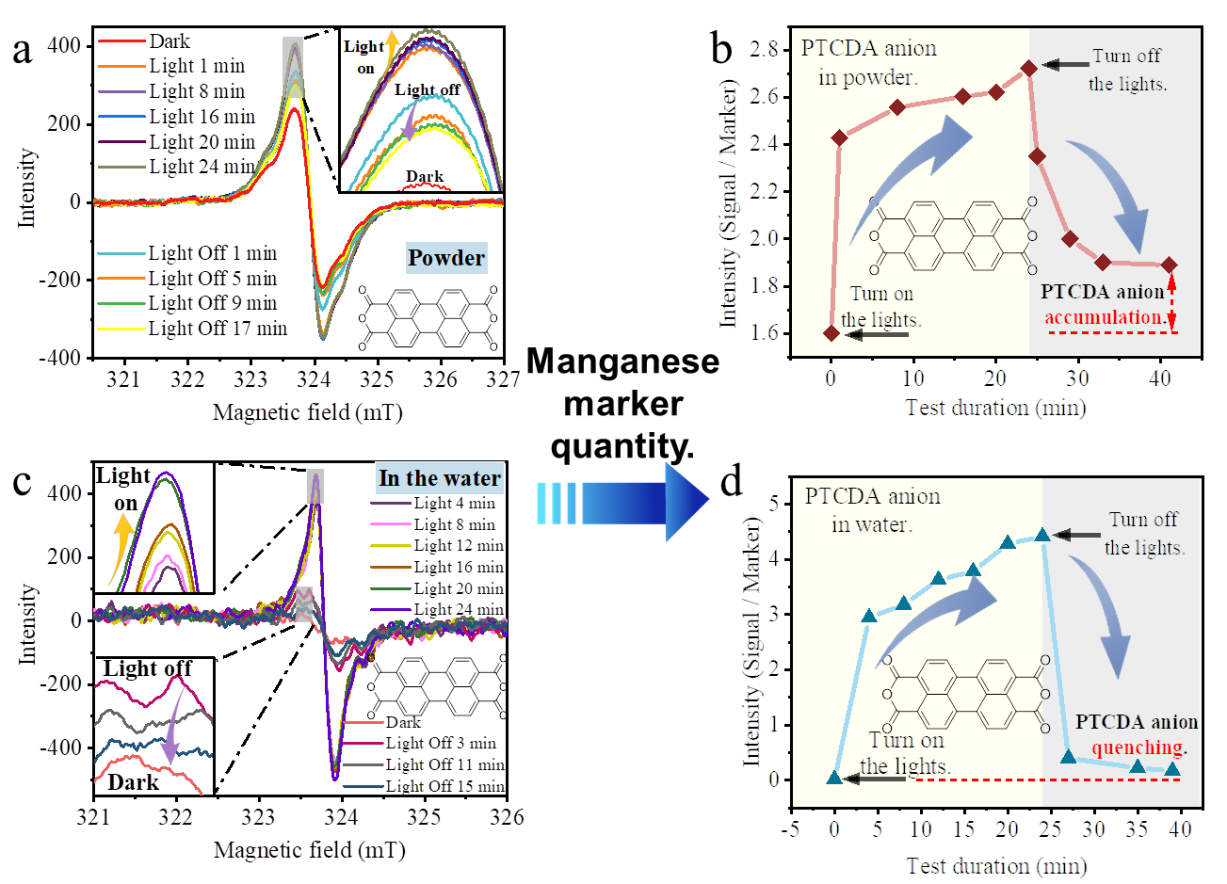
Figure S13. (a) The EPR signal of PTCDA solid powder and (b) semi-quantitative PTCDA anion. (c) The EPR signal of PTCDA in water and (b) semi-quantitative PTCDA anion.
The EPR data showed that PTCDA solid powder showed obvious PTCDA anion signal after illumination (Figure 3d). With the prolongation of the illumination time, the PTCDA anion signal gradually increased. When the illumination was stopped, the signal immediately attenuated, indicating that PTCDA anion can be self-quenched. When the light is turned off for 17 minutes, the signal of PTCDA anion is still much stronger than initial dark state. The reason is that there is not enough electron acceptor to capture electrons of PTCDA anion leading accumulated on the surface of PTCDA to form a stable electronic reservoir. Then test the anion EPR signal of PTCDA supramolecular catalyst dispersed in a water environment, where water or oxygen in water can act as an electron acceptor. In the dark, there is no obvious PTCDA anion signal performance. After 4 minutes of light, strong PTCDA anion appear. Surprisingly, compared with powder PTCDA, PTCDA dispersed in water can almost return to the dark state after15 minutes of turning off the light. The reason is that both PTCDA⁻ and PTCDA²⁻ can reduce water or oxygen in the water, that is, the electrons of the PTCDA anion will be transferred to the electron acceptor, causing the PTCDA anion to be reduced to neutral PTCDA. Also show that the generation and quenching of PTCDA anion is a reversible process in the presence of electron acceptors (such as water or oxygen in water). The above results suggest that PTCDA obtains electrons under light excitation to generate many PTCDA anion, forming a stable electronic reservoir that stores many electrons. When there is an electron acceptor, the electrons of the PTCDA anion are captured.
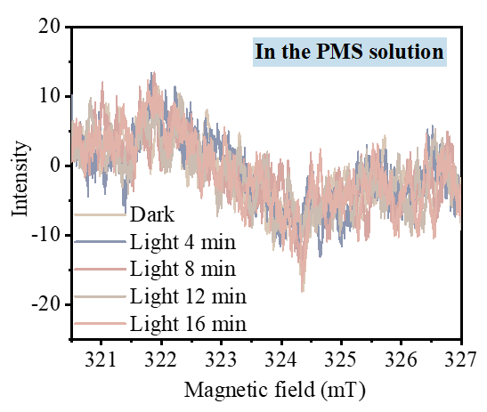
Figure S14. The EPR signal of PTCDA dispersed in 0.3mM PMS solution.
The EPR signal of PTCDA anion after illumination is quite weak and it hardly appears with the prolonged illumination time, which directly shows that PMS as an acceptor enabling to reduce the existence of PTCDA anion. As mentioned above, both PTCDA⁻ and PTCDA²⁻ can reduce oxygen to superoxide radicals (E=-0.33V vs. SHE).
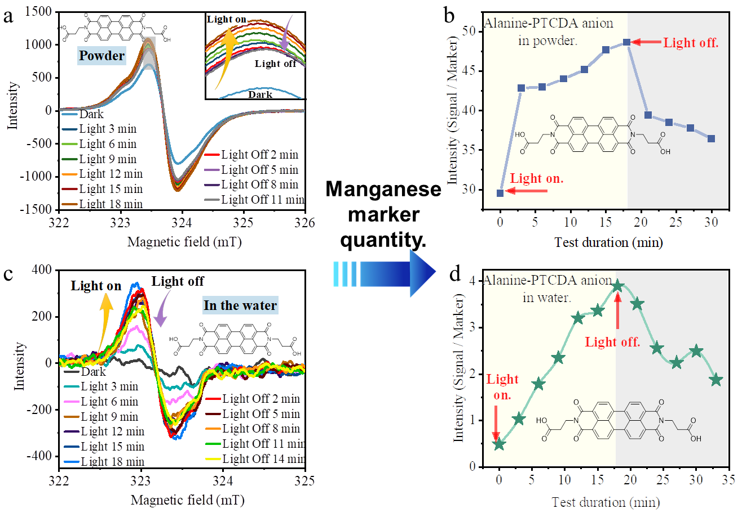
Figure S15. (a) The EPR signal of Alanine-PTCDA solid powder and (b) semi-quantitative PTCDA anion. (c) The EPR signal of Alanine -PTCDA in water and (b) semi-quantitative PTCDA anion.
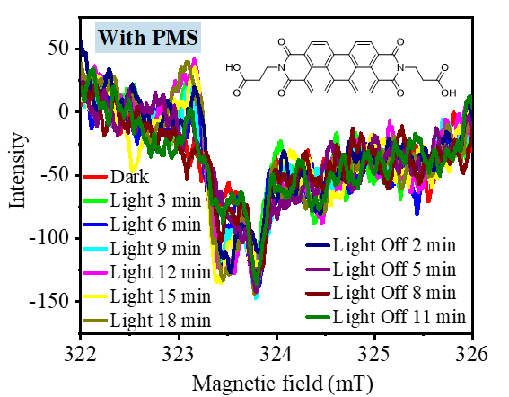
Figure S16. The EPR signal of Alanine-PTCDA dispersed in 0.3mM PMS solution.
PTCDA has the same law as above, which indicates that PTCDA with large conjugate produces electron library and gives electron universality.

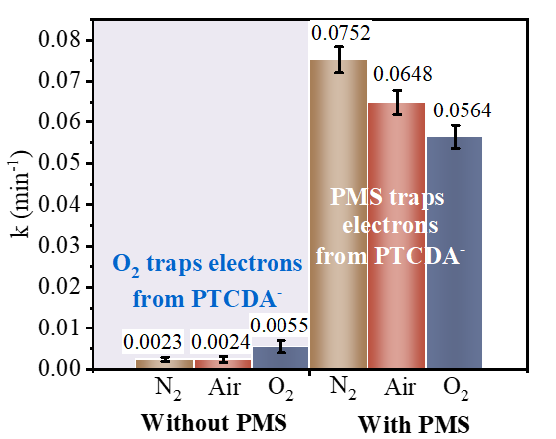
Figure S17. The rate constants of photocatalytic reaction in different atmospheres.
As aforementioned, both PTCDA⁻ and PTCDA²⁻ can reduce oxygen to superoxide radicals. However, due to the particularity of PMS itself, the electron acceptor is PMS rather than O₂ promote photodegradation, which is confirmed under different atmospheres. In the absence of PMS, degradation rate constant in saturated dissolved oxygen (k₁ (O₂) =0.0055 min⁻¹) is 2.3 times higher than that in the air atmosphere (k₁ (air)=0.0024 min⁻¹). It shows again that oxygen as an electron acceptor can obtain electrons from the PTCDA electron reservoir to generate superoxide radicals, meanwhile enhance the photogenerated e⁻-h⁺ separation so that h⁺ participated in degradation. In the case of adding PMS, the order of reaction rate: k₂(N₂)> k₂(Air)> k₂(O₂), which emphasizes the importance of PMS (Figure S19). O₂ and PMS compete to capture PTCDA-electrons, but PMS trapped electrons generate abundant reactive oxygen species after activated, which is directly responsible for high-flux degradation.

PMS and PTCDA formed strong adsorption
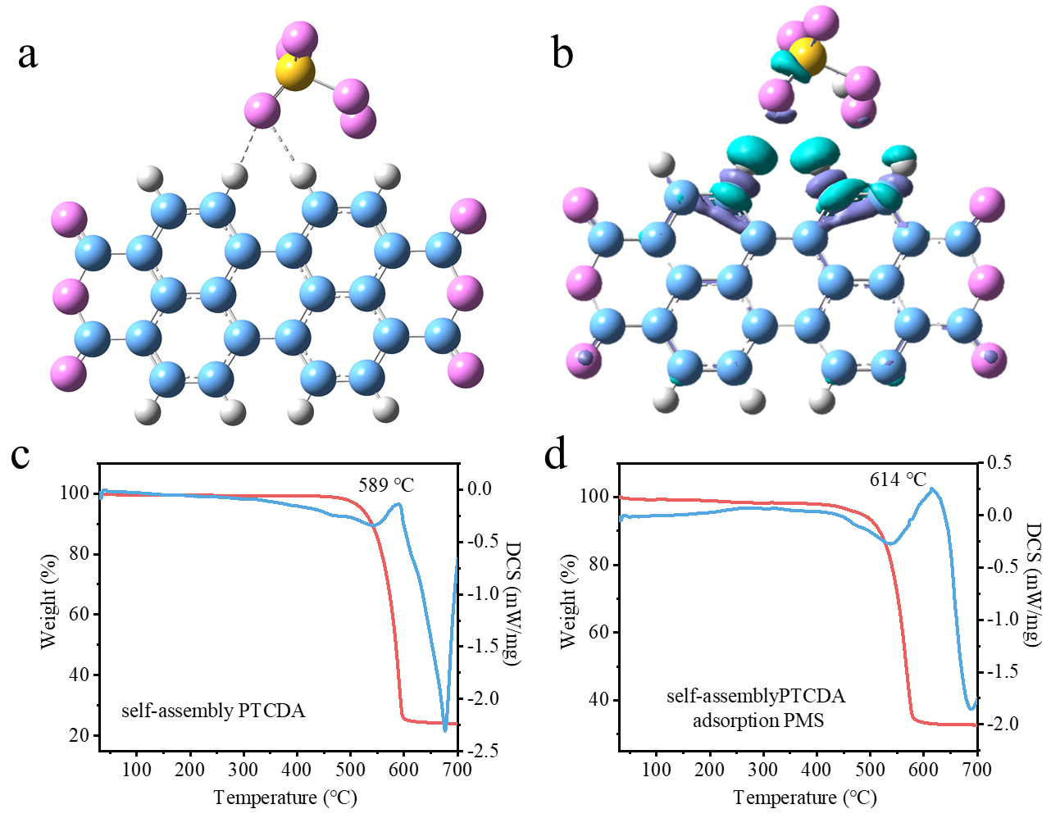
Figure S18. (a) The calculation model of PMS adsorption on PTCDA, (b) Charge density difference of PMS adsorption on PTCDA. Thermogravimetry of (c) PTCDA and (d) PTCDA adsorption PMS.
The adsorption of PMS on PTCDA is the first step to obtain electrons. The most stable adsorption state of HSO₅⁻ and PTCDA is calculated theoretically. The oxygen of PMS and hydrogen of PTCDA are chemically adsorbed and the adsorption energy is -87.35kJ/mol, which indicates that PMS can spontaneously react on the surface of PTCDA. The charge density difference intuitively reflects that electrons are depleted for PTCDA but accumulation for PMS, further demonstrated the chemical adsorption of PMS on PTCDA. In addition, the temperature at which the PTCDA adsorbed to the PMS undergoes a phase change has increased significantly further suggesting that there is a strong adsorption between them (Figure S18 c, d), which establishes a high-speed transfer channel of charge from PTCDA to PMS. Since the supramolecular photocatalyst PTCDA does not have the risk of a large amount of catalyst deactivation and metal leaching in the catalytic process, and has a strong adsorption energy for PMS molecules, it is theoretically an ideal activator for activating PMS.

Excellent photogenerated electron-hole separation in PTCDA/PMS system
The prerequisite for a large number of photogenerated h⁺ to participate in the degradation reaction is to effectively separate from e⁻- h⁺ pairs, which is measured by the open circuit voltage (OCP) attenuation of PTCDA in PMS after turning off the lights. The normalized open circuit voltage signal and the first-order kinetic model can be used to calculate the composite constant of the average photogenerated charge^{[3]}:
$\frac{E-E_{ph}}{E_{da}-E_{ph}}=1-\exp^{-kt}$ (7)
Where E--open circuit voltage varying with time
$E_{ph}$--open circuit voltage after light stabilization
$E_{da}$--open circuit voltage after dark stabilization
K--attenuation coefficient of open circuit voltage
OCP decay kinetics reflects the charge recombination. After the lamp is turned off, there is no continuous photogenerated charge generated at the working electrode. The reduced open circuit voltage is due to the recombination of the existing photogenerated charge. Since the recombination of electron-hole pairs in the bulk phase of the material is in the range of ns-μs, the observed slow decay of OCP on the order of minutes is not due to recombination in the crystal lattice but the recombination of the interface between the charge and the adsorbed substance. The decay rate of the PTCDA working electrode in a PMS sodium sulfate solution containing 0.7 mmol/L as the electrolyte is k=7×10⁻⁵ s⁻¹, which is reduced by 74% compared to k=27×10⁻⁵ s⁻¹ without PMS addition. The reason is that the PTCDA⁻ accumulated on the surface of the working electrode easily to recombine with the photogenerated holes. When PMS is added, the PMS in the solution acts as an electron capture point to capture the electrons of the PTCDA⁻, which removes the photogenerated e⁻ leading a longer survival time of h⁺. This directly suggested that PMS is indeed activated by taking away the electrons of PTCDA⁻.

Many hydroxyl - adducts of BPA produce in the Co₃O₄/PMS system
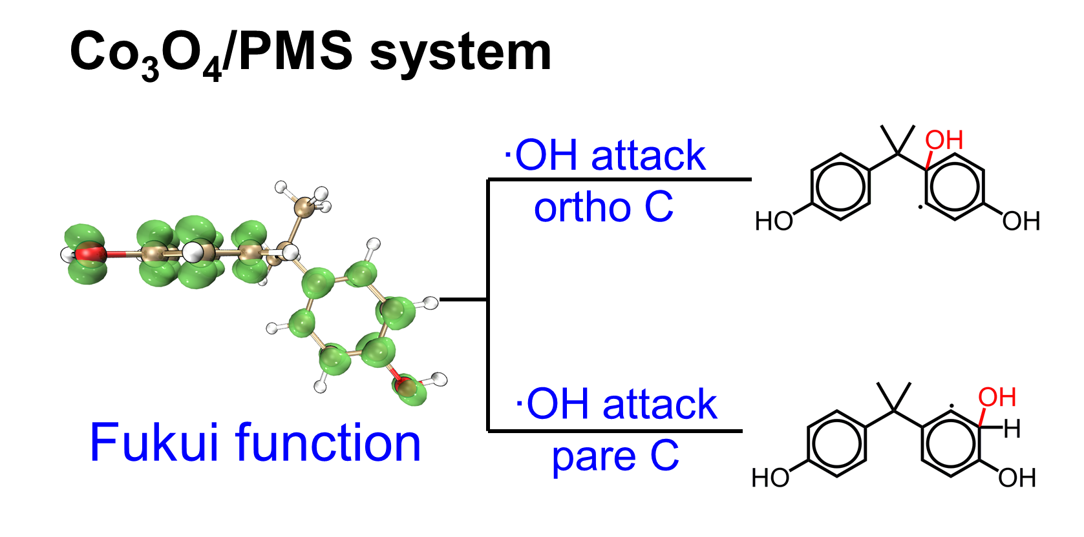Figure S19. BPA was attacked by hydroxyl radicals in a cavitation-free system.
Fukui function is used to predict the site of free radical attack on BPA. The larger the green area, the more likely the site is to be attacked by free radicals. The ortho and para-carbon of the hydroxyl group are active sites.

Alkyl radicals were detected during PTCDA/PMS degradation of BPA
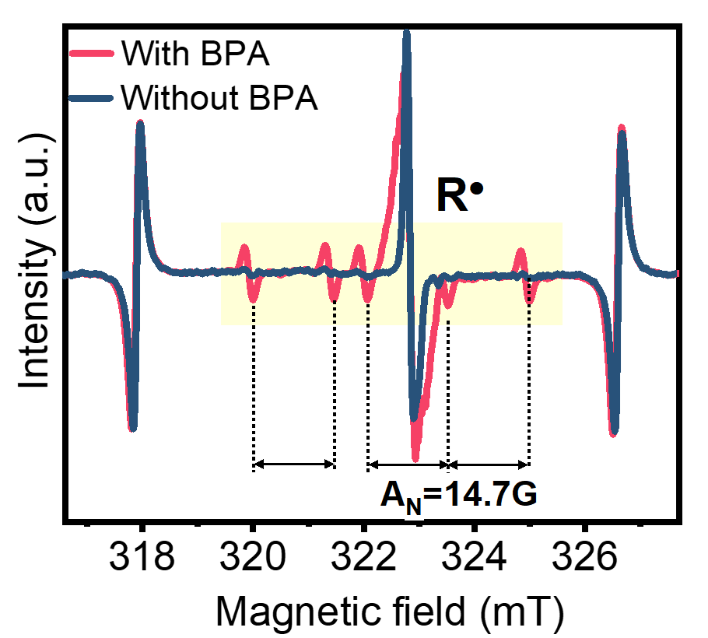
Figure S20. The EPR signal of the captured alkyl radicals. Test conditions: DMPO is used as the capture agent, the solvent is acetonitrile, and bisphenol A is added as needed, and the test is performed under λ≥420nm irradiation.
Using DMPO as the trapping agent, EPR detected the six peaks with A_{N}= 14.7 Gauss hyperfine division constant (one of which was covered by the PTCDA anion peak), which belongs to the alkane free radical (R∙) signal. The six-fold peak did not appear without BPA. Although it is impossible to determine the organic molecules of R·, but sufficient to account for the generation of R· in PTCDA/PMS.

Active oxygen component identification
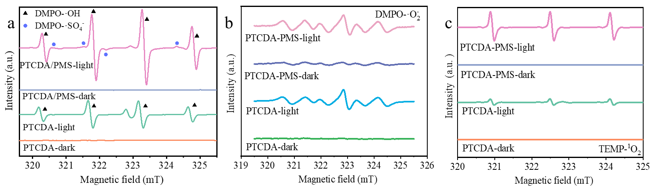
Figure S21. The ESR spectra of (a) DMPO-·OH, (b) DMPO-·O₂⁻ (c)TEMP-¹O₂ in the presence of PTCDA under visible light irradiation, respectively.
We tested the ESR signal. Without the addition of PMS, signals representing hydroxyl radicals, singlet oxygen and superoxide radicals can also be observed. But this does not make the PTCDA obtain considerable photocatalytic activity. Note that the valence band position (+1.64V) and conduction band position (-0.33V) of PTCDA are difficult to oxidize water to ·OH and reduce O₂ to ·O₂⁻. However, PTCDA⁻ and PTCDA²⁻ can reduce O₂ to produce ·O₂⁻ further initiate ·OH^{[4]}. After adding PMS, these reactive oxygen species signals have been significantly enhanced. In addition, sulfate radicals were observed, again indicating that PMS was successfully activated

Performance of PTCDA/PMS to degrade BPA in different water bodies
Table S3. Water quality parameters of actual water ª
 | TOC (mg/L) | TN (mg/L) | NH₄—N (mg/L) | SO₄²⁻ (mg/L) | Cl (mg/L) | NO₃⁻ (mg/L)
Songhua river | 8.84 | 1.82 | 0.36 | 13.34 | 9.47 | 4.38
WWTW ^{b} | 6.26 | 12.01 | 0.54 | 85.7 | 78.35 | 50.87
ª Water samples were filtered by the 0.45 μm fiberglass membranes to remove the particulate
matters.
^{b} Effluent from the second sedimentation tank of Wenchang Wastewater Treatment Plant

Xenon light source used in this study can simulate sunlight
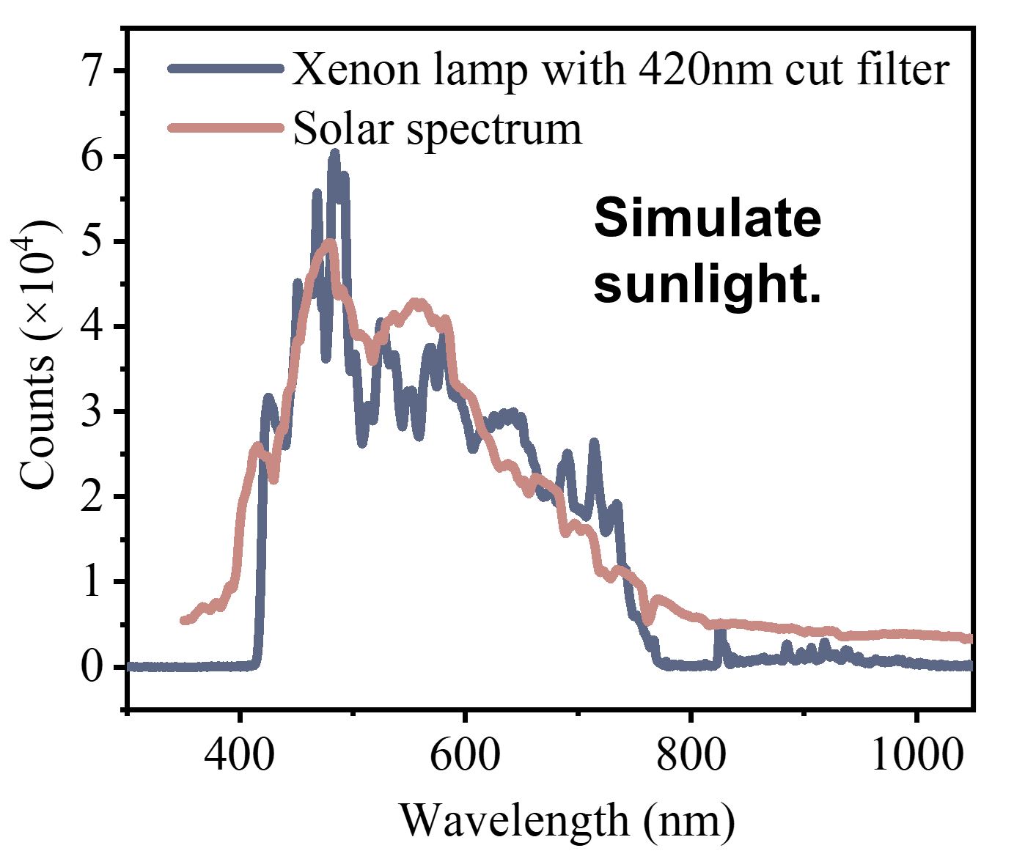
Figure S22. The comparison between the spectrum of the xenon lamp used to simulate sunlight and the spectrum of the sun.
Note that this device uses a xenon lamp with a 420nm filter as the light source, which is highly similar to the spectrum of sunlight.

PTCDA/PMS has excellent degradation performance under actual sunlight
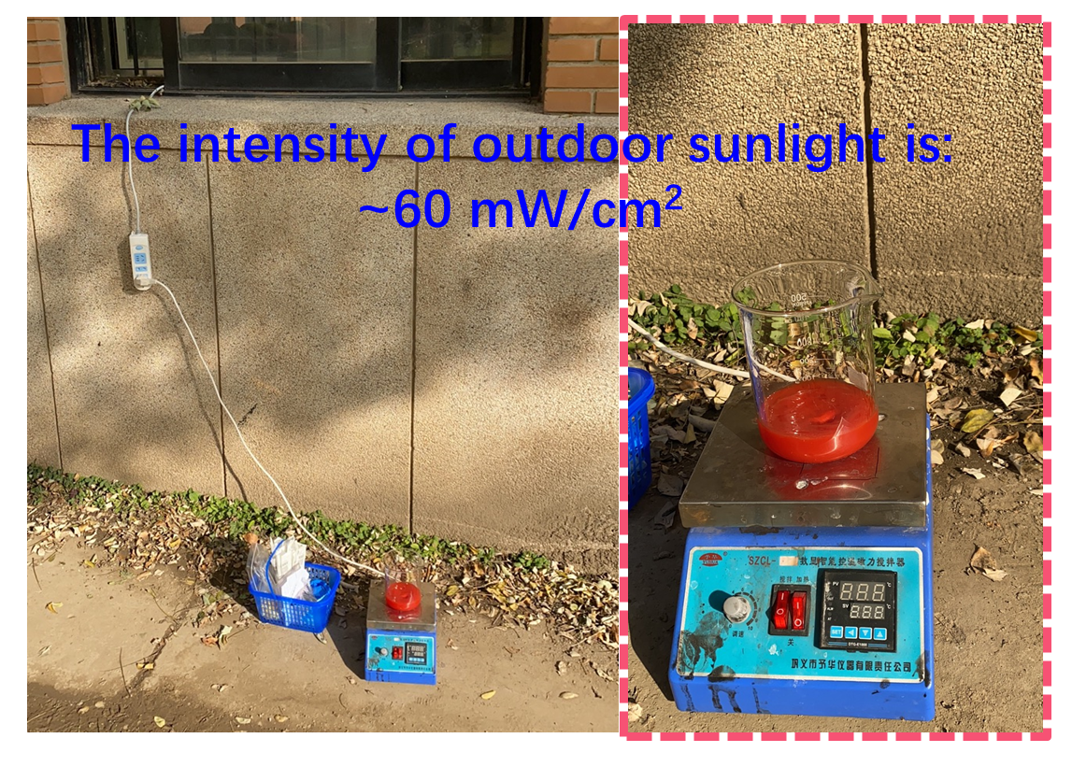
Figure S23. Outdoor testing of the degradation effect of PTCDA/PMS system on BPA in autumn in Beijing.
The picture shows PTCDA/PMS testing outdoors in the autumn of Tsinghua campus in Beijing. Light intensity for ~ 60 mW/cm².
- Characterization of PTCDA's charge transport capability.
The PTCDA catalyst used in this work is to strip the purchased commercial PTCDA with concentrated sulfuric acid, and then add water to cause precipitation by self-assembly process. In this section, the morphology and photoelectrochemical characterization of self-assembled PTCDA were carried out.
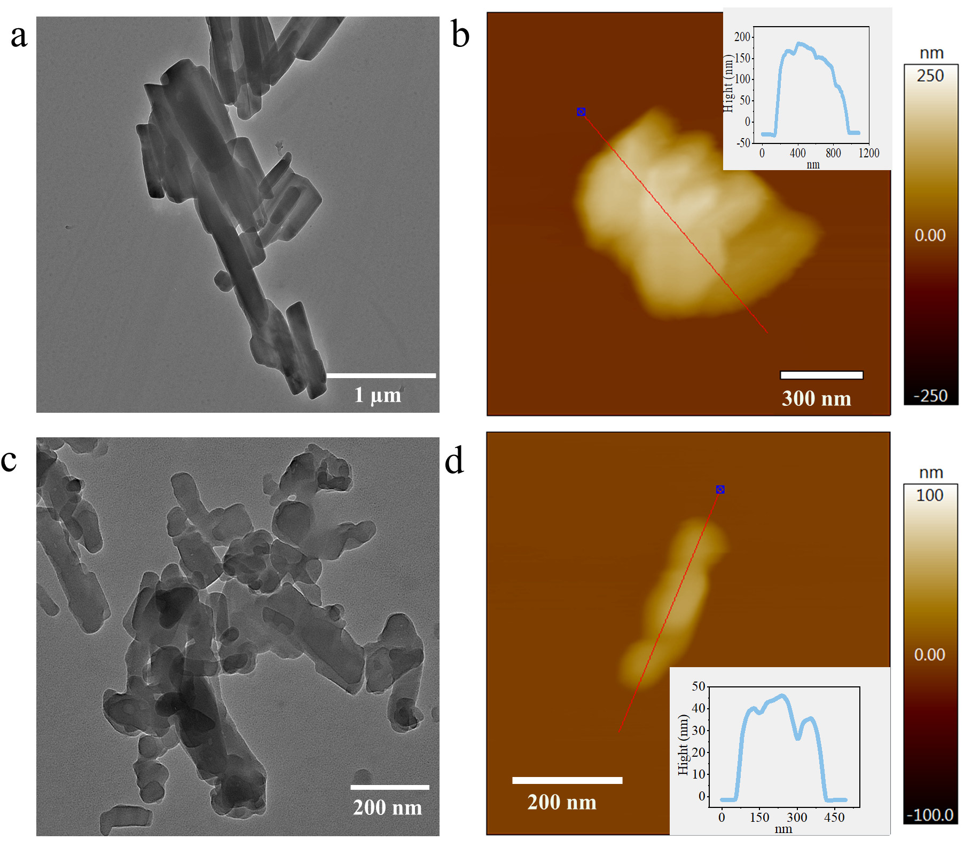
Figure S24. (a) TEM image and (b) AFM analysis of commercial PTCDA supramolecular. (c) TEM image and (b) AFM analysis of self-assembled PTCDA supramolecular.
The TEM image of the commercial PTCDA shows that it has a micron size and a thickness of as much as 150 nm. After the concentrated sulfuric acid treatment, the TEM of self-assembly PTCDA showed that it became smaller to nanometer size, and the thickness was also reduced to 40 nm. Therefore, self-assembled PTCDA is nanostructured compared to commercial PTCDA.
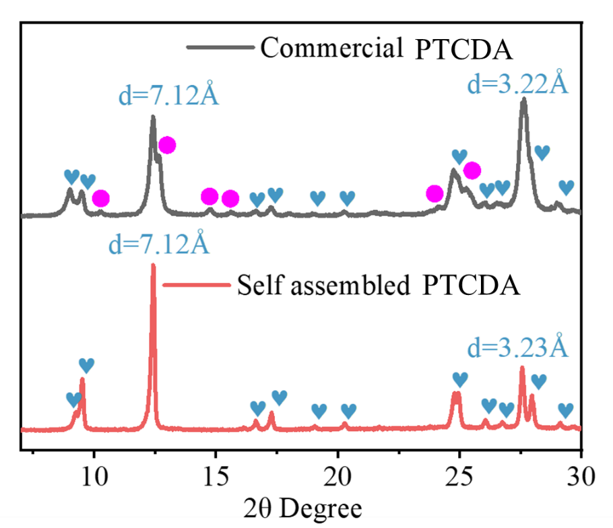
Figure S25. XRD peaks of commercial PTCDA and self-assembled PTCDA supramolecular system.
Semiconductor PTCDA provides the basis for charge transfer in the degradation process. Excellent charge transport performance is the cornerstone of the photocatalytic degradation process. The PTCDA was fabricated by a simple dissolution-reprecipitation method. The absorption spectrum confirmed the generation of aggregates. PTCDA showed a relatively sharp molecular absorption peak in concentrated sulfuric acid, indicating that the PTCDA intercalation was stripped into molecular PTCDA with concentrated sulfuric acid. The UV absorption spectrum in water shows a blue shift of the maximum absorption peak and the absorption curve also loses the fine structure, which indicates that a strong π-π stacking interaction is existed between the PTCDA molecules within the PTCDA supramolecular^{[5]}. And such a structure implies tremendous changes in optical and electrical properties compared to single-molecule PTCDA (Figure S26a). Under the excitation of visible light at 535nm, the PTCDA quenched more than 86% of the fluorescent signal in the molecular state of PTCDA (Figure S26b), which indicates that the charge transfer channel generated by the accumulation of π-π allows the photogenerated charge to be transported more smoothly. In addition, the rigid framework aid to reduce self-quenching and avoids the high recombination of photogenerated electrons and holes.
Compared with commercial PTCDA, the PTCDA has eliminated many crystal planes (marked by the pink circle in Figure S25), such as crystal planes with interplanar spacing of 8.65Å, 6.99, 6.01 Å, 5.67 Å, ​​3.69 Å, etc., which indicates the orientation of PTCDA more regular. In addition, in the PTCDA, concentrated sulfuric acid removed plenty of impurities in the commercial PTCDA, and the interplanar spacing of many crystal planes (indicated by the blue hearts in the XRD diagram) was reduced by 0.003~0.233 Å (The specific reduction value is shown in Table S2). Because the strong π-π overlap (a more delocalized state) enable to stabilize the +1 or 1 charged state and produce a more efficient route for transporting charge carriers from one molecule to its neighbor molecule. In a more delocalized state, the splitting of the HOMO/LUMO lead a higher electron bandwidth. In this case, large polaron or band-like transport can be formed, which is promising for charge transport^{[6]}. It should be noted that after π-π assembly, the crystal plane with d=7.12 Å is still the main peak, indicating that this plane is the dominant crystal plane. Moreover, PTCDA has greatly reduced its size and thickness compared with commercial PTCDA (Figure S24). So far, the internal configuration of PTCDA supramolecular is that the PTCDA molecules of the perylene core skeleton are arranged in parallel with a stacking distance of 3.2~3.6 Å.
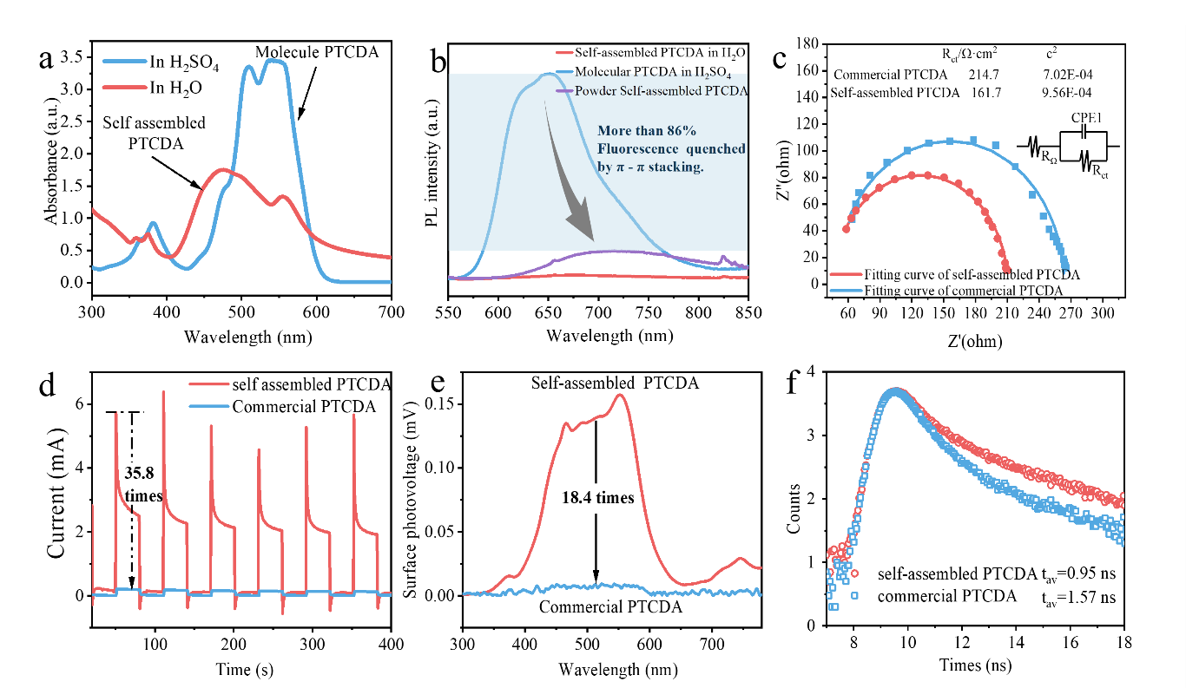
Figure S26. (a) UV–vis absorption spectra of non-aggregated form (PTCDA dissolved in H₂SO₄) and aggregated form (PTCDA aggregation dispersed in water). (b) photoluminescence spectra (PL) at 535 nm excitation wavelength. (c) Electrochemical impedance spectroscopy (EIS), (d) photocurrent under λ≥420 nm, (e) surface photovoltage irradiation and (f) Lifetime of photogenerated holes detected by time-resolved SPV of PTCDA.
As shown by the above data, PTCDA has better degradation activity than commercial PTCDA. Therefore, we further compared the photoelectrochemical performance of self-assembly and commercial PTCDA to confirm that the excellent charge transport performance is the key step for the as-prepared system to obtain high-efficiency degradation activity.
The effect of π-π on the PTCDA photogenerated charge transfer resistance was first tested. Electrochemical impedance spectroscopy (EIS) is analyzed according to Vorotynsev theoretical model R(C(R)) (Figure S26c). The impedance curve corresponding to the high frequency area in the complex function graph is an approximate semicircle, indicating that it is charge transfer progress. R_{Ω}(C(R_{ct})) is used to simulate the circuit, where R_{Ω} represents the ohmic resistance of the electrode system, and R_{ct} represents the charge transfer resistance^{[7]}. The fitted χ² values all reach the order of 10⁻⁴, indicating that the fitting effect is great. The smaller radius of the curve corresponding to the PTCDA than that of the commercial PTCDA suggested a faster Faraday reaction kinetic. The resistance of the simulated charge transfer (161.7Ω/cm²) less than commercial PTCDA (214.7Ω/cm²) stated clearly that strong Π- Π-stacked nanPTCDA obtains a smaller charge transfer resistance. In electrochemistry, the polarization of the electrode reflects the obstruction of the electrode.
The excellent charge transfer capability enables the photogenerated charges to reach the surface faster and in larger quantities^{[8]}. This result is verified by photocurrent (Figure S26d). The photogenerated current of PTCDA is one order of magnitude higher than that of commercial PTCDA (35.8 times). The 30s spike may be caused by charge recombination caused by long-range electron transport. The surface photovoltage signal of PTCDA is 18.4 times that of the commercial PTCDA (Figure S26e), which further shows its excellent photo-generated charge transport properties. Whether it is commercial or self-assembly PTCDA, its surface photovoltage is positive because PTCDA is an N-type semiconductor. Time-resolved fluorescence spectroscopy is used to quantify the effect of low charge transfer resistance on charge lifetime^{[9]}. The fluorescence lifetime is the reciprocal of the decay rate. The longer the fluorescence lifetime, the slower the decay and the greater the chance of photogenerated charges participating in the reaction^{[10]}. The PTCDA has a fluorescence lifetime of 1.57ns, which is 1.65 times that of the commercial PTCDA (0.95ns). It is further proved that the excellent charge transfer is beneficial to the separation of carriers to the surface to participate in the reaction (Figure S26f). It is discussed above that the PTCDA produced by such strong Π-Π stacking has excellent charge transport performance, which lays a solid foundation for catalytic degradation.

Table S4 Crystal plane reduction data represented by XRD diffraction peaks of commercial and self-assembled PTCDA
Commercial PTCDA (2θ°) | d-spacing(Å) | self-assembled PTCDA (2θ°) | d-spacing(Å) | d-spacing decreased (Å)
9.01 | 9.807 | 9.23 | 9.574 | 0.233
9.49 | 9.312 | 9.52 | 9.283 | 0.029
16.61 | 5.333 | 16.63 | 5.327 | 0.006
17.22 | 5.145 | 17.28 | 5.128 | 0.018
18.94 | 4.682 | 19.05 | 4.655 | 0.027
20.25 | 4.382 | 20.29 | 4.373 | 0.009
26.03 | 3.420 | 26.05 | 3.418 | 0.003
24.75 | 3.594 | 24.78 | 3.590 | 0.004
26.49 | 3.362 | 26.76 | 3.329 | 0.033
27.88 | 3.198 | 27.97 | 3.187 | 0.010
28.99 | 3.078 | 29.14 | 3.062 | 0.016

According to the Bragg equation 2dsinθ = nλ, where d is the interplanar spacing, θ is the angle between the incident X-ray and the corresponding crystal plane, λ is the wavelength of the X-ray λ = 0.15406 nm, and n is the diffraction order n = 1. According to the angle of XRD diffraction peaks, the interplanar spacing d is calculated. After self-assembly of commercial PTCDA, most of the interplanar spacing is reduced. The specific values are shown in Table S2. This is due to two aspects: one is that concentrated sulfuric acid removes impurities in the commercial PTCDA; the other is that the Π-Π stacking effect is stronger and the interplanar spacing is reduced.

Reference

[1] S. Grimme, J. Antony, S. Ehrlich, H. Krieg, J. Chem. Phys. 2010, 132, 19.
[2] F. Weigend, R. Ahlrichs, Physical Chemistry Chemical Physics 2005, 7, 3297-3305.
[3] aZ. F. Jiang, H. L. Sun, T. Q. Wang, B. Wang, W. Wei, H. M. Li, S. Q. Yuan, T. C. An, H. J. Zhao, J. G. Yu, P. K. Wong, Energy Environ. Sci. 2018, 11, 2382-2389; bJ. Kim, D. Monllor-Satoca, W. Choi, Energy Environ. Sci. 2012, 5, 7647-7656.
[4] aP. Chen, L. Blaney, G. Cagnetta, J. Huang, B. Wang, Y. Wang, S. Deng, G. Yu, Environ. Sci. Technol. 2019, 53, 1564-1575; bD. Dvoranova, Z. Barbierikova, V. Brezova, Molecules 2014, 19, 17279-17304; cB. H. J. Bielski, D. E. Cabelli, R. L. Arudi, A. B. Ross, J. Phys. Chem. Ref. Data 1985, 14, 1041-1100.
[5] aD. Liu, J. Wang, X. Bai, R. Zong, Y. Zhu, Adv Mater 2016, 28, 7284-7290; bJ. Wang, W. Shi, D. Liu, Z. Zhang, Y. Zhu, D. Wang, Appl. Catal. B 2017, 202, 289-297.
[6] C. L. Wang, H. L. Dong, L. Jiang, W. P. Hu, Chem Soc Rev 2018, 47, 422-500.
[7] W. Luo, X. Chen, Z. Wei, D. Liu, W. Yao, Y. Zhu, Appl. Catal. B 2019, 255.
[8] aY. Sheng, H. Miao, J. Jing, W. Yao, Y. Zhu, Appl. Catal. B 2020, 272; bY. Guo, W. Shi, Y. Zhu, EcoMat 2019, 2, 12007.
[9] Y. Guo, W. Shi, Y. Zhu, Y. Xu, F. Cui, Appl. Catal. B 2020, 262, 118262.
[10] Y. Guo, J. Nan, Y. Xu, F. Cui, W. Shi, Y. Zhu, J. Mater. Chem. A 2020, 8, 8.

