Original Article
Peptide Isolated from Noni Seeds Confers Gastroprotective Effect by Improving Inflammation and Oxidative Stress in Mice
Supplementary material

Scheme of isolation of McLTP₁ according to Campos et al. (2016)

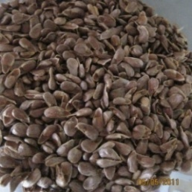
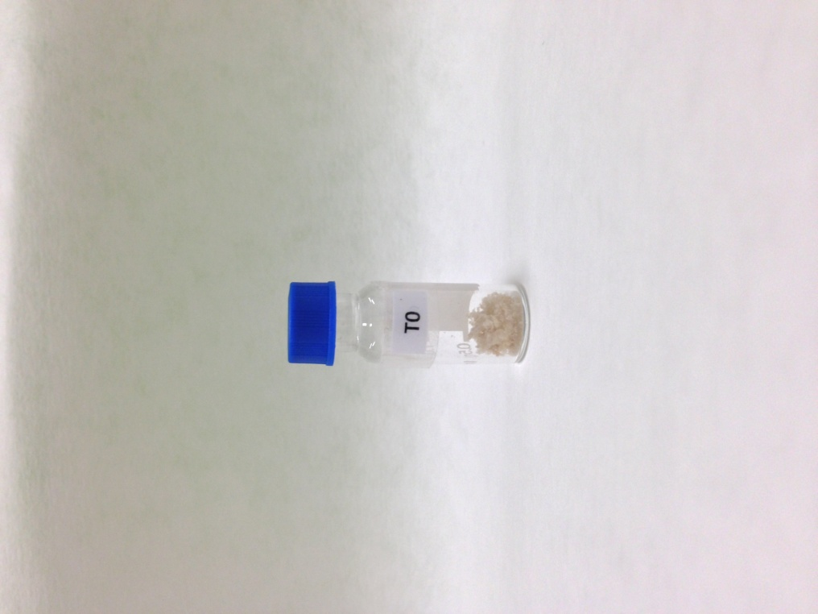
Defatted noni seed flour
Crude extract
Precipitation with trichloroacetic acid (TCA) 2.5% (w/v)
Size-exclusion chromatography
(Sephadex G-50)
Protein extraction
0.050 M Tris–HCl/0.25 M NaCl, pH 8.5 (1:10 w/v) 4°C
McLTP₁

Noni seeds

Macroscopic images of stomachs from mice in ethanol-induced gastric lesion. (A) Vehicle; (B) McLTP₁ 4 mg/kg (C) McLTP₁ 8 mg/kg; (D) McLTP₁ 16 mg/kg and (E) NAC 300mg/kg.

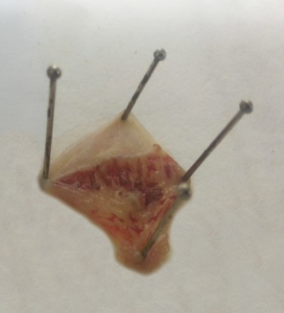
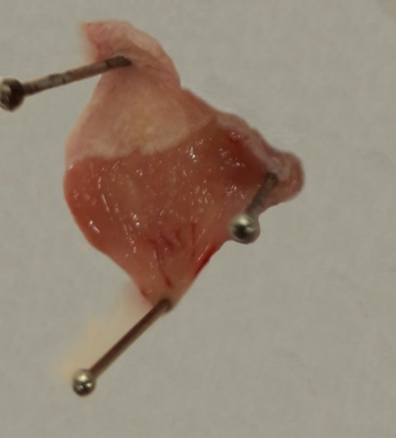
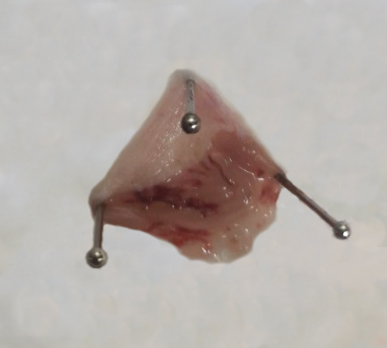
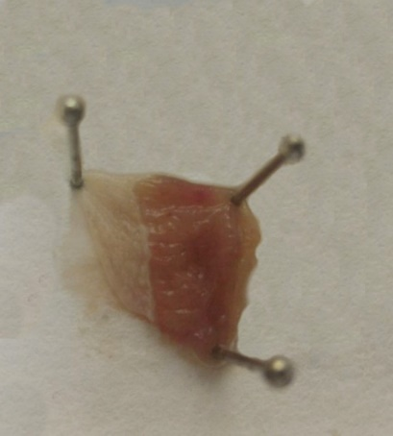
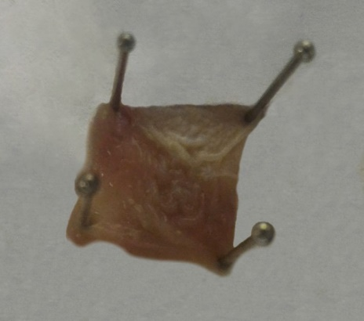
A
B
C
D
E

