Supporting material
Appendix 1: Land cover classes.
Land cover class | Description
Non-agricultural vegetation - habitat | Open green spaces, which includes forest, parks, regrowth marginal land and vegetated recreation areas such as golf courses which represent habitat for urban biodiversity.
Impervious | Land covered by buildings and other man-made structures such as residential, commercial services, industrial area, mixed urban or built-up lands.
Water | Lakes, reservoirs, stream, rivers, swamps.
Bare soil | Lands with exposed soil, sand or rocks, and never have more than 10% vegetated cover during any time of the year. Bare ground, bare exposed rocks, quarries and gravel pits.
Minor roads | Single lane roads (Appendix 2).
Major roads | Dual lane roads and motorways (Appendix 2), commonly fenced and with large volumes of traffic.
Oil palm | Oil palm plantations
Rubber | Rubber plantations
Other agriculture | Agriculture crops, mixed agriculture, orchards.

Appendix 2: Application and processing of ancillary data: OSM Data.
New class | Original OSM class
Main Road | - motorway link, trunk_link, secondary_link, primary_links  - primary  - secondary  - motorway  - trunk  - Escape (emergency lane when car breaks down or needed to stop)
Minor Roads | - service  - residential  - living_street  - Pathway: footway, steps, path, bridleway, pedestrian  - Tertiary  - Link roads: tertiary_link  - Special: cycleway, track  - Unclassified (connection between small roads)  - Corridor  - Raceway  - Construction (some were link roads)  - Road  - Bustop (some located on the footway)  - Elevator (located near the footway)

Appendix 3: Confusion matrix.
Class | Impervious | Non-agricultural vegetation | Water | Bare soil | Minor roads | Major roads | Oil palm | Rubber tree | Other agriculture | Total | User Accuracy
impervious | 31 | 2 | 3 | 3 | 0 | 0 | 1 | 0 | 0 | 40 | 0.775
non-agricultural vegetation | 0 | 36 | 0 | 1 | 0 | 0 | 1 | 1 | 1 | 40 | 0.9
water | 0 | 0 | 40 | 0 | 0 | 0 | 0 | 0 | 0 | 40 | 1
bare soil | 2 | 0 | 0 | 38 | 0 | 0 | 0 | 0 | 0 | 40 | 0.95
minor roads | 0 | 0 | 0 | 0 | 40 | 0 | 0 | 0 | 0 | 40 | 1
major roads | 0 | 0 | 0 | 0 | 0 | 40 | 0 | 0 | 0 | 40 | 1
oil palm | 1 | 0 | 0 | 0 | 0 | 0 | 38 | 1 | 0 | 40 | 0.95
Rubber tree | 0 | 4 | 0 | 0 | 0 | 0 | 2 | 33 | 1 | 40 | 0.825
other agriculture | 1 | 4 | 0 | 1 | 0 | 0 | 3 | 5 | 26 | 40 | 0.65
Total | 35 | 46 | 43 | 43 | 40 | 40 | 45 | 40 | 28 | 360 | 0
Producer Accuracy | 0.886 | 0.783 | 0.930 | 0.884 | 1 | 1 | 0.844 | 0.825 | 0.929 | 0 | 0.894
Overall accuacy |  |  |  |  |  |  |  |  |  |  | 89.4%

Appendix 4: Landcover map of Greater Kuala Lumpur – Larger version of Figure 2.
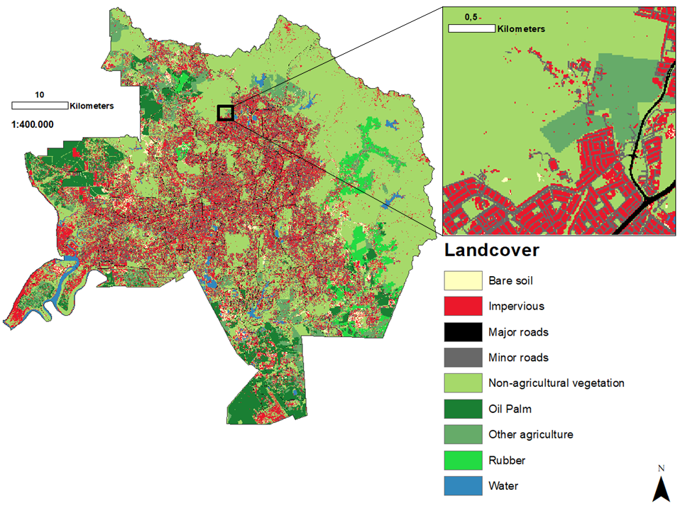

Appendix 5: Clustering coefficient for species group a) small arboreal, b) small terrestrial, c) medium arboreal, and d) medium terrestrial.
