Supplemental Information (SI)
Role and Mechanism of Cotrimoxazole Resistance to Talaromyces marneffei fungus in vitro
Jie Chen^{1,2,3}, Rongfeng Chen^{1,2}, Wudi Wei^{1,2}, Fengxiang Qin^{1,2}, Xiu Chen^{1,2}, Jinhao He¹, Hong Zhang¹, Gang Wang^{1,2}, Minjuan Shi^{1,2}, Tongxue Qin^{1,2}, Yinlu Liao^{1,2}, Yuting Wu^{1,2}, Beibei Lu^{1,2}, Xing Tao^{1,2}, Li Ye^{1,2#}, Hao Liang^{1,2#}, Junjun Jiang^{1,2#}

1.Guangxi Key Laboratory of AIDS Prevention and Treatment, School of Public Health, Guangxi Medical University, Nanning 530021, Guangxi, China;
2.Guangxi-ASEAN Collaborative Innovation Center for Major Disease Prevention and Treatment, Life Sciences Institute, Guangxi Medical University, Nanning 530021, Guangxi, China;
3.Guangxi Collaborative Innovation Centre of Regenerative Medicine and Medical BioResource Development and Application, Guangxi Medical University, Nanning, Guangxi 530021, China
Fig 1. Percentage of cell viability of THP-1 macrophages under different concentrations of TMP/SMX, SMX, and TMP. All data were shown as mean ± SD of the results from at least three independent experiments.

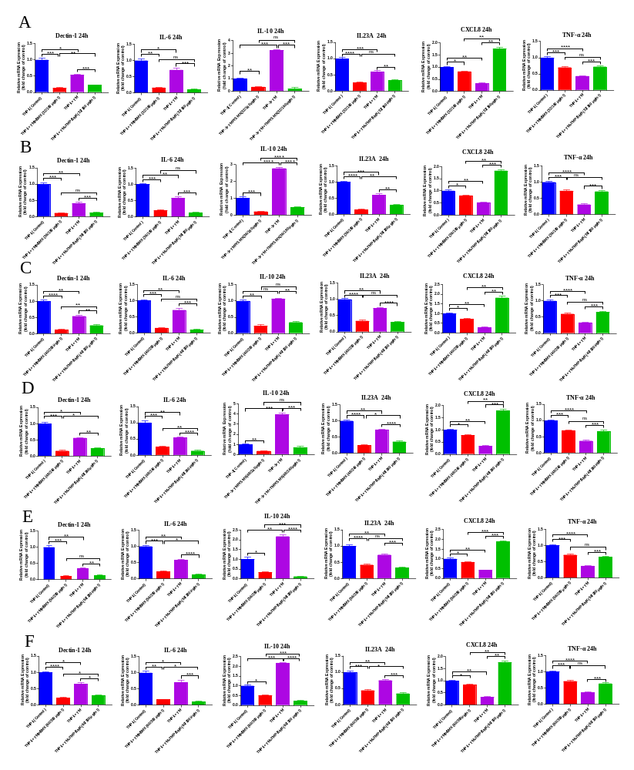
Fig.2 Dectin-1 and downstream IL-6, IL-10, IL-23A, CXCL8 and TNF-α mRNA expression levels in THP-1 macrophages infected with T.marneffei spores treated with TMP/SMX or without were analyzed by quantitative PCR at different concentration of TMP/SMX. All the levels of mRNA expression were normalized to GAPDH and all data were showed as mean ± SD of results from at least three independent experiments (*, p<0.05, **, p<0.01, ***, p<0.001, ****, p<0.0001, n.s, no significant difference, by Student’s t-test)

Supplemental Figure Lengends
Figure S1 (Related to Figure 1).
Human THP-1 macrophages were seeded at 1×10⁴ per well on one 96-well plate, establish experimental group, negative control group and blank control group, among which blank control group was not seeded THP-1 macrophages, then placing the plate in a humid atmosphere at 37℃, containing 5%CO₂ for 48h. After stimulating to macrophages for 48h, DMEM medium was removed, adding 10μl TMP/SMX, SMX and TMP to experimental group respectively and 90μl DMEM medium in experimental group. Adding 100μl DMEM to negative control group and blank control group, then placing the plate in 37℃, 5% CO₂ atmosphere for 48h. After 48h incubation, adding 20μl CellTiter-Glo® Luminescent Cell Viability Assay to each well on 96-well plate to detect cell viability respectively. The 96-well plate was oscillating in Microporous plate thermostatic oscillator for 3 minutes, then incubating at 37℃ for 10 minutes. BioTek Multifunctional enzyme labeling instrument was used to measure the absorbance (OD) of each well at 450nm. Calculate the cell viability value of TMP/SMX,SMX and TMP according to the following formula: A=mean OD value of negative control- mean OD value of blank control, B=mean OD value of each compound well in the experimental group－mean OD value of blank control, C=B/A×100%,then the cell viability value of each well in the experimental group(%).The cell viability of human THP-1 macrophages under different concentrations of TMP/SMX, SMX and TMP were shown as cell viability percentage curve respectively. The cell viability value above 80% means the concentration of TMP/SMX, SMX and TMP causes little toxicity to THP-1 macrophages while the percentage below 80% means the concentration of drugs causes significant toxicity toTHP-1 macrophages. All data were shown as mean ± SD of the results from at least three independent experiments.

Figure S2 (Related to Figure 2).
Dectin-1 signaling pathway plays an important role in the role and mechanism of cotrimoxazole resistance towards T.marneffei spores infected into THP-1 macrophages. THP-1 macrophages were infected with T.marneffei spores (MOI=5:1, fungi to cell) for 6-12h. Levels of Dectin-1, IL-6, IL-10, IL-23A, CXCL8, TNF-α was measured by RT-qPCR respectively. Dectin-1 and pro-T.marneffei inflammatory cytokines IL-6, IL-10, IL-23A in Dectin-1 mediated pathway were up-regulated following T.marneffei infection in vitro, while the levels of anti-T.marneffei inflammatory cytokines CXCL8 and TNF-α were down-regulated. But the levels of Dectin-1, IL-6, IL-10, IL-23A were down-regulated after adding TMP/SMX to TM-infected macrophages for 24h, and the levels of CXCL8 and TNF-α were up-regulated after adding TMP/SMX to TM-infected macrophages for 24h. (a) Adding 32/160μg/ml TMP/SMX to TM-infected macrophages for 24h. (b) Adding 36/180μg/ml TMP/SMX to TM-infected macrophages for 24h. (c) Adding 40/200μg/ml TMP/SMX to TM-infected macrophages for 24h. (d) Adding 48/240μg/ml TMP/SMX to TM-infected macrophages for 24h. (e) Adding 56/280μg/ml TMP/SMX to TM-infected macrophages for 24h. (f) Adding 60/300μg/ml TMP/SMX to TM-infected macrophages for 24h. All the levels of mRNA expression were normalized to GAPDH and all data were showed as mean ± SD of results from at least three independent experiments (*, p<0.05, **, p<0.01, ***, p<0.001, ****, p<0.0001, n.s, no significant difference, by Student’s t-test)

