Supplementary information for
Synthesis of Mesoscale Ordered Two-dimensional Hydrogen-Bond Organic Framework with the Observation of Flat Band

Minghu Pan, Xin Zhang, Yinong Zhou, Pengdong Wang, Qi Bian, Hang Liu, Xingyue Wang, Xiaoyin Li, Aixi Chen, Xiaoxu Lei, Shaojian Li, Zhengwang Cheng, Zhibin Shao, Haoquan Ding, Jianzhi Gao, Fangsen Li and Feng Liu

Methods
Sample preparation and STM Characterization
The Au(111) substrates were cleaned by repeated cycles of argon ion sputtering and annealing processes to obtain a clean and defect-free surface before deposition of THPB molecules. THPB molecules were subsequently dosed onto Au(111) single-crystal surface held at a temperature of ~ 300 K at a base pressure better than 2×10⁻¹⁰ torr. The desired 2D HOF were obtained by maintaining the rate of evaporation of THPB molecules in the range of 0.06-0.07 ML/min.
STM experiments were carried out on an ultrahigh vacuum (UHV) commercial STM system (Unisoku) which can reach a low temperature of 400 mK by using a single-shot ³He cryostat. The base pressure was 2.0 × 10⁻¹⁰ Torr. The THPB samples were fabricated at the preparation chamber and then transferred in situ into STM chamber. All the STM measurements are performed at a temperature of 77 K. A commercial Pt−Ir tip was carefully prepared by e-beam heating. The STS and dI/dV mapping were obtained by the standard lock-in method by applying an additional small AC voltage with a frequency of 973.0 Hz. The dI/dV spectra were collected by disrupting the feedback loop and sweeping the DC bias voltage. WSxM software was used for post processing of all STM data¹.

ARPES measurement
The ARPES measurements were performed at the Vacuum Interconnected Nanotech Workstation of Suzhou Institute of Nano-Tech and Nano-Bionics (SINANO) with a ScientaOmicron DA30L analyzer and monochromatized He Iα (hν = 21.218 eV) light source. The samples were grown in situ and measured at T = 12 K (unless otherwise specified) with a background vacuum better than 5 × 10⁻¹¹ mbar.

LEED measurement
Low-energy electron diffraction (LEED) were carried out in preparation chamber equipped with a 4-grid SPECTALEED instrument at room temperature.

In-situ Raman measurements
In-situ Raman measurements were performed by transferring the samples via the UHV tubes (base pressure better than 2×10⁻¹⁰ mbar) in Nano-X at room temperature. And the Raman spectra were obtained under the back-scattering geometry by a confocal micro-Raman system (Horiba IHR550 system) with 532 nm excitation.

Density-Functional-Theory (DFT) calculations
Our first-principles DFT calculations were performed with local-density-approximation (LDA)² and Heyd-Scuseria-Ernzerhof (HSE)^{3,4} functionals using Vienna Ab initio Simulation Package⁵ code. An energy cutoff of 450 eV and an 8 × 8 × 1 Monkhorst-Pack k-point grid is used⁶. The THPB-HOF monolayer contains 45 atoms per unit cell; the structure is optimized until the atomic forces are smaller than 0.01 eV/Å and the change of total energy per cell is smaller than 10⁻⁵ eV. SOC interaction is also considered in the self-consistent calculation⁷. Wannier charge centers are calculated by Wannier functions using C-p_{z} and O-p_{z} orbitals^{8,9}. The 6 × 6 × 1 Monkhorst-Pack k-point grid is used for HSE calculations.

Tight-Binding (TB) calculations
The TB model is constructed for a breathing-Kagome lattice with two nearest-neighbor hopping t_{H} and t_{C} parameters. The Hamiltonian is written as:
$$H=t_{H}\sum_{〈i,j〉}{c_{i}^{†}c_{j}}+t_{C}\sum_{〈i,j〉}{c_{i}^{†}c_{j}}.$$
t_{H} = 0.05 eV and t_{C} = 0.26 eV are derived by fitting the DFT-LDA bands with the TB Hamiltonian, as shown in Fig. 3d.

DFT-Wannier calculations of APRES
The ARPES simulation is carried out in the basis of the maximally localized Wannier functions for p_{z} orbitals of carbon atoms. Under the assumption that the complicated momentum and orbital matrix elements are the same, the intensity of photocurrent I(k, ε) for wave vector k, energy ε is^{10,11,12}
$I\left(k,ε\right)=Im\sum_{n}{\int{dt_{1}}\int{dt_{2}}s\left(t_{1}\right)s\left(t_{2}\right)e^{iε\left(t_{1}-t_{2}\right)}×G_{nn}^{<}\left(k,t_{1},t_{2}\right)}$,
where s is the envelope function of probe pulse and $G_{aa}^{<}\left(k,t_{1},t_{2}\right)$ is the lesser Green function of the system. The lesser Green function can be obtained by
$G^{<}\left(k,t_{1},t_{2}\right)=U\left(k,t_{1},0\right)G^{<}\left(k,0,0\right)U^{†}\left(k,t_{2},0\right)$,
where $G^{<}\left(k,0,0\right)=i\sum_{α}{|\left.φ_{kα}\right\rangle \left\langle φ_{kα}\right.|f\left(E_{kα}\right)}$ with eigenvalue $E_{kα}$, eigenvector $|\left.φ_{kα}\right\rangle$, and Fermi-Dirac distribution
$f\left(E_{kα}\right)=\frac{1}{e^{\frac{E_{kα}-E_{F}}{k_{B}T}}+1}$.
Temperature T is adopted as approaching zero (T → 0). The time evolution operator
$$U\left(k,t,t^{'}\right)=\hat{T}e^{-i\int_{t^{'}}^{t}{H\left(k,\overline{t}\right)d\overline{t}}}$$
with time-ordering operator $\hat{T}$ is calculated by
$U\left(k,t,t^{'}\right)=U_{N_{t,t^{'}}-1}\left(k,δt\right)⋯⋯U_{1}\left(k,δt\right)U_{0}\left(k,δt\right)$,
where the time step is $δt=\frac{t-t^{'}}{N_{t,t^{'}}}=0.01fs$ and the time evolution operator in the time δt is
$$U\left(k,δt\right)=e^{-i\frac{H\left(k\right)δt}{}}\frac{1-i\frac{H\left(k\right)δt}{2}}{1+i\frac{H\left(k\right)δt}{2}}$$
with general Planck constant . The probe pulse with vector potential A(t) = A₀s(t)(sin(ωt),0,0) has Gaussian envelop with the full width at half maximum FWHM = 47 fs, photon energy ω = 20 eV, and peak amplitude A₀ = 600 V/c (c is light velocity in vacuum).

Supplementary Results and Discussions
- STM observation of a nearly-full coverage THPB monolayer and domains
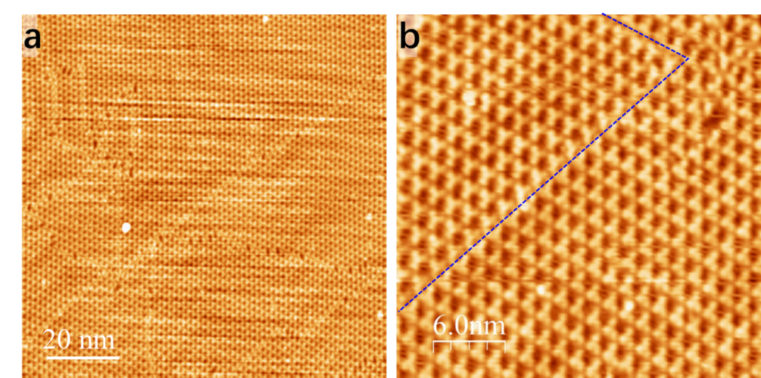
Figure S1 | a, STM image of a nearly-full coverage of THPB monolayer grown on Au surface. b, The zoom-in image showing two domains of THPB-HOF separated by a domain wall, marked by blue dashed lines. Note the orientations of two domains are rotated 180º.

- More line cuts along different momentum paths from ARPES
To check the flatness of the observed FB over the whole BZ, we measured the dispersions along different line cuts of momentum paths. In Fig. S2a and S2b, line cuts 1,2 and 3 show the existence of FB of HOF intersecting with Au surface sp band.
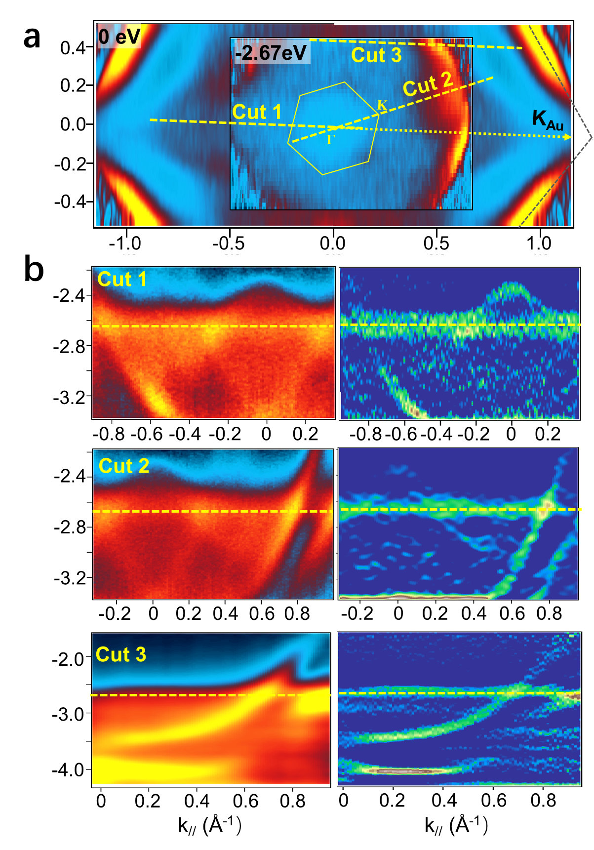
Figure S2 | a, The CECs measured at 0 eV (back panel) and -2.67 eV (the energy of FBs, front panel), showing the Au sp band moves from the BZ boundary at 0 eV to the halfway to zone center at -2.67 eV. b, Three line cuts measured along the yellow dashed lines marked as yellow dashed lines in (a), showing the flatness of the flat bands along different k paths in momentum space. The left and right panels in (b) are ARPES intensity and second-derivative plots, respectively.

- Raman characterization of THPB-HOF and THPB in alcohol solution
For comparison, we prepared high-concentration THPB dissolved in alcohol solution, then drop and dry the solution on the surface of Si(111). On the other hand, the THPB-HOF monolayer is prepared on Au(111) surface. The Raman spectra were collected before and after surface preparation. One can see two characteristic Raman peaks located at 2440 and 3273 cm⁻¹ for the THPB layer on the Au surface (red curve), which are absent in the Raman spectrum of THPB solution (black curve). It suggests that these two Raman peaks are likely originated from H-bonds which are destroyed in the solution.
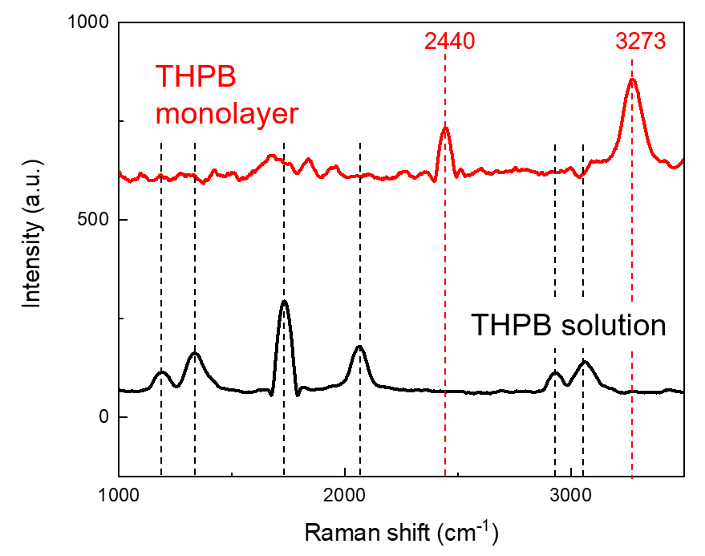
Figure S3 | Raman spectroscopic measurements of THPB monolayer on Au(111) (red) and THPB in solution then drop on Si(111) surface (black).

- Details of calculated band structure and band topology
The calculated work function of THPB-HOF is 3.43 eV. The bandgap of THPB monolayer is 2.99 eV by LDA and 3.87 eV by HSE.
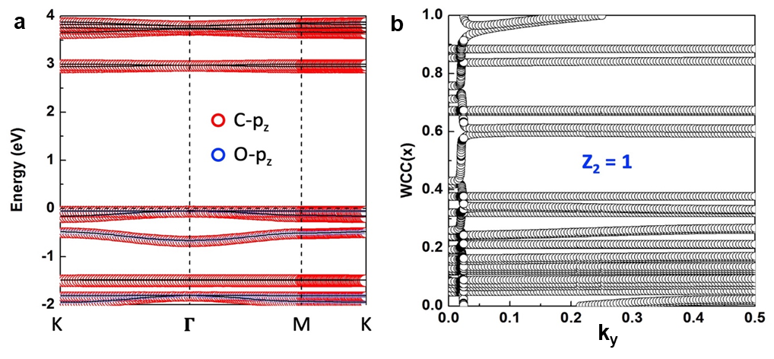
Figure S4 | a, The electronic band structures and orbital contributions of THPB-HOF obtained from DFT-LDA calculations. b, Wannier charge centers for all the occupied bands by adding an SOC gap below the flat band confirming it to have a Z₂=1.

- Details of Raman calculation results for THPB-HOF
We attribute the additional experimental peak at 2308 cm⁻¹ not captured by calculation to the second-order Raman scattering (see details in SI) considering the following facts. First, this peak is persistent which has been observed in different samples, suggesting it be an intrinsic Raman peak of the material. Secondly, the off-resonant Raman calculation cannot account for higher-order Raman scatterings and hence will miss this peak. Thirdly, this additional experimental peak can be assigned as a second-order overtone Raman shift of the mode at 1183 cm⁻¹ in the calculated spectrum. Especially, this mode (Fig. S5) shows similar C-H vibration patterns as the E_{2g} vibration mode (with a frequency of 1178 cm⁻¹) of benzene, which contributes an overtone Raman peak at 2353 cm⁻¹ as observed under a 212.8 nm excitation^{13,14}.

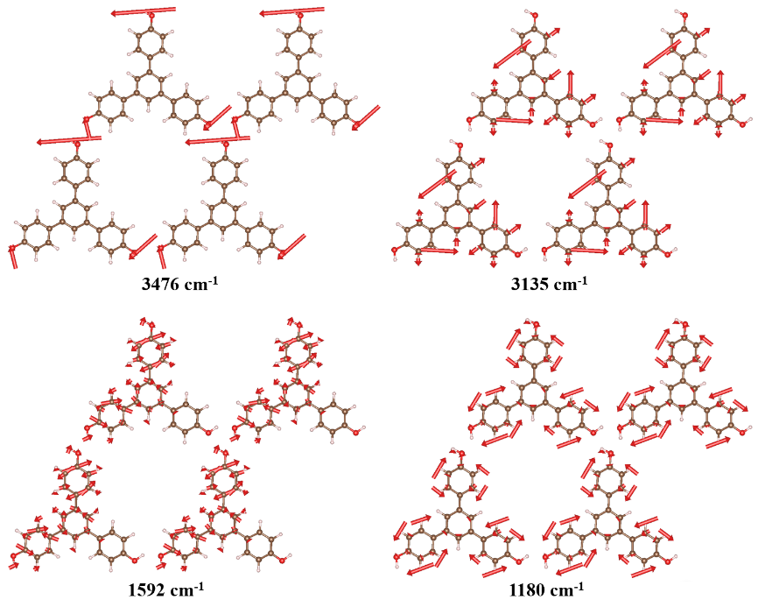
Figure S5 | Visualization of vibrations modes corresponding to the four prominent Raman peaks of THPB-HOF. The red arrows represent the vibration magnitude and direction.
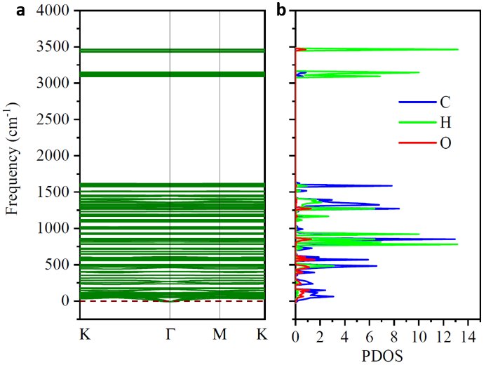
Figure S6 | Phonon band structure (a) and atom-projected density of states (b) of THPB monolayer.

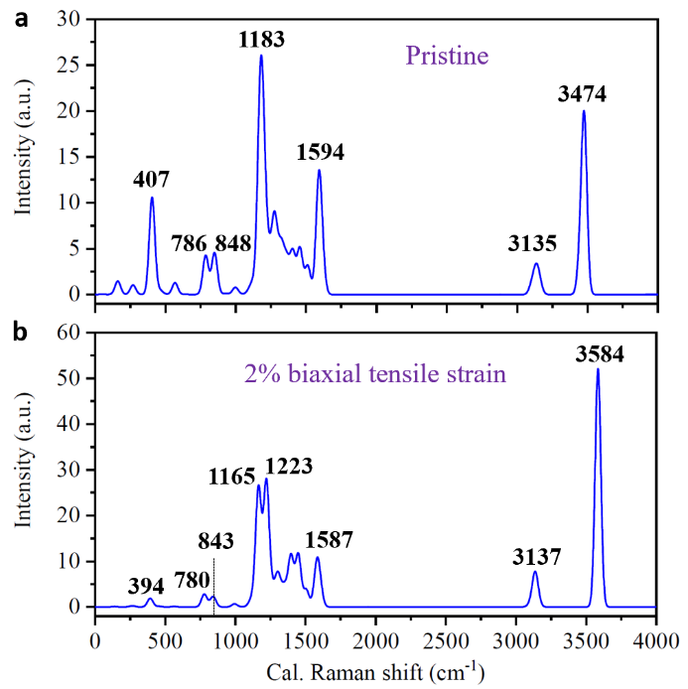
Figure S7 | Calculated Raman spectra of the pristine THPB-HOF (a) and the 2% biaxial tensile strained THPB-HOF (b). Note that the results in (a) are the same with Fig. 4d in the main text, which are reproduced here for the ease of comparison.

References

S1. I. Horcas, R. Fernandez, J.M. Gomez-Rodriguez, J. Colchero, J. Gomez-Herrero and A. M. Baro, Rev. Sci. Instrum. 78, 013705 (2007)
S2. J. P. Perdew and A. Zunger, Phys. Rev. B 23, 5048 (1981).
S3. Heyd J, Scuseria GE, Ernzerhof M. J. Chem. Phys.118, 8207(2003).
S4. Heyd J, Scuseria GE, Ernzerhof M. J. Chem. Phys.124, 219906E(2006).
S5. G. Kresse and J. Furthmüller, Phys. Rev. B 54, 11169 (1996)
S6. M. Methfessel and A. T. Paxton, Phys. Rev. B 40, 3616 (1989)
S7. D. Hobbs, G. Kresse, and J. Hafner, Phys. Rev. B 62, 11556 (2000)
S8. N. Marzari and D. Vanderbilt, Phys. Rev. B 56, 12847 (1997);
S9. Q. Wu, S. Zhang, H.-F. Song, M. Troyer, and A. A. Soluyanov, Comput. Phys. Comm., 224, 405-416 (2018)
S10. J. K. Freericks, H. R. Krishnamurthy, and Th. Pruschke, Theoretical Description of Time-Resolved Photoemission Spectroscopy: Application to Pump-Probe Experiments, Phys. Rev. Lett. 102, 136401(2009)
S11. Sentef, M., Claassen, M., Kemper, A. et al. Theory of Floquet band formation and local pseudospin textures in pump-probe photoemission of graphene. Nat. Commun. 6, 7047 (2015).
S12. Aaron Farrell, A. Arsenault, and T. Pereg-Barnea, Dirac cones, Floquet side bands, and theory of time-resolved angle-resolved photoemission, Phys. Rev. B 94, 155304 (2016).
S13. Ziegler, L. D. & Hudson, B. Resonance Raman scattering of benzene and benzene‐d 6 with 212.8 nm excitation. J. Chem. Phys. 74, 982-992 (1981).
S14. Preuss, M. & Bechstedt, F. Vibrational spectra of ammonia, benzene, and benzene adsorbed on Si (001) by first principles calculations with periodic boundary conditions. Phys. Rev. B 73, 155413 (2006).

