- History for primary endpoint
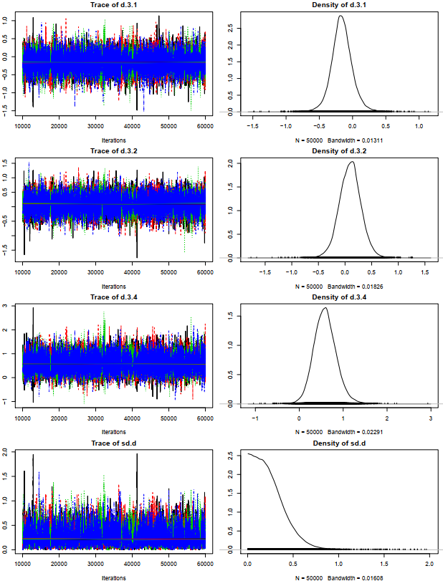
- Brooks-Gelman-Rubin diagnostic for primary endpoint
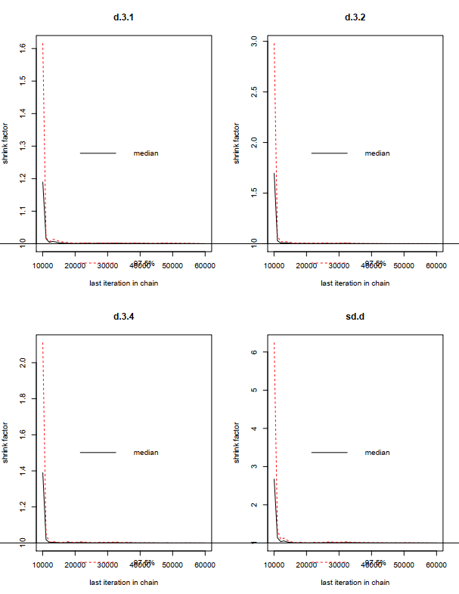
- History for all-cause mortality

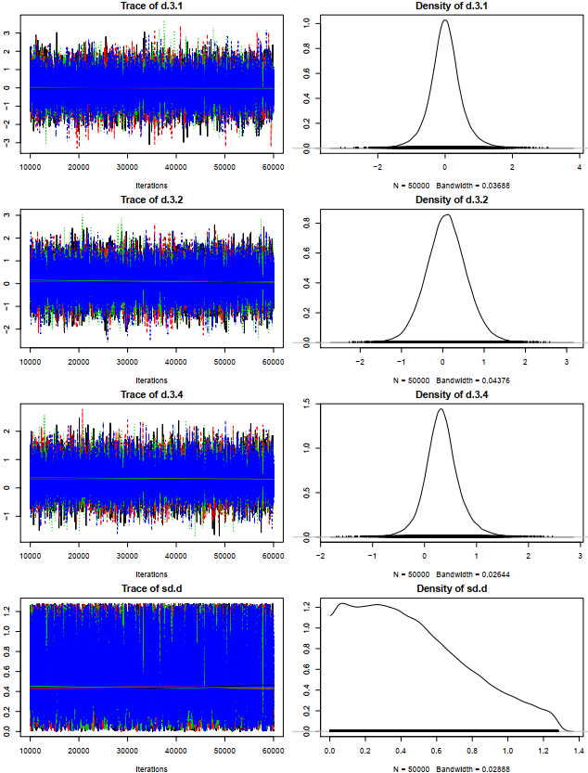
- Brooks-Gelman-Rubin diagnostic for all-cause mortality
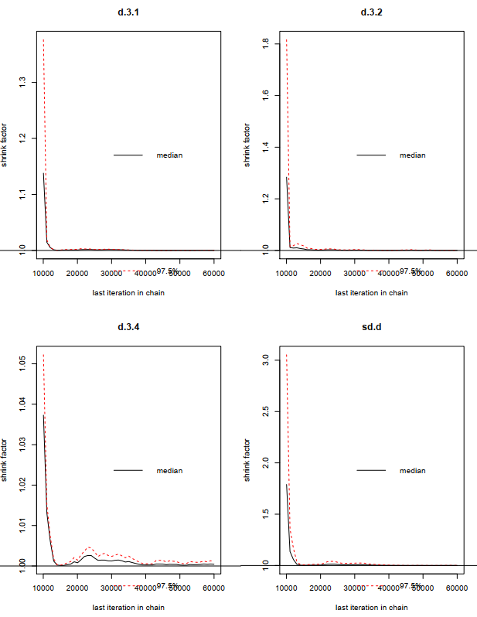
- History for cardiac mortality
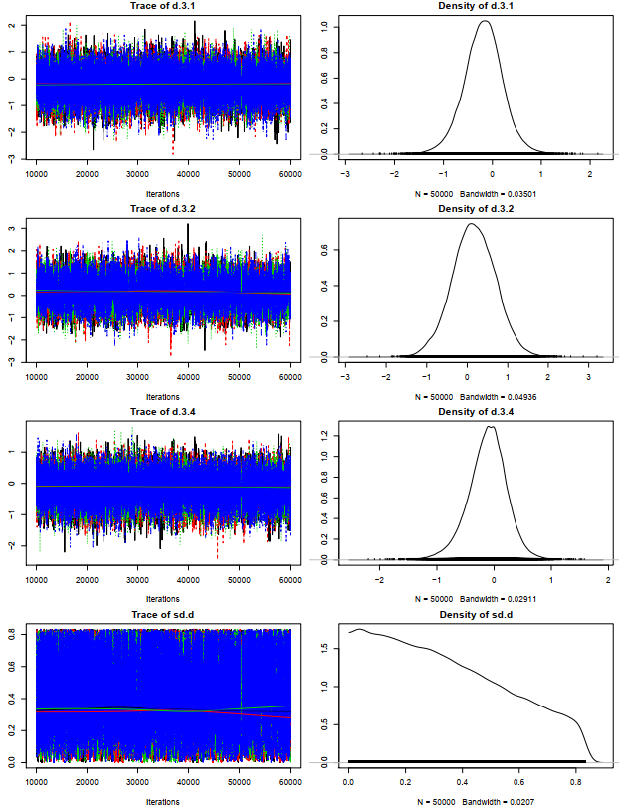
- Brooks-Gelman-Rubin diagnostic for cardiac mortality
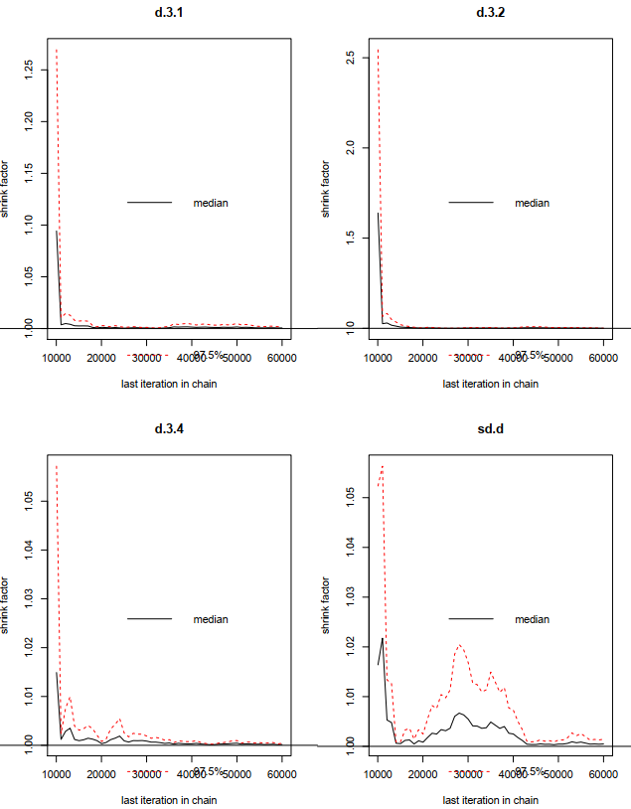
- History for myocardial infarction
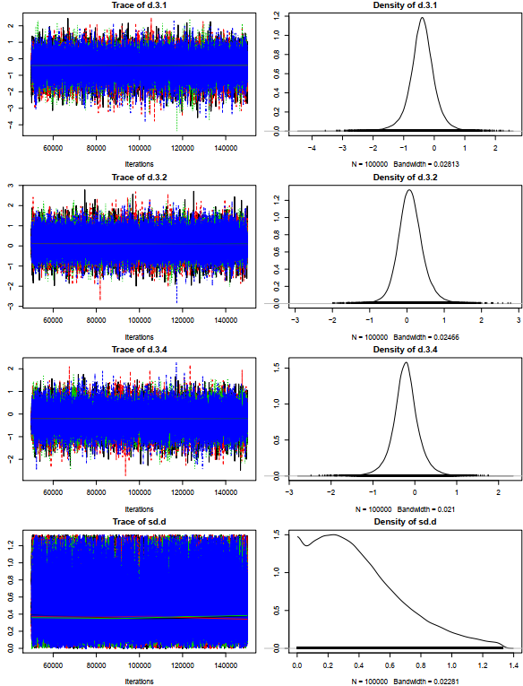
- Brooks-Gelman-Rubin diagnostic for myocardial infarction
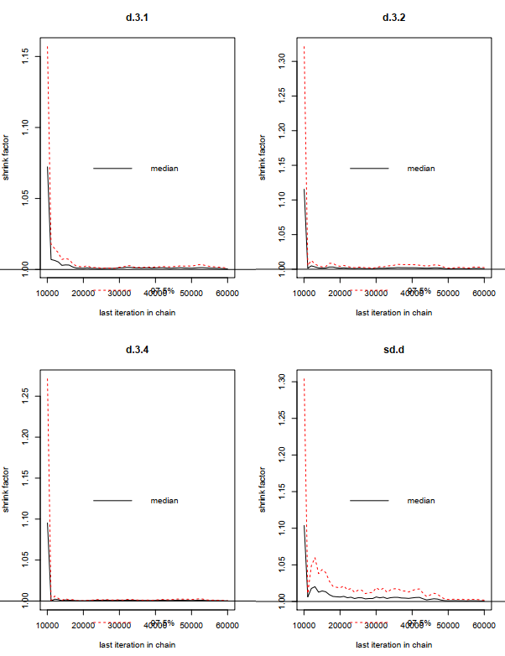
- History for stroke
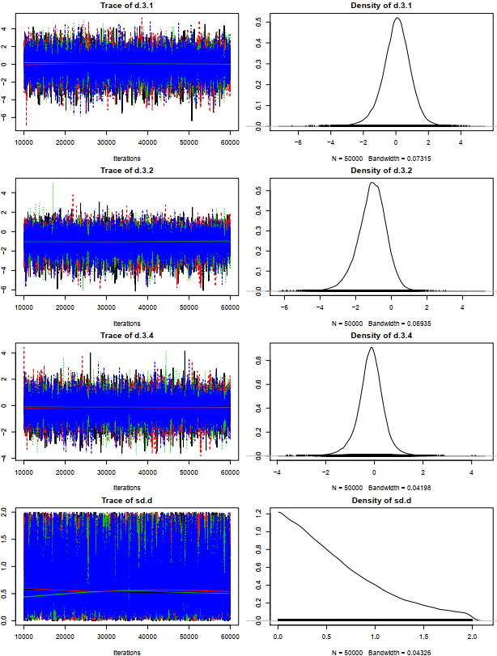
- Brooks-Gelman-Rubin diagnostic for stroke
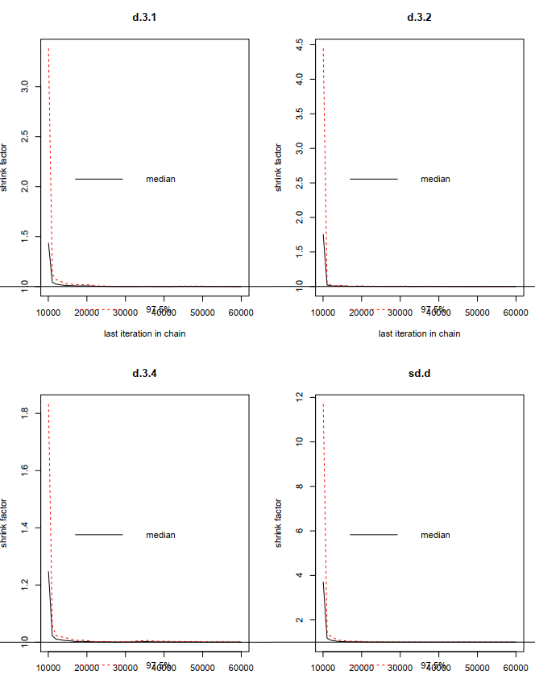
- History for target vessel revascularization
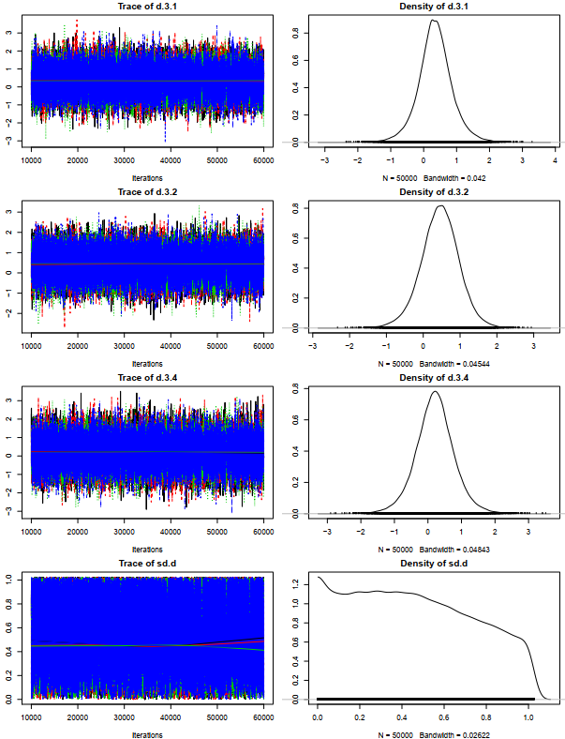
- Brooks-Gelman-Rubin diagnostic for target vessel revascularization
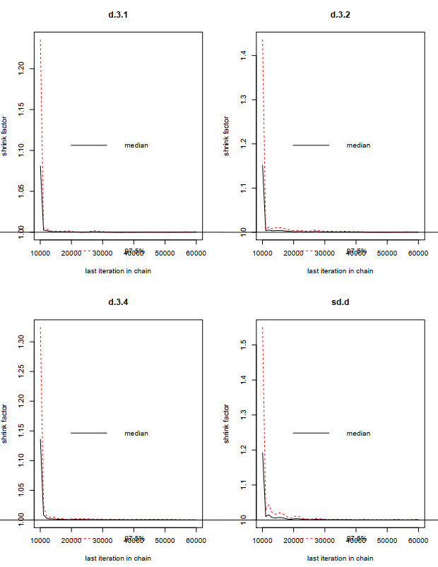
- History for definite or probable stent thrombosis
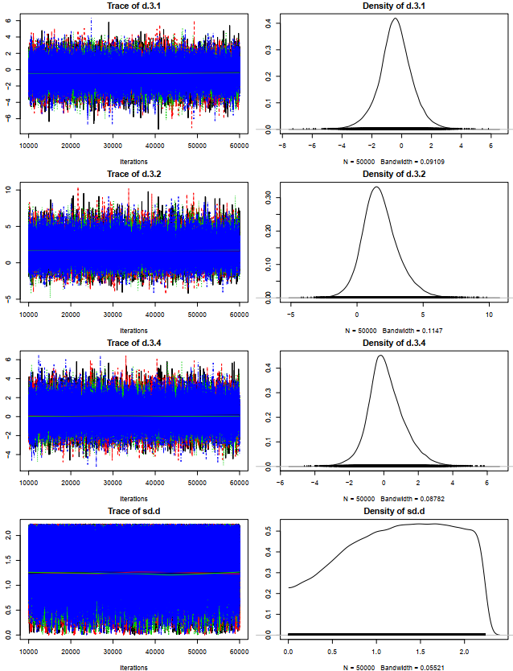
- Brooks-Gelman-Rubin diagnostic for definite or probable stent thrombosis
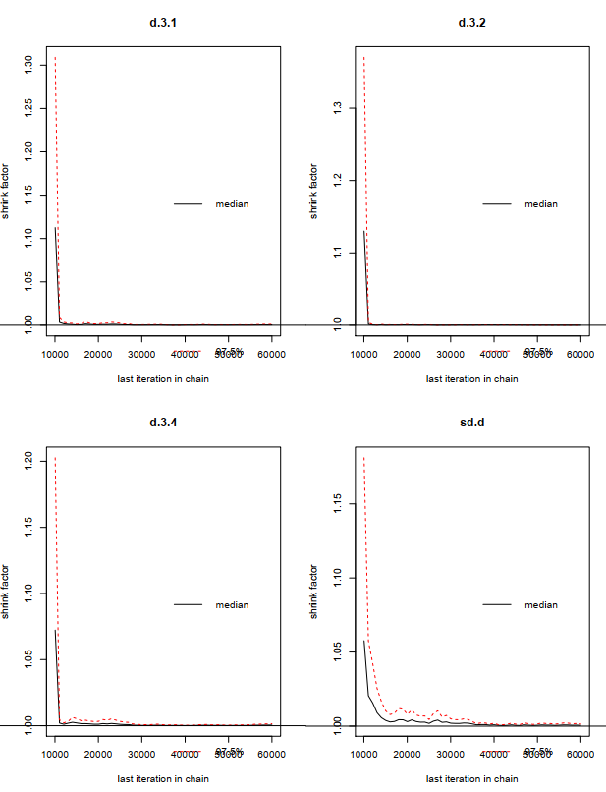
- History for major bleeding
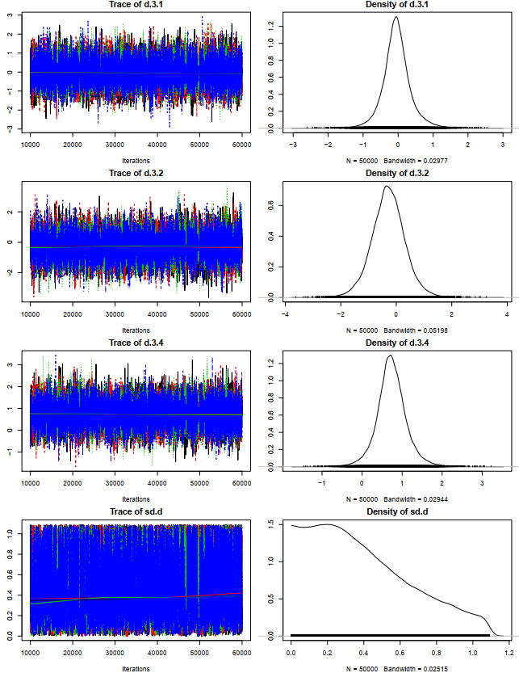
- Brooks-Gelman-Rubin diagnostic for major bleeding
Figure1. The convergence of the chains established by inspection of the history featured and the Brooks-Gelman-Rubin diagnosis
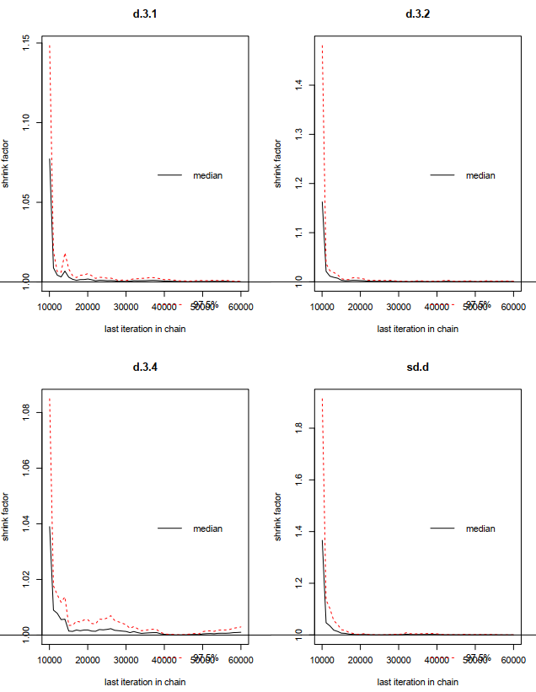

Figure 1. The convergence of the chains established by inspection of the history featured and the Brooks-Gelman-Rubin diagnosis for primary endpoint (A and B), all-cause mortality (C and D), cardiac mortality (E and F), myocardial infarction (G and H), stroke (I and J), target vessel revascularization (K and L), definite or probable stent thrombosis (M and N), major bleeding (O and P)

