- Primary endpoint
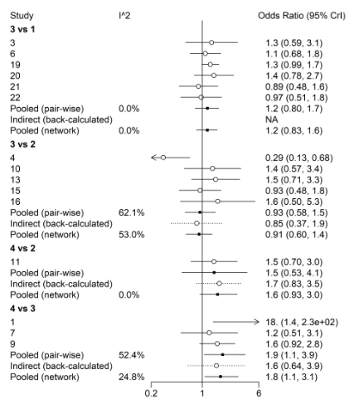
- All-cause mortality
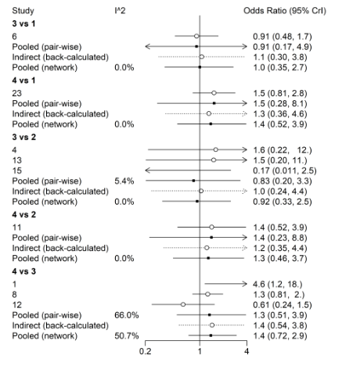
- Cardiac mortality
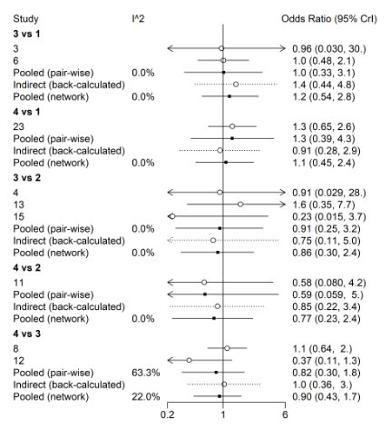
- Myocardial infarction
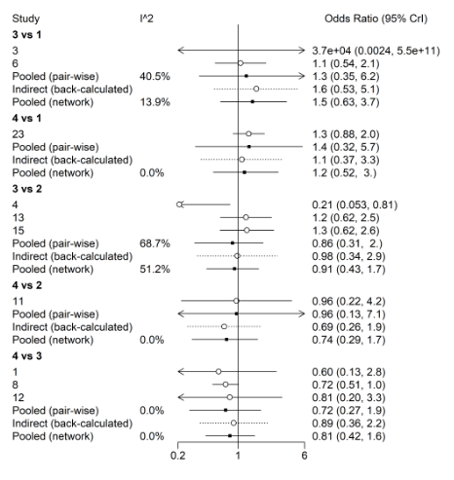
- Stroke
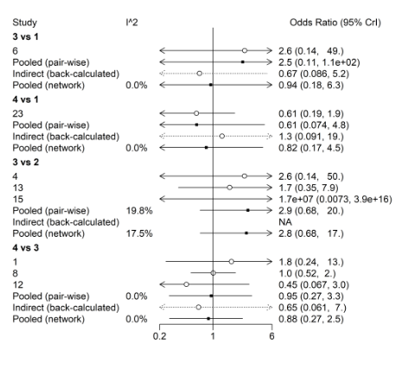
- Target vessel revascularization
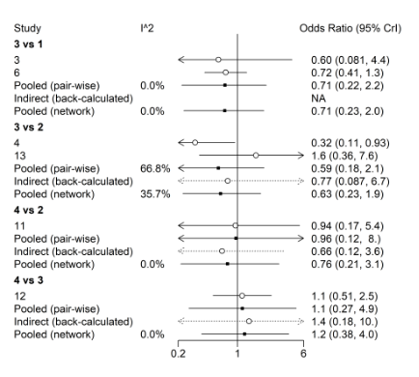
- Definite or probable stent thrombosis
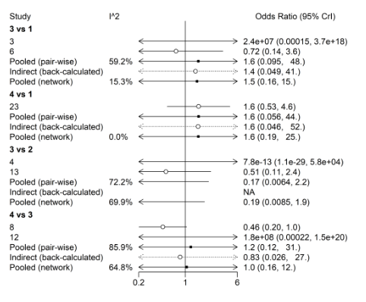
- Major bleeding
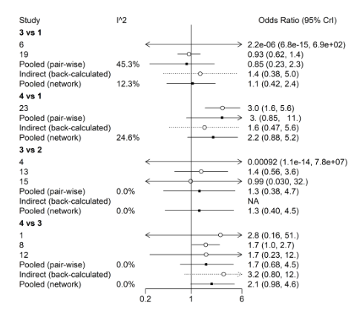
Figure 1. Forest plots of feasible pairwise comparisons with heterogeneity estimates on different outcomes
1: short-term DAPT; 2:midterm DAPT; 3:standard-term DAPT; 4: extended-term DAPT

