Supporting information of
Fabrication of near-invisible solar cell with monolayer WS₂

Xing He¹, Yuta Iwamoto¹, Toshiro Kaneko¹, and Toshiaki Kato^{1,*}

¹Graduate School of Engineering, Tohoku University, Sendai 980-8579, Japan
*Corresponding Author. e-mail: kato12@tohoku.ac.jp

Table S1| Types and basic features of solar cells with thick TMD.
Type | Material | Layer  number | PCE | Device  size | Optical transparency | Ref.
PN  (Dual gate) | MoSe₂ | 10L | 14%  (solar simulator) | μm-scale | X  (Si substrate) | S1
PN  (Plasma doping) | MoS₂ | ~120 nm | 2.8%  (Solar simulator) | μm-scale | X  (Au substrate) | S2
Hetero  (Lateral) | MoS₂/WSe₂ | 7.06/4.51 nm  (10L/6L) | ~10%  (19.1 W/m²) | μm-scale | O  (glass substrate) | S3
Hetero  (Lateral) | n-MoS₂/p-InP | 6L (MoS₂)/- | 0.11%  (solar simulator) | mm-scale | X  (Si substrate) | S4
PN  (MoO_{x} Doping) | WS₂ | < 90 nm | 1.55%  (solar simulator) | μm-scale | X  (Si substrate) | S5
Schottky | MoS₂ | 50 nm | 2.5%  (532 nm, 1000W/m²) | μm-scale | X  (Si substrate) | S6
Schottky | WSe₂ | 25 ~ 185 nm | 1.7%  (solar simulator) | μm-scale | X  (Si substrate) | S7

Table S2| Types and basic features of solar cells with monolayer and TMD with a few layers.
Type | Material | Layer  number | Total power | Device  size | Optical  transparency | Ref.
PN  (Dual gate) | WSe₂ | 1L | 170 pW  (Laser, 640 nm, 48000 W/m²) | μm-scale | X  (Si substrate) | S8
PN  (Dual gate) | WSe₂ | 1L | 9 pW  (halogen lamp, 1400 W/m²) | μm-scale | X  (Si substrate) | S9
Liquid  junction  (Vertical) | MoS₂,  WSe₂ | 1L (MoS₂)  1L (MoS₂)/1L (WSe₂)  1L (WSe₂) | –  (532 nm, 20.8 W/m²) | μm-scale | X  (ITO substrate, Pt electrode) | S10
Schottky  (lateral) | WSe₂,  WS₂ | 2L, 3L | 0.023 pW  (solar simulator, 1000 W/m²) | cm-scale | O  (PEN substrate,  Sparse scattered pattern) | S11
Schottky | WS₂ | 1L | 420 pW  (solar simulator, 1000 W/m²) | cm-scale | O  (Quartz substrate，  Dense integrated pattern) | This  work

Table S3| Schottky barrier height of Mx/ITO, as measured by the SPCM method.
Electrode | Ø_{B} [meV]
WO₃/Cu/ ITO | ~ 220
Cu/ITO | ~ 100
Ni/ITO | ~ 60
Ag/ITO | ~ 20
Au/ITO | ~ 10
ITO | ~ 5

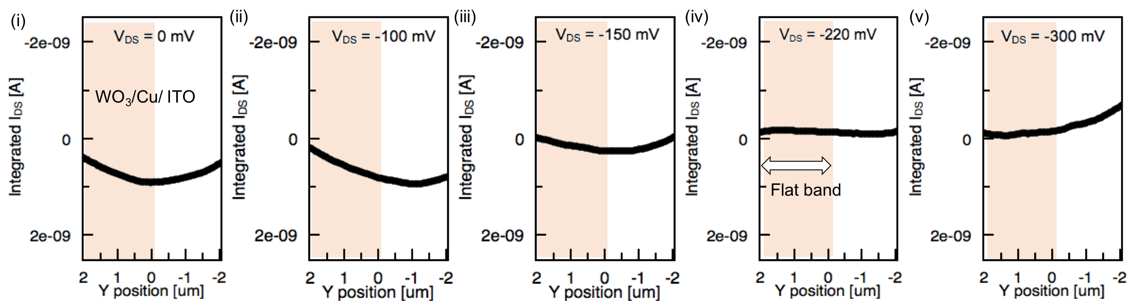
Figure S1| (i–v) Potential profile of WO₃/Cu/ITO contact with WS₂ with an inverse bias applied, V_{DS}, and flat band forms when V_{DS} = –220 mV shown in (iv), indicating Φ_{B} is 220 meV between the contact of WO₃/Cu/ITO and WS₂.

Figure captions:

Figure S1| (i–v) Potential profile of WO₃/Cu/ITO contact with WS₂ with an inverse bias applied, V_{DS}, and flat band forms when V_{DS} = –220 mV shown in (iv), indicating Φ_{B} is 220 meV between the contact of WO₃/Cu/ITO and WS₂.

Figure S2| Performance of solar cells in um² scale. (a–d) Typical I-V curves of the solar cell with electrodes of ITO–ITO, WO₃/ITO–ITO, Cu/ITO–ITO, and WO₃/Cu/ITO–ITO, respectively. Scale bars in inset images represent 50 um. (e–g) Comparison of open circuit voltage, short circuit current, and fill factor, respectively, of the solar cells shown in (a–d).

Figure S3| Devices with a simple enlarged pattern. (a) Images of the devices, (b) device area calculation method, (c) normalized P_{T}, and (d) open circuit voltage (V_{OC}) of the devices with increasing area.

Figure S4| Parallel connection equivalent circuit for the unit device. (a) Unit device treated as many small channels (i, ii, iii, …) connected in parallel. (b) Total resistance (R_{sh}) calculated from the equation 1/R_{sh} =$Σ$(1/R_{sh} (i)). (c) Schematic diagram of the device with a low parallel resistance part, which may come from impurities or metallic-like 1T phase.

Figure S5| Dependency on the number of parallel connections (N_{dev}) of unit device module A (UDM-A). (a) Images of the device structure. (b, c) Images of the devices with same channel length and width, but different N_{dev}. (d, e) Plots of normalized P_{T} and V_{oc} versus N_{dev}; black line in (d) is the ideal tendency of normalized P_{T} and black dash line in (e) is the fitting curve of V_{OC}.

Figure S6| Design of UDM-B: seriers connection of UDM-A. (a, b) Diagram of N_{se} designed for the device. (c, d, e) P_{T}, V_{OC}, I_{SC} of the devices with N_{se} values.

Figure S7| Comparision of designed patteren and simple pattern. (a) P_{T} of designed and simple patterns. (b–e) Typical I–V curve of the solar cells as shown in (a) (1)–(4). (f, g) Voc and I_{SC} of designed pattern and simple pattern.

Figure S8| Images of (a) quartz, (b) electrodes on quartz, and (c) solar cell on quartz combined with electrodes and WS₂.

Figure S9| Photoluminencent intensity of CVD grown WS₂. (a) Schematic illustration of PL intensity testing and mapping. (b) PL mapping of WS₂ sheet on SiO₂/Si substrate, green dots represent monolayer WS₂. (c) Image and (d) PL mapping of single crystal monolayer WS₂ at the red cross in (b). (e) PL intensity of WS₂ in (d).

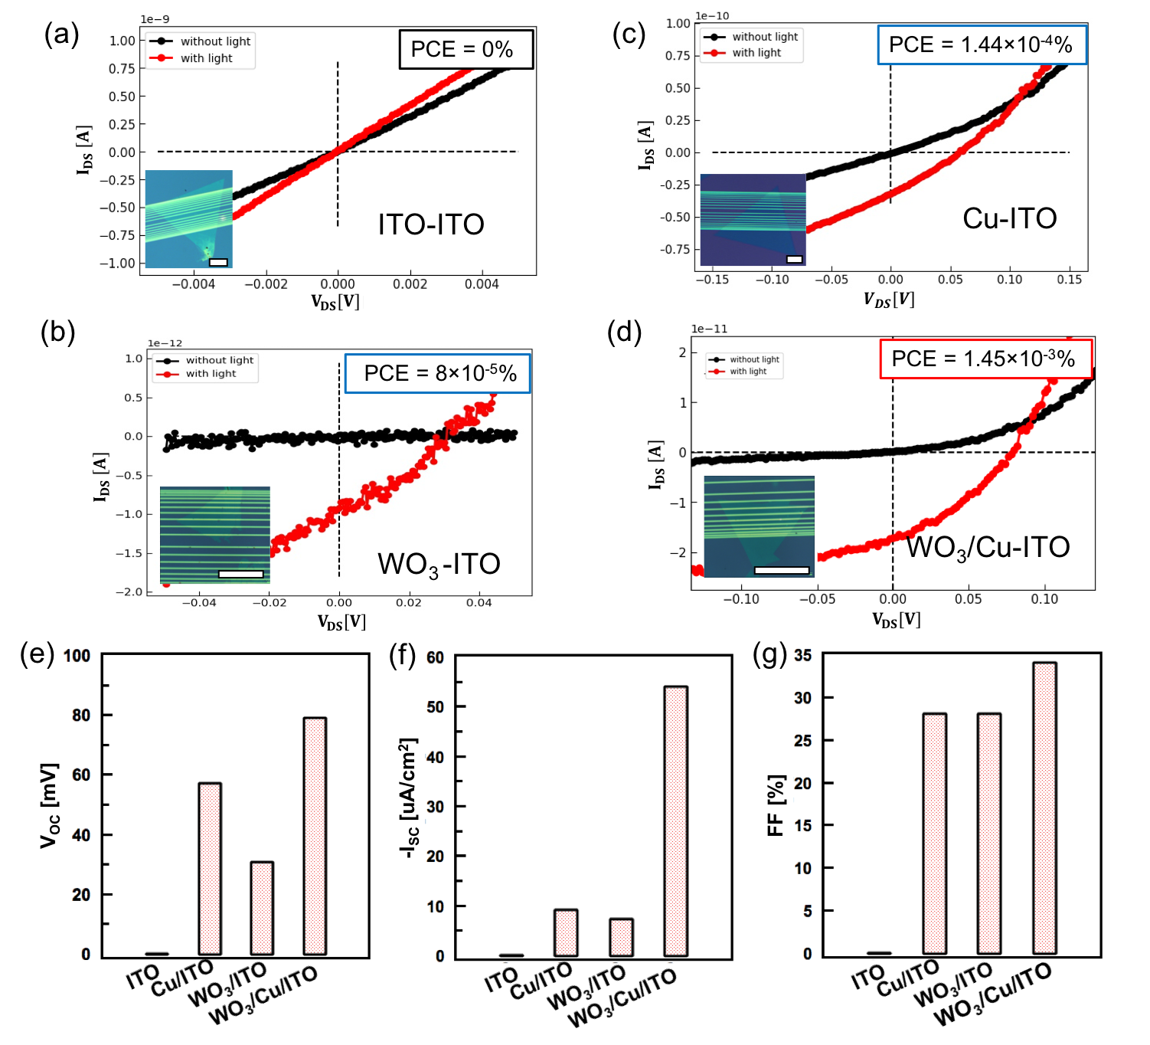
Figure S2| Performance of solar cells in um² scale. (a–d) Typical I-V curves of the solar cell with electrodes of ITO–ITO, WO₃/ITO–ITO, Cu/ITO–ITO, and WO₃/Cu/ITO–ITO, respectively. Scale bars in inset images represent 50 um. (e–g) Comparison of open circuit voltage, short circuit current, and fill factor, respectively, of the solar cells shown in (a–d).

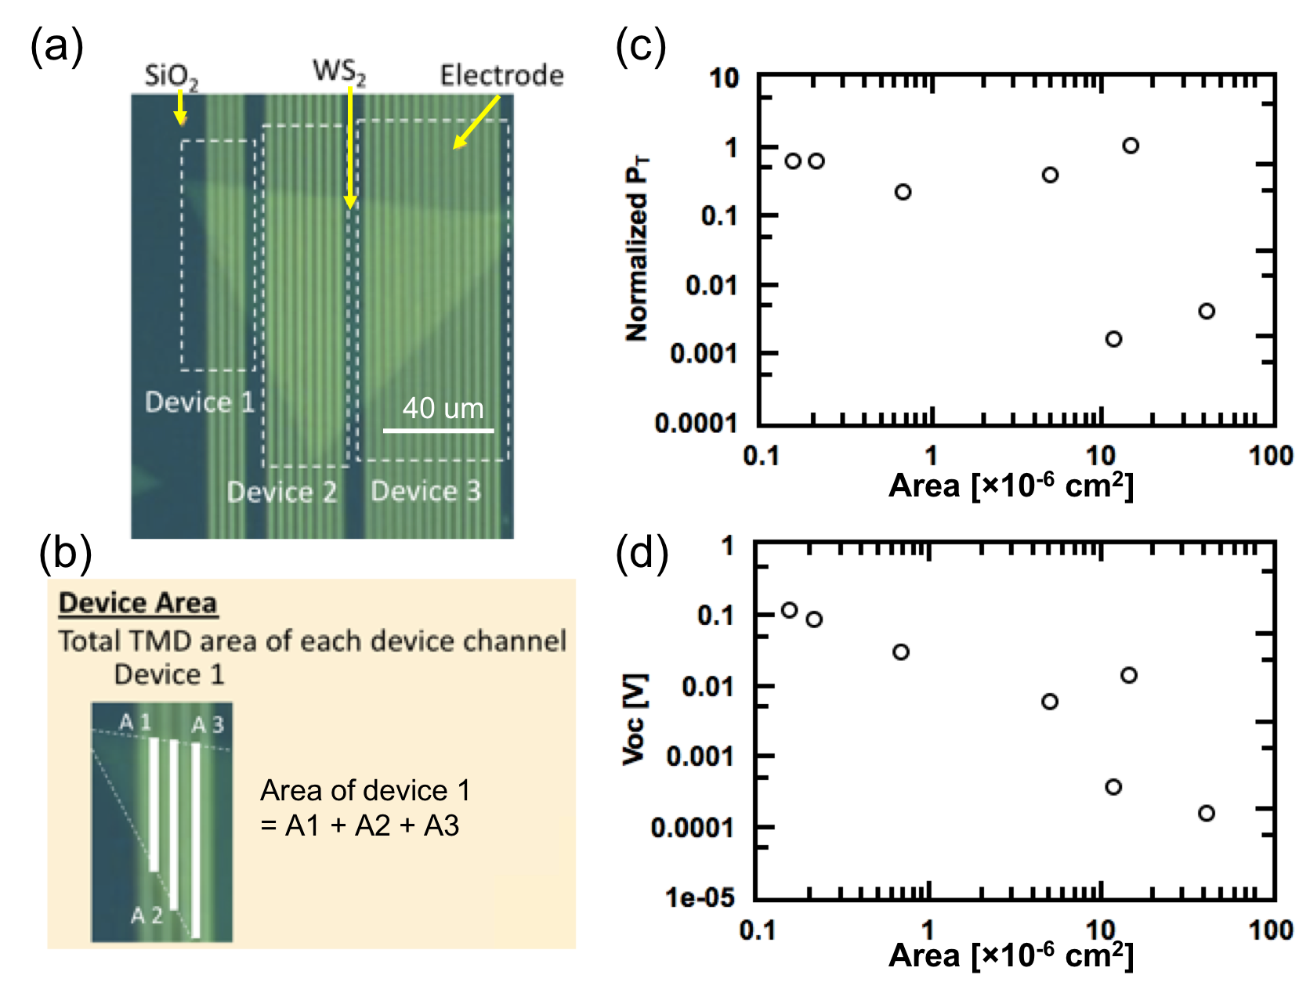

Figure S3| Devices with a simple enlarged pattern. (a) Images of the devices, (b) device area calculation method, (c) normalized P_{T}, and (d) V_{OC} of the devices with increasing area.

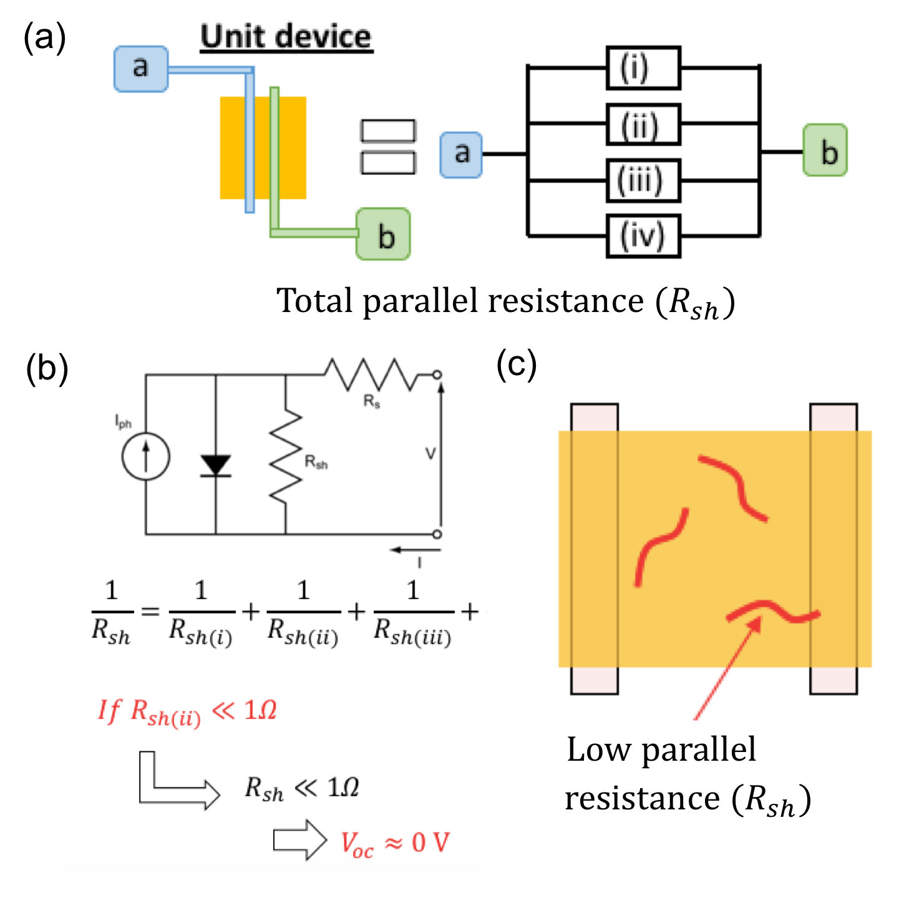
Figure S4| Parallel connection equivalent circuit for the unit device. (a) Unit device treated as many small channels (i, ii, iii, …) connected in parallel. (b) Total parallel (shunt) resistance (R_{sh}) calculated from the equation 1/R_{sh} =$Σ$(1/R_{sh} (i)). (c) Schematic diagram of the device with a low parallel resistance part, which may come from impurities or metallic-like 1T phase.

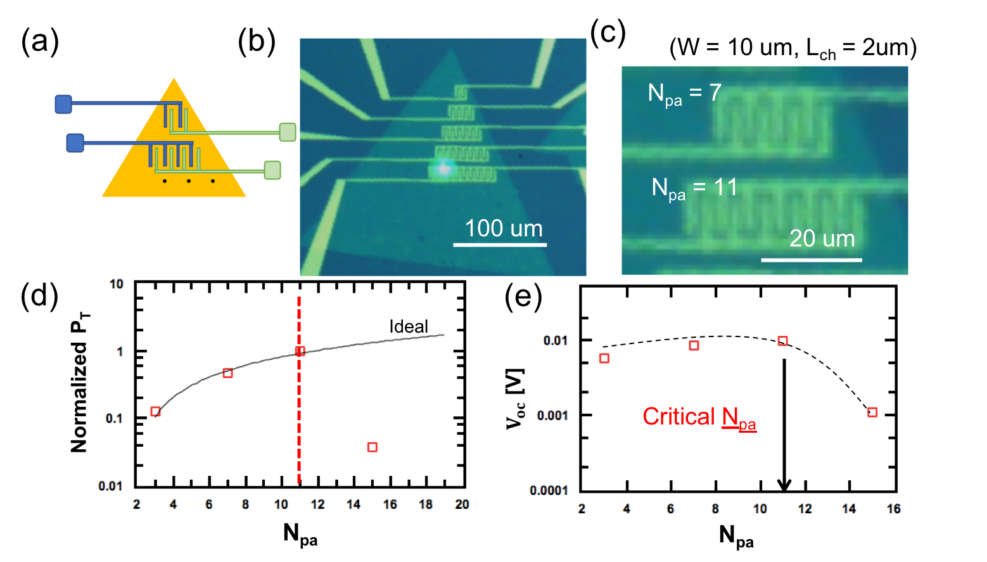

Figure S5| Dependency on the number of parallel connections (N_{pa}) of unit device module A (UDM-A). (a) Images of the device structure. (b, c) Images of the devices with same channel length and width, but different N_{pa}. (d, e) Plots of normalized P_{T} and V_{OC} versus N_{pa}; black line in (d) is the ideal tendency of normalized P_{T} and black dash line in (e) is the fitting curve of V_{OC}.

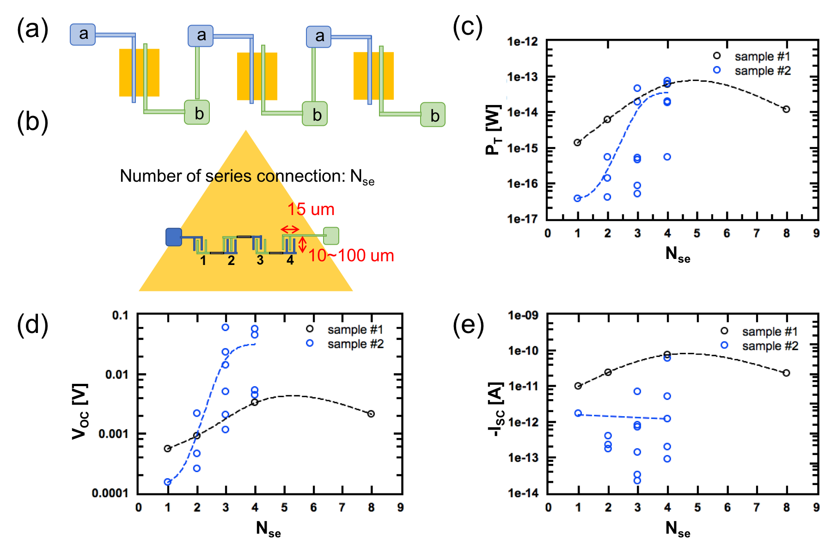

Figure S6| Design of UDM-B: seriers connection of UDM-A. (a, b) Diagram of N_{se} designed for the device. (c, d, e) P_{T}, V_{OC}, I_{SC} of the devices with N_{se} values.

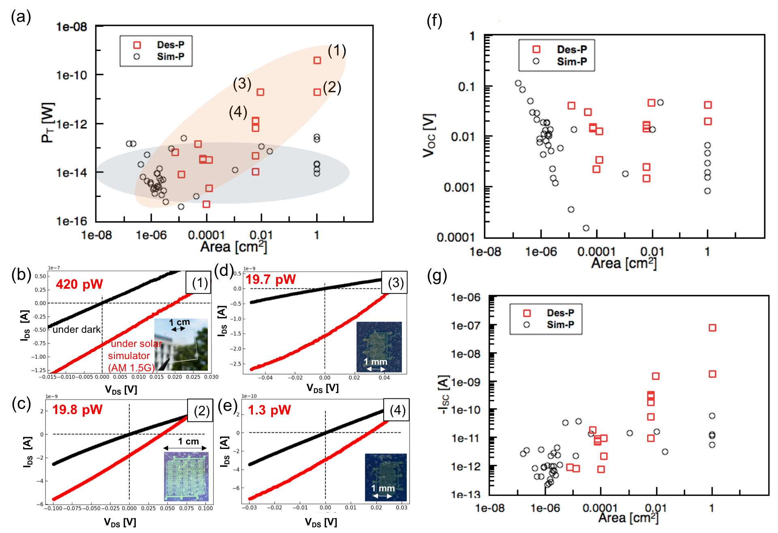

Figure S7| Comparision of designed patteren and simple pattern. (a) P_{T} of designed and simple patterns. (b–e) Typical I–V curve of the solar cells as shown in (a) (1)–(4). (f, g) V_{OC} and I_{SC} of designed pattern and simple pattern.

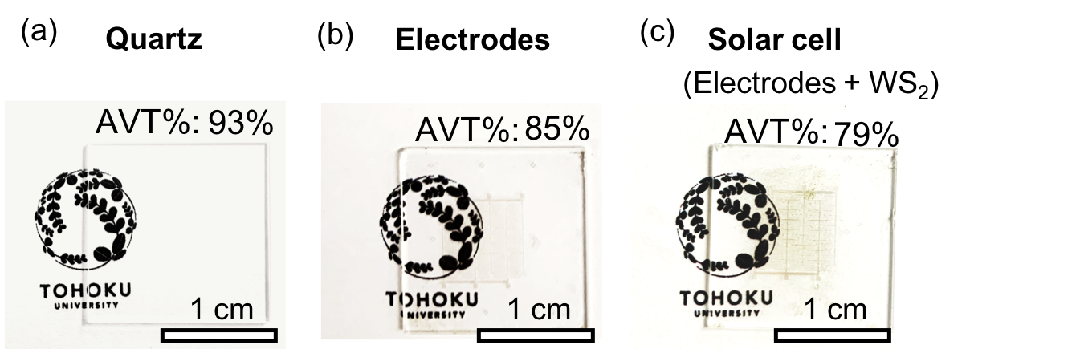

Figure S8| Images of (a) quartz, (b) electrodes on quartz, and (c) solar cell on quartz combined with electrodes and WS₂.

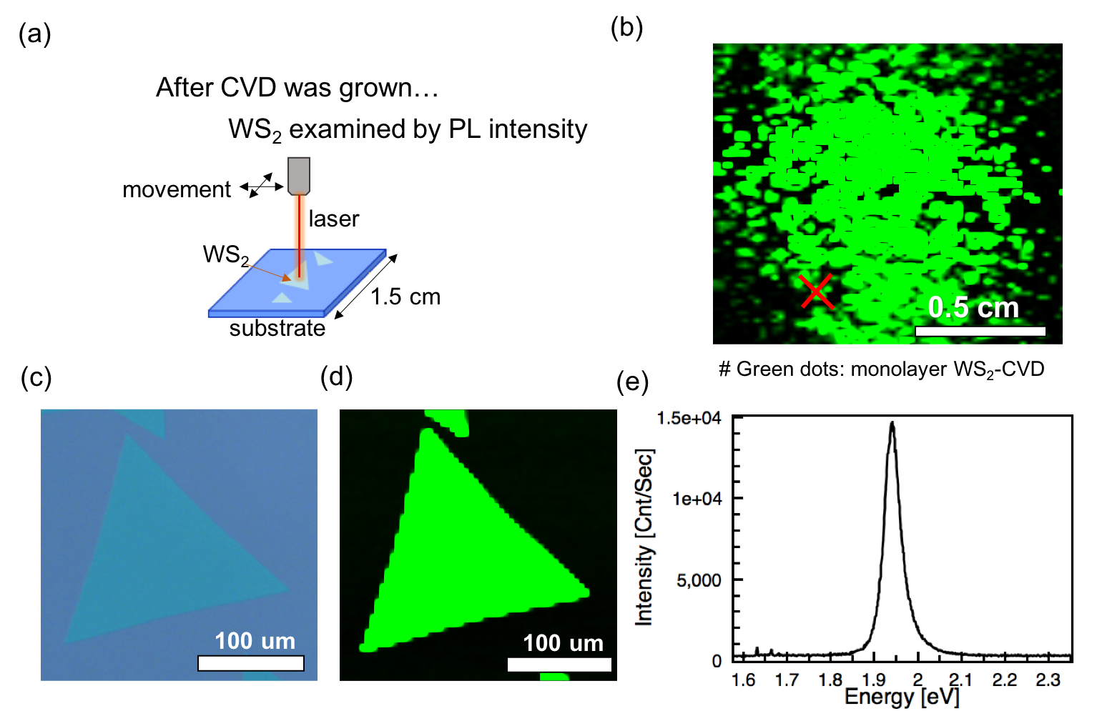

Figure S9| Photoluminencent intensity of CVD grown WS₂. (a) Schematic illustration of PL intensity testing and mapping. (b) PL mapping of WS₂ sheet on SiO₂/Si substrate, green dots represent monolayer WS₂. (c) Image and (d) PL mapping of single crystal monolayer WS₂ at the red cross in (b). (e) PL spectrum of WS₂ in (d).

References
S1. Memaran, S. et al. Pronounced photovoltaic response from multilayered transition-metal dichalcogenides pn-junctions. Nano Lett. 15, 7532–7538 (2015).
S2. Wi, S. et al. Enhancement of photovoltaic response in multilayer MoS₂ induced by plasma doping. ACS Nano 8, 5270–5281 (2014).
S3. Cho, A. J., Song, M. K., Kang, D. W. & Kwon, J. Y. Two-dimensional WSe₂/MoS₂ p-n heterojunction-based transparent photovoltaic cell and its performance enhancement by fluoropolymer passivation. ACS Appl. Mater. Interfaces 10, 35972–35977 (2018).
S4. Pawar, S. A. et al. Heterojunction solar cell based on n-MoS₂/p-InP. Opt. Mater. 86, 576–581 (2018).
S5. Nazif, N. K. et al. High-performance p-n junction transition metal dichalcogenide photovoltaic cells enabled by MoO_{x} doping and passivation. Nano Lett. 21, 3443–3450 (2021).
S6. Fontana, M. et al. Electron-hole transport and photovoltaic effect in gated MoS₂ Schottky junctions. Sci. Rep. 3, 1634–8–13 (2013).
S7. McVay, E., Zubair, A., Lin, Y., Nourbakhsh, A. & Palacios, T. Impact of Al₂O₃ passivation on the photovoltaic performance of vertical WSe₂ Schottky junction solar cells. ACS Appl. Mater. Interfaces 12, 57987–57995 (2020).
S8. Groenendijk, D. J. et al. Photovoltaic and photothermoelectric effect in a double-gated WSe₂ device. Nano Lett. 14, 5846–5852 (2014).
S9. Pospischil, A., Furchi, M. M. & Mueller, T. Solar-energy conversion and light emission in an atomic monolayer p-n diode. Nat. Nanotechnol. 9, 257–261 (2014).
S10. Wang, L. & Sambur, J. B. Efficient ultrathin liquid junction photovoltaics based on transition metal dichalcogenides. Nano Lett. 19, 2960–2967 (2019).
S11. Akama, T. et al. Schottky solar cell using few-layered transition metal dichalcogenides toward large-scale fabrication of semitransparent and flexible power generator. Sci. Rep. 7, 11967–1–10 (2017).

