Supplementary material.

Distinct neural activation pattern of age on subcomponents of inhibitory control: a fMRI meta-analysis
Jixin Long¹, Xiaoqi Song¹, You Wang^{1,2}, Chanyu Wang¹, Ruiwang Huang³, Ruibin Zhang^{1,2}*
- Cognitive control and Brain Healthy Laboratory, Department of Psychology, Southern Medical University, Guangzhou, China
- Department of Psychiatry, Zhujiang Hospital, Southern Medical University, Guangzhou, China
- School of Psychology, South China Normal University, Guangzhou, China

* Corresponding author:
Ruibin Zhang, Cognitive control and Brain Healthy Laboratory Department of Psychology, School of Public Health, Southern Medical University. Email: ruibinzhang@foxmail.com

Contents

Table S1 Information on source datasets included in the meta-analysis 4
Table S2 Brain activation in all included inhibitory control experiments 16
Table S3 Brain activation differences between cognitive inhibition and 68 contrasts for response inhibition 17
Table S4 Brain activation differences among four age groups in across all tasks tapping inhibitory control 18
Table S5 Brain activation differences among four age groups for tasks tapping cognitive inhibition only. 19
Table S6 Brain activation differences among four age groups for tasks tapping response inhibition only. 20
Figure S1 Number of studies investigating the development of inhibitory control across life span 21
Figure S2 Brain activation differences between cognitive inhibition and 68 contrasts for response inhibition 22
Figure S3 Brain activation differences among four age groups in across all tasks tapping inhibitory control 23
Figure S4 Brain activation differences among four age groups for tasks tapping cognitive inhibition only 24
Figure S5 Brain activation differences among four age groups for tasks tapping response inhibition only 25

Table S1 Information on source datasets included in the meta-analysis
Study | N(Male) | age range | Mean Age | Control Types | Paradigm | Contrast | Foci
Nicolas et al.(2012) | 28(12) | NA | 7.71 | CI | Stroop | surpass | 10
Margaret et al.(2014) | 33(19) | 5.7-10.7 | 8.1 | CI | Simon | Incongruent>congruent | 9
Silvia et al.(2002) | 16(9) | 8-12 | 10 | CI | Flanker | Incongruent>Neutral | 5
Silvia et al.(2002) | 16(9) | 8-12 | 10 | CI | Flanker | NoGo>Neutral | 2
Kate et al.(2008) | 11(6) | 8-14 | 11.5 | CI | Antisaccade | Antisaccade | 12
Byron et al.(2009) | 18(8) | NA | 14.67 | CI | Stroop | incongruent - rest | 44
Katya et al.(2006) | 29(29) | 10-17 | 15 | CI | Simon Task | Incongruent-Congruent | 5
Katerina et al.(2009) | 78 | 8-27 | 15.62 | CI | Antisaccade | correct AS | 5
Aarthi et al.(2011) | 30(12) | 8-25 | 15.8 | CI | Antisaccade | NA | 12
Natasha et al.(2018) | 171(121) | NA | 16.2 | CI | Stroop | Incongruent>Congruent | 17
Rozmin et al.(2009) | 21(10) | NA | 16.3 | CI | Simon | incongruent>congruent | 6
Jessica et al.(2011) | 65 | 14-25 | 18.8 | CI | Stroop | Incongruent> Congruent | 17
Brian et al.(2016) | 18(10) | 18-22 | 19.9 | CI | Flanker | target condition | 11
Shihua et al.(2017) | 33(18) | NA | 20 | CI | Stroop | Incongruent>Neutral | 5
Jun et al.(2016) | 24(14) | 19-24 | 21 | CI | Stroop | Incongruent > congruent | 13
Kim et al.(2013) | 74(35) | 18.36-25.95 | 21.47 | CI | Stroop | Incongruent>Neutral | 17
Tor et al.(2005) | 14 | 18-25 | 21.5 | CI | Flanker | Incongruent | 9
Jing et al.(2018) | 30(10) | 18-25 | 21.65 | CI | Flanker | Incongruent > fixation | 31
Juan et al.(2017) | 25(11) | 18-25 | 21.7 | CI | Antisaccade | antisaccade | 18
Yongning et al.(2015) | 20(10) | 18-27 | 21.7 | CI | Stroop | Incongruent>Congruent | 20
Julien et al.(2012) | 25(12) | 18-29 | 21.8 | CI | Stroop | incongruent>neutral | 19
Blandyna et al.(2011) | 66(15) | 19-34 | 22.35 | CI | Flanker | Homogeneous>conflict | 26
Margarethe et al.(2014) | 20(10) | NA | 22.95 | CI | Flanker/SRC | Incongruent>congruent | 4
David et al.(2015) | 24(11) | 20-29 | 23.3 | CI | Flanker | incongruent>congruent | 10
Rachel et al.(2005) | 15(4) | NA | 23.3 | CI | Stroop | incongruent>neutral | 23
Marcel et al.(2001) | 10(4) | 20-26 | 23.5 | CI | Stroop | Incongruent-congruent | 5
Joseph et al.(2012) | 25(11) | 18-33 | 23.8 | CI | Flanker | incongruent>congruent | 9
Fiona et al.(2008) | 11(4) | 22-34 | 24 | CI | Flanker | Incongruent >Congruent | 5
Seiki et al.(2011) | 78(35) | 20-28 | 24 | CI | WCST | Control-release | 22
Silvia et al.(2002) | 16(9) | 19-33 | 24 | CI | Flanker | Incongruent>Neutral | 11
Silvia et al.(2002) | 16(9) | 19-33 | 24 | CI | Flanker | NoGo>Neutral | 16
Gerd et al.(2013) | 34(16) | 18-51 | 24.1 | CI | Stroop | Incongruent>congruent | 8
Birte et al.(2008) | 24(9) | NA | 24.2 | CI | Simon | Incongruent>Neutral | 6
Sebastian et al.(2013) | 21(12) | NA | 24.23 | CI | Stroop | Incongruent go>congruent go | 24
Sebastian et al.(2013) | 21(12) | NA | 24.23 | CI | GNG | No-go>congruent go | 17
Sebastian et al.(2013) | 21(12) | NA | 24.23 | CI | SST | Stop>congruent go | 24
Junichi et al.(2007) | 24(12) | 20-29 | 24.5 | CI | Antisaccade | Antisaccade>Control | 53
Andrew et al.(2012) | 26(13) | NA | 24.88 | CI | Stroop | Incongruent>congruent | 17
Benedikt et al.(2010) | 19 | NA | 24.9 | CI | saccade | Inhibition | 7
Reto et al.(2015) | 15(7) | NA | 25.4 | CI | Flanker | Conflict correct | 13
Chobok et al.(2011) | 13(8) | 19-32 | 25.5 | CI | Stroop | Incongruent>neutral | 7
Matthias et al.(2006) | 20(3) | 21-31 | 25.5 | CI | Simon | Incompatible > compatible | 38
Josep et al.(2008) | 34(12) | NA | 25.8 | CI | Flanker | Inhibited>Responses | 11
Marcel et al.(2006) | 20(8) | 21-37 | 26 | CI | Stroop | Incongruent>Congruent | 7
Matthew et al.(2006) | 10(4) | 22-33 | 26 | CI | prosaccIade | Pro-response | 23
Matthew et al.(2006) | 10(4) | 22-33 | 26 | CI | antisaccade | Anti-response | 24
Stefanie et al.(2012) | 19 | 19-36 | 26 | CI | picture-word interference task | Response suppression | 23
Rachel et al.(2006) | 70(34) | NA | 26.7 | CI | Stroop | Control | 11
Yigal et al.(2010) | 14(8) | NA | 27 | CI | Antisaccade | Antisaccade | 7
Sebastian et al.(2013) | 24(9) | NA | 27.42 | CI | Simon Task | incongruent go>congruent go | 22
Tu et al.(2006) | 10(5) | NA | 27.9 | CI | Antisaccade | Antisaccade | 21
Katya et al.(2006) | 23(23) | 20-43 | 28 | CI | Simon Task | Incongruent>Congruent | 9
Marc et al.(2003) | 11 | NA | 29 | CI | Stroop | Incongruent | 11
Katja et al.(2009) | 14(6) | NA | 29.45 | CI | Stroop | negative>neutral | 25
Rebecca et al.(2013) | 14(9) | NA | 29.6 | CI | Antisaccade | Antisaccade | 13
Magali et al.(2008) | 14(14) | 23-37 | 30 | CI | Simon | withholding movement | 7
Sebastian et al.(2012) | 24(11) | NA | 30.3 | CI | Simon Task | Incongruent >Congruent | 10
Xun et al.(2004) | 11(3) | 24-40 | 32 | CI | Simon Stroop | Incongruent > Congruent | 49
Lisa et al.(2009) | 11(11) | NA | 34.1 | CI | Stroop | Stroop>Baseline | 6
Gerd et al.(2006) | 16(0) | NA | 38.8 | CI | Stroop | Incongruent>congruent | 2
Nicole et al.(2006) | 12(12) | NA | 39 | CI | Stroop | Correct Stroop | 5
Tetsuya et al.(2004) | 21 | NA | 39.2 | CI | Antisaccade | Antisaccade>rest | 29
Sebastian et al.(2013) | 49(19) | 20-77 | 39.96 | CI | Simon Task | Success inhibition | 10
Schulte et al.(2011) | 17(17) | NA | 50 | CI | Stroop | Incongruent>Congruent | 4
Juan et al.(2017) | 25(10) | 49-83 | 66.2 | CI | Antisaccade | antisaccade | 18
Margarethe et al.(2014) | 19(10) | NA | 70.26 | CI | Flanker/SRC | Incongruent>congruent | 6
Tieme et al.(2015) | 17(13) | NA | 10.28 | RI | SST | Successful Inhibition | 4
James et al.(2003) | 12(7) | 9.3-11.7 | 10.9 | RI | GNG | NoGo>Go | 16
Bruce et al.(2013) | 11(6) | 9-12 | 10.98 | RI | GNG | NoGo>Go | 7
Du et al.(2012) | 22(13) | 8-15 | 11.5 | RI | GNG | NoGo>Go | 14
David et al.(2009) | 11(5) | NA | 12.6 | RI | GNG | NoGo>Go | 8
Rebecca et al.(2012) | 44(15) | 4-38 | 13.26 | RI | GNG | NoGO | 20
Victor et al.(2008) | 14(6) | NA | 13.3 | RI | GNG | NoGo>Go | 31
Yanni et al.(2016) | 76(40) | 8-19 | 13.9 | RI | MSIT | NA | 7
Alessandra et al.(2010) | 15(7) | NA | 14.13 | RI | SST | Stop>Go | 5
Byron et al.(2009) | 15 | NA | 14.2 | RI | Motor Inhibition | on>off | 40
Manpreet et al.(2010) | 22(13) | NA | 14.3 | RI | GNG | NoGo-Go | 2
Tamm et al.(2002) | 19(8) | 8-20 | 14.41 | RI | GNG | NoGo>Go | 4
Ashley et al.(2015) | 21(12) | 13-16 | 14.5 | RI | SST | Stop>Go | 38
Savani et al.(2019) | 43(3) | NA | 14.61 | RI | SST | Stop>Go | 1
Michael et al.(2007) | 50 | 11-17 | 14.7 | RI | GNG | response inhibition | 60
Katya et al.(2006) | 29(29) | 10-17 | 15 | RI | GNG | NoGo>Go | 4
Leslie et al.(2017) | 7(3) | NA | 15 | RI | GNG | NoGo>Go | 4
Mehereen et al.(2014) | 12 | 9-18 | 15.4 | RI | SST | Stop>Go | 11
Leanne et al.(2004) | 12(12) | 14-16 | 15.58 | RI | GNG | NoGo | 3
James et al.(2011) | 13 | NA | 15.93 | RI | GNG | NoGo>Go | 7
Yi et al.(2016) | 17(17) | 12-18 | 15.94 | RI | GNG | NoGo>Go | 14
Lora et al.(2020) | 117 | 7-13 | 16.26 | RI | GNG | Correct reject>base | 20
Sarah et al.(2015) | 95(77) | 14-18 | 16.29 | RI | GNG | NoGo>Go | 13
Rozmin et al.(2009) | 21(10) | NA | 16.3 | RI | SST | Succ Inhibition | 7
Sarah et al.(2013) | 123(59) | 9-26 | 16.65 | RI | GNG | NoGo>Go | 13
Margot et al.(2014) | 43(20) | 10-26 | 17.1 | RI | GNG | NoGo>Go | 14
Kurt et al.(2004) | 9 | 16.1-19.9 | 17.5 | RI | GNG | NoGo>Go | 5
Samuel et al.(2020) | 35(16) | NA | 18.08 | RI | GNG | NoGo>Go | 8
Keith et al.(2015) | 15(12) | 12-26 | 18.4 | RI | GNG | NoGo>Go | 24
Janette et al.(2013) | 20(7) | NA | 18.7 | RI | GNG | NoGo | 19
Julia et al.(2017) | 23 | 18-20 | 18.8 | RI | GNG | negative > neutral | 15
Adriana et al.(2011) | 25(14) | 16-21 | 19 | RI | SST | SuccStop-Go | 22
Wouter et al.(2009) | 40(35) | 10-35 | 19.6 | RI | GNG | Successful Inhibition | 23
Matthijs et al.(2005) | 20(10) | NA | 20 | RI | SST | Stop>Go | 8
Stephen et al.(2008) | 16(9) | NA | 20 | RI | SST | Increased activation | 14
Emma et al.(2009) | 21(9) | NA | 20.13 | RI | GNG | NoGo>Oddball | 3
Yanqing et al.(2019) | 27(9) | 18-23 | 20.5 | RI | SST | Stop>Go | 19
Yanqing et al.(2019) | 27(9) | 18-23 | 20.5 | RI | SST | Stop>Continue | 4
Carmelinda et al.(2013) | 13(6) | 19-26 | 21 | RI | GNG | inhibition>control | 17
Agatha et al.(2011) | 26(11) | NA | 21.3 | RI | SST | go/stop-stop > go/stop-go | 7
Agatha et al.(2011) | 26(11) | NA | 21.3 | RI | SST | go-stop > go/stop-go | 2
Margot et al.(2014) | 24(11) | 18-26 | 21.49 | RI | marble task | NoGo>Go | 23
Margot et al.(2014) | 24(11) | 18-26 | 21.49 | RI | SST | SuccStop>SuccGo | 13
Chuah et al.(2006) | 27(15) | 19-26 | 21.5 | RI | GNG | Stop | 5
Patricia et al.(2011) | 14 | 18-25 | 21.5 | RI | SST | Stop>Go | 24
Tor et al.(2005) | 14 | 18-25 | 21.5 | RI | GNG | NoGo | 13
Marie et al.(2011) | 34(9) | NA | 21.56 | RI | GNG | NoGo>Null | 8
Adnan et al.(2013) | 18(8) | NA | 21.6 | RI | SST | Stop>Go | 20
Elliot et al.(2014) | 60(27) | 18-30 | 21.63 | RI | SST | Stop>Go | 31
Katya et al.(2013) | 66(41) | 13-45 | 22 | RI | SST | Succ inhibition | 4
Srikanth et al.(2010) | 35(16) | NA | 22 | RI | SST | SuccStop>UnSuccStop | 14
Srikanth et al.(2010) | 35(16) | NA | 22 | RI | SST | SuccStop>UnSuccStop | 12
Sabrina et al.(2019) | 22(11) | 18-28 | 22.14 | RI | GNG | inhibition>control | 10
Bram et al.(2010) | 24(6) | 19-26 | 22.2 | RI | SST | SuccStop>Go | 71
Bram et al.(2010) | 24(6) | 19-26 | 22.2 | RI | SST | SuccStop>UnSuccStop | 14
Junichi et al.(2009) | 22(10) | NA | 22.3 | RI | SST | Stop>Go | 57
Matthew et al.(2012) | 20(7) | 18-28 | 22.5 | RI | GNG | NoGo>Go | 17
Carsten et al.(2014) | 16(1) | 19-24 | 22.8 | RI | SST | SS>Go ，US>Go | 29
Carsten et al.(2010) | 15(6) | NA | 22.9 | RI | SST | Stop>Go | 50
David et al.(2012) | 18(9) | NA | 23 | RI | GNG | Succ NoGo | 19
Koji et al.(2014) | 46(26) | 20-26 | 23 | RI | SST | SuccStop>Go | 17
Robert et al.(2009) | 16(6) | 19-42 | 23 | RI | GNG | correct response inhibition | 10
Brendan et al.(2015) | 20(9) | 18-35 | 23.05 | RI | GNG | NoGo success | 3
Narun et al.(2016) | 58(29) | NA | 23.18966 | RI | GNG | Go/NoGo > Go | 10
Hsueh et al.(2013) | 16(6) | 19-34 | 23.5 | RI | GNG | NoGo>Go | 15
Junichi et al.(2009) | 25(10) | 20-27 | 23.5 | RI | GNG | NoGo>Go | 104
Leung et al.(2007) | 12(6) | 19-28 | 23.5 | RI | SST | Stop>Go | 15
Sara et al.(2011) | 20(9) | 18-33 | 23.55 | RI | SST | SuccStop>Go | 7
Hiroki et al.(2008) | 15(7) | 19-32 | 23.6 | RI | GNG | NoGo>Go | 104
Kurt et al.(2011) | 16(8) | 18-35 | 23.6 | RI | GNG | Inhibition | 8
Anna et al.(2013) | 50(50) | 18-30 | 23.65 | RI | GNG | Succ>Unsucc | 3
Anna et al.(2013) | 42(42) | 18-30 | 23.65 | RI | SST | Succ>Unsucc | 17
Vanessa et al.(2013) | 13(5) | 19-31 | 23.69 | RI | SST | Stop>Go | 13
Christoph et al.(2011) | 12(5) | 23-24 | 23.7 | RI | GNG | NoGo>Go | 4
Fassbender et al.(2006) | 16(5) | 20-30 | 23.7 | RI | GNG | correct inhibitions | 18
Christina et al.(2014) | 37(20) | NA | 23.8 | RI | GNG | Stimuli>Go | 9
Martin et al.(2007) | 14(4) | 18-31 | 23.9 | RI | GNG | NoGo>Go | 30
Fiona et al.(2008) | 11(4) | 22-34 | 24 | RI | GNG | NoGo>Go | 23
Fiona et al.(2008) | 11(4) | 22-34 | 24 | RI | SST | Stop>Go | 41
Sara et al.(2012) | 16(5) | 21-32 | 24.1 | RI | SST | SuccStop>Go | 8
Chih et al.(2014) | 23(23) | NA | 24.35 | RI | GNG | NoGo>Go | 1
Kristin et al.(2005) | 10(5) | NA | 24.4 | RI | GNG | NoGo>Go | 12
Yu et al.(2015) | 24(14) | NA | 24.4 | RI | GNG | NoGo>Go | 8
Chiao et al.(2015) | 15 | NA | 24.47 | RI | GNG | NoGo>Go | 7
Cristina et al.(2005) | 12(12) | 19-36 | 24.7 | RI | GNG | NoGo>Go | 15
Franco et al.(2016) | 21(8) | 17.7-33.5 | 24.7 | RI | GNG | Succ No>Go | 20
Huster et al.(2010) | 22(11) | 20-28 | 24.7 | RI | GNG | NoGo | 9
Sarah et al.(2014) | 17(9) | 20-35 | 24.71 | RI | Flanker/GNG | NoGo>neutral | 16
Maren et al.(2011) | 15(15) | NA | 24.8 | RI | SST | stopinhibit>go | 2
Jamadar et al.(2010) | 18(7) | NA | 25 | RI | GNG | NoGo>Go | 43
James et al.(2016) | 20(9) | 20-31 | 25 | RI | SST | stopinhibit>go | 28
Jing et al.(2012) | 28(13) | 20-38 | 25 | RI | GNG | Correct NoGo | 11
Jobu et al.(2002) | 11(9) | 19-40 | 25 | RI | GNG | NoGo | 9
Sheng et al.(2012) | 25(10) | 19-52 | 25 | RI | SST | Stop>Go | 1
James et al.(2003) | 12(5) | 20.6-30.9 | 25.1 | RI | GNG | NoGo>Go | 13
Shuji et al.(2004) | 17(10) | 23-30 | 25.1 | RI | GNG | NoGo>Go | 11
Todd et al.(2012) | 10(5) | NA | 25.2 | RI | GNG | NoGo>Go | 6
Seiki et al.(1999) | 6(5) | 20-31 | 25.5 | RI | GNG | NoGo>Go | 5
Sonia et al.(2012) | 12(4) | 20-31 | 25.5 | RI | GNG | NoGo | 18
Elliot et al.(2009) | 14(6) | 21-34 | 25.6 | RI | GNG | NoGo>Go | 21
Salvatore et al.(2017) | 17(7) | NA | 25.8 | RI | GNG | Correct Inhibition | 17
Maguire et al.(2003) | 6(6) | 22-30 | 26 | RI | GNG | Go/NoGo>Go | 16
Matthew et al.(2006) | 10(4) | 22-33 | 26 | RI | GNG | NoGo>response | 20
Sebastian et al.(2015) | 28(11) | 21-47 | 26.1 | RI | SST | Stop>Go | 13
Stefanie et al.(2010) | 15(5) | NA | 26.2 | RI | GNG | NoGo | 20
Stefanie et al.(2010) | 15(5) | NA | 26.2 | RI | SST | Stop | 32
Vina et al.(2009) | 12(7) | NA | 26.2 | RI | GHG | NoGo>Go | 18
Jennifer et al.(2006) | 16(8) | 20-33 | 26.25 | RI | SST | SuccStop>NoStop | 7
Stefan et al.(2008) | 15(15) | 20-42 | 26.7 | RI | GNG | NG>Oddball | 5
Brevers et al.(2017) | 16(6) | NA | 26.87 | RI | SST | success stop>unsuccess stop | 16
Jiaxiang et al.(2012) | 18(5) | 20-39 | 27 | RI | GNG | NoGo | 8
Weidong et al.(2009) | 12(6) | 18-36 | 27 | RI | SST | Stop>Go | 25
Zubicaray et al.(2000) | 8(8) | NA | 27 | RI | GNG | NoGo>Go | 11
Hughes et al.(2014) | 12(6) | 19-41 | 27.25 | RI | SST | Stop>Go | 15
Roberto et al.(2010) | 21(10) | NA | 27.4 | RI | GNG | NoGo>Go | 2
Tamar et al.(2016) | 20(7) | NA | 27.4 | RI | GNG | NoGo>Go | 9
Sebastian et al.(2013) | 24(9) | NA | 27.42 | RI | GNG | NoGo>Go | 25
Sebastian et al.(2013) | 24(9) | NA | 27.42 | RI | SST | Stop>go | 22
Hayato et al.(2011) | 13(8) | NA | 27.5 | RI | SST | SuccStop>Go | 6
Hughes et al.(2013) | 15(8) | 22-34 | 27.5 | RI | SST | Signal inhibit>baseline | 4
Hughes et al.(2013) | 15(8) | 22-34 | 27.5 | RI | SST | Signal inhibit>respond | 2
Stephan et al.(2010) | 17(8) | 23-33 | 27.5 | RI | GNG | NoGo | 15
Charlotte et al.(2015) | 16(12) | 20-38 | 28 | RI | SST | Stop correct>Go | 63
Durston et al.(2002) | 10(5) | NA | 28 | RI | GNG | NoGo>Go | 10
Katya et al.(2006) | 23(23) | 20-43 | 28 | RI | GNG | NoGo>Go | 11
Weidong et al.(2014) | 23(11) | 19-37 | 28 | RI | SST | Stop>Go | 33
Karoly et al.(2014) | 53(25) | 21-53 | 28.3 | RI | SST | correct reject>go | 8
Franziska et al.(2013) | 17(17) | NA | 28.4 | RI | GNG | NoGo>Go | 13
Franziska et al.(2013) | 17(17) | NA | 28.4 | RI | SST | Stop>Go | 20
Barbara et al.(2013) | 14(14) | 18-39 | 28.5 | RI | SST | stopinhibit>go | 16
Weidong et al.(2011) | 26(15) | 18-39 | 28.5 | RI | SST | Stop>Go | 50
Giuseppe et al.(2006) | 57(32) | NA | 28.6 | RI | GNG | NoGo>Con/NoGo>NEU | 16
Hugh et al.(2006) | 71(26) | 18-46 | 29 | RI | GNG | NoGo>Go | 20
Adam et al.(2006) | 13(9) | NA | 29.2 | RI | SST | stopinhibit>go | 35
Andre et al.(2007) | 14(8) | 22-35 | 29.4 | RI | SST | Success Stop | 3
Mehren et al.(2019) | 20(16) | NA | 29.5 | RI | GNG | Correct NoGo | 16
Li et al.(2008) | 18(18) | 23-44 | 29.59 | RI | GNG | NoGo>Go | 22
Melanie et al.(2011) | 11(5) | NA | 29.7 | RI | GNG | NoGo>Rnd | 17
Richard et al.(2011) | 12(12) | NA | 29.9 | RI | GNG | NoGo>Go | 11
Richard et al.(2011) | 12(12) | NA | 29.9 | RI | GNG | NoGo>0 | 9
Catherine et al.(2009) | 15(5) | 23-40 | 30 | RI | GNG | correct inhibition | 3
Clare et al.(2004) | 15(5) | 23-40 | 30 | RI | GNG | Successful inhibition | 23
Garavan et al.(2002) | 14(4) | 19-45 | 30 | RI | GNG | Stops | 16
Robert et al.(2004) | 15(5) | 23-40 | 30 | RI | GNG | Successful inhibition | 21
Peter et al.(2001) | 16(9) | NA | 30.2 | RI | GNG | NoGo>baseline | 19
Peter et al.(2001) | 16(9) | NA | 30.2 | RI | GNG | NoGo>Go | 23
Sebastian et al.(2012) | 24(11) | NA | 30.3 | RI | GNG | NoGo>Go | 19
Sebastian et al.(2012) | 24(11) | NA | 30.3 | RI | SST | Stop>Go | 28
Hayato et al.(2012) | 13(11) | NA | 30.7 | RI | SST | SuccStop>Go | 8
Gioele et al.(2018) | 36(15) | NA | 30.75 | RI | GNG | NoGo>Go | 18
Eliza et al.(2014) | 62(32) | NA | 30.82 | RI | SST | Stop-inhibition>Go | 4
Dongming et al.(2008) | 20(8) | 22-40 | 31 | RI | SST | Succ-inhibition>Go | 10
Dongming et al.(2008) | 20(8) | 22-40 | 31 | RI | GNG | Succ-inhibition>Go | 8
Eileen et al.(2014) | 14(14) | NA | 31 | RI | GNG | No-Go > Oddball | 17
Garavan et al.(1999) | 14(8) | NA | 31 | RI | GNG | NoGO | 14
Lori et al.(2005) | 13(5) | NA | 31 | RI | GNG | NoGo>Go | 4
Marion et al.(2017) | 20(10) | 20-42 | 31 | RI | GNG | (nogo+go) - (go_control) | 21
Mark et al.(2004) | 42(13) | 18-46 | 31 | RI | GNG | Success Inhibition | 19
Robert et al.(2004) | 15(7) | 20-40 | 31 | RI | GNG | Success inhibition | 64
Corey et al.(2014) | 123(66) | NA | 31.14 | RI | SST | Stop Inhibit>Go | 17
Dean et al.(2007) | 11(2) | 15.5-48.8 | 31.4 | RI | GNG | NoGo>Go | 12
Sien et al.(2018) | 149(66) | 18-72 | 31.6 | RI | SST | Stop>Go | 11
Olivia et al.(2010) | 60(30) | 22-42 | 32 | RI | SST | Stop>Go | 18
Ray Li et al.(2006) | 24(18) | 22-42 | 32 | RI | SST | SuccSTop-FailStop | 9
Ray Li et al.(2008) | 40(20) | 22-42 | 32 | RI | SST | SuccStop>Go | 2
Ian et al.(2008) | 14(14) | 18-45 | 32.14 | RI | GNG | NoGo>Go | 1
Wuyi et al.(2018) | 116(59) | NA | 32.3 | RI | SST | Stop>Go | 20
Ans et al.(2012) | 23(11) | NA | 33.3 | RI | GNG | Inhibit negative >neutral | 11
Ray Li et al.(2008) | 30(30) | 22-45 | 33.5 | RI | SST | SuccStop | 8
Emma et al.(2013) | 20(15) | 20.8-43.4 | 33.7 | RI | GNG | NoGo>Go | 13
Natania et al.(2016) | 54(16) | NA | 33.8 | RI | GNG | Correct response inhibition | 10
Vaughn et al.()2013 | 102(49) | 23-52 | 33.92 | RI | GNG | Correct Rejection>Hits | 36
Horn et al.(2003) | 21(21) | 18-50 | 34 | RI | GNG | NoGo>Go | 14
Sharp et al.(2010) | 26(17) | 23-59 | 34 | RI | SST | Stop correct>Go | 10
Lisa et al.(2009) | 11(11) | NA | 34.1 | RI | GNG | NoGo>Baseline | 11
Scott et al.(2007) | 22(8) | NA | 34.2 | RI | GNG | Correct Rejection | 8
Audun et al.(2013) | 24(13) | NA | 34.5 | RI | GNG | NoGo | 19
Arthur et al.(2009) | 20(10) | NA | 34.6 | RI | GNG | Correct NoGo>Go | 16
Pascale et al.(2009) | 16(6) | NA | 34.6 | RI | GNG | NoGo>Go | 7
Elin et al.(2013) | 13(0) | NA | 34.9 | RI | GNG | Correct NoGo | 5
Robert et al.(2007) | 14(6) | NA | 34.9 | RI | GNG | NoGo | 13
Hughes et al.(2012) | 10(7) | NA | 35.1 | RI | SST | Stop>Baseline | 5
Arthur et al.(2007) | 21(19) | NA | 35.7 | RI | GNG | NoGo>Go | 11
Katya et al.(2001) | 15(15) | 26-58 | 36 | RI | SST | Stops | 6
Katya et al.(2001) | 15(15) | 26-58 | 36 | RI | GNG | NoGo | 12
Thang et al.(2020) | 72(36) | 21-74 | 36.4 | RI | GNG | NoGo success | 5
Christian et al.(2017) | 40(26) | 20-57 | 36.65 | RI | GNG | NoGo>Go | 16
Townsend et al.(2012) | 30(17) | NA | 37 | RI | GNG | NoGo | 24
Patricia et al.(2014) | 28(23) | 20-56 | 38.89 | RI | SST | Stop>Go | 9
Nicole et al.(2006) | 12(12) | NA | 39 | RI | GNG | Correct NoGo | 11
Erin et al.(2008) | 23(10) | 21-68 | 39.3 | RI | GNG | NoGo>Go | 6
Susanne et al.(2008) | 16 | NA | 39.3 | RI | GNG | NoGo>Control | 13
Sebastian et al.(2013) | 49(19) | 20-77 | 39.96 | RI | GNG | no-go>go | 10
Sebastian et al.(2013) | 49(19) | 20-77 | 39.96 | RI | SST | Stop>go | 10
Katya et al.(2001) | 40 | 26-58 | 40 | RI | SST | Stop | 5
Katya et al.(2001) | 7 | 26-58 | 40 | RI | GNG | NoGo | 10
Sandra et al.(2013) | 48(22) | NA | 40.7 | RI | SST | Stop>Inhibit | 9
Arthur et al.(2009) | 10(5) | NA | 41.5 | RI | GNG | NoGo>Go | 20
Marta et al.(2017) | 21(17) | NA | 41.95 | RI | GNG | NoGo>Go | 9
Sarah et al.(2006) | 58(21) | NA | 45.3 | RI | GNG | NoGo>Go | 5
Elliot et al.(2012) | 31(16) | NA | 46 | RI | GNG | NoGo>Go | 18
Habermeyer et al.(2013) | 7(7) | 35-61 | 47 | RI | GNG | NoGo > Go | 16
Sjoerds et al.(2013) | 16(10) | NA | 47.1 | RI | SST | SuccStop>Go | 22
Kristy et al.(2004) | 28(14) | 19-77 | 50.4 | RI | GNG | inhibition | 34
Scott et al.(2003) | 22(7) | NA | 50.45 | RI | GNG | NoGo | 23
Kristy et al.(2002) | 34(14) | 18-78 | 52.3 | RI | GNG | NoGo | 43
Christina et al.(2017) | 38(11) | 41-75 | 61 | RI | GNG | Correct Rejects > Hits | 17
David et al.(2012) | 13(4) | 55-85 | 62 | RI | SST | Stop>Go | 18
Peter et al.(2018) | 37(21) | NA | 62.5 | RI | SST | Stop>Go | 3
Francesca et al.(2011) | 11(4) | NA | 66.9 | RI | GNG | NoGo>baseline | 5
Mirjam et al.(2018) | 24(15) | 61-72 | 67.5 | RI | SST | StopSuccess > Go | 12
James et al.(2016) | 20(9) | 62-81 | 68.7 | RI | SST | stopinhibit>go | 4
N = number of subjects; CI = cognitive inhibition; RI = response inhibition; GNG = Go/NoGo task; SST = stop signal tas

Table S2 Brain activation in all included inhibitory control experiments
Regions | R/L | MNI |  |  | No.Voxs | Maximum P
 |  | x | y | z
Insula | R | 38 | 20 | -6 | 2885 | 0.54
Insula | L | -34 | 14 | -2 | 2045 | 0.41
Pallidum | L | -16 | 6 | 6 | 1165 | 0.31
Thalamus | R | 4 | -14 | 4 | 542 | 0.23
Thalamus | R | 14 | -6 | 6 | 456 | 0.28
Thalamus | R | 14 | -6 | 6 | 456 | 0.28
Pallidum | R | 18 | 8 | 4 | 897 | 0.4
Inferior frontal gyrus | L | -38 | 28 | 0 | 563 | 0.36
Inferior frontal gyrus | R | 44 | 16 | 12 | 1486 | 0.48
Inferior frontal gyrus | L | -42 | 16 | 14 | 701 | 0.37
Inferior frontal gyrus | R | 42 | 26 | 30 | 948 | 0.37
Middle frontal gyrus | R | 34 | 40 | 36 | 447 | 0.31
Middle frontal gyrus | R | 30 | 48 | 24 | 796 | 0.32
Superior frontal gyrus | R | 28 | 2 | 56 | 1594 | 0.31
Precentral gyrus | R | 46 | 8 | 34 | 1931 | 0.39
Precentral gyrus | L | -34 | -4 | 52 | 488 | 0.22
Middle cingulate cortex | R | 2 | 30 | 34 | 1043 | 0.35
Middle cingulate cortex | L | -2 | 16 | 40 | 1263 | 0.4
Supplementary motor area | R | 4 | 12 | 56 | 1424 | 0.42
Supplementary motor area | R | 2 | -2 | 62 | 551 | 0.32
Middle temporal gyrus | R | 58 | -32 | 0 | 646 | 0.26
Superior temporal gyrus | R | 58 | -44 | 14 | 1021 | 0.33
Supramarginal gyrus | R | 56 | -44 | 30 | 1254 | 0.36
Inferior parietal lobule | R | 40 | -54 | 42 | 711 | 0.39
Supramarginal gyrus | R | 48 | -42 | 44 | 1225 | 0.4
Superior occipital gyrus | R | 20 | -66 | 48 | 579 | 0.31
Angular gyrus | R | 32 | -56 | 50 | 890 | 0.35
Inferior parietal lobule | L | -50 | -48 | 38 | 618 | 0.29
Inferior parietal lobule | L | -38 | -48 | 46 | 1029 | 0.31
Superior parietal lobule | L | -28 | -60 | 50 | 670 | 0.3
Maximum P is the maximum proportion of studies exhibiting the effect at the peak density weighted by sample size. The coordinates are Montreal Neurological Institute (MNI) standard stereotaxic spaces. The voxel size is 2 × 2 × 2mm³. R/L: right/left hemisphere

Table S3 Brain activation differences between cognitive inhibition and 68 contrasts for response inhibition
Regions | R/L | MNI |  |  | No.Voxs | Maximum P
 |  | x | y | z
Cognitive inhibition > Response inhibition
No significant results
Response inhibition > Cognitive inhibition
Supplementary motor area | R | 10 | 14 | 58 | 175 | 0.33
Angular gyrus | R | 50 | -50 | 36 | 100 | 0.27
Middle frontal gyrus | R | 32 | 44 | 26 | 103 | 0.28
Insula | R | 32 | 16 | 14 | 23 | 0.26
Putamen | R | 28 | 12 | -2 | 121 | 0.29
Putamen | L | -24 | 12 | 4 | 416 | 0.32
Superior temporal gyrus | R | 52 | -26 | -2 | 74 | 0.26
Maximum P is the maximum proportion of studies exhibiting the effect at the peak density weighted by sample size. The coordinates are Montreal Neurological Institute (MNI) standard stereotaxic spaces. The voxel size is 2 × 2 × 2mm³. R/L: right/left hemisphere

Table S4 Brain activation differences among four age groups in across all tasks tapping inhibitory control
Regions | R/L | MNI |  |  | No.Voxs | Maximum P
 |  | x | y | z
Young > Underaged
Supplementary motor area | R | 6 | 10 | 60 | 1254 | 0.28
Superior occipital gyrus | L | -18 | -72 | 40 | 41 | 0.19
Inferior parietal lobule | L | -50 | -42 | 40 | 537 | 0.24
Middle frontal gyrus | L | -38 | 36 | 22 | 46 | 0.19
Supramarginal gyrus | R | 54 | -44 | 32 | 954 | 0.24
Middle temporal gyrus | R | 64 | -42 | 10 | 33 | 0.18
Putamen | R | 28 | 8 | 6 | 27 | 0.21
Insula | L | -34 | 18 | 4 | 290 | 0.25
Inferior frontal gyrus | R | 36 | 28 | 28 | 2102 | 0.29
Middle-aged > Young
Inferior parietal lobule | R | 48 | -48 | 48 | 222 | 0.32
Middle-aged > Underaged
Supplementary motor area | R | 4 | 16 | 50 | 137 | 0.42
Middle frontal gyrus | R | 36 | 40 | 30 | 177 | 0.38
Inferior parietal lobule | R | 50 | -46 | 40 | 1378 | 0.49
Young > Older
Angular gyrus | R | 36 | -60 | 34 | 94 | 0.25
Inferior parietal lobule | L | -46 | -48 | 36 | 1125 | 0.28
Middle cingulate gyrus | R | 4 | -24 | 34 | 280 | 0.19
Anterior cingulate gyrus | L | 0 | 28 | 28 | 536 | 0.27
Inferior frontal gyrus | R | 42 | 22 | 6 | 44 | 0.22
Middle temporal gyrus | L | -46 | -60 | 0 | 165 | 0.22
Middle temporal gyrus | R | 56 | -36 | 0 | 910 | 0.24
Inferior frontal gyrus | L | -44 | 14 | 20 | 1280 | 0.3
Inferior frontal gyrus | R | 42 | 16 | 30 | 4398 | 0.37
Maximum P is the maximum proportion of studies exhibiting the effect at the peak density weighted by sample size. The coordinates are Montreal Neurological Institute (MNI) standard stereotaxic spaces. The voxel size is 2 × 2 × 2mm³. R/L: right/left hemisphere

Table S5 Brain activation differences among four age groups for tasks tapping cognitive inhibition only.
Regions | R/L | MNI |  |  | No.Voxs | Maximum P
 |  | x | y | z
Young > Underaged
Supplementary motor area | R | 2 | 2 | 60 | 13 | 0.32
Supplementary motor area | L | 0 | 18 | 50 | 42 | 0.37
Precuneus | L | -6 | -62 | 48 | 47 | 0.34
Inferior parietal lobule | L | -42 | -44 | 40 | 57 | 0.34
Precuneus | L | -14 | -70 | 36 | 23 | 0.33
Middle frontal gyrus | L | -36 | 38 | 22 | 109 | 0.39
Insula | R | 40 | 24 | -6 | 18 | 0.31
Older > Middle-aged
Superior frontal gyrus | R | 30 | -4 | 68 | 130 | 0.99
Supplementary motor area | R | 12 | -20 | 70 | 88 | 0.99
Superior occipital gyrus | L | -22 | -74 | 36 | 56 | 0.99
Underaged > Middle-aged
Angular gyrus | R | 30 | -58 | 50 | 28 | 0.51
Middle-aged > Underaged
Supramarginal gyrus | R | 56 | -30 | 26 | 22 | 0.78
Young > Older
Inferior parietal lobule | L | -32 | -60 | 40 | 249 | 0.38
Anterior cingulate gyrus | R | 4 | 30 | 30 | 18 | 0.32
Inferior frontal gyrus | L | -38 | 34 | 22 | 24 | 0.37
Inferior frontal gyrus | R | 46 | 10 | 26 | 368 | 0.39
Inferior frontal gyrus | L | -42 | 12 | 18 | 132 | 0.36
Insula | R | 40 | 24 | -8 | 530 | 0.51
Older > Young
Precentral gyrus | R | 12 | -20 | 76 | 8 | 0.99
Maximum P is the maximum proportion of studies exhibiting the effect at the peak density weighted by sample size. The coordinates are Montreal Neurological Institute (MNI) standard stereotaxic spaces. The voxel size is 2 × 2 × 2mm³. R/L: right/left hemisphere

Table S6 Brain activation differences among four age groups for tasks tapping response inhibition only.
Regions | R/L | MNI |  |  | No.Voxs | Maximum P
 |  | x | y | z
Young > Underaged
Supplementary motor area | R | 12 | 10 | 60 | 990 | 0.32
Superior occipital gyrus | R | 22 | -70 | 42 | 161 | 0.23
Inferior parietal lobule | L | -52 | -42 | 38 | 249 | 0.24
Supramarginal gyrus | R | 48 | -44 | 36 | 1048 | 0.28
Insula | L | -34 | 16 | 4 | 113 | 0.24
Inferior frontal gyrus | R | 40 | 22 | 30 | 2296 | 0.3
Inferior temporal gyrus | R | 44 | -66 | -4 | 113 | 0.22
Middle-aged > Young
Inferior parietal lobule | R | 48 | -48 | 50 | 115 | 0.36
Middle-aged > Underaged
Supplementary motor area | L | 0 | 12 | 54 | 20 | 0.38
Inferior parietal lobule | R | 48 | -46 | 44 | 975 | 0.54
Young > Older
Supramarginal gyrus | R | 58 | -30 | 40 | 19 | 0.22
Superior occipital gyrus | R | 22 | -70 | 36 | 74 | 0.24
Inferior parietal lobule | R | 34 | -50 | 42 | 357 | 0.32
Precentral gyrus | L | -42 | 2 | 40 | 315 | 0.21
Middle cingulate gyrus | R | 4 | -26 | 34 | 382 | 0.23
Inferior parietal lobule | L | -46 | -46 | 42 | 2094 | 0.3
Middle temporal gyrus | L | -44 | -62 | -2 | 44 | 0.21
Inferior temporal gyrus | R | 44 | -60 | -6 | 18 | 0.2
Middle temporal gyrus | R | 56 | -32 | -2 | 1256 | 0.27
Inferior frontal gyrus | R | 32 | 12 | 32 | 10056 | 0.4
Inferior frontal gyrus | L | -42 | 20 | 8 | 745 | 0.34
Maximum P is the maximum proportion of studies exhibiting the effect at the peak density weighted by sample size. The coordinates are Montreal Neurological Institute (MNI) standard stereotaxic spaces. The voxel size is 2 × 2 × 2mm³. R/L: right/left hemisphere
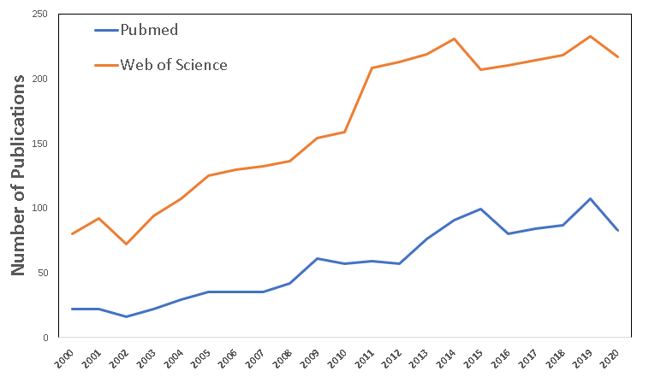

Figure S1 Number of studies investigating the development of inhibitory control across life span (1 Jan. 2000–31 Mar. 2020).
Two databases— PubMed and Web of Science— were searched using the keywords “inhibitory control” and “neural development”.

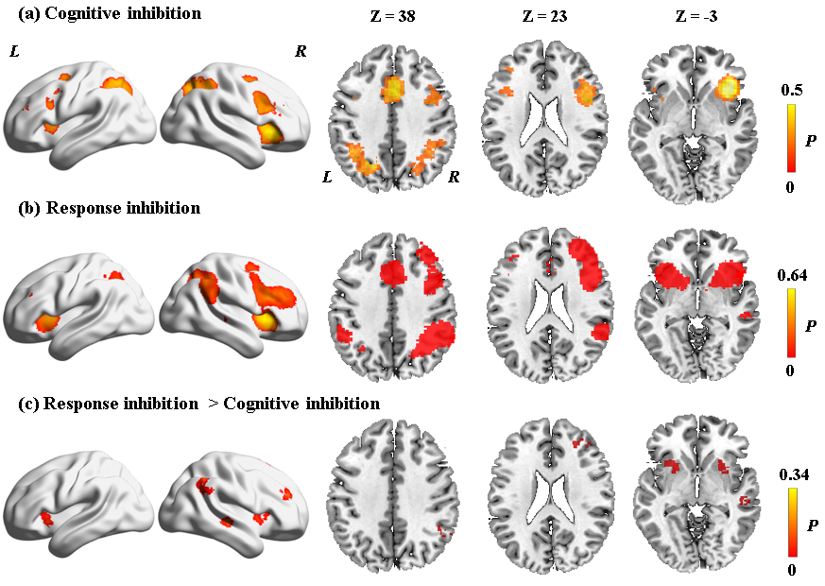

Figure S2 Brain activation differences between cognitive inhibition and 68 contrasts for response inhibition
Brain areas activated in (a) cognitive inhibition and (b) 68 contrasts for response inhibition. (c)Brain activation differences between cognitive inhibition and 68 contrasts for response inhibition. L/R: left/right. P represents the proportion of studies exhibiting the effect at the peak density weighted by sample size.

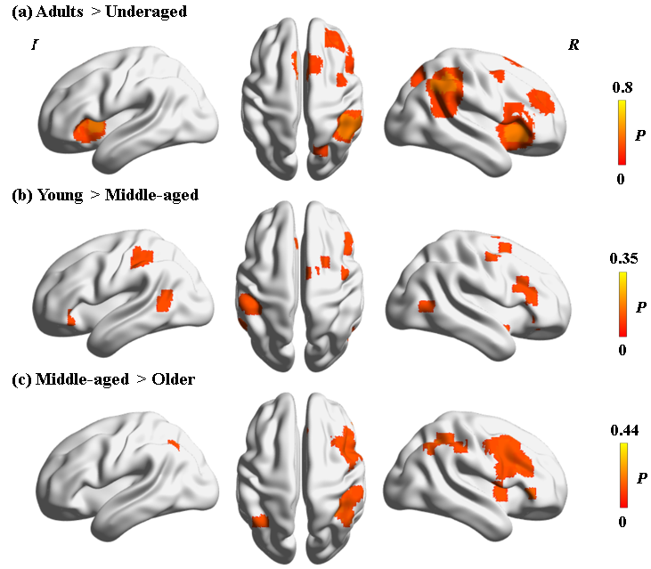

Figure S3 Brain activation differences among four age groups in across all tasks tapping inhibitory control.
(a) brain regions with higher activation in adults than underaged. (b) brain regions with higher activation in young than middle-aged adults. (c) brain regions with higher activation in middle-aged than older adults.

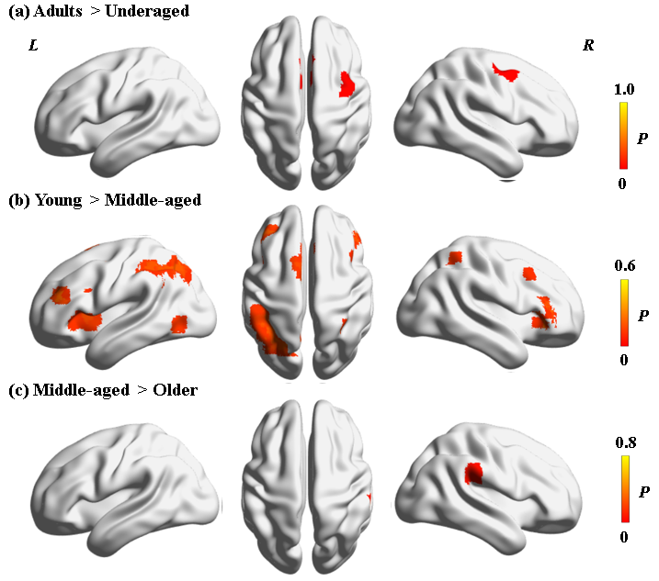

Figure S4 Brain activation differences among four age groups for tasks tapping cognitive inhibition only.
(a) brain regions with higher activation in adults than underaged. (b) brain regions with higher activation in young than middle-aged adults. (c) brain regions with higher activation in middle-aged than older adults.

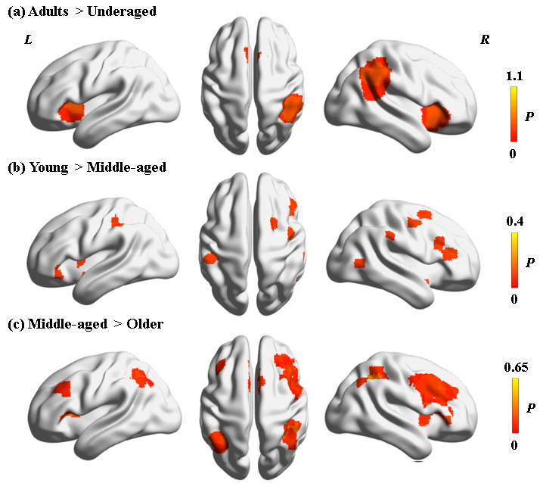

Figure S5 Brain activation differences among four age groups for tasks tapping response inhibition only.
(a) brain regions with higher activation in adults than underaged. (b) brain regions with higher activation in young than middle-aged adults. (c) brain regions with higher activation in middle-aged than older adults.

