SUPPLEMENTARY MATERIAL
Neighbourhood environment and socioeconomic inequalities in cancer admissions: a prospective study using UK Biobank and linked administrative records

Kate E. Mason*, Neil Pearce, Steven Cummins
*Corresponding Author: kate.mason@liverpool.ac.uk

1. Primary analysis stratified by sex
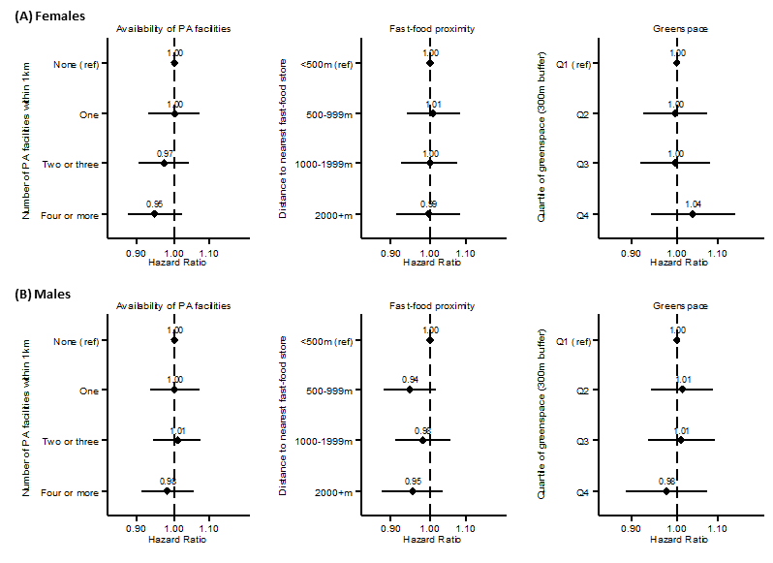
Figure S1: Hazard ratios for associations between neighbourhood characteristics and all cancer-related hospital admissions, stratified by sex

Table S1. Modification of the association between neighbourhood availability of PA facilities and hospital admissions due to cancer, by household income and area deprivation, stratified by sex
 | Annual household income |  |  |  | Area deprivation
 | FEMALES |  | MALES |  | FEMALES |  | MALES
 | < £31,000 | At least £31,000 | < £31,000 | At least £31,000 | More deprived | Less deprived | More deprived | Less deprived
Number of PA facilities | HR (95% CI); P | HR (95% CI); P | HR (95% CI); P | HR (95% CI); P | HR (95% CI); P | HR (95% CI); P | HR (95% CI); P | HR (95% CI); P
None | 1.00 (ref) | 0.89 (0.81, 0.98) P=0.018 | 1.00 (ref) | 1.03 (0.94, 1.13) P=0.482 | 1.00 (ref) | 1.08 (0.96, 1.21) P=0.217 | 1.00 (ref) | 0.97 (0.87, 1.09) P=0.602
One | 0.95 (0.87, 1.04) P=0.236 | 0.96 (0.87, 1.07) P=0.501 | 1.02 (0.93, 1.11) P=0.703 | 1.00 (0.91, 1.11) P=0.932 | 1.09 (0.94, 1.26) P=0.251 | 1.05 (0.93, 1.19) P=0.407 | 1.06 (0.92, 1.22) P=0.421 | 0.95 (0.85, 1.07) P=0.415
2-3 | 0.98 (0.90, 1.07) P=0.668 | 0.85 (0.77, 0.94) P=0.002 | 1.02 (0.93, 1.11) P=0.700 | 1.02 (0.93, 1.13) P=0.652 | 1.13 (0.99, 1.29) P=0.081 | 0.99 (0.87, 1.12) P=0.876 | 1.00 (0.88, 1.13) P=0.951 | 0.99 (0.88, 1.11) P=0.865
4 or more | 0.96 (0.88, 1.05) P=0.401 | 0.82 (0.74, 0.91) P=0.000 | 1.01 (0.93, 1.11) P=0.742 | 0.96 (0.87, 1.06) P=0.405 | 1.00 (0.87, 1.14) P=0.959 | 1.02 (0.90, 1.16) P=0.758 | 1.02 (0.90, 1.16) P=0.745 | 0.94 (0.83, 1.05) P=0.270
Stratum-specific HRs  (4+ facilities vs 0) | 0.94 (0.85, 1.03) P=0.181 | 0.96 (0.85, 1.08) P=0.532 | 1.01 (0.92, 1.11) P=0.864 | 0.94 (0.84, 1.05) P=0.243 | 1.03 (0.89, 1.19) P=0.711 | 0.94 (0.86, 1.02) P=0.152 | 1.02 (0.89, 1.17) P=0.808 | 0.96 (0.88, 1.05) P=0.391
Relative excess risk due to interaction (RERI) | -0.034 (-0.154, 0.087)  P=0.584 |  | -0.089 (-0.216, 0.039)  P=0.172 |  | -0.054 (-0.213, 0.104)  P=0.502 |  | -0.056 (-0.203, 0.091)  P=0.454

Table S2. Modification of the association between fast-food proximity and hospital admissions due to cancer, by household income and area deprivation, stratified by sex
 | Annual household income |  |  |  | Area deprivation
 | FEMALES |  | MALES |  | FEMALES |  | MALES
 | < £31,000 | At least £31,000 | < £31,000 | At least £31,000 | More deprived | Less deprived | More deprived | Less deprived
Fast-food proximity | HR (95% CI); P | HR (95% CI); P | HR (95% CI); P | HR (95% CI); P | HR (95% CI); P | HR (95% CI); P | HR (95% CI); P | HR (95% CI); P
Closer than 500m | 1.00 (ref) | 0.78 (0.69, 0.88) P=0.000 | 1.00 (ref) | 1.00 (0.89, 1.12) P=0.971 | 1.00 (ref) | 0.92 (0.82, 1.03) P=0.138 | 1.00 (ref) | 0.91 (0.82, 1.01) P=0.088
500-999m | 0.94 (0.86, 1.03) P=0.174 | 0.90 (0.81, 1.00) P=0.050 | 0.94 (0.86, 1.03) P=0.160 | 0.95 (0.86, 1.06) P=0.349 | 0.95 (0.85, 1.06) P=0.368 | 0.97 (0.87, 1.07) P=0.527 | 0.85 (0.77, 0.95) P=0.005 | 0.91 (0.83, 1.00) P=0.058
1000-1999m | 0.97 (0.88, 1.06) P=0.461 | 0.84 (0.76, 0.94) P=0.002 | 0.99 (0.90, 1.08) P=0.762 | 0.97 (0.87, 1.07) P=0.547 | 0.95 (0.84, 1.08) P=0.452 | 0.95 (0.86, 1.05) P=0.314 | 1.03 (0.92, 1.15) P=0.649 | 0.89 (0.80, 0.98) P=0.015
At least 2000m | 0.93 (0.84, 1.03) P=0.141 | 0.88 (0.79, 0.99) P=0.028 | 0.96 (0.87, 1.06) P=0.394 | 0.95 (0.85, 1.05) P=0.311 | 0.94 (0.81, 1.09) P=0.420 | 0.95 (0.85, 1.06) P=0.320 | 0.92 (0.79, 1.06) P=0.235 | 0.89 (0.80, 0.98) P=0.024
Stratum-specific HRs  (≥2000m vs <500m) | 0.95 (0.85, 1.06) P=0.364 | 1.08 (0.93, 1.24) P=0.314 | 0.99 (0.89, 1.10) P=0.847 | 0.90 (0.79, 1.02) P=0.101 | 0.93 (0.79, 1.10) P=0.403 | 1.03 (0.93, 1.15) P=0.521 | 0.91 (0.78, 1.07) P=0.264 | 0.97 (0.88, 1.07) P=0.515
Relative excess risk due to interaction (RERI) | 0.174 (0.047, 0.301)  P=0.007 |  | -0.010 (-0.149, 0.129)  P=0.886 |  | 0.087 (-0.075, 0.249)  P=0.294 |  | 0.059 (-0.095, 0.213)  P=0.451

Table S3. Modification of the association between neighbourhood greenspace and hospital admissions due to cancer, by household income and area deprivation, stratified by sex
 | Annual household income |  |  |  | Area deprivation
 | FEMALES |  | MALES |  | FEMALES |  | MALES
 | < £31,000 | At least £31,000 | < £31,000 | At least £31,000 | More deprived | Less deprived | More deprived | Less deprived
Greenspace | HR (95% CI); P | HR (95% CI); P | HR (95% CI); P | HR (95% CI); P | HR (95% CI); P | HR (95% CI); P | HR (95% CI); P | HR (95% CI); P
Q1 (least greenspace) | 1.00 (ref) | 0.79 (0.71, 0.88) P=0.000 | 1.00 (ref) | 0.93 (0.84, 1.04) P=0.216 | 1.00 (ref) | 0.97 (0.87, 1.08) P=0.538 | 1.00 (ref) | 0.90 (0.81, 1.00) P=0.049
Q2 | 0.94 (0.86, 1.03) P=0.202 | 0.88 (0.79, 0.98) P=0.020 | 1.02 (0.93, 1.11) P=0.685 | 0.94 (0.85, 1.05) P=0.258 | 1.02 (0.91, 1.13) P=0.786 | 0.96 (0.87, 1.05) P=0.347 | 0.96 (0.87, 1.07) P=0.480 | 0.94 (0.86, 1.03) P=0.191
Q3 | 0.97 (0.89, 1.07) P=0.591 | 0.84 (0.75, 0.94) P=0.002 | 0.95 (0.86, 1.04) P=0.281 | 1.04 (0.93, 1.15) P=0.495 | 0.98 (0.86, 1.13) P=0.795 | 0.97 (0.88, 1.06) P=0.498 | 1.01 (0.89, 1.15) P=0.845 | 0.92 (0.84, 1.01) P=0.078
Q4 (most greenspace) | 0.95 (0.85, 1.06) P=0.330 | 0.96 (0.85, 1.08) P=0.461 | 0.95 (0.85, 1.06) P=0.348 | 0.96 (0.85, 1.08) P=0.492 | 0.87 (0.72, 1.06) P=0.166 | 1.02 (0.92, 1.14) P=0.681 | 0.85 (0.71, 1.02) P=0.078 | 0.91 (0.82, 1.01) P=0.066
Stratum-specific HRs  (Q4 vs Q1) | 0.98 (0.86, 1.11) P=0.756 | 1.11 (0.95, 1.30) P=0.180 | 0.96 (0.84, 1.09) P=0.503 | 1.00 (0.87, 1.16) P=0.985 | 0.83 (0.66, 1.04) P=0.112 | 1.08 (0.96, 1.21) P=0.205 | 0.85 (0.68, 1.05) P=0.131 | 1.01 (0.90, 1.13) P=0.893
Relative excess risk due to interaction (RERI) | 0.220 (0.097, 0.344)  P<0.001 |  | 0.077 (-0.052, 0.207)  P=0.243 |  | 0.182 (-0.002, 0.367)  P=0.053 |  | 0.158 (-0.013, 0.330)  P=0.071

2. Secondary outcomes
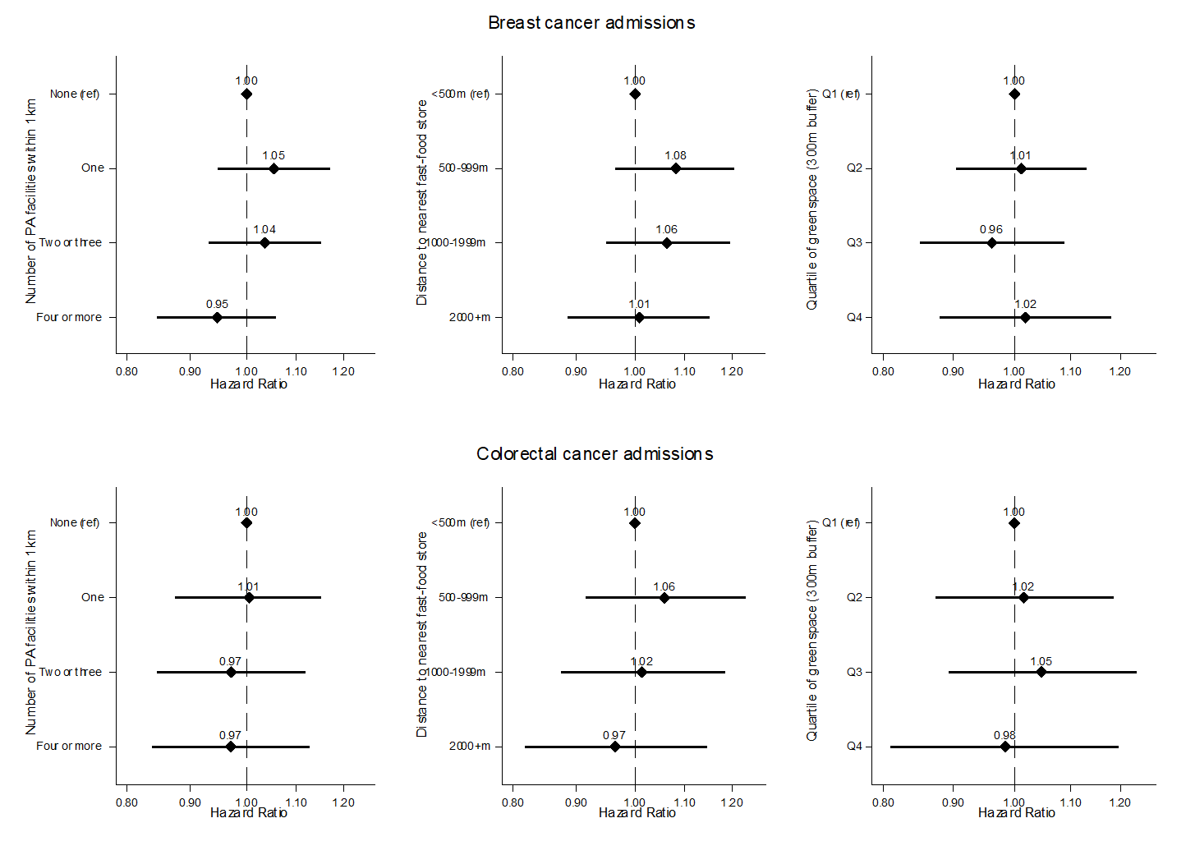
Figure S2: Hazard ratios for associations between neighbourhood characteristics and hospital admissions for breast cancer (females only) and colorectal cancer (all).
Table S5. Modification of the association between neighbourhood environment variables and hospital admissions due to breast cancer, by household income and area deprivation (females only)
Breast cancer-related admissions | Annual household income |  | Area deprivation
Breast cancer-related admissions | Less than £31,000 | At least £31,000 | More deprived | Less deprived
Number of PA facilities | HR (95% CI); P | HR (95% CI); P | HR (95% CI): P | HR (95% CI); P
None | 1.00 (ref) | 1.00 (0.87, 1.15) P=0.977 | 1.00 (ref) | 1.15 (0.95, 1.38) P=0.142
One | 1.03 (0.89, 1.19) P=0.683 | 1.08 (0.92, 1.26) P=0.336 | 1.16 (0.92, 1.46) P=0.196 | 1.18 (0.97, 1.43) P=0.090
2-3 | 1.07 (0.94, 1.23) P=0.313 | 0.99 (0.85, 1.15) P=0.889 | 1.17 (0.95, 1.45) P=0.137 | 1.14 (0.94, 1.38) P=0.183
4 or more | 1.02 (0.88, 1.18) P=0.778 | 0.86 (0.73, 1.00) P=0.056 | 0.95 (0.77, 1.18) P=0.647 | 1.10 (0.91, 1.34) P=0.315
Stratum-specific HRs  (4+ facilities vs 0) | 1.03 (0.88, 1.20) P=0.731 | 0.86 (0.72, 1.01) P=0.071 | 1.03 (0.81, 1.29) P=0.827 | 0.94 (0.82, 1.07) P=0.331
Relative excess risk due to interaction (RERI) | -0.161 (-0.358, 0.036) P=0.109 |  | 0.004 (-0.239, 0.247) P=0.975
 | Less than £31,000 | At least £31,000 | More deprived | Less deprived
Fast-food proximity | HR (95% CI); P | HR (95% CI); P | HR (95% CI): P | HR (95% CI); P
Closer than 500m | 1.00 (ref) | 0.77 (0.64, 0.93) P=0.006 | 1.00 (ref) | 0.98 (0.82, 1.16) P=0.801
500-999m | 0.95 (0.82, 1.09) P=0.447 | 1.01 (0.86, 1.17) P=0.942 | 0.96 (0.81, 1.15) P=0.690 | 1.14 (0.97, 1.33) P=0.113
1000-1999m | 0.98 (0.84, 1.13) P=0.736 | 0.94 (0.80, 1.10) P=0.449 | 1.07 (0.89, 1.29) P=0.468 | 1.07 (0.91, 1.26) P=0.405
At least 2000m | 0.94 (0.80, 1.10) P=0.437 | 0.88 (0.74, 1.04) P=0.126 | 0.91 (0.72, 1.16) P=0.452 | 1.04 (0.88, 1.24) P=0.645
Stratum-specific HRs  (≥2000m vs <500m) | 0.95 (0.80, 1.13) P=0.548 | 1.12 (0.91, 1.36) P=0.291 | 0.86 (0.66, 1.12) P=0.254 | 1.08 (0.92, 1.26) P=0.334
Relative excess risk due to interaction (RERI) | 0.162 (-0.028, 0.353) P=0.094 |  | 0.151 (-0.103, 0.405) P=0.243
 | Less than £31,000 | At least £31,000 | More deprived | Less deprived
Greenspace | HR (95% CI); P | HR (95% CI); P | HR (95% CI): P | HR (95% CI); P
Q1 (least greenspace) | 1.00 (ref) | 0.82 (0.70, 0.97) P=0.019 | 1.00 (ref) | 1.00 (0.86, 1.18) P=0.954
Q2 | 0.93 (0.80, 1.07) P=0.279 | 0.95 (0.81, 1.11) P=0.525 | 1.00 (0.84, 1.18) P=0.982 | 1.06 (0.92, 1.22) P=0.432
Q3 | 0.98 (0.84, 1.14) P=0.784 | 0.79 (0.67, 0.94) P=0.007 | 0.95 (0.76, 1.18) P=0.629 | 1.02 (0.88, 1.17) P=0.813
Q4 (most greenspace) | 0.87 (0.73, 1.04) P=0.134 | 1.00 (0.84, 1.20) P=0.958 | 0.78 (0.57, 1.07) P=0.123 | 1.10 (0.94, 1.30) P=0.240
Stratum-specific HRs  (Q4 vs Q1) | 0.84 (0.68, 1.03) P=0.097 | 1.23 (0.99, 1.53) P=0.060 | 0.69 (0.47, 0.99) P=0.044 | 1.14 (0.96, 1.35) P=0.137
Relative excess risk due to interaction (RERI) | 0.307 (0.126, 0.488) P=0.001 |  | 0.316 (0.041, 0.591) P=0.024

Table S6. Association between neighbourhood characteristics and breast cancer-related hospital admissions, stratified by household income and area deprivation in combination
Breast cancer-related admissions | Combined household income and area deprivation
Breast cancer-related admissions | Less than £31,000 & more deprived | At least £31,000 & more deprived | Less than £31,000 & less deprived | At least £31,000 & less deprived
 | HR (95% CI); P | HR (95% CI); P | HR (95% CI); P | HR (95% CI); P
Number of PA facilities
None | 1.00 (ref) | 1.00 (ref) | 1.00 (ref) | 1.00 (ref)
One | 1.22 (0.92, 1.61) P=0.165 | 1.13 (0.74, 1.73) P=0.581 | 0.97 (0.81, 1.15) P=0.698 | 1.08 (0.91, 1.27) P=0.385
2-3 | 1.29 (0.99, 1.68) P=0.055 | 1.07 (0.71, 1.60) P=0.747 | 0.97 (0.82, 1.16) P=0.757 | 0.98 (0.82, 1.16) P=0.794
4 or more | 1.11 (0.84, 1.48) P=0.450 | 0.85 (0.56, 1.29) P=0.444 | 1.01 (0.84, 1.22) P=0.912 | 0.87 (0.72, 1.05) P=0.158
Fast-food proximity
Closer than 500m | 1.00 (ref) | 1.00 (ref) | 1.00 (ref) | 1.00 (ref)
500-999m | 0.87 (0.70, 1.09) P=0.234 | 1.11 (0.82, 1.51) P=0.511 | 1.00 (0.82, 1.22) P=0.985 | 1.40 (1.12, 1.74) P=0.003
1000-1999m | 1.00 (0.78, 1.27) P=0.977 | 1.05 (0.73, 1.50) P=0.799 | 0.99 (0.81, 1.21) P=0.955 | 1.27 (1.02, 1.59) P=0.031
At least 2000m | 0.85 (0.62, 1.17) P=0.321 | 0.87 (0.53, 1.43) P=0.575 | 0.99 (0.80, 1.22) P=0.902 | 1.22 (0.96, 1.54) P=0.104
Greenspace
Q1 (least greenspace) | 1.00 (ref) | 1.00 (ref) | 1.00 (ref) | 1.00 (ref)
Q2 | 0.93 (0.75, 1.15) P=0.489 | 0.99 (0.72, 1.37) P=0.973 | 0.95 (0.77, 1.17) P=0.636 | 1.13 (0.91, 1.41) P=0.252
Q3 | 0.94 (0.72, 1.23) P=0.639 | 0.64 (0.40, 1.03) P=0.068 | 1.05 (0.85, 1.30) P=0.629 | 0.99 (0.79, 1.23) P=0.898
Q4 (most greenspace) | 0.61 (0.38, 0.97) P=0.036 | 0.80 (0.43, 1.50) P=0.486 | 0.92 (0.72, 1.19) P=0.533 | 1.35 (1.05, 1.73) P=0.017

Table S7. Modification of the association between neighbourhood environment variables and hospital admissions due to colorectal cancer, by household income and area deprivation
Colorectal cancer-related admissions | Annual household income |  | Area deprivation
Colorectal cancer-related admissions | Less than £31,000 | At least £31,000 | More deprived | Less deprived
Number of PA facilities | HR (95% CI); P | HR (95% CI); P | HR (95% CI): P | HR (95% CI); P
None | 1.00 (ref) | 0.85 (0.71, 1.02) P=0.077 | 1.00 (ref) | 1.31 (1.02, 1.70) P=0.035
One | 0.95 (0.80, 1.13) P=0.566 | 0.93 (0.75, 1.14) P=0.477 | 1.34 (0.98, 1.83) P=0.068 | 1.24 (0.95, 1.62) P=0.111
2-3 | 0.92 (0.77, 1.10) P=0.352 | 0.89 (0.73, 1.09) P=0.274 | 1.18 (0.88, 1.59) P=0.268 | 1.23 (0.95, 1.60) P=0.118
4 or more | 0.92 (0.77, 1.10) P=0.381 | 0.89 (0.72, 1.09) P=0.243 | 1.26 (0.95, 1.67) P=0.112 | 1.18 (0.91, 1.55) P=0.216
Stratum-specific HRs  (4+ facilities vs 0) | 0.87 (0.72, 1.06) P=0.169 | 1.13 (0.89, 1.42) P=0.313 | 1.33 (0.97, 1.81) P=0.073 | 0.87 (0.73, 1.04) P=0.123
Relative excess risk due to interaction (RERI) | 0.115 (-0.114, 0.345) P=0.325 |  | -0.389 (-0.811, 0.033) P=0.071
 | Less than £31,000 | At least £31,000 | More deprived | Less deprived
Fast-food proximity | HR (95% CI); P | HR (95% CI); P | HR (95% CI): P | HR (95% CI); P
Closer than 500m | 1.00 (ref) | 0.91 (0.71, 1.16) P=0.431 | 1.00 (ref) | 0.99 (0.78, 1.25) P=0.924
500-999m | 1.12 (0.93, 1.34) P=0.225 | 0.88 (0.71, 1.09) P=0.248 | 0.94 (0.74, 1.19) P=0.582 | 1.12 (0.91, 1.37) P=0.296
1000-1999m | 1.03 (0.85, 1.25) P=0.744 | 0.91 (0.73, 1.13) P=0.405 | 1.12 (0.87, 1.43) P=0.368 | 0.99 (0.80, 1.22) P=0.914
At least 2000m | 0.87 (0.71, 1.07) P=0.195 | 1.00 (0.80, 1.25) P=0.984 | 0.87 (0.63, 1.21) P=0.414 | 0.99 (0.79, 1.24) P=0.917
Stratum-specific HRs  (≥2000m vs <500m) | 0.89 (0.71, 1.11) P=0.290 | 1.06 (0.81, 1.40) P=0.650 | 0.87 (0.61, 1.24) P=0.440 | 1.00 (0.82, 1.23) P=0.967
Relative excess risk due to interaction (RERI) | 0.220 (-0.048, 0.488) P=0.107 |  | 0.125 (-0.208, 0.457) P=0.462
 | Less than £31,000 | At least £31,000 | More deprived | Less deprived
Greenspace | HR (95% CI); P | HR (95% CI); P | HR (95% CI); P | HR (95% CI); P
Q1 (least greenspace) | 1.00 (ref) | 0.87 (0.69, 1.09) P=0.214 | 1.00 (ref) | 0.96 (0.77, 1.20) P=0.745
Q2 | 1.02 (0.85, 1.23) P=0.805 | 0.88 (0.70, 1.10) P=0.248 | 0.98 (0.78, 1.23) P=0.844 | 1.02 (0.85, 1.23) P=0.825
Q3 | 0.99 (0.81, 1.20) P=0.911 | 1.00 (0.81, 1.24) P=0.991 | 1.04 (0.79, 1.38) P=0.760 | 1.05 (0.87, 1.26) P=0.643
Q4 (most greenspace) | 0.96 (0.77, 1.20) P=0.717 | 0.89 (0.70, 1.14) P=0.367 | 0.77 (0.51, 1.15) P=0.203 | 1.01 (0.81, 1.25) P=0.962
Stratum-specific HRs  (Q4 vs Q1) | 1.04 (0.80, 1.34) P=0.779 | 0.92 (0.68, 1.26) P=0.619 | 0.69 (0.43, 1.12) P=0.135 | 1.08 (0.86, 1.37) P=0.494
Relative excess risk due to interaction (RERI) | 0.069 (-0.189, 0.327) P=0.601 |  | 0.272 (-0.083, 0.627) P=0.133

Table S8. Association between neighbourhood characteristics and colorectal cancer-related hospital admissions, stratified by household income and area deprivation in combination
Colorectal cancer-related admissions | Combined household income and area deprivation
Colorectal cancer-related admissions | Less than £31,000 & more deprived | At least £31,000 & more deprived | Less than £31,000 & less deprived | At least £31,000 & less deprived
 | HR (95% CI); P | HR (95% CI); P | HR (95% CI); P | HR (95% CI); P
Number of PA facilities
None | 1.00 (ref) | 1.00 (ref) | 1.00 (ref) | 1.00 (ref)
One | 1.37 (0.95, 1.98) P=0.090 | 1.33 (0.71, 2.48) P=0.373 | 0.83 (0.67, 1.02) P=0.077 | 1.10 (0.87, 1.39) P=0.421
2-3 | 1.28 (0.90, 1.83) P=0.173 | 1.11 (0.61, 2.03) P=0.724 | 0.80 (0.65, 0.99) P=0.043 | 1.12 (0.88, 1.42) P=0.367
4 or more | 1.38 (0.96, 1.99) P=0.084 | 1.21 (0.67, 2.19) P=0.533 | 0.72 (0.56, 0.91) P=0.006 | 1.11 (0.86, 1.44) P=0.414
Fast-food proximity
Closer than 500m | 1.00 (ref) | 1.00 (ref) | 1.00 (ref) | 1.00 (ref)
500-999m | 1.01 (0.76, 1.34) P=0.949 | 0.83 (0.53, 1.31) P=0.427 | 1.22 (0.96, 1.56) P=0.111 | 1.00 (0.74, 1.35) P=0.999
1000-1999m | 1.10 (0.81, 1.50) P=0.549 | 1.25 (0.77, 2.03) P=0.359 | 1.05 (0.81, 1.35) P=0.713 | 0.93 (0.69, 1.26) P=0.638
At least 2000m | 0.84 (0.55, 1.27) P=0.400 | 0.99 (0.51, 1.92) P=0.984 | 0.92 (0.69, 1.21) P=0.539 | 1.09 (0.80, 1.49) P=0.592
Greenspace
Q1 (least greenspace) | 1.00 (ref) | 1.00 (ref) | 1.00 (ref) | 1.00 (ref)
Q2 | 1.03 (0.79, 1.36) P=0.807 | 0.68 (0.41, 1.12) P=0.132 | 1.08 (0.82, 1.40) P=0.593 | 1.07 (0.77, 1.47) P=0.697
Q3 | 1.05 (0.74, 1.48) P=0.797 | 0.85 (0.47, 1.53) P=0.591 | 1.06 (0.81, 1.40) P=0.659 | 1.17 (0.85, 1.61) P=0.330
Q4 (most greenspace) | 0.68 (0.37, 1.23) P=0.203 | 0.67 (0.28, 1.59) P=0.366 | 1.14 (0.83, 1.56) P=0.42 | 1.05 (0.73, 1.50) P=0.802

3. Sensitivity analyses: Restricting follow-up time to January 2012 onwards

Table S9. Hospital admissions by household income and area deprivation (follow-up time restricted to January 2012 onwards)
 | N | Number of cancer admissions (%)
Total | 320812 | 8168 (2.5)
Household income (annual pre-tax)
<£31,000 | 151885 | 4728 (3.1)
£31,000 or more | 168927 | 3440 (2.0)
Area deprivation
More deprived | 94194 | 2419 (2.6)
Less deprived | 226618 | 5749 (2.5)

Table S10. Modification of the associations between neighbourhood environment variables and hospital admissions due to cancer, by household income and area deprivation (follow-up time restricted to January 2012 onwards)
All cancer-related admissions | Annual household income |  | Area deprivation
All cancer-related admissions | Less than £31,000 | At least £31,000 | More deprived | Less deprived
Number of PA facilities | HR (95% CI) | HR (95% CI) | HR (95% CI) | HR (95% CI)
None | 1.00 (ref) | 0.98 (0.90, 1.07) P=0.669 | 1.00 (ref) | 1.01 (0.91, 1.12) P=0.846
One | 0.96 (0.88, 1.04) P=0.317 | 0.94 (0.85, 1.04) P=0.212 | 1.07 (0.94, 1.22) P=0.276 | 0.93 (0.84, 1.04) P=0.220
2-3 | 0.99 (0.91, 1.07) P=0.781 | 0.90 (0.82, 0.98) P=0.022 | 1.00 (0.89, 1.13) P=0.971 | 0.96 (0.86, 1.07) P=0.457
4 or more | 0.96 (0.88, 1.04) P=0.328 | 0.89 (0.81, 0.98) P=0.014 | 0.96 (0.86, 1.08) P=0.538 | 0.95 (0.85, 1.06) P=0.385
Stratum-specific HRs (4+ facilities vs 0) | 0.93 (0.86, 1.02) P=0.131 | 0.94 (0.84, 1.04) P=0.218 | 0.94 (0.83, 1.07) P=0.346 | 0.95 (0.87, 1.03) P=0.181
Relative excess risk due to interaction (RERI) | -0.053 (-0.166, 0.061) P=0.362 |  | -0.022 (-0.157, 0.113) P=0.751
Fast-food proximity | HR (95% CI) | HR (95% CI) | HR (95% CI) | HR (95% CI)
Closer than 500m | 1.00 (ref) | 0.86 (0.77, 0.96) P=0.008 | 1.00 (ref) | 0.93 (0.84, 1.03) P=0.188
500-999m | 0.92 (0.85, 1.00) P=0.053 | 0.91 (0.83, 1.01) P=0.065 | 0.91 (0.82, 1.01) P=0.077 | 0.94 (0.86, 1.03) P=0.170
1000-1999m | 0.99 (0.91, 1.07) P=0.760 | 0.91 (0.83, 1.01) P=0.065 | 1.05 (0.95, 1.17) P=0.330 | 0.93 (0.85, 1.02) P=0.133
At least 2000m | 0.94 (0.85, 1.03) P=0.163 | 0.93 (0.84, 1.02) P=0.132 | 0.91 (0.79, 1.05) P=0.184 | 0.94 (0.85, 1.04) P=0.236
Stratum-specific HRs (≥2000m vs <500m) | 0.97 (0.88, 1.07) P=0.576 | 1.01 (0.89. 1.14) P=0.860 | 0.93 (0.80, 1.08) P=0.315 | 1.00 (0.91, 1.10) P=0.946
Relative excess risk due to interaction (RERI) | 0.125 (0.004, 0.245) P=0.042 |  | 0.096 (-0.049, 0.242) P=0.196
Greenspace | HR (95% CI) | HR (95% CI) | HR (95% CI) | HR (95% CI)
Q1 (least greenspace) | 1.00 (ref) | 0.87 (0.79, 0.96) P=0.006 | 1.00 (ref) | 0.94 (0.85, 1.04) P=0.218
Q2 | 0.98 (0.91, 1.07) P=0.668 | 0.87 (0.79, 0.97) P=0.008 | 0.98 (0.89, 1.09) P=0.740 | 0.93 (0.86, 1.01) P=0.106
Q3 | 0.93 (0.85, 1.02) P=0.109 | 0.94 (0.85, 1.04) P=0.244 | 0.96 (0.85, 1.09) P=0.567 | 0.93 (0.86, 1.01) P=0.105
Q4 (most greenspace) | 0.93 (0.84, 1.04) P=0.199 | 0.94 (0.85, 1.05) P=0.300 | 0.86 (0.72, 1.02) P=0.081 | 0.95 (0.86, 1.05) P=0.306
Stratum-specific HRs (Q4 vs Q1) | 0.97 (0.86, 1.09) P=0.574 | 1.02 (0.89, 1.17) P=0.768 | 0.87 (0.70, 1.06) P=0.166 | 1.01 (0.91, 1.23) P=0.789
Relative excess risk due to interaction (RERI) | 0.139 (0.023, 0.255) P=0.019 |  | 0.150 (-0.014, 0.314) P=0.072

Table S11. Association between neighbourhood characteristics and cancer-related hospital admissions, stratified by household income and area deprivation in combination (follow-up time restricted to January 2012 onwards)
All cancer-related admissions | Combined household income and area deprivation
All cancer-related admissions | Less than £31,000 & more deprived | At least £31,000 & more deprived | Less than £31,000 & less deprived | At least £31,000 & less deprived
 | HR (95% CI) | HR (95% CI) | HR (95% CI) | HR (95% CI)
Number of PA facilities
None | 1.00 (ref) | 1.00 (ref) | 1.00 (ref) | 1.00 (ref)
One | 1.01 (0.87, 1.18) P=0.876 | 1.18 (0.91, 1.53) P=0.203 | 0.92 (0.83, 1.02) P=0.106 | 0.94 (0.84, 1.04) P=0.232
2-3 | 1.00 (0.86, 1.15) P=0.964 | 0.95 (0.74, 1.22) P=0.681 | 0.96 (0.87, 1.07) P=0.488 | 0.94 (0.84, 1.05) P=0.263
4 or more | 0.94 (0.80, 1.09) P=0.390 | 0.95 (0.75, 1.22) P=0.702 | 0.93 (0.83, 1.04) P=0.216 | 0.95 (0.85, 1.07) P=0.425
 | HR (95% CI) | HR (95% CI) | HR (95% CI) | HR (95% CI)
Fast-food proximity
Closer than 500m | 1.00 (ref) | 1.00 (ref) | 1.00 (ref) | 1.00 (ref)
500-999m | 0.93 (0.82, 1.05) P=0.221 | 0.90 (0.74, 1.08) P=0.267 | 0.94 (0.84, 1.06) P=0.308 | 1.10 (0.96, 1.27) P=0.153
1000-1999m | 1.05 (0.92, 1.20) P=0.504 | 1.09 (0.88, 1.34) P=0.432 | 1.00 (0.89, 1.12) P=0.995 | 1.01 (0.88, 1.16) P=0.862
At least 2000m | 0.89 (0.75, 1.06) P=0.206 | 1.03 (0.78, 1.36) P=0.840 | 1.00 (0.88, 1.13) P=0.968 | 1.03 (0.90, 1.20) P=0.643
 | HR (95% CI) | HR (95% CI) | HR (95% CI) | HR (95% CI)
Greenspace
Q1 (least greenspace) | 1.00 (ref) | 1.00 (ref) | 1.00 (ref) | 1.00 (ref)
Q2 | 1.00 (0.89, 1.13) P=0.965 | 0.94 (0.77, 1.15) P=0.528 | 1.03 (0.91, 1.16) P=0.675 | 0.97 (0.84, 1.11) P=0.630
Q3 | 0.92 (0.79, 1.08) P=0.310 | 1.08 (0.84, 1.39) P=0.556 | 1.00 (0.88, 1.14) P=0.987 | 1.02 (0.88, 1.17) P=0.805
Q4 (most greenspace) | 0.76 (0.59, 0.97) P=0.031 | 1.17 (0.82, 1.67) P=0.388 | 1.04 (0.90, 1.21) P=0.593 | 1.02 (0.86, 1.19) P=0.850

4. Sensitivity analyses: Models additionally adjusted for baseline BMI, hypertension and medications for hypertension and high cholesterol
Table S12. Modification of the association between neighbourhood variables and admissions, by household income and area deprivation (with additional adjustment)
All cancer-related admissions | Annual household income |  | Area deprivation
All cancer-related admissions | Less than £31,000 | At least £31,000 | More deprived | Less deprived
 | HR (95% CI) | HR (95% CI) | HR (95% CI) | HR (95% CI)
Number of PA facilities
None | 1.00 (ref) | 0.96 (0.90, 1.02) P=0.224 | 1.00 (ref) | 1.03 (0.95, 1.11) P=0.530
One | 0.98 (0.92, 1.05) P=0.594 | 0.99 (0.92, 1.06) P=0.728 | 1.08 (0.97, 1.20) P=0.145 | 1.01 (0.93, 1.10) P=0.854
2-3 | 1.00 (0.94, 1.06) P=0.939 | 0.94 (0.88, 1.01) P=0.094 | 1.06 (0.96, 1.16) P=0.238 | 1.00 (0.92, 1.09) P=0.979
4 or more | 0.99 (0.93, 1.05) P=0.695 | 0.90 (0.83, 0.97) P=0.004 | 1.01 (0.92, 1.11) P=0.775 | 0.98 (0.90, 1.07) P=0.722
Stratum-specific HRs (4+ facilities vs 0) | 0.97 (0.91, 1.04) P=0.397 | 0.96 (0.88, 1.04) P=0.277 | 1.02 (0.93, 1.13) P=0.643 | 0.96 (0.90, 1.02) P=0.152
Relative excess risk due to interaction (RERI) | -0.051 (-0.139, 0.038) P=0.261 |  | -0.056 (-0.165, 0.053) P=0.316
 | HR (95% CI) | HR (95% CI) | HR (95% CI) | HR (95% CI)
Fast-food proximity
Closer than 500m | 1.00 (ref) | 0.89 (0.82, 0.97) P=0.007 | 1.00 (ref) | 0.92 (0.85, 0.99) P=0.028
500-999m | 0.93 (0.88, 1.00) P=0.035 | 0.93 (0.86, 1.00) P=0.046 | 0.90 (0.83, 0.97) P=0.006 | 0.94 (0.87, 1.01) P=0.076
1000-1999m | 0.97 (0.91, 1.04) P=0.392 | 0.91 (0.84, 0.98) P=0.010 | 0.98 (0.90, 1.07) P=0.685 | 0.92 (0.85, 0.99) P=0.019
At least 2000m | 0.94 (0.87, 1.01) P=0.076 | 0.91 (0.84, 0.98) P=0.019 | 0.92 (0.83, 1.03) P=0.137 | 0.91 (0.85, 0.99) P=0.020
Stratum-specific HRs  (≥2000m vs <500m) | 0.97 (0.90, 1.04) P=0.369 | 0.97 (0.88, 1.07) P=0.547 | 0.92 (0.82, 1.03) P=0.150 | 1.00 (0.93, 1.07) P=0.927
Relative excess risk due to interaction (RERI) | 0.082 (-0.013, 0.176) P=0.090 |  | 0.073 (-0.039, 0.185) P=0.200
 | HR (95% CI) | HR (95% CI) | HR (95% CI) | HR (95% CI)
Greenspace
Q1 (least greenspace) | 1.00 (ref) | 0.86 (0.80, 0.93) P=0.000 | 1.00 (ref) | 0.94 (0.87, 1.02) P=0.118
Q2 | 0.98 (0.92, 1.04) P=0.464 | 0.91 (0.84, 0.98) P=0.011 | 0.99 (0.92, 1.07) P=0.783 | 0.95 (0.89, 1.02) P=0.135
Q3 | 0.96 (0.89, 1.02) P=0.192 | 0.94 (0.87, 1.02) P=0.122 | 1.00 (0.91, 1.10) P=0.985 | 0.95 (0.89, 1.01) P=0.122
Q4 (most greenspace) | 0.94 (0.87, 1.02) P=0.132 | 0.96 (0.88, 1.04) P=0.285 | 0.85 (0.75, 0.97) P=0.019 | 0.97 (0.90, 1.04) P=0.390
Stratum-specific HRs (Q4 vs Q1) | 0.96 (0.88, 1.05) P=0.392 | 1.05 (0.95, 1.17) P=0.339 | 0.83 (0.71, 0.97) P=0.021 | 1.04 (0.95, 1.12) P=0.393
Relative excess risk due to interaction (RERI) | 0.151 (0.062, 0.241) P=0.001 |  | 0.172 (0.045, 0.298) P=0.008
Table S13. Association between neighbourhood characteristics and cancer-related hospital admissions, stratified by household income and area deprivation in combination (adjusted for additional risk factors)
All cancer-related admissions | Combined household income and area deprivation
All cancer-related admissions | Less than £31,000 & more deprived | At least £31,000 & more deprived | Less than £31,000 & less deprived | At least £31,000 & less deprived
 | HR (95% CI) | HR (95% CI) | HR (95% CI) | HR (95% CI)
Number of PA facilities
None | 1.00 (ref) | 1.00 (ref) | 1.00 (ref) | 1.00 (ref)
One | 1.06 (0.94, 1.19) P=0.377 | 1.13 (0.92, 1.39) P=0.246 | 0.95 (0.88, 1.02) P=0.182 | 1.02 (0.94, 1.11) P=0.589
2-3 | 1.07 (0.96, 1.20) P=0.228 | 1.04 (0.85, 1.26) P=0.712 | 0.96 (0.88, 1.03) P=0.252 | 0.99 (0.91, 1.07) P=0.786
4 or more | 1.05 (0.93, 1.18) P=0.403 | 0.98 (0.80, 1.19) P=0.804 | 0.94 (0.86, 1.02) P=0.156 | 0.97 (0.88, 1.06) P=0.449
 | HR (95% CI) | HR (95% CI) | HR (95% CI) | HR (95% CI)
Fast-food proximity
Closer than 500m | 1.00 (ref) | 1.00 (ref) | 1.00 (ref) | 1.00 (ref)
500-999m | 0.88 (0.80, 0.97) P=0.009 | 0.93 (0.80, 1.08) P=0.352 | 1.00 (0.91, 1.09) P=0.996 | 1.06 (0.96, 1.18) P=0.249
1000-1999m | 0.96 (0.86, 1.06) P=0.418 | 1.01 (0.86, 1.20) P=0.880 | 1.03 (0.94, 1.12) P=0.558 | 0.98 (0.89, 1.09) P=0.742
At least 2000m | 0.87 (0.76, 1.00) P=0.046 | 1.06 (0.85, 1.32) P=0.597 | 1.02 (0.93, 1.12) P=0.681 | 0.98 (0.88, 1.09) P=0.702
 | HR (95% CI) | HR (95% CI) | HR (95% CI) | HR (95% CI)
Greenspace
Q1 (least greenspace) | 1.00 (ref) | 1.00 (ref) | 1.00 (ref) | 1.00 (ref)
Q2 | 0.99 (0.90, 1.08) P=0.778 | 0.96 (0.82, 1.13) P=0.641 | 1.01 (0.92, 1.11) P=0.859 | 1.03 (0.92, 1.15) P=0.617
Q3 | 0.96 (0.85, 1.08) P=0.484 | 1.04 (0.85, 1.27) P=0.729 | 1.00 (0.91, 1.10) P=0.983 | 1.05 (0.94, 1.18) P=0.365
Q4 (most greenspace) | 0.75 (0.62, 0.91) P=0.003 | 1.06 (0.79, 1.41) P=0.702 | 1.02 (0.91, 1.15) P=0.687 | 1.08 (0.95, 1.22) P=0.234

5. Examination of proportional hazards assumption (primary models)

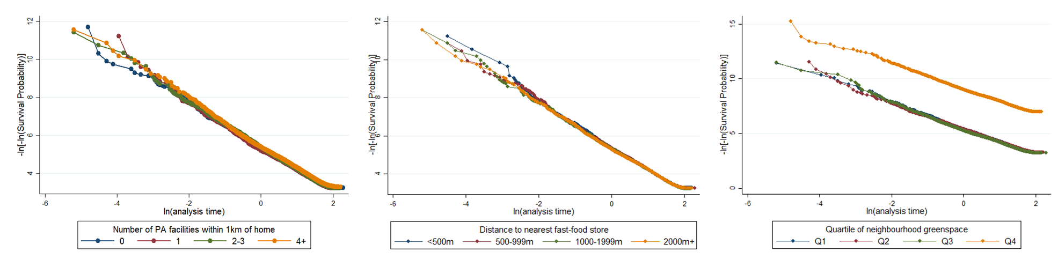
Figure S3. Log-log plots (adjusted for all covariates) for graphical examination of proportional hazards assumption

