Supplementary Information

Title: Dodging COVID-19 Infection: Low Expression and localization of ACE2 and TMPRSS2 in Human Umbilical Cord-derived Mesenchymal Stem Cells
Running title: ACE2 and TMRPSS2 expression in hUC-MSCs
Authors:
Jonathan J Hernandez^{1,2}, Doyle E Beaty¹, Logan L Fruhwirth¹, Ana P Lopes Chaves¹, Neil H Riordan^{1,2}
- Aidan Research and Consulting LLC, 11496 Luna Rd, suite 1100, Farmers Branch, Texas 75234
- Medistem Inc Panama, Ciudad del Saber, Edif. 221 / Clayton Panama, Rep. of Panama.
Corresponding author: Jonathan J Hernandez, PhD. jhernandez@aidanresearch.com

Keywords: ACE2 expression, TMPRSS2 expression, COVID-19, SARS-Cov2, mesenchymal stem cells, hUC-MSC

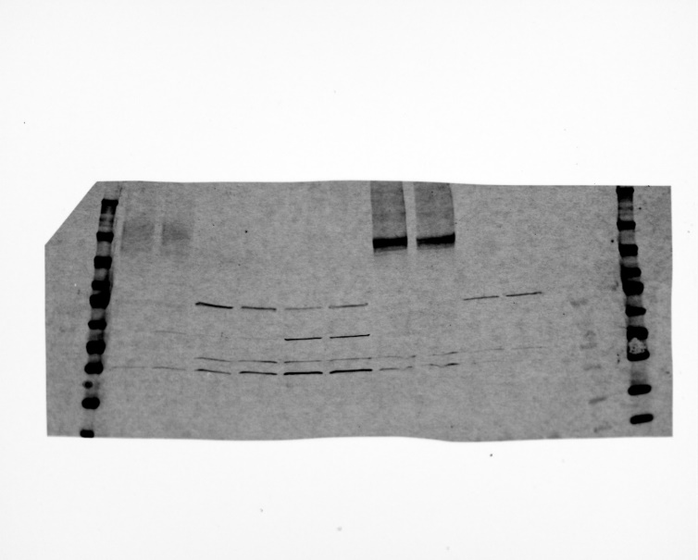
kDa
250

130

95

70
55

43

34

26

15

10

ACE2 ~120kDa
TMPRSSA ~50kDa
Filtered for Alexa Fluor 680
Filtered for Alexa Fluor 488
a)
HBEpC
AT1
ACE2 Trans
hUC-MSCs
hUC-MSCs
Lung tissue failed
HBEpC
AT1
ACE2 Trans
hUC-MSCs
hUC-MSCs
Lung tissue failed

GAPDH ~37 kDa

b)
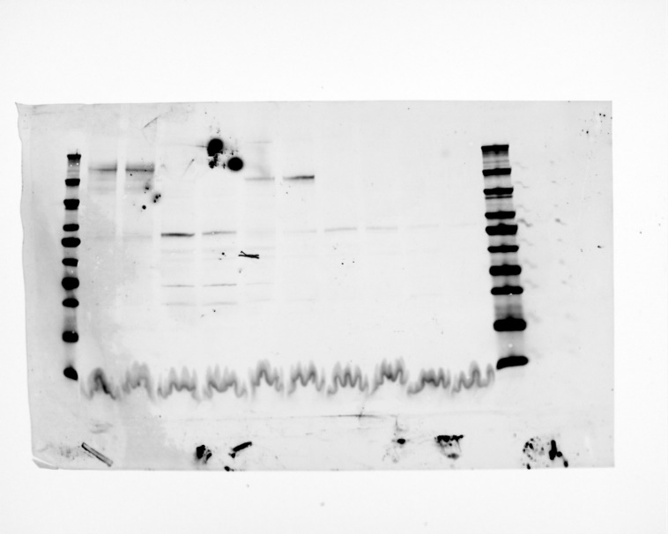
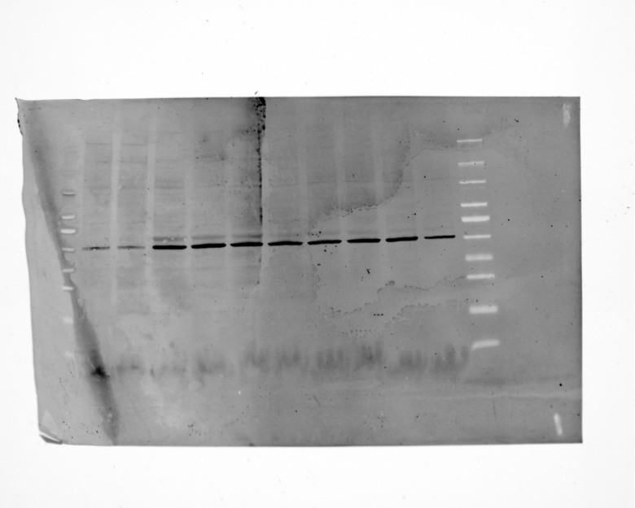
Lung tissue
Failed section of the membrane
Lung tissue
Failed section of the membrane
kDa
250

130

95

70
55

43

34

26

15

10

ACE2 ~120kDa
TMPRSSA ~50kDa
GAPDH ~37 kDa

Supplemental Figure 1. a) Full length blots of representative samples HBEpc, AT1, ACE2 Trans hUC-MSCs. b) Full length blots of representative sample Lung tissue. iBright™ Prestained Protein Ladder (LC5615) was used as the molecular weight marker.

