Supporting information

Table S1 Associations between LY96 expression and several immune gene markers
Description | Gene markers | Cor | P
T cell | CD3D | 0.388 | ***
T cell | CD3E | 0.365 | ***
T cell | CD3G | 0.389 | ***
T cell | CD2 | 0.484 | ***
CD8+ T cell | CD8A | 0.428 | ***
CD8+ T cell | CD8B | 0.394 | ***
B cell | CD19 | 0.416 | ***
B cell | CD79A | 0.471 | ***
Monocyte | CD86 | 0.644 | ***
Monocyte | CD115 (CSF1R) | 0.537 | ***
TAM | CCL2 | 0.056 | 0.198
TAM | CD68 | 0.463 | ***
TAM | IL10 | 0.605 | ***
M1 Macrophage | IRF5 | 0.159 | ***
M1 Macrophage | INOS (NOS2) | -0.063 | 0.149
M1 Macrophage | COX2 (PTGS2) | 0.219 | ***
M2 Macrophage | CD163 | 0.576 | ***
M2 Macrophage | VSIG4 | 0.625 | ***
M2 Macrophage | MS4A4A | 0.651 | ***
Neutrophils | CD11b (ITGAM) | 0.500 | ***
Neutrophils | CCR7 | 0.440 | ***
Dendritic cell | HLA-DPB1 | 0.474 | ***
Dendritic cell | HLA-DQB1 | 0.255 | ***
Dendritic cell | HLA-DRA | 0.508 | ***
Dendritic cell | HLA-DPA1 | 0.481 | ***
Dendritic cell | BDCA-1 (CD1C) | 0.240 | ***
Dendritic cell | BDCA-4 (NRP1) | 0.054 | 0.216
Dendritic cell | CD11c (ITGAX) | 0.425 | ***
Th1 | T-bet (TBX21) | 0.159 | ***
Th1 | STAT4 | 0.320 | ***
Th1 | STAT1 | 0.441 | ***
Th1 | IFNG | 0.401 | ***
Th1 | TNF | 0.221 | ***
Treg | FOXP3 | 0.430 | ***
Treg | CCR8 | 0.428 | ***
Treg | TGFB1 (TGFβ) | 0.211 | ***
T cell exhaustion | PD-1 (PDCD1) | 0.376 | ***
T cell exhaustion | CTLA4 | 0.389 | ***
T cell exhaustion | LAG3 | 0.422 | ***
T cell exhaustion | TIM-3 (HAVCR2) | 0.210 | ***
T cell exhaustion | GZMB | 0.230 | ***
***: P<.01，**: P<.05

Table S2 Details on drugs targeting LY96
Name | Drug Type | Targets
Morphine | Small Molecule | LY96, OPRD1, OPRK1, OPRM1
Methadone | Small Molecule | CHRNA10, GRIN3A, HTR3A, LY96, OPRD1, OPRM1, ORM2
3-Hydroxy-Myristic Acid | Small Molecule | LY96, TLR4
Lauric Acid | Small Molecule | ADH5, C8G, GLTP, GM2A, HNF4A, LTF, LY96, PLA2G2A, PLA2G2D, PPARA, TLR4, VLDLR
Myristic acid | Small Molecule | ABL1, ARF1, ARF6, ECI2, FKBP1A, GM2A, GUCA1A, HNF4A, INS, LY96, NCOA1, PKIA, PPARA, PPP3CA, PPP3R1, PRKACA, PVR, RCVRN, TLR4, TRAPPC3

Figure S1 The overall survival of genes related to LY96
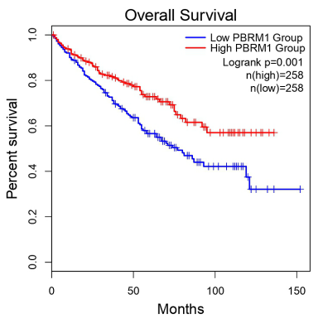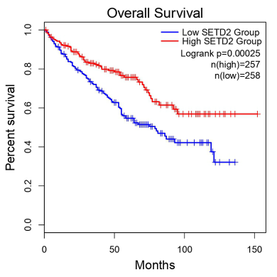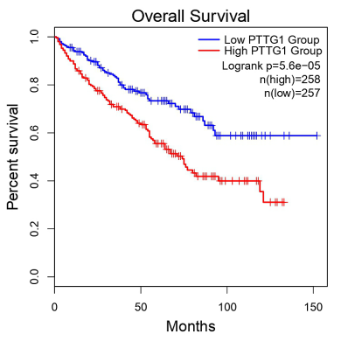
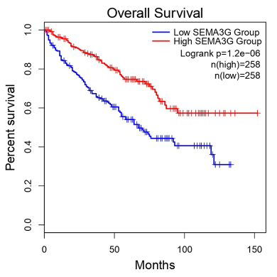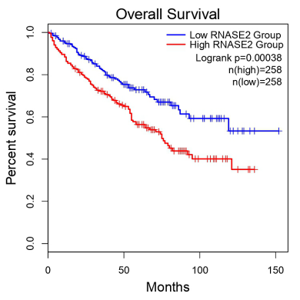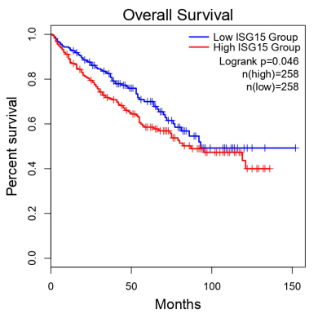
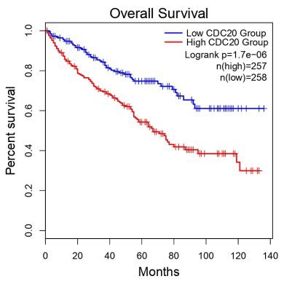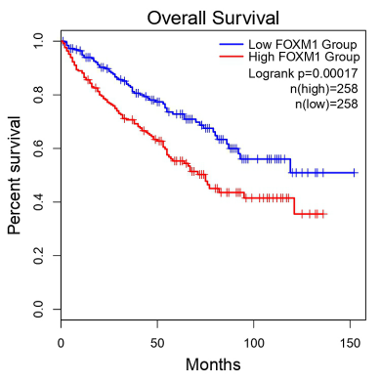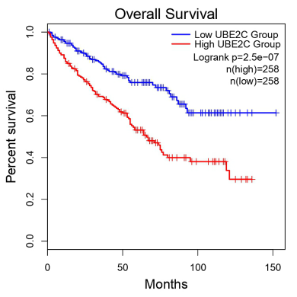
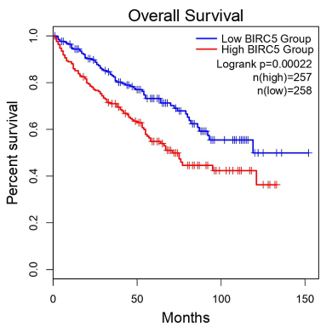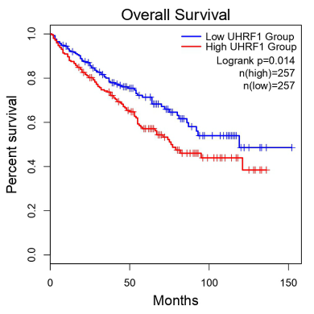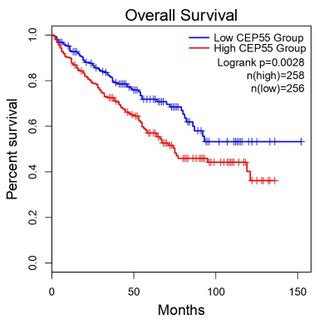

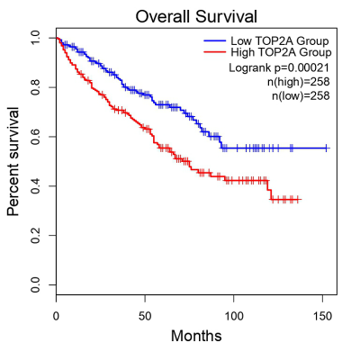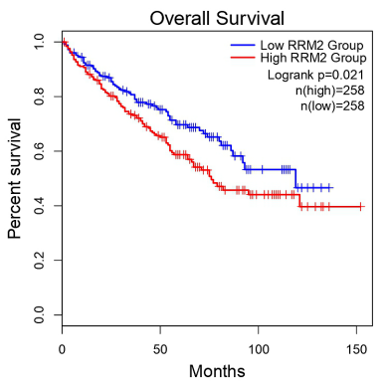

Figure S2 The relationships between LY96 and other related genes

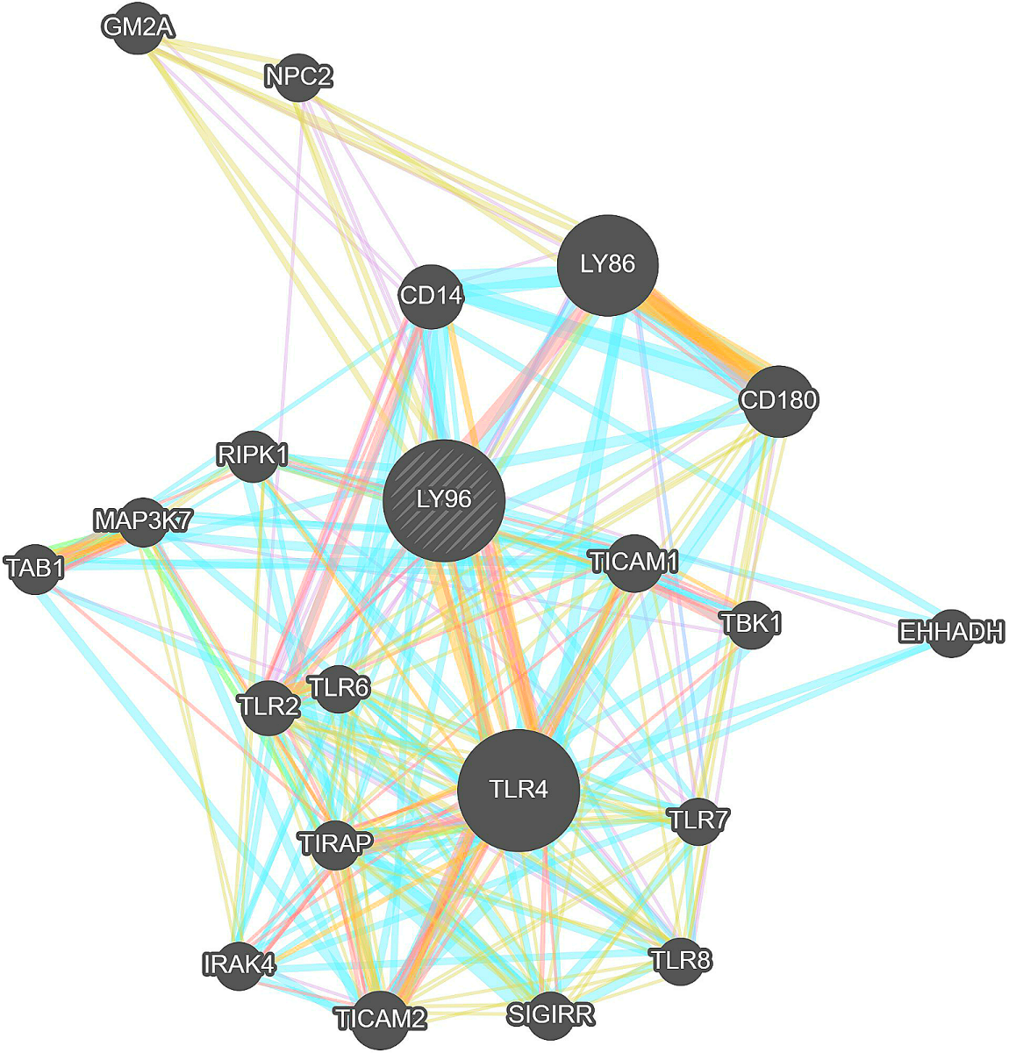

Supplementary Figure 3
a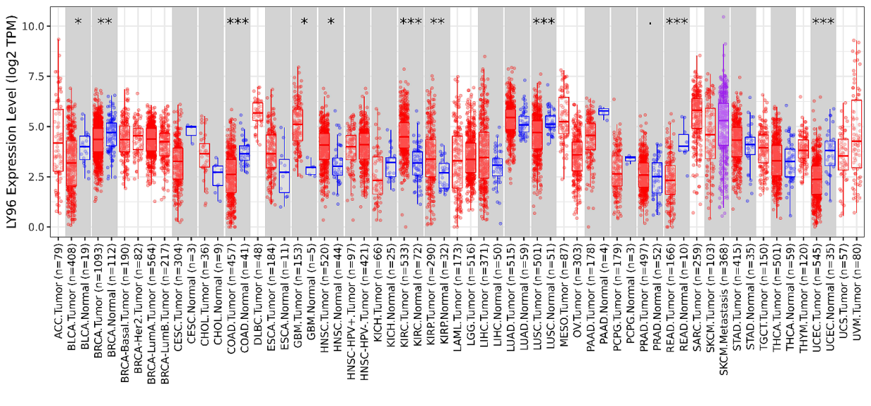
b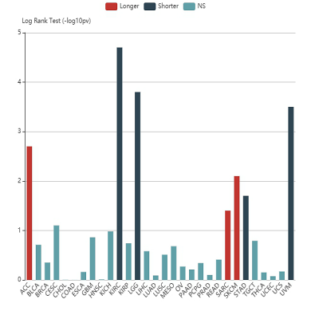c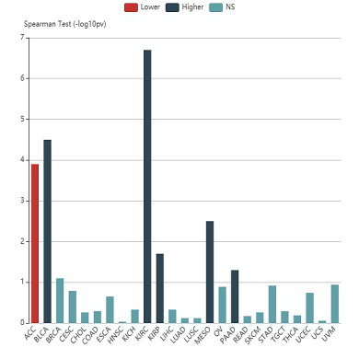d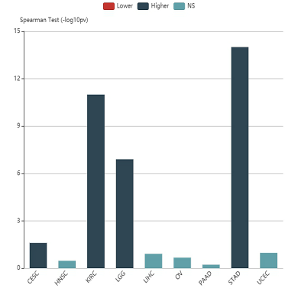
e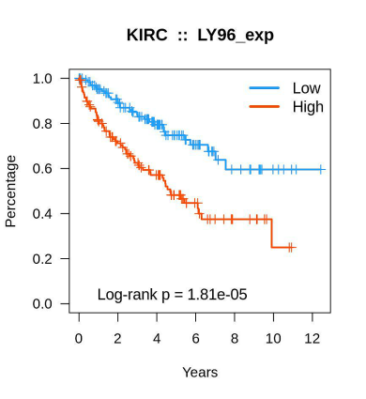f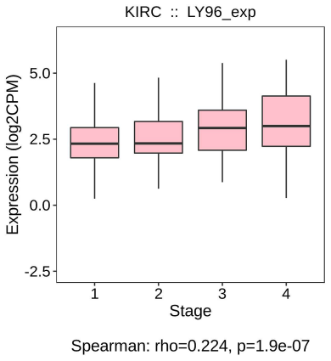g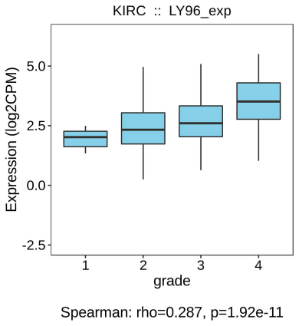

a: LY96 expression in diverse cancer types
b: Associations between LY96 expression and overall survival across cancers
c: Associations between LY96 expression and stage across cancers
d: Associations between LY96 expression and grade across cancers
e-g: Associations between LY96 expression and OS, stage, and grade in KIRC

