SI & Methods for - Extreme Non-Wetting of Condensation-Induced Droplets on Smooth Monolayer Suspended Graphene
Haidong Wang^{1†}, Daniel Orejon^{2,3†}, Dongxing Song¹, Xing Zhang¹**, Glen McHale², Hiroshi Takamatsu⁴, Yasuyuki Takata^{3,4}, Khellil Sefiane²*

¹ Department of Engineering Mechanics, Tsinghua University, Beijing, 100084, China.
² School of Engineering, Institute for Materials and Processes, University of Edinburgh, Edinburgh, EH9 3FB, Scotland, UK.
³ International Institute for Carbon-Neutral Energy Research (WPI – I2CNER), Kyushu University, Fukuoka, 819-0395, Japan.
⁴ Department of Mechanical Engineering, Kyushu University, Fukuoka, 819-0395, Japan.

†This author contributed equally to the work.
*Corresponding author. Email: ksefiane@ed.ac.uk
**Corresponding author. Email: x-zhang@tsinghua.edu.cn

SI-1. Substrate Fabrication
The fabrication procedure was as follows: monolayer graphene was grown on copper foil by using standard chemical vapor deposition (CVD) method^{S1}. Then, the graphene was transferred onto a SiO₂/Si target substrate by using common poly(methyl-methacrylate) (PMMA) transfer method. To create well defined holes and trenches, prior to the graphene transfer procedure, the SiO₂/Si target substrate was subjected to electron beam (EB) lithography and reactive ion etching (RIE). After the transfer procedure and in order remove the PMMA layer, the SiO₂/Si target sample coated with graphene and PMMA was dipped into acetone at ~50 °C for more than 4 hours. The warmth of the solvent as well as the sufficient immersion time induced the thorough PMMA removal and minimizes contamination and residual PMMA left on the graphene^{S1, S2}. To avoid the rupture of the membrane, the final step consisted on drying the graphene sample by using an HITACHI HCP-2 supercritical point dryer. The high quality of the suspended graphene sample was confirmed by Scanning Electron Microscopy (SEM), Atomic Force Microscopy (AFM), Tunneling Electron Microscopy (TEM) and Raman spectroscopy (see Fig. 2 in the main text). In addition to monolayer graphene (1L), double-layer graphene (2L) and four-layer (4L) samples were prepared by stacking the monolayer graphene several times following the same CVD growth and the same PMMA transfer procedures reported above^{S2}. On the other hand, multi-layer graphite (ML) sample was prepared by mechanical exfoliation method and then transferred onto the substrate.

SI-2. Sample Characterization of 1L Suspended Graphene
Within the Supplementary Information, we follow the same nomenclature as established within the main text. We do henceforth refer to suspended graphene with the superscript ^{sus} and to supported graphene with subscript _{sup}. From the surface characterization by optical microscopy and SEM shown in Fig. 2a (main text), the successful fabrication of both 1L^{sus} and 1L_{sup} is demonstrated. 1L graphene was completely suspended (1L^{sus}) over holes with up to 5 μm in diameter and over trenches of 5 μm in width and tens of micrometers in length. From Fig. 2a (main text), we note the optical transparency of graphene to SEM as previously reported^{S3}. When looking into AFM topography characterization, Fig. 2b (main text) shows that the roughness of 1L^{sus} is slightly smaller than that of 1L_{sup} on the smooth substrate. The latter indicates that the suspended graphene membrane is quite smooth and most of the polymer residues have been removed from the surface. In addition, the lower-right inset of Fig. 2c (main text) presents a high-resolution TEM image of 1L^{sus} showing the clean lattice with perfect honeycomb structure, which is characteristic of high quality graphene. From Fig. 2c (main text), some nanoscale islands of residues can be perceived on the graphene, which may serve as nuclei for the condensation experiment. In addition, ED pattern (top-right inset in Fig. 2c (main text)) exhibits the perfect 6-fold symmetry of the carbon atoms, which is also characteristic of high quality graphene. Finally, Fig. 2d (main text) shows Raman spectra of 1L, 2L, 4L and ML. For 1L, the height of the 2D peak (~2700 cm⁻¹) is almost twice as large as that of the G peak (~1580 cm⁻¹) evidencing the monolayer structure^{S4}. The height ratio between 2D and G peaks decreases as the number of graphene layers increase. For ML sample, the 2D peak is much wider and shorter than the G peak, which is consistent with literature. It is worth noting that the D peak (~1300 cm⁻¹) is almost absent for all four samples, which highlights the negligible defects of the carbon lattice. Next, we include additional optical microscopy, SEM and AFM topography characterization of 1L, 2L, 4L and ML graphene fabricated substrates.

SI-2.1 Sample Characterization by Optical Microscopy and SEM
Fig. S1 to Fig. S4 present surface characterization by optical microscopy and SEM experimental observations of 1L, 2L, 4L and ML samples, respectively.
Figure S1 – (a) Optical microscopy and (b) SEM images of 1L graphene sample. Some SEM images were taken at different tilting angles. Scale bars are included.

Figure S2 – (a) Optical microscopy and (b) SEM images of 2L graphene sample. Scale bars are included.

Figure S3 – (a) Optical microscopy and (b) SEM images of 4L graphene sample. Scale bars are included.

Figure S4 – (a) Optical microscope and (b) SEM images of ML graphite sample. Scale bars are included

From Fig. S1 and as reported within the main text, the successful fabrication of both 1L^{sus} and 1L_{sup} is demonstrated. We note the optical transparency of graphene to both optical microscopy and to SEM^{S3}. In addition, when comparing optical microscopy and SEM snapshots of 1L, 2L, 4L and ML, the higher transparency of 1L^{sus} when compared to 2L^{sus}, 4L^{sus} and ML^{sus} is evident. In the case of 1L^{sus}, due to the thin nature of graphene layer, the membrane may rupture during the transfer and the drying process. Hence, some empty holes can be appreciated in the image (Fig. S1 to S4). We must note here the almost absence of wrinkles and boundaries on 1L and 2L graphene samples, while these features are commonly seen on 4L graphene and ML graphite samples. From Fig. S1, 1L_{sup} closely fits the curvature of the substrate, whereas 1L^{sus} is smooth and flat. In contrast, 2L^{sus}, 4L^{sus} and ML^{sus} have noticeable wrinkles and curvature giving rise to the presence of nanometer hills and valleys. To characterize and quantify the nanoscale features, we next show AFM topography of surface roughness on 1L, 2L, 4L and ML graphene samples.

SI-2.2 AFM Topography Characterization of Surface Roughness of Graphene
Fig. S5 shows AFM tapping-mode amplitude image of 1L^{sus} graphene, height image of 1L_{sup} graphene on smooth SiO₂/Si substrate, height images of bare rough SiO₂/Si substrate and 1L_{sup} graphene on rough SiO₂/Si substrate.
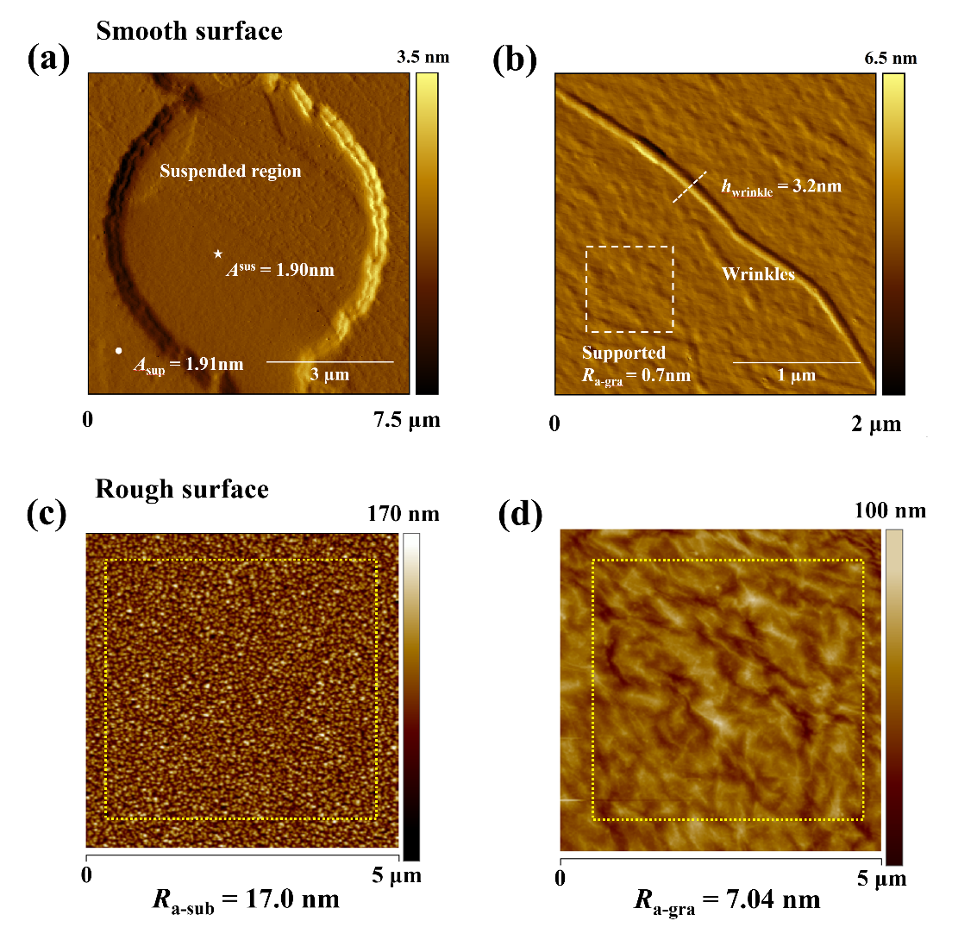
Figure S5 – AFM characterization of 1L graphene sample for (a) tapping-mode amplitude image of 1L^{sus} graphene, (b) height image of 1L_{sup} on smooth SiO₂/Si substrate, (c) height image of bare rough SiO₂/Si substrate, and (d) height image of 1L_{sup} on rough SiO₂/Si substrate. Dotted area indicates the test area for the calculation of the average roughness, R_{a}.

Figure S5a shows the AFM tapping-mode amplitude image of 1L^{sus} graphene, which is the same position as Fig. 2b. More details of the suspended graphene can be found in Fig. S5a. The amplitude of AFM cantilever is almost the same on both suspended and supported regions, showing the high stability of AFM measurement. The root mean square surface roughness, R_{a}, of 1L_{sup} transferred onto a smooth SiO₂/Si substrates was found to be ca. 1 nm, whereas for 1L^{sus} it is smaller than 1 nm (see Fig. 2b in main text). Small wrinkles can be noticed on the surface of the 1L graphene, which were presumably induced by the PMMA transfer and cleaning procedures. The wrinkles on 1L graphene might increase slightly the average surface roughness, so the roughness of 1L supported graphene on the smooth substrate is slightly higher than that of suspended 1L graphene (Fig. S5b and Fig. 2b in main text). On the other hand, due to the weak bonding between the graphene and the rough silicon substrate, the graphene supported on the rough substrate presents much higher roughness than that of the smooth substrate (Fig. S5c & S5d). We note here that due to the enhanced roughness after the graphene transfer procedure onto a rough SiO₂/Si substrate, experimental observations shown along the main text were limited to the graphene transferred onto the flat/smooth SiO₂/Si substrate.
Next we present AFM topography images on 2L_{sup} (Fig. S6a), 4L_{sup} (Fig. S6b) and ML_{sup} (Fig. S6c&d):
Figure S6 – AFM topography results of (a) 2L_{sup} on smooth SiO₂/Si substrate; (b) 4L_{sup} on smooth SiO₂/Si substrate; (c) ML_{sup} on smooth SiO₂/Si substrate and (d) enlarged AFM topography of ML_{sup} on smooth SiO₂/Si substrate. The yellow dashed box indicates the test area for measuring the mean roughness R_{a}.

Fig. S6 summarizes AFM results of 2L, 4L and ML samples. Wrinkles and presence of nanometer peaks and valleys are reported on 2L_{sup}, 4L_{sup} and ML_{sup} membranes. Comparing AFM results included in Fig. S6 to those presented Fig. 2b (main text), 1L^{sus} and 1L_{sup} profiles are smoother with the near absence of ridges or wrinkles. Meanwhile, it is worth noting that surface roughness does not depend on the number of layers and 2L, 4L and ML samples have similar surface roughness R_{a}.

SI-3. ESEM Experimental Observations
Experimental observations of condensation were undertaken in an Environmental Scanning Electron Microscope FEI Versa 3DTM (Hillsboro, Oregon, U.S.A.), where temperature of the surface and the vapor pressure of the environment could be finely controlled. Graphene sample was fixed to a 45° sample holder using double side carbon tape and then the sample holder was fixed onto the Peltier stage, to allow for experimental observations at a tilting angle of ca. 80° with respect to the electron beam. The temperature of the Peltier stage and the water vapor pressure were precisely controlled with the xT Microscope Control software with an average deviation from the equilibrium liquid-vapor curve of ± 0.3 ºC and ± 16 Pa and a maximum deviation of ± 0.7 ºC and ± 30 Pa ^{S5}. The initial temperature of the Peltier stage was set to 0 ºC on the graphene surface, which was further confirmed by additional measurements with an external thermocouple. Once the graphene sample was placed on the Peltier stage, the chamber was vacuumed for several minutes to ~10⁻³ Pa, removing any presence of non-condensable gases, and thereafter the chamber was set into Environmental Scanning Electron Microscopy (ESEM) mode. Then, the vapor pressure was slowly increased from ~100 Pa to ~600 Pa until the condensation occurred. The pressure rate was increased at the lowest rate of 6 Pa/min. The dynamics of droplet growth was recorded by the software at 1 frame every ca. 3 seconds. After each experimental observation, in order to evaporate the water condensed, the vapor pressure was decreased at low rates to avoid the rupture of graphene.
Fig. S7 includes ESEM experimental observations of 12 non-wetting droplets on 1L^{sus} at different intervals of condensation.

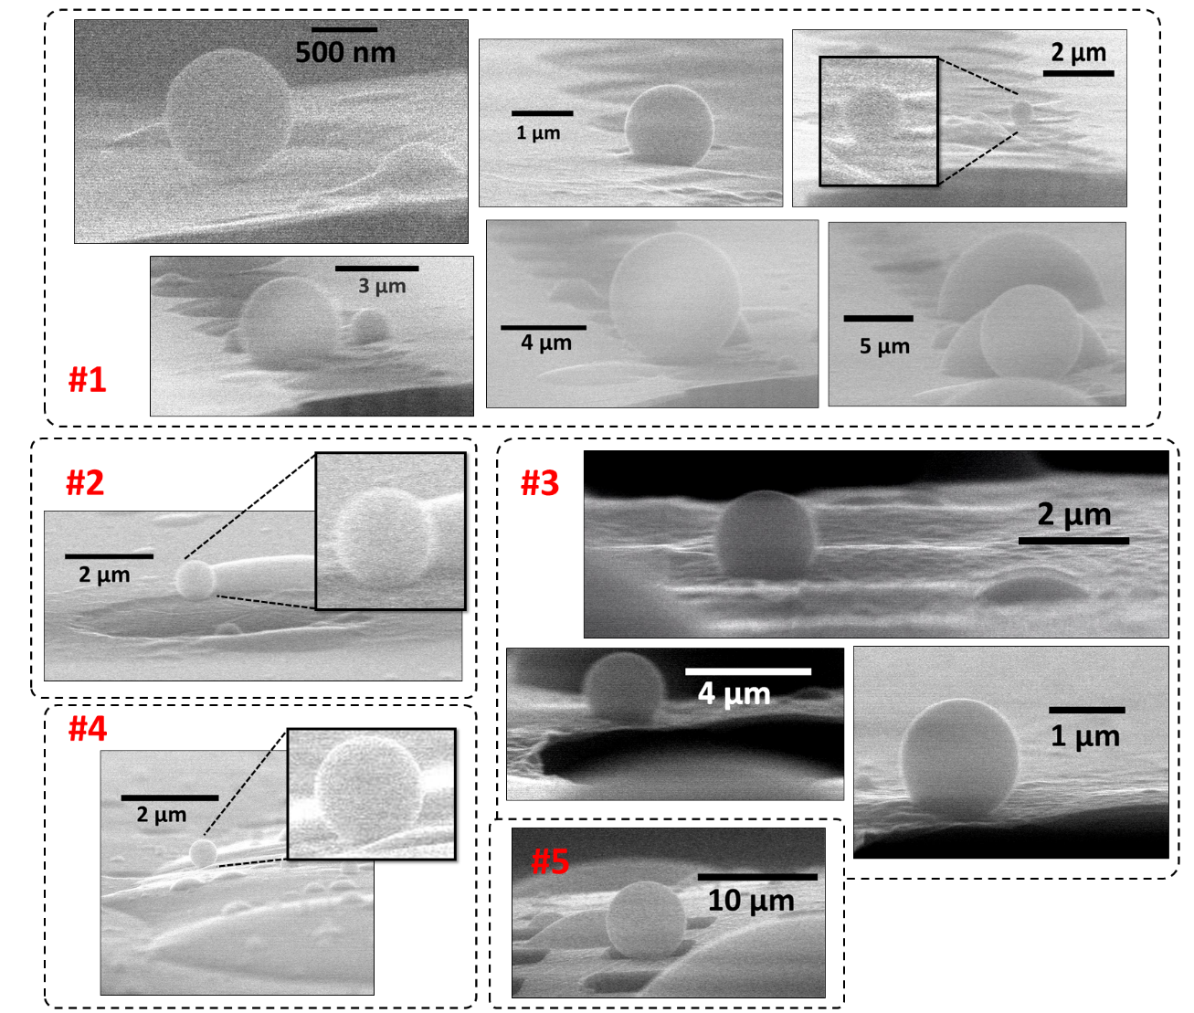
Figure S7 – Non-wetting water droplets on 1L suspended graphene. Five different samples were prepared and tested in the experiment, as shown from #1 to #5.

Three 1L suspended graphene samples were tested in the experiment. Here, we define “non-wetting droplet” as a droplet with a measured contact angle larger than 120º, which was believed to be the limit for hydrophobicity on smooth surfaces. The largest contact angle of droplet approaches 180º (top-left of Fig. S7), which is the ideal limit for the free-standing droplet in vacuum and/or in air. Non-wetting droplets presented in Fig. S7 and contact angles above 140° presented in Fig. 4 (main text) are the direct evidence of the superhydrophobicity of 1L^{sus}. Fig. 3 (main text) and Fig. 4 (main text) compare different condensed droplets on 1L, 2L, 4L and ML samples on both supported and suspended regions. It demonstrates that the presence of non-wetting droplets is a solely characteristic of 1L^{sus} graphene. It is worth noting that the transition from a non-wetting droplet growing on 1L^{sus} to a wetting droplet upon contact with the 1L_{sup} evidences the exceptionally different wetting properties between 1L^{sus} and 1L_{sup}, as presented in Fig. 3b (main text). For 2L, 4L and ML graphene samples, the contact angles are almost same for the droplets on both supported and suspended regions as in Fig. 4 (main text).
On the contrary, ESEM observations on suspended monolayer graphene above a TEM grid (seemingly to the work of Zhang et al.^{S6} reporting on the intrinsic wettability of pristine graphene) yielded contact angles ranging from 20° to 31° for a droplet on suspended monolayer graphene as shown in Fig. S8(left). While contact angles as high as 60° were observed for droplets where part of the droplet footprint rests on the suspended and other part on the supported monolayer graphene as presented in Fig. S8(right). The magnitude of the contact angle values on the suspended monolayer graphene above TEM grid with closed holes are well in agreement with the recent work of Zhang et al.^{S6}.
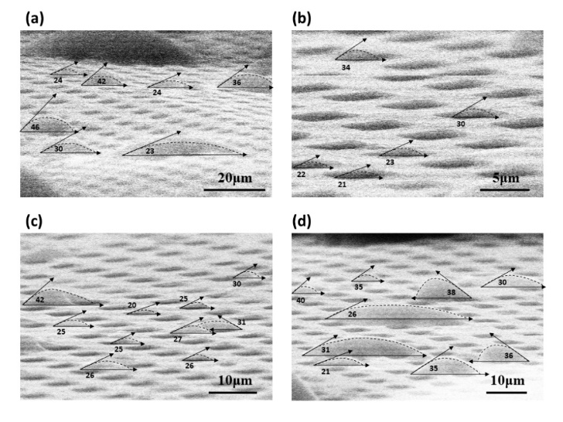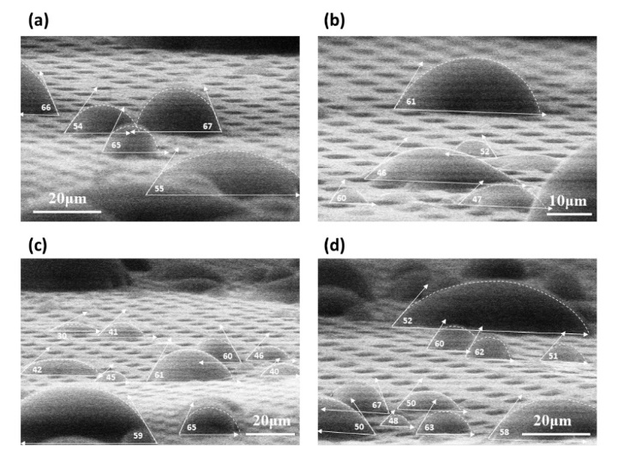
Figure S8 – (left) ESEM characterization of droplets on monolayer graphene suspended above a TEM grid with closed holes. (right) ESEM characterization of graphene sample on TEM grid after several circles of condensation and evaporation. (a) to (d) show the droplets at different areas of TEM grid. The contact angle value of each droplet is marked in the image.

SI-4. Statistical Analysis
In what follows, a more detailed discussion regarding the statistical analysis involving all ESEM experimental observations on different suspended and supported graphene samples is provided. Fig. S9 shows the statistical analysis of both suspended and supported graphene with different layers as the number of non-wetting droplets, N_{non-wetting}, over the total number of droplets, N_{total}, on suspended and supported substrates.
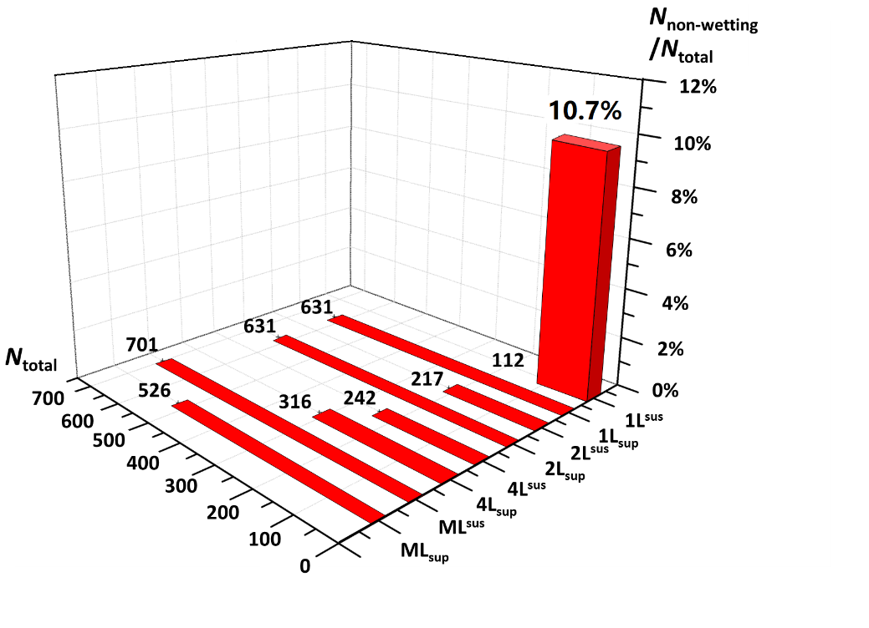
Figure S9 – Statistical analysis as the number of non-wetting droplets, N_{non-wetting}, over the total number of droplets, N_{total}, on suspended and supported substrates. Non-wetting droplets only appear on 1L^{sus} graphene. The total number of droplets, N_{total}, on each of the substrates is also included.

For the statistical analysis, we have considered typical snapshots from ESEM experimental observations and counted the numbers of both wetting and non-wetting droplets. Up to 12 different non-wetting droplets are observed on 1L^{sus}, whereas only wetting droplets are observed on 1L_{sup} and on any multi-layer graphene either suspended or supported. When comparing all the experimental evidences and the different substrates studied, a total of 1262 and 2104 wetting droplets with contact angles below 100º are reported on suspended and on supported graphene, respectively. The greater percentage of droplets reported on multi-layer graphene either suspended or supported when compared to 1L^{sus} is explained in terms of the greater roughness, which lowers the energy required for droplet nucleation^{S7}. Nonetheless, when comparing wetting and non-wetting droplets on 1L^{sus} with pristine lattice, the probability of seeing a non-wetting droplet with a contact angle above 120° on 1L^{sus} is 10.7%, while there is absence of non-wetting droplets for all the other cases.
We must note here that on an ideal smooth hydrophobic surface, droplet nucleation is almost impracticable since the energy required for the nucleation on the atomic smooth shydrophobic surfaces is extremely high. This is consistent with the low number of droplets reported on 1L^{sus} when compared to multi-layer sample. It is possible that the residue islands (Fig. 2c (main text)) on 1L^{sus} play the role of nucleation sites in droplet growth during condensation. Aiming to induce nucleation sites for droplet condensation, we changed the surface energy of graphene by fluorination. Due to rather low surface energy induced by the fluorination procedure, the number of droplets on the fluorinated graphene was also particularly low.

SI-5. Minimum Radius for Nucleation
The critical droplet radius for homogeneous nucleation, r_{e}, can be obtained by making use of the Kelvin equation $r_{e}={2T_{v}γ_{lv}}/{h_{fg}ρ_{l}ΔT}$ where T_{v} is the temperature of the vapor, γ_{lv} is the liquid-vapor interfacial tension, h_{fg} the latent heat of vapor to liquid phase-change, ρ_{l} the density of the liquid and ΔT the subcooling temperature^{S7}. In the case of heterogeneous nucleation, the free energy for heterogeneous nucleation, $∆G_{heterog}$, scales to the free energy for homogeneous nucleation, $∆G_{homog}$, as $∆G_{heterog} =f(θ)∆G_{homog}$ where $f\left(θ\right)={2-3\cos{θ+\cos^{3}(θ)}}/4$ which varies from 0 for complete wetting surfaces to 1 for heterogeneous nucleation or θ = 180°, and so does the radius required for nucleation. Figure S10 shows the calculated radius for nucleation, r_{e}, versus subcooling temperature. ΔT, for homogeneous nucleation and for heterogeneous nucleation for various surface wettability surfaces.

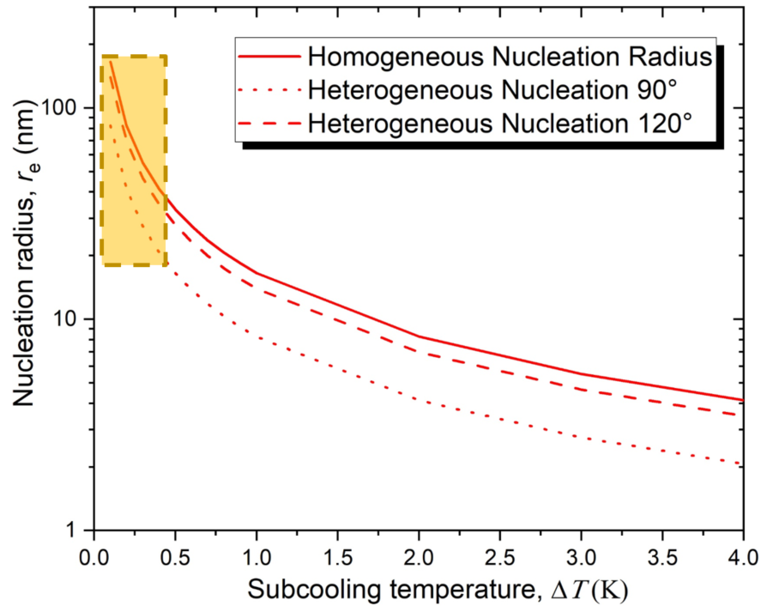
Figure S10 – Droplet nucleation radius, r_{e} (nm), versus subcooling temperature, ΔT (K), in red lines and ESEM experimental accessible region near the liquid-vapor saturation curve in shaded orange.

In the present conditions where ESEM works near the liquid-vapor saturation curve^{S5} with an average deviation from the equilibrium liquid-vapor curve of ± 0.3 ºC and ± 16 Pa, r_{e} is in the order of tens of nanometers, which is several times greater than the characteristic length and/or the height of the defects found in the 1L^{sus} in the nanometer range.

References:
- Srivastava, A. et al. Novel liquid precursor-based facile synthesis of large-area continuous, single, and few-layer graphene films. Chem. Mater. 22, 3457–3461 (2010).
- Lin, Y.-C. et al. Clean transfer of graphene for isolation and suspension. ACS Nano 5, 2362–2368 (2011).
- Nair, R. R. et al. Fine structure constant defines visual transparency of graphene. Science (80-. ). 320, 1308–1308 (2008).
- Li, Q. Q. et al. Raman spectroscopy at the edges of multilayer graphene. Carbon 85, 221–224 (2015).
- Orejon, D. et al. Droplet migration during condensation on chemically patterned micropillars. RSC Adv. 6, 36698–36704 (2016).
- Zhang et al. Intrinsic Wettability in Pristine Graphene. Adv. Mater. 2103620 (2021)
- Fisher, L. R. et al. The Kelvin equation and the capillary condensation of water. Nature 290, 575–576 (1981).

