Supporting information
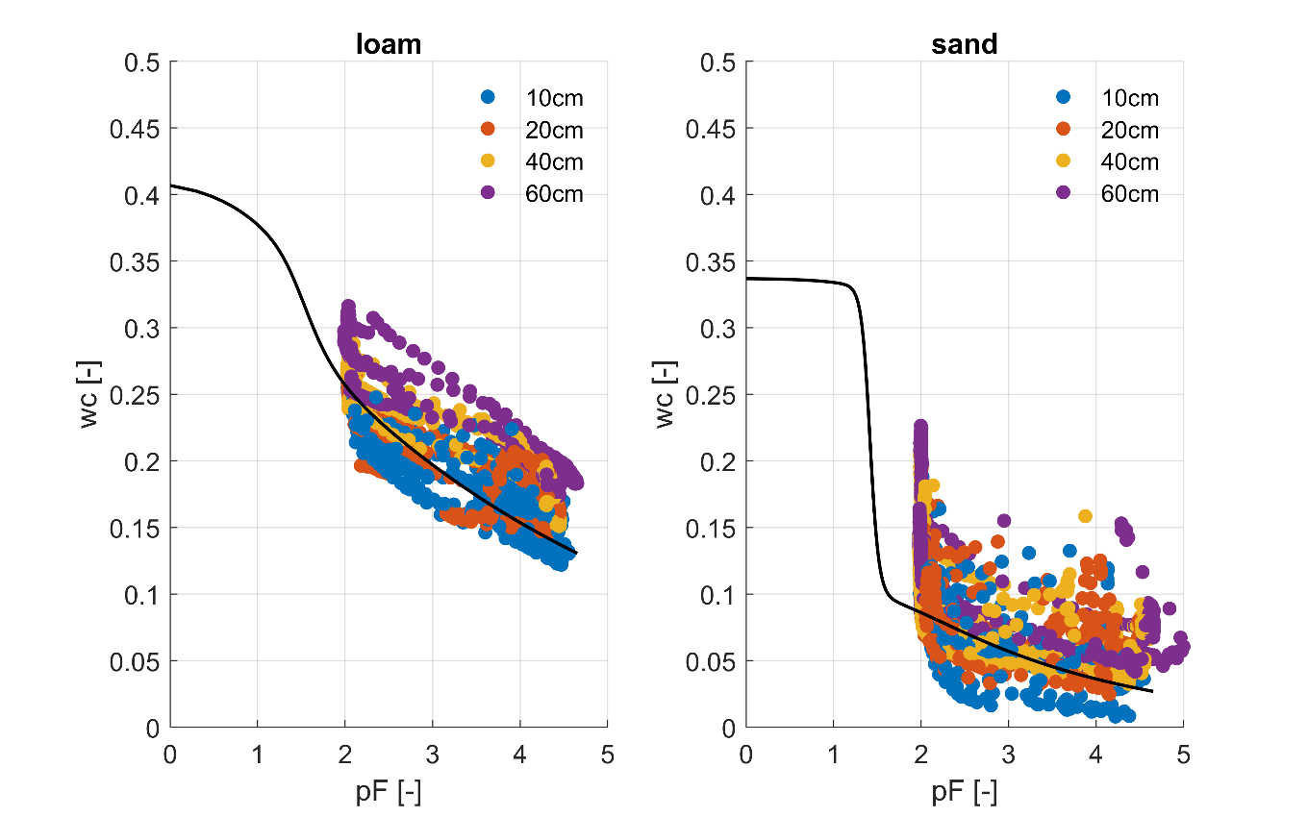
Figure S1. Measured soil water content and soil water potential obtained from TEROS 21 sensors (midnight values). Black line indicates parameterization used in the simulations (see Table 1). Data is colored according to soil depth.

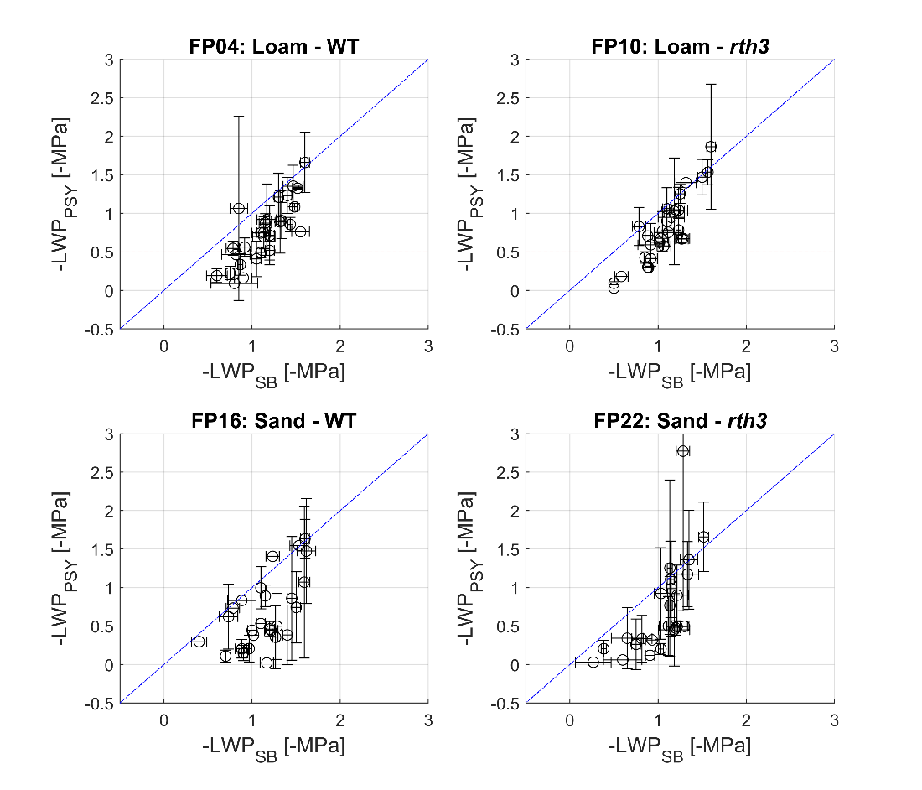
Figure S2. Comparison between leaf water potential data measured in 2020 with psychoremeters (LWP_{PSY}) and with Scholander bomb (LWP_{SB}). Blue line is the one-one line and red dashed horizonal line indicates the (absolute) LWP below which the accuracy of the psychrometer measurements is low. Vertical and horizontal bars show +/- the standard error of the individual measurements.

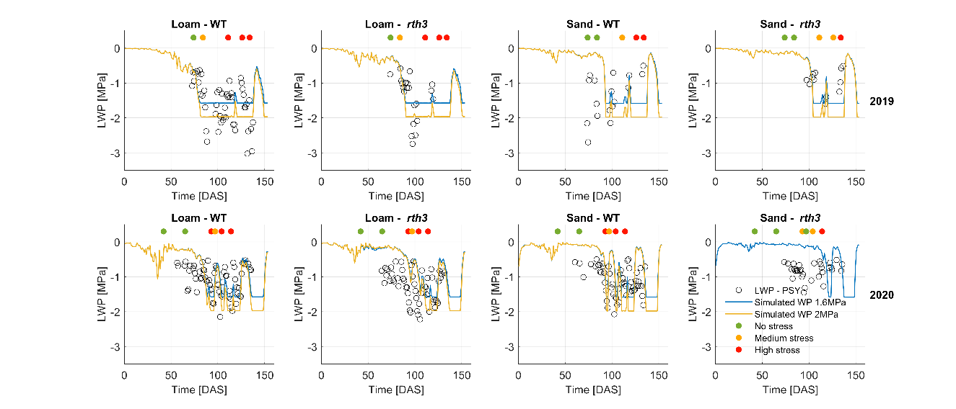
Figure S3. Impact of critical treshold water potential at the collar on the simulated leaf water potentials. Simulations with a critical threshold of –1.6 MPa is plotted in blue, whereas simulations with a critical threshold of –2 MPa is depicted in yellow.

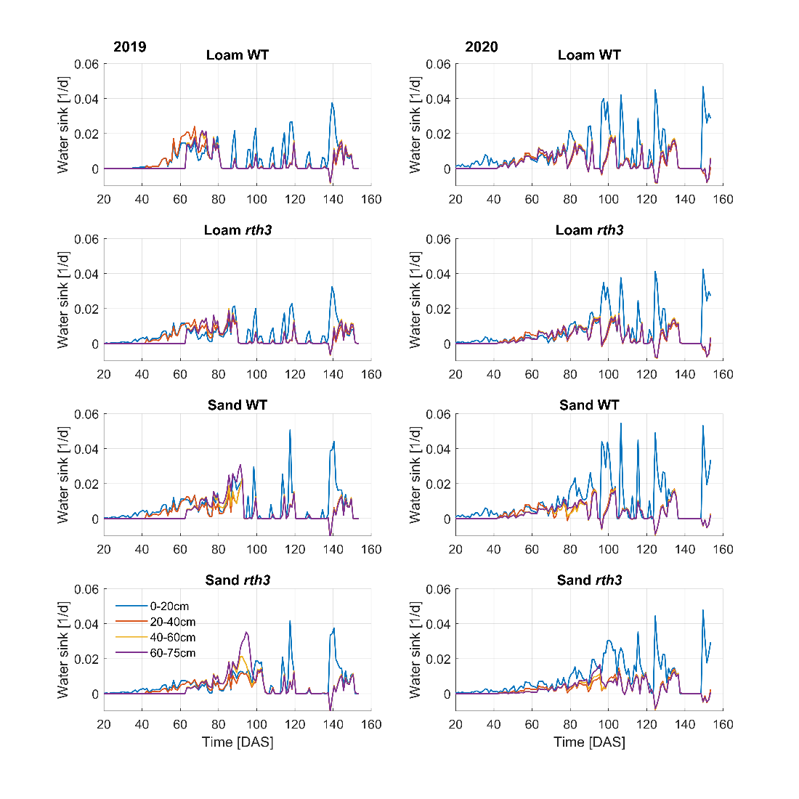
Figure S4. Simulated midday water sink for 4 soil layers (0-20, 20-40, 40-60 and 60-75 cm) and all treatments.

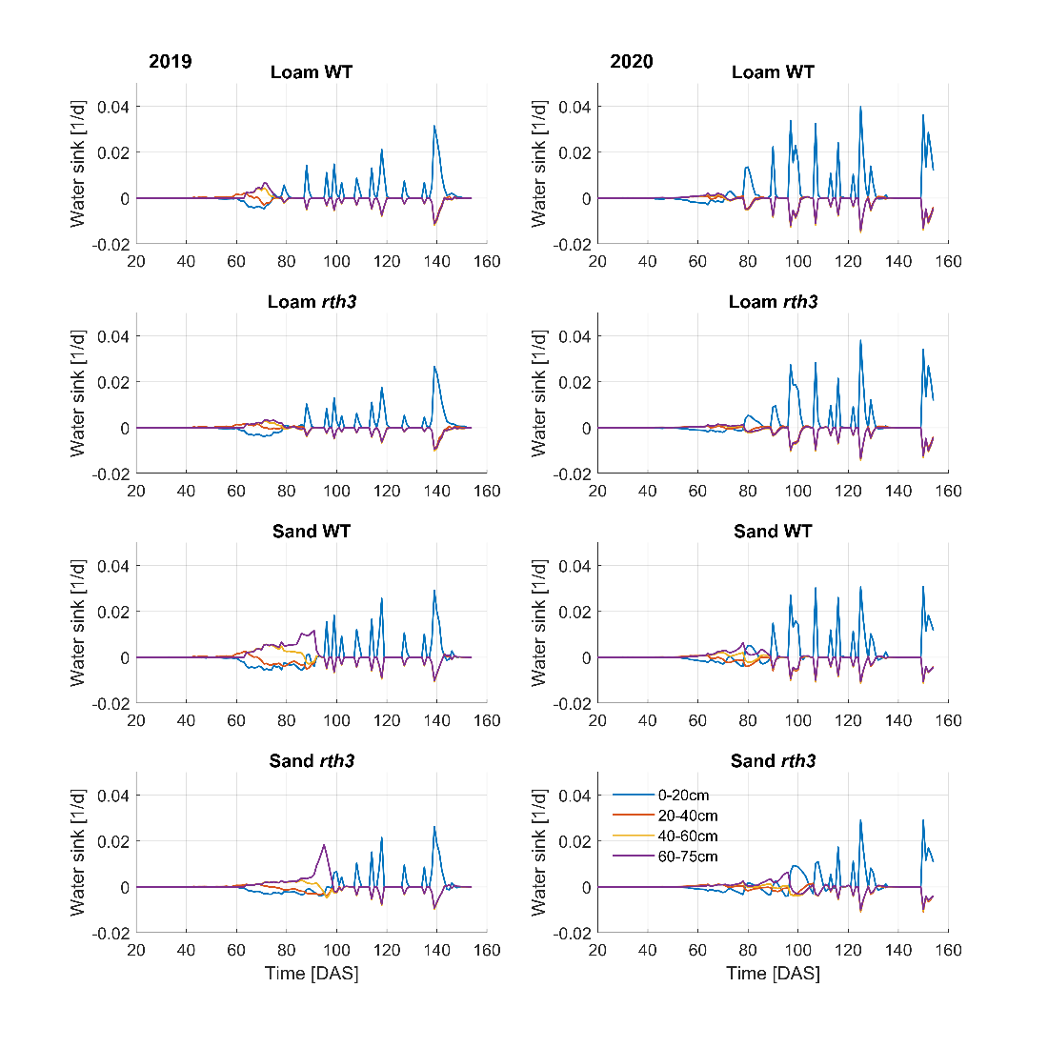
Figure S5. Simulated midnight water sink for 4 soil layers (0-20, 20-40, 40-60 and 60-75 cm) and all treatments.

