Supplementary information
Effects of phosphorus fertiliser use redistribution on crop calorie production and equal availability

Zhaohai Bai 1, 2#, Ling Liu 1#, Carolien Kroeze 3, Maryna Strokal 3, Xinping Chen 4,5 Lin Ma 1,4*

1 Hebei Key Laboratory of Soil Ecology, Center for Agricultural Resources Research, Institute of Genetic and Developmental Biology, The Chinese Academy of Sciences, 286 Huaizhong Road, Shijiazhuang 050021, Hebei, China;

2 Xiongan Institute of Innovation, The Chinese Academy of Sciences, Xiongan District, Hebei, China;

3 Water Systems and Global Change Group, Wageningen University & Research, Droevendaalsesteeg 3, 6708 PB Wageningen, the Netherlands;

4 Interdisciplinary Research Center for Agriculture Green Development in Yangtze River Basin, Southwest University, Tiansheng Road 02, Chongqing 400715, China.

5 College of Resources and Environment, Southwest University, Tiansheng Road 02, Chongqing 400715, China.

# These authors contributed equally to this paper.

* Corresponding author:
L. Ma: malin1979@sjziam.ac.cn.

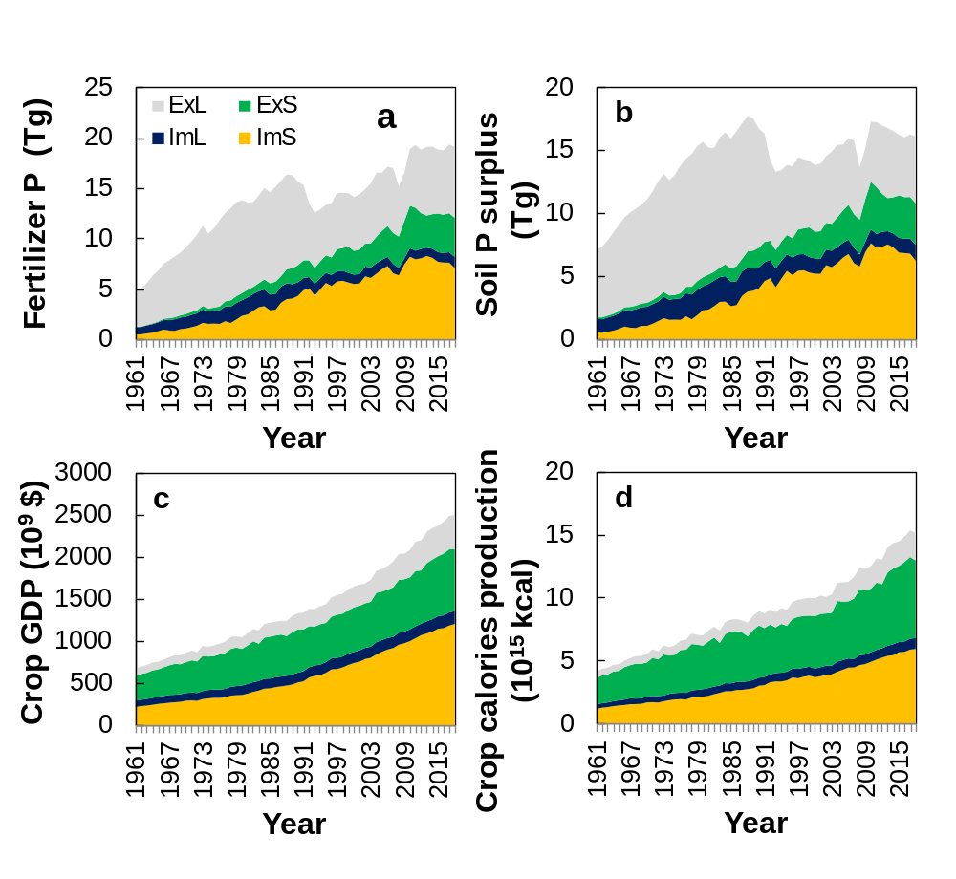
Fig S1. Changes of synthetic phosphorus (P) use (a), and soil P surplus (b), gross domestic production (GDP) value of crop production (e), and production of crop in terms of energy (in calorie) (f) of different country groups from 1961 to 2018.
Note: See Fig 1 for detailed information for countries in each group.

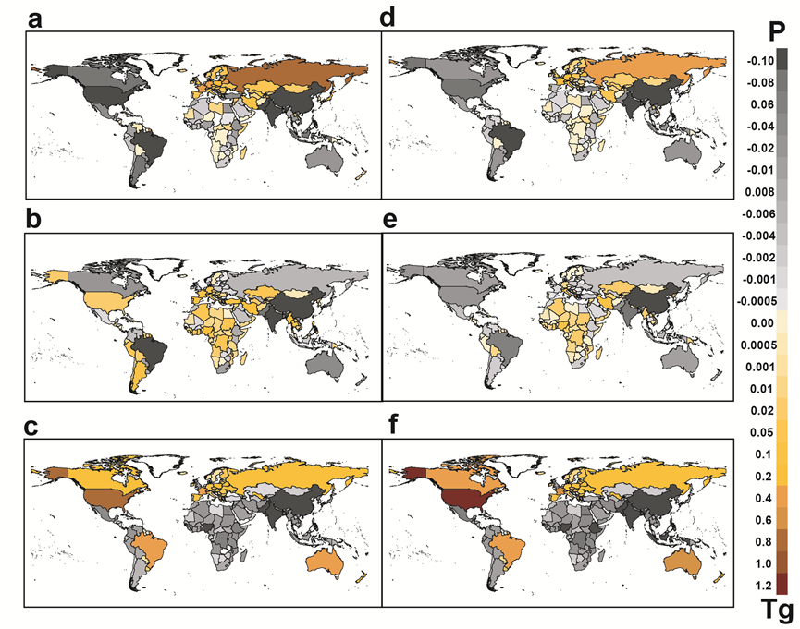
Fig S2. Transfer of synthetic phosphorus (P) fertilizer reduction duty between countries under different principles at lower-limit (a, Responsibility; b, Capability; c, Equality) and upper-limit (d, Responsibility; e, Capability; f, Equality) planetary boundary for P.
Note: The positive values in the map represent transfer reduction duty to other countries, and the minus values represent carryout extra reduction duty. There are no transfer of reduction duties under the Food Security principle.

Fig S3. Redistributed synthetic P fertilizer use of different countries under different redistribution principles at lower-limit (a-d) and upper-limit (e-h) planetary boundary.
Fig S4. Synthetic P fertilizer reduction duty of different countries under different redistribution principles at lower-limit (a-d) and upper-limit (e-h) planetary boundary.
Note: Minus values show that no reduction quota will be distributed, and even high HIN fixation or synthetic P fertilizer application rate will be allocated relative to their current fixation rate.

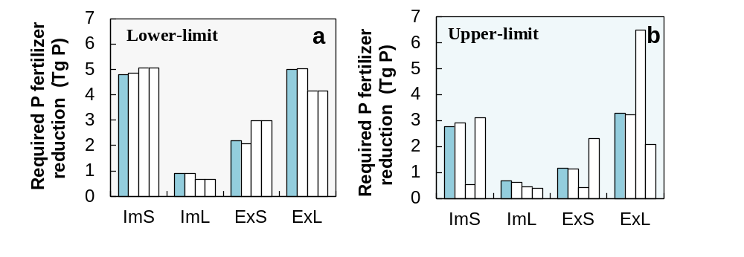
Fig S5. Required synthetic P fertilizer reduction of different country groups under different redistribution principles at lower-limit (a) and upper-limit (e) planetary boundary.
Note: See Fig 1 for detailed information for countries in each group.

Table S1. List of countries categorized in agricultural P product trade and level of livestock production, and economics.
Country | Agricultural P product trade –  level of livestock production | Economic
Afghanistan | Net import&Small | Low income
Albania | Net import&Large | Other
Algeria | Net import&Small | Other
Angola | Net import&Small | Lower-middle-income
Antigua and Barbuda | Net import&Small | High-income
Argentina | Net export&Large | High-income
Armenia | Net import&Small | Other
Australia | Net export&Large | High-income
Austria | Net export&Large | High-income
Azerbaijan | Net import&Small | Other
Bahamas | Net import&Small | High-income
Bahrain | Net import&Small | High-income
Bangladesh | Net import&Small | Lower-middle-income
Barbados | Net import&Small | High-income
Belarus | Net export&Large | Other
Belgium | Net export&Large | High-income
Belize | Net import&Small | other
Benin | Net import&Small | Low income
Bhutan | Net import&Large | Lower-middle-income
Bolivia | Net import&Large | Lower-middle-income
Bosnia and Herzegovina | Net import&Small | Other
Botswana | Net import&Large | Other
Brazil | Net export&Large | Other
Brunei Darussalam | Net import&Small | High-income
Bulgaria | Net import&Large | Other
Burkina Faso | Net import&Small | Low income
Burundi | Net import&Small | Low income
Cabo Verde | Net import&Small | Lower-middle-income
Cambodia | Net import&Small | Lower-middle-income
Cameroon | Net import&Small | Lower-middle-income
Canada | Net export&Large | High-income
Central African Republic | Net import&Small | Low income
Chad | Net import&Small | Low income
Chile | Net import&Large | High-income
China | Net import&Small | Other
Colombia | Net import&Large | Other
Comoros | Net import&Small | Low income
Congo | Net import&Small | Lower-middle-income
Costa Rica | Net export&Large | other
Côte d'Ivoire | Net import&Small | Lower-middle-income
Croatia | Net import&Small | High-income
Cuba | Net import&Small | Other
Cyprus | Net import&Large | High-income
Czechia | Net export&Large | High-income
Democratic Korea | Net import&Small | Low income
Democratic Congo | Net import&Small | Low income
Denmark | Net export&Large | High-income
Djibouti | Net import&Small | Lower-middle-income
Dominica | Net import&Small | Other
Dominican Republic | Net import&Small | Other
Ecuador | Net import&Large | Other
Egypt | Net import&Small | Lower-middle-income
El Salvador | Net import&Small | Lower-middle-income
Equatorial Guinea | Net import&Small | Other
Eritrea | Net import&Small | Low income
Estonia | Net export&Large | High-income
Eswatini | Net import&Small | Lower-middle-income
Ethiopia | Net export&Small | Low income
Fiji | Net import&Small | Other
Finland | Net import&Large | High-income
France | Net export&Large | High-income
French Polynesia | Net import&Small | High-income
Gabon | Net import&Small | Other
Gambia | Net import&Small | Low income
Georgia | Net import&Small | Lower-middle-income
Germany | Net export&Large | High-income
Ghana | Net import&Small | Lower-middle-income
Greece | Net import&Large | High-income
Grenada | Net import&Small | Other
Guatemala | Net import&Small | Other
Guinea | Net import&Small | Low income
Guinea-Bissau | Net import&Small | Low income
Guyana | Net import&Small | Other
Haiti | Net import&Small | Low income
Honduras | Net import&Small | Lower-middle-income
Hungary | Net export&Large | High-income
Iceland | Net export&Large | High-income
India | Net export&Small | Lower-middle-income
Indonesia | Net import&Small | Lower-middle-income
Iran | Net import&Small | Other
Iraq | Net import&Small | Other
Ireland | Net export&Large | High-income
Israel | Net import&Large | High-income
Italy | Net import&Large | High-income
Jamaica | Net import&Small | other
Japan | Net import&Small | High-income
Jordan | Net import&Small | Other
Kazakhstan | Net import&Small | Other
Kenya | Net import&Small | Lower-middle-income
Kuwait | Net import&Small | High-income
Kyrgyzstan | Net import&Small | Lower-middle-income
Lao | Net import&Small | Lower-middle-income
Latvia | Net export&Small | High-income
Lebanon | Net import&Small | Other
Lesotho | Net import&Small | Lower-middle-income
Liberia | Net import&Small | Low income
Libya | Net import&Small | Other
Lithuania | Net export&Small | High-income
Luxembourg | Net export&Large | High-income
Madagascar | Net import&Small | Low income
Malawi | Net import&Small | Low income
Malaysia | Net import&Small | Other
Maldives | Net import&Small | Other
Mali | Net export&Small | Low income
Malta | Net import&Large | High-income
Martinique | Net export&Small | Other
Mauritania | Net import&Small | Lower-middle-income
Mauritius | Net import&Small | Other
Mexico | Net import&Large | Other
Micronesia | Net import&Small | Lower-middle-income
Mongolia | Net export&Large | Lower-middle-income
Montenegro | Net import&Large | Other
Morocco | Net import&Small | Lower-middle-income
Mozambique | Net import&Small | Low income
Myanmar | Net import&Small | Lower-middle-income
Namibia | Net import&Small | Other
Nepal | Net import&Small | Low income
Netherlands | Net export&Large | High-income
New Caledonia | Net import&Small | High-income
New Zealand | Net export&Large | High-income
Nicaragua | Net export&Small | Lower-middle-income
Niger | Net import&Small | Low income
Nigeria | Net import&Small | Lower-middle-income
Norway | Net import&Large | High-income
Oman | Net import&Small | High-income
Pakistan | Net export&Small | Lower-middle-income
Palestine | Net import&Small | Lower-middle-income
Panama | Net import&Large | High-income
Papua New Guinea | Net import&Small | Lower-middle-income
Paraguay | Net export&Large | Other
Peru | Net import&Small | Other
Philippines | Net import&Small | Lower-middle-income
Poland | Net export&Large | High-income
Portugal | Net import&Large | High-income
Puerto Rico | Net import&Large | High-income
Qatar | Net import&Small | High-income
Republic of Korea | Net import&Small | High-income
Republic of Moldova | Net import&Small | Lower-middle-income
Réunion | Net export&Small | Other
Romania | Net import&Large | Other
Russian Federation | Net export&Large | Other
Rwanda | Net export&Small | Low income
Saint Kitts and Nevis | Net import&Small | High-income
Saint Lucia | Net import&Small | Other
Saint Vincent | Net import&Small | Other
Samoa | Net import&Small | Other
Sao Tome and Principe | Net import&Small | Lower-middle-income
Saudi Arabia | Net import&Small | High-income
Senegal | Net import&Small | Low income
Serbia | Net import&Large | Other
Sierra Leone | Net import&Small | Low income
Singapore | Net import&Small | High-income
Slovakia | Net import&Large | High-income
Slovenia | Net export&Large | High-income
Solomon Islands | Net import&Small | Lower-middle-income
Somalia | Net import&Small | Low income
South Africa | Net import&Large | Other
South Sudan | Net import&Small | Low income
Spain | Net export&Large | High-income
Sri Lanka | Net import&Small | Lower-middle-income
Sudan | Net import&Small | Lower-middle-income
Suriname | Net import&Small | Other
Sweden | Net import&Large | High-income
Switzerland | Net import&Large | High-income
Syrian Arab Republic | Net import&Small | Low income
Tajikistan | Net import&Small | Low income
Thailand | Net export&Small | Other
Timor-Leste | Net import&Small | Lower-middle-income
Togo | Net import&Small | Low income
Tonga | Net import&Small | Other
Trinidad and Tobago | Net import&Small | High-income
Tunisia | Net import&Small | Lower-middle-income
Turkey | Net export&Large | Other
Turkmenistan | Net import&Small | Other
Uganda | Net export&Small | Low income
Ukraine | Net export&Large | Lower-middle-income
United Arab Emirates | Net import&Small | High-income
UK | Net import&Large | High-income
Tanzania | Net export&Large | Low income
USA | Net export&Large | High-income
Uruguay | Net export&Large | High-income
Uzbekistan | Net import&Small | Lower-middle-income
Vanuatu | Net import&Small | Lower-middle-income
Venezuela | Net import&Large | Other
Viet Nam | Net import&Small | Lower-middle-income
Yemen | Net import&Small | Low income
Zambia | Net import&Small | Lower-middle-income
Zimbabwe | Net import&Small | Low income

Table S2. List of the main data sources and their web-links.
 |  | FAOSTAT | Sub-items | Web-link or Equations
Responsibility method | Synthetic P fertilizer | Input | Fertilizers by nutrient | http://www.fao.org/faostat/en/#data/RFN
Responsibility method | Manure N applied to field | Emissions | Manure applied to soils | http://www.fao.org/faostat/en/#data/GU
Responsibility method | Manure P applied to field | Literature |  | Manure P _{applied} = Manure N _{applied} / (Manure N/P ratio)
Responsibility method | Straw N applied to field | Emissions | Crop residues | http://www.fao.org/faostat/en/#data/GA
Responsibility method | Straw P applied to field | Literature |  | Straw P _{applied} = Straw N / (Straw N/P ratio)
 | Crop P uptake | Literature |  | Nesme et al., 2018
Capability method | GDP value of crop production | Production | Value of agricultural production | http://www.fao.org/faostat/en/#data/QV
Equality method | Human population | Population | Years | http://www.fao.org/faostat/en/#data/OA
Equality method | Human population | Population | Year Projections | http://www.fao.org/faostat/en/#data/OA
Food Security method | Crop calories | Production | Crops | Bai et al., 2021
Human excretion | Protein supply quantity | Food Balances | New Food Balances | http://www.fao.org/faostat/en/#data/FBS
Impacts on crop productivity | N fertilizer | Input | Fertilizers by nutrient | http://www.fao.org/faostat/en/#data/RFN
Impacts on crop productivity | P fertilizer use | Input | Fertilizers by nutrient | http://www.fao.org/faostat/en/#data/RFN
Impacts on crop productivity | K fertilizer use | Input | Fertilizers by nutrient | http://www.fao.org/faostat/en/#data/RFN
Impacts on crop productivity | Pesticides use | Input | Pesticides Use | http://www.fao.org/faostat/en/#data/RP
Impacts on crop productivity | Machinery | Investment | Machinery | http://www.fao.org/faostat/en/#data/RM
Impacts on crop productivity | Energy use | Emissions - Agriculture | Energy Use | http://www.fao.org/faostat/en/#data/GN
Impacts on crop productivity | Cereal sown area | Crops and livestock products | Area harvested | https://www.fao.org/faostat/en/#data/QCL
Impacts on crop productivity | Bean sown area | Crops and livestock products | Area harvested | https://www.fao.org/faostat/en/#data/QCL
Impacts on crop productivity | Vegetable sown area | Crops and livestock products | Area harvested | https://www.fao.org/faostat/en/#data/QCL

Table S3. Fractions of N to P for crop straw and livestock manure.
Crop straw | Straw N/P | Reference | Livestock | Manure N/P | Reference
Barley | 7.48 | Bouwman et al., 2017;  Liu et al., 2018;  Smil et al., 2000;  Wang et al., 2020 | Cattle, non-dairy | 4.6 | OECD, 2020;  Pagliari et al., 2012;  Sheldrick et al., 2003  Velthof et al., 2015
Beans, dry | 16.4 |  | Sheep | 6.28
Maize | 5.23 |  | Goats | 6.28
Millet | 8.38 |  | Chickens, layers | 3.25
Oats | 7.73 |  | Chickens, broilers | 5.05
Potatoes | 12.39 |  | Swine, market | 3.71
Rice, paddy | 7.62 |  | Cattle, dairy | 5.34
Rye | 0.74 |  | Buffaloes | 4.6
Sorghum | 8.11
Soybeans | 12.9
Wheat | 7.15

Reference
- Bouwman, A.F., Beusen, A.H., Lassaletta, L. et al. (2017). Lessons from temporal and spatial patterns in global use of N and P fertilizer on cropland. Sci. Rep. 7:40366.
- Liu, X.Y., Li, S.T. (2018). Temporal and spatial distribution of nutrient resource from livestock and poultry feces and its returning to cropland. Transactions of the Chin. Soci. Agri. Eng. 34(4): 1-14. (in Chinese with English abstract).
- Nesme, T., Metson, G.S., Bennett, E.M. (2018). Global phosphorus flows through agricultural trade. Glob. Environ. Change 50:133-141.
- Organization for Economic Co-operation and Development Statistics (OECD stat) (2020). https://stats.oecd.org/#.
- Pagliari, P.H., Laboski, C.A. (2012). Investigation of the inorganic and organic phosphorus forms in animal manure. J. Environ. Qual. 41:901-910.
- Sheldrick, W., Syers, J.K., Lingard, J. (2003). Contribution of livestock excreta to nutrient balance. Nutr. Cycl. Agroecosys 66:119-131.
- Smil, V. (2000). Crop resiudes: Agricultural’s largest harvest. Bioscience 4: 299-308.
- Velthof, G.L., Hou, Y., Oenema, O. (2015). Nitrogen excretion factors of livestock in the European Union: a review. J. Sci. Food Agri. 95:3004-14.
- Wang, X., Yang, Z., Liu, X., et al. (2020). The composition characteristics of different crop straw types and their multivariate analysis and comparison. Waste Manage. 110, 87-97.

