PTEN is a predictive biomarker of trastuzumab resistance and prognostic factor in HER2-overexpressing gastroesophageal adenocarcinoma

Daiju Yokoyamaª, Shigeo Hisamoriª*, Yasunori Deguchi^{a,b}, Tatsuto Nishigoriª, Hiroshi Okabe^{c}, Seiichiro Kanaya^{d}, Dai Manaka^{e}, Yoshio Kadokawa^{f}, Hiroaki Hata^{g}, Sachiko Minamiguchi^{h}, Shigeru Tsunodaª, Kazutaka Obamaª, Yoshiharu Sakai^{a,d} on behalf of Kyoto Esophageal and Gastric Surgery Study Group (KEGG)

ªDepartment of Surgery, Graduate School of Medicine, Kyoto University
^{b}Department of Surgery, Takeda General Hospital
^{c}Department of Gastroenterological Surgery, New Tokyo Hospital
^{d}Department of Surgery, Osaka Red Cross Hospital
^{e}Department of Surgery, Kyoto Katsura Hospital
^{f}Department of Gastrointestinal Surgery, Tenri Hospital
^{g}Department of Surgery, National Hospital Organization Kyoto Medical Center
^{h}Department of Diagnostic Pathology, Graduate School of Medicine, Kyoto University

*Corresponding Author: Shigeo Hisamori*

Supplementary Data

Supplementary Figure 1
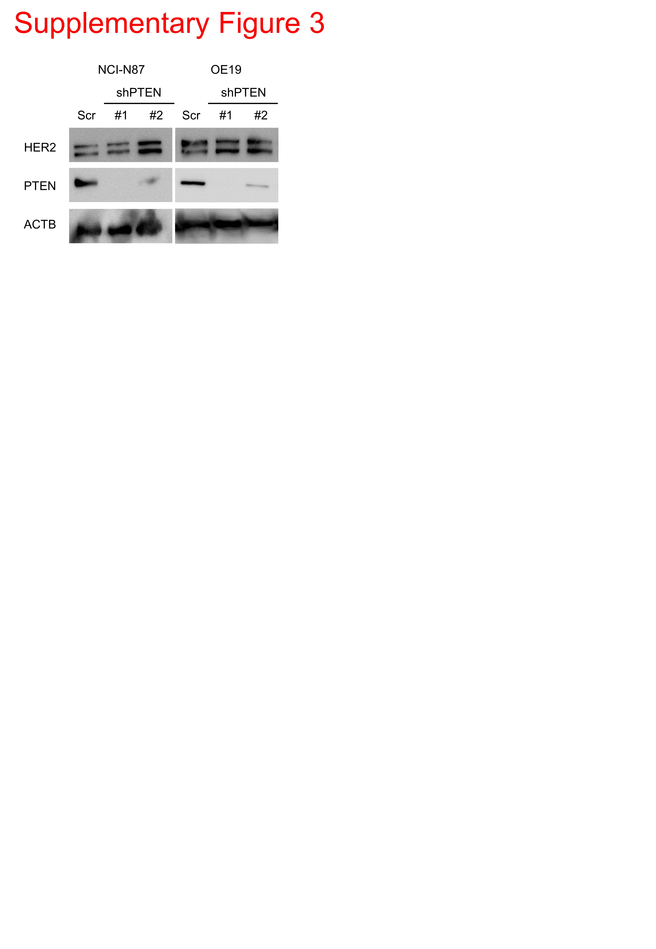
Western blotting analysis of HER2 and PTEN in NCl-N87 and OE19 cells. PTEN knockdown was achieved with shRNA (shPTEN#1 and shPTEN#2). ShPTEN#1 had a better knock down efficacy than shPTEN#2. Abbreviation: ACTB, Actin Beta.

Supplementary Figure 2
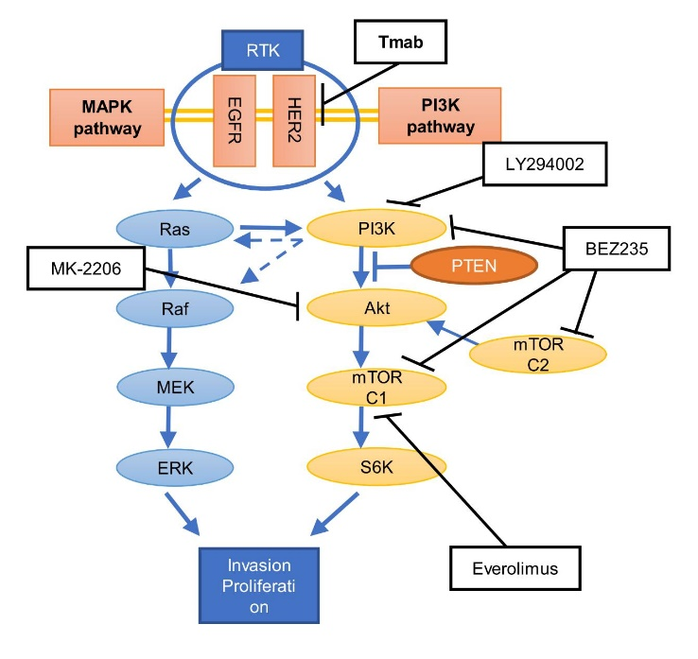
Complex interactions between the PI3K and MAPK pathways: LY294002 inhibits PI3K; everolimus inhibits mTORC1; MK-2206 inhibits Akt; and NVP-BEZ235 potentially inhibits PI3K, mTORC1, and mTORC2.

Supplementary Figure 3
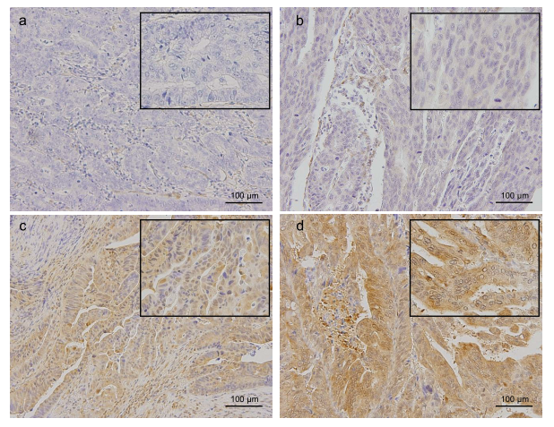
PTEN expression in gastroesophageal adenocarcinoma specimens. Representative PTEN scoring by IHC. (a) Score 0: no immunostaining is detectable within the tumor cells. (b) Score 1: weak immunostaining. (c) Score 2: intermediate immunostaining. (d) Score 3: strong immunostaining. PTEN loss was defined as negative staining (score 0) of cells in more than 75% of the tumor. Scale bars represent 100 μm.

Supplementary Figure 4
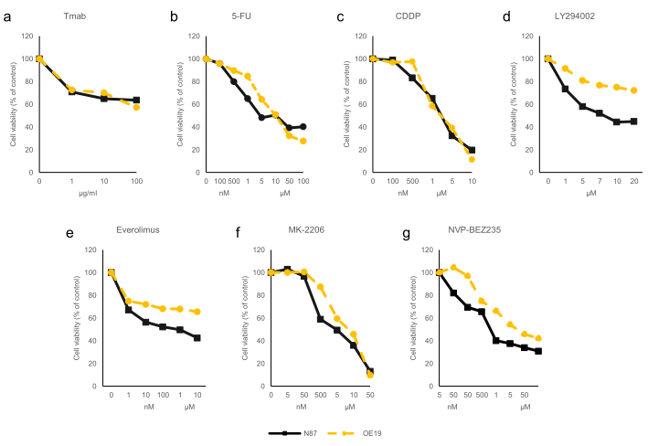
In cell viability assay, NCI-N87 and OE19 cells were exposed to increasing concentrations of test reagents. Cell viability was measured using the WST-8 colorimetric assay: (a) Tmab; (b) 5-FU; (c) CDDP; (d) LY294002; (e) Everolimus; (f) MK-2206; (g) NVP-BEZ235. 5-FU, LY294002, everolimus, MK-2206, and NVP-BEZ235 were dissolved in dimethyl sulfoxide at least less than 0.1% concentration. Each test reagent concentration was increased until the cell viability decreased less than 50%. Each control included DMSO at the same concentration. LY294002 did not inhibit cell growth over 50% in OE19 cells. The reagent exposure time was 120 h. n=3 for each test reagent and control.

Figure 3
These images are the results of experiments performed in the order shown below; from the left,From the left, Control [Ns, siPTEN#1, siPTEN#2], Tmab [Ns, siPTEN#1, siPTEN#2], target agent [Ns, siPTEN#1, siPTEN#2], agent plus Tmab [Ns, siPTEN#1, siPTEN#2]

Control-Tmab
HER2
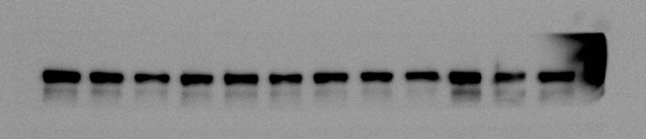
185kDa
PTEN
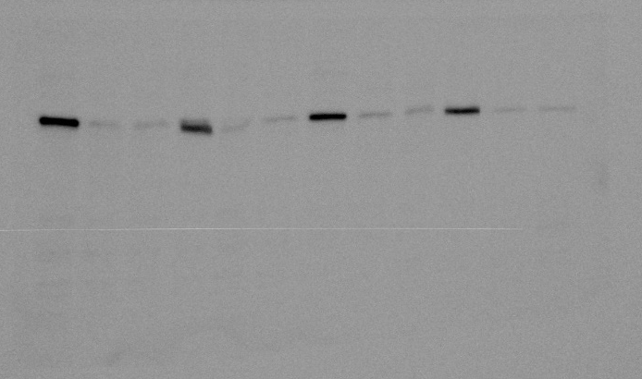
54kDa
total-Akt
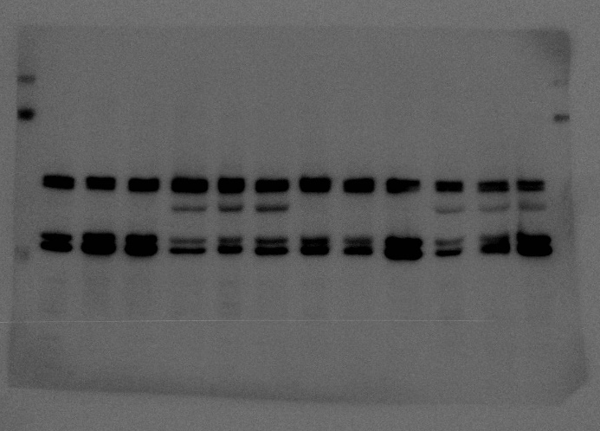
60kDa

phospho-Akt
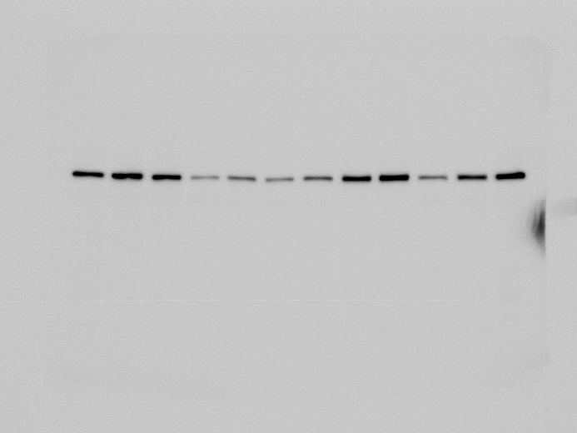
60kDa
total-S6
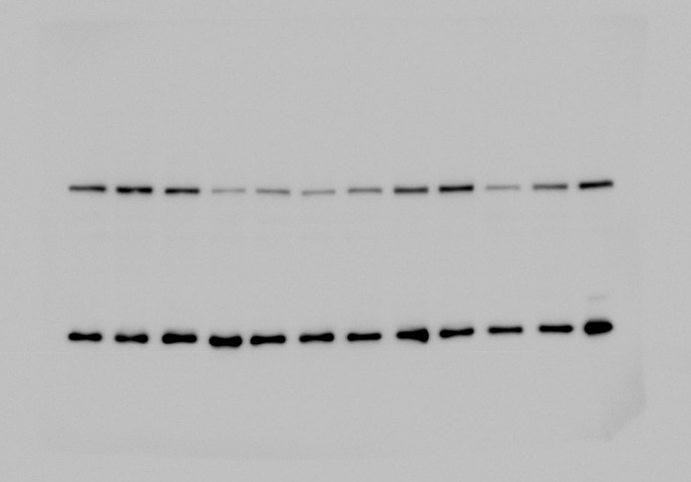
32kDa
phospho-S6
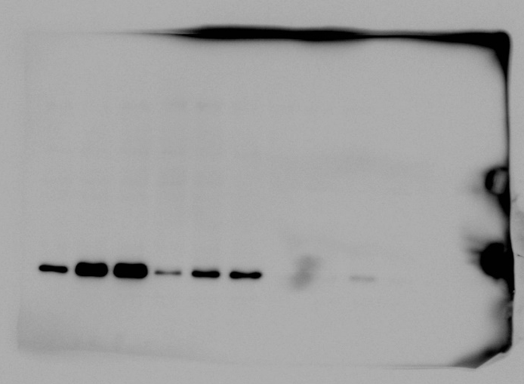
32kDa

total-ERK
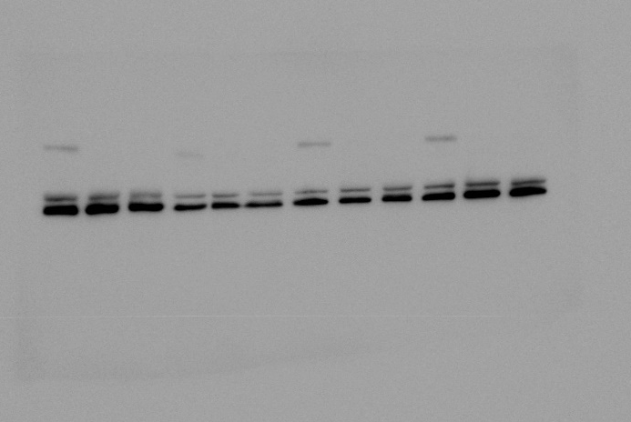
44, 42kDa
phospho-ERK
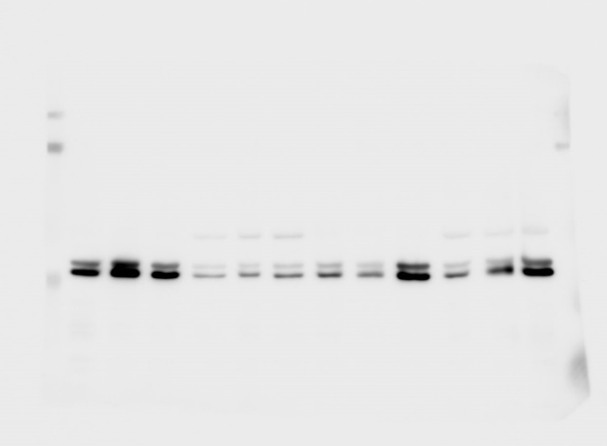
44, 42kDa
ACTB
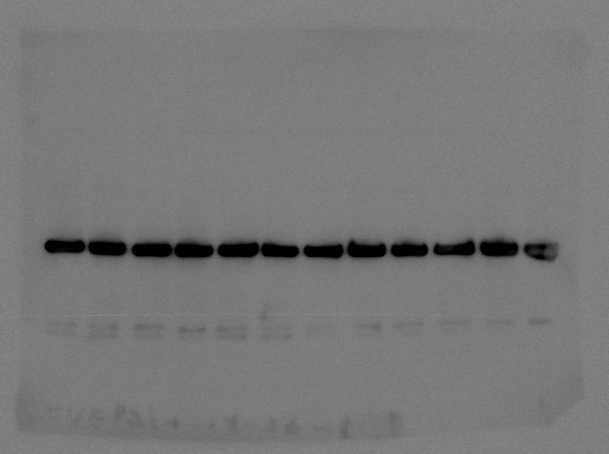

LY294002
HER2
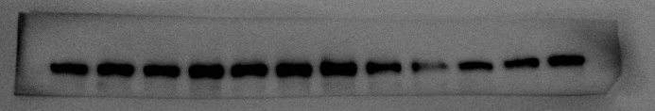
185kDa
PTEN
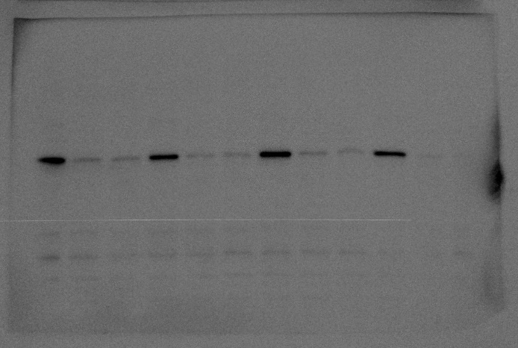
54kDa
total-Akt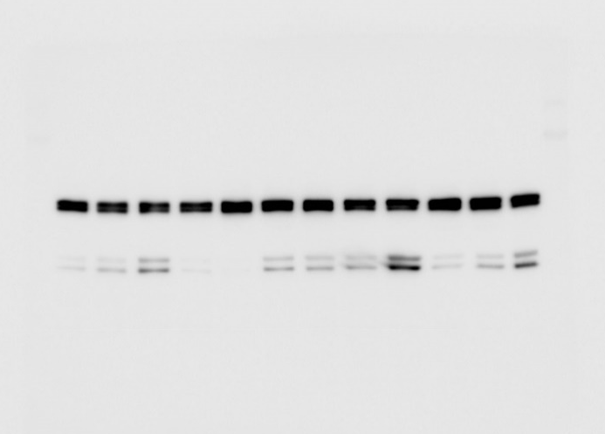
60kDa
phospho-Akt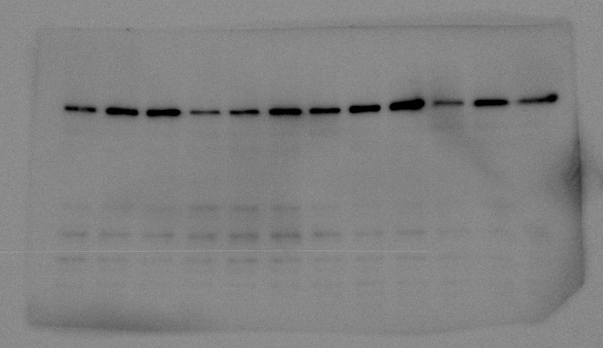
60kDa

total-S6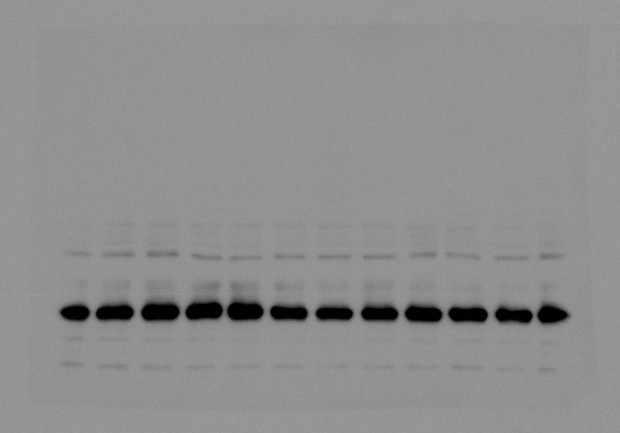
32kDa
phospho-S6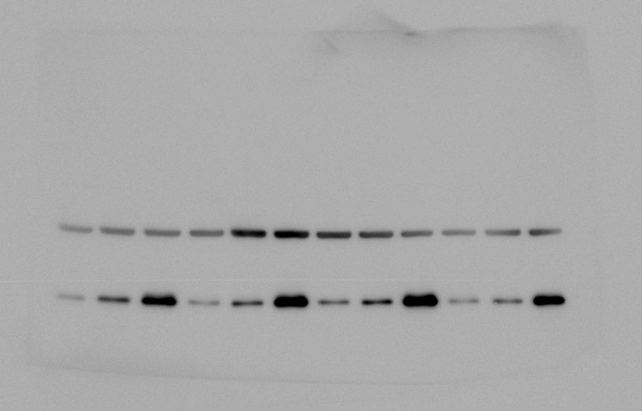
32kDa
total-ERK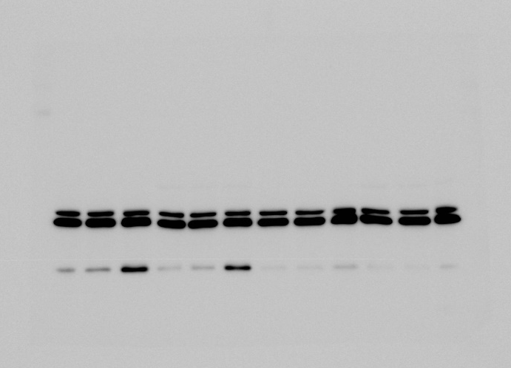
44, 42kDa

phospho-ERK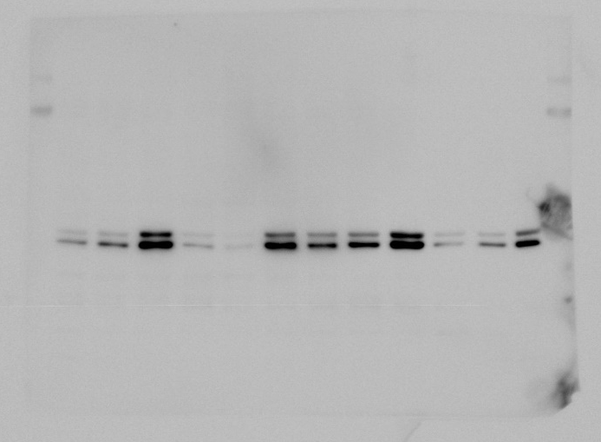
44, 42kDa
ACTB
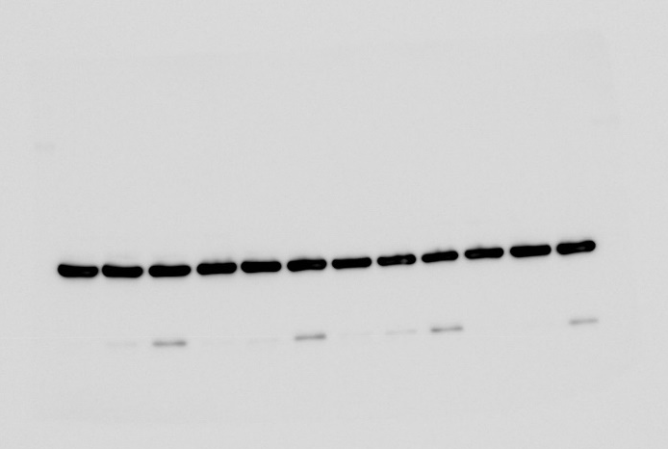

Everolimus
HER2
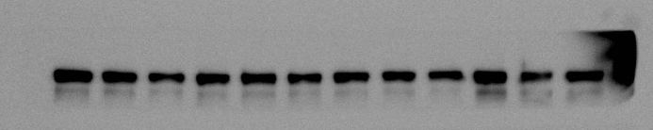
185kDa
PTEN
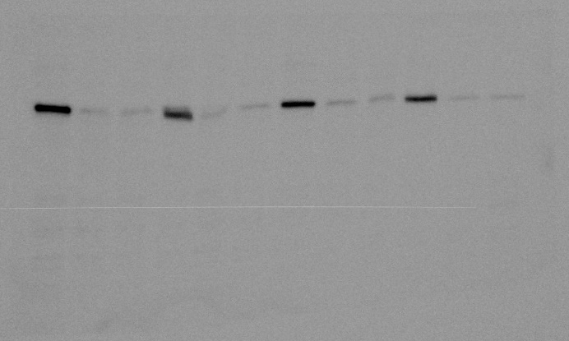
54kDa
total-Akt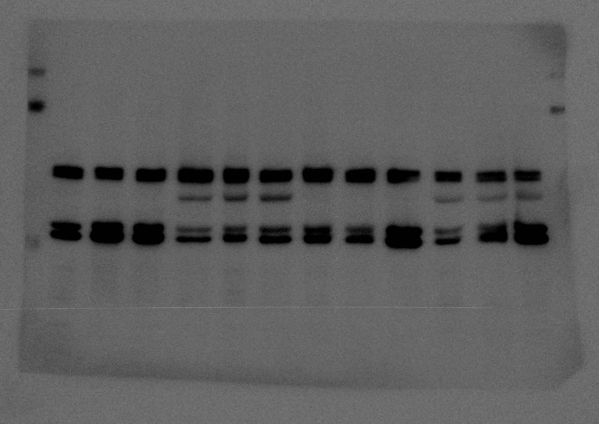
60kDa
phospho-Akt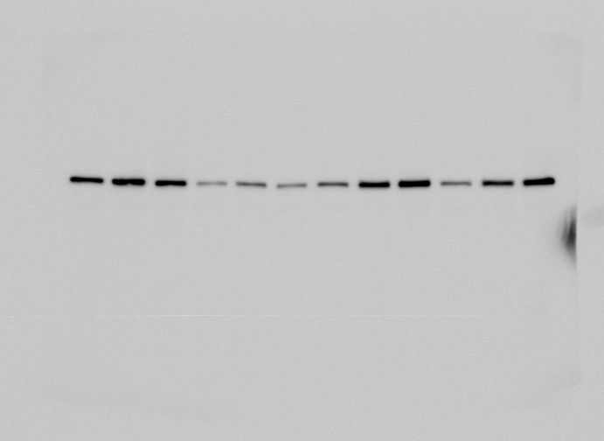
60kDa

total-S6 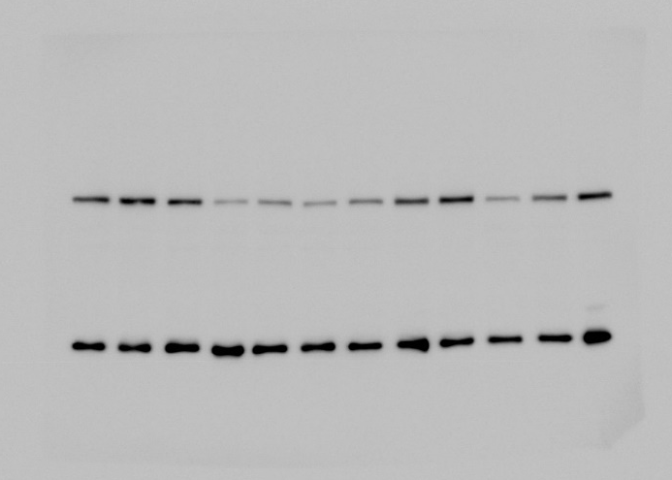
32kDa
phospho-S6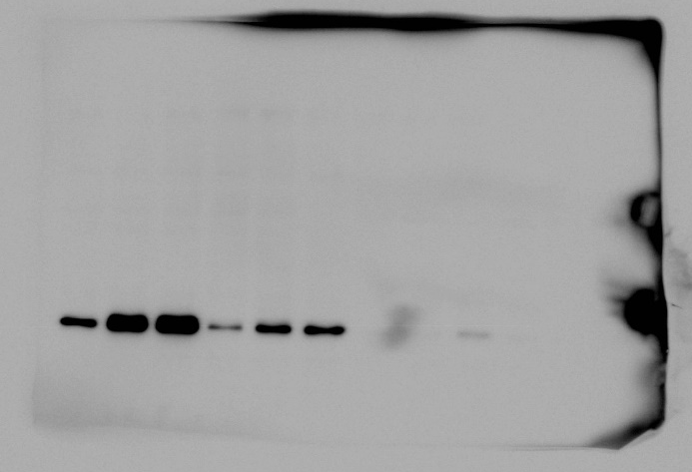
32kDa
total-ERK 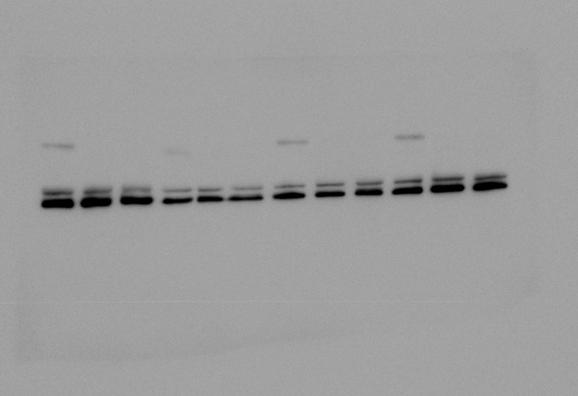
44, 42kDa

phospho-ERK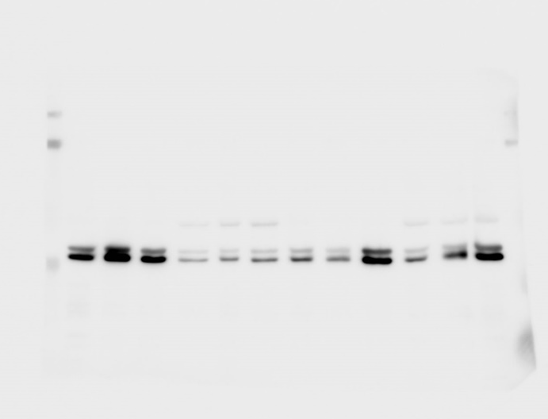
44, 42kDa
ACTB 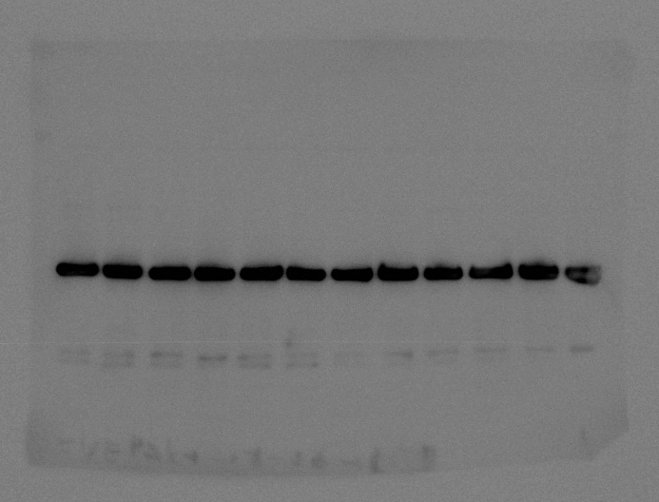

MK2206
HER2
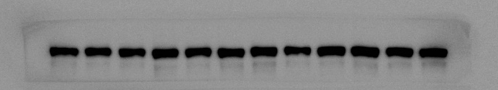
185kDa
PTEN
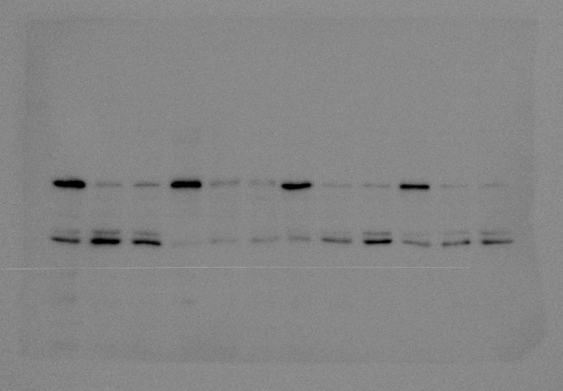
total-Akt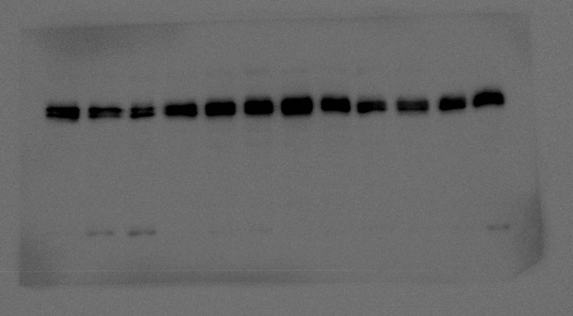
60kDa
phospho-Akt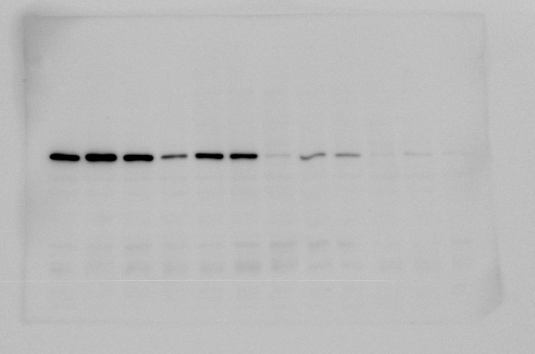
60kDa

total-S6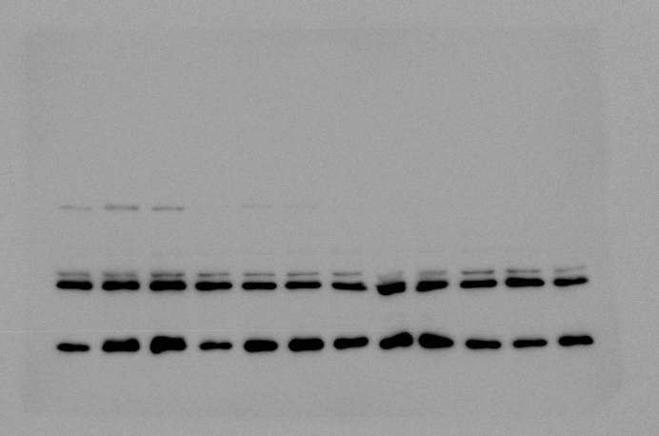
32kDa
54kDa
phospho-S6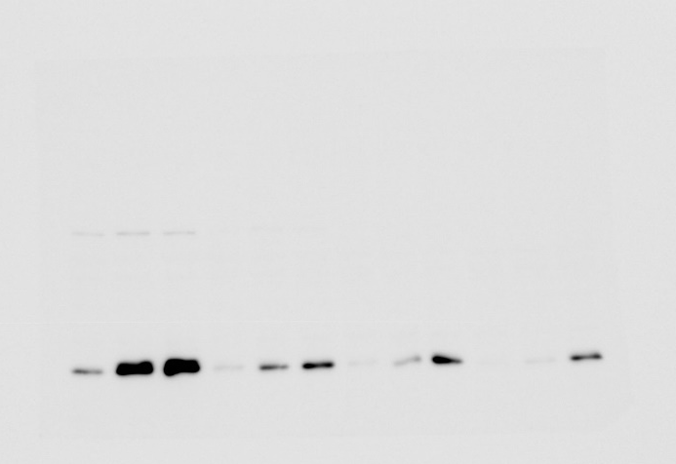
32kDa
total-ERK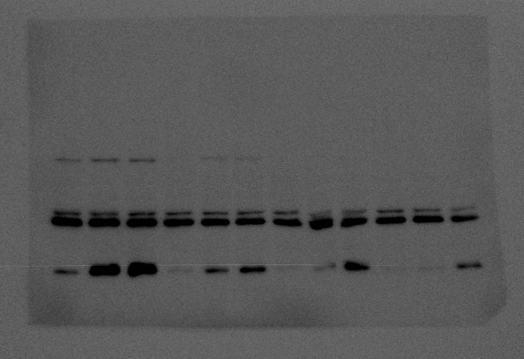
44, 42kDa

phospho-ERK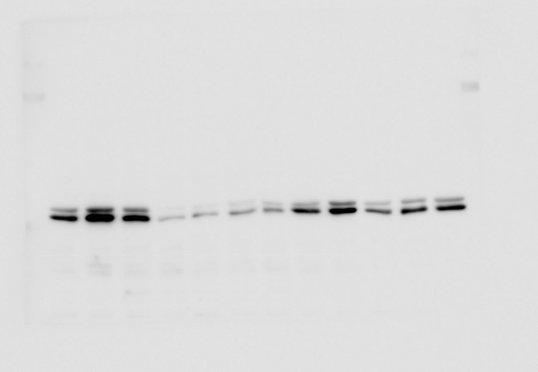
44, 42kDa
ACTB
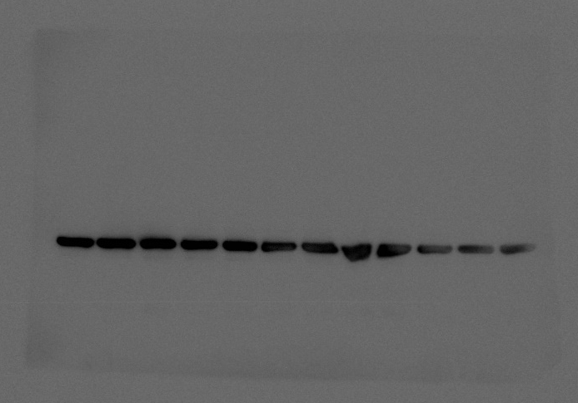

NVP-BEZ235
HER2
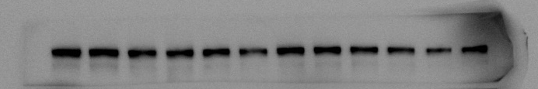
185kDa
PTEN
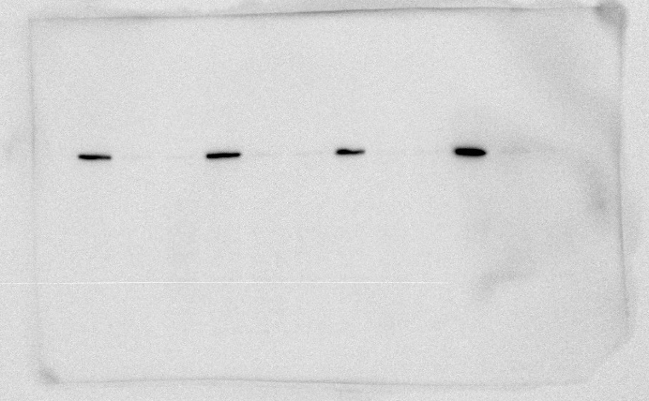
54kDa
total-Akt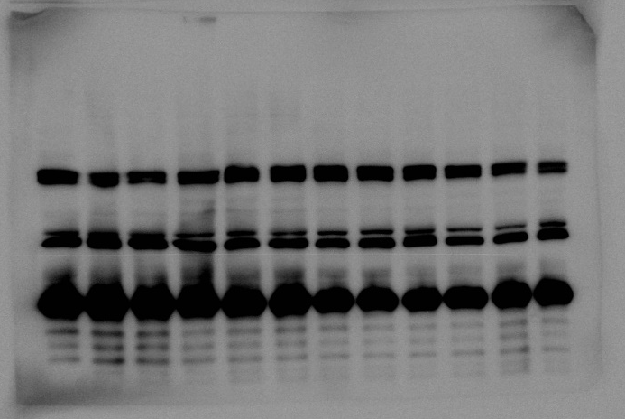
60kDa
phospho-Akt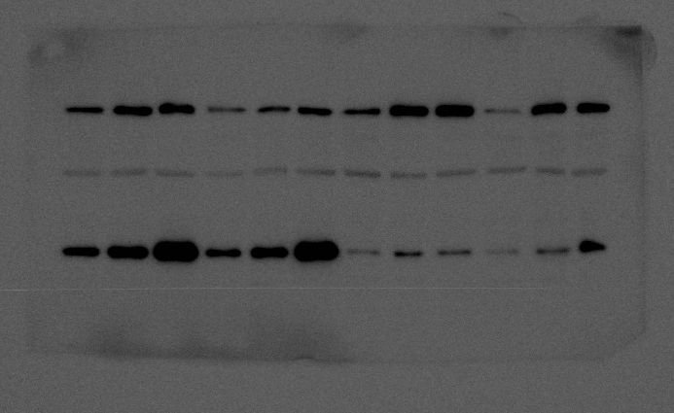
60kDa

total-S6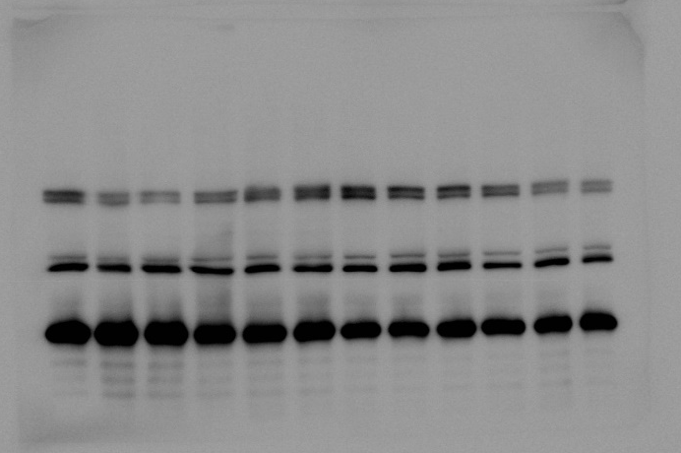
32kDa
phospho-S6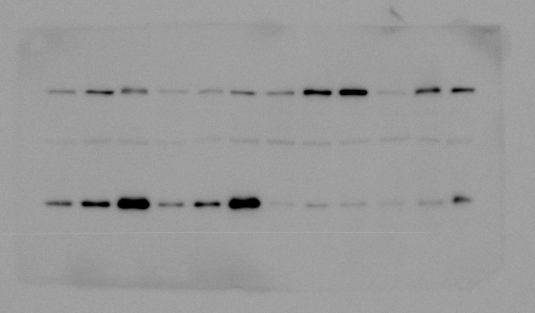
32kDa
total-ERK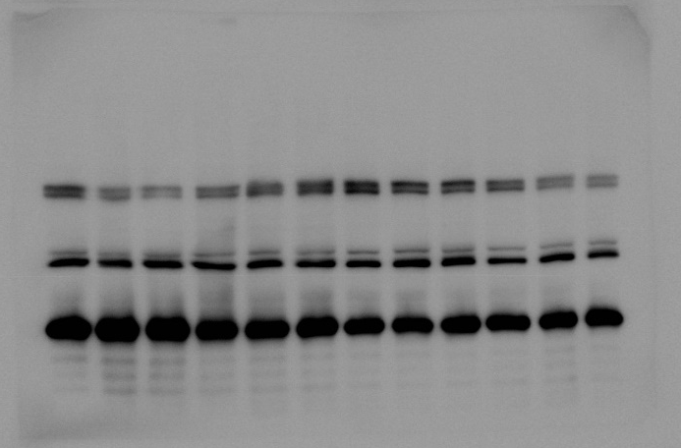
44, 42kDa

phospho-ERK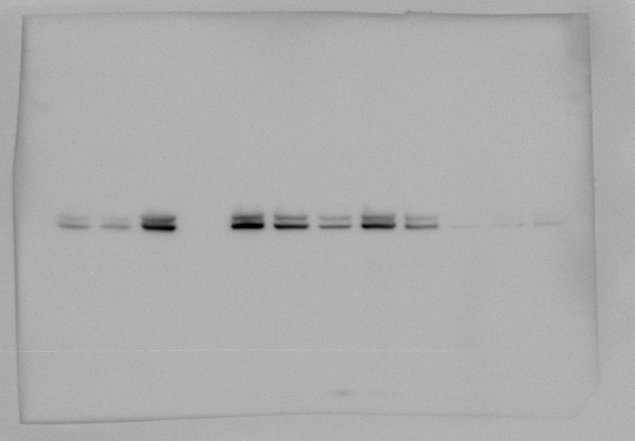
44, 42kDa
ACTB
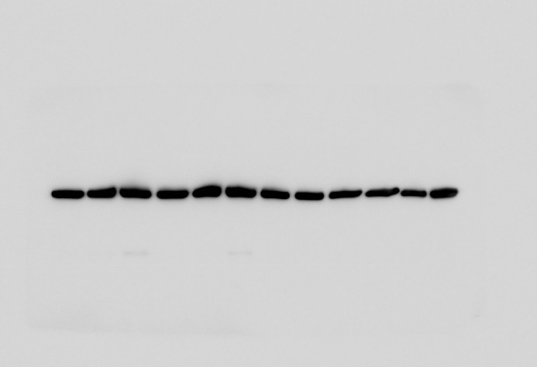

Supplementary Figure 1
N87
HER2
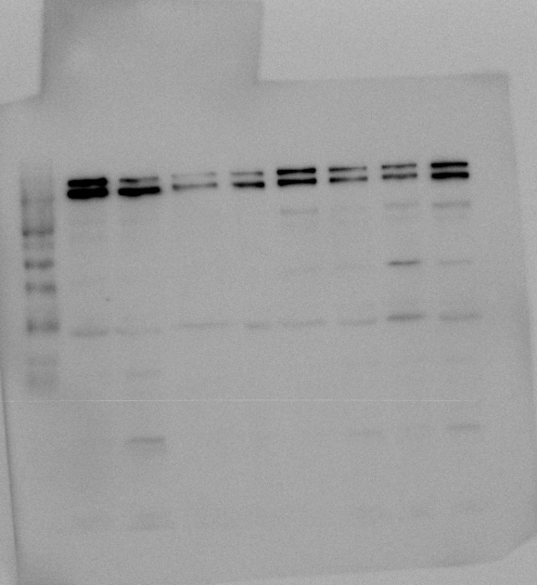
185kDa
PTEN
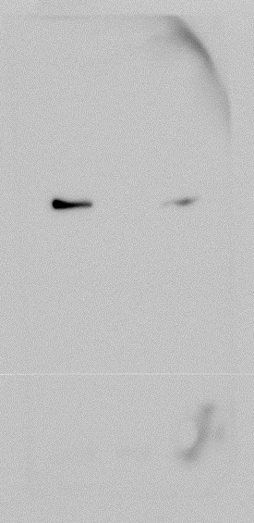
54kDa
ACTB
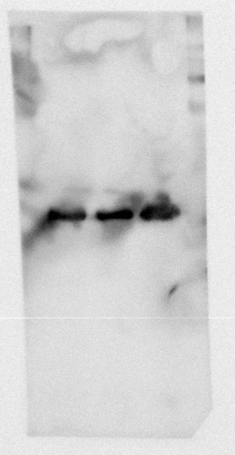

OE19
HER2
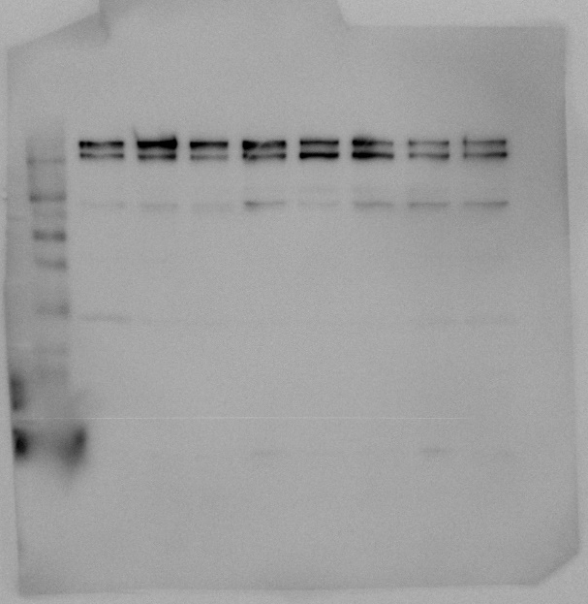
185kDa
PTEN
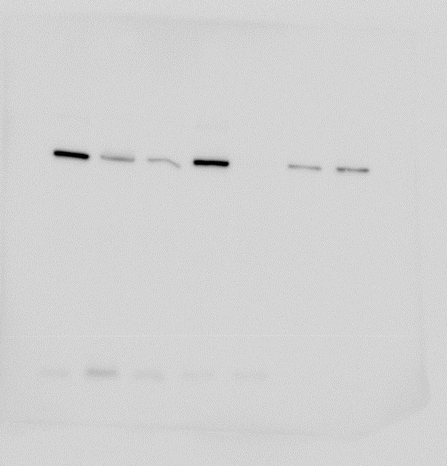
54kDa
ACTB
