Facile synthesis of hydrous zirconia-impregnated chitosan beads as a filter medium for efficient removal of phosphate from water

Zhiyong Zhang, Tang Liu, and Deyi Wu*

School of Environmental Science and Engineering, Shanghai Jiao Tong University, No. 800, Dongchuan Road, Shanghai 200240, China

Table S1. Fitting results of the adsorption kinetic data of phosphate on the materials to the kinetic models
Kinetic model | HZCB-1 | Powder of HZCB-1 | Ferrolox
Pseudo-first-order model
k₁ (×10⁻³ min⁻¹) | 2.580 | 11.27 | 1.330
Q_{e1} (mg/g) | 19.51 | 19.56 | 10.47
R² | 0.9595 | 0.7853 | 0.9571
Pseudo-second-order model
k₂ (×10⁻⁴ min⁻¹) | 1.082 | 9.973 | 1.991
Q_{e2} (mg/g) | 20.86 | 20.15 | 11.60
R² | 0.9967 | 0.9994 | 0.9944
Elovich
α (mg/g min) | 0.1674 | 10.30 | 0.1128
β (g/mg) | 0.2891 | 0.4799 | 0.5674
R² | 0.9872 | 0.9544 | 0.9642
Intra-particle diffusion
k_{id, 1} (mg/g min^{-0.5}) | 0.4803 | 0.5753 | 0.2409
C₁ | -0.3753 | 6.448 | -0.0215
R2 1 | 0.9607 | 0.9420 | 0.9889
k_{id, 2} (mg/g min^{-0.5}) | 0.1247 | 0.0409 | 0.0766
C₂ | 10.19 | 17.28 | 5.100
R2 2 | 0.8720 | 0.7905 | 0.9127

Table S2. Fitting results of the adsorption isotherm data of phosphate on the investigated materials to the Langmuir model and the Freundlich model.
Materials | Langmuir model |  |  | Freundlich model
Materials | Q_{m}  (mg/g) | K_{L}  (L/mg) | R² | K_{F}  ((mg/g)·(mg/L)^{-1/n}) | n | R²
Chitosan | 13.16 | 0.0213 | 0.9277 | 0.534 | 1.507 | 0.9908
Hydrous zirconia | 27.32 | 0.4362 | 0.9963 | 14.693 | 7.734 | 0.9907
HZCB-1 | 42.02 | 0.1029 | 0.9927 | 13.351 | 4.363 | 0.9792
Ferrolox | 25.58 | 0.1405 | 0.9715 | 3.656 | 0.527 | 0.9875

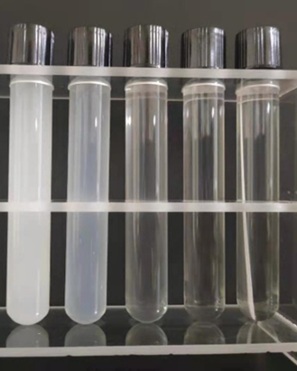
Fig. S1. Pictures of the mixed solutions of chitosan and zirconium oxychloride for the preparation of HZCBs. From left to right: HZCB-0.25; HZCB-0.5; HZCB-0.75; HZCB-1; HZCB-2.

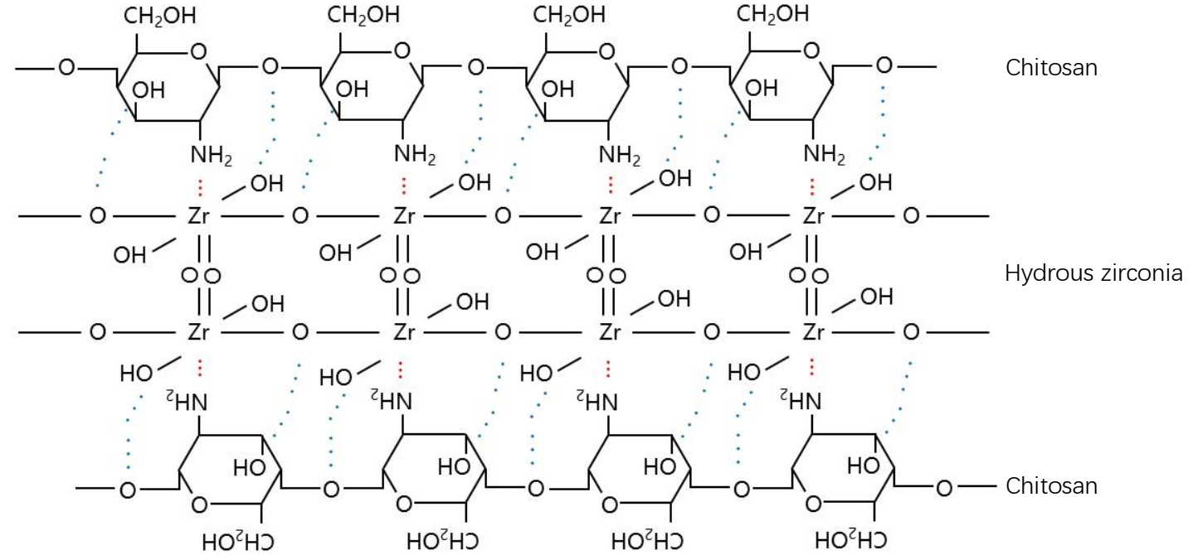

Fig. S2. A schematic diagram shows the interactions between hydrous zirconia and chitosan in the HZCBs and their precursors. The blue dotted line depicts the hydrogen bonding while the red dotted line represents the coordination bonding. The free hydroxyls on hydrous zirconia are responsible for the uptake of phosphate. The extensive hydrogen bonding among chitosan molecules was omitted in this figure.

* Corresponding author. E-mail address: dywu@sjtu.edu.cn (D. Y. Wu).

