Supplementary Material
Novel drug discovery against breast and lung cancer using pharmacophore based 2H-1-benzopyran-2-one derivative
Akhilesh Kumar Maurya, Nidhi Mishra*
Chemistry laboratory, Department of Applied Sciences, Indian Institute of Information Technology Allahabad, Prayagraj, India-211012

Table S1: Pharma score of compounds active against Breast cancer cell lines

HypoID | Survival | Site | Vector | Volume | Select | Matches | Inactive | Adjusted | BEDROC | RefLig
AAARR_1 | 4.6775 | 0.981 | 0 | 0.5073 | 1.3696 | 66 | 1.4651 | 3.2123 | 0.9684 | mol_45
AARR_1 | 4.4344 | 0.9844 | 0 | 0.5078 | 1.1226 | 66 | 1.4693 | 2.9651 | 0.9565 | mol_45
AARR_2 | 4.4313 | 0.9847 | 0 | 0.5073 | 1.1197 | 66 | 1.4683 | 2.963 | 0.8549 | mol_45
AARR_3 | 4.4079 | 0.9817 | 0 | 0.5075 | 1.0991 | 66 | 1.4651 | 2.9428 | 0.9489 | mol_45
AAAR_1 | 4.3161 | 0.9802 | 0 | 0.5072 | 1.0092 | 66 | 1.4641 | 2.8521 | 0.9676 | mol_45
AAAR_2 | 4.2972 | 0.9831 | 0 | 0.5061 | 0.9885 | 66 | 1.4665 | 2.8307 | 0.9617 | mol_45

HypoID | Survival | Site | Vector | Volume | Select | Matches | Inactive | Adjusted | BEDROC | RefLig
AAARR_1 | 4.6469 | 0.9992 | 0 | 0.608 | 1.3677 | 47 | 1.5717 | 3.0753 | 0.9808 | mol_47
AAARR_2 | 4.1247 | 0.6934 | 0 | 0.3494 | 1.4099 | 47 | 1.1493 | 2.9754 | 0.8953 | mol_34
AARR_1 | 4.4015 | 0.9991 | 0 | 0.608 | 1.1223 | 47 | 1.5716 | 2.8299 | 0.9704 | mol_47
AARR_2 | 4.3985 | 0.9992 | 0 | 0.608 | 1.1192 | 47 | 1.5718 | 2.8268 | 0.8731 | mol_47
AARR_3 | 4.3766 | 0.9991 | 0 | 0.6079 | 1.0974 | 47 | 1.5716 | 2.805 | 0.9678 | mol_47
AAAR_1 | 4.2866 | 0.9991 | 0 | 0.608 | 1.0074 | 47 | 1.5716 | 2.715 | 0.9796 | mol_47
AAAR_2 | 4.2669 | 0.9997 | 0 | 0.6081 | 0.987 | 47 | 1.5724 | 2.6945 | 0.9653 | mol_47
Table S2: Pharma score of compounds active against Breast cancer Lung cancer cell lines

Table S3: Pharmacophoric screened Compounds from library against their respective pharmacophoric hypothesis
 | Compounds screen against Breast Cancer |  |  |  | Compounds screen against Lung Cancer
Sr. No. | PUBCHEM CID | Volume Score | Fitness | PhaseScreen  Score | PUBCHEM CID | Volume Score | Fitness | PhaseScreen  Score
1 | 6228345 | 0.689 | 1.689 | 1.689 | 129834282 | 0.801 | 1.738 | 1.738
2 | 101030530 | 0.681 | 1.678 | 1.678 | 129657348 | 0.777 | 1.735 | 1.735
3 | 44479225 | 0.674 | 1.674 | 1.674 | 5338538 | 0.764 | 1.725 | 1.725
4 | 24762091 | 0.655 | 1.654 | 1.654 | 5338538 | 0.762 | 1.723 | 1.723
5 | 5390004 | 0.652 | 1.652 | 1.652 | 54724919 | 0.741 | 1.717 | 1.717
6 | 665507 | 0.651 | 1.651 | 1.651 | 5428528 | 0.756 | 1.716 | 1.716
7 | 101030533 | 0.653 | 1.65 | 1.65 | 5428531 | 0.751 | 1.715 | 1.715
8 | 101030539 | 0.649 | 1.649 | 1.649 | 5428528 | 0.753 | 1.715 | 1.715
9 | 101030524 | 0.648 | 1.648 | 1.648 | 25128694 | 0.779 | 1.714 | 1.714
10 | 1143424 | 0.641 | 1.641 | 1.641 | 5428531 | 0.751 | 1.713 | 1.713
11 | 90112495 | 0.639 | 1.639 | 1.639 | 16394697 | 0.753 | 1.711 | 1.711
12 | 5281406 | 0.639 | 1.639 | 1.639 | 54724919 | 0.737 | 1.703 | 1.703
13 | 9551622 | 0.64 | 1.635 | 1.635 | 86733970 | 0.715 | 1.676 | 1.676
14 | 2045080 | 0.634 | 1.634 | 1.634 | 129872951 | 0.725 | 1.66 | 1.66
15 | 101030538 | 0.636 | 1.633 | 1.633 | 129733712 | 0.679 | 1.657 | 1.657
16 | 16194470 | 0.638 | 1.632 | 1.632 | 15257669 | 0.718 | 1.654 | 1.654
17 | 24762091 | 0.636 | 1.631 | 1.631 | 18504520 | 0.694 | 1.651 | 1.651
18 | 101030535 | 0.633 | 1.631 | 1.631 | 129872951 | 0.715 | 1.645 | 1.645
19 | 101030540 | 0.63 | 1.63 | 1.63 | 132277625 | 0.697 | 1.643 | 1.643
20 | 20864864 | 0.635 | 1.629 | 1.629 | 129733712 | 0.683 | 1.641 | 1.641

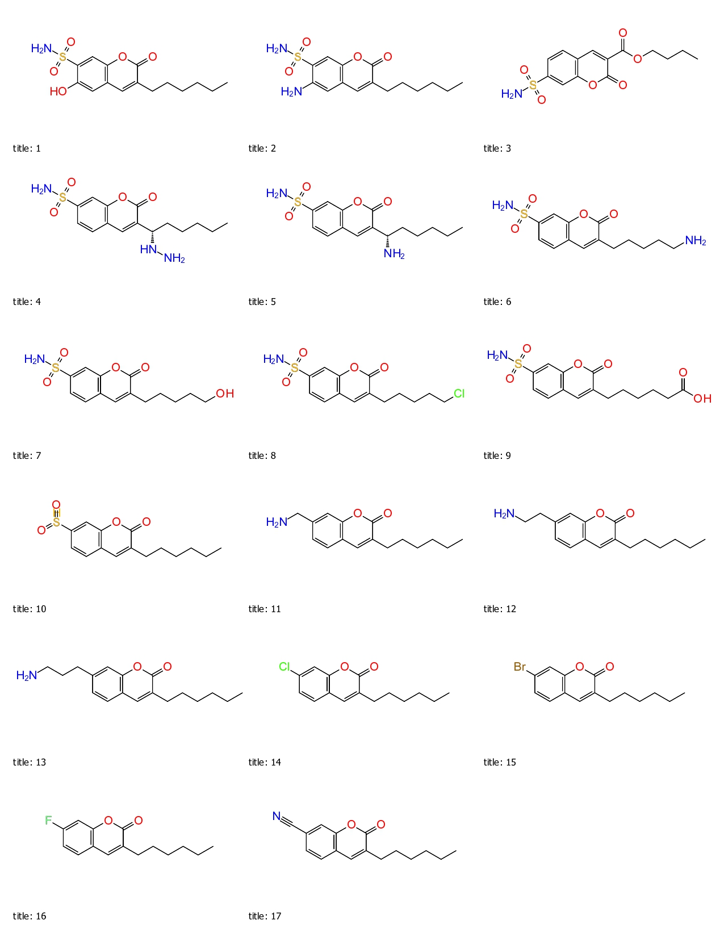
Figure S1: Designed structure against Breast cancer
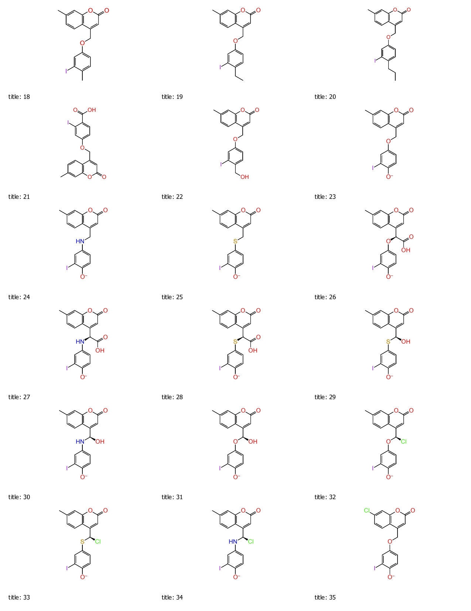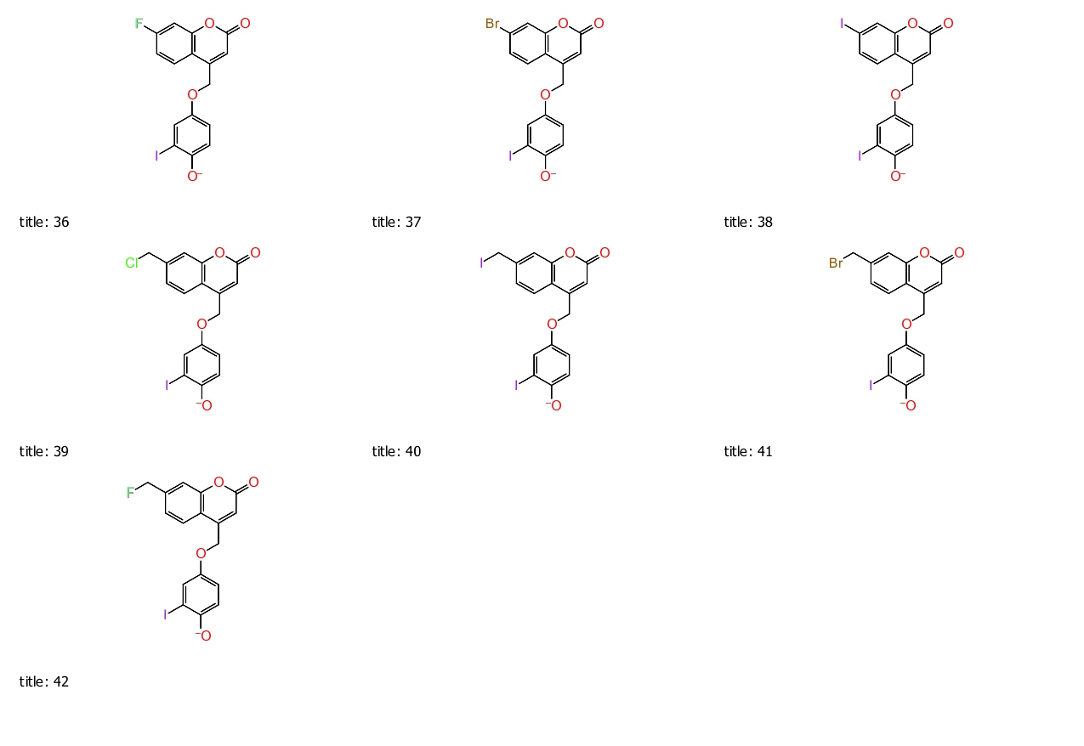
Figure S2: Designed structure against Lung cancer

