Supplementary Information for

Redox evolution during arc magma differentiation revealed by mineral/melt Fe³⁺ and Fe²⁺ partitioning

This PDF file includes:

Supplementary Text1
Supplementary Figures (Fig. S1 to S4)

Other Supplementary Information for this manuscript include the following:

Supplementary Tables (1-5) (in Excel)
Supplementary Text2: A related manuscript which is now under review in GCA and will be attached as “Supplementary Information” (in PDF)

Supplementary Text1

1. The derivation of the Equation 1
At equilibrium condition, DFe³⁺ between mineral and melt can be expressed as:
${\text{DFe}}^{\text{3+}}\text{=}\frac{{\text{C}}_{{\text{Fe}}^{\text{3+}}}^{\text{min}}}{{\text{C}}_{{\text{Fe}}^{\text{3+}}}^{\text{melt}}}\text{=}\frac{{\text{C}}_{{\text{Fe}}_{\text{T}}}^{\text{min}}\text{-}{\text{C}}_{{\text{Fe}}^{\text{2+}}}^{\text{min}}}{{\text{C}}_{{\text{Fe}}_{\text{T}}}^{\text{melt}}{\text{-C}}_{{\text{Fe}}^{\text{2+}}}^{\text{melt}}}$ (I)
Dividing the numerator and denominator of equation (1) by ${\text{C}}_{{\text{Fe}}_{\text{T}}}^{\text{melt}}$, we obtain:
${\text{DFe}}^{\text{3+}}\text{=}\frac{{\text{DFe}}_{\text{T}}\text{-}{\text{C}}_{{\text{Fe}}^{\text{2+}}}^{\text{min}}\text{/}{\text{C}}_{{\text{Fe}}_{\text{T}}}^{\text{melt}}}{\text{1-}{{\text{(Fe}}^{\text{2+}}}/{{\text{Fe}}_{\text{T}}{\text{)}}^{\text{melt}}}}$ (II)
Because ${\text{C}}_{{\text{Fe}}^{\text{2+}}}^{\text{min}}\text{=}{{\text{DFe}}^{\text{2+}}\text{×C}}_{{\text{Fe}}^{\text{2+}}}^{\text{melt}}$ (III) and ${\text{C}}_{{\text{Fe}}^{\text{2+}}}^{\text{melt}}\text{/}{\text{C}}_{{\text{Fe}}_{\text{T}}}^{\text{melt}}\text{=1-}{{\text{(Fe}}^{\text{3+}}}/{{\text{Fe}}_{\text{T}}{\text{)}}^{\text{melt}}}$ (IV), where ${\text{C}}_{{\text{Fe}}^{\text{3+}}}^{\text{min}}$, ${\text{C}}_{{\text{Fe}}^{\text{2+}}}^{\text{min}}$, ${\text{C}}_{{\text{Fe}}_{\text{T}}}^{\text{min}}$, ${\text{C}}_{{\text{Fe}}^{\text{3+}}}^{\text{melt}}$, ${\text{C}}_{{\text{Fe}}^{\text{2+}}}^{\text{melt}}$, and${\text{C}}_{{\text{Fe}}_{\text{T}}}^{\text{melt}}$ are Fe³⁺, Fe²⁺ and Fe_{T} contents in mineral and melt, and ${{\text{(Fe}}^{\text{3+}}}/{{\text{Fe}}_{\text{T}}{\text{)}}^{\text{melt}}}$ is the ratio of Fe³⁺ to Fe_{T} in the melt. Combining Eqs. 2‒4 and rearrange, the DFe³⁺ can be expressed as:
$\text{DFe}\text{3+}\text{=}\frac{\text{DFe}\text{T}\text{-DFe}\text{2+}}{{\text{(Fe}\text{3+}\text{/Fe}\text{T}\text{)}}^{\text{melt}}}\text{+DFe}\text{2+}$ (V)
Equation (V) (i.e. Equation 1 in the main text) indicates that DFe³⁺ can be obtained when DFe_{T}, DFe²⁺ and ${\text{(Fe}\text{3+}\text{/}\text{Fe}\text{T}\text{)}}^{\text{melt}}$ are accurately determined.

2. The relationship amongst lnKd, ΔH/T, PΔV/T and W_{FeMg}/T
${\text{Kd}}_{{\text{Fe}}^{\text{2+}}\text{-Mg}}$ is the ratio of DFe²⁺ (CFe²⁺_{mineral}/CFe²⁺_{melt}) to DMg (CMg _{mineral}/CMg _{melt}). For olivine, ${\text{Kd}}_{{\text{Fe}}^{\text{2+}}\text{-Mg}}$ can be described by the following equation^{65,20}:
$\text{lnKd}\text{=}\frac{\text{T∆S-∆H-P∆V+}{\text{W}}_{\text{FeMg}}\left(\text{1-2Mg\#}\right)}{\text{RT}}$ (S1)
where T, P, ΔS, ΔH and ΔV are the, temperature (in kelvin), pressure (in bars), enthalpy, entropy and volume changes of the following reaction: Fe₂SiO₄(melt) + Mg₂SiO₄(olivine) = Fe₂SiO₄(olivine)+ Mg₂SiO₄(melt), respectively. W_{FeMg} is a symmetrical regular solution interaction parameter for the forsterite–fayalite binary solid solution. Mg# is MgO/(MgO+FeO) in mole of mineral and R is gas constant. Because Eq. (1) describes a universal relation between Fe²⁺- and Mg- end member of ferromagnesian minerals, ${\text{Kd}}_{{\text{Fe}}^{\text{2+}}\text{-Mg}}$ for amphibole should follow the similar formula. To explore the effects of temperature, pressure and mineral composition on lnKd of amphibole, we collected amphibole-melt pairs from reduced experiments where DFe_{T} approximates DFe²⁺ and evaluated the relationship amongst lnKd, ΔH/T, PΔV/T and W_{FeMg}/T (Table S1). Our results reveal that, similar to olivine, lnKd for amphibole also do not change dramatically with 1/T, P/T and (1−Mg#)/T and Kd do not change with DMg (Fig. S1). Therefore, for amphibole, the relation between DFe²⁺ and DMg could be described in the form of DFe²⁺ = a*DMg+b, where a and b arc constants.

3. Introduction of the redox modeling processes
We investigated the fO₂ evolution by exploring how the Fe³⁺/Fe²⁺ (i.e. Fe³⁺/Fe_{T}) varies during arc magma differentiation on the basis of the fractional crystallization experiments of Ulmer et al.⁹. The Fe³⁺/Fe²⁺ ratio relies on Fe³⁺ and Fe²⁺ contents (CFe³⁺ and CFe³⁺) of the melt. During near fractional crystallization, CFe³⁺ and CFe³⁺ at each step can be calculated using the following equations:
C_{L}Fe³⁺= C₀Fe³⁺/ (1+DFe³⁺tot * (1-F)) (S2)
C_{L}Fe²⁺= C₀Fe²⁺/ (1+DFe²⁺tot * (1-F)) (S3)
where C₀Fe³⁺ and C₀Fe²⁺ are Fe³⁺ and Fe²⁺ contents in the primary melt, F is the fraction of residual melt at the step and DFe³⁺tot and DFe²⁺tot are the bulk Fe³⁺ and Fe²⁺ partition coefficient of the fractionating mineral assemblage. At each step, the F was reported in Ulmer et al.⁹ and the DFe³⁺tot and DFe²⁺tot are weighted average of DFe²⁺ and DFe³⁺ for each mineral, respectively.
${\text{DFe}}^{\text{3+}}\text{tot=}\sum_{\text{i=1}}^{\text{n}}{{\text{DFe}}_{\text{i}}^{\text{3+}}\text{×}{\text{W}}_{\text{i}}}$ (S4)
${\text{DFe}}^{\text{2+}}\text{tot=}\sum_{\text{i=1}}^{\text{n}}{{\text{DFe}}_{\text{i}}^{\text{2+}}\text{×}{\text{W}}_{\text{i}}}$ (S5)
where W_{i} is the percentage proportion of mineral i and DFe³⁺_{i} and DFe²⁺_{i} are partition coefficients for Fe³⁺ and Fe²⁺ in mineral i.
At each step, DFe²⁺ of silicate minerals are calculated from the DMg in the experiments (Eqs. 3−5) and that of mag and spl are calculated from the experimental temperature (Eqs. 11−12). For the case of DFe³⁺, we first calculated the DFe³⁺/DFe²⁺ ratio for different minerals (Eqs. 6−10) and then multiply it by DFe²⁺ to acquire the DFe³⁺ of different minerals at given condition. Following the above rationale, we performed fractional crystallization modelling by assuming Fe³⁺/Fe_{T} of the primitive arc basalts equals 0.2(±0.05). Details for the modelling processes are summarized in data file S5 and the modelling results are reported in Fig.7.

Supplementary Figures
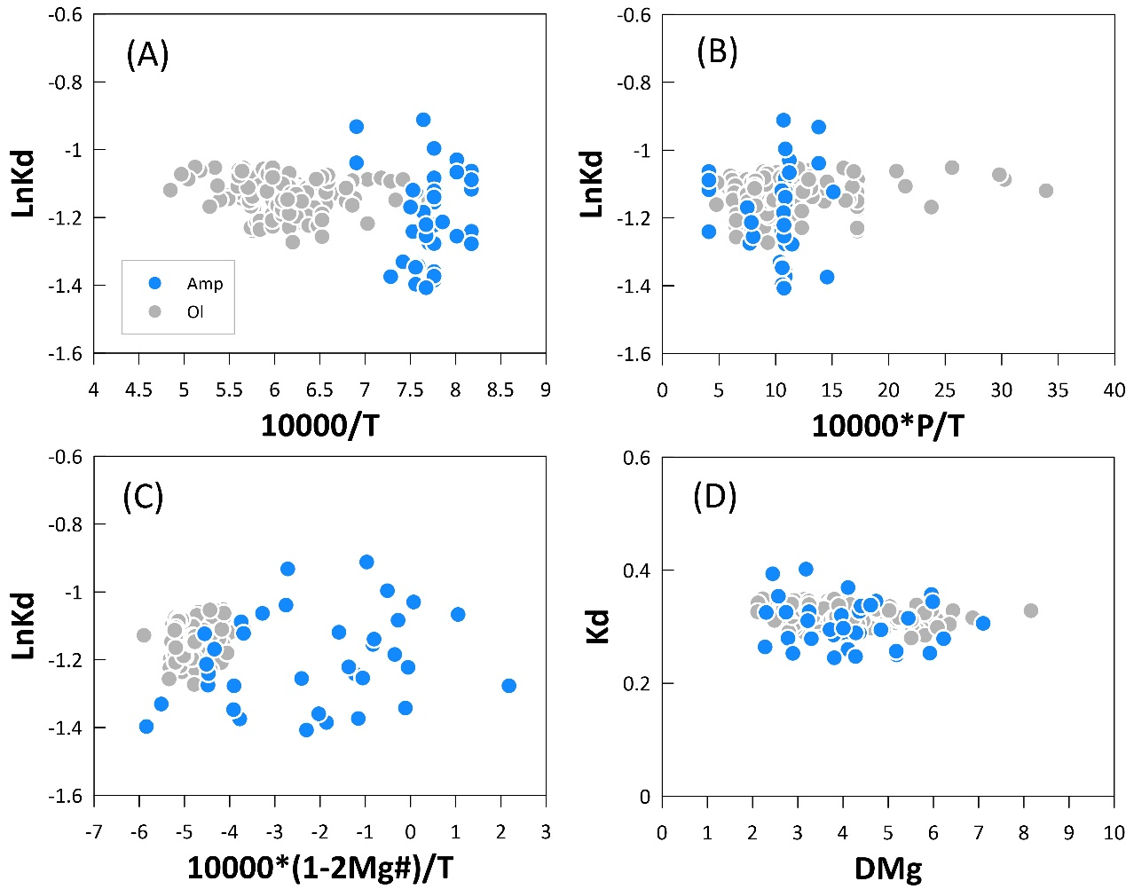
Fig. S1. The effects of temperature, pressure, mineral composition and DMg on Fe²⁺−Mg exchange partition coefficient between amphibole and melt. (A) lnKd vs. 10000/T. (B) lnKd vs. 10000*P/T. (C) lnKd vs. 10000*(1-2Mg#)/T. (D) Kd vs. DMg. [Data sources: Adam and Green³⁷; King et al.²⁸; Tiepolo et al.³⁸; Li et al.³⁴; Ulmer et al.⁹]. The olivine data compiled by X in related manuscript are plotted for comparison.

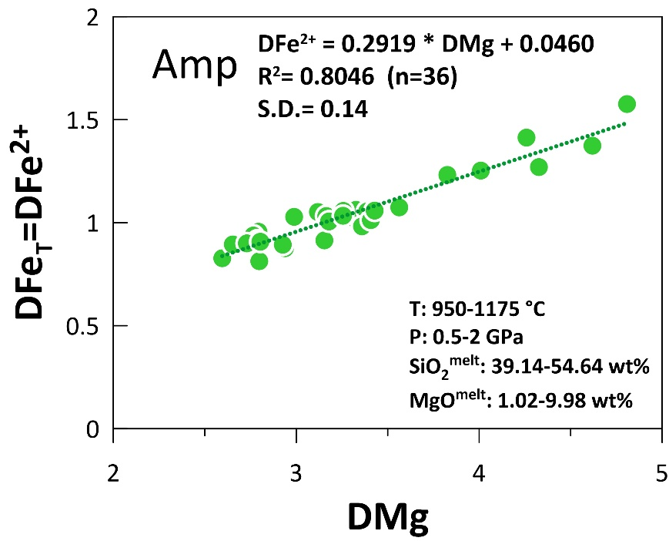
Fig. S2. Linear regression of DFe²⁺ (represented by DFe_{T}) as a function of DMg. Insert shows the T and P ranges of the collected experimental amphibole-melt pairs and SiO₂ and MgO contents of the coexisting melt.
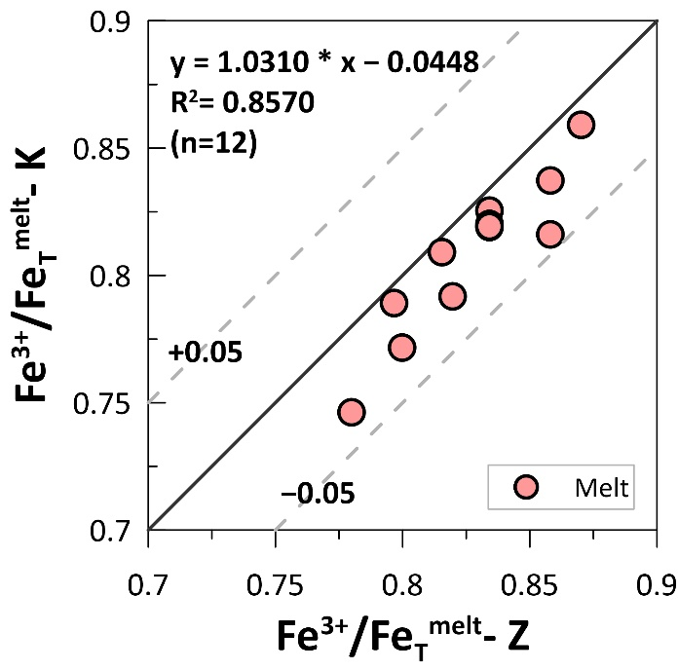
Fig. S3. A comparison of the Fe³⁺/Fe_{T} in our experimental melts calculated from Zhang et al.¹⁸ [abbr. Fe³⁺/Fe_{T}^{melt} -Z] and Kress and Carmichael¹⁷ [abbr. Fe³⁺/Fe_{T}^{melt} -K]. The difference between these two methods is within 0.05 (light grey dashed line), demonstrating the accuracy of both methods.
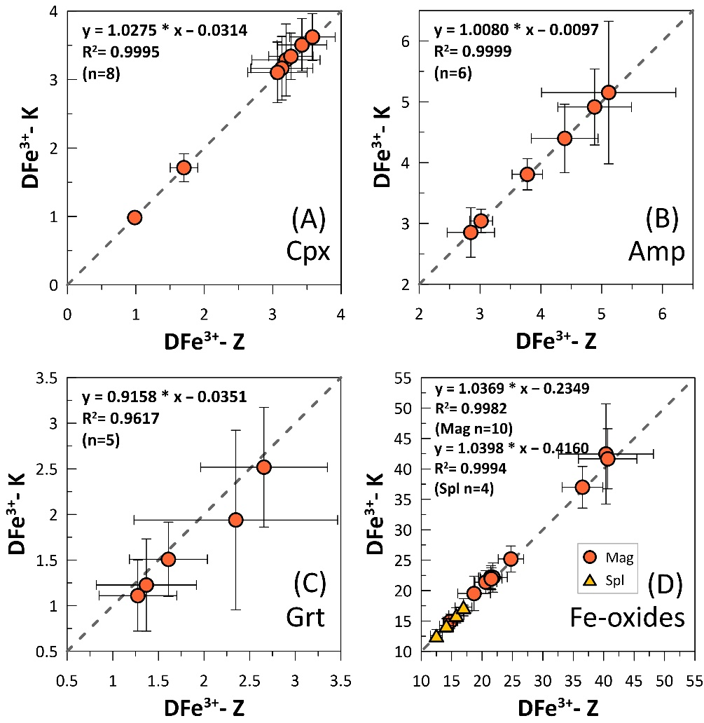
Fig. S4. Comparisons of DFe³⁺ respectively calculated from Fe³⁺/Fe_{T}^{melt} of Zhang et al.¹⁸[abbr. DFe³⁺-Z] and Kress and Carmichael¹⁷ [abbr. DFe³⁺-K]. (A) Cpx. (B) Amp. (C) Grt. (D) Mag and Spl. The good agreement between the calculated DFe³⁺ indicate the accuracy of the DFe³⁺ no matter which method was used in Fe³⁺/Fe_{T}^{melt} calculation.

Supplementary Table 1. (separate xlsx file)
Collected amphibole and coexisting melt composition data for DFe²⁺ linear fitting from references.

Supplementary Table 2. (separate xlsx file)
Conditions and run products of the experiments.

Supplementary Table 3. (separate xlsx file)
Major element compositions of quenched melt(a), clinopyroxene(b), amphibole(c), garnet(d), magnetite(e) spinel(f) and allanite(g).

Supplementary Table 4. (separate xlsx file)
DFe³⁺and DFe²⁺ for clinopyroxene(a), amphibole(b), garnet(c), magnetite(d), spinel(e) and orthopyroxene(f) from this study and literatures (italics).

Supplementary Table 5. (separate xlsx file)
Parameters of redox evolution modeling of a high-Mg basalt (mb) and a high-Mg basaltic andesite (ba).

