Efficient electrocatalytic reduction of CO₂ to ethane over nitrogen-doped Fe₂O₃

Peng Chen^{1,2}, Pei Zhang¹,* Xinchen Kang^{1,2}, Lirong Zheng³, Guang Mo³, Ruizhi Wu^{1,2}, Jing Tai¹, Buxing Han^{1,2,4,5}*

1. Institute of Chemistry, Chinese Academy of Science, Beijing, 100190 (China)
2. School of Chemistry, University of Chinese Academy of Sciences
3. Beijing Synchrotron Radiation Facility, Institute of High Energy Physics, Chinese Academy of Sciences, Beijing, 100049 (China)
4. Shanghai Key Laboratory of Green Chemistry and Chemical Processes, School of Chemistry and Molecular Engineering, East China Normal University, Shanghai 200062, China.
5. Institute of Eco-Chongming, 20 Cuiniao Road, Chenjia Town, Chongming District, Shanghai, 202162 (China)

Methods
EXAFS study. The X-ray absorption fine structure spectra (Fe K-edge) were collected at 1W1B station in Beijing Synchrotron Radiation Facility (BSRF). The storage rings of BSRF were operated at 2.5 GeV with an average current of 250 mA. Using Si (111) double-crystal monochromator, the data collection was carried out in transmission mode using ionization chamber. All spectra were collected in ambient conditions. The raw data were energy-calibrated, background corrected, and normalized using Ifeffit software. For the Fe K-edge measurements, Fe foil was used as reference.
The acquired EXAFS data were processed according to the standard procedures using the ATHENA module implemented in the IFEFFIT software packages. The k³-weighted EXAFS spectra were obtained by subtracting the post-edge background from the overall absorption and then normalizing with respect to the edge-jump step. Subsequently, k³-weighted χ(k) data of Fe K-edge were Fourier transformed to real (R) space using a hanning windows (d_{k}=1.0 Å⁻¹) to separate the EXAFS contributions from different coordination shells. To obtain the quantitative structural parameters around central atoms, least-squares curve parameter fitting was performed using the ARTEMIS module of IFEFFIT software packages.
Quasi in situ X-ray photoelectron spectra (XPS). The Quasi in situ X-ray photoelectron spectra (XPS) were measured on an AXIS ULTRA DLD spectrometer with AlKα resource (hv = 1486.6 eV). The samples were prepared in glove box and transferred to the XPS chamber for the measurement. For investigating the evolution of Fe, N and O species in the reaction process, catalysts were electrolyzed with time in the CO₂-saturated electrolytes. Then the samples were washed by acetone immediately and put into the glove box. Subsequently, the samples were cut into 33 mm and glued on a stage with a double sided adhesive. The stage was evacuated into vacuum to prevent the samples to be oxidized in the air. The subsequent testing processes were the same as that of the common X-ray photoelectron spectroscopy. The contaminated carbon C 1s signal at 284.8 eV was used to calibrate binding energies. The spectra were deconvolved with XPS PEAK 4.1 software by subtracting the Shirley background and applying the Lorentzian- Gaussian function.
Electrochemical study. Working electrode preparation. To prepare catalyst electrode, the synthesized catalysts were loaded on the glassy carbon electrode by spraying catalyst ink. The catalyst ink was prepared by dispersing 5.0 mg of catalysts into a mixture solution of 1.0 mL actone and 10 μL Nafion (Alfa, 5 wt %) with sonication for 30 min. Glassy carbon plate (Alfa Aesar, 1 mm thick) was used as the substrate electrode after mechanical polishing and complete cleaning with deionized water. The loaded amount of the catalyst on carbon support was 2 mg/cm².
An electrochemical workstation (CHI 6081E, Shanghai CH Instruments Co., China) was used for all electrochemical experiments. [Bmim]PF₆/MeCN/H₂O (W/W/W= 30/65/5) was used as the cathode electrolyte. The LSV measurements were carried out in a typical H-type cell with three-electrode configuration composed of a working electrode, a platinum gauze auxiliary electrode and Ag/Ag⁺ reference electrode. Before each set of experiment, the electrolyte was bubbled with N₂ or CO₂ for at least 30 min to form saturated solution. The LSV measurement in gas-saturated electrolyte was conducted at a sweep rate of 0.001 mV/s in the potential range of -1 to -2.6 V vs Ag/Ag⁺ (0.01 M AgNO₃ in 0.1 M TBAP-MeCN).
Product analysis. Gas chromatography (GC) and ¹H-NMR spectroscopy were employed to analyze the gaseous and liquid products from CO₂RR using different catalysts, respectively. The gaseous product was collected and analyzed by gas chromatography (GC, HP 4890D), which was equipped with FID and TCD detectors using helium as the internal standard. 1H NMR measurements were performed on a Bruker Avance III 400 HD spectrometer and no liquid product was detected. The current density and Faradaic efficiencies (FEs) of the products were calculated using the amounts of the products obtained from GC analysis.
From the GC peak areas and calibration curves of the TCD detector, the moles of a gaseous product can be obtained. After the quantification, the FE of each product was calculated as follows:
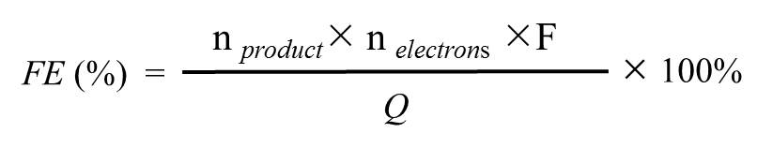
where F is the Faraday constant (96485 C mol-1), n_{product} is the product derived (mol) from GC (gaseous products), n_{electrons} is the electron transfer number, and Q is the total charge passed during the CO₂ electrolysis.
Electrochemical impedance spectroscopy (EIS) measurements. The EIS measurements were recorded using CO₂-saturated electrolyte at open circuit potential with an amplitude of 5.0 mV (10⁻² to 10⁵ Hz). The value for R_{ct} was obtained by fitting the EIS spectra using the Zview software (Version 3.1, Scribner Associates, USA), which gave a goodness of fit of > 95%.

Discussions

Phase identification of iron nitrides and iron oxy-nitrides sites in Mössbauer spectroscopy.
On the basis of the Mössbauer parameters (values of IS and QS), the doublet D1 were attributed to FeN₄ in the low- spin state¹. The parameters of D2 emerged with the increase of Fe content, which exhibited a decrease of IS value signifying the decreasing coordination number of N in FeN₄². Two sextets were identified as iron oxynitride (Fe-N-O) phase with different coordination environment of N and O according to the parameters of hyperfine field (H). The FeO_{1.5-n}N_{n} phase had value of H close to that of Fe₂O₃, which was attributed to the occupying of N atoms in the oxygen sublattice³. The peak area ratios of FeO_{1.5-n}N_{n} and γ-Fe₂O₃ in the catalysts were 0:1 (without FeO_{1.5-n}N_{n}), 26.7:21.4, 36.9:22.5 and 43.9:30.5, respectively with various Fe content. A range of 0.34 ≤ n ≤ 0.55 was obtained in the system⁴. Concerning the oxidation behavior of iron nitrides and the mobility of N at elevated temperature, the additional sextet was assigned as Fe-N-O with N-rich, denoted as FeO_{m}N_{4-m}, of which formation might be attributed to the diffusion of N atoms from the surface region into deeper FeN₄ layers. According to the resonance areas of FeN₄, FeO_{m}N_{4-m}, the range of 0.2 ≤ m ≤ 0.58 was obtained.

Supplementary Figures

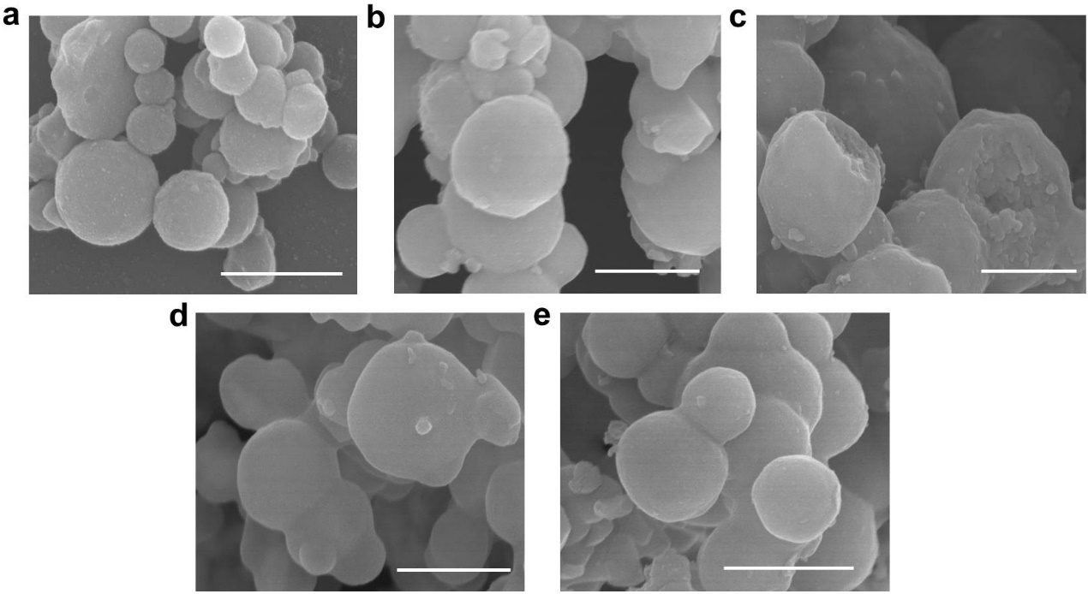
Supplementary Fig. 1. SEM images of xFe2O3-N@CN with different Fe content (the subscript x corresponds to mole fraction of Fe in the catalysts after carbonization): a, _{0.05}Fe₂O₃-N@CN. b, _{0.11}Fe₂O₃-N@CN. c, _{0.17}Fe₂O₃-N@CN. d, _{0.2}Fe₂O₃-N@CN. e, _{0.3}Fe₂O₃-N@CN. The scale bars are 500 nm.

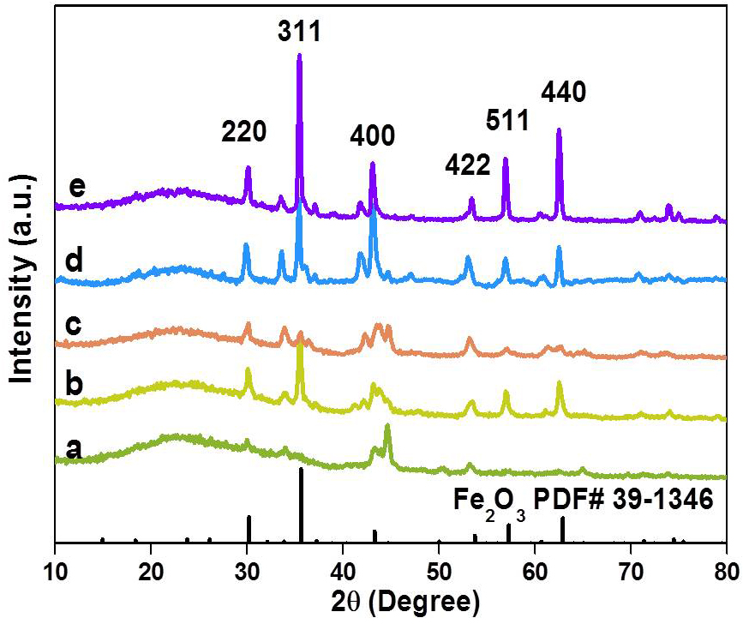
Supplementary Fig. 2. XRD patterns of _{x}Fe₂O₃-N@CN with different Fe content: a, _{0.05}Fe₂O₃-N@CN. b, _{0.11}Fe₂O₃-N@CN. c, _{0.17}Fe₂O₃-N@CN. d, _{0.2}Fe₂O₃-N@CN. e, _{0.3}Fe₂O₃-N@CN.

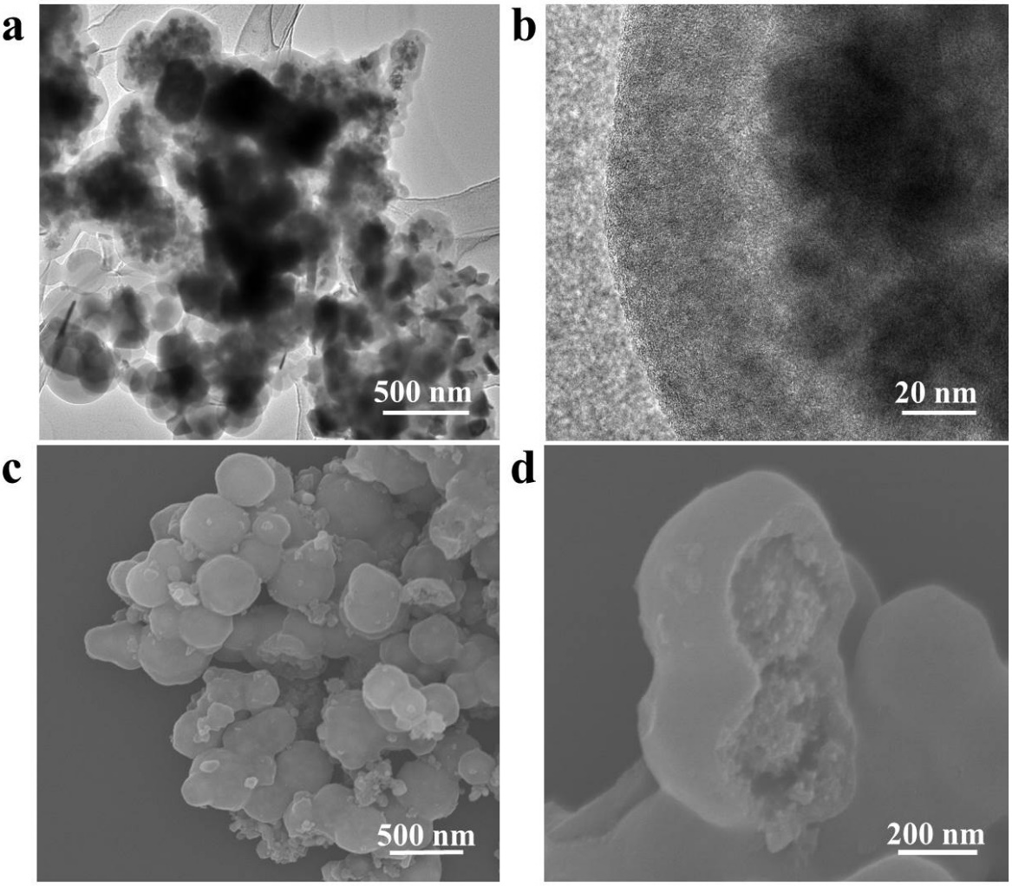
Supplementary Fig. 3. The transmission electron microscopy (TEM) and scanning electron microscopy (SEM) images of _{0.3}Fe₂O₃-N@CN.

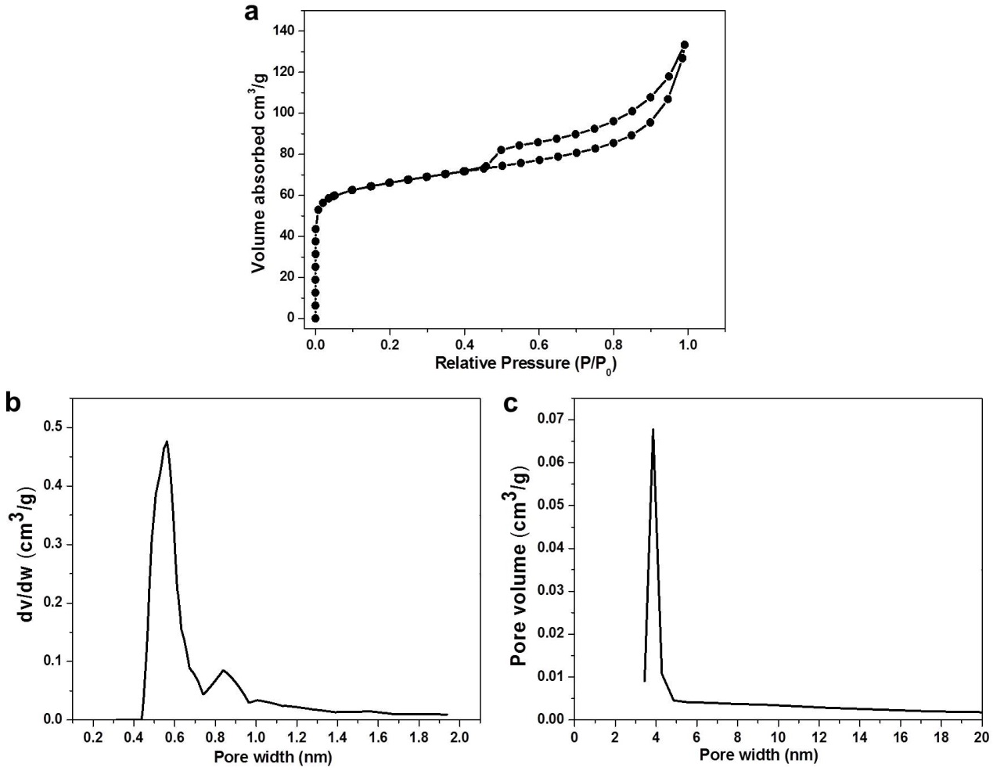
Supplementary Fig. 4. a, N₂ isothermal adsorption-desorption curves. b, c, Pore distribution of _{0.3}Fe₂O₃-N@CN: the mesopore size distribution curves calculated from Horvath-Kawazoe (HK) model and Barrett–Joyner–Halenda (BJH) model, respectively.

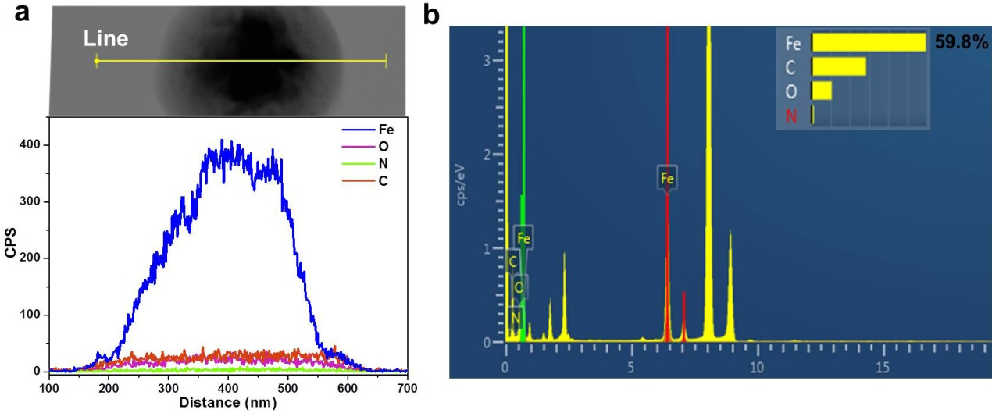
Supplementary Fig. 5. The composition distribution of Fe, O, N and C elements in the nanoparticle of _{0.3}Fe₂O₃-N@CN analyzed by EDX.

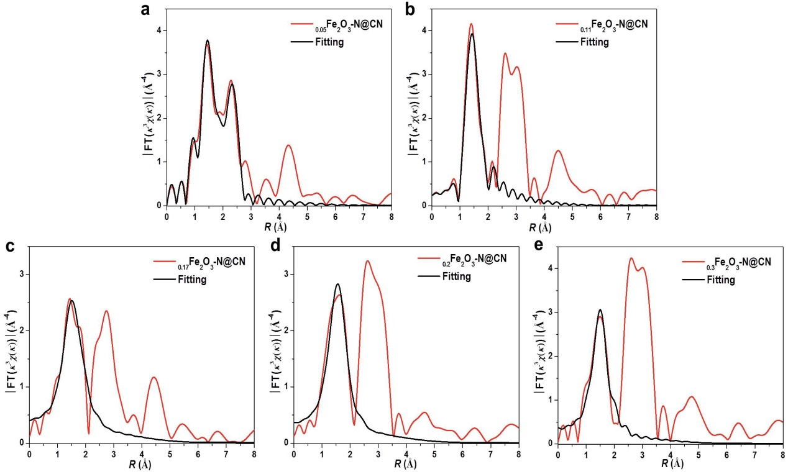
Supplementary Fig. 6. Corresponding FT-EXAFS fitting curves of _{x}Fe₂O₃-N@CN. a, _{0.05}Fe₂O₃-N@CN. b, _{0.11}Fe₂O₃-N@CN. c, _{0.17}Fe₂O₃-N@CN. d, _{0.2}Fe₂O₃-N@CN. e, _{0.3}Fe₂O₃-N@CN.
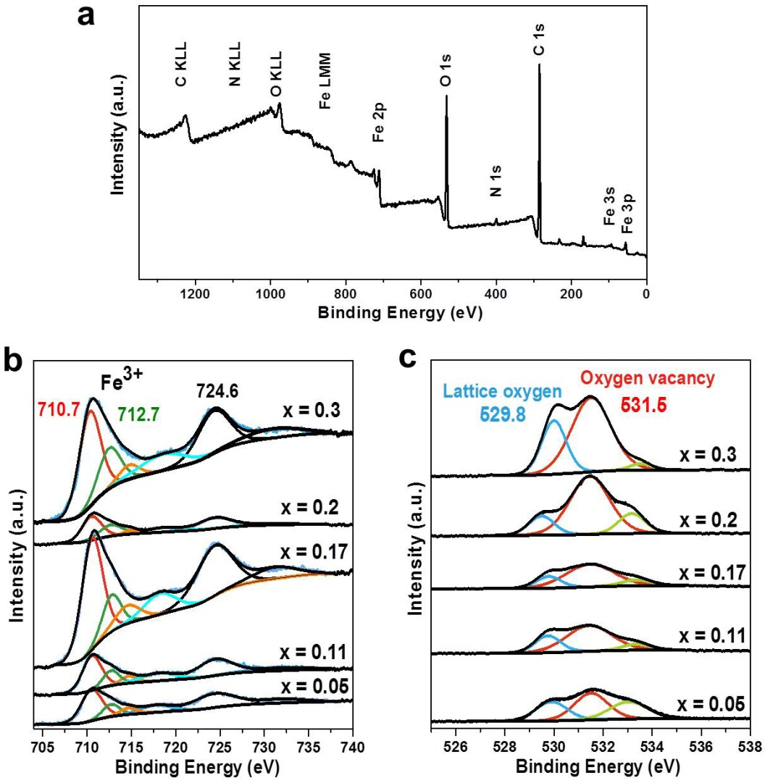
Supplementary Fig. 7. a, XPS survey spectrum of _{0.3}Fe₂O₃-N@CN. b, XPS spectra of _{x}Fe₂O₃-N@CN in Fe 2p. c, The high-resolution O 1s spectra of _{x}Fe₂O₃-N@CN. x= 0.05, 0.11, 0.17, 0.2 and 0.3.

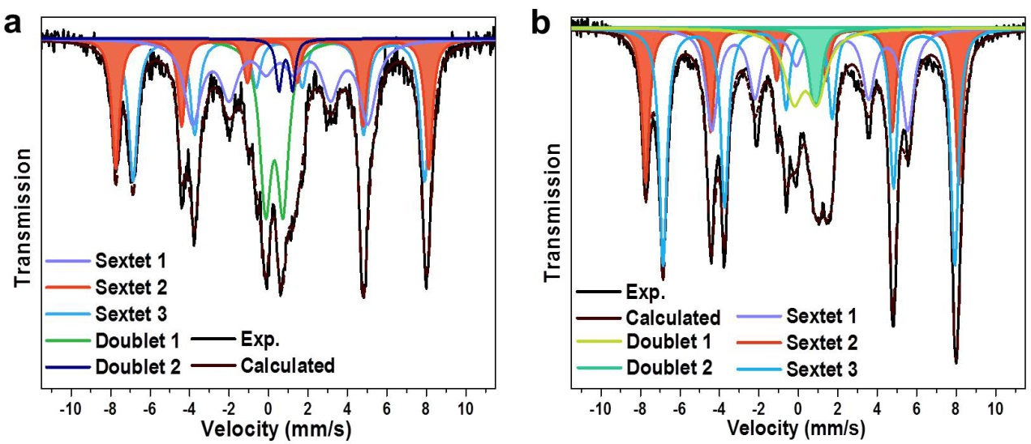
Supplementary Fig. 8. Experimental ⁵⁷Fe Mössbauer transmission spectra and the corresponding fittings with spectral components for _{x}Fe₂O₃-N@CN. a, _{0.17}Fe₂O₃-N@CN. b, _{0.2}Fe₂O₃-N@CN.
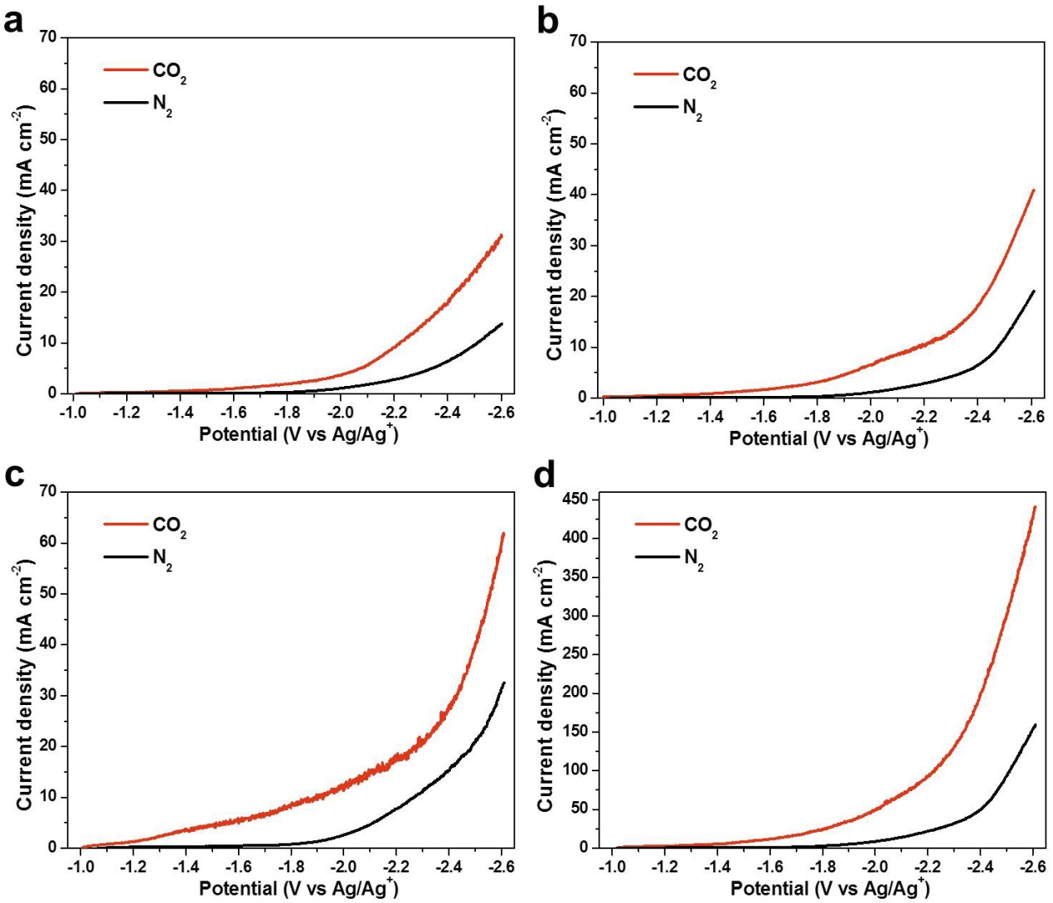
Supplementary Fig. 9. LSV curves of _{x}Fe₂O₃-N@CN in N₂ and CO₂-saturated electrolytes. a, _{0.05}Fe₂O₃-N@CN. b, _{0.11}Fe₂O₃-N@CN. c, _{0.17}Fe₂O₃-N@CN. d, _{0.2}Fe₂O₃-N@CN.

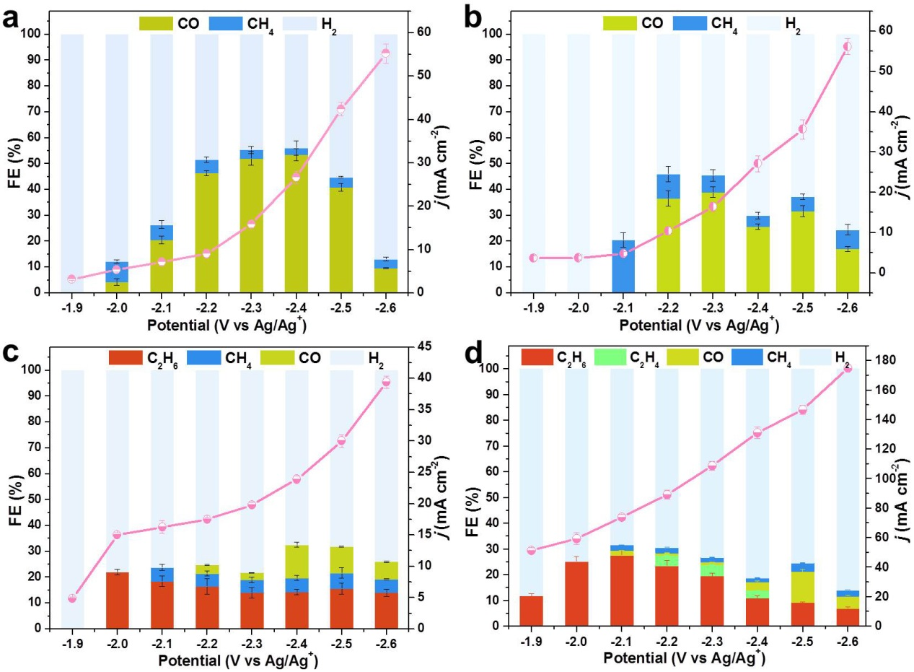
Supplementary Fig. 10. Catalytic performances of _{x}Fe₂O₃-N@CN, the FEs and current density. a, _{0.05}Fe₂O₃-N@CN. b, _{0.11}Fe₂O₃-N@CN. c, _{0.17}Fe₂O₃-N@CN. d, _{0.2}Fe₂O₃-N@CN.

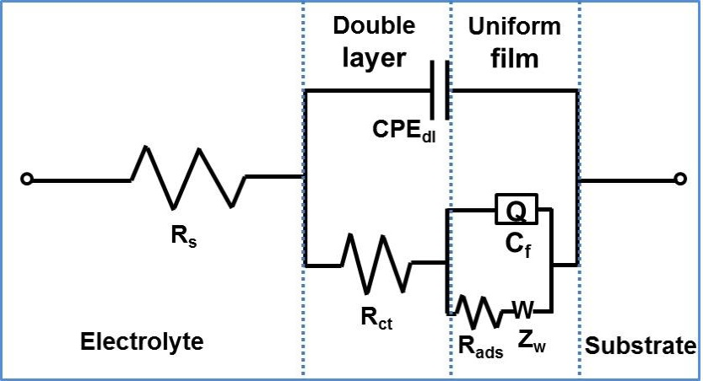
Supplementary Fig. 11. Randles’ equivalent circuit used for fitting the experimental impedance data of the electrode: solution resistance (R_{s}), double layer capacitance (CPE_{dl}), electron transfer resistance (R_{ct}), film capacitance (C_{f}), film resistance (R_{f}) and Warburg-type impedance (Zw).

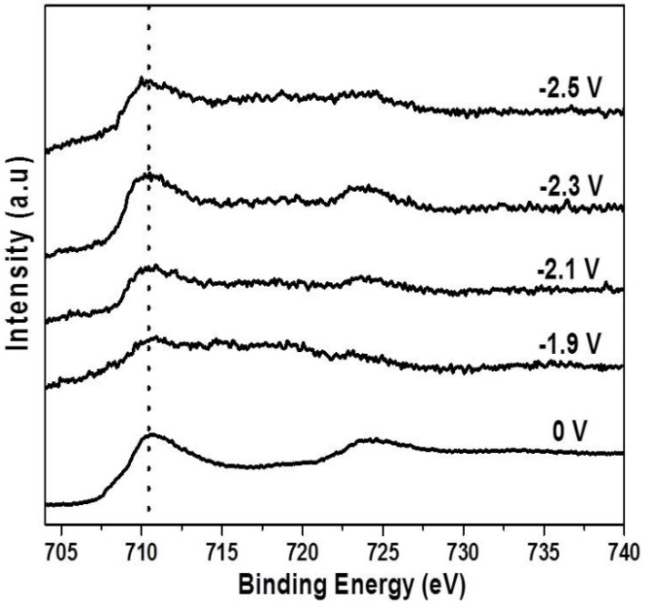
Supplementary Fig. 12. The quasi-operando XPS Fe 2p spectra before (0 V) and after reaction at applied potential from −1.9 V to −2.5 V vs Ag/Ag⁺ over _{0.3}Fe₂O₃-N@CN.

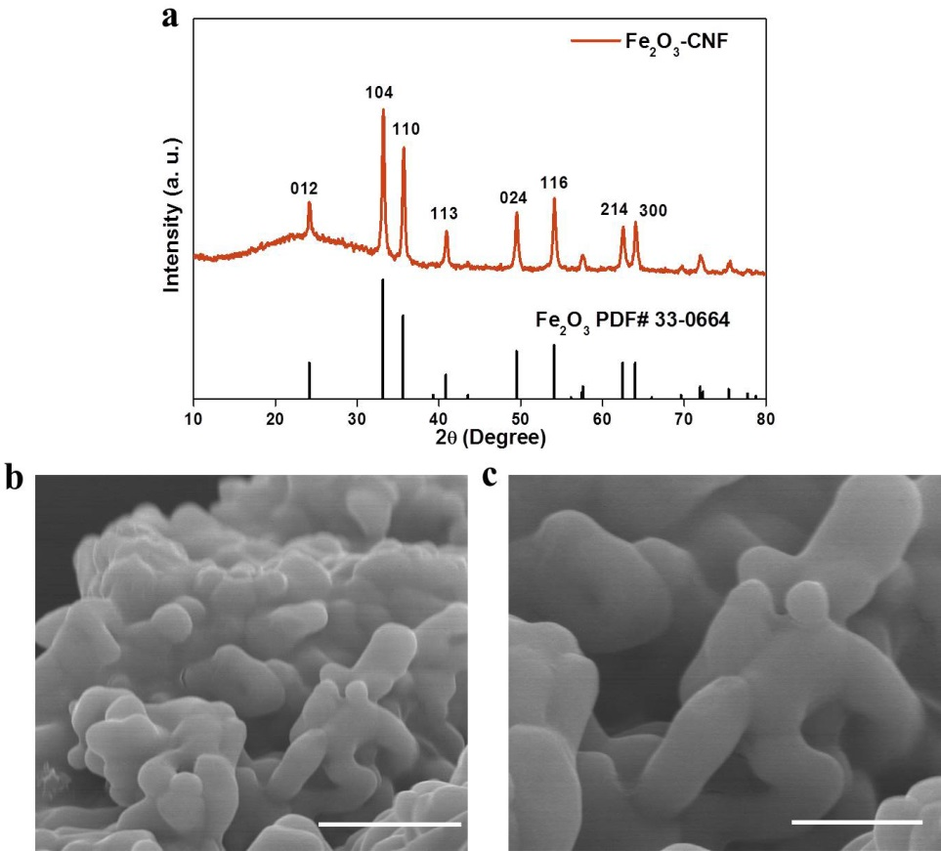
Supplementary Fig. 13. Characterizations of Fe₂O₃-CNF obtained by calcining _{0.3}Fe₂O₃-N@CN in muffle at 600 °C for 6 hours. a, XRD patterns. b, c, SEM images of Fe₂O₃-CNF. The scale bars of b, c are 1 μm and 500 nm, respectively.

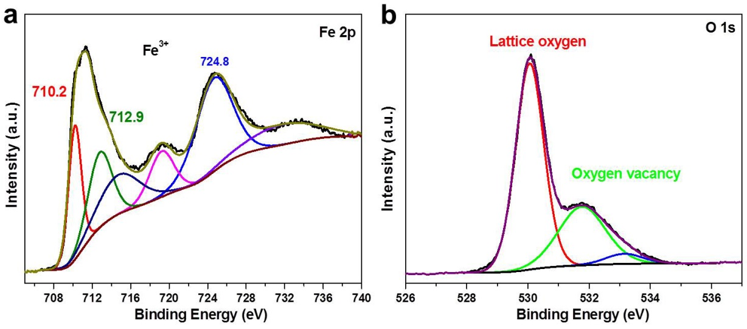
Supplementary Fig. 14. High-resolution Fe 2p and O 1s XPS spectra for Fe₂O₃-CNF.

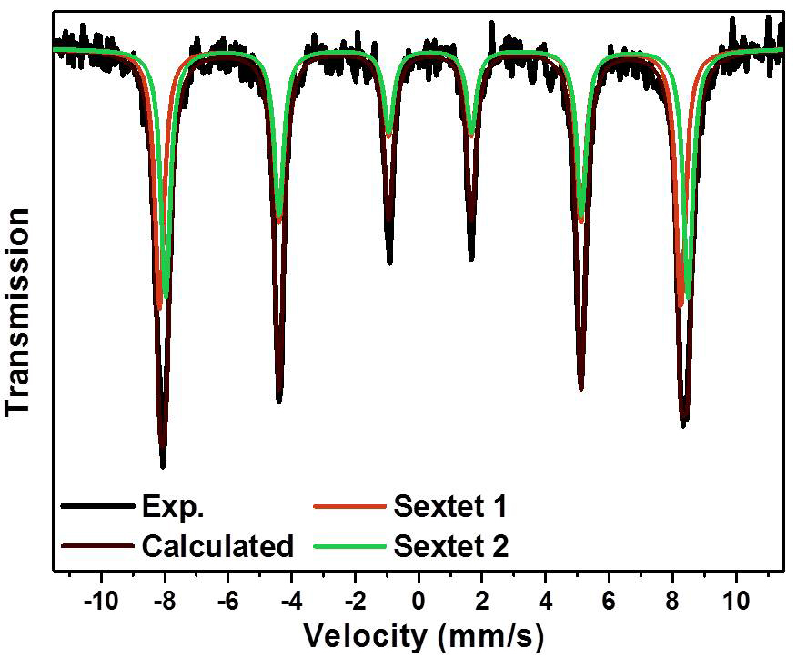
Supplementary Fig. 15. Experimental ⁵⁷Fe Mössbauer transmission spectra and the corresponding fittings with spectral components for Fe₂O₃-CNF.

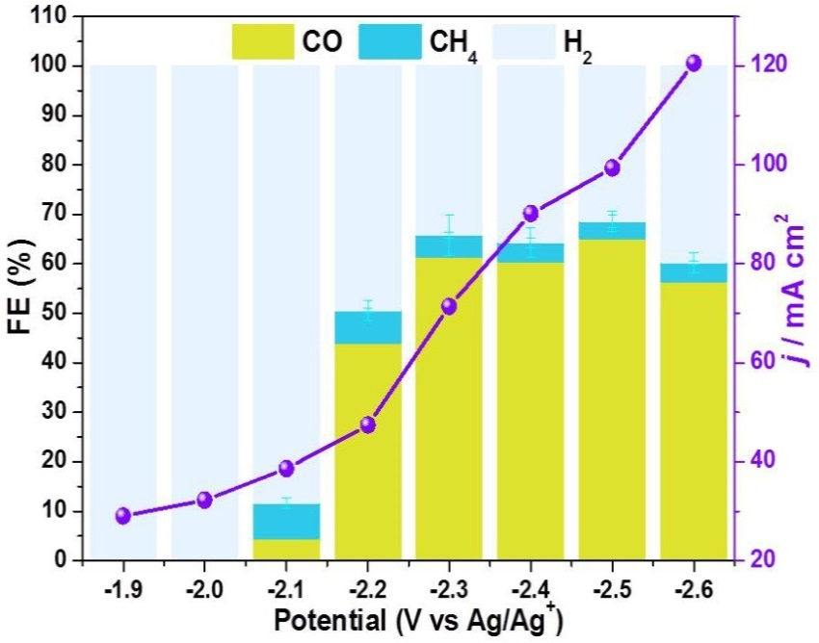
Supplementary Fig. 16. CO₂ electroreduction performance over Fe₂O₃-CNF. Faradaic efficiency and current density over Fe₂O₃-CNF.

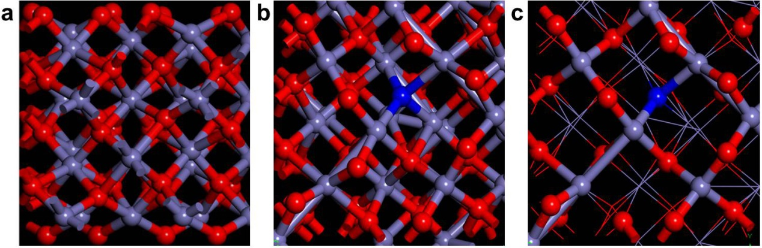
Supplementary Fig. 17. The structures of the two catalyst models of pristine Fe₂O₃. a, FeO_{1.5-n}N_{n} with N doping. b, FeO_{1.5-n}N_{n} with N doping and oxygen vacancies. c, Colour codes: Fe atom (purple), N atom (blue), O atom (red).

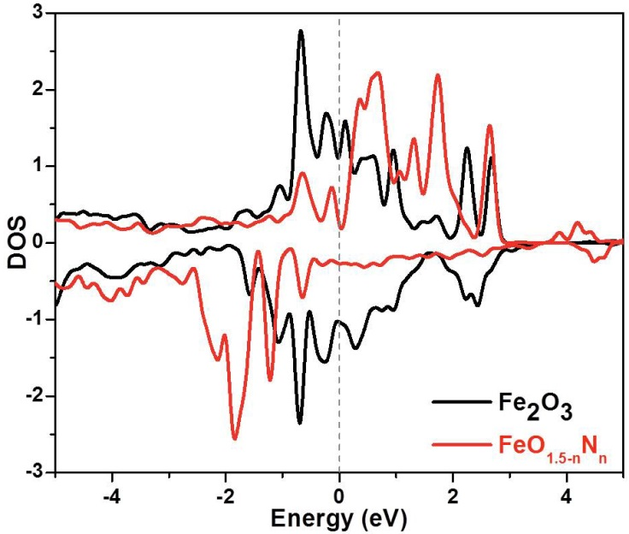
Supplementary Fig. 18. DOS of the 3d orbitals of the central Fe ion in the two models.

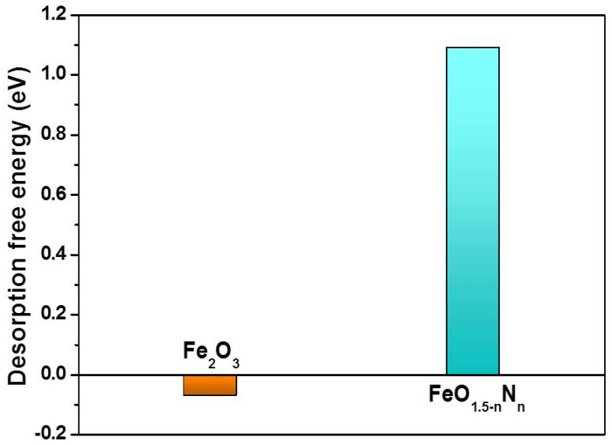
Supplementary Fig. 19. The desorption free energy of *CO intermediate over catalysts of pristine Fe₂O₃ and N-doped Fe₂O₃, respectively.
Supplementary Tables

Supplementary Table 1. EXAFS fitting parameters at the Fe K-edge for various samples.*
Sample | Path | N | R (Å) | σ² (Å²·10⁻³) | ΔE₀ (eV) | R factor
_{0.05}Fe₂O₃-N@CN | Fe-O | 4.1±0.2 | 2.00±0.01 | 12.8±0.7 | 4.6±0.5 | 0.011
_{0.05}Fe₂O₃-N@CN | Fe-Fe | 1.1±0.1 | 2.59±0.01 | 6.3±0.8 | 9.9±0.9 | 0.011
_{0.11}Fe₂O₃-N@CN | Fe-O₁ | 2.1±0.1 | 1.89±0.01 | 2.1±0.5 | -6.8±0.8 | 0.007
_{0.11}Fe₂O₃-N@CN | Fe-O₂ | 2.0±0.1 | 2.04±0.01 | 2.1±0.5 | -6.8±0.8 | 0.007
_{0.17}Fe₂O₃-N@CN | Fe-O₁ | 3.0±0.1 | 2.00±0.01 | 14.3±0.6 | 11.0±0.2 | 0.006
_{0.17}Fe₂O₃-N@CN | Fe-O₂ | 2.5±0.1 | 2.18±0.01 | 14.3±0.6 | 11.0±0.2 | 0.006
_{0.2}Fe₂O₃-N@CN | Fe-O₁ | 3.0±0.1 | 2.03±0.01 | 13.6±0.8 | 8.5±0.3 | 0.008
 | Fe-O₂ | 2.3±0.1 | 2.19±0.01 | 13.6±0.8 | 8.5±0.3 | 0.008
_{0.3}Fe₂O₃-N@CN | Fe-O₁ | 3.0±0.1 | 2.00±0.01 | 10.0±0.7 | 7.2±0.3 | 0.007
_{0.3}Fe₂O₃-N@CN | Fe-O₂ | 1.7±0.1 | 2.19±0.01 | 10.0±0.7 | 7.2±0.3 | 0.007
Fe₂O₃ | Fe-O₁ | 3.0±0.2 | 1.93±0.01 | 12.4±0.8 | 1.6±0.4 | 0.010
Fe₂O₃ | Fe-O₂ | 3.0±0.2 | 1.97±0.01 | 12.4±0.8 | 1.6±0.4 | 0.010
*N = Coordination numbers; R = Bond distance; σ² = Debye-Waller factors; ΔE₀ = The inner potential correction; R factor = fitting degree.
Supplementary Table 2. Values of the main parameters of Randles equivalent circuit elements obtained by fitting the EIS spectra with Randles’ equivalent circuit and R(C(R(Q(RW)))) at CO₂ equilibrium potential.
Electrode | R_{ct} (Ω·cm²)
_{0.05}Fe₂O₃-N@CN | 5.81
_{0.11}Fe₂O₃-N@CN | 5.43
_{0.17}Fe₂O₃-N@CN | 4.98
_{0.2}Fe₂O₃-N@CN | 3.58
_{0.3}Fe₂O₃-N@CN | 3.52

Supplementary Table 3. Mössbauer parameters derived from the fittings. Isomer shift (IS), quadrupole splitting (QS), hyperfine field (H) and relative spectral area % of each component.
Samples | Component | IS  (mm/s) | QS  (mm/s) | H  (T) | Area  (%) | Assignment
_{0.05}Fe₂O₃-N@CN | D1 | 0.28 | 0.85 | —— | 42.4 | FeN₄
_{0.05}Fe₂O₃-N@CN | Sextet 1 | 0.55 | 0.04 | 28.01 | 27.9 | FeO_{m}N_{4-m}
_{0.05}Fe₂O₃-N@CN | Sextet 2 | 0.155 | 0.21 | 48.55 | 20.6 | γ-Fe₂O₃
_{0.05}Fe₂O₃-N@CN | Sextet 3 | -0.11 | 0.03 | 33.62 | 9.1 | ɑ-Fe
_{0.17}Fe₂O₃-N@CN | D1 | 0.30 | 0.89 | —— | 19.6 | FeN₄
_{0.17}Fe₂O₃-N@CN | D2 | 0.87 | 0.69 | —— | 3.2 | FeN₄
_{0.17}Fe₂O₃-N@CN | Sextet 1 | 0.58 | 0.02 | 27.56 | 29.2 | FeO_{m}N_{4-m}
_{0.17}Fe₂O₃-N@CN | Sextet 2 | 0.19 | 0.004 | 49.29 | 21.4 | γ-Fe₂O₃
_{0.17}Fe₂O₃-N@CN | Sextet 3 | 0.53 | -0.02 | 45.91 | 26.7 | FeO_{1.5-n}N_{n}
_{0.2}Fe₂O₃-N@CN | D1 | 0.36 | 1.18 | —— | 12.3 | FeN₄
_{0.2}Fe₂O₃-N@CN | D2 | 0.87 | 0.31 | —— | 4.4 | FeN₄
_{0.2}Fe₂O₃-N@CN | Sextet 1 | 0.63 | -0.10 | 30.87 | 23.9 | FeO_{m}N_{4-m}
_{0.2}Fe₂O₃-N@CN | Sextet 2 | 0.18 | 0.05 | 49.33 | 22.5 | γ-Fe₂O₃
_{0.2}Fe₂O₃-N@CN | Sextet 3 | 0.54 | -0.01 | 45.93 | 36.9 | FeO_{1.5-n}N_{n}
_{0.3}Fe₂O₃-N@CN | D1 | 0.69 | 0.23 |  | 5.7 | FeN₄
_{0.3}Fe₂O₃-N@CN | D2 | 0.39 | 1.10 | —— | 14.4 | FeN₄
_{0.3}Fe₂O₃-N@CN | Sextet 1 | -0.30 | 0.10 | 21.68 | 5.5 | FeO_{m}N_{4-m}
_{0.3}Fe₂O₃-N@CN | Sextet 2 | 0.19 | 0.02 | 49.46 | 30.5 | γ-Fe₂O₃
_{0.3}Fe₂O₃-N@CN | Sextet 3 | 0.54 | -0.006 | 46.00 | 43.9 | FeO_{1.5-n}N_{n}
Note: 0.2 ≤ m ≤ 0.58, 0.34 ≤ n ≤ 0.55, the values were obtained according to the QS, H and resonance area of the components.

Supplementary Table 4. Mössbauer parameters derived from the fittings. Isomer shift (IS), quadrupole splitting (QS), hyperfine field (H) and relative spectral area % of each component.
Sample | Component | IS (mm/s) | QS (mm/s) | H (T) | Area (%) | Assignment
Fe₂O₃-CNF | Sextet 1 | 0.20 | -0.31 | 51.03 | 51.2 | ɑ-Fe₂O₃
Fe₂O₃-CNF | Sextet 2 | 0.31 | -0.11 | 51.15 | 48.8 | ɑ-Fe₂O₃

References
1. Koslowski U. I., Abs-Wurmbach I., Fiechter S. & Bogdanoff P. Nature of the catalytic centers of porphyrin-based electrocatalysts for the ORR: A correlation of kinetic current density with the site density of Fe−N₄ centers. J. Phys. Chem. C 112, 15356 (2008).
2. Andres, H. et al., Planar three-coordinate high-spin Fe(II) complexes with large orbital angular momentum: Mössbauer, electron paramagnetic resonance, and electronic structure studies. J. Am. Chem. Soc. 124, 3012 (2002).
3. Borsa, D. M. & Boerma, D. O. Phase identification of iron nitrides and iron oxy-nitrides with Mössbauer spectroscopy. Hyperfine Interact. 151, 31–48 (2003).
4. Dong, Y. F. et al. Air-stable porous Fe₂N encapsulated in carbon microboxes with high volumetric lithium storage capacity and a long cycle life. Nano Lett. 17, 5740−5746 (2017).

