SUPPLEMENTARY INFORMATION

Novel tRNA-like transcripts from the NEAT1-MALAT1 genomic region critically influence human innate immunity and macrophage functions

Martina Gast ^{1,2 #}, Vanasa Nageswaran ^{1,3 #}, Andreas W. Kuss ^{4 #}, Ana Tzvetkova ^{4,5}, Xiaomin Wang ¹, Liliana H. Mochmann ¹, Pegah Ramezani-Rad ¹, Stefan Weiss ^{4,6}, Stefan Simm ⁵, Tanja Zeller ^{7,8}, Henry Voelzke ^{6,9}, Wolfgang Hoffmann ^{6,9}, Uwe Völker ^{4,6}, Stefan B. Felix ^{6,10}, Marcus Dörr ^{6,10}, Antje Beling ^{2,11,12}, Carsten Skurk ^{1,2}, David-Manuel Leistner ^{1,2,12}, Bernhard H. Rauch ^{6,13,14}, Tetsuro Hirose ¹⁵, Bettina Heidecker ¹, Karin Klingel ¹⁶, Shinichi Nakagawa ^{17,18}, Wolfram C. Poller ^{19,20}, Filip K. Swirski ^{19,20},
Arash Haghikia ^{1,2,12 #}, Wolfgang Poller ^{1,2,21 # §}

¹ Department of Cardiology, Campus Benjamin Franklin; ¹¹ Institute for Biochemistry; and ²¹ Berlin-Brandenburg Center for Regenerative Therapies (BCRT), all at Charité - Universitätsmedizin Berlin, Charité-Universitätsmedizin Berlin, corporate member of Freie Universität Berlin, Humboldt-Universität zu Berlin, and Berlin Institute of Health, Berlin, Germany.
³ Institute for Chemistry and Biochemistry, Freie Universität Berlin, Berlin, Germany.
⁴ Department of Functional Genomics, Interfaculty Institute of Genetics and Functional Genomics; and ⁵ Institute of Bioinformatics, both at University Medicine Greifswald, Greifswald, Germany.
⁷ Clinic for General and Interventional Cardiology, University Heart and Vascular Center Hamburg, Hamburg, Germany.
⁹ Institute for Community Medicine, University Medicine Greifswald, Greifswald, Germany.
¹⁰ Department of Cardiology, University Medicine Greifswald, Greifswald, Germany.
¹² Berlin Institute of Health (BIH), Berlin, Germany.
¹³ Institute for Pharmacology, University Medicine Greifswald, Greifswald, Germany.
¹⁴ Department Human Medicine, Section Pharmacology and Toxicology, Carl von Ossietzky Universität, Oldenburg, Germany.
¹⁵ Graduate School of Frontier Biosciences, Osaka University, 1-3 Yamadaoka, Suita 565-0871, Japan.
¹⁶ Institute for Pathology and Neuropathology, Department of Pathology, University Hospital Tübingen, Germany.
¹⁷ RNA Biology Laboratory, RIKEN Advanced Research Institute, Wako, Saitama, Japan.
¹⁸ Faculty of Pharmaceutical Sciences, Hokkaido University, Sapporo, Japan.
¹⁹ Center for Systems Biology, Massachusetts General Hospital and Harvard Medical School, MA, USA.
²⁰ Cardiovascular Research Institute, Icahn School of Medicine at Mount Sinai, New York, NY, USA
German Center for Cardiovascular Research (DZHK) ² Site Berlin, ⁶ Site Greifswald, ⁸ Site Hamburg/Lübeck/Kiel,
Germany.
# equal contributions § correspondence

Running Title: A novel class of tRNA-like small noncoding RNAs

For high resolution versions of the supplemental figures please refer to the Supplementary Information source files.

Patients and Methods
For human studies approval was granted by the institutional ethics review board and the regulatory authorities. Investigation of human tissues was conform to the principles in the Declaration of Helsinki. Informed consent was given prior to inclusion of people in the study.

SHIP population study and cohorts
SHIP samples were genotyped using the Affymetrix Genome-Wide Human SNP Array 6.0. Genotyping of samples within SHIP-TREND was obtained in two batches using Illumina Infinium HumanOmni2.5 BeadChip and the Illumina Infinium Global Screening Array, respectively. Genotypes were determined using Birdseed 2 for SHIP and the GenomeStudio 2.0 Genotyping Module (GenCall algorithm) for SHIP-TREND. Standard genotype quality control was performed excluding arrays < 92% sample call rate for SHIP and <94% sample call rate for SHIP-TREND and duplicates (based on estimated IBD), mismatches between reported and genotyped sex, genetic PCA outliers, and arrays with extreme heterozygosity. Variants with call rate < 0.95 and a Hardy-Weinberg equilibrium p-value < 0.0001 were removed before imputation. Pre-phasing and Imputation of genotypes was performed with the Eagle and Minimac3 software to HRC reference v1.1 panel on Michigan Imputation Server v1.0.1 (https://imputationserver.sph.umich.edu/).

CRISPR-Cas9 experiments
THP-1 cells were grown in RPMI medium containing FCS (10% [v/v]) and penicillin/streptomycin (50 I.U./50 μg/ml). Parts of the menRNA and mascRNA regions were deleted from THP-1 cells using an adaptation of the CRISPR/Cas9 protocol described in Gundry et al. 2016. Protospacer sequences for each target gene were identified using the CRISPRscan scoring algorithm [www.crisprscan.org (Moreno-Mateos et al.)]. Extensive target searches employing http://www.crisprscan.com/, http://crispor.tefor.net/, and https://cctop.cos.uni-heidelberg.de identified no off-targets of potential relevance. DNA templates for single guide RNAs (sgRNAs) were generated by PCR (KAPA HiFi HotStart ReadyMix PCR Kit) using the pX458 plasmid containing the sgRNA scaffold sequence and using the following primers:
G1_human_mascRNA | taatacgactcactataGGTTGGCACTCCTGGTTTCCgttttagagctagaaatagc
G5_human_mascRNA | taatacgactcactataGGACGGGGTTCAAATCCCTGgttttagagctagaaatagc

G9_human_menRNA | taatacgactcactataGGGGCACGTCCAGCACGGCTgttttagagctagaaatagc
G10_human_menRNA | taatacgactcactataGGTCCAGCACGGCTGGGCCGgttttagagctagaaatagc

universal reverse | AGCACCGACTCGGTGCCACT

PCR products were used to generate sgRNAs by in vitro transcription using HiScribe T7 High Yield RNA Synthesis Kit. 0.5µg of purified sgRNA was incubated with Cas9 protein (1 μg; PNA Bio) for 15-20 min at room temperature. 2x10⁵ THP-1 cells were electroporated with the sgRNA/Cas9 complex using the Neon Transfection System at 1400 V, 20 ms, and one pulse. For the small RNA-deficient cell lines, two sgRNAs were selected at either end of the target sequence to delete the region in between. Deletion of mascRNA and menRNA was confirmed by PCR with the following primer pairs:
CRISPR_hu-masc_fw | CGTATTGTTTTCTCAGGTTTTGC
CRISPR_hu-masc_rev | ACCTCCCCAAAACTCCAAGA

CRISPR_hu-men_fw | TCTGTGAAAGAGTGAGCAGGA
CRISPR_hu-masc_rev | CCCAATGCTACCCCTCTAGG

Single-cell clones were generated by single-cell plating of the parental cell line. Gene deletions in the single-cell clones were confirmed by sequencing and proved to be stable over >25 passages so far.
Cell culture studies
Human monocyte cultures
Human THP-1 cells were cultured in RPMI 1640 medium with 10% fetal bovine serum, 2 mM L-glutamine, 100 U/mL penicillin and 100 μg/mL streptomycin. For gene expression analysis of wildtype (WT) and CRISPR-Cas9 targeted THP-1 cells under immune challenge, cells were stimulated with 100 ng/ml LPS, 10 ng/ml LPS 1 μg/ml, 1 ng/ml LPS, or 1 μg/ml Concanavalin A (Con A). After 24 h, RNA was isolated by TRIzol/Chloroform.
THP-1 monocyte adhesion to flow-primed human aortic endothelial cells
For analysis of WT and CRISPR-Cas9 targeted THP-1 monocytes adhesion to flow-primed endothelial cells, primary human aortic endothelial cells (HAECs) were cultured in Endothelial Growth Medium-2 with 10% fetal bovine serum, 100 U/mL penicillin and 100 μg/mL streptomycin and seeded to confluence in µ-Slide y-shaped ibiTreat chambers . Endothelial cells were exposed to unidirectional flow (20 dyn/cm²) for 48 h using yellow/green perfusion sets prior to the experiment. THP-1 monocytes were labelled with 1,1'-dioctadecyl-3,3,3',3'-tetramethylindocarbocyanine (DiI) for 15 min at 37°C, respectively, and after three times wahsing 1 × 10⁶ labelled cells were added to the flow reservoir for 30 min. After flow-termination, non-adherent cells were gently washed out with PBS, then cells were fixed with 4% paraformaldehyde and the number of cells adhering to both the straight and branched channel regions was assessed by fluorescence phase-contrast microscope quantified using ImageJ Software.
Tube formation angiogenesis assay
(a) Conditioned media transfer experiment: Tube formation by HAECs treated with ΔmenRNA and ΔmascRNA monocyte-conditioned media was assayed on reduced growth factor basement membrane extract (BME) in 96-well tissue cultured-treated clear-bottom plates (15 × 10³ cells per well). Briefly, 60 µl of ice-cold BME was added per well and incubated at 37°C and 5% CO₂ for 30 min to allow gel formation. HAECs were plated on top of the gelled BME at a density of 1.5 x 10⁴ cells/well in 50 µl culture medium followed by transfer of 50 µl of monocyte-conditioned media of both ΔmenRNA and ΔmascRNA and incubated further for 24 h. After tube formation was observed, endothelial cells were stained by adding 50 µl of 6 µM Calcein AM solution per well for 15 min at 37°C. Tubular network of the cells was captured using a fluorescent inverted microscope and quantified by ImageJ Software.
(b) Monocyte-HAEC co-cultures in matrigel: Endothelial tube formation in reduced growth factor matrigel was performed similarly as described above. Here, direct DiI-labeled co-cultured ΔmenRNA and ΔmascRNA monocytes at a cell density of 5 x 10³ per well together with HAECs (1.5 x 10⁴ cells/well) were added on the BME gel and cultured for 24 h at 37°C and 5% CO² to form tubular networks.

Reactive oxygen species assay
Intracellular ROS production in WT and CRISPR-Cas9 targeted THP-1 macrophages was determined as previously described using 2',7'-dichlorodihydrofluorescein diacetate (H2DCFDA). Upon cleavage of the acetate groups by intracellular esterases, the cell-permeant H₂DCFDA is retained within the cells and easily oxidized to the highly fluorescent 2′,7′-dichlorofluorescin (DCF) in response to ROS production/oxidative stress. Control and CRISPR/Cas9-targeted THP-1 cells were cultured in black 96 wells (overnight treatment with 0,1 µM PMA) before LPS addition for 24h. After washing with HBSS, cells were incubated with 5 μM H2DCFDA (Molecular Probes) in HBSS for 1 h at 37 °C. Cells were washed again and ROS production was induced by 400 μM H₂O₂. Fluorescence intensity was quantified every 10 min (excitation 485 nm, emission 535 nm) at 37°C using a fluorescence plate reader (Tecan).

Cytokine measurements
Conditioned cell culture media of wildtype (WT) and CRISPR-Cas9 targeted THP-1 cells were tested for IFNγ, TNF, IL6, MCP1, IL10, and IL12p70 by use of Mouse Inflammation Cytometric Bead Assay (CBA) (BD Biosciences, Heidelberg, Germany) on a FACS CantoII flow cytometer (BD Biosciences) according to the manufacturer’s protocol.

Cell proliferation studies
The proliferation assay of WT and CRISPR-Cas9 targeted THP-1 cells was conducted as follows: 5 x10⁴ cells were seeded into clear 96 well plates, one plate for each time point. Proliferation was determined using WST1 reagent (Sigma-Aldrich) according to the manufacturer’s instructions. Absorbance at 450 nm was measured 2 h after addition of WST1 and incubation at 37°C on a Tecan plate reader. Absorbance of WT cells was set to one at each time point.

Foam cell formation and oxLDL uptake
To induce foam cell formation, we seeded 5x10⁵ THP-1 monocytes per well containing glass cover slips. Monocyte differentiation into macrophages was induced by adding 100 nM PMA to each well on days 0 and 1 and incubation for 48h hours. Thereafter the thus generated macrophages were washed with PBS, then incubated with 50µg/ml human ox-LDL for 24h in serum-free medium to induce foam cell formation. After ox-LDL incubation, Oil Red O staining (ORO) of the cells was performed as follows: wash with PBS, fix cells with 4% PFA/PBS for 15 min at RT, wash 3 times with PBS, rinse with 60% isopropanol for 15 s to facilitate the staining of neutral lipids, stain cells with filtered ORO working solution for 15 min at RT and in dark. ORO stock solution was prepared by dissolving 0.5 g ORO powder in 80 ml isopropanol (100%), mixed at 56 °C overnight, adjusted to 100 ml, mixed under gentle stirring, and filtered after pre-warming to 60°C. Working solution was prepared by diluting ORO stock solution with ddH2O 3:2 = factor 1.5. For staining, cells were rinsed with water and then hematoxylin used as a counterstain (cell nuclei) for 10 s. Destaining by washing with 60% isopropanol for 15 s, then PBS 3 times. Glass cover slips were taken out and mounted on slides for polarization microscopy and microphotography.

Monocyte-macrophage transition and macrophage polarization experiments
Monocyte-M0 macrophage differentiation and subsequent M1/M2 macrophage polarization studies employing FACS and TaqMan were conducted as follows: First, M0 macrophages were generated by incubation of THP-1 monocyte clones for seven days, with PMA at a concentration of 100 ng/ml. Thereafter, the cells were further incubated for another seven days, either with IFN-γ at 20 ng/ml plus LPS at 100 ng/ml to induce M1 polarization, or with IL-4 at 20 ng/ml plus IL-13 at 20 ng/ml to induce M2 polarization. The ’M0’ TaqMan-based expression profiles and FACS data in Fig. 7 were obtained on day 7 of culture to characterize monocyte - M0 macrophage transition. The ’M1’ and ’M2’ expression profiles displayed there were obtained in day 14 of culture.

FACS analyses of the macrophage clones
After macrophage polarization, cells were washed once with ice-cold PBS and scrapped off using a mini scraper. Subsequently, macrophages were again washed with PBS + 5% FBS and incubated with 50 µl Fcγ-receptor block (BD Biosciences) in PBS for 10 min at RT to block unspecific binding. Cells were centrifuged at 300 x g for 5 min at 4°C. Then cells pellets were resuspended with 50 µl of FACS Buffer (PBS + 0,5%FBS + 0,05% NaN3) and stained with APC mouse anti-human CD14 (BioLegend), PE mouse anti-human CD11b (BD Biosciences) and Live/Dead Fixable Aqua Dead Cell Stain (Invitrogen) for 30 min at 4 °C in the dark. Cells were resuspended in 450 µl of FACS Buffer and analyzed with Attune™ NxT Flow Cytometer (Thermo Fisher Scientific). Statistical analysis was performed using GraphPad Prism 9 software. Experimental data were analyzed by using one-way analysis of variance (ANOVA) with Dunnett´s post hoc test for multiple comparisons. The distribution of variables was assessed by Kolmogorov–Smirnov tests of normality.

Human adenovirus and coxsackievirus B3 studies
THP-1 cells were cultured in RPMI 1640 medium (ATCC modification + 10 % fetal calf serum + 1 % P/S) at 37 °C, 5 % CO2. 5x10⁵ cells were seeded in 12-well culture plates and differentiation to macrophage-like cells was triggered by addition of 0.1 μM PMA o/n. Afterwards cells were transduced with coxsackievirus B3 at MOI 30. Detection of CVB3 genome, replicative intermediates, and plaque forming units (PFU) was conducted as described. In the adenovirus experiments, cells were instead transduced with a recombinant adenoviral virus expressing GFP (AdV5-GFP) or an “empty” adenovector expressing no transgene, at MOI 25, 12h post PMA addition. Virus structures were described previously.
RNA sequencing and data analysis
For the transcriptome mapping of control vs. CRISPR‐Cas9 generated ΔmenRNA or ΔmascRNA cells, four biological cell culture replicates were grown for each of the three clones. From each of these cultures separate total RNA isolations were conducted by TRIZOL/Chloroform method. Thereafter the individual RNA preps were pooled for each of the clones, and the three resulting RNA pools (control, ΔmenRNA, ΔmascRNA) were subsequently used for RNA-seq analyses as follows. RNA integrity was visualized using Agilent Bioanalyzer 2100. For NGS-library preparation we used Illumina TruSeq Stranded Total RNA Library Prep Human/Mouse/Rat (S45-S56) or NEBNext Ultr II Directional RNA Library Prep Kit Illumina (E7760S) in combination with the NEBNext rRNA Depletion Kit (Human/Mouse/Rat) (E6310L) (S145-S154). For all samples paired end (2x75bp) sequencing was carried out on an Illumina NextSeq platform using NextSeq 500/550 High Output Kit v2.5 (150 cycles). The resulting reads were mapped to the human genome (GRCh37 release 87/hg19) using STAR v2.7.5b with standard options. We then ran the htseq-count module from software package HTSeq with the stranded=reverse option reflecting the used library kit. As we used rRNA-depleted samples, all with rRNA-annotation were excluded from further analyses. To detect differentially expressed genes we used the R package DESeq v1.34.1. Next we normalized the raw gene specific read counts as Transcripts per Million base pairs (TPM) in order to perform a gene set enrichment analysis (GSEA) using the R package ssGSEA2.0 by mapping them against a selection of gene set collections from Molecular Signature Database (MsigDB). We thus generated Enrichment Scores (ES) for each sample and various gene sets. ES reflects how strongly the majority of genes from an individual gene set are expressed per regarded sample. This ES was then normalized to account for variations in gene set size. To correct for multiple testing the ssGSEA package uses Benjamini-Hochberg method, which calculates false discovery rates (FDR). For any combination of gene set and sample with a FDR value ≥ 0.05 we set the NES to zero. The gene set collections we used were: C2.CP: Canonical pathways; KEGG selection as a subset of CP; C2.CGP: chemical and genetic perturbations; C7: immunologic signature gene sets.

Quantitative RT-PCR
For quantitative gene expression analyses, isolated RNA was digested using RNase free peqGOLD DNase I (Peqlab, Erlangen, Germany) for 30 min to avoid genomic DNA contamination. To analyze the mRNA expression of target genes, 1 µg to 1,5 µg of total RNA was reverse transcribed using the High Capacity RNA-to-cDNA kit (Life Technologies, Darmstadt, Germany) according to the manufacturer’s protocol and finally diluted to a concentration of 25 ng/µl. Assays for the following human target and reference genes were employed:
RT-PCR target | Gene name | TaqMan assay ID
AEN | apoptosis enhancing nuclease | Hs00224322_m1
AGO1 | argonaute RISC component 1 | Hs01084661_m1
AGO2 | argonaute RISC component 2 | Hs01085579_m1
ANG | angiogenin | Hs04195574_sH
ANGPT1 | angiopoietin 1 | Hs00919201_m1
ANGPT4 | angiopoietin 4 | Hs00907074_m1
ANGPTL4 | angiopoietin like 6 | Hs01101122_m1
BOK | BCL2 family apoptosis regulator BOK | Hs00261296_m1
CIITA | class II major histocompatibility complex transactivator | Hs00931699_m1
CCR5 | C-C motif chemokine receptor 5 | Hs00152917_m1
CCR7 | C-C motif chemokine receptor 7 | Hs01013469_m1
CD11b (ITGAM) | integrin subunit α_{M}
CD11c (ITGAX) | integrin subunit α_{X}
CD36 (SCARB3) | scavenger receptor
CD64 (FCGR1A) | IgG Fc receptor 1
CD80 | CTLA-4 counter-receptor
CD93 (C1QR1)
CSF1 (MCSF) | macrophage colony stimulating factor
CSF1R (CD115) | CSF1 receptor
CTIF | cap binding complex dependent translation initiation factor | Hs00969548_m1
EEF1A2 | eukaryotic translation elongation factor 1 α2 | Hs00951287_m1
EIF3CL | eukaryotic translation initiation factor 3 subunit C like | Hs01105769_g1
ESAM | endothelial cell adhesion molecule | Hs01113367_g1
FAS | Fas cell surface death receptor | Hs00236330_m1
FASLG | Fas ligand | Hs00181226_g1
GADD45G | growth arrest and DNA damage inducible γ | Hs02566147_s1
HDAC4 | histone deacetylase 4 | Hs01041648_m1
HDAC 9 | histone deacetylase 9 | Hs01081548_g1
ICAM1 | intercellular adhesion molecule 1 | Hs00164932_m1
ICAM2 | intercellular adhesion molecule 2 | Hs00609563_m1
ICAM3 | intercellular adhesion molecule 3 | Hs00913466_g1
ICAM4 | intercellular adhesion molecule 3 | Hs05017468_s1
IFIT1 | interferon induced protein with tetratricopeptide repeats 1 | Hs01911452_s1
IFIT2 | interferon induced protein with tetratricopeptide repeats 2 | Hs01584837_s1
IFIT3 | interferon induced protein with tetratricopeptide repeats 3 | Hs01922752_s1
IFITM1 | interferon induced transmembrane protein 1 | Hs00705137_s1
IFITM2 | interferon induced transmembrane protein 2 | Hs00829485_sH
IFITM3 | interferon induced transmembrane protein 3 | Hs04194512_g1
IFITM5 | interferon induced transmembrane protein 5 | Hs00416846_m1
IFNAR1 | interferon alpha and beta receptor subunit 1 | Hs01066116_m1
IFNAR2 | interferon α and β receptor subunit 2 | Hs01022059_m1
IFNB1 | interferon beta 1 | Hs00277188_s1
IFNG | interferon gamma | Hs00989291_m1
IL1A | interleukin 1A | Hs00174092_m1
IL1B | interleukin 1B | Hs01555410_m1
IL10 | interleukin 10 | Hs00961619_m1
IL18R1 | interleukin 18 receptor 1 | Hs00977691_m1
IL18RAP | interleukin 18 receptor accessory protein | Hs00187256_m1
IL2 | interleukin 2 | Hs00174114_m1
IL2RB | interleukin 2 receptor β | Hs01081697_m1
IL2RG | interleukin 2 receptor γ | Hs00415671_m1
IL4R | interleukin 4 receptor | Hs00965057_m1
IL6 (IFNB2) | interleukin 6 | Hs00174131_m1
IL6R | interleukin 6 receptor | Hs01075664_m1
IL8 | interleukin 8 | Hs00174103_m1
IRF3 | interferon regulatory factor 3 | Hs01547282_m1
IRF7 | interferon regulatory factor 7 | Hs01014809_g1
IRF9 | interferon regulatory factor 3 | Hs00196051_m1
ISG15 | ISG15 ubiquitin like modifier | Hs01921425_s1
MAVS | mitochondrial antiviral signaling protein | Hs00920075_m1
MALAT1 | metastasis associated lung adenocarcinoma transcript 1 | Hs00273907_s1
MCAM (CD146) | melanoma cell adhesion molecule
MEFV | MEFV innate immuity regulator pyrin | Hs00925524_m1
MRC1 (CD206) | macrophage mannose receptor 1
MSR1 (SR-A) | macrophage scavenger receptor 1
NAIP | NLR family apoptosis inhibitory protein | Hs03037952_m1
NCAM1 | neural cell adhesion molecule 1 | Hs00941830_m1
NCAM2 | neural cell adhesion molecule 2 | Hs01562296_m1
NEAT1 | nuclear paraspeckle assembly transcript 1 | Hs01008264_s1
NFATC2 | nuclear factor of activated T cells 2 | Hs00905451_m1
NOD2 | nucleotide binding oligomerization domain containing 2 | Hs01550753_m1
NOS2 | nitric oxide synthase 2 | Hs01075529_m1
NOS3 | nitric oxide synthase 3 | Hs01574665_m1
NLRC3 | NLR family CARD domain containing 3 | Hs01054713_m1
NLRC4 | NLR family CARD domain containing 4 | Hs00368367_m1
NLRC5 | NLR family CARD domain containing 5 | Hs01072143_m1
NT5C1A | 5'-nucleotidase cytosolic IA | Hs00261369_m1
OLR1 (LOX1) | oxidized low density lipoprotein receptor 1
RIPK3 | receptor interacting serine/threonine kinase 3 | Hs00179132_m1
RLR1 (DDX58) | RIG-like receptor 1 | Hs00204833_m1
RLR2 (IFIH1) | RIG-like receptor 2 | Hs01070332_m1
RLR3 (DHX58) | RIG-like receptor 3 | Hs00225561_m1
ROCKI | MARCKS cis-regulating lncRNA promoter of cytokines and inflammation
SERPING1
SLFN12L | schlafen family member 12 like | Hs04334088_m1
SLFN5 | schlafen family member 5 | Hs00288058_m1
SOX4 | SRY-box transcription factor 4 | Hs05029754_s1
TGFA | transforming growth factor α | Hs00608187_m1
TGFB2 | transforming growth factor β2 | Hs00234244_m1
TGFBI | transforming growth factor β induced | Hs00932747_m1
TLR1 (LPRS)
TLR2 | Toll-like receptor 2 | Hs02621280_s1
TLR8 | Toll-like receptor 8 | Hs00152972_m1
TLR9 | Toll-like receptor 9 | Hs00152973_m1
TLR10 (CD290) | Toll-like receptor 10
TNF (TNFSF2) | tumour necrosis factor α | Hs00174128_m1
TWIST2 | twist family bHLH transcription factor 2 | Hs02379973_s1
VCAM | vascular cell adhesion molecule 1 | Hs01003372_m1
VEGFA | vascular endothelial growth factor A | Hs00900055_m1
18S | 18S-RNA | Hs9999901_s1
GAPDH | glyceraldehyde-3-phosphate dehydrogenase | Hs99999905_m1
HPRT1 | hypoxanthine phosphoribosyltransferase 1 | Hs01003267_m1

Expression levels measured by qPCR were quantified as delta-delta-C_{t} values, determined by the C_{t} value of a candidate RNA minus the C_{t} of the reference gene.

Statistical analyses
Cell culture experiments: Statistical data analyses were done using IBM SPSS Statistics 24 or GraphPad software. Descriptive statistics include absolute and relative frequencies for categorial variables and mean and standard deviation, median, and range for quantitative measurements. For inter-group comparisons Student’s t-test or the χ² test was used for quantitative or categorical variables, respectively. P-values ≤ 0.05 are considered significant, and no Bonferroni adjustment has been performed.
Human molecular genetics: Genome-wide association analyses of healthy samples versus samples with inflammatory, metabolic, and/or cardiovascular conditions were performed via logistic regression analysis implemented in snptest v2.5.2. For sensitivity analysis samples were stratified by sex. Summary-level results were meta-analyzed with METAL (Willer CJ, Li Y, Abecasis GR. METAL: fast and efficient meta- analysis of genomewide association scans. Bioinformatics. 2010;26:2190–1) using the classical approach which utilizes the effect size estimates and standard errors. Only variants with an imputation quality > 30% and Hardy-Weinberg equilibrium p-value > 0.0001 were included in the meta-analysis. Variants with p-value < 5×10⁻⁸ (the standard threshold) were considered to be genome-wide significant.

References regarding the methods
1. M. C. Gundry et al., Highly Efficient Genome Editing of Murine and Human Hematopoietic Progenitor Cells by CRISPR/Cas9. Cell Rep 17, 1453-1461 (2016).
2. L. Brunetti, M. C. Gundry, A. Kitano, D. Nakada, M. A. Goodell, Highly Efficient Gene Disruption of Murine and Human Hematopoietic Progenitor Cells by CRISPR/Cas9. J Vis Exp (2018).
3. M. Kespohl et al., Protein modification with ISG15 blocks coxsackievirus pathology by antiviral and metabolic reprogramming. Sci Adv 6, eaay1109 (2020).
4. S. Pinkert et al., Prevention of cardiac dysfunction in acute coxsackievirus B3 cardiomyopathy by inducible expression of a soluble coxsackievirus-adenovirus receptor. Circulation 120, 2358-2366 (2009).
5. D. Werk et al., Combination of soluble coxsackievirus-adenovirus receptor and anti-coxsackievirus siRNAs exerts synergistic antiviral activity against coxsackievirus B3. Antiviral Res 83, 298-306 (2009).
6. H. Fechner et al., Coxsackievirus B3 and adenovirus infections of cardiac cells are efficiently inhibited by vector-mediated RNA interference targeting their common receptor. Gene Ther 14, 960-971 (2007).
7. L. Suckau et al., Long-term cardiac-targeted RNA interference for the treatment of heart failure restores cardiac function and reduces pathological hypertrophy. Circulation 119, 1241-1252 (2009).
8. A. Dobin et al., STAR: ultrafast universal RNA-seq aligner. Bioinformatics 29, 15-21 (2013).
9. S. Anders, P. T. Pyl, W. Huber, HTSeq--a Python framework to work with high-throughput sequencing data. Bioinformatics 31, 166-169 (2015).
10. S. Anders, W. Huber, Differential expression analysis for sequence count data. Genome Biol 11, R106 (2010).
11. D. A. Barbie et al., Systematic RNA interference reveals that oncogenic KRAS-driven cancers require TBK1. Nature 462, 108-112 (2009).
12. A. Subramanian et al., Gene set enrichment analysis: a knowledge-based approach for interpreting genome-wide expression profiles. Proc Natl Acad Sci U S A 102, 15545-15550 (2005).
13. A. Liberzon et al., Molecular signatures database (MSigDB) 3.0. Bioinformatics 27, 1739-1740 (2011).

Supplemental Figure S1A
CRISPR-Cas9 target region to generate ΔmenRNA cells

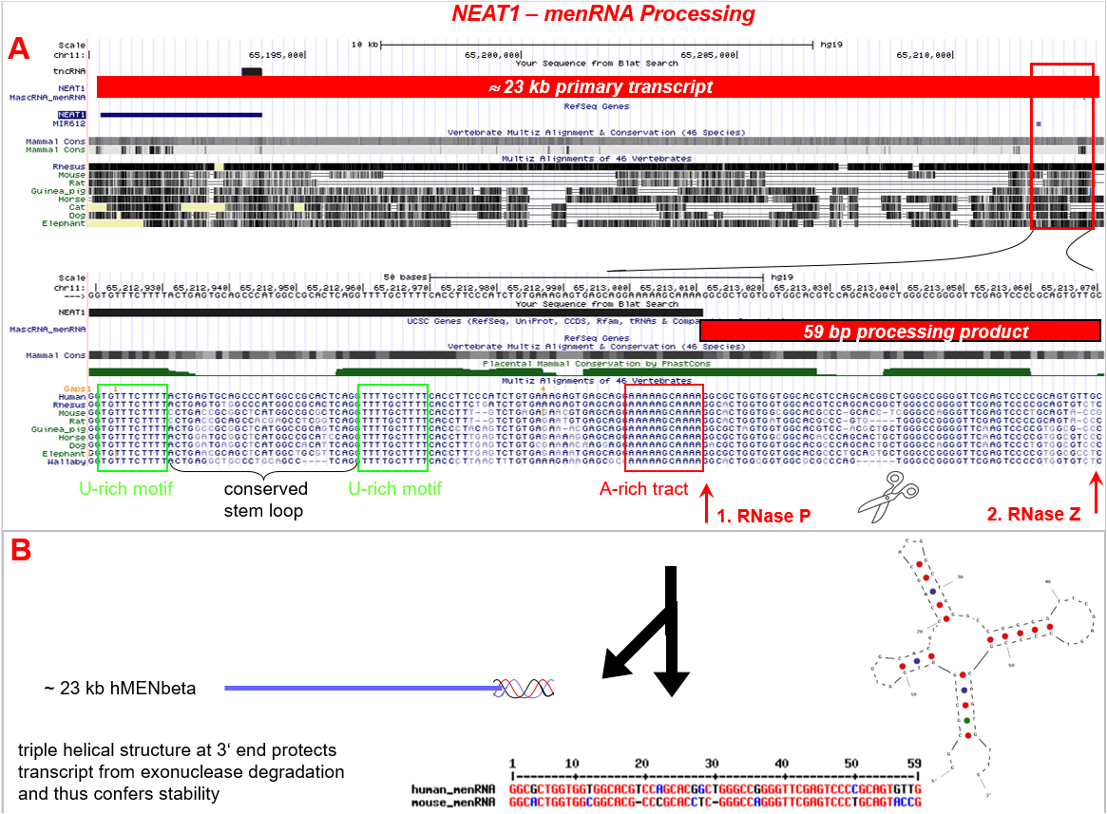

Supplemental Figure S1B
CRISPR-Cas9 target region to generate ΔmascRNA cells

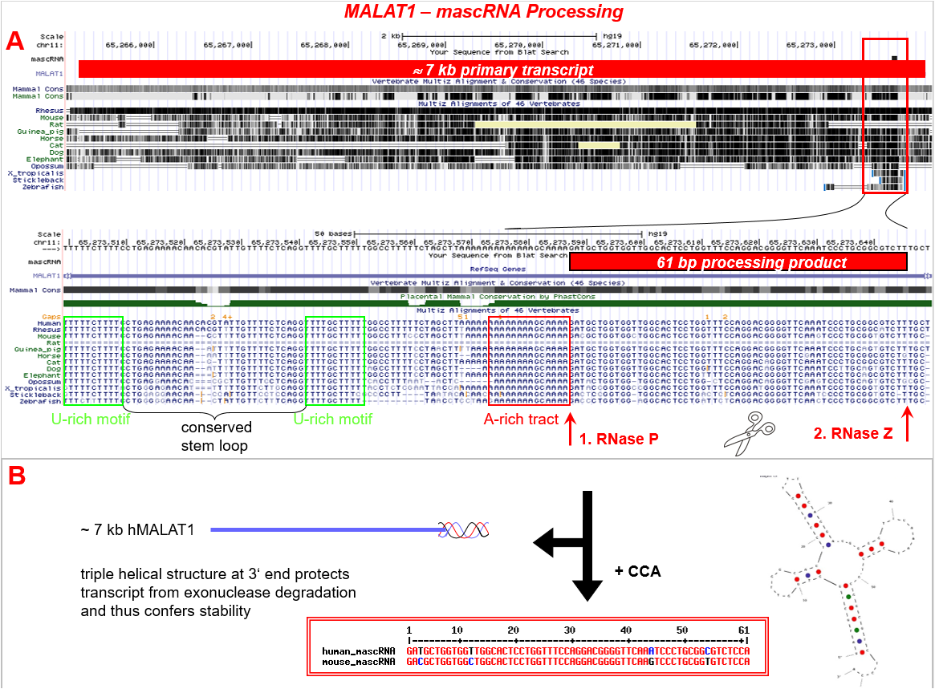

Supplemental Figure S1C
Recombinant expression and Northern blot analysis of menRNA
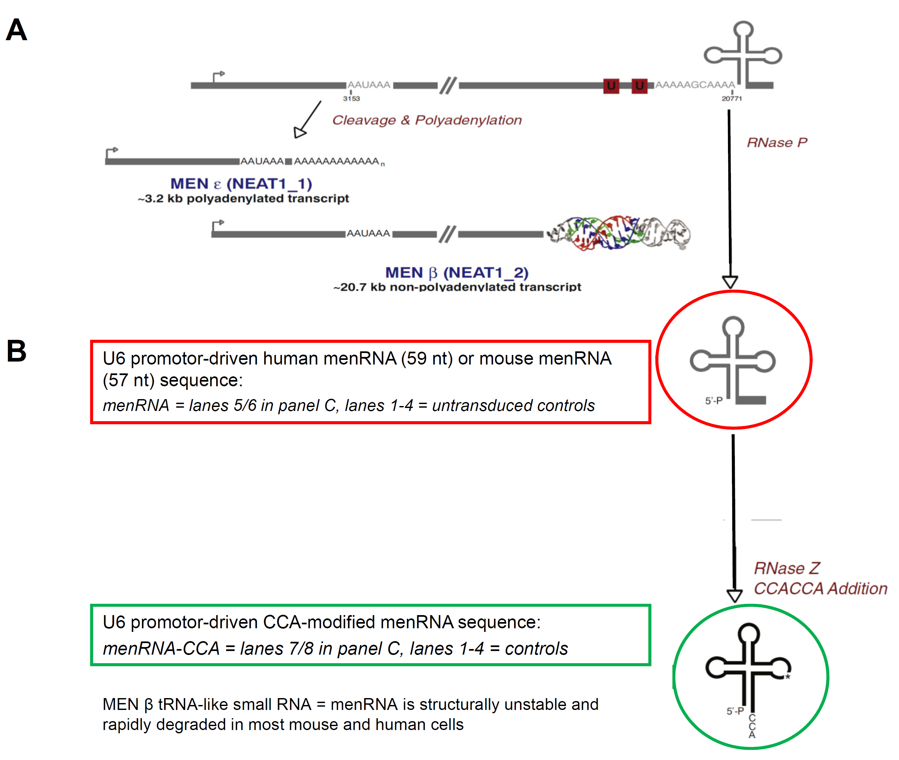

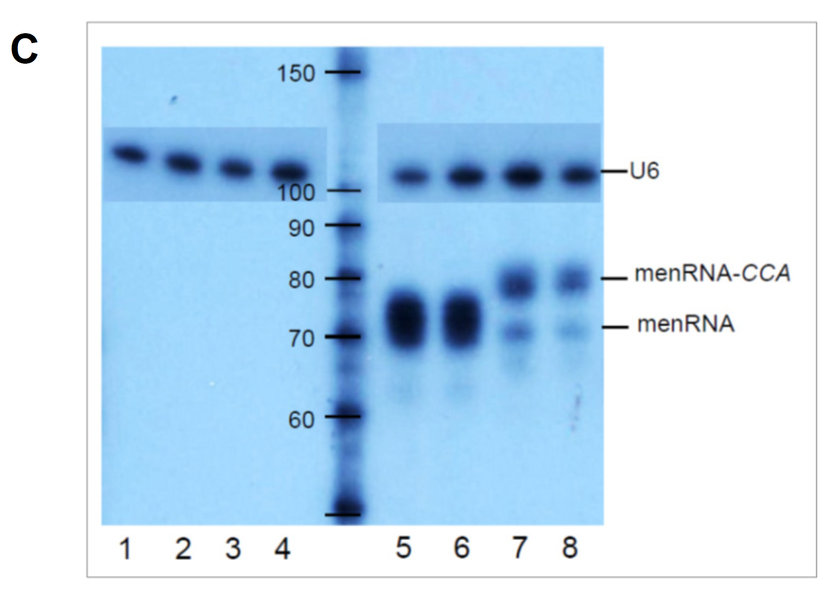

Panel A: Locations of two long primary transcripts from the NEAT1 locus with size 3.7 kb and poly A tail (MEN ε), or size ≈23 kb and triple helical tail (MEN β). A tRNA-like ’menRNA’ is enzymatically generated at the far 3’ end of NEAT1. Panel B: Outline of the enzymatic biosynthesis of menRNA. This product is posttranscriptionally modified by CCA or CCACCA addition with CCACCA tagging it for rapid degradation (Wilusz et al. tRNAs marked with CCACCA are targeted for degradation. Science 2011;334:817-821 | Kuhn et al. On-enzyme refolding permits small RNA and tRNA surveillance by the CCA-adding enzyme. Cell 2015;160:644-658). Panel C: Northern blot analysis of HEK 293 cells transfected with recombinant adenovectors expressing menRNA (lanes 5/5) or menRNA±CCA (lanes 7/8). Lanes 1-4 show untransduced HEK 293 control cells. In these and several others including THP-1 cells there was no detectable menRNA. U6 RNA was employed as loading control.

Supplemental Figure S1D
Immunomodulating effects of recombinant menRNA in murine macrophages

Strict evolutionary conservation of the menRNA sequence, as opposed to considerable variability in the other regions of the NEAT1 locus, suggests important cellular functions of the tRNA-like menRNA. Since we are aware of no pharmacological or other approach to selectively enhance menRNA formation from its precursor NEAT1, we employed recombinant menRNA vectors (Suppl. Fig. S1C) as a first experimental approximation to enhancement of endogenous menRNA formation.
In murine RAW monocytes-macrophages, recombinant menRNA or menRNA-CCA did not significantly alter the expression of its parent transcript NEAT1. As shown above, however, menRNA±CCA induced five genes (CCL5, IFIT1-3, IFIH1) directly. Of interest, FAS induction occurred only with menRNA-CCA, but not unmodified menRNA. IL-6 was suppressed by both.
Although recombinant menRNA overexpression is certainly an imperfect substitute for ’physiological’ enhancement of its endo-genous enzymatic formation, its observed capacity to induce the innate immune sensors IFIT1-3 and the chemokine CCL5 suggests immunoregulatory functions menRNA in monocytes where its precursor NEAT1 is significantly enriched as compared to other immune cell subpopulations (Gast et al. Immune system-mediated atherosclerosis caused by deficiency of long non-coding RNA MALAT1 in ApoE^{-/-}mice. Cardiovasc Res 2019;115:302-314). The fact that FAS is differentially affected by menRNA±CCA does suggest a degree of specificity of interaction of the recombinant menRNAs with their cellular targets.

Supplemental Figure S1E
Requirement of Northern blot analysis for mascRNA detection and quantification

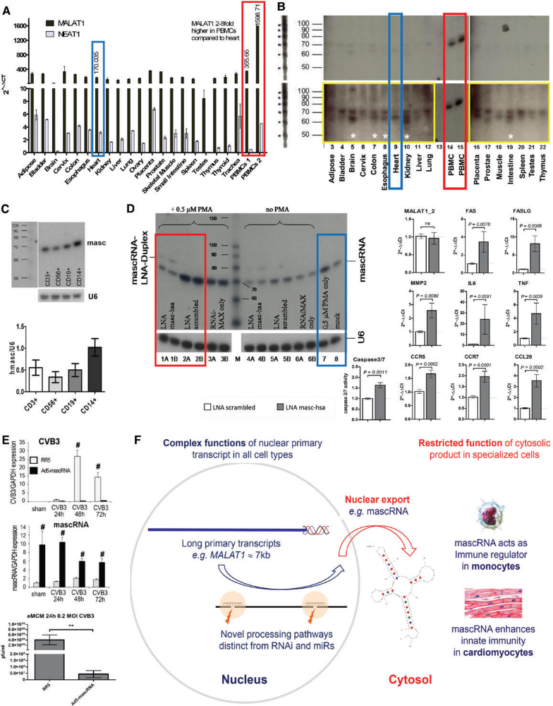

Northern blot analysis shows very low abundance of mascRNA below the detection limit in all investigated human solid organs (panel B), contrasting with high levels in circulating human immune cells (PBMCs). Panel C displays the Northern-based mascRNA quantification in FACS-sorted human PBMC subfractions, with highest abundance in CD14+ monocytes. Reproduced by permission from Gast et al. Long noncoding RNA MALAT1-derived mascRNA is involved in cardiovascular innate immunity. J Mol Cell Biol 2016;8:178-181).

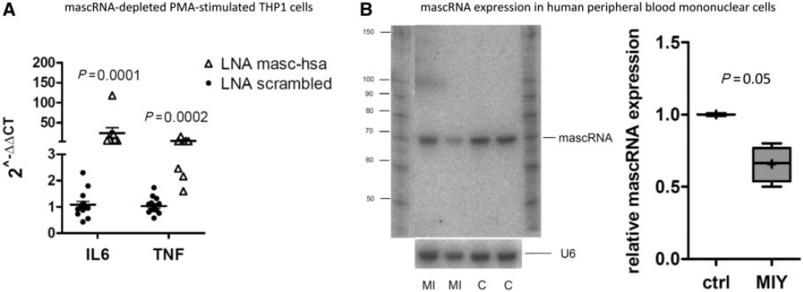

In a previous translational study of post-myocardial infarction patients, mascRNA abundance in circulating immune cells was quantitated in a subgroup of patients and controls for which sufficient RNA was available for Northern blot analysis. Reproduced by permission from Gast et al. Immune system-mediated atherosclerosis caused by deficiency of long non-coding RNA MALAT1 in ApoE^{-/-}mice. Cardiovasc Res 115, 302-314 (2019).

Supplemental Figure S2
Structure prediction for residual sequences in ΔmenRNA and ΔmascRNA cells

Panel A
residual menRNA (human)
5’-ggcgctggtg gtggcacgtc cagcacggct gggccggggt tcgagtcccc gcagtgttg-3’

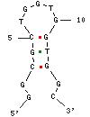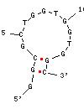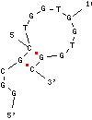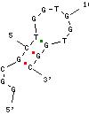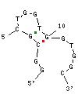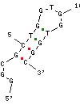

Panel B
residual mascRNA (human)
5‘-GATGCTGGTGGTTGGCACTCCTGGTTTCCAGGACGGGGTTCAAATCCCTGCGGCGTCT-3‘

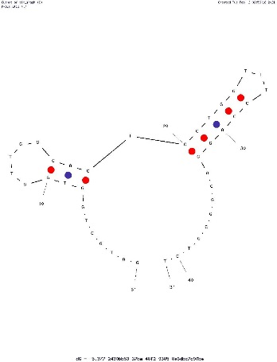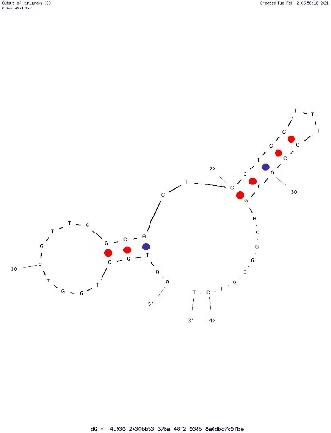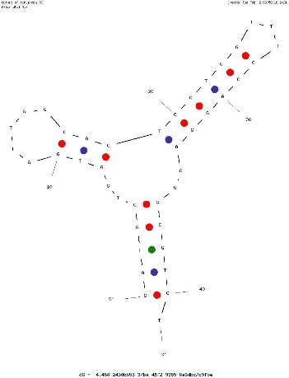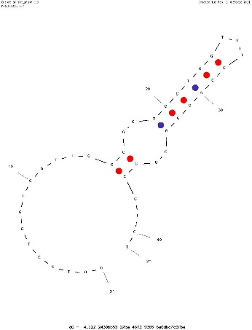
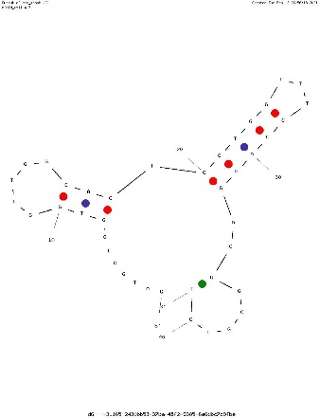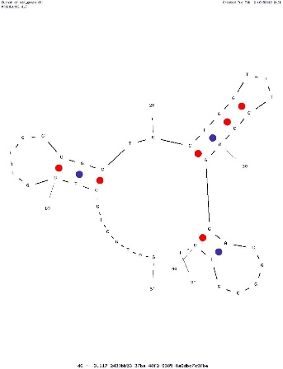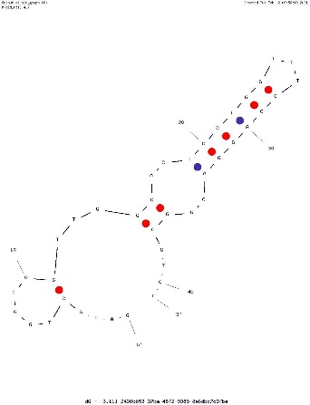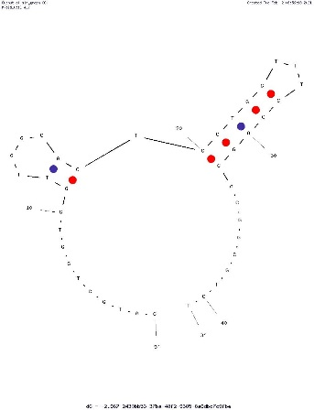

Possible structures acquired by sequence residues in ΔmenRNA and ΔmascRNA clones as predicted by OligoAnalyzer (IDT) https://eu.idtdna.com/calc/analyzer. None of these structures has resemblance with classical or atypical tRNAs.

Supplemental Figure S3A
In vitro transcription of single-guide RNAs

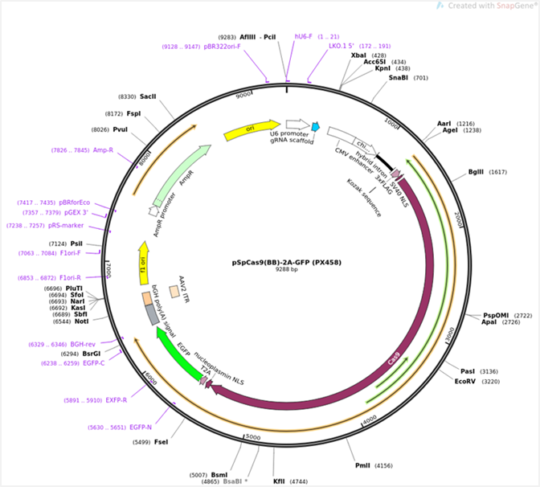

Supplemental Figure S3B
PCR analysis of ΔmenRNA and ΔmascRNA cells

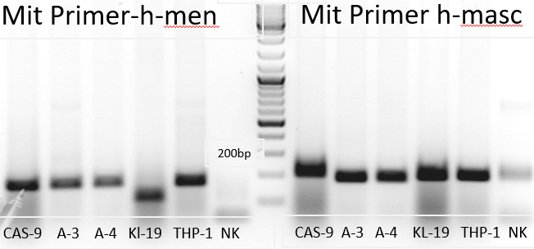

Supplemental Figure S4
Known sequence polymorphisms in the human menRNA and mascRNA sequences

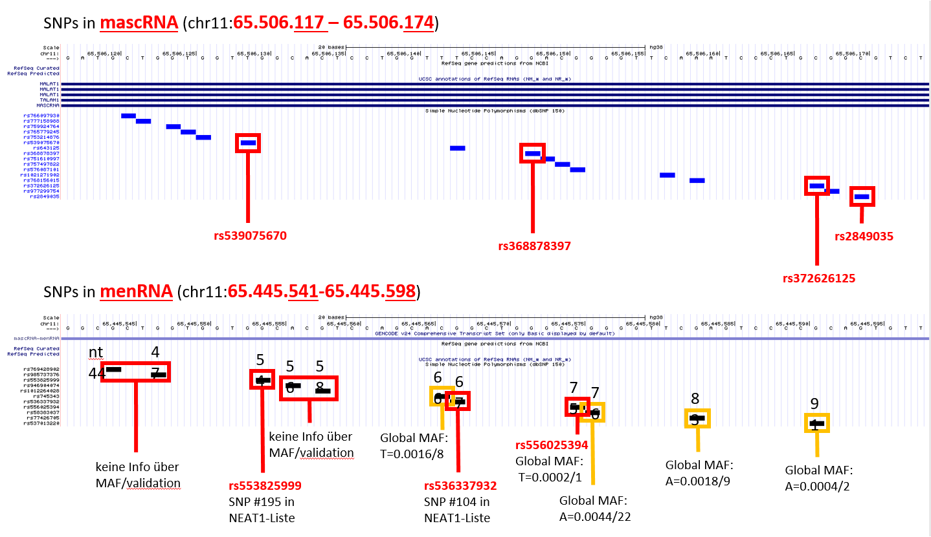

Supplemental Figure S5
Outline regarding SNPs analyses in SHIP cohorts

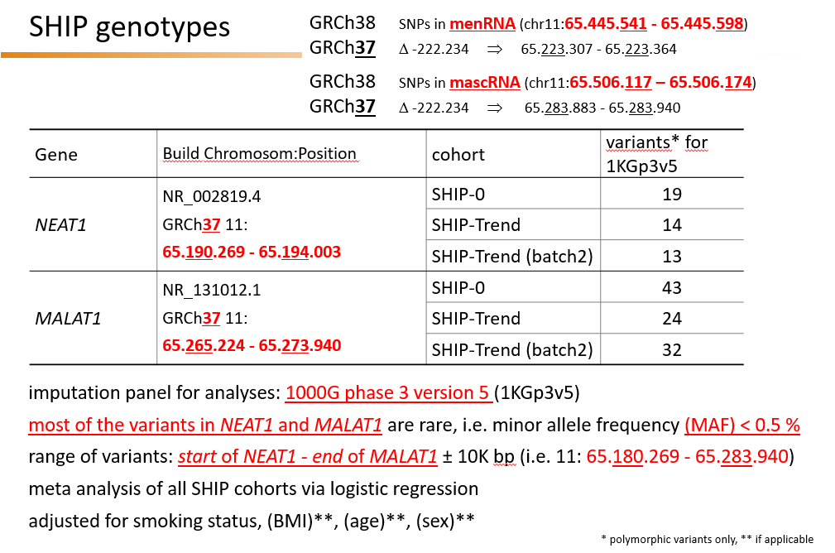

Genetic heterogeneity of the NEAT1-MALAT1 region in humans
SNPs available from the SHIP study for the NEAT1-MALAT1 region, with their respective positions, are shown in Suppl. Fig. S6AB. No full sequence data for the specific target regions of the current study, i.e. mascRNA and menRNA, are currently available for the SHIP general population or for any patient cohorts, although several SNP are known to occur mascRNA and menRNA (Suppl. Fig. 4). Consistent with prior findings in cell culture and animal models (Gast et al. Immune system-mediated atherosclerosis caused by deficiency of long non-coding RNA MALAT1 in ApoE^{-/-} mice. Cardiovasc Res 2019;115: 302-314 | Cremer et al. Hematopoietic deficiency of the long noncoding RNA MALAT1 promotes atherosclerosis and plaque inflammation. Circulation 2019;139:1320-1334), one MALAT1 SNP with very low minor allele frequency (MAF=0.01) was associated (p=0.0062) with systemic low level inflammation (CRP>3.0 mg/L) (Suppl. Fig. S7). This SNP is located upstream of MALAT1 in the promotor region regulating MALAT1 expression (Suppl. Fig. S6A). Further, there was an association (p<0.01) of eight SNPs (low MAF=0.09 for all) within the NEAT1 region with the phenotype of BMI >35 kg/m² and LDL >164 mg/dl (Suppl. Fig. S6B).

Supplemental Figure S6A
Positions of MALAT1 region SNPs analyzed in SHIP cohorts

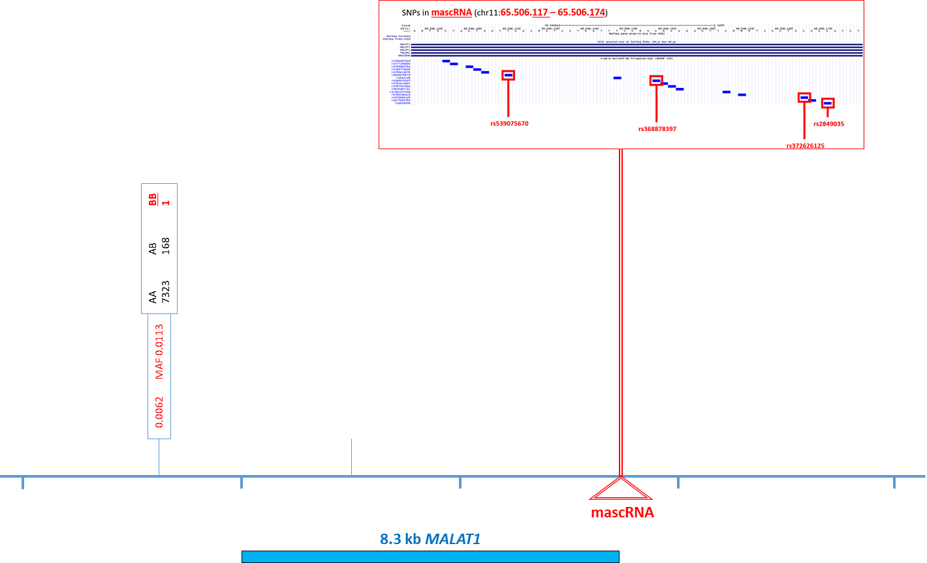

Supplemental Figure S6B
Positions of NEAT1 region SNPs analyzed in SHIP cohorts

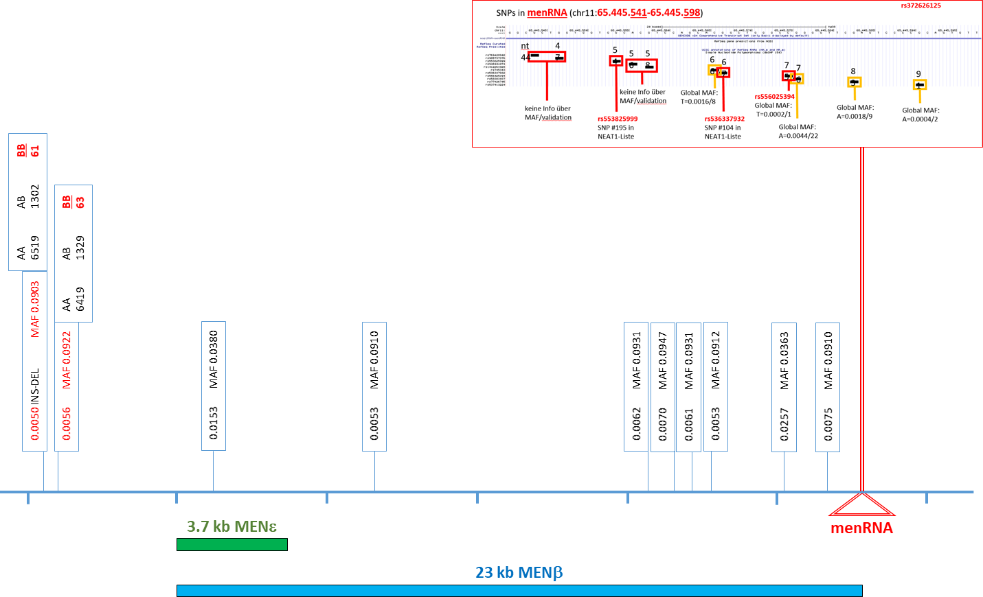

Supplemental Figure S7A
Human population genetic data

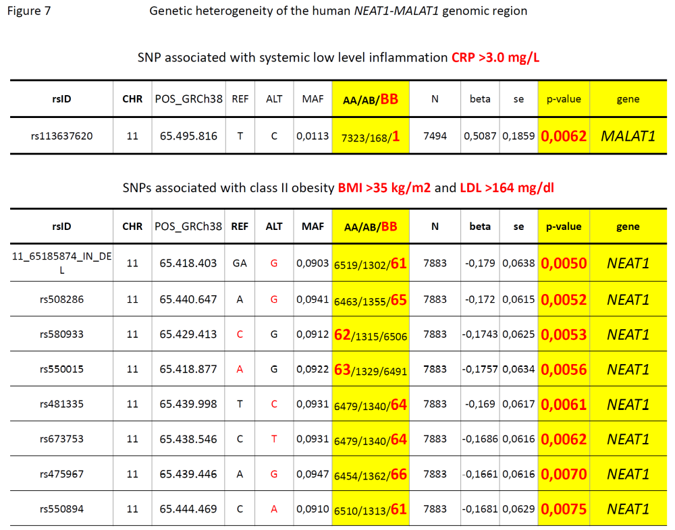

Supplemental Figure S8A

Transduction of recombinant GFP-expressing adenovirus into CRISPR-Cas9-generated defective human macrophages

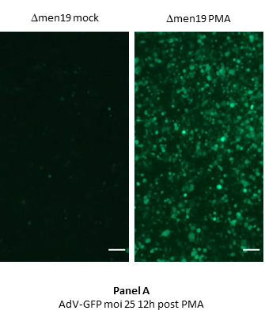

Supplemental Figure S8B

Transduction of human coxsackievirus B3 into CRISPR-Cas9-generated defective human macrophages

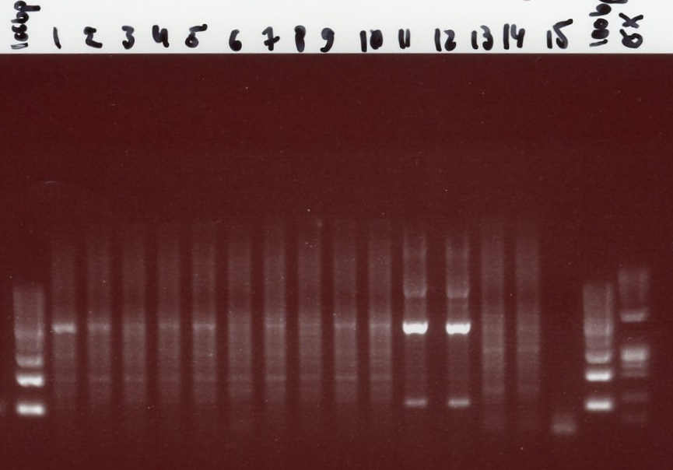

Marker: Øx bzw 100bp Peqlab
lane 1: Δmen19 cells + 30moi CVB3 (18.11.2020)
lane 2: Δmasc4 cells + 30moi CVB3 (18.11.2020)
lane 3: Δmasc3 cells + 30moi CVB3 (18.11.2020)
lane 4: cas 9 cells + 30moi CVB3 (18.11.2020)
lane 5: THP-1 cells + 30moi CVB3 (18.11.2020)
lane 6: Δmen19 cells + 30moi CVB3 (24.11.2020)
lane 7: Δmasc4 cells + 30moi CVB3 (24.11.2020)
lane 8: Δmasc3 cells + 30moi CVB3 (24.11.2020)
lane 9: cas 9 cells + 30moi CVB3 (24.11.2020)
lane10: THP-1 cells + 30moi CVB3 (24.11.2020)
lanes 11+12: Vero cells + 30moi CVB3 (positive control)
lanes 13+14: Vero cells w/o CVB3 (negative control)
lane 15: water control PCR reagents
Expected fragment size for CVB3 replicative intermediates: 478bp

Supplemental Figure S9A

Anomalous expression of innate immune sensor molecules and interferon-induced genes in ΔmenRNA and ΔmascRNA macrophages

Upon PMA-induced differentiation of ΔmenRNA and ΔmascRNA monocytes into macrophages (Suppl. Fig. S8A), these displayed further disturbances of innate immune regulation under baseline conditions including constitutive induction of the cytosolic innate immune sensor molecules RLR1 (DExD/H-box helicase DDX58), RLR2 (IFIH1; MDA-5), RLR3 (RNA helicase DHX58; LGP2), and MAVS (mitochondrial antiviral signaling protein). In ΔmenRNA macrophages several interferon (IFN) system genes were also constitutively upregulated up to ∼15-fold: the IFN regulatory factors IRF3, IRF7, and IRF9; IFN-stimulated gene ISG15; IFN-induced transmembrane proteins IFITM1 and IFITM3 In ΔmenRNA macrophages several interferon (IFN) system genes were also constitutively upregulated up to ∼15-fold: the IFN regulatory factors IRF3, IRF7, and IRF9; IFN-stimulated gene ISG15; IFN-induced transmembrane proteins IFITM1, IFITM3; and GVINP1. Bar graphs show means ± SE from three biological replicates.

Supplemental Figure S9B

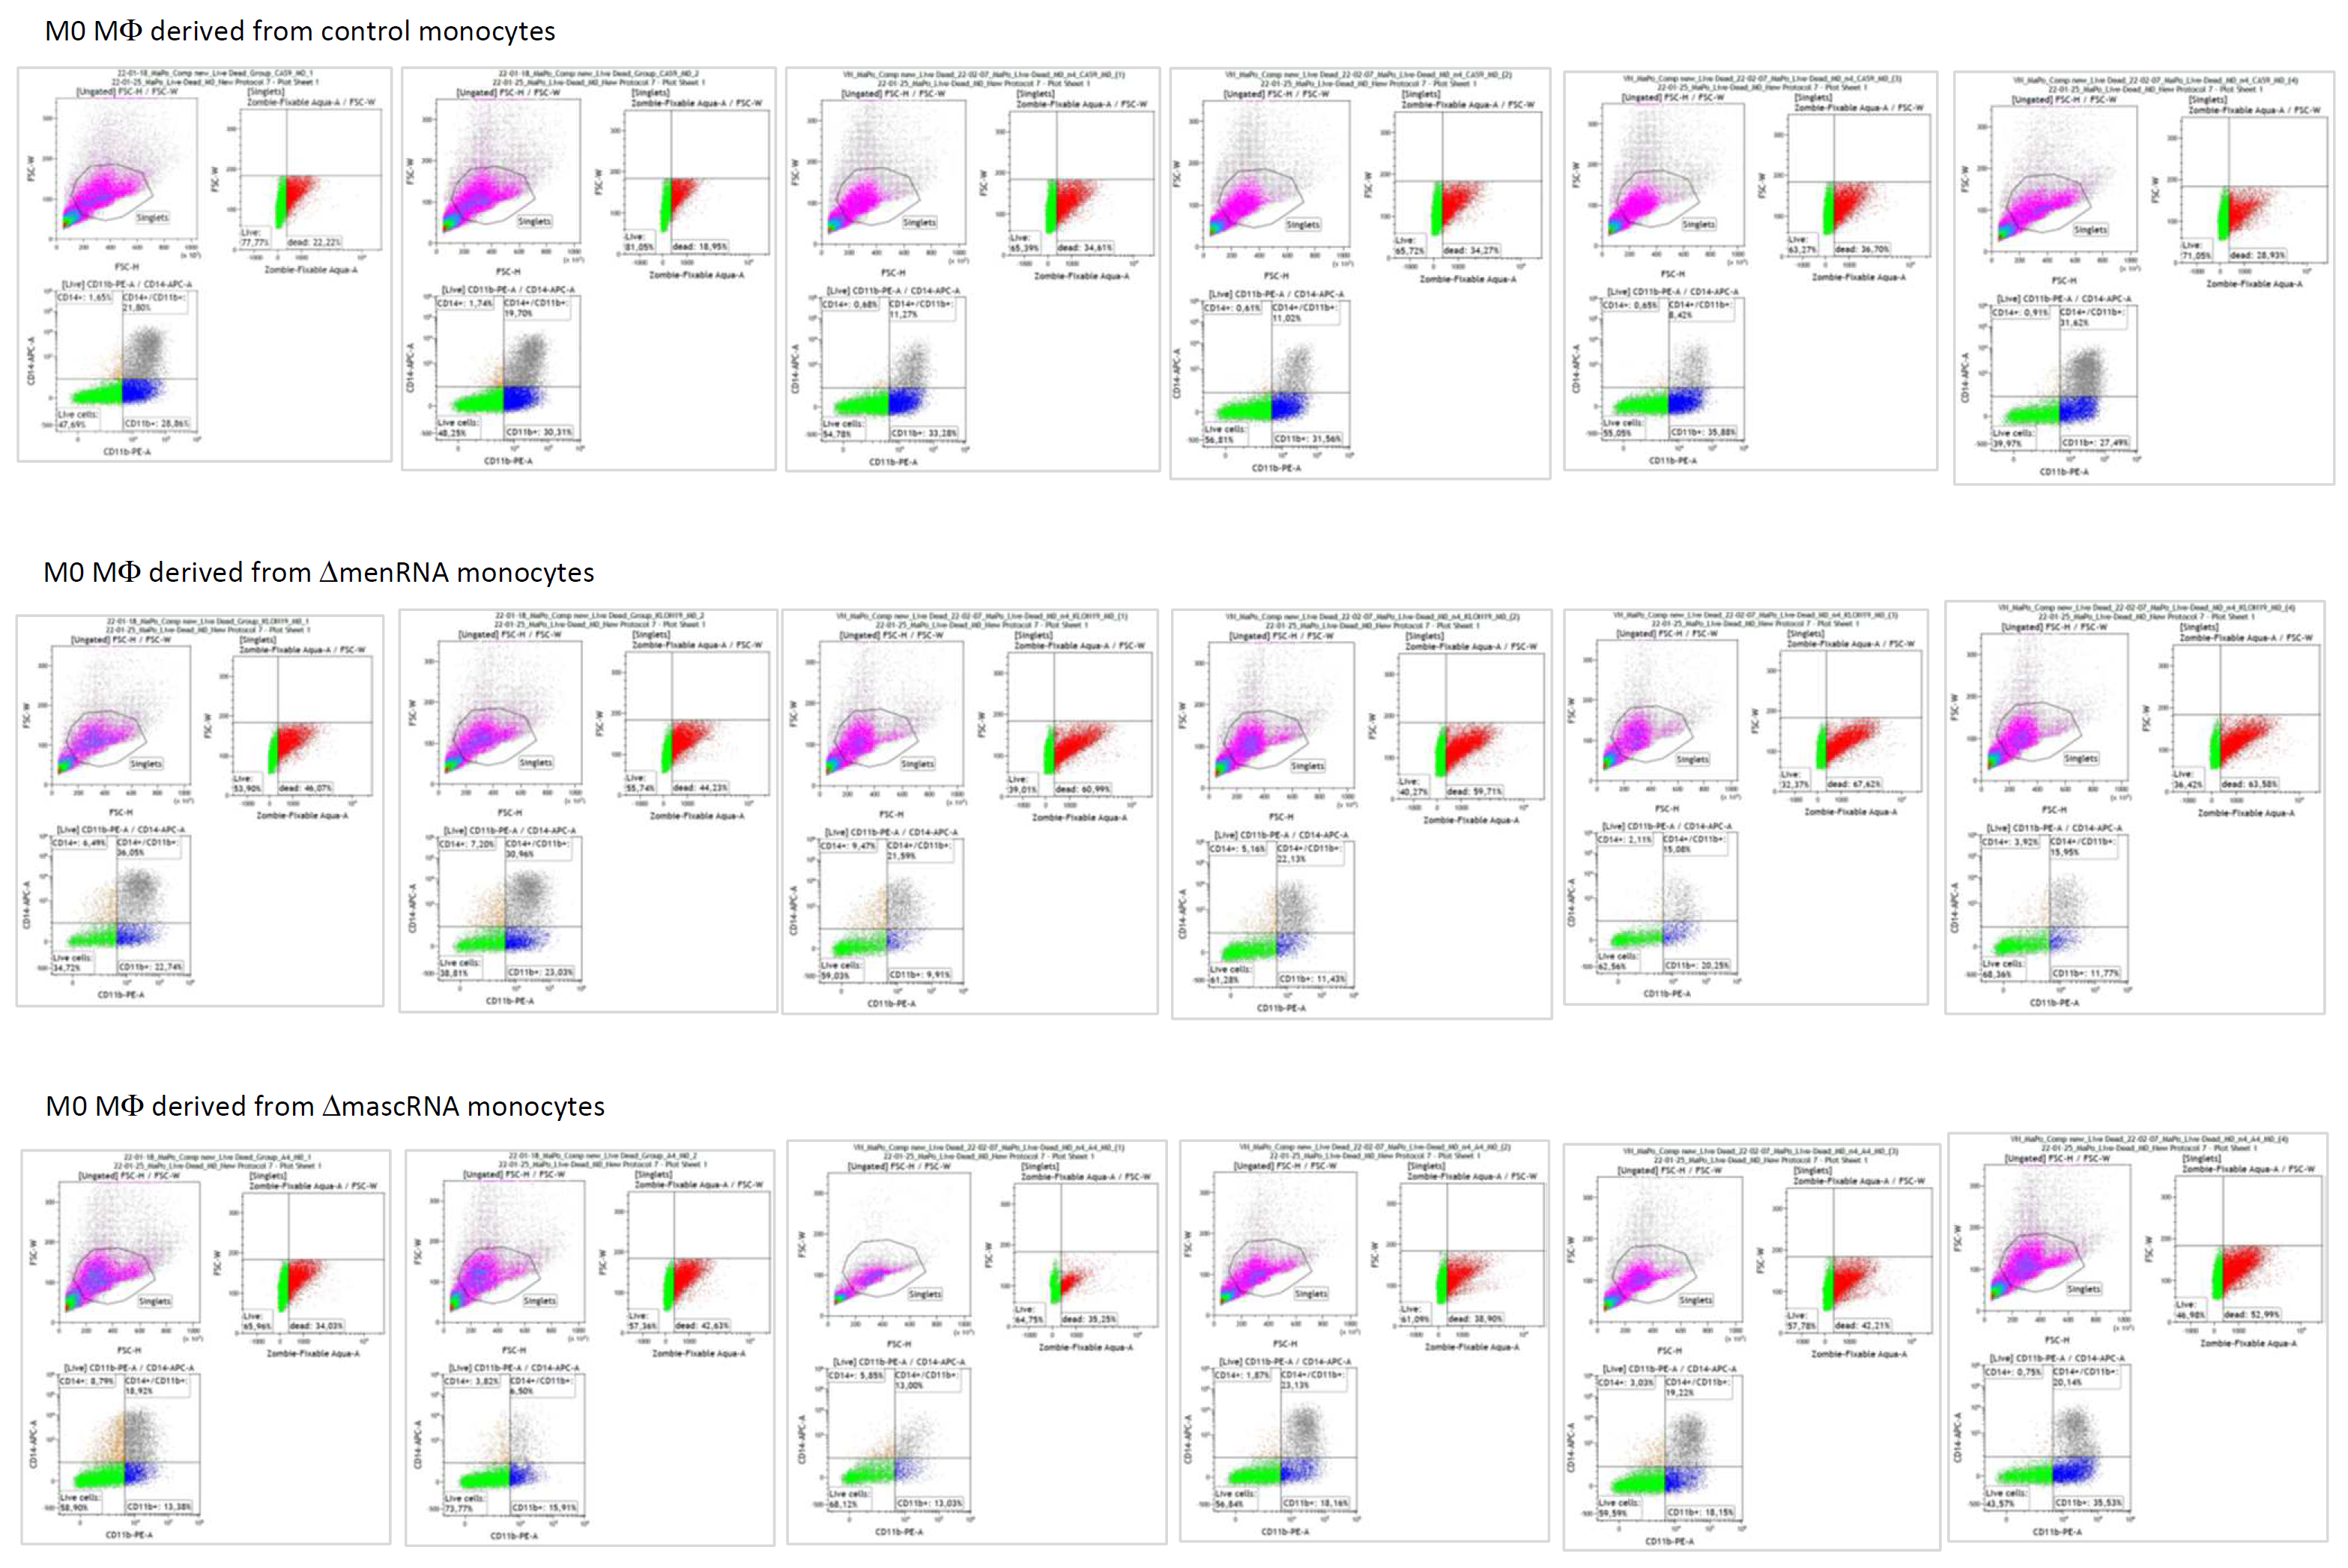
FACS analysis of ΔmenRNA and ΔmascRNA monocyte to M0 macrophage transition

Supplemental Table S1
RNA-seq FPKM data for ΔmenRNA monocytes

S1A - Innate immune sensors

BASELINE |  |  | control | Δmen19 | ratio
CIITA | class II major histocompatibility complex transactivator | 6,669 |  | 115,166 | 17,270
NOD2 | nucleotide binding oligomerization domain containing 2 | 21,117 |  | 157,454 | 7,456
NLRC5 | NLR family CARD domain containing 5 | 230,068 |  | 870,944 | 3,786
TLR2 | toll like receptor 2 | 379,000 |  | 1299,218 | 3,428
PYCARD | PYD and CARD domain containing | 368,997 |  | 147,557 | 0,400
CARD10 | caspase recruitment domain family member 10 | 33,343 |  | 8,997 | 0,270
NAIP | NLR family apoptosis inhibitory protein | 54,460 |  | 8,997 | 0,165
NLRC4 | NLR family CARD domain containing 4 | 33,343 |  | 5,398 | 0,162
MEFV | MEFV innate immuity regulator, pyrin | 240,071 |  | 32,390 | 0,135
NLRC3 | NLR family CARD domain containing 3 | 185,610 |  | 14,396 | 0,078

LPS100 |  | control | Δmen19 | ratio
BOK | BCL2 family apoptosis regulator BOK | 2,404 | 17,473 | 7,269
NOD2 | nucleotide binding oligomerization domain containing 2 | 68,505 | 321,171 | 4,688
FAM129C | niban apoptosis regulator 3 | 2,404 | 9,985 | 4,154
NLRC5 | NLR family CARD domain containing 5 | 292,050 | 1161,542 | 3,977
PYCARD | PYD and CARD domain containing | 760,771 | 371,926 | 0,489
RIPK3 | receptor interacting serine/threonine kinase 3 | 137,011 | 34,114 | 0,249
NAIP | NLR family apoptosis inhibitory protein | 69,707 | 16,641 | 0,239
CARD14 | caspase recruitment domain family member 14 | 4,807 | 0,832 | 0,173
TLR1 | toll like receptor 1 | 104,561 | 15,809 | 0,151
NLRC4 | NLR family CARD domain containing 4 | 63,698 | 6,656 | 0,104
MEFV | MEFV innate immuity regulator, pyrin | 301,664 | 26,626 | 0,088
MPEG1 | macrophage expressed 1 | 212,728 | 16,641 | 0,078
TLR8 | toll like receptor 8 | 32,450 | 2,496 | 0,077
TLR10 | toll like receptor 10 | 10,817 | 0,832 | 0,077
NLRC3 | NLR family CARD domain containing 3 | 137,011 | 4,160 | 0,030
TLR7 | toll like receptor 7 | 4,807 | 0,000

S1B – Transcription and nuclear factors, epigenetic modifiers

BASELINE |  |  | control | men19 | ratio
GDAP1L1 | ganglioside induced differentiation associated protein 1 like 1 | 0,000 |  | 17,995
HDAC11 | histone deacetylase 11 | 0,000 |  | 3,599
GCM1 | glial cells missing transcription factor 1 | 0,000 |  | 8,098
SIM1 | SIM bHLH transcription factor 1 | 0,000 |  | 8,098
CCPG1 | cell cycle progression 1 | 52,238 |  | 556,936 | 10,662
NPDC1 | neural proliferation, differentiation and control 1 | 4,446 |  | 44,987 | 10,119
MTURN | maturin, neural progenitor differentiation regulator homolog | 24,452 |  | 233,931 | 9,567
RGCC | regulator of cell cycle | 6,669 |  | 51,285 | 7,690
GATA2 | GATA binding protein 2 | 21,117 |  | 91,773 | 4,346
NFATC2 | nuclear factor of activated T cells 2 | 563,499 |  | 120,565 | 0,214
METTL7B | methyltransferase like 7B | 166,716 |  | 33,290 | 0,200
TBX15 | T-box transcription factor 15 | 73,355 |  | 13,496 | 0,184
GATA6 | GATA binding protein 6 | 10,003 |  | 1,799 | 0,180
HIC1 | HIC ZBTB transcriptional repressor 1 | 5,557 |  | 0,900 | 0,162
SOX4 | SRY-box transcription factor 4 | 868,033 |  | 134,960 | 0,155
EBF1 | EBF transcription factor 1 | 6,669 |  | 0,900 | 0,135
SPIB | Spi-B transcription factor | 14,449 |  | 1,799 | 0,125
HDAC9 | histone deacetylase 9 | 332,320 |  | 39,588 | 0,119
TWIST2 | twist family bHLH transcription factor 2 | 17,783 |  | 1,799 | 0,101
TFAP2C | transcription factor AP-2 gamma | 25,563 |  | 1,799 | 0,070
GDAP1 | ganglioside induced differentiation associated protein 1 | 100,029 |  | 5,398 | 0,054
SAMSN1 | SAM domain, SH3 domain and nuclear localization signals 1 | 184,499 |  | 5,398 | 0,029
KDM5D | lysine demethylase 5D | 553,496 |  | 0,900 | 0,002

LPS100 |  | control | Δmen19 | ratio
MNDA | myeloid cell nuclear differentiation antigen | 245,177 | 1499,355 | 6,115
MTURN | maturin, neural progenitor differentiation regulator homolog | 51,680 | 255,439 | 4,943
RAVER2 | ribonucleoprotein, PTB binding 2 | 87,735 | 428,506 | 4,884
RNASE2 | ribonuclease A family member 2 | 567,273 | 2410,450 | 4,249
HDAC4 | histone deacetylase 4 | 676,642 | 2322,252 | 3,432
GATA2 | GATA binding protein 2 | 33,652 | 114,823 | 3,412
HDAC9 | histone deacetylase 9 | 403,822 | 86,533 | 0,214
GATA3 | GATA binding protein 3 | 22,835 | 2,496 | 0,109
NFATC2 | nuclear factor of activated T cells 2 | 1471,065 | 78,213 | 0,053
GATA6 | GATA binding protein 6 | 16,826 | 0,832 | 0,049
DNASE2 | deoxyribonuclease 2, lysosomal | 379,785 | 14,145 | 0,037
SAMSN1 | SAM domain, SH3 domain and nuclear localization signals 1 | 627,366 | 17,473 | 0,028
TWIST2 | twist family bHLH transcription factor 2 | 61,294 | 1,664 | 0,027
KDM5D | lysine demethylase 5D | 656,210 | 14,977 | 0,023

S1C – Translation and ribosomal factors, nucleic acid modifiers

BASELINE |  | control | Δmen19 | ratio
NSUN7 | NOP2/Sun RNA methyltransferase family member 7 | 0,000 | 22,493
EEF1A2 | eukaryotic translation elongation factor 1 alpha 2 | 13,337 | 92,673 | 6,948
CTIF | cap binding complex dependent translation initiation factor | 45,569 | 269,021 | 5,904
PPARGC1A | PPARG coactivator 1 alpha | 11,114 | 55,784 | 5,019
SARS | seryl-tRNA synthetase 1 - serine | 536,824 | 2288,927 | 4,264
AARS | alanyl-tRNA synthetase 1 - alanine | 1134,778 | 3961,535 | 3,491
RNASE2 | ribonuclease A family member 2 | 530,156 | 1765,281 | 3,330
GARS | glycyl-tRNA synthetase 1 - glycine | 821,353 | 2439,183 | 2,970
TRMT61A | tRNA methyltransferase 61A | 118,924 | 42,288 | 0,356
TRMT2B | tRNA methyltransferase 2 homolog B | 261,188 | 82,776 | 0,317
RIMKLA | ribosomal modification protein rimK like family member A | 27,786 | 4,499 | 0,162
MT-TD | mitochondrially encoded tRNA Asp (GAU/C) - aspartic acid | 6,669 | 0,900 | 0,135
DNASE2 | deoxyribonuclease 2 lysosomal | 76,689 | 9,897 | 0,129
MT-TE | mitochondrially encoded tRNA Glu (GAA/G) - glutamic acid | 8,892 | 0,900 | 0,101
DDX3Y | DEAD-box helicase 3 Y-linked | 986,957 | 2,699 | 0,003
RPS4Y1 | ribosomal protein S4 Y-linked 1 | 1050,309 | 0,900 | 0,001
EIF1AY | eukaryotic translation initiation factor 1A Y-linked | 152,267 | 0,000

LPS100
NT5E | 5'-nucleotidase ecto | 9,615 | 54,083 | 5,625
RAVER2 | ribonucleoprotein, PTB binding 2 | 87,735 | 428,506 | 4,884
RNASE2 | ribonuclease A family member 2 | 567,273 | 2410,450 | 4,249
MT-TV | mitochondrially encoded tRNA Val (GUN) - valine | 1,202 | 4,992 | 4,154
MT-TY | mitochondrially encoded tRNA Tyr (UAU/C) - tyrosine | 1,202 | 4,992 | 4,154
PPARGC1A | PPARG coactivator 1 alpha | 9,615 | 35,778 | 3,721
MT-TM | mitochondrially encoded tRNA Met (AUA/G) - methionine | 14,422 | 4,160 | 0,288
METTL7B | methyltransferase like 7B | 359,353 | 95,686 | 0,266
TPMT | thiopurine S-methyltransferase | 322,096 | 75,717 | 0,235
RNASE6 | ribonuclease A family member k6 | 27,643 | 3,328 | 0,120
MT-TD | mitochondrially encoded tRNA Asp (GAU/C) - aspartic acid | 21,633 | 1,664 | 0,077
DNASE2 | deoxyribonuclease 2 lysosomal | 379,785 | 14,145 | 0,037
EIF1AY | eukaryotic translation initiation factor 1A Y-linked | 167,057 | 4,992 | 0,030
DDX3Y | DEAD-box helicase 3 Y-linked | 1022,775 | 28,290 | 0,028
RPS4Y1 | ribosomal protein S4 Y-linked 1 | 1044,408 | 23,297 | 0,022

S1D - Long noncoding RNAs, antisense transcripts, microRNAs

BASELINE |  | control | Δmen19 | ratio
MIR146A | MIR3142 host gene | 0,000 | 51,285
MIR616 | microRNA 616 | 0,000 | 26,992
RP11-1L12.3 | BBOX1 antisense RNA 1 | 0,000 | 15,296
VAC14-AS1 | VAC14 antisense RNA 1 | 0,000 | 14,396
AC008174.3 | FSIP2 antisense RNA 1 | 0,000 | 11,697
MIR181A1HG |  | 105,587 | 19,794 | 0,187
RP1-249H1.4 | MARCKS cis regulating lncRNA promoter of cytokines and inflammation (ROCKI) | 102,252 | 15,296 | 0,150
DGUOK-AS1 | DGUOK antisense RNA 1 | 12,226 | 1,799 | 0,147
PCED1B-AS1 | PCED1B antisense RNA 1 | 524,599 | 58,483 | 0,111
SENCR | smooth muscle and endothelial cell enriched migration/differentiation-associated lncRNA | 11,114 | 0,900 | 0,081
IL10RB-AS1 |  | 14,449 | 0,900 | 0,062
IL12A-AS1 | IL12A antisense RNA 1 | 47,792 | 1,799 | 0,038

LPS100 |  | control | Δmen19 | ratio
PCED1B-AS1 | PCED1B antisense RNA 1 | 343,729 | 69,892 | 0,203
RP1-249H1.4 | MARCKS cis regulating lncRNA promoter of cytokines and inflammation (ROCKI) | 82,928 | 15,809 | 0,191
RP4-612B15.3 | CLCA4 antisense RNA 1 | 8,413 | 0,832 | 0,099
KIF25-AS1 | KIF25 antisense RNA 1 | 12,019 | 0,832 | 0,069
RP11-366L20.2 | HMGA2 antisense RNA 1 | 66,102 | 4,160 | 0,063
RP11-82L2.1 | SMC2 antisense RNA 1 (head to head) | 16,826 | 0,832 | 0,049
IL12A-AS1 | IL12A antisense RNA 1 | 63,698 | 0,832 | 0,013
DPP10-AS1 | DPP10 antisense RNA 1 | 8,413 | 0,000
ZNF582-AS1 | ZNF582 antisense RNA 1 (head to head) | 7,211 | 0,000

S1E – Interleukins and TNF systems, interferon-induced genes

BASELINE |  | control | Δmen19 | ratio
ADAMTS20 | ADAM metallopeptidase with thrombospondin type 1 motif 20 | 0,000 | 19,794
IL8 | C-X-C motif chemokine ligand 8 | 1,111 | 19,794 | 17,810
SLFN12L | schlafen family member 12 like | 0,000 | 22,493
C1QTNF3 | C1q and TNF related 3 | 16,672 | 82,776 | 4,965
TNFAIP8 | TNF alpha induced protein 8 | 315,648 | 1485,463 | 4,706
TNF | tumor necrosis factor | 216,730 | 510,150 | 2,354
TNIK | TRAF2 and NCK interacting kinase | 154,490 | 55,784 | 0,361
TNFSF13 | TNF superfamily member 13 | 17,783 | 3,599 | 0,202
ADAMTS4 | ADAM metallopeptidase with thrombospondin type 1 motif 4 | 12,226 | 1,799 | 0,147
IL4R | interleukin 4 receptor | 198,947 | 27,892 | 0,140
TNFRSF10C | TNF receptor superfamily member 10c | 6,669 | 0,900 | 0,135
IL16 | interleukin 16 | 54,460 | 7,198 | 0,132
ADAM21 | ADAM metallopeptidase domain 21 | 8,892 | 0,900 | 0,101
IL1RN | interleukin 1 receptor antagonist | 156,713 | 12,596 | 0,080
IL18R1 | interleukin 18 receptor 1 | 48,903 | 3,599 | 0,074
IL2RB | interleukin 2 receptor subunit beta | 20,006 | 0,900 | 0,045
IL12A-AS1 | IL12A antisense RNA 1 | 47,792 | 1,799 | 0,038
ADAM28 | ADAM metallopeptidase domain 28 | 28,897 | 0,900 | 0,031
ADAMTS9 | ADAM metallopeptidase with thrombospondin type 1 motif 9 | 526,822 | 5,398 | 0,010

LPS100 |  | control | Δmen19 | ratio
TNFRSF19 | TNF receptor superfamily member 19 | 0,000 | 5,824
SLFN12L | schlafen family member 12 like | 1,202 | 30,786 | 25,615
IL9R | interleukin 9 receptor | 1,202 | 8,321 | 6,923
IL17D | interleukin 17D | 1,202 | 7,488 | 6,231
IL20RA | interleukin 20 receptor subunit alpha | 1,202 | 4,992 | 4,154
TNFAIP8 | TNF alpha induced protein 8 | 430,262 | 1611,681 | 3,746
IL8 | C-X-C motif chemokine ligand 8 | 9,615 | 30,786 | 3,202
ADAMTS5 | ADAM metallopeptidase with thrombospondin type 1 motif 5 | 14,422 | 4,160 | 0,288
ADAMTS4 | ADAM metallopeptidase with thrombospondin type 1 motif 4 | 7,211 | 1,664 | 0,231
IL4R | interleukin 4 receptor | 399,014 | 72,388 | 0,181
ADAMTS10 | ADAM metallopeptidase with thrombospondin type 1 motif 10 | 90,139 | 13,313 | 0,148
IL10RA | interleukin 10 receptor subunit alpha | 198,305 | 28,290 | 0,143
IRAK2 | interleukin 1 receptor associated kinase 2 | 93,744 | 10,817 | 0,115
SLFN5 | schlafen family member 5 | 292,050 | 29,122 | 0,100
IL4I1 | interleukin 4 induced 1 | 486,749 | 43,267 | 0,089
TNFRSF25 | TNF receptor superfamily member 25 | 82,928 | 6,656 | 0,080
IL2RG | interleukin 2 receptor subunit gamma | 10,817 | 0,832 | 0,077
IL21R | interleukin 21 receptor | 55,285 | 4,160 | 0,075
ADAMTS9 | ADAM metallopeptidase with thrombospondin type 1 motif 9 | 462,712 | 29,954 | 0,065
ADAM28 | ADAM metallopeptidase domain 28 | 222,342 | 11,649 | 0,052
IL16 | interleukin 16 | 135,809 | 7,488 | 0,055
TNFRSF9 | TNF receptor superfamily member 9 | 20,431 | 0,832 | 0,041
IL2RB | interleukin 2 receptor subunit beta | 43,267 | 0,832 | 0,019
TNIP3 | TNFAIP3 interacting protein 3 | 93,744 | 1,664 | 0,018
IL18R1 | interleukin 18 receptor 1 | 58,891 | 0,832 | 0,014
ADAMTS3 | ADAM metallopeptidase with thrombospondin type 1 motif 3 | 10,817 | 0,000
IL18RAP | interleukin 18 receptor accessory protein | 7,211 | 0,000

S1F – Cluster of differentiation and other leukocyte markers

BASELINE |  | control | Δmen19 | ratio
CD93 |  | 42,235 | 1454,872 | 34,483
MARCO | macrophage receptor with collagenous structure = SR-A6 | 21,594 | 2,223 | 9,709
FCGR2C | Fc fragment of IgG receptor IIc | 10,003 | 1,799 | 0.180
C8G | complement C8 gamma chain | 5,557 | 0,900 | 0,162
CD52 | CD52 molecule | 56,683 | 8,997 | 0,159
LILRB1 | leukocyte immunoglobulin like receptor B1 | 34,455 | 5,398 | 0,157
LILRA1 | leukocyte immunoglobulin like receptor A1 | 163,381 | 22,493 | 0,138
KIAA1462 | junctional cadherin 5 associated | 202,282 | 26,092 | 0,129
KIAA1462 | junctional cadherin 5 associated | 202,282 | 26,092 | 0,129
CD40 | CD40 molecule | 71,132 | 8,098 | 0,114
CD53 | CD53 molecule | 671,308 | 70,179 | 0,105
CD248 | CD248 molecule | 8,892 | 0,900 | 0,101
MPEG1 | macrophage expressed 1 | 14,449 | 0,900 | 0,062
CD300A | CD300a molecule | 417,901 | 23,393 | 0,056
CD300LB | CD300 molecule like family member b | 18,894 | 0,900 | 0,048
CD180 | CD180 molecule | 296,754 | 8,098 | 0,027
CD36 | scavenger receptor (SR-B2) | 300,088 | 6,298 | 0,021
CFP | complement factor properdin | 104,475 | 1,799 | 0,017
LILRB2 | leukocyte immunoglobulin like receptor B2 | 60,018 | 0,900 | 0,015
PCDH10 | protocadherin 10 | 316,760 | 3,599 | 0,011
FCGR2B | Fc fragment of IgG receptor IIb | 12,226 | 0,000

LPS100 |  | control | Δmen19 | ratio
MARCO | macrophage receptor with collagenous structure = SR-A6 | 0,000 | 8,321
C1R | complement C1r | 9,615 | 2,496 | 0,260
C5AR1 | complement C5a receptor 1 | 57,689 | 14,145 | 0,245
LILRB1 | leukocyte immunoglobulin like receptor B1 | 193,498 | 32,450 | 0,168
LILRA1 | leukocyte immunoglobulin like receptor A1 | 426,657 | 67,396 | 0,158
LILRA2 | leukocyte immunoglobulin like receptor A2 | 962,682 | 150,601 | 0,156
LILRB2 | leukocyte immunoglobulin like receptor B2 | 300,463 | 17,473 | 0,058
LILRA5 | leukocyte immunoglobulin like receptor A5 | 21,633 | 0,000 | 0,000
CD300C | CD300c molecule | 97,350 | 19,969 | 0,205
CD180 | CD180 molecule | 463,914 | 69,060 | 0,149
CFP | complement factor properdin | 348,537 | 34,946 | 0,100
CD248 | CD248 molecule | 16,826 | 1,664 | 0,099
CD36 | scavenger receptor (SR-B2) | 525,209 | 45,763 | 0,087
CD40 | CD40 molecule | 367,766 | 25,794 | 0,070
CD52 | CD52 molecule | 56,487 | 2,496 | 0,044
CD300A | CD300a molecule | 296,857 | 11,649 | 0,039
FCGR2C | Fc fragment of IgG receptor IIc | 54,083 | 1,664 | 0,031
CD48 | CD48 molecule | 33,652 | 0,832 | 0,025
FCGR2B | Fc fragment of IgG receptor IIb | 43,267 | 0,832 | 0,019
CD80 | CD80 molecule | 57,689 | 0,000
CD86 | CD86 molecule | 27,643 | 0,000
CD1C | CD1c molecule | 27,643 | 0,000
CD1A | CD1a molecule | 8,413 | 0,000
CD1B | CD1b molecule | 3,606 | 0,000
CD1E | CD1e molecule | 3,606 | 0,000

S1G – Cell adhesion molecules

BASELINE |  | control | Δmen19 | ratio
GPR126 | adhesion G protein-coupled receptor G6 | 2,223 | 28,792 | 12,952
BAI3 | adhesion G protein-coupled receptor B3 | 5,557 | 59,383 | 10,686
NCAM2 | neural cell adhesion molecule 2 | 5,557 | 59,383 | 10,686
CEACAM19 | CEA cell adhesion molecule 19 | 1,111 | 10,797 | 9,714
AMIGO1 | adhesion molecule with Ig like domain 1 | 6,669 | 61,182 | 9,175
GPR97 | adhesion G protein-coupled receptor G3 | 3,334 | 22,493 | 6,746
BAI2 | adhesion G protein-coupled receptor B2 | 2,223 | 9,897 | 4,452
NCAM1 | neural cell adhesion molecule 1 | 36,677 | 13,496 | 0,368
ICAM5 | intercellular adhesion molecule 5 | 7,780 | 2,699 | 0,347
ICAM2 | intercellular adhesion molecule 2 | 58,906 | 17,095 | 0,290
PVRL1 | nectin cell adhesion molecule 1 | 45,569 | 12,596 | 0,276
GPR133 | adhesion G protein-coupled receptor D1 | 14,449 | 3,599 | 0,249
ICAM3 | intercellular adhesion molecule 3 | 103,364 | 23,393 | 0,226
KIRREL | kirre like nephrin family adhesion molecule 1 | 96,695 | 21,594 | 0,223
CEACAM21 | CEA cell adhesion molecule 21 | 28,897 | 6,298 | 0,218
MCAM | melanoma cell adhesion molecule (CD146) | 18,894 | 3,599 | 0,190
ICAM1 | intercellular adhesion molecule 1 | 81,135 | 12,596 | 0,155
GPR124 | adhesion G protein-coupled receptor A2 | 262,299 | 37,789 | 0,144
ITGB7 | integrin subunit beta 7 | 58,906 | 8,098 | 0,137
ESAM | endothelial cell adhesion molecule | 17,783 | 1,799 | 0,101
ITGAM | integrin subunit alpha M (CD11b) | 294,531 | 11,697 | 0,040
ICAM4 | intercellular adhesion molecule 4 | 13,337 | 0,000 | 0,000
NEGR1 | neuronal growth regulator 1 | 74,466 | 2,699 | 0,036
AMICA1 | junction adhesion molecule like | 7,780 | 0,000 | 0,000

LPS100 |  | control | Δmen19 | ratio
CDH2 | cadherin 2 | 0,000 | 3,328
NCAM2 | neural cell adhesion molecule 2 | 1,202 | 49,091 | 40,846
CIB3 | calcium and integrin binding family member 3 | 1,202 | 20,801 | 17,308
AMIGO1 | adhesion molecule with Ig like domain 1 | 4,807 | 74,885 | 15,577
BAI3 | adhesion G protein-coupled receptor B3 | 6,009 | 33,282 | 5,538
GPR126 | adhesion G protein-coupled receptor G6 | 8,413 | 30,786 | 3,659
MCAM | melanoma cell adhesion molecule (CD146) | 27,643 | 7,488 | 0,271
ITGAL | integrin subunit alpha L | 352,142 | 69,060 | 0,196
ITGB7 | integrin subunit beta 7 | 74,515 | 14,145 | 0,190
L1CAM | L1 cell adhesion molecule | 161,048 | 20,801 | 0,129
GPR124 | adhesion G protein-coupled receptor A2 | 218,737 | 25,794 | 0,118
NCAM1 | neural cell adhesion molecule 1 | 90,139 | 9,985 | 0,111
VCAM1 | vascular cell adhesion molecule 1 | 42,065 | 4,160 | 0,099
CADM1 | cell adhesion molecule 1 | 8,413 | 0,832 | 0,099
ITGAX | integrin subunit alpha X (CD11c) | 1028,784 | 92,358 | 0,090
ICAM1 | intercellular adhesion molecule 1 | 618,953 | 54,083 | 0,087
ITGA6 | integrin subunit alpha 6 | 325,701 | 28,290 | 0,087
EMR1 | adhesion G protein-coupled receptor E1 | 58,891 | 4,160 | 0,071
ITGAM | integrin subunit alpha M (CD11b) | 835,286 | 33,282 | 0,040
ITGA1 | integrin subunit alpha 1 | 58,891 | 1,664 | 0,028
ICAM4 | intercellular adhesion molecule 4 | 7,211 | 0,000
CEACAM1 | CEA cell adhesion molecule 1 | 6,009 | 0,000
ESAM | endothelial cell adhesion molecule | 6,009 | 0,000
EMR3 | adhesion G protein-coupled receptor E3 | 4,807 | 0,000
CEACAM3 | CEA cell adhesion molecule 3 | 3,606 | 0,000

S1H – Growth and angiogenic factor systems

BASELINE |  | control | Δmen19 | ratio
GREB1 | growth regulating estrogen receptor binding 1 | 0,000 | 26,092
LTBP1 | latent transforming growth factor beta binding protein 1 | 0,000 | 9,897
GADD45G | growth arrest and DNA damage inducible gamma | 0,000 | 5,398
GDF9 | growth differentiation factor 9 | 1,111 | 13,496
GDF6 | growth differentiation factor 6 | 2,223 | 23,393
FGF9 | fibroblast growth factor 9 | 2,223 | 21,594 | 12,143
IGFBPL1 | insulin like growth factor binding protein like 1 | 2,223 | 16,195 | 10,524
GDF15 | growth differentiation factor 15 | 2,223 | 16,195 | 9,714
LTBP2 | latent transforming growth factor beta binding protein 2 | 2,223 | 11,697 | 7,286
TGFB2 | transforming growth factor beta 2 | 188,944 | 634,313 | 7,286
CSF1 | colony stimulating factor 1 = macrophage colony stimulating factor (M-CSF) | 2.223 | 13.496 | 6.060
TGFBR3L | transforming growth factor beta receptor 3 like | 16,672 | 47,686 | 5,262
VEGFA | vascular endothelial growth factor A | 17,783 | 6,298 | 3,357
LTBP3 | latent transforming growth factor beta binding protein 3 | 157,824 | 51,285 | 2,860
FGFR3 | fibroblast growth factor receptor 3 | 40,012 | 11,697 | 0,354
FGFR1 | fibroblast growth factor receptor 1 | 1571,573 | 364,393 | 0,325
GAS2L1 | growth arrest specific 2 like 1 | 8,892 | 1,799 | 0,292
IGF2BP1 | insulin like growth factor 2 mRNA binding protein 1 | 74,466 | 2,699 | 0,232
GRTP1 | growth hormone regulated TBC protein 1 | 14,449 | 0,000 | 0,202
CSF1R | CSF1 receptor | 704,652 | 98,071 | 0,139
TGFA | transforming growth factor alpha | 6,669 | 0,000 | 0,067
NEGR1 | neuronal growth regulator 1 | 74,466 | 2,699 | 0,036
PDGFD | platelet derived growth factor D | 14,449 | 0,000
PGF | placental growth factor | 6,669 | 0,000

LPS100 |  | control | Δmen19
TGFB2 | transforming growth factor beta 2 | 0,000 | 41,603
LTBP1 | latent transforming growth factor beta binding protein 1 | 0,000 | 7,488
IGFBP4 | insulin like growth factor binding protein 4 | 52,881 | 297,874 | 5,633
TGFBR3L | transforming growth factor beta receptor 3 like | 3,606 | 19,137 | 5,308
IGFBPL1 | insulin like growth factor binding protein like 1 | 7,211 | 34,114 | 4,731
PDGFC | platelet derived growth factor C | 51,680 | 168,906 | 3,268
GRB10 | growth factor receptor bound protein 10 | 255,994 | 814,577 | 3,182
VEGFA | vascular endothelial growth factor A | 192,296 | 341,141 | 1,774
GAS7 | growth arrest specific 7 | 4074,273 | 1399,509 | 0,343
TGFB3 | transforming growth factor beta 3 | 30,046 | 9,985 | 0,332
TGFBI | transforming growth factor beta induced | 694,670 | 219,661 | 0,316
GDF9 | growth differentiation factor 9 | 6,009 | 1,664 | 0,277
IGF2BP1 | insulin like growth factor 2 mRNA binding protein 1 | 2573,162 | 546,657 | 0,212
CSF1R | CSF1 receptor | 1118,923 | 212,173 | 0,190
GRTP1 | growth hormone regulated TBC protein 1 | 13,220 | 2,496 | 0,189
GAS1 | growth arrest specific 1 | 4,807 | 0,832 | 0,173
ANGPTL6 | angiopoietin like 6 | 16,826 | 2,496 | 0,148
FGF17 | fibroblast growth factor 17 | 8,413 | 0,832 | 0,099
IGF2 | insulin like growth factor 2 | 55,285 | 4,160 | 0,075
PDGFRL | platelet derived growth factor receptor like | 15,624 | 0,832 | 0,053
NEGR1 | neuronal growth regulator 1 | 222,342 | 9,153 | 0,041
ANGPT1 | angiopoietin 1 | 8,413 | 0,000 | 0,000

S1I – Chemokines and chemokine receptors

BASELINE |  | control | Δmen19 | ratio
CCL20 | C-C motif chemokine ligand 20 | 1,111 | 25,193 | 22,667
CCR2 | C-C motif chemokine receptor 2 | 434,572 | 160,153 | 0,369
CXCR3 | C-X-C motif chemokine receptor 3 | 13,337 | 0,900 | 0,067
CX3CR1 | C-X3-C motif chemokine receptor 1 = fractalkine | 843,581 | 13,496 | 0,016
CCR7 | C-C motif chemokine receptor 7 | 7,780 | 0,000 | 0,000

LPS100 |  | control | Δmen19 | ratio
CXCR4 | C-X-C motif chemokine receptor 4 | 242,774 | 865,332 | 3,564
CXCL14 | C-X-C motif chemokine ligand 14 | 1,202 | 4,160 | 3,462
IL8 | C-X-C motif chemokine ligand 8 | 9,615 | 30,786 | 3,202
CCL20 | C-C motif chemokine ligand 20 | 4,807 | 14,977 | 3,115
CCR2 | C-C motif chemokine receptor 2 | 189,892 | 559,138 | 2,944
CXCL10 | C-X-C motif chemokine ligand 10 | 75,717 | 14,977 | 0,198
CXCL11 | C-X-C motif chemokine ligand 11 | 4,807 | 0,832 | 0,173
CXCL13 | C-X-C motif chemokine ligand 13 | 44,468 | 4,992 | 0,112
CX3CR1 | C-X3-C motif chemokine receptor 1= fractalkine | 735,532 | 81,541 | 0,111
CCR7 | C-C motif chemokine receptor 7 | 73,313 | 1,664 | 0,023
CXCR3 | C-X-C motif chemokine receptor 3 | 38,459 | 0,832 | 0,022
CXCL16 | C-X-C motif chemokine ligand 16 | 13,220 | 0,000
ACKR3 | atypical chemokine receptor 3 | 7,211 | 0,000
CCR9 | C-C motif chemokine receptor 9 | 6,009 | 0,000
CCR10 | C-C motif chemokine receptor 10 | 6,009 | 0,000

Supplemental Table S2
RNA-seq FPKM data for ΔmascRNA monocytes

S2A - Innate immune sensors

BASELINE |  | control | ΔmascA4 | ratio
IFITM10 | interferon induced transmembrane protein 10 | 2,121 | 18,385 | 8,667
IFITM3 | interferon induced transmembrane protein 3 | 27,577 | 156,978 | 5,692
IFITM1 | interferon induced transmembrane protein 1 | 9,899 | 45,255 | 4,571
CIITA | class II major histocompatibility complex transactivator | 42,426 | 182,434 | 4,300
NAIP | NLR family apoptosis inhibitory protein | 42,426 | 148,492 | 3,500
KIAA1324 | endosome-lysosome associated apoptosis and autophagy regulator 1 | 1,414 | 4,243 | 3,000
IFRD2 | interferon related developmental regulator 2 | 955,301 | 308,299 | 0,323
AEN | apoptosis enhancing nuclease | 661,852 | 178,191 | 0,269
PERP | p53 apoptosis effector related to PMP22 | 164,756 | 32,527 | 0,197

S2B – Transcription and nuclear factors, epigenetic modifiers

BASELINE |  | control | ΔmascA4 | ratio
SP5 | Sp5 transcription factor | 1,414 | 28,284 | 20,000
TP53INP1 | tumor protein p53 inducible nuclear protein 1 | 22,627 | 302,642 | 13,375
SIM1 | SIM bHLH transcription factor 1 | 3,536 | 45,255 | 12,800
NPIPB9 | nuclear pore complex interacting protein family member B9 | 0,707 | 8,485 | 12,000
ETV1 | ETS variant transcription factor 1 | 21,920 | 165,463 | 7,548
ELF3 | E74 like ETS transcription factor 3 | 0,707 | 4,243 | 6,000
HDAC11 | histone deacetylase 11 | 1,414 | 8,485 | 6,000
CHD5 | chromodomain helicase DNA binding protein 5 | 6,364 | 36,770 | 5,778
METTL7A | methyltransferase like 7A | 53,033 | 206,475 | 3,893
NFATC4 | nuclear factor of activated T cells 4 | 67,882 | 260,215 | 3,833
DNASE1 | deoxyribonuclease 1 | 436,285 | 1159,655 | 2,658
CCPG1 | cell cycle progression 1 | 86,974 | 181,019 | 2,081
ETV4 | ETS variant transcription factor 4 | 77,075 | 9,899 | 0,128

S2C – Translation and ribosomal factors, nucleic acid modifiers

BASELINE |  | control | ΔmascA4 | ratio
RNASE6 | ribonuclease A family member k6 | 18,385 | 57,983 | 3,154
DNASE1 | deoxyribonuclease 1 | 436,285 | 1159,655 | 2,658
MRPS26 | mitochondrial ribosomal protein S26 | 262,337 | 82,024 | 0,313
MRPS12 | mitochondrial ribosomal protein S12 | 458,205 | 132,936 | 0,290
RRP9 | ribosomal RNA processing 9, U3 small nucleolar RNA binding protein | 498,510 | 123,037 | 0,247
NT5C1A | 5'-nucleotidase, cytosolic IA | 13,435 | 1,414 | 0,105

S2D - Long noncoding RNAs, antisense transcripts, microRNAs

BASELINE |  | control | ΔmascA4 | ratio
RP11-443A13.5 | KCNMA1 antisense RNA 1 | 0,000 | 24,042
AC078883.3 | ITGA6 antisense RNA 1 | 0,000 | 12,728
RP11-496I9.1 | LMNTD2 antisense RNA 1 | 0,000 | 12,728
RP1-249H1.4 | MARCKS cis regulating lncRNA promoter of cytokines and inflammation (ROCKI) | 294,156 | 934,795 | 3,178
MIR3648 | microRNA 3648-2 | 3661,399 | 574,171 | 0,157
MIRLET7D | microRNA let-7d | 12,728 | 1,414 | 0,111
CELF2-AS1 | CELF2 antisense RNA 1 | 14,142 | 1,414 | 0,100

S2E – Interleukins and TNF systems, interferon-induced genes

BASELINE |  | control | ΔmascA4 | ratio
ADAMTS4 | ADAM metallopeptidase with thrombospondin type 1 motif 4 | 4,243 | 26,870 | 6,333
SLFN5 | schlafen family member 5 | 38,184 | 162,635 | 4,259
IL17C | interleukin 17C | 0,707 | 2,828 | 4,000
IL1B | interleukin 1 beta | 2,121 | 8,485 | 4,000
IL10RA | interleukin 10 receptor subunit alpha | 32,527 | 100,409 | 3,087
ADAMTS10 | ADAM metallopeptidase with thrombospondin type 1 motif 10 | 76,368 | 224,860 | 2,944
ADAM33 | ADAM metallopeptidase domain 33 | 2,121 | 5,657 | 2,667
ADAMTS6 | ADAM metallopeptidase with thrombospondin type 1 motif 6 | 17,678 | 46,669 | 2,640
IL8 | C-X-C motif chemokine ligand 8 | 2,121 | 4,243 | 2,000
TRAF5 | TNF receptor associated factor 5 | 33,234 | 5,657 | 0,170
IL12A | interleukin 12A | 15,556 | 1,414 | 0,091

S2F – Cluster of differentiation and other leukocyte markers

BASELINE |  | control | ΔmascA4 | ratio
FCGR2C | Fc fragment of IgG receptor IIc | 7,778 | 288,500 | 37,091
FCGR2B | Fc fragment of IgG receptor IIb | 7,071 | 207,889 | 29,400
LSP1 | lymphocyte specific protein 1 | 12,728 | 309,713 | 24,333
C1R | complement C1r | 0,707 | 12,728 | 18,000
C5AR2 | complement component 5a receptor 2 | 1,414 | 18,385 | 13,000
LAX1 | lymphocyte transmembrane adaptor 1 | 1,414 | 9,899 | 7,000
CFP | complement factor properdin | 71,418 | 434,164 | 6,079
LILRA5 | leukocyte immunoglobulin like receptor A5 | 1,414 | 5,657 | 4,000
LILRA4 | leukocyte immunoglobulin like receptor A4 | 0,707 | 2,828 | 4,000
MST1 | macrophage stimulating 1 | 34,648 | 138,593 | 4,000
C5AR1 | complement C5a receptor 1 | 14,142 | 55,154 | 3,900
LILRB3 | leukocyte immunoglobulin like receptor B3 | 2,121 | 7,071 | 3,333
LILRA6 | leukocyte immunoglobulin like receptor A6 | 1,414 | 4,243 | 3,000
MPEG1 | macrophage expressed 1 | 14,849 | 43,841 | 2,952
CD93 | CD93 molecule | 824,487 | 2,828 | 0,003

S2G – Cell adhesion molecules

BASELINE |  | control | ΔmascA4 | ratio
JAM2 | junctional adhesion molecule 2 | 0,000 | 15,556
NCKAP1 | NCK associated protein 1 | 0,707 | 9,899 | 14,000
CEACAM1 | CEA cell adhesion molecule 1 | 0,707 | 8,485 | 12,000
KIRREL3 | kirre like nephrin family adhesion molecule 3 | 0,707 | 7,071 | 10,000
CEACAM6 | CEA cell adhesion molecule 6 | 103,945 | 840,043 | 8,082
AMICA1 | junction adhesion molecule like | 3,536 | 21,213 | 6,000
CEACAM4 | CEA cell adhesion molecule 4 | 12,021 | 59,397 | 4,941
ITGAM | integrin subunit alpha M | 298,399 | 1364,716 | 4,573
CEACAM19 | CEA cell adhesion molecule 19 | 4,243 | 18,385 | 4,333
PCDH11X | protocadherin 11 X-linked | 4,950 | 19,799 | 4,000
CDHR4 | cadherin related family member 4 | 0,707 | 2,828 | 4,000
SMAGP | small cell adhesion glycoprotein | 41,719 | 161,220 | 3,864
ITGA9 | integrin subunit alpha 9 | 25,456 | 89,095 | 3,500
ITGAX | integrin subunit alpha X | 328,805 | 1093,187 | 3,325
ICAM1 | intercellular adhesion molecule 1 | 57,983 | 190,919 | 3,293
ICAM4 | intercellular adhesion molecule 4 | 16,263 | 49,497 | 3,043
PCDHB9 | protocadherin beta 9 | 4,950 | 14,142 | 2,857
CDH23 | cadherin related 23 | 45,962 | 130,108 | 2,831
KIAA1462 | junctional cadherin 5 associated | 502,046 | 155,563 | 0,310
PCDH17 | protocadherin 17 | 118,794 | 5,657 | 0,048

S2H – Growth and angiogenic factor systems

BASELINE |  | control | ΔmascA4 | ratio
ANGPT4 | angiopoietin 4 | 0,000 | 5,657
ANGPT1 | angiopoietin 1 | 0,000 | 5,657
IGFALS | insulin like growth factor binding protein acid labile subunit | 0,000 | 5,657
ANG | angiogenin | 0,707 | 8,485 | 12,000
LTBP2 | latent transforming growth factor beta binding protein 2 | 2,121 | 18,385 | 8,667
GDF7 | growth differentiation factor 7 | 1,414 | 11,314 | 8,000
TGFA | transforming growth factor alpha | 3,536 | 28,284 | 8,000
FGF11 | fibroblast growth factor 11 | 4,243 | 32,527 | 7,667
ANGPTL4 | angiopoietin like 4 | 1,414 | 8,485 | 6,000
FGF17 | fibroblast growth factor 17 | 2,828 | 15,556 | 5,500
GDF5 | growth differentiation factor 5 | 0,707 | 2,828 | 4,000
NGFR | nerve growth factor receptor | 2,828 | 8,485 | 3,000
GADD45G | growth arrest and DNA damage inducible gamma | 1,414 | 4,243 | 3,000
VEGFA | vascular endothelial growth factor A | 456,084 | 1294,005 | 2,837
TGFBI | transforming growth factor beta induced | 717,006 | 2022,325 | 2,821
CSF1 | colony stimulating factor 1 = macrophage colony-stimulating factor (M-CSF) | 4,950 | 1,414 | 0,286

S2I – Chemokines and chemokine receptors

BASELINE |  | control | ΔmascA4 | ratio
CXCL16 | C-X-C motif chemokine ligand 16 | 1,414 | 11,314 | 8,000
CCL22 | C-C motif chemokine ligand 22 | 4,950 | 22,627 | 4,571
ACKR2 | atypical chemokine receptor 2 | 6,364 | 28,284 | 4,444
CCL24 | C-C motif chemokine ligand 24 | 4,243 | 18,385 | 4,333
CCR10 | C-C motif chemokine receptor 10 | 0,707 | 2,828 | 4,000
CRLF1 | cytokine receptor like factor 1 | 2,828 | 11,314 | 4,000
CRLF2 | cytokine receptor like factor 2 | 1,414 | 5,657 | 4,000

Manuscript with complete references

The evolutionary conserved NEAT1-MALAT1 cluster encounters high interest in both cardiovascular medicine and oncology. In the cardiovascular field, we observed suppression of lncRNA NEAT1 in circulating immune cells of post-myocardial infarction (MI) patients ¹. Mice lacking lncRNAs NEAT1 ¹ or MALAT1 ²⁻⁴ displayed immune disturbances affecting monocyte-macrophage and T cell differentiation and rendering the immune system highly vulnerable to stress stimuli, thereby promoting the development of atherosclerosis ^{1,2,4-8}. Uncontrolled inflammation is also a key driver of multiple other diseases ^{1,2,9-19}.
Here, we report the first biological functions of two novel tRNA-type transcripts from the NEAT1-MALAT1 cluster (Fig. 1) and describe deep impact upon innate immunity and macrophage functions. While we previously investigated mice deficient in the entire NEAT1 or MALAT1 locus, we now aimed to selectively disrupt only tRNA-like transcripts ‘menRNA’ arising from NEAT1 ^{17,20,21}, or ‘mascRNA’ arising from MALAT1. To date, no biological function of neither one of the tRNA-like transcripts has been reported. Both lncRNAs give rise to transcripts of vastly different size (NEAT1: 23kb MENβ, 3.7kb MENε, 59nt ‘menRNA’; MALAT1: 8.3 kb primary, 58nt ‘mascRNA’), and traditional knockout methods are unable to selectively inactivate one of the small transcripts only. Through CRISPR-Cas9 editing ²²⁻²⁵, we therefore developed human monocyte-macrophage cell lines with short deletions in the respective tRNA-encoding sequences to disrupt normal menRNA or mascRNA formation, respectively. These editing procedures occur outside of the primary transcript sequences required for regular formation of the triple-helix structures at their 3’-ends which support stabilization of the respective lncRNAs (Fig. 1AB). The CRISPR-Cas9-based editing of menRNA or mascRNA selectively prevented only the normal transcript folding and formation of mature menRNA or mascRNA, respectively. Unlike monocytes and macrophages in NEAT1^{-/-} mice ¹, CRISPR-Cas9-generated ΔmenRNA cells retained MEN-β and MEN-ε expression. Similarly, ΔmascRNA monocytes preserved expression of the long MALAT1 precursor while mascRNA, normally highly enriched in this cell type, became ablated.
Beyond prior work documenting immune function of the NEAT1-MALAT1 cluster, the current study identifies menRNA and mascRNA as novel elements of innate immunity impacting upon cytokine regulation, immune cell-endothelium interactions, angiogenesis, and monocyte-macrophage differentiation and functions. These molecules are prototypes of a new class of RNAs distinct from other small transcripts (miRNAs, siRNAs) by biosynthetic pathway and intracellular kinetics. From an evolutionary perspective, the NEAT1-MALAT1 genomic region appears as archetype of a functionally highly integrated RNA processing system.

Results
Targeted deletion of tRNA-like transcripts from the NEAT1-MALAT1 cluster
While previously investigated mice were deficient in the entire NEAT1 or MALAT1 locus ^{1,2,4}, we here aimed to selectively disrupt only the novel 59-nt tRNA-like transcript ‘menRNA’ with so far unknown biological functions (Fig. 1A). Through CRISPR-Cas9 editing, we developed human THP-1 monocyte-macrophage cell lines with deletions of different extent all of which prevent, however, normal transcript folding and formation of menRNA or mascRNA, respectively. Unlike monocytes/macrophages in NEAT1^{-/-} mice ¹, the CRISPR/Cas9-generated ΔmenRNA cells retained apparently normal MEN-β and MEN-ε expression. Similarly, ΔmascRNA monocytes/macrophages preserved expression of the MALAT1 precursor (Fig. 1B) whereas mascRNA, normally highly enriched in this cell type, became ablated (Suppl. Fig. S1-S3). As a consequence of its rapid turnover, the cellular steady-state level of menRNA is very low. For this reason, the silencing efficacy of ASOs or siRNAs with regard to menRNA abundance in the cells could not be ascertained neither by RT-PCR nor Northern blot analyses (Suppl. Fig. S1C and D). Very low menRNA abundance in immune cells is in sharp contrast to the enrichment of mascRNA in monocytes first described by our group ³. We found high efficacy of antisense oligonucleotides (ASOs) targeting the mascRNA sequence, regarding reduction of the mascRNA level in monocytes. Importantly, however, neither ASOs nor siRNAs are capable to selectively react with and thereby ablate only the ’mature’ menRNA or mascRNA, respectively. Instead, they will also react with the 23kb NEAT1 and 8.3kb MALAT1 long precursor transcripts and mediate their premature decay, making unequivocal distinction between biological effects of menRNA/mascRNA ablation from those of NEAT1/MALAT1 reduction ^{1,2,4} impossible. In the peculiar case of the high-turnover menRNA, the CRISPR-Cas9 deletion clone as employed here is obviously a highly specific system for selective menRNA ablation and subsequent functional assignment of cellular/biological functions to menRNA. Finally, any attempt to generate germ-line menRNA or mascRNA deficient animal models would be technically demanding and likely also display developmental/ embryonic anomalies of disturbances in somatic cells other than immune cells/monocytes. One would instead need mice with a monocyte-specific, adult-age inducible, selective knockout of the menRNA or mascRNA sequence only to resolve these issues. Beyond these technical challenges, there exists no murine homologue to human IL-8 which was, however, the most strongly deregulated cytokine in circulating immune cells of post-MI patients ¹. These ambiguities are avoided by CRISPR-mediated deletion in one specific cell type/line of human origin. We examined whether absence of menRNA in ΔmenRNA monocytes affects, by some cytosolic-nuclear feedback mechanism, the cellular expression level of NEAT1. Under the experimental conditions employed here, however, there was no change as detectable by RNA-sequencing (RNA-seq) and qRT-PCR.

Defective innate immune sensing by ΔmenRNA and ΔmascRNA cells
RNA-seq identified profound alterations in the baseline transcriptomes of ΔmenRNA and ΔmascRNA monocytes (Fig. 2AB, Suppl. Tables S1/S2). A prominent finding was gross dysbalance between multiple innate immune sensors in ΔmenRNA monocytes (Fig. 3AB, Table S1A), including cytosolic NOD-like receptors NOD2 ²⁶⁻³³ and CIITA ³⁴⁻³⁶, NLR-class receptors NLRC3 ³⁷⁻³⁹, NLRC4 ^{39,40} and MEFV ^{39,41,42}, and membrane-bound Toll-like receptors (TLR 2, TLR1, TLR10, TLR7). In the context of baseline induction of NOD2 and TLR2, it is notable that twist family bHLH transcription factor 2 (TWIST2) ⁴³ was ∼10-fold down in ΔmenRNA cells (Fig. 3DE), and loss of NLRC3 and TWIST2 expression in ΔmenRNA monocytes could not be rescued by LPS (Fig. 3H)(compare Fig. 5AD). ΔmascRNA monocytes displayed induction of interferon (IFN)-induced transmembrane (IFITM) proteins ⁴⁴(Fig. 3C, Table S2A).

Transcription, translation, and epigenome level anomalies in defective monocytes
Transcription and nuclear factors and epigenome modifiers (Fig. 3D-F, Tables S1B/S2B), as well as translation factors, ribosomal proteins and nucleic acid modifiers (Fig. 3I-L, Tables S1C/S2C) were deregulated in defective cells. At the transcriptional level, in addition to TWIST2, transcription factor (TF) GATA2 was ∼4-fold induced and GATA6 ∼20-fold suppressed (Fig. 3DE) ⁴⁵, and NFATC2 ⁴⁶ switched off in ΔmenRNA cells (Fig. 5AD). Further TFs and epigenome modifiers turned into disequilibrium upon LPS challenge (Fig. 3E), among them histone deacetylases, lysine demethylases, and METTL methyltransferases ⁴⁷. At the level of translation, three initiation and elongation-related factors (EIF3CL, EEF1A2, CTIF) were induced while initiation factor EIF1AY ^{48,49} and ribosomal protein RPS4Y1 were switched off in ΔmenRNA cells (Fig. 3IK). Nucleic acid-modifying enzymes deregulated include DEAD-box helicase DDX3Y (shut off), and NOP2/Sun methyltransferase NSUN7 ⁵⁰⁻⁵⁶ which is switched on in ΔmenRNA cells (Fig. 3I, Table S1C). At the level of tRNAs, genomically or mitochondrially encoded tRNAs ⁵¹⁻⁵⁵ and tRNA methyltransferases turned into imbalance. In ΔmascRNA cells (Fig. 3L), cytosolic nucleotidase NT5C1A ⁵⁷ dephosphorylating 5' and 2'(3')-phosphates of deoxyribonucleotides with broad substrate specificity, is suppressed. Furthermore, RNA-seq identified deregulation of long noncoding RNAs (lncRNAs) and antisense (AS) RNAs in ΔmenRNA and ΔmascRNA monocytes (Tables S1D/2D). Thus, ΔmenRNA cells showed ∼7-fold downregulation of a recently discovered novel transcript designated ’MARCKS cis-regulating lncRNA promoter of cytokines and inflammation’ or ‘regulator of cytokines and inflammation’ (ROCKI) (Fig. 4DE, Table S1D/S2D). This transcript of particular interest was identified by Zhang et al. ⁵⁸⁻⁶¹ by genome-wide scan of macrophages for pairs of cis-acting lncRNAs and protein-coding genes involved in innate immunity.

Excessive inflammatory cytokine production by ΔmenRNA and ΔmascRNA cells
We found massively elevated basal expression and secretion of IL-8, TNF, and IL1B in ΔmenRNA monocytes (Fig. 4AB). ΔmascRNA monocytes displayed exaggerated LPS induction of IL1A, IL1B, IL10, and ISG15 (Fig. 4C). Conversely, ΔmenRNA but not ΔmascRNA macrophages displayed blunted NOS2 expression and impaired ROS production upon LPS or H2O2 challenge (Fig. 5B). There were anomalies of further interleukin (IL)/receptor and TNF cytokine/receptor systems (Fig. 4D-F, Tables S1E/S2E). Receptor IL4R was ∼7-fold and M2 macrophage polarization regulator IL4I1 ⁶²⁻⁶⁷ ∼11-fold down in ΔmenRNA monocytes (Fig. 4DE). Even more pronounced was disequilibrium within the IL18 system ^{68,69}. Receptor IL18R1 and IL18 receptor accessory protein (IL18RAP) were switched off. IL2 receptor IL2R-β (IL2RB) was ∼52-fold and IL2R-γ (IL2Rc) ∼13-fold suppressed ⁷⁰⁻⁷⁶. IL1 receptor antagonist (IL1RN) was ∼12-fold and IL1 receptor associated kinase 2 (IRAK2) ∼8-fold down in ΔmenRNA cells. Among ligands, IL16 remained ∼18-fold suppressed even after LPS stimulation.
‘Regulator of cytokines and inflammation’ (ROCKI) was ∼7-fold and SLFN5, a transcriptional co-repressor of interferon (IFN) responses and antiviral restriction factor ⁷⁷⁻⁸⁰, ∼10-fold suppressed in ΔmenRNA monocytes (Fig. 4DE) while another member (SLFN12L) of the SLFN family of IFN-induced genes was ∼26-fold up. Several ADAM metallopeptidases (Tables S1E/S2E) as well as cluster of differentiation (CD) and other leukocyte marker proteins ⁸¹⁻⁸³ (Tables S1F/S2F) were likewise deregulated and some of them switched off in ΔmenRNA (Fig. 4DE) or ΔmascRNA cells (Fig. 4F).

Disturbed growth pattern and endothelium interactions of ΔmenRNA monocytes
At the cellular level, ΔmenRNA monocytes displayed an anomalous growth pattern with spontaneous cell cluster formation in liquid culture (Fig. 5A), and defective endothelial adhesion under multiple flow conditions (Fig. 5B). The LPS-dependent induction of cell adhesion molecules (ICAM1, VCAM1) was defective in ΔmenRNA monocytes (Fig. 5C), contrasting with exacerbated induction in ΔmascRNA monocytes. ΔmenRNA monocyte-conditioned medium altered expression of multiple gene in HAEC monolayers (Fig. 5D), whereas ΔmascRNA monocyte medium had no such effect. This observation of transcriptome changes in endothelial cells under influence of the ΔmenRNA monocyte secretome prompted further studies regarding indirect influence of the anomalous monocyte clones upon endothelial cell behaviour, mediated via their secretomes, or via interaction between the monocytes and endothelial cells in co-cultures of both cell types in matrigel (Fig. 5H-M). RNA-seq identified profound deregulation of further cell adhesion molecules in ΔmenRNA monocytes (Fig. 5EF, Table S1G), including adhesion G protein-coupled receptors ⁸⁴, intercellular and neural cell adhesion molecules, integrins, vascular cell adhesion molecule, melanoma cell adhesion molecule MCAM (CD146), and endothelial cell-specific adhesion molecule (ESAM). ΔmascRNA cells also displayed anomalous cell adhesion molecule expression (Fig. 5G, Table S2G), however distinct from ΔmenRNA monocytes. Neuronal growth regulator NEGR1 ^{85,86} is ∼28-fold suppressed in ΔmenRNA but unaltered in ΔmascRNA monocytes, whereas cytoskeleton regulating NCKAP1 ⁸⁷⁻⁹¹ was ∼14-fold increased in ΔmascRNA while unaltered in ΔmenRNA cells. lncRNA SENCR, involved in maintenance of endothelial cell homeostasis ⁹²⁻⁹⁴, is ∼12-fold down in ΔmenRNA monocytes (Table S2D), suggesting menRNA loss may lead to SENCR downregulation and cellular dysfunction in endothelial cells, too.

Impact of ΔmenRNA and ΔmascRNA monocytes upon angiogenesis
A quantitative effect of ΔmenRNA and ΔmascRNA monocyte-conditioned media upon HAEC-based tube formation was observed in matrigel assays. Supernatant from each of the defective cell clones significantly reduced the tube number (Fig. 5H). Beyond this quantitative effect of secreted factors from the cells, direct co-culture of ΔmenRNA as well as of ΔmascRNA monocytes with the HAECs in the matrigel assay lead to profound alterations of HAEC cell morphology (Fig. 5I). In co-cultures with either of the defective monocyte clones, there was a massive increase in the size of HAECs at branch side nodes where ≥3 endothelial cells came into contact. When the defective monocytes clones were stained red before addition to the HAEC-matrigel mixture, there was significant accumulation of red cells at branch side nodes where HAEC hypertrophy occurred (Fig. 5I). Consistent with these observations, multiple growth and angiogenesis-associated factors and chemokines ⁹⁵⁻¹⁰⁶ were in disequilibrium in ΔmenRNA (Fig. 5KL, Table S1H) and ΔmascRNA monocytes (Fig. 5M, Table S12H).

Response of ΔmenRNA and ΔmascRNA macrophages to human-pathogenic viruses
PMA-based in vitro differentiation of ΔmenRNA and ΔmascRNA monocytes into adherent macrophages rendered the cells susceptible to transduction by recombinant adenovirus expressing GFP (Suppl. Fig. S8A). Similarly, ΔmenRNA and ΔmascRNA macrophages became transducible with human coxsackievirus B3 (CVB3) and displayed an immune response to the internalized CVB3 ssRNA genome, in the absence of active CVB3 virus replication (Suppl. Fig. S8B). In ΔmenRNA macrophages, without LPS stimulation or adenovirus transduction, IL8 expression was >100-fold induced compared to controls (Fig. 6A). Adenovirus resulted in moderate IL8 decrease, while control cells retained extremely low IL8 expression upon transduction. Several other genes had significantly higher baseline expression in ΔmenRNA macrophages, either without response to virus (TNF, SLFN12L, NOD2, TLR2, Il1B), or with significant further induction upon exposure (RIG-like receptors RLR1 and RLR2, ISG 15, TGFB2). Most conspicuous was a complete shutdown of genes suppressed in ΔmenRNA monocytes (Fig. 3A-E, Fig. 4EF) already before their transformation into macrophages: NOD-like innate immune genes NLRC3 and MEFV, IL2 receptor subunits β and γ ⁷⁰⁻⁷⁶, transcription factor TWIST2, and NFATC2 ⁴⁶. None of these genes fully silenced in macrophages could be ’rescued’ by adenovirus exposure (Fig. 6A), similar to findings in LPS-stimulated monocytes (Fig. 3A-E, Fig. 4EF). Fig. 6B shows the response of ΔmenRNA macrophages to CVB3. Regarding IL8, their response to CVB3 with further IL8 induction beyond their already very high baseline level, was opposite to their anti-adenovirus reaction. ISG15 and Il1B responded similarly to CVB3 and RR5, while IRF7 and IRF9 expression were downregulated by CVB3 only. Inducible NO synthase (NOS2) expression as well as ROS production upon LPS or H2O2 challenge was significantly reduced in ΔmenRNA macrophages (Fig. 6C). Fig. 6D summarizes key defects of the antiviral response.

menRNA deletion critically disturbs scavenger receptor expression and oxLDL uptake
ΔmenRNA macrophages display loss of oxLDL uptake (Fig. 6E), consistent with their loss of scavenger receptors (Fig. 6F) ¹⁰⁷⁻¹¹³. ΔmenRNA cells showed further anomalies regarding receptors involved in phagocytosis: Fcγ receptors (FcγRs) ¹¹⁴⁻¹¹⁷ and complement receptors (CRs) ¹¹⁸ (Fig. 6HI).

Defective monocyte-macrophage transition and polarization of ΔmenRNA and ΔmascRNA cells
ΔmenRNA monocytes are unable to normally differentiate into M0 macrophages upon PMA exposure (Fig. 7A). This is consistent with disturbances of CD molecule expression in these cells, including CD11b (ITGAM), CD11c (ITGAX) ^{119,120}, and CD93 ^{82,121-132}. Beyond monocyte-macrophage transition, there was defective M1/M2 polarization ^{133,134} of ΔmenRNA and ΔmascRNA cells. Rather simple expression profiles allowed distinction between ΔmascRNA and ΔmenRNA macrophages and controls (Fig. 7B-D). A “M2-like” pattern CD163^{hi} CD200R^{hi} CD206^{hi} TGFB3^{hi} TLR10^{hi} was observed in ΔmascRNA cells ^{135,136}. A profile involving IL1B, CD93, TGFB2, TLR7, CSF1 and its receptor CSF1R ¹³⁷⁻¹⁴⁹ unequivocally characterizes ΔmenRNA monocytes-macrophages and is preserved through polarization. Upon prolonged culture, the morphological aspect of M2-polarized ΔmenRNA cell cultures was clearly distinct from control and ΔmascRNA cells (Fig. 7E).

Genetic heterogeneity of the NEAT1-MALAT1 region in humans
Since multiple data suggests inflammation control functions of the NEAT1-MALAT1 cluster, we investigated the extent of variability of this region in humans by screening for sequence variants in cohorts from the population-wide SHIP study. The SHIP database encompasses clinical, biochemical, and molecular genetic data from 7.500 individuals from Central Europe (Suppl. Fig. S5 and S6AB). Full sequence data for the specific target regions of the current study, i.e. mascRNA and menRNA, are currently unavailable for any patient cohorts, although several SNP are known to occur mascRNA and menRNA (Suppl. Fig. S4). One MALAT1 SNP with low minor allele frequency (MAF=0.01) located in the MALAT1 promotor was associated (p=0.0062) with systemic low level inflammation (CRP>3.0 mg/L) (Suppl. Fig. S7A).

Discussion
NEAT1 and MALAT1 are involved in two fields of medicine (cardiovascular and malignant diseases) linked to some degree by common immune-related mechanisms ^{5,6,8,9,11}. A unified concept to explain the connections of this genomic region to apparently diverse diseases may be derived from recent observations regarding immunoregulatory functions of transcripts from this cluster, encompassing the current study assigning novel immune functions to both tRNA-like transcripts. Despite differences in their specific regulatory properties, it appears that the fundamental principle of ’employing’ this peculiar type of small ncRNAs was evolutionarily advantageous.

Prior studies of the NEAT1-MALAT1 cluster: We reported suppression of lncRNA NEAT1 in circulating immune cells of post-MI patients. In mice lacking lncRNAs NEAT1 ¹ or MALAT1 ²⁻⁴ we observed immune disturbances rendering the immune system unstable and highly vulnerable to immune stress. MALAT1^{-/+} ApoE^{-/-} mice suffered accelerated atherosclerosis despite normal diet compared to ApoE^{-/-} mice. NEAT1^{-/-} mice showed anomalous T cell and monocyte-macrophage differentiation, and systemic inflammation. NEAT1 promotes inflammasome activation in macrophages, regulates M2 polarization ¹⁵⁰, and influences Th17/CD4⁺ T cell differentiation. NEAT1 knockdown induces a tolerogenic phenotype in dendritic cells by inhibiting NLRP3 inflammasome activation ¹⁵¹. Further NEAT1 or MALAT1 related anomalies were reported in non-immune cell types: cardiomyocytes ¹⁵²⁻¹⁵⁵ ¹⁵⁶, endothelial cells, and smooth muscle cells where an HDAC9-MALAT1-BRG1 complex mediates dysfunction ^{157,158}. Clinically, NEAT1 correlated with increased exacerbation risk, severity, and inflammation in asthma ¹⁵⁹, and with worse disease condition and poor recurrence-free survival in acute ischemic stroke. NEAT1 is elevated in peripheral blood cells of Parkinson disease patients ¹⁶⁰ and abnormally expressed in a wide variety of human cancers ¹⁶¹.

Functional dissection of the NEAT1-menRNA system: A subset of lncRNAs, termed architectural RNAs (arcRNAs), function in formation and maintenance of phase-separated membraneless organelles. In the crowded intracellular environment these are important forms of compartmentalization. Thus, NEAT1 is a well-characterized arcRNA acting as an essential scaffold of paraspeckle nuclear bodies ¹⁶²⁻¹⁶⁹. In contrast, no cellular or biological functions of the cytosolic menRNA or mascRNA were known so far. Synopsis of prior genetic studies of MALAT1 and NEAT1 ^{17,170-176} with the present one delineate the NEAT1-MALAT1 region as a highly integrated RNA processing circuitry critically contributing to immune homeostasis. Its components MEN-β, MEN-ε, menRNA, MALAT1, TALAM1 ¹⁷⁶ and mascRNA are obviously set for balanced interaction with each other, and genetic ablation of any element leads to major dysfunction.

Critical defects of innate immune sensing: One key finding in ΔmenRNA cells was deregulation of membrane-bound (TLR2) and cytosolic immune sensors (Fig. 3). NOD2 ^{26,27,30,31} and CIITA ³⁴⁻³⁶ were massively induced while NLR-class receptors NLRC3 ³⁷⁻³⁹, NLRC4 ^{39,40} and MEFV ^{39,41,42} were shut off in ΔmenRNA cells and could be rescued neither by LPS nor virus exposure. TWIST2, a critical regulator of cytokines in human monocyte-derived macrophages ⁴³, NFATC2 which translocates to the nucleus upon T cell receptor stimulation ⁴⁶, and IL2 receptor subunits β and γ ⁷⁰⁻⁷³}⁷⁴⁻⁷⁶, were likewise shut down and not rescuable. Further, there was massive downregulation of lncRNA ROCKI, apparently resulting from mere deletion of the small ‘menRNA’ sequence from an otherwise intact ∼23 kb NEAT1. An important recent study ⁵⁸ discovered that ROCKI is a master regulator of inflammatory responses. Beyond the transcription level, ΔmenRNA and ΔmascRNA cells displayed major changes of their epigenomes (Fig. 3).

Loss of inflammatory cytokine control: ΔmenRNA and ΔmascRNA cells display anomalous antiviral responses (Fig. 5). Even in absence of infectious agents or other immune challenges, however, ΔmenRNA cells display massive inductions of IL8 and TNF (Fig. 4). Regarding IL8, clinical observational studies suggest a critical role of IL8 in cardiovascular diseases ¹⁷⁷⁻¹⁸⁵ and stroke ¹⁸⁶⁻¹⁸⁸. IL8 is mechanistically involved in the innate immune response by TLR4 signaling, induces neutrophil extracellular traps (NETs) via activation NFκB signaling ¹⁸⁹, mediates hyper-signaling in aortic aneurysms, and is involved in endothelial adhesion ¹⁹⁰. With regard to IL8, our prior transcriptome analysis of circulating immune cells from post-MI patients ¹ is of interest. IL8 was the most decisively upregulated gene post-MI, contrary to an extremely low level in healthy subjects, although all patients were receiving state-of-the-art post-MI pharmacological treatment. In that study, the long primary lncRNA transcript NEAT1 was significantly suppressed in post-MI PBMCs. The new data from ΔmenRNA cells are consistent with the assumption that reduction of the menRNA level in PBMCs (consecutive to or independent of the observed NEAT1 reduction) directly contributes to IL8 induction. Further, the marked IL1B induction in post-MI PBMCs would parallel the high baseline IL1B expression in ΔmenRNA cells. It would have been most interesting to directly measure menRNA levels in the post-MI PBMCs. Due to the complex secondary and tertiary structure of mature menRNA this would have required, however, Northern blot analyses for which there was insufficient RNA available in that former post-MI study. For future translational studies, our approach to study menRNA and mascRNA directly suggests new avenue since their highly dynamic levels may be more closely related to clinical parameters and clinical course than those of their nuclear precursors.

Imbalance of angiogenic factors and chemokine systems: Excessive inflammatory cytokine production appears as one downstream consequence of defective immune sensing. Imbalance of angiogenic factors, chemokines, and cell-cell adhesion molecules may be considered as further sequelae of dysfunction at the sensor level. It is not unexpected that the anomalies at this level should have far-reaching impact upon the cells’ biological behavior. Thus, irrespective of differences between ΔmenRNA and ΔmascRNA cells, both significantly decreased tube formation in matrigel assay and displayed profound deregulation of cell-cell adhesion molecules (Fig. 5). In the case of ΔmenRNA cells, the latter was immediately apparent by their anomalous growth in clusters, and their defective endothelial flow adhesion to HAECs. While de-repression of multiple growth/angiogenetic factors appears directly linked to anomalous endothelial cell growth and morphology in the monocyte-endothelial cell co-cultures, this imbalance of growth/angiogenetic factors apparently does not support effective tube formation, but instead hinders it.

Defective foam cell formation and macrophage polarization: This occurs in the context of large-scale disturbance of the cells’ immune sensors from NOD-like and Toll-like (Fig. 3) to phagocytosis-related receptors (Fig. 6). Overall, the cells are unable to adequately respond to immune challenges including LPS, viruses, oxLDL, and polarization cytokines (Fig. 7). Defective interaction with endothelium and angiogenesis-promoting matrix may be added to their anomalous relationship with the environment (Fig. 5).

Loss of nucleus-to-cytosol supply of menRNA or mascRNA: As both menRNA and mascRNA are continuously exported from nucleus to cytosol under normal conditions (Fig. 8), changes of the translational/ribosomal apparatus are likely to be linked to the complete loss of nucleus-to-cytosol supply of these tRNA-like molecules in the defective cells. Importantly, mascRNA displays very high steady-state levels within immune cells, while other cell types are essentially devoid of it, although they do express precursor MALAT1 at normal levels ^{2,3}. While the exact molecular function of the high mascRNA levels in immune cells (Suppl. Fig. S1E) remains undefined in humans and other species carrying MALAT1-like genomic loci ¹⁹¹⁻¹⁹⁵, key importance for immune homeostasis was highly likely by inference and is definitely confirmed by the present data. In this context, a recent study by Lu et al. ¹⁹³ is of interest showing that mascRNA binds directly to multi-tRNA synthetase complex component glutaminyl-tRNA synthetase, and promotes global protein translation and cell proliferation by positively regulating QARS protein levels.
In the case of menRNA, on the other hand, steady-state levels in immune cells are very low. This may be entirely due, however, to the known CCACCA-tagging of menRNA for rapid degradation ^{21,196-199}. menRNA’s primary nucleus-to-cytosol supply rate may be similar to that of mascRNA, which just remains stable as it is not CCACCA-tagged. ΔmenRNA cells display major disequilibrium at the tRNA/translational level with induction of initiation and elongation factors EIF3CL, EEF1A2 and CTIF, whereas translation initiation factor EIF1AY ⁴⁹ was switched off. Further, there was deregulation of tRNAs, tRNA methyltransferases (TRMT61, TRMT2B), and RNA methyltransferase NSUN7.
Pioneering recent studies discovered hitherto unknown immune functions of tRNAs and their enzymatic processing products and may contribute to explain our current findings regarding the impact of menRNA and mascRNA ablation. tRNA products encompass tRNA-derived small RNAs (tsRNAs), tRNA-derived stress-induced RNAs (tiRNAs), and tRNA-derived fragments (tRFs). Pereira et al. ¹⁰⁴ found that m(5)U54 tRNA hypomodification, from lack of methyltransferase TRMT2A, drives tsRNAs generation. As similar tRNA methyltransferases are deregulated in ΔmenRNA and ΔmascRNA cells, this may change tsRNA generation therein.
Yue et al. ¹⁰⁵ found SLFN2 protection of tRNAs from stress-induced cleavage to be essential for T cell-mediated immunity. SLFN2 binds tRNAs and protects them from cleavage by the ribonuclease angiogenin (∼12-fold induced in ΔmascRNA cells) ^{100,104}. SLFN2 deficient T cells display accumulation of stress-induced tiRNAs which inhibit translation and promote stress-granule formation. They found IL2R-β and IL2R-γ fail to be translationally up-regulated after T cell receptor stimulation, while we observed ∼52-fold IL2R-β and ∼13-fold IL2R-γ suppression in ΔmenRNA monocytes upon LPS stimulation. In these cells, SLFN family member SLFN12L was ∼31-fold induced whereas SLNF5 was ∼10-fold suppressed compared to controls. Yue et al. showed ROS trigger an oxidative stress response leading to translation repression which is countered by SLFN2. In ΔmenRNA monocytes we found LPS-stimulated ROS production as well as NOS2 expression are blunted, suggesting disturbance of a regulatory circuit encompassing menRNA, SLFN family members ^{77,200-206}, and NO and ROS biosynthetic enzymes in these defective cells.

Genetic variability of the NEAT1-MALAT1 genomic region in humans: Within a cohort of 7.492 individuals we found one rare (MAF 0.0113) MALAT1 promotor SNP associated with low-level chronic inflammation. The current pilot study in a population wide-cohort was not designed to identify clinical phenotype associations with mascRNA or menRNA sequence variants which are known to occur, however, in humans. For five of the known menRNA SNPs MAFs are very low ranging from 0.0044 to 0.0002. Given the distinct functional sensitivity of the tRNA-like sequences to point mutations, it seems worthwhile to obtain full sequences in patient cohorts suffering from atherosclerosis and other disorders associated with chronic low-level inflammation.

Conclusions and outlook: Beyond prior work in mice documenting immune function of the NEAT1-MALAT1 region, the current study identifies menRNA and mascRNA as novel components of innate immunity with deep impact upon cytokine regulation, immune cell - endothelium interactions, angiogenesis, and macrophage formation and functions. These tRNA-like transcripts are prototypes of a new class of ncRNAs distinct from other small transcripts (miRNAs, siRNAs) by biosynthetic pathway and intracellular kinetics, suggesting a novel link for the apparent relevance of the NEAT1-MALAT1 cluster in cardiovascular and neoplastic diseases. The NEAT1-MALAT1 region has emerged as a highly integrated RNA processing circuitry. Its components MEN-β, MEN-ε, menRNA, MALAT1, TALAM1, and mascRNA are set for well-balanced interactions with each other, and ablation of any element leads to major cellular and systemic dysfunction. For future translational studies, our approach to study menRNA and mascRNA directly suggests new avenue since their highly dynamic levels may be more closely related to clinical parameters and clinical course than those of their nuclear precursors. They may also have value as therapeutic targets for pharmacological intervention since they are more easily accessible than their extremely complex nuclear-located precursor molecules.

Figure Legends
Figure 1
Targeted deletion of tRNA-like transcripts from the NEAT1-MALAT1 cluster
Panel A: The NEAT1-MALAT1 gene cluster encodes two primary transcripts which are subsequently processed to transcripts of vastly different size. The NEAT1 locus yields the 23kb MENβ (NEAT1_1) and 3.7kb MENε (NEAT1_2). Of note, the long MENβ transcript forms an unusual triple helix structure at its 3’-end which has been shown to stabilize this long transcript. From the primary transcript, an additional short tRNA-like 59nt ‘menRNA’ is generated through RNAse P and Z enzymatic cleavage.
Panel B: The MALAT1 locus yields a 8.3 kb primary transcript also forms a stabilizing triple helix at the 3’-end, and through enzymatic cleavage another small tRNA-like 59nt ‘mascRNA’. Using CRISPR-Cas9, we developed human monocyte-macrophage cell lines with menRNA or mascRNA sequence deletions as indicated. The editing procedures occur outside of the primary transcript sequences required for regular formation of the triple-helix structures at their 3’-ends which support stabilization of the respective lncRNAs. Under the experimental conditions employed there was no change in NEAT1 expression as detectable by RNA-sequencing (RNA-seq) and qRT-PCR.
Further details on targeted genomic regions (Suppl. Fig. S1AB), recombinant expression and Northern blot analysis of menRNA (Suppl. Fig. S1CD), structure prediction for residual transcripts (Suppl. Fig. S2), in vitro transcription of single-guide RNAs for CRISPR-Cas9 experiments (Suppl. Fig. S3A), and PCR analysis and sequencing of the deletion clones (Suppl. Fig. S3BC) are provided in the Supplement.

Figure 2
Gene set enrichment analysis of ΔmenRNA and ΔmascRNA monocytes
RNA-seq identified profound alterations in the baseline transcriptomes of ΔmenRNA (panel A) and ΔmascRNA (panel B) monocytes. Gene set enrichment analysis (GSEA) of RNA‐seq datasets mapped against gene sets from Molecular Signature Database’s (MSigDB) collection derived from Kyoto Encyclopedia of Genes and Genomes (KEGG) pathway database. For further details on RNA-seq analyses please refer to Suppl. Tables S1/S2.

Figure 3
Disturbances of innate immune sensing, transcription and translation in defective monocytes
Panels A-C (Innate immune sensing)
A key finding of the RNA-seq was imbalance between multiple innate immune sensors in ΔmenRNA cells under baseline (panel A) and LPS-stimulated (panel B) conditions (Table S1A). Amongst cytosolic receptors, NOD2 ^{30,31} was ∼8-fold and CIITA ³⁶ ∼17-fold induced, whereas NLR-class receptors NLRC3, NLRC4, NAIP and MEFV ⁴⁰ were suppressed in ΔmenRNA monocytes. Amongst membrane-bound Toll-like receptors, TLR 2 showed ∼10-fold elevated baseline expression in ΔmenRNA cells (compare Fig. 5A). In contrast, defective induction was seen for TLR6, TLR1, TLR8, TLR10, and TLR7 in ΔmenRNA upon LPS challenge (panel B). In the context of the observed massive baseline induction of NOD2 and TLR2 it is notable that twist family bHLH transcription factor 2 (TWIST2) ⁴³ was ∼10-fold down in these ΔmenRNA cells (panels AB), and that loss of NLRC3 and TWIST2 expression in ΔmenRNA monocytes could not be rescued by LPS (panel H, compare Fig. 5AD for related findings in macrophages). mascRNA cells likewise displayed anomalies in immune sensor expression (panel C)(Table S2A), however different from those observed in ΔmenRNA cells. Prominent in ΔmascRNA monocytes was the induction of interferon (IFN)-induced transmembrane (IFITM) proteins which represent primary cellular defenses against multiple viruses ⁴⁴. Upon PMA-induced differentiation of ΔmenRNA and ΔmascRNA monocytes into macrophages multiple further baseline anomalies of antiviral defense genes became apparent (Suppl. Fig. S9).
In both defective clones there was imbalance of apoptosis-related genes. In LPS-stimulated ΔmenRNA cells (panel B) apoptosis regulator BOK and Niban apoptosis regulator FAM129C ²⁰⁷⁻²¹⁰ were upregulated, whereas serine/threonine kinase RIPK3 and apoptosis inhibitor NAIP ²¹¹⁻²¹³ and CARD14 ²¹⁴ were suppressed here. In ΔmascRNA cells (panel C), NAIP was induced while apoptosis enhancing nuclease AEN ²¹⁵ was ∼ 3.-fold and p53 apoptosis effector PERP ²¹⁶ ∼ 5.1-fold suppressed (Table S2A).
In addition to alterations of protein-coding genes, RNA-seq identified deregulation of long noncoding RNAs (lncRNAs) and antisense (AS) RNAs in ΔmenRNA and ΔmascRNA monocytes (Tables S1D/2D). Thus, ΔmenRNA cells showed ∼7-fold downregulation of a recently discovered novel transcript designated ’MARCKS cis-regulating lncRNA promoter of cytokines and inflammation’ or ‘regulator of cytokines and inflammation’ (ROCKI) (panels AB)(Tables S1D/S2D). This transcript of particular interest was identified by Zhang et al. ⁵⁸⁻⁶¹ conducting a genome-wide scan of TLR-stimulated macrophages for pairs of cis-acting lncRNAs and protein-coding genes involved in innate immunity.

Panels D-F (Transcriptional level)
Several transcription factors (TF), nuclear factors and epigenome modifiers were deregulated in defective cells. At the transcriptional level, in addition to TWIST2, TF GATA2 was ∼4-fold induced and GATA6 ∼20-fold suppressed, and NFATC2 ⁴⁶ switched off in ΔmenRNA cells (panels DE) at baseline already (compare Fig. 5AD for related findings in macrophages). Further TFs (SOX4, ETS1, STAST4) and epigenome modifiers turned into disequilibrium upon LPS challenge, among them histone deacetylases (HDAC4, HDAC9, HDAC11), lysine demethylases (KDM1B, KDM7A), and METTL methyltransferase family members ⁴⁷ known or predicted to methylate DNA, RNA or proteins (METTL7A, METTL7B). Panel G summarizes the most prominent changes of cytosolic and membrane-bound innate immune sensors, and of transcription factors and epigenome modifiers, in ΔmenRNA and ΔmascRNA monocytes. Panel H exemplifies how LPS-stimulation exacerbates several of these deregulations (e.g. CIITA and NOD2) while this stimulation it is uncapable to overcome certain blocks (e.g. of NLRC3 or TWIST2)(see Fig. 5AD for related findings in macrophages). Bar graphs show means ± SE from three biological replicates.
Panels I-L (Translational level)
Particular anomalies were identified regarding translation factors, ribosomal proteins and nucleic acid modifiers in ΔmenRNA (panels IK) as well as ΔmascRNA monocytes (panel L). In ΔmenRNA cells the translation initiation and elongation factors EIF3CL, EEF1A2, and CTIF were induced, whereas the initiation factor EIF1AY was completely silenced ^{48,49}. DEAD-box helicase DDX3Y and ribosomal protein RPS4Y1 were switched off, too, in menRNA-deficient cells under baseline conditions (panel I) and these shutdowns persisted upon LPS stimulation of the cells (panels K). By contrast, RNA methyltransferase NSUN7 which is able to reinforce transcription concomitant with m(5)C marks on enhancer RNAs ^{50,54}, was switched on in ΔmenRNA monocytes (panel I) while undetectable in control cells. At the level of tRNAs, genomically or mitochondrially encoded tRNAs ^{52,54} and tRNA methyltransferases (TRMT61A, TRMT2B) displayed major deregulation in ΔmenRNA cells (panel IK). ΔmascRNA cells (panel L), on the other hand, showed none of these alterations, whereas cytosolic nucleotidase NT5C1A ⁵⁷ which dephosphorylates the 5' and 2'(3')-phosphates of deoxyribonucleotides and has broad substrate specificity, is ∼10-fold suppressed here.
Panel M summarizes major changes regarding the translational machinery in menRNA-deficient monocytes, including translation factors and a poly(A) binding protein, tRNA methylases, two SLFN family members, angiogenin (ANG), and IL2 receptor subunits β and γ ⁷⁰⁻⁷⁶. These alterations within the translation system of ΔmenRNA monocytes may lead to accumulation of anomalous tRNAs and tRNA fragments (tiRNAs, tsRNAs), in particular under conditions of cellular or immune stress (for details see the discussion section Loss of nucleus-to-cytosol supply of menRNA or mascRNA).

Figure 4
menRNA and mascRNA deletion results in loss of cytokine control and imbalance of interleukin systems
Panel A: Prominent was massively elevated expression and secretion of the IL-8, TNF, and IL1B in unstimulated ΔmenRNA cells. Cytometric bead assay protein data on media conditioned by control monocytes (green), ΔmenRNA (orange), and ΔmascRNA cells (red). Panel B: qRT-PCR quantification of gene expression levels. For all three proinflammatory cytokines, ΔmenRNA displayed far more pronounced induction than ΔmascRNA cells. Panel C: ΔmascRNA monocytes displayed exaggerated induction of IL1A, IL1B, IL10, and ISG15 expression upon LPS-stimulation as compared to controls. Only stimulated ΔmenRNA cells showed a further increase of IL8 expression, whereas IL16 ²¹⁷⁻²²¹ was suppressed in this clone at baseline, and failed to become induced upon LPS challenge.
Panels D-F: RNA-seq identified further anomalies of IL and TNF systems. Among receptors, IL4R was ∼7-fold and IL4-induced gene (IL4I1) ∼11-fold suppressed in stimulated ΔmenRNA cells (panels DE). Even more pronounced was disequilibrium in the IL18 system (IL18R1 >70-fold inhibited, IL18 receptor accessory protein IL18RAP switched off). In the IL2 system, receptor subunit IL2R-β was ∼52-fold and IL2R-γ ∼13-fold suppressed in LPS-stimulated ΔmenRNA monocytes (panel E). Regarding the IL1 system, IL1 receptor antagonist IL1RN was ∼12-fold and IL1 receptor associated kinase IRAK2 ∼8-fold down in ΔmenRNA cells. Among the ligands, IL16 expression remained ∼18-fold blunted even upon LPS-challenge (compare panel C).

Figure 5
Impact of menRNA and mascRNA deletions upon monocyte-endothelium interactions and angiogenesis
Panels A-D (Endothelial cell interactions)
At the cellular level, ΔmenRNA monocytes displayed an anomalous growth pattern with spontaneous cell cluster formation in liquid culture (panel A). Despite this morphological anomaly, there was no significant difference in their cell proliferation kinetics compared to ΔmascRNA and control monocytes (data not shown). ΔmenRNA cell showed defective endothelial adhesion under multiple flow conditions (panel B). While expression of vascular cell adhesion molecule 1 (VCAM-1) was ∼200-fold induced by LPS, starting from a very low baseline level in control cells, this induction was almost entirely blunted in ΔmenRNA cells. Similarly, the LPS-dependent induction of ICAM1 was strongly reduced in these defective cells (panel C). Transfer of ΔmenRNA monocyte-conditioned medium to HAEC endothelial monolayers triggered changes in the expression of multiple genes including ∼10-fold increased ISG15, ∼8-fold increased IL8, ∼7-fold increased IRAK1, ∼7-fold increased ICAM1, whereas ΔmascRNA-conditioned medium exerted no such influence. Bars graphs show means ± SE from two biological replicates (panel D).
Panels E-G (Cell adhesion molecule profiles)
RNA-seq identified profound deregulation of multiple cell adhesion molecules in ΔmenRNA cells (panels EF) including adhesion G protein-coupled receptors (GPRs, BAIs) ^{84,222}, intercellular adhesion molecules (ICAMs), neural cell adhesion molecules (NCAMs), integrins (α_{M}, α_{L}, α_{X}, α₁, α₄, α₆, β₇) ^{119,120}, vascular cell adhesion molecule (VCAM1), and ESAM (endothelial cell-specific adhesion molecule) ²²³⁻²²⁶.
ΔmascRNA cells (panel G) displayed deregulation of several cell adhesion molecules, too, however distinct from those observed in ΔmenRNA cells. Thus, neuronal growth regulator NEGR1, involved in neuronal growth and connectivity and cell-cell interactions in general ^{85,86}, is ∼28-fold down in Δmen19 while unaltered in Δmasc19 cells. Cytoskeleton regulating NCKAP1 ⁸⁷⁻⁹¹ was ∼14-fold increased in ΔmascRNA while unaltered in ΔmenRNA cells.
Panels H-M (Angiogenesis, growth factors and chemokine systems)
Quantitative effects of both ΔmenRNA (orange) and ΔmascRNA (red) monocyte-conditioned media upon HAEC-based tube formation in an angiogenesis assay, as compared to Cas9 controls (green). Supernatant from each of the defective cell clones highly significantly reduced the number of tubes formed. Bars graphs show means ± SE from three biological replicates (panel H). Beyond a quantitative effect of secreted factors from the cells, direct co-culture of ΔmenRNA as well as of ΔmascRNA monocytes with the HAECs lead to profound alterations of HAEC cell morphology. In co-cultures with any of the defective monocytic clones, there was a massive increase in the size of HAECs at many branch side nodes where ≥3 endothelial cells came into contact (white arrows in the upper and middle rows). When the defective monocytes clones were red-stained (with DiI) before addition to the HAEC-matrigel mixture, there was significant accumulation of red cells (black arrows in the lower row) at branch side nodes where HAEC hypertrophy occurred (panel I).
Multiple growth and angiogenesis-associated factors as well as chemokines were in disequilibrium in both ΔmenRNA (panels KL, table S1G) and ΔmascRNA monocytes (panel M, table S2G). Compared to controls, ΔmascRNA monocytes showed ∼12-fold increased baseline expression of angiogenin (ANG), a key protein of angiogenesis interacting with endothelial and smooth muscle cells resulting in cell migration, invasion, proliferation and formation of tubular structures. Beyond these properties, ANG exhibits ribonucleolytic activity critical for its biological functions and is also involved in nucleic acid metabolism ^{96,98-106}. ΔmascRNA cells (panel M) displayed induction of angiopoietins ANGPT1 and ANGPT4, angiopoietin-like 4 (ANGPTL4), and vascular endothelial growth factor (VEGFA). While ΔmenRNA monocytes likewise showed induction of VEGFA, angiopoietin like 6 (ANGPTL6) was ∼7-fold down and ANGPT1 shut off here.
Within the transforming growth factor system, TGF β2 (TGFB2) expression was undetectable in controls but strongly induced in ΔmenRNA cells (panels KL). Similarly, one latent TGF β-binding protein (LTBP1) and TGFBR3L were induced from low baseline levels. Conversely, TGF β3 (TGFB3) was downregulated as well as the TGF β-induced gene TGFBI. GREB1, a suppressor of TGF-β signaling ^{227,228}, was undetectable in controls, but high in ΔmenRNA cells. ΔmascRNA monocytes (panel M) also displayed significant TGF system deregulation, but distinct from ΔmenRNA cells. Thus, TGF α (TGFA) was ∼8-fold induced in ΔmascRNA cells while TGF β2 expression was unchanged. Another latent TGF β-binding protein (LTBP2) and TGF β induced (TGFBI) gene were upregulated here. Insulin like growth factor (IGF) system is likewise disturbed, and growth differentiation factors including GDF5, a bone morphogenetic protein (BMP) ligand from the TGF-β superfamily ²²⁹.
While two chemokine receptors (CXCR4 and CCR2) were ∼3-fold induced in stimulated ΔmenRNA cells (panels KL), C-X3-C chemokine receptor 1 (CX3CR1) (fractalkine receptor) ²³⁰⁻²³⁵ displays ∼9-fold reduced expression. Receptors CCR7 and CXCR3 were massively ∼44-fold suppressed in ΔmenRNA cells. Among ligands, CXC-type CXCL10, CXCL11, CXCL13, and CXCl16 displayed up to ∼10-fold suppressed expression in this clone ²³⁶⁻²³⁹.

Figure 6
Antiviral response, foam cell formation and oxLDL uptake of ΔmenRNA and ΔmascRNA macrophages
Panels A-D (Response to human-pathogenic viruses)
PMA-induced differentiation of ΔmenRNA cells to adherent macrophages rendered the cells susceptible to efficient transduction by recombinant viruses derived from the human-pathogenic double-stranded DNA (dsDNA) adenovirus type 5. At a multiplicity of infection (MOI) 25, the GFP-expressing virus AdV-CMV-GFP efficiently transduced these macrophages, resulting in strong GFP expression in >50 % of cells (Suppl. Fig. S8A). In thus generated macrophages, without LPS stimulation or virus exposure, the IL8 expression level was massively ∼130-fold compared to controls (panel A). Transduction with a recombinant adenovirus without the GFP expression cassette (AdV-RR5) resulted in a significant decrease of IL8 expression level in these ΔmenRNA cells, to ∼40-fold of the level in control macrophages. In contrast, control cells displayed no change of their very low baseline IL8 expression, in response to AdV-RR5. ΔmenRNA macrophages showed ∼17-fold higher baseline TNF expression compared to controls. Transduction with AdV-RR5 resulted in no significant change of TNF transcription, neither in ΔmenRNA nor control cells. Similarly, TLR2 expression was ∼5-fold higher in ΔmenRNA macrophages vs. controls, without changes in response to AdV-RR5. Several other genes were induced in response to transduction (RIG-like receptors RLR1 and RLR2, ISG 15), but without significant differences between defective and control cells. Striking was a complete shutdown of several genes already suppressed in ΔmenRNA monocytes (Fig. 3A-E, Fig. 4EF) before their transformation into macrophages: NOD-like innate immune genes NLRC3 and MEFV, IL2 receptor subunits β and γ ⁷⁰⁻⁷⁶, transcription factor TWIST2, and NFATC2 ⁴⁶. None of these genes fully silenced in macrophages could be ’rescued’ by adenovirus exposure, similar to findings in LPS-stimulated monocytes (Fig. 3A-E, Fig. 4EF). Bar graphs show means ± SE from three biological replicates.
Panel B shows the response of ΔmenRNA macrophages to Coxsackievirus B3, an important human-pathogenic single-stranded RNA (ssRNA) virus. Their IL8 response to CVB3 (∼5-fold induction upon virus exposure) was opposite to that to AdV-RR5 (reduction of IL8 to ∼2/3 of the high baseline level). Efficient transduction by CVB3 was detected by qRT-PCR, while CVB3 (-) minus strand-specific RT-PCR indicative of active replication was negative for all clones (Suppl. Fig. S8B). Bar graphs show means ± SE from two biological replicates. Panel C displays blunted NOS2 expression (qRT-PCR) by ΔmenRNA but not ΔmascRNA macrophages at baseline and upon adenovirus exposure, as well as impaired ROS production after LPS or H₂O₂ challenge. Bars graphs show means ± SE from three biological replicates. Panel D summarizes the leading anomalies in CRISPR-Cas9 modified human ΔmenRNA macrophages.
Panels E-K (Foam cell formation and oxLDL uptake)
Panels E-G: Whereas ΔmascRNA macrophages displayed an oxLDL uptake pattern undistinguishable from that of control cells (intracellular Oil Red-positive OR⁺ vesicles as indicated by red arrows). In contrast, essentially no normal-sized intracellular OR⁺ vesicles were observed in ΔmenRNA macrophages (p< 0.0001) 24 hrs after oxLDL exposure. A minor number of very small OR⁺ particles is visible in ΔmenRNA cells. It appears these minute particles are not artifacts, and do not represent spontaneous intracellular accumulation of any OR⁺ material in the ΔmenRNA cells, but residues of defective oxLDL endocytosis since they do not show up without prior oxLDL challenge (panel G).The striking defect of oxLDL uptake by ΔmenRNA macrophages is paralleled by loss of scavenger receptors CD36 ²⁴⁰⁻²⁴⁵, MCAM (CD146)^{246,247}, MSR1, and OLR1 (LOX1) ^{248,249} (panel F). Bars graphs show means ± SE from four biological replicates.
Panels H-K: These changes occur in the context of further anomalies, identified by RNA-seq of monocytes, affecting phagocytosis as an evolutionarily conserved general defense mechanism involving, beyond scavenger receptors, Fcγ receptors (FcγRs) ¹¹⁴⁻¹¹⁷ and complement receptors (CRs) ¹¹⁸. FCGR2 genes encoding Fc fragments of inhibitory FcγRIIB are suppressed in ΔmenRNA cells and not rescuable by LPS (panel HI). Complement component properdin (CFP) is likewise down. Of note, ΔmascRNA cells (panel K) display opposed deregulation of the same FCGR2 genes, and induction of properdin and other complement components. Remarkable is also strong opposed deregulation of CD93 ^{127-129,250} in ΔmenRNA compared to ΔmenRNA monocytes. While massively induced in ΔmenRNA cells, CD93 was shut down in ΔmascRNA monocytes, contrasting with robust expression in controls. CD93 is a lectin receptor involved in control of the immune response ^{82,130}. Another distinction between the defective clones regards MPEG-1 (perforin-2), an evolutionary ancient protein involved in the unspecific immune defense ⁸³, which was ∼16-fold down in ΔmenRNA while upregulated in ΔmascRNA cells.
Scavenger receptor CD36 ^{81,240,251} was ∼48-fold down in ΔmenRNA monocytes. They also show suppression of Cluster of Differentiation (CD) marker CD40, a member of the TNF receptor family, and of CD52, a glycoprotein modulating T-cell activation ²⁵²⁻²⁵⁴. CD300A and CD300C, involved in viral immune evasion ^{255,256}, were ∼26-fold and ∼5-fold suppressed, respectively. None of the group 1 CD1 molecules, normally expressed on cells specialized in antigen presentation, could be induced by LPS-treatment of ΔmenRNA cells. Finally, leukocyte immunoglobulin like receptors (LILRs) ²⁵⁷ were broadly deregulated. ΔmascRNA cells (panel K) displayed none of these ΔmenRNA-associated CD molecule or LILR deregulations.

Figure 7
Anomalous monocyte-macrophage differentiation and polarization
Whereas the monocyte clones had similar proliferation kinetics in liquid culture (Fig. 5A), they differed with respect to their macrophage differentiation and response to polarization agents. Monocyte-M0 macrophage differentiation and subsequent M1/M2 macrophage polarization were conducted as follows: First, M0 macrophages were generated by incubation of THP-1 monocyte clones for seven days, with PMA at a concentration of 100 ng/ml. Thereafter, the cells were further incubated for another seven days, either with IFN-γ at 20 ng/ml plus LPS at 100 ng/ml to induce M1 polarization, or with IL-4 at 20 ng/ml plus IL-13 at 20 ng/ml to induce M2 polarization. ’M0’ expression profiles and FACS data in panels A-C were obtained on day 7 of culture. The ’M1’ and ’M2’ expression profiles in panels BC were obtained on day 14 of culture. Expression profiling allowed unequivocal distinction between each of the three clones (ΔmenRNA, ΔmenRNA, controls).
Panel A: ΔmenRNA monocytes were uncapable of normal differentiation into M0 macrophages upon PMA exposure, consistent with the grave disturbance of CD molecule expression in these monocytes (including CD11b, CD11c). In accordance with these transcription level alterations, FACS analysis identified defective transition from monocytes (both ΔmenRNA and ΔmascRNA) to M0 macrophages as assessed by CD11b and CD14 expression. The graphs display the statistics of 5-6 independent biological samples (one-way ANOVA multiple comparisons, FACS gatings in Suppl. Fig. S9B).
Panel B: A distinctive expression profile was characteristic of ΔmenRNA cells. It was observed in ΔmenRNA monocytes (Fig. 4A-C), ΔmenRNA M0 macrophages, and preserved upon their treatment with M1 or M2 polarization protocol. This conserved pattern encompasses IL1B, CD93, TGFB2, CSF1 and its receptor CSF1R. While high pro-inflammatory IL1B expression is common to M1-polarized cells, the massive induction of CD93 or the CSF1 - CSF1 receptor system ¹³⁸⁻¹⁴⁹ observed here is not commonly associated with either M1 or M2 polarized cells. Bars graphs in panels B and C show means ± SE from four biological replicates. The expression levels of each gene are normalized to the control clone level at the respective time, i.e. day 7 for M0 macrophages, and day 14 for M1 and M2 polarized cells.
Panel C: Beyond M0 differentiation, another characteristic expression profile developed for ΔmascRNA cells. A “M2-prone” pattern comprising CD163^{hi} CD200R1^{hi} CD206^{hi} CX3CR1^{hi} TLR10^{hi} was observed in ΔmascRNA macrophages upon the M2 polarization protocol ^{230,248,258-275}. This is easily distinguished from the profile of control and ΔmenRNA cells after this treatment. TLR10 was recently identified as anti-inflammatory pattern-recognition receptor ^{135,136} and added to this “M2-prone” pattern.
Panel D: At the end of the 14 days M2 polarization protocol, the morphological aspect of M2-polarized ΔmenRNA macrophages was grossly different from that of control cells and ΔmascRNA cells. At that time, ”colony-like” cell clusters became visible in both control and ΔmascRNA cultures, whereas the distribution of the M2-polarized ΔmenRNA macrophage remained essentially homogeneous.

Figure 8
Summary figure and working model
Analysis of monocytes-macrophages carrying narrowly targeted deletions of the novel tRNA-like molecules indicates they are critical building blocks required for balanced function of innate immunity. The grave disturbance of multiple immune sensor systems - with complex downstream sequelae – might be addressed by a working hypothesis invoking a primordial defect linked to the peculiar structure of menRNA and mascRNA. They closely resemble common tRNAs, strongly suggesting that they also interact with the ribosomal machinery. Accordingly, ablation of nucleus-to-cytosol supply of menRNA or mascRNA would cause imbalance within the translation system, consistent with the observed deregulation of multiple translation factors, tRNAs, tiRNAs, and ribosomal proteins in defective cells. Delineation of a specific molecular mechanism to prove this hypothesis is far beyond the scope of this study which attempted to first identify any distinct biological functions of menRNA and mascRNA within the NEAT1-MALAT1 cluster.
Considering the minute and narrowly targeted genetic interventions employed, the extent of disturbances from key innate immune sensors to complex downstream sequelae, is unexpected. Beyond primary defects at sensor level, the grave loss of cytokine control, angiogenesis-modifying effects of ΔmenRNA and ΔmascRNA monocytes, and defects of key ΔmenRNA and ΔmascRNA macrophage functions, constitute the first known biological functionalities of these cytosolic molecules. From this starting point it appears warranted to generate murine models, with cell type-specific inducible knockout of menRNA or mascRNA only, to further elucidate their functions in disease models.
For future translational studies, our approach to study menRNA and mascRNA directly suggests new avenue since their highly dynamic levels may be more closely related to clinical parameters and clinical course than those of their nuclear precursors. They may also have value as therapeutic targets for pharmacological intervention since they are more easily accessible than their extremely complex nuclear-located precursor molecules. A prior observation that recombinant mascRNA ³ abolishes virus replication in cardiomyocytes does suggest potential of mascRNA- and menRNA-targeting interventions.
From an evolutionary perspective, the NEAT1-MALAT1 genomic region appears as a highly integrated RNA processing circuitry critically contributing to immune homeostasis. Its components MEN-β, MEN-ε, menRNA, MALAT1, TALAM1, and mascRNA are obviously set for well-balanced interactions with each other ^{17,170-175}. Genetic ablation of any element therefore leads to major dysfunction.

References
1. Gast, M., et al. Long noncoding RNA NEAT1 modulates immune cell functions and is suppressed in early onset myocardial infarction patients. Cardiovasc Res 115, 1886-1906 (2019).
2. Gast, M., et al. Immune system-mediated atherosclerosis caused by deficiency of long non-coding RNA MALAT1 in ApoE-/-mice. Cardiovasc Res 115, 302-314 (2019).
3. Gast, M., et al. Long noncoding RNA MALAT1-derived mascRNA is involved in cardiovascular innate immunity. J Mol Cell Biol 8, 178-181 (2016).
4. Cremer, S., et al. Hematopoietic Deficiency of the Long Noncoding RNA MALAT1 Promotes Atherosclerosis and Plaque Inflammation. Circulation 139, 1320-1334 (2019).
5. Van't Klooster, C.C., et al. The relation between systemic inflammation and incident cancer in patients with stable cardiovascular disease: a cohort study. Eur Heart J 40, 3901-3909 (2019).
6. Lancellotti, P., Marechal, P., Donis, N. & Oury, C. Inflammation, cardiovascular disease, and cancer: a common link with far-reaching implications. Eur Heart J 40, 3910-3912 (2019).
7. Poller, W., et al. Non-coding RNAs in cardiovascular diseases: diagnostic and therapeutic perspectives. Eur Heart J 39, 2704-2716 (2018).
8. Libby, P. Fanning the flames: inflammation in cardiovascular diseases. Cardiovasc Res 107, 307-309 (2015).
9. Galon, J. & Bruni, D. Approaches to treat immune hot, altered and cold tumours with combination immunotherapies. Nat Rev Drug Discov 18, 197-218 (2019).
10. Xu, Y., et al. Long Non-coding RNA NEAT1 Alleviates Acute-on-Chronic Liver Failure Through Blocking TRAF6 Mediated Inflammatory Response. Front Physiol 10, 1503 (2019).
11. Panigrahy, D., et al. Preoperative stimulation of resolution and inflammation blockade eradicates micrometastases. J Clin Invest 129, 2964-2979 (2019).
12. Modic, M., et al. Cross-Regulation between TDP-43 and Paraspeckles Promotes Pluripotency-Differentiation Transition. Mol Cell 74, 951-965 e913 (2019).
13. Zhang, P., Cao, L., Zhou, R., Yang, X. & Wu, M. The lncRNA Neat1 promotes activation of inflammasomes in macrophages. Nat Commun 10, 1495 (2019).
14. Zhou, Z.W., Zheng, L.J., Ren, X., Li, A.P. & Zhou, W.S. LncRNA NEAT1 facilitates survival and angiogenesis in oxygen-glucose deprivation (OGD)-induced brain microvascular endothelial cells (BMECs) via targeting miR-377 and upregulating SIRT1, VEGFA, and BCL-XL. Brain Res 1707, 90-98 (2019).
15. Simchovitz, A., et al. NEAT1 is overexpressed in Parkinson's disease substantia nigra and confers drug-inducible neuroprotection from oxidative stress. FASEB J 33, 11223-11234 (2019).
16. Huang, S., et al. Long noncoding RNA NEAT1 accelerates the proliferation and fibrosis in diabetic nephropathy through activating Akt/mTOR signaling pathway. J Cell Physiol 234, 11200-11207 (2019).
17. Yamazaki, T., et al. Functional Domains of NEAT1 Architectural lncRNA Induce Paraspeckle Assembly through Phase Separation. Mol Cell 70, 1038-1053 e1037 (2018).
18. Yamazaki, T., Fujikawa, C., Kubota, A., Takahashi, A. & Hirose, T. CRISPRa-mediated NEAT1 lncRNA upregulation induces formation of intact paraspeckles. Biochem Biophys Res Commun 504, 218-224 (2018).
19. Wang, Y., et al. Genome-wide screening of NEAT1 regulators reveals cross-regulation between paraspeckles and mitochondria. Nat Cell Biol 20, 1145-1158 (2018).
20. Wilusz, J.E., Freier, S.M. & Spector, D.L. 3' end processing of a long nuclear-retained noncoding RNA yields a tRNA-like cytoplasmic RNA. Cell 135, 919-932 (2008).
21. Kuhn, C.D., Wilusz, J.E., Zheng, Y., Beal, P.A. & Joshua-Tor, L. On-enzyme refolding permits small RNA and tRNA surveillance by the CCA-adding enzyme. Cell 160, 644-658 (2015).
22. Pickar-Oliver, A. & Gersbach, C.A. The next generation of CRISPR-Cas technologies and applications. Nat Rev Mol Cell Biol 20, 490-507 (2019).
23. Hille, F., et al. The Biology of CRISPR-Cas: Backward and Forward. Cell 172, 1239-1259 (2018).
24. Musunuru, K. Genome Editing: The Recent History and Perspective in Cardiovascular Diseases. J Am Coll Cardiol 70, 2808-2821 (2017).
25. Hille, F. & Charpentier, E. CRISPR-Cas: biology, mechanisms and relevance. Philos Trans R Soc Lond B Biol Sci 371(2016).
26. Caruso, R., Warner, N., Inohara, N. & Nunez, G. NOD1 and NOD2: signaling, host defense, and inflammatory disease. Immunity 41, 898-908 (2014).
27. Trindade, B.C. & Chen, G.Y. NOD1 and NOD2 in inflammatory and infectious diseases. Immunol Rev 297, 139-161 (2020).
28. Negroni, A., Pierdomenico, M., Cucchiara, S. & Stronati, L. NOD2 and inflammation: current insights. J Inflamm Res 11, 49-60 (2018).
29. Liu, H.Q., et al. NOD2-mediated innate immune signaling regulates the eicosanoids in atherosclerosis. Arterioscler Thromb Vasc Biol 33, 2193-2201 (2013).
30. Yuan, H., et al. Pivotal role of NOD2 in inflammatory processes affecting atherosclerosis and periodontal bone loss. Proc Natl Acad Sci U S A 110, E5059-5068 (2013).
31. Johansson, M.E., et al. Innate immune receptor NOD2 promotes vascular inflammation and formation of lipid-rich necrotic cores in hypercholesterolemic mice. Eur J Immunol 44, 3081-3092 (2014).
32. Liu, Y., et al. NOD2 contributes to myocardial ischemia/reperfusion injury by regulating cardiomyocyte apoptosis and inflammation. Life Sci 149, 10-17 (2016).
33. Chen, L., Cao, S.Q., Lin, Z.M., He, S.J. & Zuo, J.P. NOD-like receptors in autoimmune diseases. Acta Pharmacol Sin (2021).
34. Geirsson, A., Paliwal, I., Lynch, R.J., Bothwell, A.L. & Hammond, G.L. Class II transactivator promoter activity is suppressed through regulation by a trophoblast noncoding RNA. Transplantation 76, 387-394 (2003).
35. Geirsson, A., Lynch, R.J., Paliwal, I., Bothwell, A.L. & Hammond, G.L. Human trophoblast noncoding RNA suppresses CIITA promoter III activity in murine B-lymphocytes. Biochem Biophys Res Commun 301, 718-724 (2003).
36. Geirsson, A., Bothwell, A.L. & Hammond, G.L. Inhibition of alloresponse by a human trophoblast non-coding RNA suppressing class II transactivator promoter III and major histocompatibility class II expression in murine B-lymphocytes. J Heart Lung Transplant 23, 1077-1081 (2004).
37. Eren, E., Berber, M. & Ozoren, N. NLRC3 protein inhibits inflammation by disrupting NALP3 inflammasome assembly via competition with the adaptor protein ASC for pro-caspase-1 binding. J Biol Chem 292, 12691-12701 (2017).
38. Gultekin, Y., Eren, E. & Ozoren, N. Overexpressed NLRC3 acts as an anti-inflammatory cytosolic protein. J Innate Immun 7, 25-36 (2015).
39. Zheng, D., Liwinski, T. & Elinav, E. Inflammasome activation and regulation: toward a better understanding of complex mechanisms. Cell Discov 6, 36 (2020).
40. Sundaram, B. & Kanneganti, T.D. Advances in Understanding Activation and Function of the NLRC4 Inflammasome. Int J Mol Sci 22(2021).
41. Swanson, K.V., Deng, M. & Ting, J.P. The NLRP3 inflammasome: molecular activation and regulation to therapeutics. Nat Rev Immunol 19, 477-489 (2019).
42. Schnappauf, O., Chae, J.J., Kastner, D.L. & Aksentijevich, I. The Pyrin Inflammasome in Health and Disease. Front Immunol 10, 1745 (2019).
43. Sun, R., Hedl, M. & Abraham, C. Twist1 and Twist2 Induce Human Macrophage Memory upon Chronic Innate Receptor Treatment by HDAC-Mediated Deacetylation of Cytokine Promoters. J Immunol 202, 3297-3308 (2019).
44. Bailey, C.C., Zhong, G., Huang, I.C. & Farzan, M. IFITM-Family Proteins: The Cell's First Line of Antiviral Defense. Annu Rev Virol 1, 261-283 (2014).
45. Tremblay, M., Sanchez-Ferras, O. & Bouchard, M. GATA transcription factors in development and disease. Development 145(2018).
46. Du, M., et al. Inhibition of NFAT suppresses foam cell formation and the development of diet-induced atherosclerosis. FASEB J 35, e21951 (2021).
47. Ignatova, V.V., Jansen, P., Baltissen, M.P., Vermeulen, M. & Schneider, R. The interactome of a family of potential methyltransferases in HeLa cells. Sci Rep 9, 6584 (2019).
48. Zhang, B., et al. Identification of key gene modules and pathways of human platelet transcriptome in acute myocardial infarction patients through co-expression network. Am J Transl Res 13, 3890-3905 (2021).
49. Godfrey, A.K., et al. Quantitative analysis of Y-Chromosome gene expression across 36 human tissues. Genome Res 30, 860-873 (2020).
50. Aguilo, F., et al. Deposition of 5-Methylcytosine on Enhancer RNAs Enables the Coactivator Function of PGC-1alpha. Cell Rep 14, 479-492 (2016).
51. D'Souza, A.R. & Minczuk, M. Mitochondrial transcription and translation: overview. Essays Biochem 62, 309-320 (2018).
52. Suzuki, T., et al. Complete chemical structures of human mitochondrial tRNAs. Nat Commun 11, 4269 (2020).
53. de Crecy-Lagard, V., et al. Matching tRNA modifications in humans to their known and predicted enzymes. Nucleic Acids Res 47, 2143-2159 (2019).
54. Van Haute, L., et al. NSUN2 introduces 5-methylcytosines in mammalian mitochondrial tRNAs. Nucleic Acids Res 47, 8720-8733 (2019).
55. Li, X., et al. Base-Resolution Mapping Reveals Distinct m(1)A Methylome in Nuclear- and Mitochondrial-Encoded Transcripts. Mol Cell 68, 993-1005 e1009 (2017).
56. Jia, Z., et al. A coronary artery disease-associated tRNAThr mutation altered mitochondrial function, apoptosis and angiogenesis. Nucleic Acids Res 47, 2056-2074 (2019).
57. Hunsucker, S.A., Spychala, J. & Mitchell, B.S. Human cytosolic 5'-nucleotidase I: characterization and role in nucleoside analog resistance. J Biol Chem 276, 10498-10504 (2001).
58. Zhang, Q., et al. The long noncoding RNA ROCKI regulates inflammatory gene expression. EMBO J 38(2019).
59. Iyer, D.N., et al. Pathophysiological roles of myristoylated alanine-rich C-kinase substrate (MARCKS) in hematological malignancies. Biomark Res 9, 34 (2021).
60. Liu, J., et al. MARCKS cooperates with NKAP to activate NF-kB signaling in smoke-related lung cancer. Theranostics 11, 4122-4136 (2021).
61. Ard, R., et al. PKCalpha-mediated phosphorylation of the diacylglycerol kinase zeta MARCKS domain switches cell migration modes by regulating interactions with Rac1 and RhoA. J Biol Chem, 100516 (2021).
62. Yue, Y., et al. IL4I1 Is a Novel Regulator of M2 Macrophage Polarization That Can Inhibit T Cell Activation via L-Tryptophan and Arginine Depletion and IL-10 Production. PLoS One 10, e0142979 (2015).
63. Sadik, A., et al. IL4I1 Is a Metabolic Immune Checkpoint that Activates the AHR and Promotes Tumor Progression. Cell 182, 1252-1270 e1234 (2020).
64. Junttila, I.S. Tuning the Cytokine Responses: An Update on Interleukin (IL)-4 and IL-13 Receptor Complexes. Front Immunol 9, 888 (2018).
65. Liu, X., et al. Interleukin-4 Is Essential for Microglia/Macrophage M2 Polarization and Long-Term Recovery After Cerebral Ischemia. Stroke 47, 498-504 (2016).
66. Callejas, B.E., et al. Interleukin-4 Programmed Macrophages Suppress Colitis and Do Not Enhance Infectious-Colitis, Inflammation-Associated Colon Cancer or Airway Hypersensitivity. Front Immunol 12, 744738 (2021).
67. Takenaka, M., Yabuta, A., Takahashi, Y. & Takakura, Y. Interleukin-4-carrying small extracellular vesicles with a high potential as anti-inflammatory therapeutics based on modulation of macrophage function. Biomaterials 278, 121160 (2021).
68. Shiga, T., et al. Usefulness of Interleukin-18 as a Diagnostic Biomarker to Differentiate Adult-Onset Still's Disease With/Without Macrophage Activation Syndrome From Other Secondary Hemophagocytic Lymphohistiocytosis in Adults. Front Immunol 12, 750114 (2021).
69. Zhao, G., et al. Interleukin-18 accelerates cardiac inflammation and dysfunction during ischemia/reperfusion injury by transcriptional activation of CXCL16. Cell Signal 87, 110141 (2021).
70. Scheibenbogen, C., Keilholz, U., Richter, M., Andreesen, R. & Hunstein, W. The interleukin-2 receptor in human monocytes and macrophages: regulation of expression and release of the alpha and beta chains (p55 and p75). Res Immunol 143, 33-37 (1992).
71. Matsui, K. Role of interleukin-2 receptor expression on macrophages from Salmonella-infected mice. FEMS Immunol Med Microbiol 24, 97-103 (1999).
72. Nelson, B.J., Danielpour, D., Rossio, J.L., Turpin, J. & Nacy, C.A. Interleukin-2 suppresses activated macrophage intracellular killing activity by inducing macrophages to secrete TGF-beta. J Leukoc Biol 55, 81-90 (1994).
73. Lohmann-Matthes, M.L., Emmendoerffer, A. & Hao, L. Influence of interleukin-2 on the differentiation of macrophages. Pathobiology 59, 117-121 (1991).
74. Li, H., et al. Macrophage precursor cells produce perforin and perform Yac-1 lytic activity in response to stimulation with interleukin-2. J Leukoc Biol 56, 117-123 (1994).
75. Li, H., Kniep, E., Emmendorffer, A. & Lohmann-Matthes, M.L. Differentiation of macrophage precursors to cells with LAK activity under the influence of CSF-1 and high dose IL-2. Scand J Immunol 33, 511-520 (1991).
76. Li, H., Schwinzer, R., Baccarini, M. & Lohmann-Matthes, M.L. Cooperative effects of colony-stimulating factor 1 and recombinant interleukin 2 on proliferation and induction of cytotoxicity of macrophage precursors generated from mouse bone marrow cell cultures. J Exp Med 169, 973-986 (1989).
77. Kim, E.T., et al. Comparative proteomics identifies Schlafen 5 (SLFN5) as a herpes simplex virus restriction factor that suppresses viral transcription. Nat Microbiol 6, 234-245 (2021).
78. Arslan, A.D., et al. Human SLFN5 is a transcriptional co-repressor of STAT1-mediated interferon responses and promotes the malignant phenotype in glioblastoma. Oncogene 36, 6006-6019 (2017).
79. Fischietti, M., et al. Schlafen 5 as a novel therapeutic target in pancreatic ductal adenocarcinoma. Oncogene 40, 3273-3286 (2021).
80. Metzner, F.J., Huber, E., Hopfner, K.P. & Lammens, K. Structural and biochemical characterization of human Schlafen 5. Nucleic Acids Res 50, 1147-1161 (2022).
81. Prabhudas, M., et al. Standardizing scavenger receptor nomenclature. J Immunol 192, 1997-2006 (2014).
82. Griffiths, M.R., Botto, M., Morgan, B.P., Neal, J.W. & Gasque, P. CD93 regulates central nervous system inflammation in two mouse models of autoimmune encephalomyelitis. Immunology 155, 346-355 (2018).
83. McCormack, R. & Podack, E.R. Perforin-2/Mpeg1 and other pore-forming proteins throughout evolution. J Leukoc Biol 98, 761-768 (2015).
84. Bassilana, F., Nash, M. & Ludwig, M.G. Adhesion G protein-coupled receptors: opportunities for drug discovery. Nat Rev Drug Discov 18, 869-884 (2019).
85. Singh, K., et al. Neuronal Growth and Behavioral Alterations in Mice Deficient for the Psychiatric Disease-Associated Negr1 Gene. Front Mol Neurosci 11, 30 (2018).
86. Kim, H., Hwang, J.S., Lee, B., Hong, J. & Lee, S. Newly Identified Cancer-Associated Role of Human Neuronal Growth Regulator 1 (NEGR1). J Cancer 5, 598-608 (2014).
87. Guo, H., et al. NCKAP1 Disruptive Variants Lead to a Neurodevelopmental Disorder with Core Features of Autism. Am J Hum Genet 107, 963-976 (2020).
88. Teng, Y., et al. The WASF3-NCKAP1-CYFIP1 Complex Is Essential for Breast Cancer Metastasis. Cancer Res 76, 5133-5142 (2016).
89. Xiong, Y., et al. Nck-associated protein 1 associates with HSP90 to drive metastasis in human non-small-cell lung cancer. J Exp Clin Cancer Res 38, 122 (2019).
90. Swaminathan, K., et al. The RAC1 Target NCKAP1 Plays a Crucial Role in the Progression of Braf;Pten-Driven Melanoma in Mice. J Invest Dermatol 141, 628-637 e615 (2021).
91. Afzal, T.A., et al. NCK Associated Protein 1 Modulated by miRNA-214 Determines Vascular Smooth Muscle Cell Migration, Proliferation, and Neointima Hyperplasia. J Am Heart Assoc 5(2016).
92. Lyu, Q., et al. SENCR stabilizes vascular endothelial cell adherens junctions through interaction with CKAP4. Proc Natl Acad Sci U S A 116, 546-555 (2019).
93. Yu, B. & Wang, S. Angio-LncRs: LncRNAs that regulate angiogenesis and vascular disease. Theranostics 8, 3654-3675 (2018).
94. Boulberdaa, M., et al. A Role for the Long Noncoding RNA SENCR in Commitment and Function of Endothelial Cells. Mol Ther 24, 978-990 (2016).
95. DeNardo, D.G. & Ruffell, B. Macrophages as regulators of tumour immunity and immunotherapy. Nat Rev Immunol 19, 369-382 (2019).
96. Rashad, S., Niizuma, K. & Tominaga, T. tRNA cleavage: a new insight. Neural Regen Res 15, 47-52 (2020).
97. Frantz, S., Vincent, K.A., Feron, O. & Kelly, R.A. Innate immunity and angiogenesis. Circ Res 96, 15-26 (2005).
98. Sheng, J. & Xu, Z. Three decades of research on angiogenin: a review and perspective. Acta Biochim Biophys Sin (Shanghai) 48, 399-410 (2016).
99. Prehn, J.H.M. & Jirstrom, E. Angiogenin and tRNA fragments in Parkinson's disease and neurodegeneration. Acta Pharmacol Sin 41, 442-446 (2020).
100. Lyons, S.M., Fay, M.M., Akiyama, Y., Anderson, P.J. & Ivanov, P. RNA biology of angiogenin: Current state and perspectives. RNA Biol 14, 171-178 (2017).
101. Zong, T., et al. tsRNAs: Novel small molecules from cell function and regulatory mechanism to therapeutic targets. Cell Prolif 54, e12977 (2021).
102. Sarangdhar, M.A. & Allam, R. Angiogenin (ANG)-Ribonuclease Inhibitor (RNH1) System in Protein Synthesis and Disease. Int J Mol Sci 22(2021).
103. Hogg, M.C., et al. 5'ValCAC tRNA fragment generated as part of a protective angiogenin response provides prognostic value in amyotrophic lateral sclerosis. Brain Commun 2, fcaa138 (2020).
104. Pereira, M., et al. m(5)U54 tRNA Hypomodification by Lack of TRMT2A Drives the Generation of tRNA-Derived Small RNAs. Int J Mol Sci 22(2021).
105. Yue, T., et al. SLFN2 protection of tRNAs from stress-induced cleavage is essential for T cell-mediated immunity. Science 372(2021).
106. Akiyama, Y., Tomioka, Y., Abe, T., Anderson, P. & Ivanov, P. In lysate RNA digestion provides insights into the angiogenin's specificity towards transfer RNAs. RNA Biol, 1-10 (2021).
107. Chistiakov, D.A., Melnichenko, A.A., Myasoedova, V.A., Grechko, A.V. & Orekhov, A.N. Mechanisms of foam cell formation in atherosclerosis. J Mol Med (Berl) 95, 1153-1165 (2017).
108. Canton, J., Neculai, D. & Grinstein, S. Scavenger receptors in homeostasis and immunity. Nat Rev Immunol 13, 621-634 (2013).
109. Hsieh, W.Y., et al. Toll-Like Receptors Induce Signal-Specific Reprogramming of the Macrophage Lipidome. Cell Metab 32, 128-143 e125 (2020).
110. Remmerie, A. & Scott, C.L. Macrophages and lipid metabolism. Cell Immunol 330, 27-42 (2018).
111. Schulman, I.G. Liver X receptors link lipid metabolism and inflammation. FEBS Lett 591, 2978-2991 (2017).
112. Castrillo, A. & Tontonoz, P. Nuclear receptors in macrophage biology: at the crossroads of lipid metabolism and inflammation. Annu Rev Cell Dev Biol 20, 455-480 (2004).
113. Vogel, A., Brunner, J.S., Hajto, A., Sharif, O. & Schabbauer, G. Lipid scavenging macrophages and inflammation. Biochim Biophys Acta Mol Cell Biol Lipids 1867, 159066 (2022).
114. Nimmerjahn, F. & Ravetch, J.V. Fcgamma receptors as regulators of immune responses. Nat Rev Immunol 8, 34-47 (2008).
115. Clynes, R., et al. Modulation of immune complex-induced inflammation in vivo by the coordinate expression of activation and inhibitory Fc receptors. J Exp Med 189, 179-185 (1999).
116. Yuasa, T., et al. Deletion of fcgamma receptor IIB renders H-2(b) mice susceptible to collagen-induced arthritis. J Exp Med 189, 187-194 (1999).
117. Takai, T., Ono, M., Hikida, M., Ohmori, H. & Ravetch, J.V. Augmented humoral and anaphylactic responses in Fc gamma RII-deficient mice. Nature 379, 346-349 (1996).
118. Murugaiah, V., et al. Complement Proteins as Soluble Pattern Recognition Receptors for Pathogenic Viruses. Viruses 13(2021).
119. Fagerholm, S.C., MacPherson, M., James, M.J., Sevier-Guy, C. & Lau, C.S. The CD11b-integrin (ITGAM) and systemic lupus erythematosus. Lupus 22, 657-663 (2013).
120. Browne, T., Dearman, R.J. & Poles, A. Human neutrophil antigens: Nature, clinical significance and detection. Int J Immunogenet 48, 145-156 (2021).
121. Liang, Q., Su, L., Zhang, D. & Jiao, J. CD93 negatively regulates astrogenesis in response to MMRN2 through the transcriptional repressor ZFP503 in the developing brain. Proc Natl Acad Sci U S A 117, 9413-9422 (2020).
122. Sun, Y., et al. Blockade of the CD93 pathway normalizes tumor vasculature to facilitate drug delivery and immunotherapy. Sci Transl Med 13(2021).
123. Greenlee-Wacker, M.C., Galvan, M.D. & Bohlson, S.S. CD93: recent advances and implications in disease. Curr Drug Targets 13, 411-420 (2012).
124. Kielar, M., et al. Soluble Complement Component 1q Receptor 1 (sCD93) Is Associated with Graft Function in Kidney Transplant Recipients. Biomolecules 11(2021).
125. Chevrier, S., et al. CD93 is required for maintenance of antibody secretion and persistence of plasma cells in the bone marrow niche. Proc Natl Acad Sci U S A 106, 3895-3900 (2009).
126. Haralambieva, I.H., et al. Whole Transcriptome Profiling Identifies CD93 and Other Plasma Cell Survival Factor Genes Associated with Measles-Specific Antibody Response after Vaccination. PLoS One 11, e0160970 (2016).
127. Tosi, G.M., et al. CD93 as a Potential Target in Neovascular Age-Related Macular Degeneration. J Cell Physiol 232, 1767-1773 (2017).
128. Galvagni, F., et al. Dissecting the CD93-Multimerin 2 interaction involved in cell adhesion and migration of the activated endothelium. Matrix Biol 64, 112-127 (2017).
129. Alehagen, U., Shamoun, L. & Wagsater, D. Genetic variance and plasma concentration of CD93 is associated with cardiovascular mortality: Results from a 6.7year followup of a healthy communityliving elderly population. Mol Med Rep 22, 4629-4636 (2020).
130. Nativel, B., et al. CD93 is a cell surface lectin receptor involved in the control of the inflammatory response stimulated by exogenous DNA. Immunology 158, 85-93 (2019).
131. Norsworthy, P.J., et al. Murine CD93 (C1qRp) contributes to the removal of apoptotic cells in vivo but is not required for C1q-mediated enhancement of phagocytosis. J Immunol 172, 3406-3414 (2004).
132. Youn, J.C., et al. Soluble CD93 levels in patients with acute myocardial infarction and its implication on clinical outcome. PLoS One 9, e96538 (2014).
133. Yao, Y., Xu, X.H. & Jin, L. Macrophage Polarization in Physiological and Pathological Pregnancy. Front Immunol 10, 792 (2019).
134. Raggi, F., et al. Regulation of Human Macrophage M1-M2 Polarization Balance by Hypoxia and the Triggering Receptor Expressed on Myeloid Cells-1. Front Immunol 8, 1097 (2017).
135. Fore, F., Indriputri, C., Mamutse, J. & Nugraha, J. TLR10 and Its Unique Anti-Inflammatory Properties and Potential Use as a Target in Therapeutics. Immune Netw 20, e21 (2020).
136. Oosting, M., et al. Human TLR10 is an anti-inflammatory pattern-recognition receptor. Proc Natl Acad Sci U S A 111, E4478-4484 (2014).
137. Pyonteck, S.M., et al. CSF-1R inhibition alters macrophage polarization and blocks glioma progression. Nat Med 19, 1264-1272 (2013).
138. Brocheriou, I., et al. Antagonistic regulation of macrophage phenotype by M-CSF and GM-CSF: implication in atherosclerosis. Atherosclerosis 214, 316-324 (2011).
139. Cannarile, M.A., et al. Colony-stimulating factor 1 receptor (CSF1R) inhibitors in cancer therapy. J Immunother Cancer 5, 53 (2017).
140. Sjaarda, J., et al. Blood CSF1 and CXCL12 as Causal Mediators of Coronary Artery Disease. J Am Coll Cardiol 72, 300-310 (2018).
141. Liu, Y., et al. Concentration-dependent effects of CSF1R inhibitors on oligodendrocyte progenitor cells ex vivo and in vivo. Exp Neurol 318, 32-41 (2019).
142. Ramesh, A., Kumar, S., Nandi, D. & Kulkarni, A. CSF1R- and SHP2-Inhibitor-Loaded Nanoparticles Enhance Cytotoxic Activity and Phagocytosis in Tumor-Associated Macrophages. Adv Mater 31, e1904364 (2019).
143. Rojo, R., et al. Deletion of a Csf1r enhancer selectively impacts CSF1R expression and development of tissue macrophage populations. Nat Commun 10, 3215 (2019).
144. Hagan, N., et al. CSF1R signaling is a regulator of pathogenesis in progressive MS. Cell Death Dis 11, 904 (2020).
145. Henry, R.J., et al. Microglial Depletion with CSF1R Inhibitor During Chronic Phase of Experimental Traumatic Brain Injury Reduces Neurodegeneration and Neurological Deficits. J Neurosci 40, 2960-2974 (2020).
146. Hume, D.A., et al. Phenotypic impacts of CSF1R deficiencies in humans and model organisms. J Leukoc Biol 107, 205-219 (2020).
147. Xun, Q., Wang, Z., Hu, X., Ding, K. & Lu, X. Small-Molecule CSF1R Inhibitors as Anticancer Agents. Curr Med Chem 27, 3944-3966 (2020).
148. Denny, W.A. & Flanagan, J.U. Small-molecule CSF1R kinase inhibitors; review of patents 2015-present. Expert Opin Ther Pat 31, 107-117 (2021).
149. Mickeviciute, G.C., et al. Neuroimaging phenotypes of CSF1R-related leukoencephalopathy: Systematic review, meta-analysis, and imaging recommendations. J Intern Med (2021).
150. Gao, Y., et al. LncRNA NEAT1 sponges miR-214 to regulate M2 macrophage polarization by regulation of B7-H3 in multiple myeloma. Mol Immunol 117, 20-28 (2020).
151. Zhang, M., et al. Knockdown of NEAT1 induces tolerogenic phenotype in dendritic cells by inhibiting activation of NLRP3 inflammasome. Theranostics 9, 3425-3442 (2019).
152. Kenneweg, F., et al. Long Noncoding RNA-Enriched Vesicles Secreted by Hypoxic Cardiomyocytes Drive Cardiac Fibrosis. Mol Ther Nucleic Acids 18, 363-374 (2019).
153. Wu, H.J., et al. Long non-coding RNA NEAT1 modulates hypoxia/reoxygenation-induced cardiomyocyte injury via targeting microRNA-520a. Exp Ther Med 18, 2199-2206 (2019).
154. Ma, M., et al. Long non-coding RNA nuclear-enriched abundant transcript 1 inhibition blunts myocardial ischemia reperfusion injury via autophagic flux arrest and apoptosis in streptozotocin-induced diabetic rats. Atherosclerosis 277, 113-122 (2018).
155. Ruan, Z., Wang, S., Yu, W. & Deng, F. LncRNA NEAT1 aggravates diabetic myocardial ischemia-reperfusion injury through regulating PINK1 by targeting miR-27b. Int J Cardiol 286, 136 (2019).
156. Chen, H., Xia, W. & Hou, M. LncRNA-NEAT1 from the competing endogenous RNA network promotes cardioprotective efficacy of mesenchymal stem cell-derived exosomes induced by macrophage migration inhibitory factor via the miR-142-3p/FOXO1 signaling pathway. Stem Cell Res Ther 11, 31 (2020).
157. Lino Cardenas, C.L., et al. An HDAC9-MALAT1-BRG1 complex mediates smooth muscle dysfunction in thoracic aortic aneurysm. Nat Commun 9, 1009 (2018).
158. Lino Cardenas, C.L., et al. HDAC9 complex inhibition improves smooth muscle-dependent stenotic vascular disease. JCI Insight 4(2019).
159. Li, X., Ye, S. & Lu, Y. Long non-coding RNA NEAT1 overexpression associates with increased exacerbation risk, severity, and inflammation, as well as decreased lung function through the interaction with microRNA-124 in asthma. J Clin Lab Anal 34, e23023 (2020).
160. Boros, F.A., Maszlag-Torok, R., Vecsei, L. & Klivenyi, P. Increased level of NEAT1 long non-coding RNA is detectable in peripheral blood cells of patients with Parkinson's disease. Brain Res 1730, 146672 (2020).
161. Knutsen, E., et al. The expression of the long NEAT1_2 isoform is associated with human epidermal growth factor receptor 2-positive breast cancers. Sci Rep 10, 1277 (2020).
162. Smith, K.P., Hall, L.L. & Lawrence, J.B. Nuclear hubs built on RNAs and clustered organization of the genome. Curr Opin Cell Biol 64, 67-76 (2020).
163. Banani, S.F., Lee, H.O., Hyman, A.A. & Rosen, M.K. Biomolecular condensates: organizers of cellular biochemistry. Nat Rev Mol Cell Biol 18, 285-298 (2017).
164. Chen, Y., et al. Mapping 3D genome organization relative to nuclear compartments using TSA-Seq as a cytological ruler. J Cell Biol 217, 4025-4048 (2018).
165. Quinodoz, S.A., et al. Higher-Order Inter-chromosomal Hubs Shape 3D Genome Organization in the Nucleus. Cell 174, 744-757 e724 (2018).
166. Chen, W., et al. RNAs as Proximity-Labeling Media for Identifying Nuclear Speckle Positions Relative to the Genome. iScience 4, 204-215 (2018).
167. Fei, J., et al. Quantitative analysis of multilayer organization of proteins and RNA in nuclear speckles at super resolution. J Cell Sci 130, 4180-4192 (2017).
168. Yin, S., et al. Transcriptomic and open chromatin atlas of high-resolution anatomical regions in the rhesus macaque brain. Nat Commun 11, 474 (2020).
169. Machyna, M., Kiefer, L. & Simon, M.D. Enhanced nucleotide chemistry and toehold nanotechnology reveals lncRNA spreading on chromatin. Nat Struct Mol Biol 27, 297-304 (2020).
170. Nakagawa, S., et al. Malat1 is not an essential component of nuclear speckles in mice. RNA 18, 1487-1499 (2012).
171. Naganuma, T., et al. Alternative 3'-end processing of long noncoding RNA initiates construction of nuclear paraspeckles. EMBO J 31, 4020-4034 (2012).
172. Nakagawa, S., et al. The lncRNA Neat1 is required for corpus luteum formation and the establishment of pregnancy in a subpopulation of mice. Development 141, 4618-4627 (2014).
173. West, J.A., et al. Structural, super-resolution microscopy analysis of paraspeckle nuclear body organization. J Cell Biol 214, 817-830 (2016).
174. Nakagawa, S., Yamazaki, T. & Hirose, T. Molecular dissection of nuclear paraspeckles: towards understanding the emerging world of the RNP milieu. Open Biol 8(2018).
175. Isobe, M., et al. Forced isoform switching of Neat1_1 to Neat1_2 leads to the loss of Neat1_1 and the hyperformation of paraspeckles but does not affect the development and growth of mice. RNA 26, 251-264 (2020).
176. Zong, X., et al. Natural antisense RNA promotes 3' end processing and maturation of MALAT1 lncRNA. Nucleic Acids Res 44, 2898-2908 (2016).
177. Apostolakis, S., Vogiatzi, K., Amanatidou, V. & Spandidos, D.A. Interleukin 8 and cardiovascular disease. Cardiovasc Res 84, 353-360 (2009).
178. Velasquez, I.M., et al. Association of interleukin 8 with myocardial infarction: results from the Stockholm Heart Epidemiology Program. Int J Cardiol 172, 173-178 (2014).
179. Cimini, F.A., et al. Circulating IL-8 levels are increased in patients with type 2 diabetes and associated with worse inflammatory and cardiometabolic profile. Acta Diabetol 54, 961-967 (2017).
180. Kienhorst, L.B., et al. Gout Is a Chronic Inflammatory Disease in Which High Levels of Interleukin-8 (CXCL8), Myeloid-Related Protein 8/Myeloid-Related Protein 14 Complex, and an Altered Proteome Are Associated With Diabetes Mellitus and Cardiovascular Disease. Arthritis Rheumatol 67, 3303-3313 (2015).
181. Husebye, T., et al. Association of interleukin 8 and myocardial recovery in patients with ST-elevation myocardial infarction complicated by acute heart failure. PLoS One 9, e112359 (2014).
182. Zhang, Q., et al. Association between interleukin-8 gene -251 A/T polymorphism and the risk of coronary artery disease: A meta-analysis. Medicine (Baltimore) 98, e17866 (2019).
183. Hartman, M.H.T., Groot, H.E., Leach, I.M., Karper, J.C. & van der Harst, P. Translational overview of cytokine inhibition in acute myocardial infarction and chronic heart failure. Trends Cardiovasc Med 28, 369-379 (2018).
184. Moreno Velasquez, I., et al. Serum IL8 is not associated with cardiovascular events but with all-cause mortality. BMC Cardiovasc Disord 19, 34 (2019).
185. Hansen, M., et al. Inflammatory biomarkers in patients in Simvastatin treatment: No effect of co-enzyme Q10 supplementation. Cytokine 113, 393-399 (2019).
186. Szomjak, E., et al. Immunological parameters, including CXCL8 (IL-8) characterize cerebro- and cardiovascular events in patients with peripheral artery diseases. Scand J Immunol 71, 283-291 (2010).
187. Chernykh, E.R., et al. Safety and Therapeutic Potential of M2 Macrophages in Stroke Treatment. Cell Transplant 25, 1461-1471 (2016).
188. Marino, F., et al. Production of IL-8, VEGF and Elastase by Circulating and Intraplaque Neutrophils in Patients with Carotid Atherosclerosis. PLoS One 10, e0124565 (2015).
189. An, Z., et al. Neutrophil extracellular traps induced by IL-8 aggravate atherosclerosis via activation NF-kappaB signaling in macrophages. Cell Cycle 18, 2928-2938 (2019).
190. Gerszten, R.E., et al. MCP-1 and IL-8 trigger firm adhesion of monocytes to vascular endothelium under flow conditions. Nature 398, 718-723 (1999).
191. Xie, S.J., et al. mascRNA and its parent lncRNA MALAT1 promote proliferation and metastasis of hepatocellular carcinoma cells by activating ERK/MAPK signaling pathway. Cell Death Discov 7, 110 (2021).
192. Moss, W.N. RNA2DMut: a web tool for the design and analysis of RNA structure mutations. RNA 24, 273-286 (2018).
193. Lu, X., et al. The tRNA-like small noncoding RNA mascRNA promotes global protein translation. EMBO Rep 21, e49684 (2020).
194. Zhang, B., et al. Identification and Characterization of a Class of MALAT1-like Genomic Loci. Cell Rep 19, 1723-1738 (2017).
195. Akkuratov, E.E., et al. Bioinformatics analysis of plant orthologous introns: identification of an intronic tRNA-like sequence. Gene 548, 81-90 (2014).
196. Wilusz, J.E., Whipple, J.M., Phizicky, E.M. & Sharp, P.A. tRNAs marked with CCACCA are targeted for degradation. Science 334, 817-821 (2011).
197. Betat, H. & Morl, M. The CCA-adding enzyme: A central scrutinizer in tRNA quality control. Bioessays 37, 975-982 (2015).
198. Wilusz, J.E. Controlling translation via modulation of tRNA levels. Wiley Interdiscip Rev RNA 6, 453-470 (2015).
199. Wellner, K., Czech, A., Ignatova, Z., Betat, H. & Morl, M. Examining tRNA 3'-ends in Escherichia coli: teamwork between CCA-adding enzyme, RNase T, and RNase R. RNA 24, 361-370 (2018).
200. Mavrommatis, E., Fish, E.N. & Platanias, L.C. The schlafen family of proteins and their regulation by interferons. J Interferon Cytokine Res 33, 206-210 (2013).
201. Liu, F., Zhou, P., Wang, Q., Zhang, M. & Li, D. The Schlafen family: complex roles in different cell types and virus replication. Cell Biol Int 42, 2-8 (2018).
202. Puck, A., et al. Expression and regulation of Schlafen (SLFN) family members in primary human monocytes, monocyte-derived dendritic cells and T cells. Results Immunol 5, 23-32 (2015).
203. Sohn, W.J., et al. Novel transcriptional regulation of the schlafen-2 gene in macrophages in response to TLR-triggered stimulation. Mol Immunol 44, 3273-3282 (2007).
204. Li, M., et al. Codon-usage-based inhibition of HIV protein synthesis by human schlafen 11. Nature 491, 125-128 (2012).
205. Geserick, P., Kaiser, F., Klemm, U., Kaufmann, S.H. & Zerrahn, J. Modulation of T cell development and activation by novel members of the Schlafen (slfn) gene family harbouring an RNA helicase-like motif. Int Immunol 16, 1535-1548 (2004).
206. Schwarz, D.A., Katayama, C.D. & Hedrick, S.M. Schlafen, a new family of growth regulatory genes that affect thymocyte development. Immunity 9, 657-668 (1998).
207. Carpio, M.A., et al. BCL-2 family member BOK promotes apoptosis in response to endoplasmic reticulum stress. Proc Natl Acad Sci U S A 112, 7201-7206 (2015).
208. Czabotar, P.E., Lessene, G., Strasser, A. & Adams, J.M. Control of apoptosis by the BCL-2 protein family: implications for physiology and therapy. Nat Rev Mol Cell Biol 15, 49-63 (2014).
209. Ji, H., et al. AKT-dependent phosphorylation of Niban regulates nucleophosmin- and MDM2-mediated p53 stability and cell apoptosis. EMBO Rep 13, 554-560 (2012).
210. Sun, G.D., et al. The endoplasmic reticulum stress-inducible protein Niban regulates eIF2alpha and S6K1/4E-BP1 phosphorylation. Biochem Biophys Res Commun 360, 181-187 (2007).
211. He, S., et al. Receptor interacting protein kinase-3 determines cellular necrotic response to TNF-alpha. Cell 137, 1100-1111 (2009).
212. Cho, Y.S., et al. Phosphorylation-driven assembly of the RIP1-RIP3 complex regulates programmed necrosis and virus-induced inflammation. Cell 137, 1112-1123 (2009).
213. Zhang, D.W., et al. RIP3, an energy metabolism regulator that switches TNF-induced cell death from apoptosis to necrosis. Science 325, 332-336 (2009).
214. Mellett, M. Regulation and dysregulation of CARD14 signalling and its physiological consequences in inflammatory skin disease. Cell Immunol 354, 104147 (2020).
215. Kawase, T., et al. p53 target gene AEN is a nuclear exonuclease required for p53-dependent apoptosis. Oncogene 27, 3797-3810 (2008).
216. Roberts, O. & Paraoan, L. PERP-ing into diverse mechanisms of cancer pathogenesis: Regulation and role of the p53/p63 effector PERP. Biochim Biophys Acta Rev Cancer 1874, 188393 (2020).
217. Cruikshank, W.W., Kornfeld, H. & Center, D.M. Interleukin-16. J Leukoc Biol 67, 757-766 (2000).
218. Little, F.F., et al. Immunomodulatory effect of interleukin-16 on allergic airway inflammation. Chest 123, 431S-432S (2003).
219. Liu, S., et al. Interleukin 16 contributes to gammaherpesvirus pathogenesis by inhibiting viral reactivation. PLoS Pathog 16, e1008701 (2020).
220. Yoon, T., et al. Serum interleukin-16 significantly correlates with the Vasculitis Damage Index in antineutrophil cytoplasmic antibody-associated vasculitis. Arthritis Res Ther 22, 73 (2020).
221. Kawabata, K., et al. IL-16 expression is increased in the skin and sera of patients with systemic sclerosis. Rheumatology (Oxford) 59, 519-523 (2020).
222. Hamann, J., et al. International Union of Basic and Clinical Pharmacology. XCIV. Adhesion G protein-coupled receptors. Pharmacol Rev 67, 338-367 (2015).
223. Shingai, Y., et al. Autonomous TGFbeta signaling induces phenotypic variation in human acute myeloid leukemia. Stem Cells 39, 723-736 (2021).
224. Duong, C.N., et al. Interference With ESAM (Endothelial Cell-Selective Adhesion Molecule) Plus Vascular Endothelial-Cadherin Causes Immediate Lethality and Lung-Specific Blood Coagulation. Arterioscler Thromb Vasc Biol 40, 378-393 (2020).
225. Angelos, M.G., Abrahante, J.E., Blum, R.H. & Kaufman, D.S. Single Cell Resolution of Human Hematoendothelial Cells Defines Transcriptional Signatures of Hemogenic Endothelium. Stem Cells 36, 206-217 (2018).
226. Gu, P., Theiss, A., Han, J. & Feagins, L.A. Increased Cell Adhesion Molecules, PECAM-1, ICAM-3, or VCAM-1, Predict Increased Risk for Flare in Patients With Quiescent Inflammatory Bowel Disease. J Clin Gastroenterol 51, 522-527 (2017).
227. Yu, Y., Wang, Z., Zheng, Q. & Li, J. GREB1L overexpression correlates with prognosis and immune cell infiltration in lung adenocarcinoma. Sci Rep 11, 13281 (2021).
228. Matsumoto, S., et al. GREB1 induced by Wnt signaling promotes development of hepatoblastoma by suppressing TGFbeta signaling. Nat Commun 10, 3882 (2019).
229. Malinauskas, T., Peer, T.V., Bishop, B., Mueller, T.D. & Siebold, C. Repulsive guidance molecules lock growth differentiation factor 5 in an inhibitory complex. Proc Natl Acad Sci U S A 117, 15620-15631 (2020).
230. Helmke, A., et al. CX3CL1-CX3CR1 interaction mediates macrophage-mesothelial cross talk and promotes peritoneal fibrosis. Kidney Int 95, 1405-1417 (2019).
231. Schmall, A., et al. Macrophage and cancer cell cross-talk via CCR2 and CX3CR1 is a fundamental mechanism driving lung cancer. Am J Respir Crit Care Med 191, 437-447 (2015).
232. Chakarov, S., et al. Two distinct interstitial macrophage populations coexist across tissues in specific subtissular niches. Science 363(2019).
233. Bauche, D., et al. LAG3(+) Regulatory T Cells Restrain Interleukin-23-Producing CX3CR1(+) Gut-Resident Macrophages during Group 3 Innate Lymphoid Cell-Driven Colitis. Immunity 49, 342-352 e345 (2018).
234. Chidambaram, H., Das, R. & Chinnathambi, S. Interaction of Tau with the chemokine receptor, CX3CR1 and its effect on microglial activation, migration and proliferation. Cell Biosci 10, 109 (2020).
235. Korbecki, J., et al. Fractalkine/CX3CL1 in Neoplastic Processes. Int J Mol Sci 21(2020).
236. Jones, S.A. & Jenkins, B.J. Recent insights into targeting the IL-6 cytokine family in inflammatory diseases and cancer. Nat Rev Immunol 18, 773-789 (2018).
237. Stefanovic, L. & Stefanovic, B. Role of cytokine receptor-like factor 1 in hepatic stellate cells and fibrosis. World J Hepatol 4, 356-364 (2012).
238. Ozaki, K. & Leonard, W.J. Cytokine and cytokine receptor pleiotropy and redundancy. J Biol Chem 277, 29355-29358 (2002).
239. Dagoneau, N., et al. Mutations in cytokine receptor-like factor 1 (CRLF1) account for both Crisponi and cold-induced sweating syndromes. Am J Hum Genet 80, 966-970 (2007).
240. Wang, J. & Li, Y. CD36 tango in cancer: signaling pathways and functions. Theranostics 9, 4893-4908 (2019).
241. Janovitz, T., Wong, S., Young, N.S., Oliveira, T. & Falck-Pedersen, E. Parvovirus B19 integration into human CD36+ erythroid progenitor cells. Virology 511, 40-48 (2017).
242. Seizer, P., et al. CD36 and macrophage scavenger receptor a modulate foam cell formation via inhibition of lipid-laden platelet phagocytosis. Semin Thromb Hemost 36, 157-162 (2010).
243. Huangfu, N., et al. LncRNA MALAT1 regulates oxLDL-induced CD36 expression via activating beta-catenin. Biochem Biophys Res Commun 495, 2111-2117 (2018).
244. Huang-Fu, N., Cheng, J.S., Wang, Y., Li, Z.W. & Wang, S.H. Neat1 regulates oxidized low-density lipoprotein-induced inflammation and lipid uptake in macrophages via paraspeckle formation. Mol Med Rep 17, 3092-3098 (2018).
245. Chen, D.D., Hui, L.L., Zhang, X.C. & Chang, Q. NEAT1 contributes to ox-LDL-induced inflammation and oxidative stress in macrophages through inhibiting miR-128. J Cell Biochem (2018).
246. Luo, Y., et al. Macrophagic CD146 promotes foam cell formation and retention during atherosclerosis. Cell Res 27, 352-372 (2017).
247. Wang, Z., et al. CD146, from a melanoma cell adhesion molecule to a signaling receptor. Signal Transduct Target Ther 5, 148 (2020).
248. Chang, S.F., Chang, P.Y., Chou, Y.C. & Lu, S.C. Electronegative LDL Induces M1 Polarization of Human Macrophages Through a LOX-1-Dependent Pathway. Inflammation 43, 1524-1535 (2020).
249. Kraler, S., et al. Soluble lectin-like oxidized low-density lipoprotein receptor-1 predicts premature death in acute coronary syndromes. Eur Heart J (2022).
250. Khan, K.A., et al. Multimerin-2 is a ligand for group 14 family C-type lectins CLEC14A, CD93 and CD248 spanning the endothelial pericyte interface. Oncogene 36, 6097-6108 (2017).
251. Zani, I.A., et al. Scavenger receptor structure and function in health and disease. Cells 4, 178-201 (2015).
252. Zhao, Y., et al. The immunological function of CD52 and its targeting in organ transplantation. Inflamm Res 66, 571-578 (2017).
253. Mikulska, M., et al. ESCMID Study Group for Infections in Compromised Hosts (ESGICH) Consensus Document on the safety of targeted and biological therapies: an infectious diseases perspective (Agents targeting lymphoid cells surface antigens [I]: CD19, CD20 and CD52). Clin Microbiol Infect 24 Suppl 2, S71-S82 (2018).
254. Ley, K., Pramod, A.B., Croft, M., Ravichandran, K.S. & Ting, J.P. How Mouse Macrophages Sense What Is Going On. Front Immunol 7, 204 (2016).
255. Vitalle, J., et al. The Expression and Function of CD300 Molecules in the Main Players of Allergic Responses: Mast Cells, Basophils and Eosinophils. Int J Mol Sci 21(2020).
256. Vitalle, J., Terren, I., Orrantia, A., Zenarruzabeitia, O. & Borrego, F. CD300 receptor family in viral infections. Eur J Immunol 49, 364-374 (2019).
257. Lewis Marffy, A.L. & McCarthy, A.J. Leukocyte Immunoglobulin-Like Receptors (LILRs) on Human Neutrophils: Modulators of Infection and Immunity. Front Immunol 11, 857 (2020).
258. Buechler, C., Eisinger, K. & Krautbauer, S. Diagnostic and prognostic potential of the macrophage specific receptor CD163 in inflammatory diseases. Inflamm Allergy Drug Targets 12, 391-402 (2013).
259. Thornton, S., et al. A Multiparameter Flow Cytometry Analysis Panel to Assess CD163 mRNA and Protein in Monocyte and Macrophage Populations in Hyperinflammatory Diseases. J Immunol 202, 1635-1643 (2019).
260. Otsuka, F., et al. Community-based statins and advanced carotid plaque: Role of CD163 positive macrophages in lipoprotein-associated phospholipase A2 activity in atherosclerotic plaque. Atherosclerosis 267, 78-89 (2017).
261. Cominelli, A., et al. Matrix metalloproteinase-27 is expressed in CD163+/CD206+ M2 macrophages in the cycling human endometrium and in superficial endometriotic lesions. Mol Hum Reprod 20, 767-775 (2014).
262. Poderoso, T., et al. CD200R family receptors are expressed on porcine monocytes and modulate the production of IL-8 and TNF-alpha triggered by TLR4 or TLR7 in these cells. Mol Immunol 144, 166-177 (2022).
263. Pascoal Ramos, M.I., et al. CD200R1L is a functional evolutionary conserved activating receptor in human neutrophils. J Leukoc Biol 111, 367-377 (2022).
264. Kotwica-Mojzych, K., Jodlowska-Jedrych, B. & Mojzych, M. CD200:CD200R Interactions and Their Importance in Immunoregulation. Int J Mol Sci 22(2021).
265. Shin, S.P., et al. Local adenoviral delivery of soluble CD200R-Ig enhances antitumor immunity by inhibiting CD200-beta-catenin-driven M2 macrophage. Mol Ther Oncolytics 23, 138-150 (2021).
266. Abramiuk, M., et al. CD200 and CD200R Expression on Peripheral Blood Lymphocytes and Serum CD200 Concentration as a New Marker of Endometriosis. J Clin Med 9(2020).
267. Su, Y., et al. Tumor-Infiltrating T Cells Concurrently Overexpress CD200R with Immune Checkpoints PD-1, CTLA-4, and TIM-3 in Non-Small-Cell Lung Cancer. Pathobiology 88, 218-227 (2021).
268. Sun, H., et al. The CD200/CD200R signaling pathway contributes to spontaneous functional recovery by enhancing synaptic plasticity after stroke. J Neuroinflammation 17, 171 (2020).
269. Zhang, X., et al. CD200R Is Involved in the Anti-inflammatory Effect of Dexmedetomidine in Lipopolysaccharide-Stimulated Microglia. Inflammation 43, 1707-1715 (2020).
270. Wang, L., et al. Disease Progression-Dependent Expression of CD200R1 and CX3CR1 in Mouse Models of Parkinson's Disease. Aging Dis 11, 254-268 (2020).
271. Liu, J.Q., et al. CD200-CD200R Pathway in the Regulation of Tumor Immune Microenvironment and Immunotherapy. Adv Exp Med Biol 1223, 155-165 (2020).
272. Boels, M.G.S., et al. Systemic Monocyte Chemotactic Protein-1 Inhibition Modifies Renal Macrophages and Restores Glomerular Endothelial Glycocalyx and Barrier Function in Diabetic Nephropathy. Am J Pathol 187, 2430-2440 (2017).
273. Fadini, G.P., et al. An unbalanced monocyte polarisation in peripheral blood and bone marrow of patients with type 2 diabetes has an impact on microangiopathy. Diabetologia 56, 1856-1866 (2013).
274. Suzuki, Y., et al. Macrophage mannose receptor, CD206, predict prognosis in patients with pulmonary tuberculosis. Sci Rep 8, 13129 (2018).
275. Ushach, I. & Zlotnik, A. Biological role of granulocyte macrophage colony-stimulating factor (GM-CSF) and macrophage colony-stimulating factor (M-CSF) on cells of the myeloid lineage. J Leukoc Biol 100, 481-489 (2016).

