Table S1. Different types of anthocyanin and their concentrations in purple and green cultivars with three biological replications.
Compounds | p1102-1  (ng/g FW) | p1102-2  (ng/g FW) | p1102-3  (ng/g FW) | gre101-1  (ng/g FW) | gre101-2  (ng/g FW) | gre101-3  (ng/g FW) | p-value
Delphinidin 3,5-O-diglucoside | 1744.22 | 1319.68 | 1586.45 | 935.00 | 421.13 | 996.34 | 0.01
Delphinidin 3-O-galactoside | N/A | N/A | N/A | 1427.57 | 186.30 | 1541.56 | /
Delphinidin 3-O-glucoside | 24755.74 | 18867.43 | 22687.85 | 29073.98 | 8732.33 | 24322.75 | 0.78
Delphinidin 3-O-(6''-O-malonyl)-beta-D-glucoside | 37.52 | 27.11 | 58.50 | N/A | N/A | N/A | /
Cyanidin 3,5-O-diglucoside | 7886.42 | 7715.73 | 7123.08 | 9732.69 | 11270.88 | 9631.23 | 0.03
Cyanidin 3-O-galactoside | 5822.96 | 7507.99 | 3229.14 | 9616.78 | 12463.07 | 14059.87 | 0.10
Cyanidin 3-O-rutinoside | 23.59 | 6.77 | 4.02 | 3.89 | 6.47 | 22.65 | 0.97
Cyanidin 3-O-(6''-O-malonyl)-beta-D-glucoside | 787.33 | 522.01 | 643.63 | N/A | N/A | N/A | /
Petunidin 3,5-diglucoside | 97.52 | 69.50 | 42.48 | 32.84 | 8.60 | 57.58 | 0.29
Petunidin 3-O-galactoside | 743.03 | 2795.06 | 424.18 | 4067.35 | 375.29 | 6804.32 | 0.45
Petunidin 3-O-glucoside | 51121.34 | 47886.56 | 43145.22 | 59252.64 | 36954.47 | 61576.45 | 0.61
Petunidin 3-O-(6''-O-malonyl)-beta-D-glucoside | 527.52 | 288.32 | 292.66 | 807.17 | 133.97 | 2222.53 | 0.39
Pelargonidin 3-O-glucoside | 6.47 | 14.04 | 5.81 | N/A | N/A | N/A | /
Peonidin 3,5-O-diglucoside | 72.37 | 36.79 | 66.58 | N/A | N/A | N/A | /
Peonidin 3-O-glucoside | 45.54 | 44.87 | 38.82 | N/A | N/A | N/A | /
Peonidin 3-O-rutinoside | 123.55 | 61.32 | 20.69 | 30.36 | 57.85 | 146.27 | 0.89
Malvidin 3-O-rutinoside | 93.15 | 52.32 | 17.48 | 14.43 | 41.33 | 78.34 | 0.83
Quercetin 3-O-glucoside | 9482.20 | 12164.25 | 8568.76 | 7622.17 | 4170.99 | 11326.22 | 0.53

Table S2. The Chi-square (χ²) of two purple/green segregating populations.
Cross parents | Phenotype of F₁ | Population types | No. of purple progenies | No. of green progenies | Segregating ratio | χ²
pl102 × rt104 | Purple | F₂ | 102 | 35 | 3 : 1 | 0.0219
pl102 × gre101 | Purple | F₂ | 84 | 26 | 3 : 1 | 0.1091

Figure S1. Map-based cloning of the MPL gene in the F₂ population of pl102 × gre101. a The value of Δ(SNP-index) plotted along the eighteen chromosomes (X-axis) of mustard. High values were shown on Chromosome J15. b The MPL gene was mapped between markers AGH660 and AGH668 in the interval of 49.46 Mb-58.81 Mb on J15 using 110 individuals. c The MPL gene was fine mapped between markers AGH663 and AGH664 with the interval of 450 kb on J15 using 723 individuals. The numbers in parentheses refer to the number of recombinants. d Schematic diagram of predicted genes at the MPL locus. The broad arrows represent twelve predicted genes in the 450 kb region. The BjMYB113 (BjuB010898) gene was in red broad arrow, considered as the candidate gene.

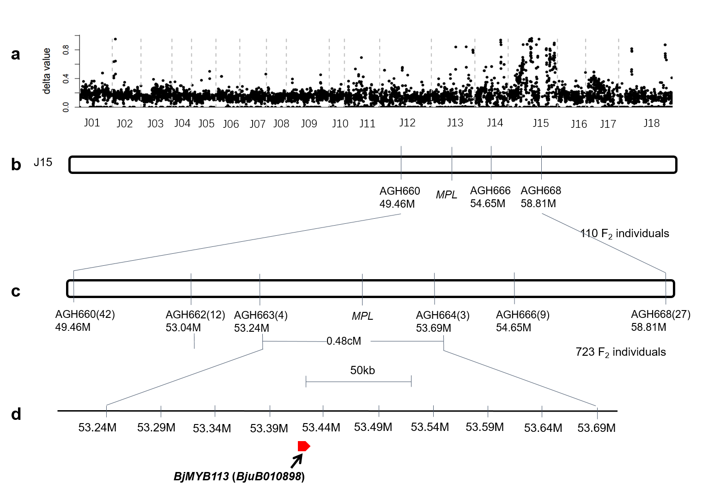

Figure S2. The alignment of protein sequences of BjMYB113 and its most similar R2R3-MYB transcription factors homologous genes. An amino acid change (M120K) was found between protein sequences of BjMYB113a and BjMYB113b.

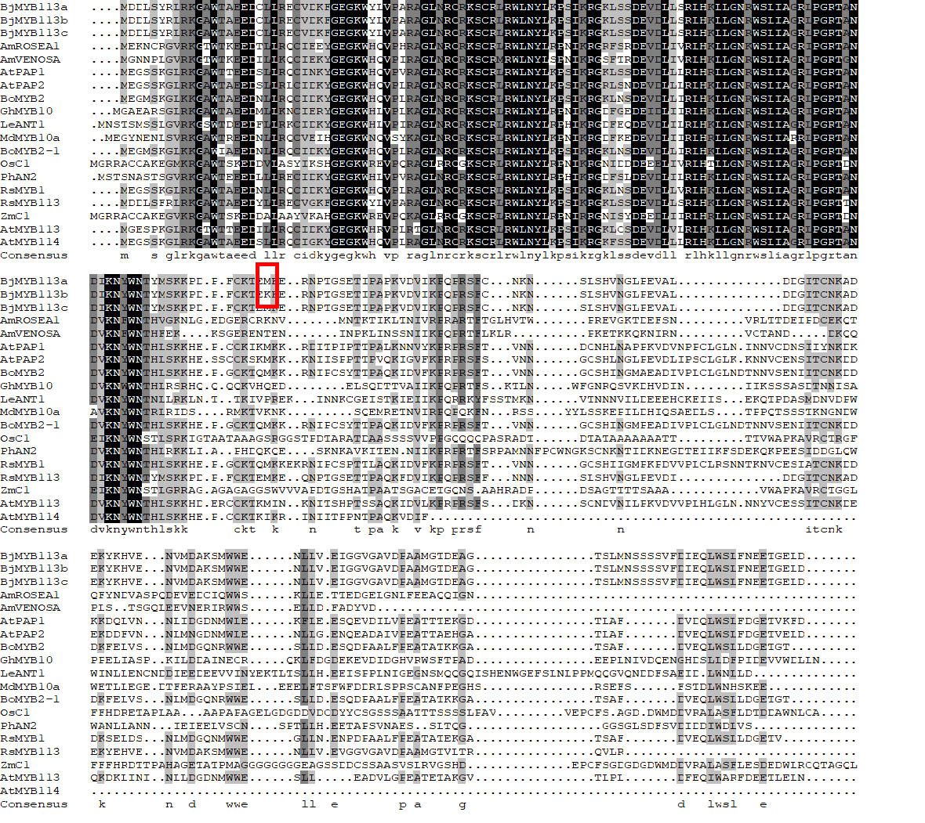

Figure S3. The neighbor-joining tree of the sequences of the BjMYB113 alleles in 58 mustard accessions. The sequences of BjMYB113 orthologue in Brassica oleracea was used as an outgroup. (The black triangle before the labels represent the 1,033-bp insertion, the black rectangular before the labels represent the 1,268-bp insertion, the red circular before the labels represent the purple phenotype).

