Supplementary Materials
Journal of Applied Phycology
Assessment of Adsorption and Removal Efficacy of Spirulina Powder for Strontium and Thallium
Mahendra Yadav^{1,2*†}, Vivek Kumar¹, Shelly Jain¹, Nidhi Sandal^{1†}, Meenakshi Kanwar Chauhan³
¹Division of CBRN Defence, Institute of Nuclear Medicine and Allied Sciences, Defence Research and Development Organization, Ministry of Defence, New Delhi-110054, India
²Narayan Institute of Pharmacy, Gopal Narayan Singh University, Sasaram, Rohtas, Bihar-821305, India
³Department of Pharmaceutics, Delhi Institute of Pharmaceutical Sciences and Research, New Delhi-110017, India
† Equal Contribution
*Address for Correspondence
Dr. Mahendra Yadav
Narayan Institute of Pharmacy, Gopal Narayan Singh University, Sasaram, Rohtas, Bihar-821305, India
Email: yadavmahendra02@gmail.com

1. Effect of Spirulina powder on adsorption of cobalt
The percentage adsorption of cobalt on Spirulina was significantly high (p<0.001) in water compared to SGF. The percentage of cobalt adsorption on Spirulina was decreased with increasing the amount of cobalt (10-100 mg L⁻¹) in water (32.358±0.645–19.712±0.672) and SGF (21.398±1.305–7.053±0.403) (Figure S1).
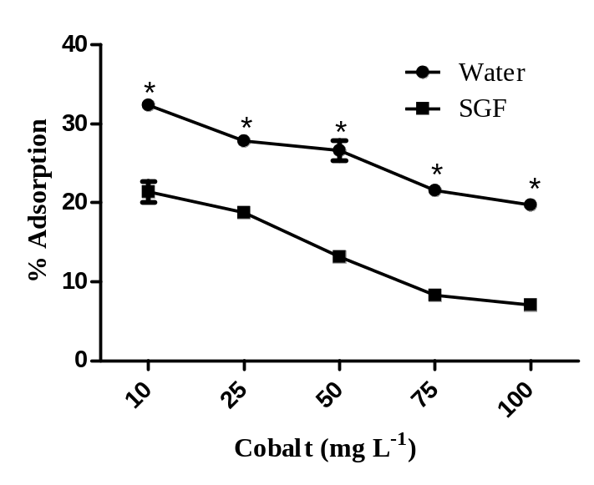
Figure S1: Percentage adsorption of different concentration of cobalt (10-100 mg L⁻¹) on Spirulina (10 g L⁻¹) in water and simulated gastric fluid. Values are expressed in Mean ± S.E.M. (n=3); Significant values are *p< 0.001 when compared to SGF. (SGF; simulated gastric fluid).
2. Effect of Spirulina powder on adsorption of strontium
The percentage adsorption of strontium on Spirulina in water and simulated physiological solutions (SGF and SIF) is illustrated in figure S2. A significant increase (p<0.001) in the adsorption of strontium was observed at low concentration of strontium (10 mg L⁻¹) in water and SIF as compared to SGF. The adsorption of strontium (10-100 mg L⁻¹) on Spirulina was significantly high (p<0.05-p<0.001) in SIF compared to water and SGF. The percentage of strontium adsorption on Spirulina was decreased with increasing the amount of strontium (10-100 mg L⁻¹) in water (29.429±4.077–5.879±2.032) and SGF (15.201±2.020–4.379±0.477). In SIF the percentage adsorption of strontium on Spirulina was almost same at all concentration (26.577±2.550–24.192±0.232) (Figure S2).
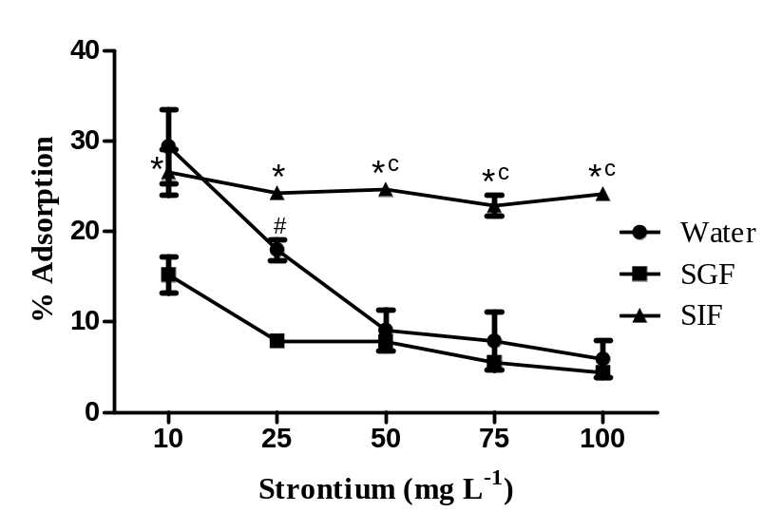
Figure S2: Percentage adsorption of different concentration of strontium (10-100 mg L⁻¹) on Spirulina (10 g L⁻¹) in water and simulated physiological solutions (SGF and SIF). Values are expressed in Mean ± S.E.M. (n=3); Significant values are #p<0.01 and *p< 0.001 when compared to SGF, and ^{c}p< 0.001 when compared to water. (SGF; simulated gastric fluid, SIF; simulated intestinal fluid).
3. Effect of Spirulina powder on adsorption of barium
Adsorption of barium on Spirulina in water and simulated physiological solution (SGF) is illustrated in Figure S3. A significant increase (p<0.05) in the percent adsorption of barium was observed at lower concentration of barium (10 mg L⁻¹) in SGF only when compared to water. Whereas, insignificant differences were observe at remaining concentration of barium in water and SGF. The percentage adsorption of barium on Spirulina was decreased with increasing the amount of barium (10-100 mg L⁻¹) in water (12.490±0.0–2.858±0.556) and SGF (18.070±3.095–5.622±0.368).
4. Effect of Spirulina powder on adsorption of cesium
The percentage adsorption of cesium on Spirulina in water and simulated physiological solutions (SGF and SIF) is illustrated in Figure S4. The percentage adsorption of cesium was high at lower concentration of cesium, which decreased with increasing the concentration in water, SGF and SIF. No significant differences were observed between the percentage cesium adsorption on Spirulina in water, SGF and SIF. The percentage of cesium adsorption on Spirulina (10 g L⁻¹) was decreased with increasing the amount of cesium (10-100 mg L⁻¹) in water (6.249±0.0–4.483±0.196), SGF (5.125±0.722–2.776±0.260) and SIF (5.665±1.583–2.289±0.309) (Figure S4).
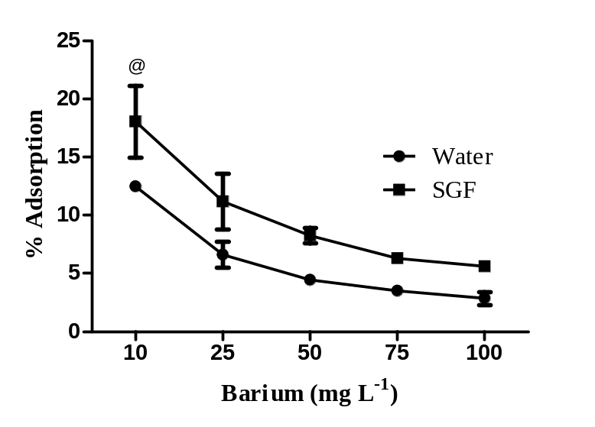
Figure S3: Percentage adsorption of different concentration of barium (10-100 mg L⁻¹) on Spirulina (10 g L⁻¹) in water and simulated gastric fluid. Values are expressed in Mean ± S.E.M. (n=3); Significant values is @p< 0.05, when compared to water. (SGF; simulated gastric fluid).
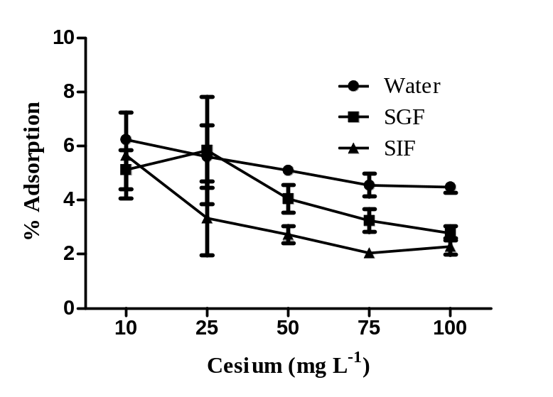
Figure S4: Percentage adsorption of different concentration of cesium (10-100 mg L⁻¹) on Spirulina (10 g L⁻¹) in water and simulated physiological solutions (SGF and SIF). Values are expressed in Mean ± S.E.M. (n=3); no significant differences were observed between water, SGF and SIF. (SGF; simulated gastric fluid, SIF; simulated intestinal fluid).
5. Effect of Spirulina powder on adsorption of thallium
The percentage adsorption of strontium on Spirulina in water and simulated physiological solutions (SGF and SIF) is illustrated in Figure S5. The percentage adsorption of thallium was high at lower concentration of thallium, which decreased with increasing the concentration in water, SGF and SIF. Spirulina showed significant increase in percentage adsorption of thallium in SGF (p<0.001) when compared to water and SIF. The percentage adsorption of thallium at low concentration (10 mg L⁻¹) on Spirulina was significantly high (p<0.05) in water as compared to SIF. The percentage of thallium adsorption on Spirulina (10 g L⁻¹) was determined in water (19.061±1.905-4.775±0.009), SGF (32.673±2.509-21.426±0.258) and SIF (14.778±0.507-7.21±0.143).

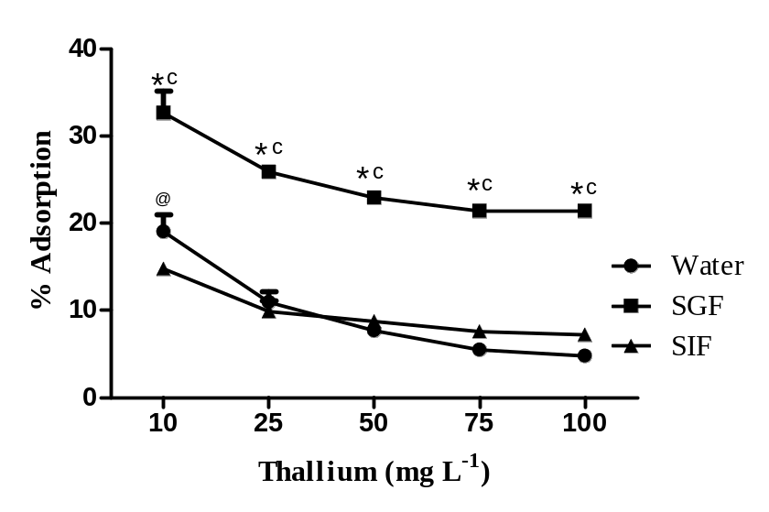
Figure S5: Percentage adsorption of different concentration of thallium (10-100 mg L⁻¹) on Spirulina (10 g L⁻¹) in water and simulated physiological solutions (SGF and SIF). Values are expressed in Mean ± S.E.M. (n=3). Significant values are @p< 0.05 and *p< 0.001 when compared to SIF, and ^{c}p< 0.001 when compared to water. (SGF; simulated gastric fluid, SIF; simulated intestinal fluid).

